**TRAFFIC PREDICTION FOR INTELLIGENT TRANSPORTATION SYSTEM**

1. **N.Periyasamy 1, Mohammed Nishad.S 2, Russel Gabriel Thomas 3 , Sreerag M 4**

1Assistant professor, Department of CSE, Hindusthan Institute of technology, Coimbatore, TamilNadu,

India

2,3,4Student, Department of CSE , Hindusthan institute of technology, Coimbatore, TamilNadu, India

**ABSTRACT**

Currently the traffic control system in our country is non-flexible to the ever growing number of vehicles on the road. Traffic

light is the basic element in traffic flow control through specified waiting and going time, fixed traffic light time systems are a bad control way. Intelligent traffic systems include smart ways to control traffic light time based on the number of vehicles in each lane. Improving traffic signal control systems will increase safety, reliability, and traffic flow speed and reduce average travelling and waiting time for passengers. The objective is to design an efficient automatic Traffic Time Saver system. The system is implemented on the traffic control. This proposed application system first captures the vehicle image. Vehicle image is extracted using the image segmentation finally converting the images from RGB to grayscale. Next, the segmentation is applied on the prepared image and then for each segment the neural networks will predict a vehicle or not. A counter will count the positive segments. Finally, the suitable periods for each light color will display in GUI.

1. **INTRODUCTION**

The proposed  traffic time saver system is to provide a user-friendly interface for vehicle users so they can save time in Traffic signals more effectively. Because traffic signals are bad. Because the traffic signal authority manually set the timer in the traffic signal. The problem will lead to a time consuming process where users need to wait for green color. Some lanes don't have any vehicles. Sometimes a green color signal will show because signal timing will cause static time control . This leads to some problems driving users to wait a long time. Traffic congestion is a major issue in many cities around the world, leading to increased travel times, air pollution, and economic costs. To address this issue, transportation authorities have been looking to adopt intelligent transportation systems (ITS) that utilize cutting-edge technologies to improve the efficiency of transportation networks. Machine learning, in particular, has shown great potential for traffic prediction in ITS. Traffic prediction refers to the process of forecasting future traffic conditions based on historical data. Accurate traffic prediction is essential for effective traffic management and congestion reduction. By using machine learning algorithms to analyze large amounts of data from sources such as GPS-enabled devices, traffic cameras, and other sensors, ITS can predict traffic conditions in real-time and optimize traffic flows accordingly.

1. **METHODOLOGY**
2. Any technique that uses information and control technologies can be divided into small functions:
3. A. Collection of Data
4. B. Processing of Data
5. C. Decision Making System
6. Arrangement and inspection support based on information. Multiple forms of wireless communication technologies have been introduced for the intelligent transportation system. Communications of radio modem on UHF and VHF frequencies are highly used for short and long-range communication in transportation system.
7. **MODELING AND ANALYSIS**

Deep learning application initially we need to collect data for training purpose . Image segmentation is one of the important processes to identify vehicle count on traffic

.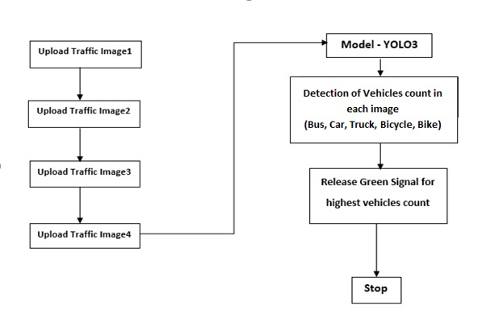

**Figure 1:** Flow chart.

1. **RESULTS AND DISCUSSION**

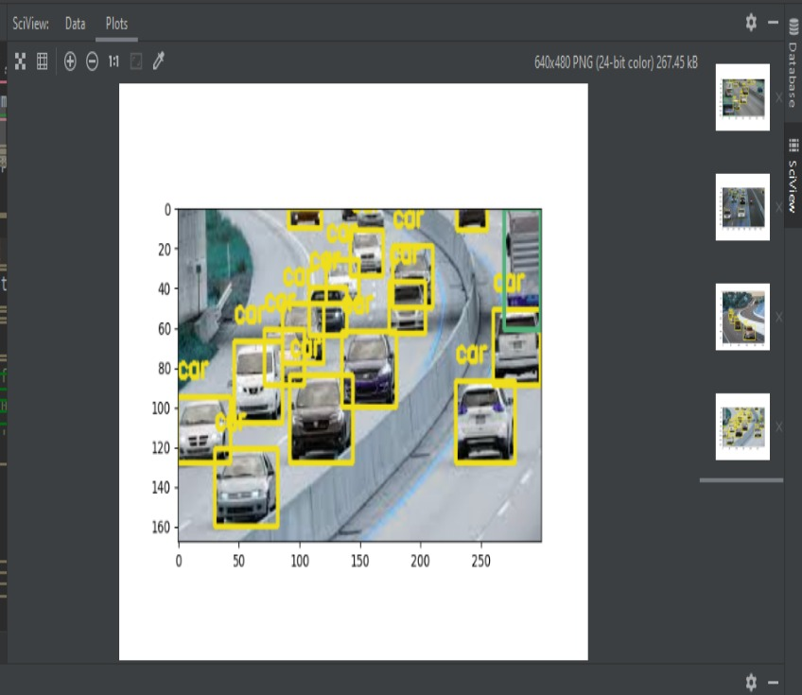

Traffic prediction is an important task for intelligent systems as it can help to improve traffic flow and reduce congestion on roads. In this project, we developed a traffic prediction system using machine learning algorithms to predict traffic flow based on historical traffic data. Overall, our project demonstrates the potential of machine learning algorithms for traffic prediction and highlights the importance of considering weather conditions when predicting traffic flow. Our system could be integrated into existing traffic management systems to help improve traffic flow and reduce congestion on roads

1. **CONCLUSION**

Implementation is the stage of the project when the theoretical design is turned out into a working system. Thus it can be considered to be the most critical stage in achieving a successful new system and in giving the user, confidence that the new system will work and be effective. Proposed system successfully presented YOLO, a new approach to object detection, algorithm that can improve the detection performance based on limited training data and an effective database expansion method. In this proposed application system first captures the vehicle image. Vehicle image is extracted using the image segmentation finally converting the images from RGB to gray scale. Next, the segmentation is applied on the prepared image and then for each segment the neural networks will predict a vehicle or not..

1. **REFERENCES**
2. D. McMillen, "The center restored: Chicago's residential price gradient remerges," Economic Perspectives, pp. 1-11, 2002.
3. A. Johnston, "A note on commute times and average income levels," CrossMark, vol. 13, pp. 151-153, 2019.
4. R. Cahuantzi, X. Chen, S. Güttel, A comparison of LSTM and GRU networks for learning symbolic sequences, pp. 1-12, 2021.
5. E. Hansson, K. Mattisson, J. Björk, P. Östergren, K. Jakobsson, "Relationship between commuting and health outcomes in a crosssectional population survey in southern Sweden," BMC Public Health, vol. 11, p. 834, 2011.