**SELF DRIVING CAR SIMULATOR**

**Mr.MURUGAN,M.E, Sudharsan L, Pranav P, Venkata Lingarao P**

1Assistant professor, Department of CSE, Hindusthan Institute of technology, Coimbatore, TamilNadu,

India

2,3,4Student, Department of CSE , Hindusthan institute of technology, Coimbatore, TamilNadu, India

**ABSTRACT**

Our analysis shows that CARLA and LGSVL simulators are the current state-of-the-art simulators for end to end testing of self-driving cars for the reasons mentioned in this paper. Finally, we present current challenges that simulation testing continues to face as we march towards building fully autonomous cars. The field of autonomous automation is of interest to researchers, and much has been accomplished in this area, of which this paper presents a detailed chronology. This paper can help one understand the trends in autonomous vehicle technology for the past, present, and future. We see a drastic change in autonomous vehicle technology since 1920s, when the first radio-controlled vehicles were designed. In the subsequent decades, we see fairly autonomous electric cars powered by embedded circuits in the roads.

1. **INTRODUCTION**

Autonomous cars provide excellent benefits, but some challenges do exist. Although the notion has been rejected, but, it is believed that an advent of autonomous cars would lead to a decrease of driving related jobs. Also, situations like inability of drivers to regain control of their cars due to inexperience of drivers, etc. is an important challenge. Lots of people love driving, and it would be difficult for them to forfeit control of their cars. Autonomous cars also pose challenges interacting with human-driven vehicles on the same route. Another challenge to autonomous cars is that who is to be held liable for damage- the car manufacturing company, the car’s occupants/owner, or the government. Thus, implementation of a legal framework and establishment of government regulations for autonomous vehicles is a major problem.

1. **METHODOLOGY**

The methodology consists of novail modules that provide new parameters for evaluating the decision making system and the self-learning neural network.

Which gives an accuracy of 98% of the total trained model as of now implemented for straight roads with car obstacles on the road.

1. **MODELING AND ANALYSIS**

According to the annual Autonomous Mileage Report published by the California Department of Motor Vehicles, Waymo has logged billions of miles in testing so far. As of 2019, the company’s self-driving cars have driven 20 million miles on public roads in 25 cities and additionally 15 billion miles through computer simulations. While the number of miles driven is important, it is the sophistication and diversity of miles accumulated that determines and shapes the maturity of the product. Additionally, the testing through simulation plays a key role in supplementing and accelerating the real-world testing [1]. It allows one to test scenarios that are otherwise highly regulated on public roads because of various safety concerns. It is an open-ended and highly configurable driving simulator that integrates the key feature of the procedural generation (PG). The simulator defines multiple basic roadblocks such as ramp, fork, and roundabout with configurable settings and a range of diverse maps can be assembled from those blocks with procedural generation, which is further turned into interactive environments

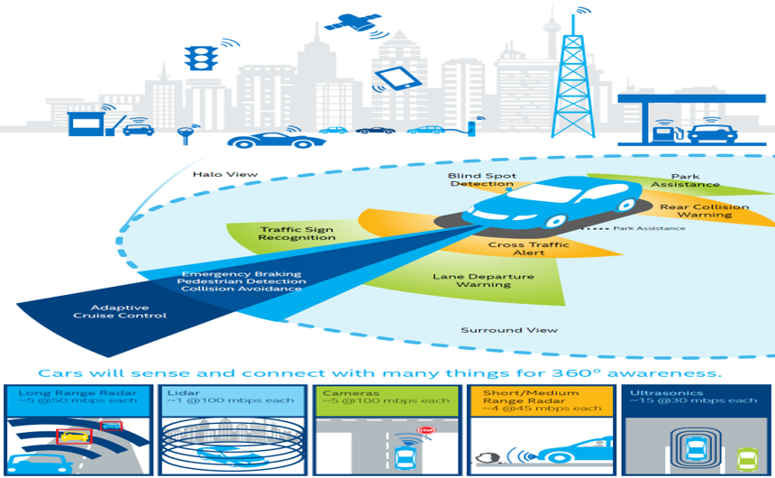

**Figure 1:** System Architecture

1. **RESULTS AND DISCUSSION**

Due to current regulations, the lack of certified systems for road use, and driver safety concerns, most of the studies mentioned in this project are based on driving simulations with different levels of realism. The use of simulations represents one of the most critical limitations in studying human factors in autonomous vehicles since drivers tend to behave differently in real vehicles and less 55 controlled environments.

There are studies, which use a real platform to determine driver reaction time. However, such works are very limited and a detailed study with a big sample of data needs to be performed to investigate all the different factors that affect TOR in a real road environment This project “Car Automation Driving” discusses basic chronology leading to the development of autonomous cars. Autonomous vehicles developed from the basic robotic cars to much efficient and practical vision guided vehicles. Most cars are expected to be fully autonomous by 2035, according to official predictions as cited earlier.

.

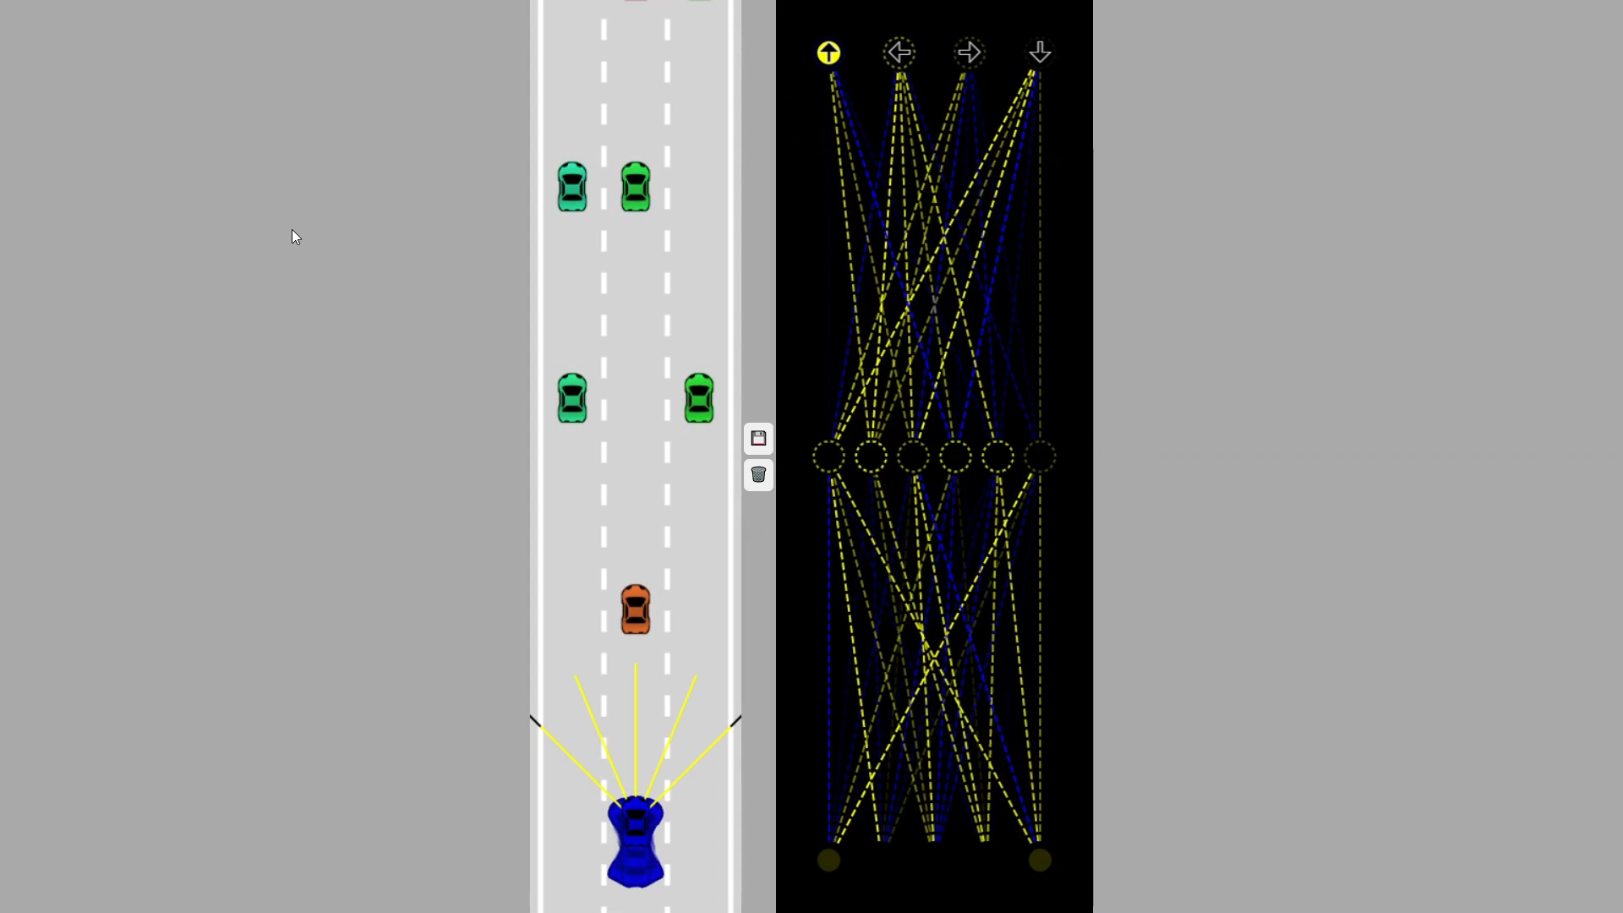

**Figure 2:** Output of our Software

1. **CONCLUSION**

This paper discusses basic chronology leading to the development of autonomous cars. Autonomous vehicles developed from the basic robotic cars to much efficient and practical vision guided vehicles. The development of Mercedes- Benz vision guided autonomous van by Ernst Dickmanns and his team gave a paradigm shift to the approach followed in autonomous cars. Also, contemporary developments in autonomous cars reflect the vivid future autonomous cars behold. Official future predictions about autonomous cars point out that most automobile companies will launch cars with semi and fully autonomous features by 2020. Most cars are expected to be fully autonomous by 2035, according to official predictions as cited earlier. This paper reviewed the historical antecedents, contemporary advancements and developments, and predictable future of semi and fully autonomous cars for public use.

1. **REFERENCES**
2. 1.Hallerbach, S.; Xia, Y.; Eberle, U.; Koester, F. (2018). "Simulation-Based Identification of Critical Scenarios for Cooperative and Automated Vehicles". SAE International Journal of Connected and Automated Vehicles. SAE International. 1 (2): 93–106
3. 2. Maki, Sydney; Sage, Alexandria (19 March 2018). "Self-driving Uber car kills Arizona woman crossing street". Reuters. Retrieved 14 April 2019.
4. 3. Gehrig, Stefan K.; Stein, Fridtjof J. (1999). Dead reckoning and cartography using stereo vision for an automated car. IEEE/RSJ International Conference on Intelligent Robots and Systems. Vol. 3. Kyongju. pp. 1507–1512.
5. 4. Thrun, Sebastian (2010). "Toward Robotic Cars". Communications of the ACM. 53 (4): 99–106
6. 5. Brodsky, Jessica (2016). "Autonomous Vehicle Regulation: How an Uncertain Legal Landscape May Hit the Brakes on Self-Driving Cars". Berkeley Technology Law Journal. 31 (Annual Review 2016): 851–878. Retrieved 29 November 201