**ELECTRONIC DOOR SECURITY SYSTEM**

**Nikita Jadhav1, Prachi Kakad2, Gandhali Patil3**

1,2,3student, Department Of Electronics & Telecommunication Engineering, Mvps’ S Kbt College Of Engineering, Nashik, Maharashtra, India

**ABSTRACT**

When we hear about home, office and other places security the first thing which comes in our mind is door security as door is a crucial part when we talk about physical security. Here we require some security system to prevent entry of unauthorized person without our access or in our absence. Hence we are designing this electronic door security system which provides authentication like Face detection, keypad operated password system and remote door access system using Esp32 module, which gives allowed access to unauthorized person like relatives, house helps, in offices we can give access to non-authority staff etc. via remote door access system when we are not there. It works in such way that we can close and open the door by app and also can check the visitor by the camera on our mobile phones and after checking we have option on the app to unlock the door from your mobile phone or to leave as it is, if we don’t want to allow that person to enter.

Keywords*:* Door security system, surveillance, Esp32 module, Face detection, remote door access.

# 1. INTRODUCTION

An electronic door security system using an ESP32 module is a sophisticated and reliable way to secure a building or home. This system combines various features such as face detection, keypad operated system, and remote door access system to ensure maximum security and convenience. The face detection feature uses a camera module to capture and analyze the image of a person's face before granting access. This feature is reliable and efficient, and it eliminates the need for physical keys or passwords. The keypad-operated system is an alternative option for granting access to those who are not recognized by the face detection feature. Users can enter a unique code on the keypad to unlock the door. This feature provides an additional layer of security and convenience. The remote door access system allows users to unlock or lock the door from a remote location using a mobile phone with internet connectivity. This feature is particular

useful for those who need to provide access to their premises to someone while they are away from the location.

## The ESP32 module, a camera module for face detection, a keypad for user authentication, an internet connectivity for remote access, and a solenoid lock for door control. The components need to be configured to work together and with the ESP32 module. To develop the software that will run on the ESP32 module to control the system. This includes programming the ESP32 to communicate with the camera module for face detection, the keypad for user authentication, and the lock for door control. The software should also enable remote access to the system through a web or mobile application. the system should be tested to ensure that all components are working together as expected. Any issues or bugs should be identified and fixed through debugging and testing. the system has been tested , you can deploy it. Install the system on the door you want to secure, and ensure that it is properly wired and connected to the power supply. you can create a system that provides reliable and secure access control to your door.

## 2. BLOCK DIAGRAM

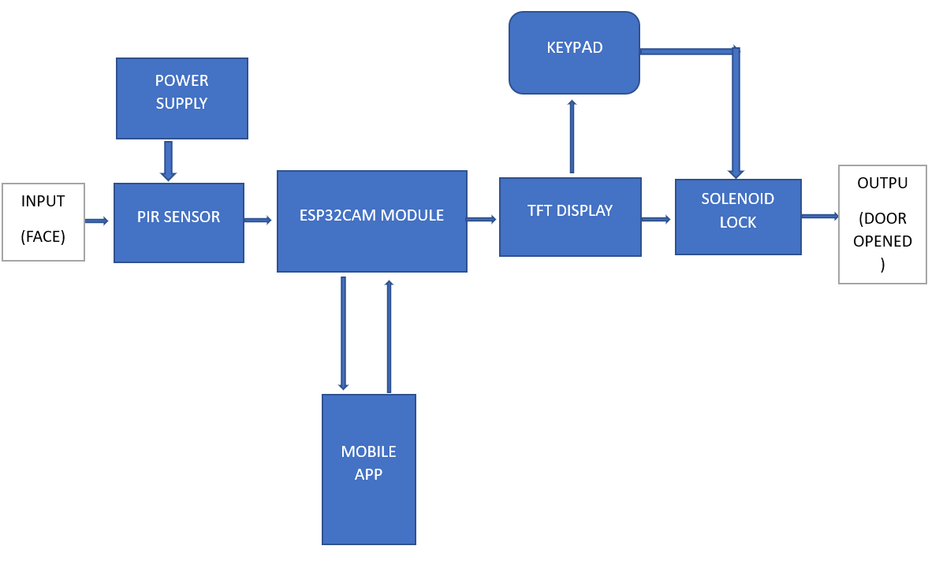

**Figure 1:** Block Diagram

## 3. FLOWCHART

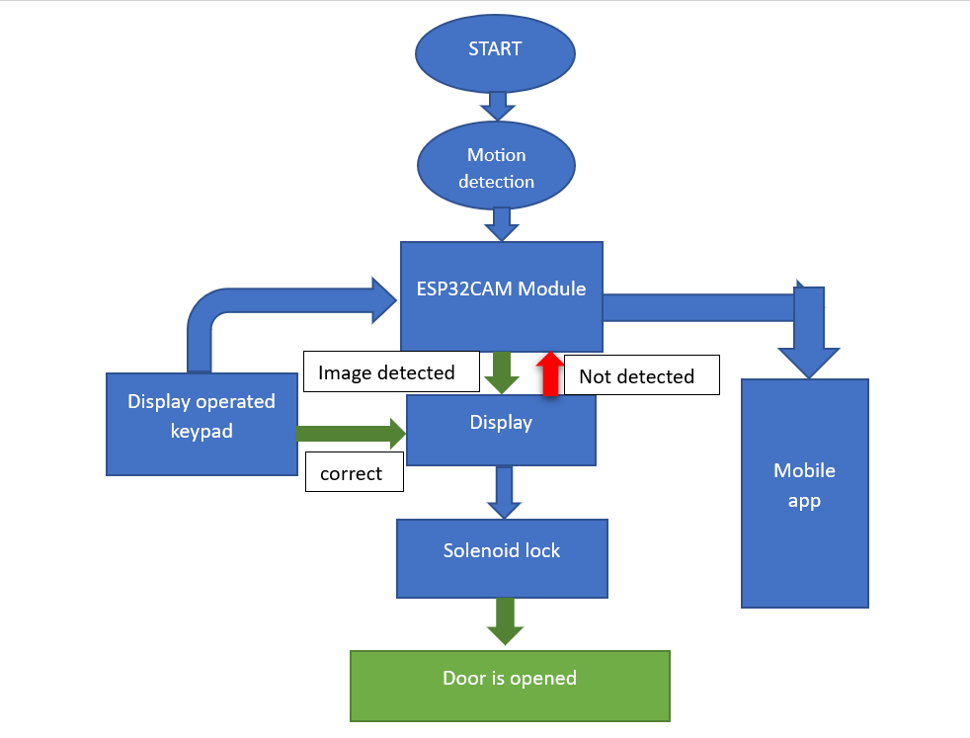

**Figure 2:** Flowchart

# 4. RESULT

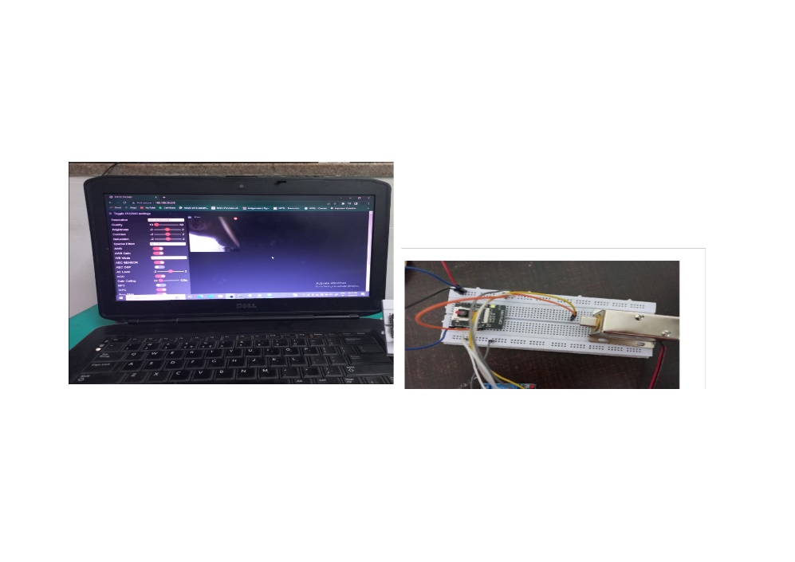

**Figure 3:** Hardware

# 5. CONCLUSION

An electronic door security system using an ESP32 module with features such as face detection, keypad operated system, and remote door access system is an excellent way to enhance the security of your building or home. The face detection feature is an advanced technology that ensures only authorized individuals gain access, while the keypad-operated system provides an additional layer of security and convenience. The remote door access system makes it possible to manage access to your premises from a remote location, which is particularly useful for businesses or individuals who are frequently on the move. With the ESP32 module, this system is reliable, efficient, and easy to set up, making it a popular choice for those looking for a high-tech solution for their security needs. In our project, we made the normal lock into a highly secure smart lock. We have increased the security of the smart lock to outperform the normal lock. We have added modern login features such as phone, fingerprint, keypad. On the security front, we have added a camera and motion sensor so that we get higher security. The benefits were easy and fast use. High security that protects our privacy and our property.

# 6. REFERENCES

1. https://www.pantechsolutions.net/smart-door-using-esp32
2. https://www.pantechsolutions.net/bluetooth-based-smart-door-lock-system-using-esp32
3. https://emanuelepagliari.it/2021/02/25/how-to-gate-control-esp32/
4. https://circuitdigest.com/microcontroller-projects/esp32-cam-face-recognition-door-lock-system
5. https://create.arduino.cc/projecthub/benjineering/easy-iot-remotely-controlling-esp32-using-an-

android-app-99a1dd

1. https://www.electroniclinic.com/esp32-cam-smart-iot-bell-circuit-diagram-and-programming/

esp32io.com/tutorials/esp32-keypad

1. https://www.hackster.io/alankrantas/tinyml-live-image-classification-on-esp32-cam-and-tft-

de1a53

1. https://circuitdigest.com/microcontroller-projects/esp32-cam-face-recognition-door-lock-system