**AUTOMATIC MONITORING AND CONTROL SYSTEM IN**

**HYDROPONICS PLANT AGRICULTURE**

**P Suresh Kumar1, Sikha G Jayan2, Shilpa K P3, Shinas4, Vaishnav5**

1Assistant Professor, Department Of Computer Science And Engineering,

Hindusthan Institute Of Technology, Coimbatore, Tamil Nadu, India

2,3,4,5Student, Department Of Computer Science And Engineering,

Hindusthan Institute Of Technology, Coimbatore, Tamil Nadu, India

**ABSTRACT**

Hydroponic plant system is becoming increasingly popular due to their efficiency, sustainability, and productivity. However, maintaining optimal growing conditions can be challenging, requiring constant monitoring and adjustments of environmental factors such as temperature, humidity, light, pH, and nutrient levels. An automatic control system using a LattePanda as the main processing unit and an adjustable interface can be implemented in a hydroponic plant system to address these challenges. This system consists of sensors to monitor environmental factors, a microcontroller to process data, control of actuators, and communication with the user interface. The adjustable interface can be tailored to the plant’s specific needs, allowing growers to monitor and adjust environmental factors as needed.

**Keywords:** Hydroponics, LattePanda, Automatic control, Sensors, Microcontroller, Monitor.

1. **INTRODUCTION**

Hydroponics is a modern technique of growing plants without soil, using nutrient-rich water solution instead. Without hydroponics, plants can grow faster and produce higher yields compared to traditional soil-based farming. However, hydroponic systems require precise control of various environmental factors, such as water pH, temperature, and nutrient levels. An automatic hydroponics control system can be implemented to adjust these parameters automatically to achieve this level of precision. The system utilizes sensors, such as temperature, humidity, pH level, and light sensors, to measure the environment and ensure optimal growth conditions. the system also provides real-time data monitoring and control through a user-friendly interface allowing farmers to access data about the growth of their plants and adjust the environment as needed. Overall, an automatic monitoring and control system for a hydroponic plant agriculture project can significantly improve the efficiency and productivity of the farming process while reducing labor costs and minimizing the environmental impact.

1. **METHODOLOGY**
   1. **Hardware Components:**

* LattePanda - a low-power single-board computer with a quad-core Intel Atom processor and an Arduino co-processor.
* Sensors – temperature, pH, nutrient, and light sensors.
* Peristaltic pumps - to control the nutrient concentration in the hydroponic system.
* LED lights - to provide the required lighting conditions for the plants.
* Relay modules - to control the on/off function of the pumps and lights.

**2.2 Software Components:**

* Arduino IDE - to program the Arduino co-processor on the LattePanda.
* Embedded C

**2.3 Methodology**:

* Hardware setup - The LattePanda and sensors were connected according to the circuit diagram, with the peristaltic pumps and LED lights being controlled by relay modules.
* Programming - The Arduino co-processor was programmed to read data from the sensors and control the pumps and lights. The main processing unit was programmed using Python to receive data from the Arduino and provide a user interface for controlling the system.
* Testing - The system was tested for its ability to monitor and adjust various parameters such as temperature, pH level, nutrient concentration, and lighting, based on the plant’s requirements.
* Validation - The system was validated by comparing the growth and yield of plants grown using the automatic control system to those grown using a manual control system.

1. **MODELING AND ANALYSIS**

Modeling and analysis of hydroponic greenhouse farming systems can help optimize crop growth and resource utilization. One approach is to use mathematical models to simulate and analyze the effects of different environmental parameters on crop growth, such as light intensity, nutrient levels, and temperature. These models can be integrated with IoT data to provide real-time feedback and recommendations for adjusting the greenhouse environment to optimize crop yield.

Another approach is to use machine learning algorithms to analyze data collected from IoT sensors, allowing for predictive analytics and automated decision-making. By analyzing patterns in the data, these algorithms can predict crop growth, detect potential issues, and recommend adjustments to the greenhouse environment. This can lead to more efficient resource utilization, reduced waste, and increased crop yield.

Overall, modeling and analysis of hydroponic greenhouse farming systems can provide valuable insights and recommendations for optimizing crop growth and resource utilization. By leveraging the power of mathematical models and machine learning algorithms, farmers can make more informed decisions and achieve better results.

The block diagram of the hardware setup is given below;

LCD Display

Arduino Uno

`

`

Moisture Sensor

Buzzer

`

Light sensor

`

`

Blynk App

`

Temperature sensor

`

Relay +Motor

**Figure 1:** Block Diagram

`

`

Ultrasonic Sensor

`

`

Light Bulb

Cooler Fan

Water pump

**Figure 1**: Block Diagram

1. **RESULTS AND DISCUSSION**

The key results of the hydroponic green housing farming system:

* Improved Crop Yield: The hydroponic green housing system using IOT results in increased crop yield due to the precise control of environmental factors. The system was able to maintain optimal temperature, humidity, and nutrient levels, resulting in stronger, healthier, and more production in the crops.
* Water and Energy Efficiency: The system regulates water and nutrient usage so that the use of energy can be optimized reduces wastage and increases overall efficiency.
* Real-Time Monitoring: The system allows the growers to monitor and control the environmental factors in real time. By this, the growers can adjust the factors and reduce the loss in production.
* Remote Access: The system provides remote access to the grower, by allowing them to monitor, control and adjust the environment from anywhere even if they are not physically present.
* Reduced Environmental Impact: The environmental impact of farming by minimizing water and energy usage and reducing the use of pesticides and herbicides. This made farming more sustainable and eco-friendlier.
* Cost Savings: The farming system resulted in cost savings due to reduced water and energy usage, fewer labor requirements, and increased crop yield. This increased productivity, and profitability and made hydroponic farming more accessible to smaller-scale growers.

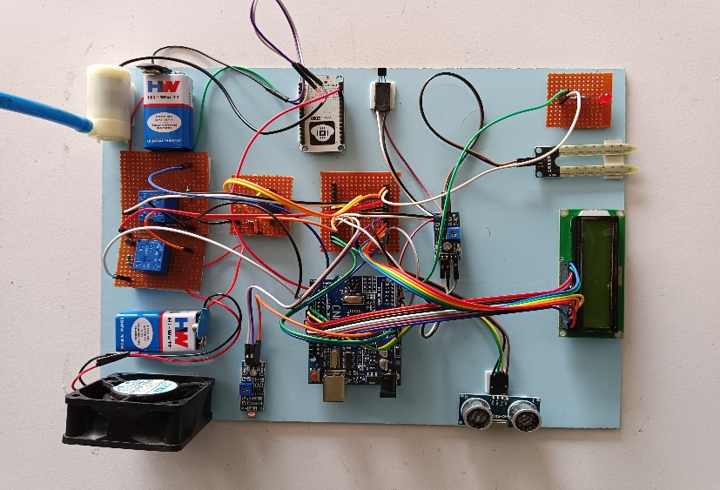

**Figure 2:** Hardware setup

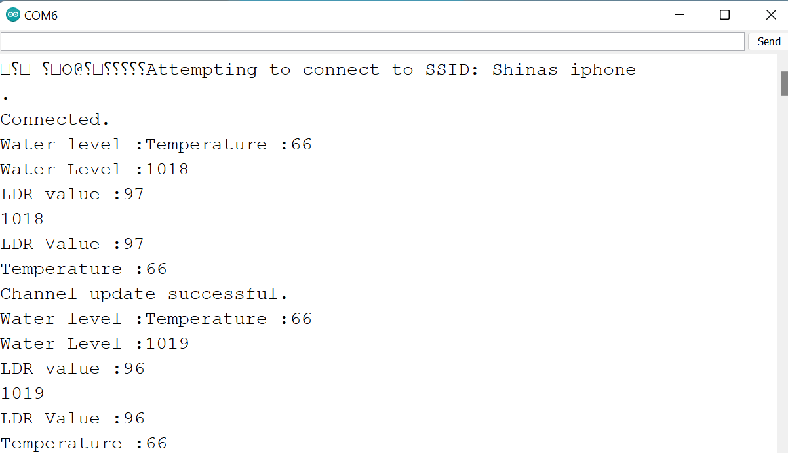

**Figure 3:** Readings of the factors

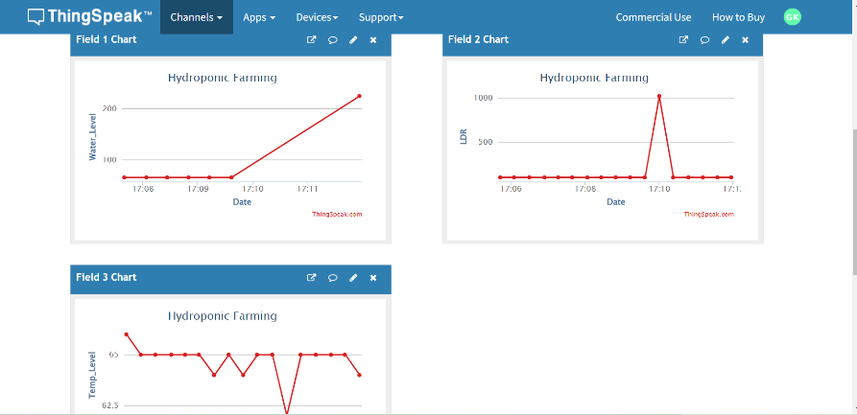

**Figure 4:** Graph showing the variations in the readings

1. **CONCLUSION**

In conclusion, the hydroponic green housing farming system is a highly effective and innovative approach to crop cultivation. The system allows the real-time monitoring of the crops, detects any issues that arise and can resolve the issues from anywhere and at any time. The hydroponic green housing farming system is an excellent solution for growers who want to maximize crop yields while minimizing environmental impact and costs. Its advanced monitoring and control capabilities, predictive analytics, and remote access features make it a highly effective and efficient way to cultivate crops. It has the potential to transform the way that crops are grown and make hydroponic farming accessible to growers of all sizes.

Some potential future scope of the system includes:

* Integration with other smart technologies: The system can be integrated with other smart technologies like artificial intelligence and machine learning which can be used for future development.
* Scaling up: The system can be used in large-scale crop production and for commercial application.
* Expansion to other crops: Hydroponic greenhouse farming can be expanded to other crops including fruits, vegetables, etc.

1. **REFERENCES**
   1. "Design of an IoT-based smart hydroponic greenhouse for sustainable agriculture" by M. Al-Rashdan, et al. (2022). This paper presents a smart hydroponic greenhouse that uses IoT technology to monitor and control various parameters such as temperature, humidity, and nutrient levels.
   2. "Smart Greenhouse Management System using IoT" by S. Bhavsar, et al. (2021). This paper proposes a smart greenhouse management system that uses IoT technology to automate the greenhouse environment, monitor plant growth, and optimize resource usage.
   3. "Design and Implementation of a Smart Greenhouse Monitoring and Control System Based on IoT" by Y. Chen, et al. (2020). This paper presents a smart greenhouse monitoring and control system that uses IoT technology to collect data on various environmental parameters and control the greenhouse environment.
   4. "Smart Greenhouse Management System using IoT and Machine Learning Techniques" by S. Sivakumar, et al. (2019). This paper proposes a smart greenhouse management system that uses IoT technology and machine learning techniques to optimize resource usage, monitor plant growth, and control the greenhouse environment.
   5. Lakhiar, I. A., Gao, J., Syed, T. N., Chandio, F. A., & Buttar, N. A. (2018). Modern plant cultivation technologies in agriculture under controlled environment: A review on hydroponics. Journal of Plant Interactions, 13(1), 338-352.