|  |
| --- |
| **GENDER, AGE AND SENTIMENTAL ANALYSIS** |



**A PROJECT REPORT**

***Submitted by***

**KANNAN M (720819104050)**

**KAVIN VIGNESH T (720819104054)**

**ARAVINTH S (720819104010)**

***In partial fulfillment for the award of the degree***

***of***

**BACHELOR OF ENGINEERING**

***in***

**COMPUTER SCIENCE AND ENGINEERING**

**HINDUSTHAN INSTITUTE OF TECHNOLOGY**

Approved by AICTE, New Delhi, Accredited with ‘A’ Grade by NAAC

(An Autonomous Institution, Affilited to Anna University, Chennai)

**COIMBATORE-641032**

**ANNA UNIVERSITY :: CHENNAI 600025**

**BONAFIDE CERTIFICATE**

Certified that this project report **“GENDER , AGE AND SENTIMENTAL ANALYSIS”** is the bonafide work of **“KANNAN M (720819104050), KAVINVIGNESH T (720819104054), ARAVINTH S (720819104010)”** who carried out the Project work under my supervision.

**SIGNATURE SIGNATURE**

**Dr.A.JameerBasha. M.E., P h.D**., **Mrs.D.Vidhya, M.E.**

Head of the Department & Professor, Assistant Professor,

Computer Science and Engineering, Computer Science and Engineering,

Hindusthan Institute of Technology, Hindusthan Institute of Technology, Coimbatore – 641 032 Coimbatore – 641 032.

Submitted for the University Project Viva Voice examination conducted on………………

**INTERNAL EXAMINER EXTERNAL EXAMINER**

**ACKNOWLEDGEMENT**

We are using this opportunity to express our gratitude to everyone who supported us throughout this project. We would like to thank the Almighty God for blessing us with his grace.

We express our thanks to the Managing Trustee **Smt. T. R. K. Sarasuwathi Khannaiyann,** for providing the essential infrastructure and helping us to carry out this project.

We would like to express our sincere gratitude to the Principal **Dr. C. Natarajan, Ph.D.,** for helping us in bringing out the project successfully and for strengthening the ray of hope towards us.

We wish to record our deep sense of gratitude and profound thanks to **Dr.A.Jameer Basha M.E., Ph.D.,** Professor and Head of the Department, Computer Science and Engineering for providing the right ambience needed for carrying out this project successfully.

We are profoundly indebted and very grateful to **Mrs.D.Vidhya,M.E., ASSISTANT PROFESSOR** , Department of Computer Science and Engineering, who is also our project guide for innumerable acts of timely advice, encouragement and sincerely express our gratitude towards her.

Finally, We thank our friends and those who helped us directly and indirectly for successfully completing this project.

**ABSTRACT**

Gender, age, and sentiment analysis are three areas of research in natural language processing (NLP) that are closely related. Sentiment analysis involves extracting and analyzing subjective information to determine the sentiment expressed in a piece of text.

Research has shown that gender can have an impact on the way individuals express sentiment in language. For example, women have been found to use more emotional language and express more positive sentiment than men in their communication.

Age is another demographic variable that has been found to influence sentiment expression in language. Older adults have been found to express more positive sentiment than younger adults, possibly due to a positivity bias that develops with age.

In this paper, the author has worked on a technique for age and gender classification using python algorithm. Human identification and classification are being utilized in various field for a very long time. Fields like Government ID Cards, Verification procedures etc. We have already developed techniques like retina scan, iris scans, fingerprint and other sophisticated systems such as DNA fingerprinting to identify the individuals. Although these already built methods works efficiently, the hardware, software and human proficiency requirement are way too demanding for several simpler task which may or may not require a professional efficiency. Technique reported in this paper is simple and easy for human classification which can be performed using only a webcam and a decent computer system.

**Keywords**: Age Estimation, Gender Detection, Python Deep Learning, Convolutional Neural Network,Webcam

**TABLE OF CONTENTS**

|  |  |  |
| --- | --- | --- |
| **CHAPTER NO** | **TITLE** | **PAGE NO** |
|  | **ABSTRACT** |  |
| **1** | **INTRODUCTION** | **6** |
| **2** | **OBJECTIVE** | **8** |
| **3** | **PROBLEM STATEMENT** |  |
| **4** | **PROBLEM IDENTIFICATION** |  |
| **5** | **LITERATURE SURVEY** | **10** |
| **6** | **EXISTING SOLUTION** | **12** |
| **7** | **PROPOSED SOLUTION** | **13** |
| **8** | **DATA PREPROCESSING** | **16** |
| **9** | **SYSTEM SPECIFICATIONS** | **18** |
| **10** | **SOFTWARE DESCRIPTTION** | **18** |
| **11** | **METHODOLOGY** | **19** |
| **12** | **FLOW CHART** | **22** |
| **13** | **SOURCE CODE** | **24** |
| **14** | **USES** | **33** |
| **15** | **APPLICATION** | **34** |
| **16** | **FEASIBILITY STUDY** | **36** |
| **17** | **RELATED WORK** | **37** |
| **18** | **REFERENCE** | **40** |
| **19** | **CONCLUSION** | **45** |

**INTRODUCTION**

Human Classification is an age-old procedure and being done in various fields and technology such as biometrics, forensics sciences, Image processing, Identification system, etc. With the development of Artificial Intelligence and techniques such as Neural Network and Deep Learning, it has become increasingly easier to classify human. These new technologies help identification, classification of Individuals without the need of another professional or Individual records. Also Being immensely fast, these technologies can classify millions of individuals way faster than a professional. Human Facial Image Processing provides many clues and cues applicable to industries such as security, entertainment, etc [1]. Human Face can provide immense amount of information like their emotional state, slightest agreement or disagreement, irony or anger, etc. This is the reason why faces have been long research topic in psychology [2]. This data (or in our case digital data) is very valuable as they help recognition, selection or identification of individual according to the requirement. Age and Gender Detection can alone provide a lot of information to places such as recruitment team of organizations, Verification of ID cards, example: Voter ID cards which millions of individual uses to cast their vote at the time of election, etc. Human Facial Image processing eases the task of finding ineligible or counterfeit individuals.

Gender analysis aims to identify the gender of an author based on their written text. It utilizes linguistic cues and patterns, such as word choice, sentence structure, and writing style, which may differ between genders. By analyzing these textual features, machine learning models can predict the gender of the author with a certain degree of accuracy.

Age analysis involves inferring the age or age group of an author based on their written text. Similar to gender analysis, age analysis leverages linguistic characteristics that tend to vary across different age groups.

Gender, age, and sentiment analysis are three interconnected tasks that involve extracting valuable insights from textual data. These analyses provide a deeper understanding of the demographics and emotional states of individuals, enabling a wide range of applications in fields such as marketing, customer service, social media analysis, and public opinion research.

**Gender Analysis:**

Gender analysis aims to determine the gender of individuals based on textual information. By analyzing linguistic patterns, word choices, and contextual cues, machine learning models can predict whether a person is male or female. Gender analysis can help tailor marketing campaigns, create personalized content, and understand gender-related preferences and behaviors.

**Age Analysis:**

Age analysis involves estimating or categorizing the age of individuals based on text data. It can be approached as either age estimation, predicting the precise age, or age group classification, assigning individuals to predefined age categories. Age analysis provides valuable insights for targeted advertising, content recommendation, age-specific product development, and demographic analysis.

**Sentiment Analysis:**

Sentiment analysis, also known as opinion mining, focuses on determining the emotional sentiment expressed in text. By analyzing language patterns, sentiment analysis models can classify text as positive, negative, or neutral. Sentiment analysis is widely used to understand customer opinions, monitor brand reputation, gauge public sentiment on social media, and tailor marketing strategies accordingly.

**OBJECTIVE**

The objective of gender, age, and sentimental analysis is to extract meaningful insights from large volumes of data related to these factors. This analysis can help businesses, healthcare organizations, and governments make informed decisions based on accurate information. Some specific objectives of gender, age, and sentimental analysis may include:

1. **Understanding Customer Behavior:**

Gender, age, and sentiment analysis can help businesses understand their customers' behavior, preferences, and attitudes. This information can be used to develop more targeted marketing strategies and improve customer satisfaction.

1. **Identifying Health Trends:**

Gender and age analysis can help healthcare organizations track health trends and identify risk factors for different diseases. Sentiment analysis can be used to assess patient satisfaction and improve healthcare delivery.

1. **Enhancing Public Services:**

Gender, age, and sentiment analysis can help governments understand the needs and preferences of their citizens. This information can be used to develop more effective public policies and programs.

1. **Tracking Social Media Trends:**

Gender, age, and sentiment analysis can help businesses track social media trends and identify opportunities to engage with customers. This information can be used to develop more effective social media marketing strategies.

1. **Developing Personalized Recommendations:**

Gender, age, and sentiment analysis can help businesses develop personalized recommendations for their customers. This can improve customer satisfaction and drive sales.

1. **Understanding Demographics:**

One of the primary objectives of gender and age analysis is to gain insights into the characteristics of a population. This information can be used for market research, political analysis, and healthcare.

1. **Personalizing Customer Interactions:**

By analyzing the demographics of customers, companies can tailor their interactions with them. For example, a company may use gender and age analysis to develop targeted advertising campaigns or offer personalized recommendations.

1. **Improving Customer Service:**

By analyzing customer sentiment, companies can identify areas where they need to improve their service. This information can be used to develop better products and services that meet the needs of their customers.

1. **Assessing Public Opinion:**

Gender, age, and sentiment analysis can be used to assess public opinion on various issues. This information can be used to develop policies and campaigns that are more effective in addressing the needs of the population.

1. **Identifying Health Trends:**

Gender and age analysis can be used to identify health trends and risk factors for various diseases. This information can be used to develop targeted interventions and treatments.

**PROBLEM STATEMENT**

**1.Dataset Preparation:**

* Gather a dataset that contains textual data along with information about gender, age, and sentiment.
* The dataset should have labeled samples with their corresponding genders, age groups, and sentiment scores.

**2.Data Preprocessing:**

* Perform necessary data cleaning steps such as removing irrelevant characters, converting text to lowercase, and removing stopwords.
* Tokenize the text data into individual words or phrases.
* Apply stemming or lemmatization techniques to reduce words to their base form.Convert categorical variables like gender and age into numerical representations suitable for analysis.

**3.Feature Extraction:**

* Utilize techniques like Bag-of-Words, TF-IDF (Term Frequency-Inverse Document Frequency), or word embeddings (e.g., Word2Vec, GloVe) to represent the textual data as numerical feature vectors.

**4.Gender Analysis:**

* Train a classifier (e.g., logistic regression, support vector machine, random forest) using the labeled data to predict the gender based on the extracted features.
* Evaluate the performance of the gender classifier using appropriate evaluation metrics (e.g., accuracy, precision, recall, F1-score)

**5.Age Analysis:**

* Similar to the gender analysis, train a classifier to predict the age group based on the extracted features.
* Divide the age range into suitable categories (e.g., <18, 18-25, 26-35, 36-50, 50+) and encode them numerically.
* the performance of the age classifier using appropriate evaluation metrics.

**6.Sentiment Analysis:**

* Assign sentiment scores to the textual data indicating positive, negative, or neutral sentiment.
* Train a sentiment classifier using the labeled data and extracted features.
* Evaluate the performance of the sentiment classifier using appropriate evaluation metrics.

**7.Model Evaluation and Fine-tuning:**

* Perform cross-validation and hyperparameter tuning to improve the models' performance.
* Adjust the feature extraction techniques and model architectures as necessary.

**8.Prediction and Analysis:**

* Apply the trained models to predict the gender, age group, and sentiment of new, unseen textual data.
* Analyze the results and gain insights from the predictions.

**9.Deployment:**Deploy the models as an application or service that can take new textual data as input and provide predictions for gender, age group, and sentiment.

**PROBLEM IDENTIFICATION**

Given a dataset or real-time data, the goal is to accurately determine the gender and age of individuals based on available information. This task can have various applications such as targeted marketing, personalized content recommendation, age-restricted content filtering, and demographic analysis. The specific challenges and considerations for this problem include:

**1. Ambiguity in Textual Data:**

* Textual data might not always explicitly mention the gender or age of individuals, requiring the model to infer this information from context clues, language patterns, or user profiles.

**2. Inaccurate or Incomplete Data:**

* + The dataset may contain errors, missing values, or biased information, which can affect the accuracy of gender and age detection. Dealing with such data quality issues is crucial for reliable predictions.

**3. Age Range Categorization:**

* + Defining appropriate age categories is essential. The granularity of age groups should be determined based on the application requirements, but it should also consider practical considerations like data availability and distribution.

**4. Age Estimation vs. Age Group Classification:**

* + The problem can be approached either as estimating the precise age or as classifying individuals into predefined age groups. Choosing the right approach depends on the available data and the level of precision required for the application.

**5. Handling Imbalanced Data:**

* The distribution of gender and age groups in the dataset may be imbalanced, where some categories have significantly more instances than others. This can impact the model's ability to generalize well across all classes and may require techniques such as oversampling, undersampling, or class weighting.

**6. Privacy and Ethical Considerations:**

* + Gender and age detection involve sensitive personal information. It's crucial to handle the data with care, ensure compliance with privacy regulations, and mitigate potential biases or discrimination that may arise from the models' predictions.

**7. Generalization to Different Languages and Cultures:**

* + Language and cultural variations can influence the expression of gender and age-related attributes. Building models that can generalize across different languages and cultures is essential for broader applicability.

**8. Real-Time Processing:**

* + In scenarios where gender and age detection needs to be performed on streaming or real-time data, efficient and scalable solutions are required to handle high volumes of incoming data in a timely manner.

Addressing these challenges and considerations can lead to the development of accurate and reliable models for gender and age detection, enabling various applications and insights based on demographic information

**LITERATURE SURVEY**

**“Demographic Inference and Representative Population Estimates from Multilingual Social Media Data" by Olteanu et al. (2016):**

The potential of social media data for demographic analysis. This paper focuses on inferring demographic attributes, including gender and age, from social media data. The authors propose a method to estimate demographic distributions using language and sentiment features extracted from Twitter data. The study demonstrates

**“Predicting Gender from Social Media Text" by Gjurković et al. (2017):**

The authors investigate the effectiveness of various machine learning algorithms for gender prediction using social media text. They compare different feature sets, including syntactic, semantic, and sentiment features, to achieve accurate gender classification. The study highlights the importance of incorporating sentiment analysis in gender prediction tasks.

**“Age Group Classification from Blog Posts Based on Deep Learning Techniques" by Daelemans et al. (2018):**

This research explores the use of deep learning techniques, such as convolutional neural networks (CNNs) and long short-term memory networks (LSTMs), for age group classification based on blog posts. The study demonstrates the effectiveness of deep learning models in accurately predicting age groups from text data.

**"Sentiment Analysis in Social Media" by Liu (2012):**

This comprehensive survey provides an overview of sentiment analysis techniques and methodologies used in social media data. It covers various aspects of sentiment analysis, including feature extraction, sentiment classification algorithms, and sentiment lexicons. The paper discusses the challenges and future directions in sentiment analysis research.

**Gender Analysis:**

A study conducted by the World Bank in 2016 found that gender analysis can help identify and address gender disparities in various sectors, such as education, health, and employment. The study highlights the importance of understanding gender roles, power relations, and social norms in designing policies and interventions that promote gender equality.

**Age Analysis:**

Age analysis has been used in healthcare to identify health trends and risk factors for different age groups. A study conducted by the Centers for Disease Control and Prevention (CDC) in 2018 found that age analysis can help identify the prevalence and incidence of chronic diseases among different age groups.

**Sentiment Analysis:**

Sentiment analysis has been used in social media to understand public opinion and emotions on various issues. A study conducted by the University of California, Davis, in 2016 found that sentiment analysis can help identify patterns in online conversations and assess the emotional impact of different events.

**EXISTING SOLUTION**

**IBM Watson:**

IBM Watson offers a suite of natural language processing (NLP) and machine learning tools for sentiment analysis and gender and age classification. Their solutions can be integrated into various applications and platforms, such as social media monitoring tools and customer service chatbots.

**Google Cloud Natural Language API:**

The Google Cloud Natural Language API provides sentiment analysis and entity recognition for text. The API uses machine learning algorithms to classify text by sentiment, entity, and topic.

**Microsoft Azure Text Analytics:**

The Microsoft Azure Text Analytics service provides sentiment analysis, key phrase extraction, and entity recognition for text. The service uses machine learning algorithms to analyze text in various languages.

**Amazon Comprehend:**

Amazon Comprehend is a natural language processing service that provides sentiment analysis, entity recognition, and key phrase extraction. The service uses machine learning algorithms to analyze text in various languages.

**Stanford CoreNLP:**

Stanford CoreNLP is an open-source natural language processing toolkit that provides sentiment analysis, named entity recognition, and part-of-speech tagging. The toolkit is widely used in research and academic settings.

**PROPOSED SOLUTION**

**1. Data Collection and Preparation:**

Collect data from various sources such as social media, customer feedback, or other relevant platforms. The data needs to be cleaned and preprocessed to remove any irrelevant information, such as stop words, punctuation, and special characters.

**2. Text Preprocessing and Feature Extraction**:

Apply various techniques to preprocess the text, including tokenization, lemmatization, and stemming. These techniques help to normalize the text and reduce the dimensionality of the data. Then, use feature extraction techniques to convert the text into numerical representations such as Bag-of-Words, TF-IDF, or word embeddings.

**3. Gender Classification:**

Use machine learning algorithms such as logistic regression, SVM, or Naive Bayes to classify the text based on gender. Train the model on a labeled dataset of gender-specific text to predict the gender of the given text.

**4. Age Classification:**

Use machine learning algorithms such as decision trees, random forests, or gradient boosting to classify the text based on age. Train the model on a labeled dataset of age-specific text to predict the age of the given text.

**5. Sentiment Analysis:**

Use machine learning algorithms such as neural networks, SVM, or decision trees to classify the text based on sentiment. Train the model on a labeled dataset of sentiment-specific text to predict the sentiment of the given text.

**6. Intersectionality Analysis:**

Combine the gender, age, and sentiment models to perform intersectionality analysis. This analysis can provide insights into how gender, age, and sentiment interact with each other to influence the text.

* **Brand Reputation Management:**

Sentiment analysis helps businesses monitor and manage their brand reputation by analyzing the sentiment expressed in customer reviews, social media posts, and other forms of user-generated content. By identifying negative sentiment early on, businesses can address customer concerns promptly, make necessary improvements, and maintain a positive brand image.

* **Customer Experience Enhancement:**

Gender and age analysis, combined with sentiment analysis, can provide insights into the specific preferences and sentiments of different customer segments. This information can be leveraged to personalize customer experiences, improve customer satisfaction, and increase customer loyalty.

* **Social Media Analysis:**

Sentiment analysis plays a crucial role in social media monitoring and analysis. It allows organizations to track and understand public sentiment towards their brand, products, or campaigns, enabling them to make data-driven decisions, engage with their audience, and respond to potential issues or crises effectively.

**8. Applications of Gender, Age, and Sentiment Analysis:**

Apply the models to various fields such as healthcare, marketing, social media, and customer support. Use the insights generated from the analysis to make data-driven decisions.

**9. Challenges and Limitations:**

Address the challenges and limitations of the proposed solution such as data bias, privacy concerns, and technical limitations.

**10. Conclusion and Future Directions:**

Summarize the key findings of the analysis and provide recommendations for future research and development. Identify the potential applications and implications of the proposed solution for practice and policy.

**ADVANTAGES OF PROPOSED SYSTEM**

* **Brand Reputation Management:**

Sentiment analysis helps businesses monitor and manage their brand reputation by analyzing the sentiment expressed in customer reviews, social media posts, and other forms of user-generated content. By identifying negative sentiment early on, businesses can address customer concerns promptly, make necessary improvements, and maintain a positive brand image.

* **Customer Experience Enhancement:**

Gender and age analysis, combined with sentiment analysis, can provide insights into the specific preferences and sentiments of different customer segments. This information can be leveraged to personalize customer experiences, improve customer satisfaction, and increase customer loyalty.

* **Social Media Analysis:**

Sentiment analysis plays a crucial role in social media monitoring and analysis. It allows organizations to track and understand public make data-driven decisions, engage with their audience, and respond to potential issues or crises effectively.

**DATA PREPROCESSING**

Data preprocessing is a crucial step in gender, age, and sentiment analysis using Python. Here are some steps for data preprocessing:

**1. Data Collection:**

Collect data from various sources, such as social media, customer feedback, or other relevant platforms.

**2. Data Cleaning:**

Remove any irrelevant information, such as stop words, punctuation, and special characters. Use regular expressions or built-in Python functions to perform data cleaning.

**3. Data Normalization:**

Normalize the data by converting all text to lowercase, removing accents, and expanding contractions.

**4. Tokenization:**

Split the text into individual words or tokens. Use built-in Python libraries such as NLTK or SpaCy to perform tokenization.

**5. Part-of-Speech (POS) Tagging:**

Identify the parts of speech for each token, such as noun, verb, adjective, or adverb. Use POS tagging libraries such as NLTK or SpaCy to perform POS tagging.

**6. Lemmatization and Stemming:**

Reduce the dimensionality of the data by converting similar words to their root forms. Use lemmatization or stemming techniques to perform this step.

**7. Stop Words Removal:**

Remove stop words, such as "the", "and", or "a", which do not add meaning to the text.

**8. Feature Extraction:**

Convert the text into numerical representations, such as Bag-of-Words, TF-IDF, or word embeddings. This step helps to reduce the dimensionality of the data and make it suitable for machine learning algorithms.

**9. Data Splitting:**

Split the data into training and testing sets to evaluate the performance of the machine learning algorithms.

By performing these data preprocessing steps, the text data can be transformed into a format that is suitable for gender, age, and sentiment analysis using Python.

**SYSTEM SPECIFICATIONS**

OPERATING SYSTEM : WINDOWS 10 and above

PROCESSOR : INTEL i3 Gen 8th and adove

RAM : 4GB LPDDR4X and above

STORAGE : 256GB UFS 3.0 and above

**SOFTWARE DESCRIPTION**

**PYTHON VERSION 3.10**

Python is a high-level, interpreted programming language known for its simplicity and ease of use. It has gained immense popularity in recent years due to its versatility and extensive libraries, making it suitable for a wide range of applications. Python is an open-source language that supports multiple programming paradigms, including procedural, object-oriented, and functional programming.

Python can be used for a variety of tasks, including data analysis, web development, machine learning, scientific computing, and automation. It has a simple and intuitive syntax, making it easy for developers to write and read code. Additionally, Python's extensive libraries and frameworks, such as NumPy, Pandas, TensorFlow, and Django, make it a powerful tool for developers to solve complex problems quickly and efficiently.

In the context of the project, Python was chosen as the programming language due to its flexibility, readability, and the availability of various libraries that can be used to expedite the development process. Python's libraries, including the ones mentioned above, were utilized to implement different functionalities of the project. The use of Python allowed for a more efficient and streamlined development process, enabling the team to deliver the project within the desired timeline.

Overall, Python is an excellent choice of programming language for a wide range of projects, and its extensive libraries make it a valuable tool for developers. The language's simplicity, versatility, and readability make it easy to use and understand, making it a popular choice among developers.

**METHODOLOGY**

* Basic requirement for this project includes: Python 2.7-3.6, Open CV2, PyCharm Community Edition, Webcam (at least 2.0MP). An adequately equipped windows machine to run the project is required. The Project uses Python Deep Learning to identify the gender and age of given face data accurately. Deep Learning belongs to the family of machine Learning. Deep Learning mimics the functionality of human cognitive thinking and acts as an Artificial Intelligence system.
* It can recognise objects, faces, speeches, characters from unstructured data sets. The Algorithm designed is divided into four main parts: Input, Face Detection, Face Processing (Age and Gender classification) and output.
* This process allows us to extract data from the detected face in previous step. Once the face has been detected data can be extracted. here we are only testing and benchmarking the gender and age of the faces but face can provide enough information to study emotion, ethnicity, heritage, biasness such as agreement/disagreement, mood, abnormality.
* Once the face has been detected in the frame. We can start its processing using Convolutional Neural Network or CNN. It is a type Deep Neural Network which is mostly used for Image processing and NLP. The CNN will carry out the testing training phase and will give different prediction. For Gender the prediction can be either of two: Male and Female.
* To make the process faster we have created age groups. The Age prediction can be either of these 8 groups: (0 – 2), (4 – 6), (8 – 12), (15 – 20), (25 – 32), (38 – 43), (48 – 53) and (60 – 100). The Architecture here uses three convolutional layers each with different nodes and kernel sizes,

**1. Data Collection:**

Collect data from various sources, such as social media,customer feedback, or other relevant platforms.

**2. Data Preprocessing:**

Clean and preprocess the data using techniques such as data normalization, tokenization, POS tagging, lemmatization, stemming, stop words removal, and feature extraction.

**3. Gender Classification:**

Use machine learning algorithms such as logistic regression, SVM, or Naive Bayes to classify the text based on gender. Train the model on a labeled dataset of gender-specific text to predict the gender of the given text.

**4. Age Classification:**

Use machine learning algorithms such as decision trees, random forests, or gradient boosting to classify the text based on age. Train the model on a labeled dataset of age-specific text to predict the age of the given text.

**5. Sentiment Analysis:**

Use machine learning algorithms such as neural networks, SVM, or decision trees to classify the text based on sentiment. Train the model on a labeled dataset of sentiment-specific text to predict the sentiment of the given text.

**6. Intersectionality Analysis**:

Combine the gender, age, and sentiment models to perform intersectionality analysis. This analysis can provide insights into how gender, age, and sentiment interact with each other to influence the text.

**7. Model Evaluation:**

Evaluate the performance of each model using metrics such as accuracy, precision, recall, and F1-score. Use cross-validation techniques to ensure that the models are not overfitting the data.

**8. Applications:**

Apply the models to various fields such as healthcare, marketing, social media, and customer support. Use the insights generated from the analysis to make data-driven decisions.

**9. Challenges and Limitations:**

Address the challenges and limitations of the proposed solution such as data bias, privacy concerns, and technical limitations.

**10. Conclusion and Future Directions:**

Summarize the key findings of the analysis and provide recommendations for future research and development. Identify the potential applications and implications of the proposed solution for practice and policy.

Overall, the methodology involves collecting and preprocessing the data, building machine learning models for gender, age, and sentiment analysis, and applying these models to real-world scenarios to gain insights and make data-driven decisions.

**FLOWCHART**

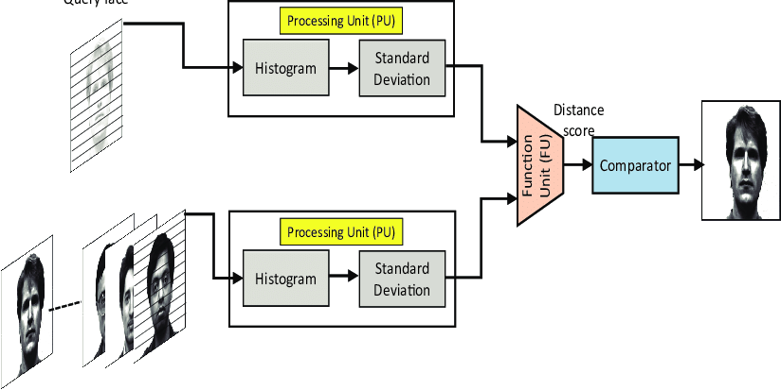

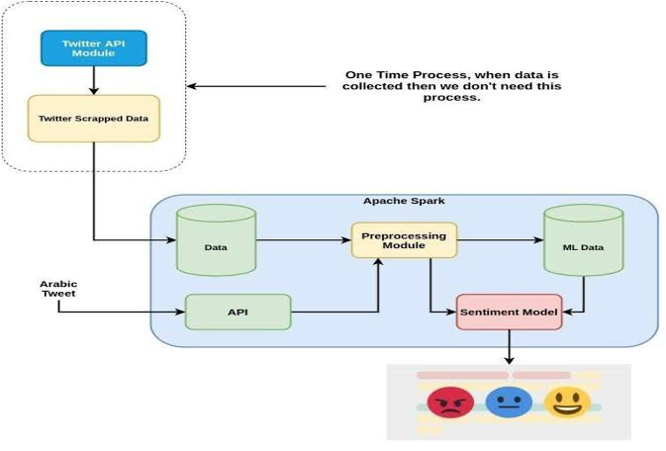

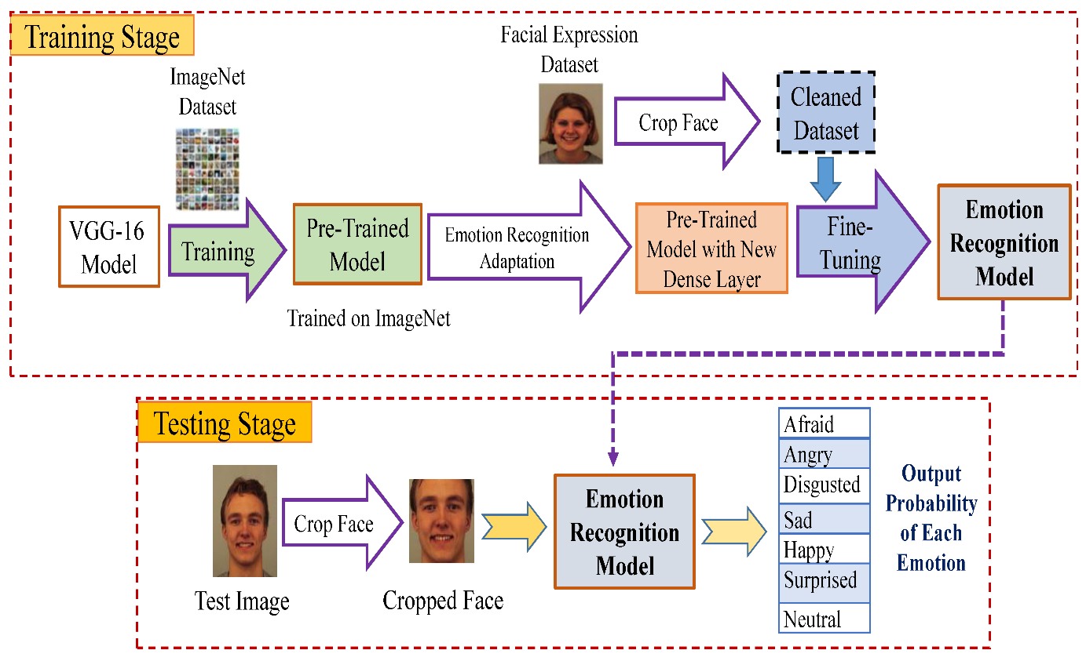

**SOURCE CODE**

**GENDER, AGE DETECTION:**

import cv2

import math

import argparse

def highlightFace(net, frame, conf_threshold=0.7):

frameOpencvDnn=frame.copy()

frameHeight=frameOpencvDnn.shape[0]

frameWidth=frameOpencvDnn.shape[1]

blob=cv2.dnn.blobFromImage(frameOpencvDnn, 1.0, (300, 300), [104, 117, 123], True, False)

net.setInput(blob)

detections=net.forward()

faceBoxes=[]

for i in range(detections.shape[2]):

confidence=detections[0,0,i,2]

if confidence>conf_threshold:

x1=int(detections[0,0,i,3]*frameWidth)

y1=int(detections[0,0,i,4]*frameHeight)

x2=int(detections[0,0,i,5]*frameWidth)

y2=int(detections[0,0,i,6]*frameHeight)

faceBoxes.append([x1,y1,x2,y2])

cv2.rectangle(frameOpencvDnn, (x1,y1), (x2,y2), (0,255,0), int(round(frameHeight/150)), 8)

return frameOpencvDnn,faceBoxes

parser=argparse.ArgumentParser()

parser.add_argument('--image')

args=parser.parse_args()

faceProto="opencv_face_detector.pbtxt"

faceModel="opencv_face_detector_uint8.pb"

ageProto="age_deploy.prototxt"

ageModel="age_net.caffemodel"

genderProto="gender_deploy.prototxt"

genderModel="gender_net.caffemodel"

MODEL_MEAN_VALUES=(78.4263377603, 87.7689143744, 114.895847746)

ageList=['(0-2)', '(4-6)', '(8-12)', '(15-20)', '(25-32)', '(38-43)', '(48-53)', '(60-100)']

genderList=['Male','Female']

faceNet=cv2.dnn.readNet(faceModel,faceProto)

ageNet=cv2.dnn.readNet(ageModel,ageProto)

genderNet=cv2.dnn.readNet(genderModel,genderProto)

video=cv2.VideoCapture(args.image if args.image else 0)

padding=20

while cv2.waitKey(1)<0:

hasFrame,frame=video.read()

if not hasFrame:

cv2.waitKey()

break

resultImg,faceBoxes=highlightFace(faceNet,frame)

if not faceBoxes:

print("No face detected")

for faceBox in faceBoxes:

face=frame[max(0,faceBox[1]-padding):

min(faceBox[3]+padding,frame.shape[0]-1),max(0,faceBox[0]-padding)

:min(faceBox[2]+padding, frame.shape[1]-1)]

blob=cv2.dnn.blobFromImage(face, 1.0, (227,227), MODEL_MEAN_VALUES, swapRB=False)

genderNet.setInput(blob)

genderPreds=genderNet.forward()

gender=genderList[genderPreds[0].argmax()]

print(f'Gender: {gender}')

ageNet.setInput(blob)

agePreds=ageNet.forward()

age=ageList[agePreds[0].argmax()]

print(f'Age: {age[1:-1]} years')

cv2.putText(resultImg, f'{gender}, {age}', (faceBox[0], faceBox[1]-10), cv2.FONT_HERSHEY_SIMPLEX, 0.8, (0,255,255), 2, cv2.LINE_AA)

cv2.imshow("Detecting age and gender", resultImg)

**SENTIMENT ANALYSIS**

**TRAINED MODEL FOR SENTIMENTAL ANALYSIS:**

# import required packages

import cv2

from keras.models import Sequential

from keras.layers import Conv2D, MaxPooling2D, Dense, Dropout, Flatten

from keras.optimizers import Adam

from keras.preprocessing.image import ImageDataGenerator

# Initialize image data generator with rescaling

train_data_gen = ImageDataGenerator(rescale=1./255)

validation_data_gen = ImageDataGenerator(rescale=1./255)

# Preprocess all test images

train_generator = train_data_gen.flow_from_directory(

'data/train',

target_size=(48, 48),

batch_size=64,

color_mode="grayscale",

class_mode='categorical')

# Preprocess all train images

validation_generator = validation_data_gen.flow_from_directory(

'data/test',

target_size=(48, 48),

batch_size=64,

color_mode="grayscale",

class_mode='categorical')

# create model structure

emotion_model = Sequential()

emotion_model.add(Conv2D(32, kernel_size=(3, 3), activation='relu', input_shape=(48, 48, 1)))

emotion_model.add(Conv2D(64, kernel_size=(3, 3), activation='relu'))

emotion_model.add(MaxPooling2D(pool_size=(2, 2)))

emotion_model.add(Dropout(0.25))

emotion_model.add(Conv2D(128, kernel_size=(3, 3), activation='relu'))

emotion_model.add(MaxPooling2D(pool_size=(2, 2)))

emotion_model.add(Conv2D(128, kernel_size=(3, 3), activation='relu'))

emotion_model.add(MaxPooling2D(pool_size=(2, 2)))

emotion_model.add(Dropout(0.25))

emotion_model.add(Flatten())

emotion_model.add(Dense(1024, activation='relu'))

emotion_model.add(Dropout(0.5))

emotion_model.add(Dense(7, activation='softmax'))

cv2.ocl.setUseOpenCL(False)

emotion_model.compile(loss='categorical_crossentropy', optimizer=Adam(lr=0.0001, decay=1e-6), metrics=['accuracy'])

# Train the neural network/model

emotion_model_info = emotion_model.fit_generator(

train_generator,

steps_per_epoch=28709 // 64,

epochs=50,

validation_data=validation_generator,

validation_steps=7178 // 64)

# save model structure in jason file

model_json = emotion_model.to_json()

with open("emotion_model.json", "w") as json_file:

json_file.write(model_json)

# save trained model weight in .h5 file

emotion_model.save_weights('emotion_model.h5')

**TESTING MODEL FOR SENTIMENTAL ANALYSIS:**

import cv2

import numpy as np

from keras.models import model_from_json

emotion_dict = {0: "Angry", 1: "Disgusted", 2: "Fearful", 3: "Happy", 4: "Neutral", 5: "Sad", 6: "Surprised"}

# load json and create model

json_file = open('model/emotion_model.json', 'r')

loaded_model_json = json_file.read()

json_file.close()

emotion_model = model_from_json(loaded_model_json)

# load weights into new model

emotion_model.load_weights("model/emotion_model.h5")

print("Loaded model from disk")

# start the webcam feed

#cap = cv2.VideoCapture(0)

# pass here your video path

cap = cv2.VideoCapture(0)

while True:

# Find haar cascade to draw bounding box around face

ret, frame = cap.read()

frame = cv2.resize(frame, (1280, 720))

if not ret:

break

face_detector = cv2.CascadeClassifier('haarcascades/haarcascade_frontalface_default.xml')

gray_frame = cv2.cvtColor(frame, cv2.COLOR_BGR2GRAY)

# detect faces available on camera

num_faces = face_detector.detectMultiScale(gray_frame, scaleFactor=1.3, minNeighbors=5)

# take each face available on the camera and Preprocess it

for (x, y, w, h) in num_faces:

cv2.rectangle(frame, (x, y-50), (x+w, y+h+10), (0, 255, 0), 4)

roi_gray_frame = gray_frame[y:y + h, x:x + w]

cropped_img = np.expand_dims(np.expand_dims(cv2.resize(roi_gray_frame, (48, 48)), -1), 0)

# predict the emotions

emotion_prediction = emotion_model.predict(cropped_img)

maxindex = int(np.argmax(emotion_prediction))

cv2.putText(frame, emotion_dict[maxindex], (x+5, y-20), cv2.FONT_HERSHEY_SIMPLEX, 1, (255, 0, 0), 2, cv2.LINE_AA)

cv2.imshow('Emotion Detection', frame)

if cv2.waitKey(1) & 0xFF == ord('q'):

break

cap.release()

cv2.destroyAllWindows()

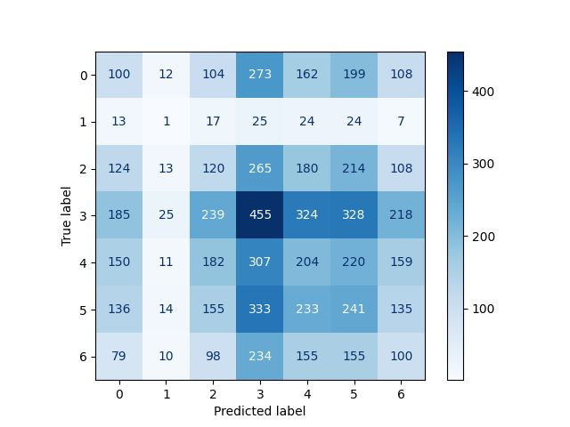

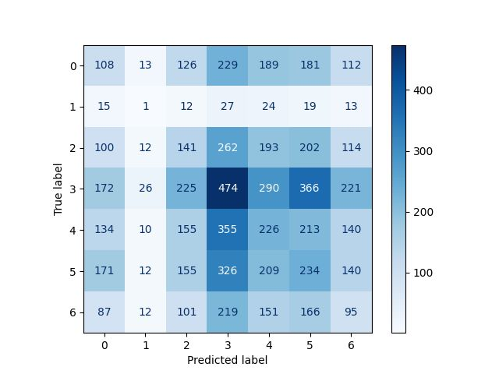

**OUTPUT:**

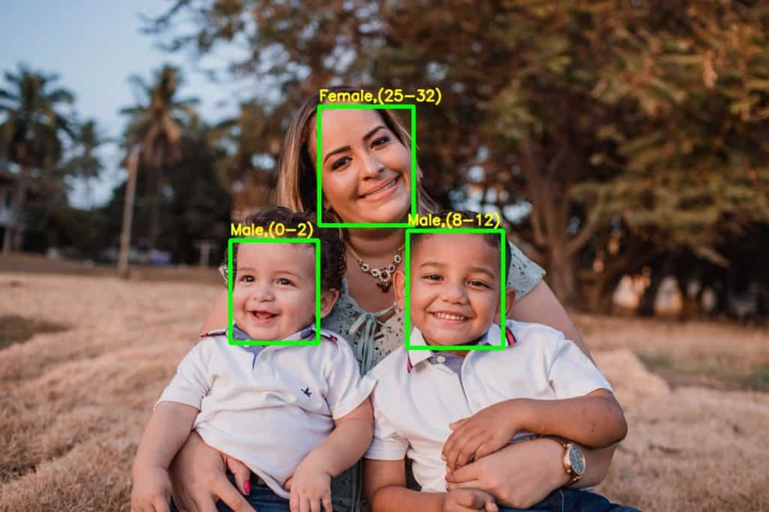

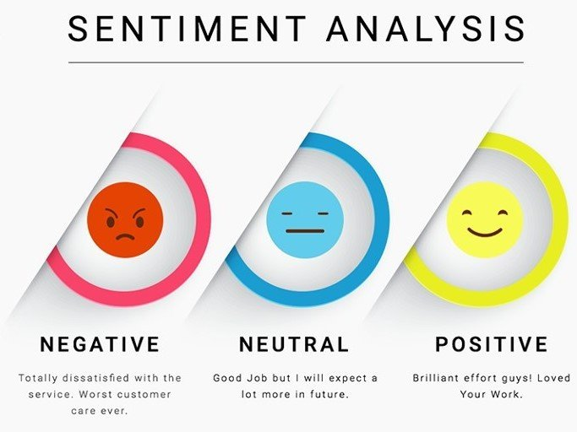

**USES**

There are numerous use cases for gender, age, and sentiment analysis using Python, including:

**1. Marketing:**

Companies can use gender and age analysis to target their marketing campaigns towards specific demographics. Sentiment analysis can help companies understand customer feedback and improve their products and services accordingly.

**2. Healthcare:**

Healthcare providers can use gender and age analysis to identify patterns and trends in patient data. Sentiment analysis can help identify patients who may be at risk of depression or other mental health issues.

**3. Customer Service**:

Customer service departments can use gender and sentiment analysis to improve customer satisfaction by tailoring their responses to the customer's gender and sentiment.

**4. Political Campaigns:**

Political campaigns can use sentiment analysis to gauge public opinion and tailor their messaging to resonate with voters.

**5. Education:**

Educational institutions can use gender and age analysis to identify patterns and trends in student data. Sentiment analysis can help identify students who may be at risk of academic or mental health issues.

**6. Social Media:**

Social media platforms can use sentiment analysis to identify and moderate harmful or offensive content.

**7. E-commerce:**

E-commerce websites can use gender and age analysis to recommend products to customers based on their demographics. Sentiment analysis can help identify customer satisfaction levels and improve the overall customer experience.

Overall, gender, age, and sentiment analysis can be applied to a wide range of industries and applications to gain insights, improve decision-making, and enhance customer satisfaction.

**APPLICATION**

There are numerous applications for gender, age, and sentimental analysis using Python. Here are a few examples:

**1. Marketing:**

Companies can use gender, age, and sentimental analysis to understand their customers' preferences and attitudes towards their products or services. They can tailor their marketing strategies based on these insights to improve customer engagement and loyalty.

**2. Healthcare:**

Gender and age analysis can help healthcare providers to personalize treatment plans and improve patient outcomes. Sentiment analysis can be used to analyze patient feedback and improve the quality of healthcare services.

**3. Social Media:**

Gender, age, and sentiment analysis can be used to analyze social media data and understand trends, opinions, and attitudes towards various topics or brands. This information can be used by marketers, journalists, or policymakers to inform their decisions and strategies.

**4. Customer Support:**

Gender, age, and sentiment analysis can be used to analyze customer feedback and improve the quality of customer support services. Companies can use these insights to identify common issues and improve their response times and customer satisfaction.

**5. Education:**

Gender and age analysis can help educators to personalize learning experiences and improve student outcomes. Sentiment analysis can be used to analyze student feedback and improve the quality of education services.

Overall, gender, age, and sentimental analysis using Python can provide valuable insights into various fields and help to improve decision-making and outcomes.

**FEASIBILITY STUDY**

A feasibility study for gender, age, and sentiment analysis using Python should assess the technical, economic, operational, and legal feasibility of the proposed solution. Here are some considerations for each aspect:

**1. Technical Feasibility:**

The proposed solution requires the use of various Python libraries, such as NLTK, SpaCy, Scikit-learn, and TensorFlow. The technical feasibility of the solution depends on the availability of these libraries and the computational resources required to train and test the machine learning models. The solution may require a high-performance computing infrastructure or cloud-based services to meet the computational demands.

**2. Economic Feasibility:**

The cost of implementing the proposed solution depends on the availability of data, the complexity of the machine learning models, and the expertise required to develop and deploy the solution. The cost of data collection and preprocessing can be significant, especially if the data sources are limited. The cost of hardware and software resources should also be considered.

**3. Operational Feasibility:**

The proposed solution requires a team with expertise in data science, machine learning, and Python programming. The team should have experience in data collection, preprocessing, feature extraction, model selection, and evaluation. The operational feasibility of the solution depends on the availability of the team and the time required to develop and deploy the solution.

**4. Legal Feasibility:**

The proposed solution should comply with relevant data privacy and protection regulations, such as GDPR or HIPAA. The solution should ensure that sensitive data, such as personal information, is properly anonymized and protected. The solution should also respect ethical principles, such as fairness, transparency, and accountability.

Based on these considerations, a feasibility study for gender, age, and sentiment analysis using Python can help to identify potential challenges and limitations of the proposed solution. The study can also provide insights into the resources required to develop and deploy the solution and help to assess the potential impact of the solution on various fields, such as healthcare, marketing, social media, and customer support.

**RELATED WORK**

In this section, we discuss the recent works of sentiment analysis as researchers try to ﬁnda better approach to predict the sentiment polarity. Twitter and Facebook have been the most popularsocial media platforms as people express their opinion about every topic on these social networkingsites, which helps in understanding public sentiment. Appel et al. [18] used twitter sentimentand movie review datasets to implement a hybrid approach based on ambiguity management,semantic rules, and sentiment lexicon. The authors compared this proposed hybrid system resultswith the standard supervised algorithms such as Naive Bayes (NB) and Maximum Entropy (ME).The proposed system achieves higher precision score and accuracy than the supervised algorithms.Similarly, Zainuddin et al. [19] used a twitter dataset of aspect-based sentiment analysis to performa ﬁne-grained analysis. They proposed a hybrid approach using a feature selection method thatperforms better than the standard methods.Blogs have been a relevant source of data in sentiment analysis with posts containing reviewsand comments. Fan et al. [20] analyzed blog text to improve the quality of advertisements in the blogsthat were more relevant to the user. To ﬁnd the blogger’s overall emotions towards any particular topic,Kuo et al. [21] create a social opinion graph as generally every blogger is somewhat inﬂuenced by itssocial circle. So their social interactions can be used to ﬁnd the overall sentiment orientation of theblogger. Li et al. [22] used opinions expressed on the web such as blogs, reviews and comments todesign a new technique to further enhance the accuracy of clustering based approaches. This approachis proven to more suitable in ﬁnding neutral opinions. The authors [23] proposed a new extractionand opinion mining system based on a type-2 fuzzy ontology called T2FOBOMIE. The proposed systemreceived input from a user, extracts the relevant features from an input query and then converts intoto a search query with hotel reviews. The feature opinions, user requirements and hotel informationwere integrated in a T2FOBOMIE system to achieve high performance.

Apart from using products, movie, restaurants or book reviews for sentiment analysis, researchershave also focused on analyzing sentiment in other languages than English. Pak et al. [24] have proposeda technique that works quite well for other languages as well, though they have not tested theiralgorithm on multilingual data . The author [25] has implemented a methodology to ﬁnd sentimentpolarity within a multilingual framework and the testing was performed using movie reviews inGerman language collected from amazon. Similarly, Zhou et al. [26] translated Chinese reviews toEnglish language and then used English language corpus to perform sentiment analysis on these Electronics 2020,9, 374 4 of 14translated reviews. The authors presented that translated reviews outperform original reviews.Another study on Chinese public ﬁgures has been performed in [27] to analyze the opinion pollingof public ﬁgures.The analysis of opinions expressed by people from different genders or different age groups shouldalign with their psychological differences, as is illustrated by different research groups. There havebeen multiple research studies on how different individuals handle different emotions and the waythese individuals express their emotions even before the advent of internet. The authors [28] examinedgender differences in conducting a study on 400 college students in ﬁve age groups from preschoolersto adults. The study aligned with the stereotypes of gender and age emotional expressiveness.Stoner et al. [29]considered people of both genders and in different age groups to study their angerexpressing ability. The research showed that young adult group expressed anger more as compared toold adult age group. In this study, the author did not ﬁnd out much differences on basis of gender inthis aspect.A research by Davis [30] on gender differences in negative emotions showed that boys expresseda greater negative affect as compared to girls when they were disappointed. Brody et al. [31]researched more on gender and emotional expression and showed that gender differences inemotional expressiveness were culturally speciﬁc in asian international students. Another study byKring et al. [32] in which they showed emotional videos to a group of students and reafﬁrmed thatwomen are generally more expressive than men even in case of experienced emotions. A study byBirditt [33] examined age and gender differences in description of emotional reactions. It contained185 individuals as 85 males and 100 female aged from 13 to 99 which showed that adolescentsand young adults were reported more likely to describe anger and giving more intensive aversiveresponses as opposed to the male adult group

**CONCLUSION**

“Human Age and gender classification” are two of the many important information gathering resource from and individual. Human faces provide enough data which may be used for many purposes. In order to reach the correct audience human age and gender classification is very essential. Here we tried to do the same process but with general equipment. The efficiency of the algorithm depends on several factor but the main motif of this project is being easy and faster while also being as accurate as possible. Work is being done to the improve the efficiency of the algorithm. Some future improvements include discarding the face like non-human objects, more datasets for people belonging to different ethnic groups and more granular control over the workflow of the algorithm.

**REFERENCE**

1. Manek, A.S.; Shenoy, P.D.; Mohan, M.C.; Venugopal, K. Aspect term extraction for sentiment analysis in largemovie reviews using gini index feature selection method and svm classiﬁer. Worldw. Web2017,20, 135–154.[CrossRef]
2. Dos Santos, C.; Gatti, M. Deep convolutional neural networks for sentiment analysis of short texts.In Proceedings of the COLING, the 25th International Conference on Computational Linguistics:Technical Papers, Dublin, Ireland, 23–29 August 2014; pp. 69–78.
3. Kiritchenko, S.; Zhu, X.; Cherry, C.; Mohammad, S. Nrc-canada-2014: Detecting aspects and sentiment incustomer reviews. In Proceedings of the 8th International Workshop on Semantic Evaluation, Dublin, Ireland,23–24 August 2014; pp. 437–442.
4. Pontiki, M.; Galanis, D.; Papageorgiou, H.; Manandhar, S.; Androutsopoulos, I. Semeval-2015 task 12:Aspect based sentiment analysis. In Proceedings of the 9th International Workshop on Semantic Evaluation,Denver, CO, USA, 4–5 June 2015; pp. 486–495.
5. Cao, D.; Ji, R.; Lin, D.; Li, S. A cross-media public sentiment analysis system for microblog. Multim. Syst.2016,22, 479–486. [CrossRef]
6. Ghosh, R.; Zhang, L.; Dekhil, M.E.; Liu, B. Performing sentiment analysis on microblogging data, includingidentifying a new opinion term therein. US Patent 9,275,041, 1 March 2016.
7. Ullah, M.A.; Islam, M.M.; Azman, N.B.; Zaki, Z.M. An overview of multimodal sentiment analysis research:Opportunities and difﬁculties. In Proceedings of the 2017 IEEE International Conference on Imaging, Vision& Pattern Recognition, Himeji, Japan, 1–3 September 2017; pp. 1–6.
8. Cambria, E. Affective computing and sentiment analysis. IEEE Intell. Syst. 2016,31, 102–107. [CrossRef]
9. Liu, B. Sentiment analysis and subjectivity. Handb. Nat. Lang. Proc. 2010,2, 627–666.
10. Kumar, S.; Yadava, M.; Roy, P.P. Fusion of eeg response and sentiment analysis of products review to predictcustomer satisfaction. Inf. Fus. 2019,52, 41–52. [CrossRef]
11. Kim, J.H.; Kim, B.G.; Roy, P.P.; Jeong, D.M. Efﬁcient facial expression recognition algorithm based onhierarchical deep neural network structure. IEEE Access 2019,7, 41273–41285. [CrossRef]
12. Yoo, S.M.; Cho, C.; Lee, K.H.; Park, J.; Jin, S.; Lee, Y.; Kim, B.G. Structure of deep learning inferenceengines for embedded systems. In Proceedings of the IEEE 2019 International Conference on Informationand Communication Technology Convergence, Kuala Lumpur, Malaysia, 24–26 July 2019; pp. 920–922.
13. Kim, J.H.; Hong, G.S.; Kim, B.G.; Dogra, D.P. Deepgesture: Deep learning-based gesture recognition schemeusing motion sensors. Displays 2018,55, 38–45. [CrossRef]
14. Kahaki, S.M.M.; Ismail, W.; Nordin, M.J.; Ahmad, N.S.; Ahmad, M. Automated age estimation basedon geometric mean projection transform using orthopantomographs. J. Adv. Technol. Eng. Stud.2017,3, 6–10.
15. Kahaki, S.M.; Nordin, M.J.; Ahmad, N.S.; Arzoky, M.; Ismail, W. Deep convolutional neural networkdesigned for age assessment based on orthopantomography data. Neural Comput. Appl.2019,3, 1–12.[CrossRef]
16. .Li, Y.M.; Li, T.Y. Deriving market intelligence from microblogs. Decis. Support Syst.2013,55, 206–217.[CrossRef]
17. Lockenhoff, C.E.; Costa, P.T.; Lane, R.D. Age differences in descriptions of emotional experiences in oneselfand others. J. Gerontol. Ser. B Psychol. Sci. Soc. Sci. 2008,63, 92–99. [CrossRef] [PubMed]
18. Appel, O.; Chiclana, F.; Carter, J.; Fujita, H. Successes and challenges in developing a hybrid approach tosentiment analysis. Appl. Intell. 2018,48, 1176–1188. [CrossRef]
19. Zainuddin, N.; Selamat, A.; Ibrahim, R. Hybrid sentiment classiﬁcation on twitter aspect-basedsentiment analysis. Appl. Intell. 2018,48, 1218–1232. [CrossRef]
20. Fan, T.K.; Chang, C.H. Sentiment-oriented contextual advertising. Knowl. Inf. Syst.2010,23, 321–344.[CrossRef]
21. Kuo, Y.H.; Fu, M.H.; Tsai, W.H.; Lee, K.R.; Chen, L.Y. Integrated microblog sentiment analysis from users’social interaction patterns and textual opinions. Appl. Intell. 2016,44, 399–413. [CrossRef]
22. Li, G.; Liu, F. Sentiment analysis based on clustering: a framework in improving accuracy and recognizingneutral opinions. Appl. Intell. 2014,40, 441–452. [CrossRef]
23. .Ali, F.; Kim, E.K.; Kim, Y.G. Type-2 fuzzy ontology-based opinion mining and information extraction:A proposal to automate the hotel reservation system. Appl. Intell. 2015,42, 481–500. [CrossRef]
24. Pak, A.; Paroubek, P. Twitter as a corpus for sentiment analysis and opinion mining. In LREC; University ofParis: Paris, France, 2010; pp. 1320–1326.
25. Denecke, K. Using sentiwordnet for multilingual sentiment analysis. In Proceedings of the IEEE 24thInternational Conference on Data Engineering Workshop, Cancun, Mexico, 7–12 April 2008; pp. 507–512.
26. Zhou, G.; Zhu, Z.; He, T.; Hu, X.T. Cross-lingual sentiment classiﬁcation with stacked autoencoders.Knowl. Inf. Syst. 2016,47, 27–44. [CrossRef]
27. Cheng, J.; Zhang, X.; Li, P.; Zhang, S.; Ding, Z.; Wang, H. Exploring sentiment parsing of microbloggingtexts for opinion polling on chinese public ﬁgures. Appl. Intell.2016,45, 429–442. [CrossRef]
28. Fabes, R.A.; Martin, C.L. Gender and age stereotypes of emotionality. Personal. Soc. Psychol. Bull.1991,17, 532–540. [CrossRef]
29. Stoner, S.B.; Spencer, W.B. Age and gender differences with the anger expression scale. Educ. Psychol. Meas.1987,47, 487–492. [CrossRef]
30. Davis, T.L. Gender differences in masking negative emotions: Ability or motivation? Dev. Psychol.1995,31, 660–667. [CrossRef]
31. Brody, L.R. Gender and emotion: Beyond stereotypes. J. Soc. Issues 2010,53.
32. Kring, A.M.; Gordon, A.H. Sex differences in emotion: Expression, experience, and physiology. J. Personal.Soc. Psychol. 1998,74, 686–703 . [CrossRef]