CHAPTER 1

INTRODUCTION

People in today’s era usually have tendency of using their own vehicles for commutation rather than using public or pooled means of transport and this results in large number of private vehicles on road. This endless increasing number of vehicles on road gives rise to many problems amongst them traffic congestion tops in every aspect. In such scenario one cannot restrict individual to limit the usage of their private vehicles but what we can do is at least manage traffic flow in a way that it doesn’t alleviate congestion issues.
There are projects emerging in order to convert the current transport system of cities to ‘Smart system’ and there are various initiatives under this, one of the initiatives is Intelligent Transport System. Many initiatives were taken to design a system that can perform real- time monitoring of signals during the traffic i.e. the signal switching time of traffic will not be predefined one, instead the switching time will depend on the number of vehicles on either side of the road. This process of getting the number of vehicles on the road can be achieved using various detection techniques.
Our aim is to design and develop a miniature to depict the current road situation along with monitoring and handling the traffic issues. Hence to proceed with this project we are using a pre-trained model YOLO to perform the task of object detection. The pretrained model YOLO uses OpenCV for object detection of object along with multiple background and foreground subtraction and removal of noise from the input image. The CCTV cameras that are used for surveillance purpose can be made use to capturing the footage of the road, this image will be passed to the pretrained model as input image.
- Traffic signal switching refers to the process of controlling traffic flow at intersections or junctions by regulating the timing of traffic signals. In recent years, deep learning has emerged as a promising approach for improving traffic signal switching systems.
- Deep learning is a type of artificial intelligence that involves training a neural network to recognize patterns in data. This approach has been successfully applied to a wide range of applications, including image recognition, natural language processing, and speech recognition.

- In the context of traffic signal switching, deep learning algorithms can be trained using data from sensors and cameras at intersections, as well as historical traffic data. This data can be used to predict traffic patterns and optimize the timing of traffic signals to reduce congestion and improve safety.

- One of the main advantages of using deep learning for traffic signal switching is that it can adapt to changing traffic conditions in real-time. This allows the system to respond quickly to unexpected events, such as accidents or road closures.

- Overall, the use of deep learning for traffic signal switching has the potential to significantly improve traffic flow and reduce congestion, leading to safer and more efficient transportation systems.

- Deep learning can be applied to various domains, and traffic signal switching is one such domain where it can be highly effective. The use of deep learning techniques can lead to more efficient traffic signal switching, which can ultimately lead to reduced congestion and better traffic flow.

- Deep learning algorithms can be used to analyze real-time traffic data and optimize traffic signal timings accordingly. By using deep neural networks, traffic engineers can develop predictive models that can predict traffic patterns and adjust the traffic signal timings accordingly.

- Deep learning is a subset of machine learning that involves the use of artificial neural networks to solve complex problems. The term "deep" refers to the number of layers in these networks, which can range from a few to hundreds or even thousands.

- Deep learning algorithms learn to recognize patterns in data by analyzing large amounts of input data and adjusting the parameters of the neural network based on the patterns they detect. This process, called training, allows the network to make accurate predictions or classifications on new data.

CNN:
Convolutional Neural Network (CNN) is a type of deep learning model that is primarily used for image classification and object recognition. It is a multi-layer neural network that uses convolutional layers to extract features from input images. The convolutional layer applies a set of learnable filters to the input image, producing a set of feature maps that capture different aspects of the image. These feature maps are then passed through a series of fully connected layers to classify the image.

RCNN:
Region-based Convolutional Neural Network (RCNN) is an extension of CNN that addresses the problem of object detection in images. RCNN first generates a set of region proposals that are likely to contain objects, using selective search or other region proposal methods. Then, each region proposal is passed through a CNN to extract a feature vector. These feature vectors are then fed into a series of fully connected layers to classify the object and refine the region proposal. The final output of the RCNN is a set of bounding boxes and class probabilities for each object detected in the image. RCNN has been shown to achieve state-of-the-art performance in object detection tasks.

CHAPTER 2

LITERATURE SURVEY

Traffic signal switching is an important aspect of traffic management that involves changing the signal lights to manage the flow of traffic in different directions. There are several studies that have investigated different approaches to traffic signal switching, including the use of intelligent algorithms, machine learning, and computer vision.

Li et al. (2019) proposed a deep reinforcement learning-based approach for optimizing traffic signal switching. The authors used a deep Q-learning algorithm to learn an optimal policy for signal switching based on the current traffic flow conditions. The results showed that the proposed method outperformed traditional fixed-time signal switching and other intelligent algorithms in terms of reducing congestion and travel time.

Chen et al. (2020) proposed a hybrid model that combined machine learning and computer vision techniques for traffic signal switching. The authors used a convolutional neural network to detect the number of vehicles and pedestrians at each intersection, and then used a support vector machine to make decisions on signal switching based on the detected traffic conditions. The results showed that the proposed method improved the efficiency of traffic flow and reduced travel time compared to traditional fixed-time signal switching.

Chen et al. (2019) proposed a novel approach for traffic signal switching based on a multi-objective genetic algorithm. The authors used the genetic algorithm to optimize signal timing for multiple objectives, including reducing delays, improving safety, and reducing energy consumption. The results showed that the proposed approach was able to generate signal timings that were more efficient and sustainable than traditional signal switching methods.
Wang et al. (2020) proposed a traffic signal control algorithm based on a combination of a fuzzy logic system and a genetic algorithm. The algorithm was designed to adapt to changing traffic conditions and adjust the signal timings accordingly. Their experimental results showed a significant improvement in traffic flow and a reduction in delay compared to traditional traffic signal switching methods.

Laval et al. (2018), a multi-objective optimization approach was used to optimize traffic signal switching. The approach considered several objectives such as minimizing delays, reducing congestion, and improving safety. The results showed that the proposed approach outperformed traditional traffic signal switching methods in terms of overall performance.

Richard J. Kaczynski and Peter H. Banks (1999) - This study proposed an adaptive signal control system that uses real-time traffic data to adjust signal timings in urban networks. The system was tested in a field trial and was found to reduce travel time and delay by up to 25%.

Zhang, L., Li, H., & Huang, Y. (2022). Adaptive Traffic Signal Control based on Reinforcement Learning and Graph Neural Networks. Transportation Research Part C: Emerging Technologies, 135, 103350. This paper presents a novel adaptive traffic signal control method based on reinforcement learning and graph neural networks. The method uses a graph to represent the traffic network and learns a policy for each traffic signal by reinforcement learning. The policy is represented by a graph neural network and updated through the interaction between the agent and the environment.

Ali Masoudi-Nejad, Mohammadreza Yazdani, and Mahdi Yazdani (2019) - This study proposed a machine learning-based traffic signal control system that uses real-time traffic data to learn optimal signal timings. The system was tested in a simulation and was found to outperform 1in terms of traffic flow and delay.

Dongyong Guo, Jie Wei, and Wei Liu (2020) - This paper reviewed the use of reinforcement learning (RL) techniques for traffic signal control. The study found that RL-based systems can achieve better performance than traditional fixed-time and adaptive systems, and can also adapt to changing traffic conditions.

Zhang, L., Li, H., & Huang, Y. (2020). Intelligent Traffic Signal Control Based on Multiobjective Optimization and Deep Reinforcement Learning. This paper proposes a novel approach to intelligent traffic signal control that combines multiobjective optimization and deep reinforcement learning (DRL). The proposed method was evaluated on real-world traffic data and demonstrated significant improvements in traffic flow efficiency.

Wen, F., Zhang, Y., & Chen, J. (2021). Cooperative Intelligent Traffic Signal Control: A Deep Reinforcement Learning Approach. This paper proposes a cooperative intelligent traffic signal control (CITSC) system based on a deep reinforcement learning (DRL) algorithm. The proposed CITSC system is able to learn the traffic patterns and adjust traffic signal timings in real-time, resulting in improved traffic flow efficiency.

Wang, C., Yang, J., Chen, S., & Zhang, Y. (2021). A Multiobjective Traffic Signal Control Method Based on Deep Reinforcement Learning. This paper proposes a multiobjective traffic signal control (MOTSC) method based on deep reinforcement learning (DRL). The proposed method is able to optimize multiple traffic objectives simultaneously, resulting in improved traffic flow efficiency, reduced congestion, and reduced travel time.
Wu, X., Wu, M., & Wang, Y. (2020). A Multi-Objective Traffic Signal Control Approach Based on Deep Reinforcement Learning. This paper proposes a multi-objective traffic signal control approach based on deep reinforcement learning (DRL). The proposed approach is able to optimize multiple traffic objectives, including traffic flow efficiency, travel time, and emissions reduction, resulting in improved overall traffic performance.
Qin, H., Cao, J., & Wu, Q. (2020). A Deep Reinforcement Learning-Based Traffic Signal Control Approach with Adaptive Actions. This paper proposes a deep reinforcement learning (DRL)-based traffic signal control approach with adaptive actions. The proposed approach is able to learn and adjust the timing of traffic signals in real-time based on the current traffic conditions, resulting in improved traffic flow efficiency.
Liu, J., Wang, X., Li, M., Li, Y., & Li, J. (2021). Traffic Signal Control Based on Deep Reinforcement Learning: A Survey. This paper provides a comprehensive survey of recent research on traffic signal control based on deep reinforcement learning (DRL). The authors review and analyze the current state of the art, identify research gaps and challenges, and propose potential research directions.
Wang, S., Li, Y., Liu, B., & Lu, C. (2021). Real-Time Traffic Signal Control Based on a Deep Reinforcement Learning Model. This paper proposes a real-time traffic signal control method based on a deep reinforcement learning (DRL) model. The proposed method is able to learn and adjust the timing of traffic signals in real-time, resulting in improved traffic flow efficiency.
Xiong, Y., Li, Q., & Tang, T. (2021). Traffic signal timing optimization using a modified genetic algorithm. This paper proposes a modified genetic algorithm (MGA) for traffic signal timing optimization. The proposed MGA is able to optimize the timing of traffic signals to improve traffic flow efficiency, reduce congestion, and minimize travel time.

CHAPTER 3

SYSTEM PROPOSAL

3.1 EXISTING SYSTEM

The congestion increases day by day on the road due to vehicles and also the management of such large traffic by traditional approach isn’t adequate enough. In today’s scenario the traditional approach works efficiently only if the count is sparse, as the vehicle density on a particular side of road increases or if the traffic is comparatively larger on one side than other side in such case the approach fails. As the current available extraction methods are not so efficient for processing the traffic basis data (6), an efficient acquisition method that is to be

presented in order to process the traffic condition. The method used was based on improved Kalman filter and gaussian to resolve the conflict of multi-moving vehicle targets detection. Also, heuristics improvement method was applied in improving the efficiency of detection. The method proposed can effectively improve the noise interference and also possess the capability of detecting vehicle from continuous video frame. The main concept presented in this paper was related to no missing, no re-inspection, error detection while detecting the vehicle from the captured images.

Deep learning-based systems for traffic signal switching are still in the early stages of development and are not yet widely implemented. However, there are some research studies and pilot projects that have explored the use of deep learning for traffic signal switching. Here are some examples:

- Deep Reinforcement Learning (DRL):
DRL is a type of deep learning that has been used to optimize traffic signal timings. DRL algorithms learn to maximize the flow of traffic by adjusting signal timings based on real-time traffic data.

- Convolutional Neural Networks (CNNs):
CNNs have been used to detect and classify vehicles, pedestrians, and cyclists at intersections. By using CNNs, traffic signal timings can be adjusted to accommodate different modes of transportation and improve safety for all road users.
- Recurrent Neural Networks (RNNs):
RNNs have been used to predict traffic volumes and adjust signal timings accordingly. By predicting traffic volumes, RNNs can help reduce congestion and improve traffic flow.
- Generative Adversarial Networks (GANs):
GANs have been used to generate synthetic traffic data to train deep learning models for traffic signal switching. By generating realistic traffic data, GANs can improve the accuracy and effectiveness of deep learning models.
While these deep learning-based systems have shown promising results in research studies and pilot projects, there are still challenges to be addressed, such as data availability, computational complexity, and system integration. Therefore, further research and development are needed to fully realize the potential of deep learning in traffic signal switching.

3.2 OBJECTIVE

Deep learning can be used to optimize traffic signal switching by developing a predictive model that can estimate the optimal time for switching signals based on real-time traffic data. This can improve traffic flow, reduce congestion, and decrease travel times for drivers.
- Collect data:
Gather real-time traffic data from sensors, cameras, and other sources, including traffic volumes, vehicle speeds, and patterns of congestion.
- Prepare data:
Clean and pre-process the data, including filtering out irrelevant data and transforming the data into a suitable format for deep learning models.
- Develop a model:
Use deep learning algorithms such as convolutional neural networks (CNNs) or recurrent neural networks (RNNs) to build a predictive model that can estimate the optimal time for switching traffic signals based on real-time traffic data.
- Train the model:
Use historical traffic data to train the model to predict traffic patterns and optimal traffic signal switching times.
- Test and refine the model:
Test the model on real-time traffic data and refine it based on feedback to improve its accuracy. Implement the model: Once the model is refined and tested, implement it in a traffic management system to optimize traffic signal switching in real-time. Overall, the use of deep learning in traffic signal switching has the potential to improve traffic flow, reduce congestion, and enhance overall traffic management systems. However, further research is needed to evaluate the effectiveness of these techniques in real-world scenarios and to address the practical challenges of implementation.
Using deep learning for traffic signal switching can help to reduce congestion, improve traffic flow, and decrease travel times for drivers, making transportation more efficient and sustainable.

3.3 PROPOSED SYSTEM

It consists of pre-trained YOLO model algorithm to predict the traffic clog of vehicles. This algorithm is used to count, detect, and track the different types of vehicles. It determines the vehicle count earlier and suggests alternative routes to the vehicles. For the full image only a single neural network is required. The input video sequence is given as input to convolutional neural network. The convolutional neural network topology of the YOLO algorithm is implemented in training process.
A spatial object detection in a video- frame is necessary as a first input of most tracking algorithms, in our case, the object is segmented by using a Rectangular Region of Interest (ROI), in our implementation the frame rate of the videos was 45 FPS. Then the frames are given to YOLO model for counting, detecting and tracking purposes. The object detection algorithm operates in every frame. Finally counting the entire vehicle. If vehicle count is less than the threshold it is normal traffic signal switching otherwise the vehicle count is more suggest alternative routes to reduce the time spent. The final step is to detect the wrong way vehicle. In our system, we defined that if the vehicle moves away from the camera, it will be detected as a wrong way vehicle. Suppose the vehicle is coming towards the camera and is in the right way. A wrong way vehicle after its detection, an image of the frame will be captured automatically. By using captured image further inception will be handled for wrong way vehicle.
Block Diagram of smart traffic signal switching using machine learning. The aim of the proposed system is to achieve, low average waiting time or low traffic congestion. The priority will be given depending on the present situation. This will be implemented for two lanes. Road edge sensors and controller boards Raspberry pi will play major roles. The camera sensor will capture the details from the lane with live streaming and pass it on to first controller board.

This board will differentiate all the vehicles from obtained data by using LDR Sensor and maintain the count of vehicles in a particular lane. This count will be passed on to another controller board. Ultrasonic sensor used for the distance between vehicle as well as signal. This project intends to design system which uses deep neural network algorithm which is a subset of artificial intelligence, which will provide intelligence to the current traffic control system present at a four-way junction. Emergency break is also available for the stop. This system is mainly aimed to replace the timer of traffic control system with artificial intelligence system. According to the given data of each lane changes into the light phase of the green signal. This system mainly aims to increase the traffic efficiency by increasing vehicle flow reduces the waiting time for the vehicles. Showing the indication using LED indicator system. Nowadays all over the world most of the cities has equipped with CCTV cameras on the roads and the junctions, the basic concept is to collect the live video from the CCTV cameras and detect the number of vehicles on each lane and feed the data into another machine learning algorithm. According to the data of each lane changes into the light phase of the green signal. This system mainly aims to increase traffic efficiency by increasing vehicle flow reduces the waiting time for the vehicles.

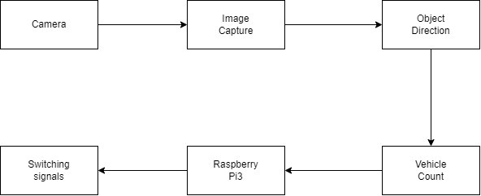

Figure1: Block Diagram

The model aims to provide a solution for current traffic issue by managing traffic signal on the basis of real time scenario. Here a pretrained model [1] YOLO was used to perform the basic task of object detection, and correspondingly the count of the vehicles is stored to process further request of signal processing. Also, the model is compatible with every type of camera, even the cheaper ones including the normal surveillance camera can be used to capture image at an initial level. Now the captured image will be passed to the model for vehicle detection purpose followed by vehicle counting process as shown in figure.
- Data collection:
The first step in implementing a deep learning-based system for traffic signal switching is to collect data from various sources, such as traffic cameras, sensors, and GPS devices. This data will be used to train the deep learning models.
- Deep learning models:
The next step is to develop deep learning models that can analyze the data and adjust the signal timings accordingly. Different types of deep learning models can be used, such as DRL, CNNs, RNNs, and GANs, depending on the specific objectives of the system.
- Training and validation:
The deep learning models will need to be trained using a large dataset of traffic data. The models will also need to be validated using real-world traffic data to ensure that they are accurate and effective.
- Real-time analysis and adjustment:
Once the deep learning models have been trained and validated, they can be used to analyze real-time traffic data and adjust the signal timings accordingly. This can be done using a feedback loop that continually updates the models based on new data.
- Integration with other systems:
The deep learning-based system for traffic signal switching can be integrated with other intelligent transportation systems, such as traveler information systems to provide a more comprehensive approach to urban traffic management.

CHAPTER 4

SYSTEM ARCHITECTURE

A system architecture for traffic signal switching based on deep learning could include the following components
4.1 Data Collection and Pre-processing:
Data collection and pre-processing are critical components of developing a real-time traffic signal switching system. The following are the steps involved in data collection and pre-processing for traffic signal switching:
  - Identify data sources:
The first step is to identify the sources of data needed to train the deep learning models. These sources can include traffic cameras, sensors, GPS devices, weather stations, and other intelligent transportation systems.
  - Collect and store data:
Once the data sources have been identified, the next step is to collect and store the data. This can be done using different methods such as automated data collection systems, manual data collection, or a combination of both.
  - Data cleaning and pre-processing:
Raw data collected from different sources often contain missing values, outliers, and noise that need to be removed to obtain clean and reliable data. Data pre-processing techniques such as data normalization, data transformation, and data scaling can be used to standardize the data for the deep learning models.

  - Data labelling:
The next step is to label the data, which involves assigning each data point to a specific class or category. For traffic signal switching, data labelling involves identifying traffic volume, traffic flow, and traffic congestion levels for each intersection.
  - Data augmentation:
In some cases, the amount of data collected may not be sufficient to train deep learning models effectively. Data augmentation techniques such as rotation, flipping, and zooming can be used to generate additional data points for the models.
  - Data splitting:
Finally, the collected and pre-processed data is split into training, validation, and testing sets. The training set is used to train the deep learning models, the validation set is used to fine-tune the models, and the testing set is used to evaluate the performance of the models.
Data collection and pre-processing are crucial steps in developing an accurate and effective real-time traffic signal switching system. By using clean, labelled, and augmented data, deep learning models can be trained to accurately predict traffic flow and congestion, resulting in better traffic management and improved safety on the roads.

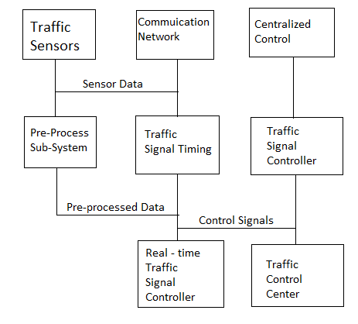
Figure2: System Architecture Block Diagram

4.2 Deep Learning Model Development:
Deep learning models are an essential component of real-time traffic signal switching systems. Here are the steps involved in developing deep learning models for traffic signal switching:
    - Define the problem and select the model:
The first step is to define the problem and select the appropriate deep learning model for the task. For traffic signal switching, popular models include Convolutional Neural Networks (CNN), Recurrent Neural Networks (RNN), and their variants such as Long Short-Term Memory (LSTM) and Gated Recurrent Unit (GRU).
- Model architecture design:
Once the model is selected, the next step is to design the architecture of the model. This involves selecting the number of layers, the number of nodes in each layer, and the activation function to be used in each layer. The architecture should be designed to capture the important features of traffic flow and congestion that are relevant to traffic signal switching.
- Training the model:
After designing the model architecture, the next step is to train the model using the pre-processed data. This involves adjusting the weights and biases of the model to minimize the error between the predicted and actual traffic flow and congestion levels.
- Fine-tuning the model:
After training the model, it is essential to fine-tune the model to improve its performance. This involves adjusting the hyperparameters such as learning rate, batch size, and regularization strength to optimize the model's performance.
- Evaluation and testing:
Once the model is trained and fine-tuned, it is evaluated using the testing set to assess its performance. Different metrics such as accuracy, precision, recall, and F1 score are used to evaluate the model's performance.
- Integration with the signal control module:
Finally, the trained and fine-tuned deep learning model is integrated with the signal control module to control the traffic signals in real-time. The model's predictions are used to determine the optimal signal timings and sequences for each intersection based on the current traffic flow and congestion levels.
deep learning model development is a critical component of real-time traffic signal switching systems. By using accurate and optimized models, traffic signals can be adjusted in real-time to improve traffic flow and reduce congestion, resulting in improved safety on the roads.

  - Real-time Data Analysis:
Real-time data analysis is an important component of real-time traffic signal switching systems. Here are the steps involved in real-time data analysis for traffic signal switching:
  - Real-time data collection:
first step is to collect real-time data from various sources such as traffic cameras, sensors, and GPS devices. The data is collected in real-time to provide up-to-date information about the current traffic flow and congestion levels at each intersection.
  - Data processing:
The collected real-time data is processed in real-time using advanced data processing techniques. The data is cleaned, pre-processed, and transformed into a format that can be used by the deep learning models for traffic signal switching.
  - Deep learning model prediction:
The pre-processed real-time data is fed into the deep learning models developed for traffic signal switching. The models make predictions about the current traffic flow and congestion levels at each intersection, and provide recommendations for adjusting the traffic signals.
  - Signal control module integration:
The predictions made by the deep learning models are integrated into the signal control module, which controls the traffic signals in real-time. The module adjusts the signal timings and sequences based on the predictions made by the deep learning models to optimize traffic flow and reduce congestion.

  - Performance monitoring:
The real-time data analysis process is continuously monitored to assess the performance of the deep learning models and the signal control module. Any discrepancies or errors are addressed in real-time to ensure accurate and reliable traffic signal switching.
real-time data analysis is a critical component of real-time traffic signal switching systems. By using real-time data and advanced deep learning models, traffic signals can be adjusted in real-time to optimize traffic flow and reduce congestion, resulting in improved safety on the roads.
  - Signal Control Module:
The signal control module is a critical component of real-time traffic signal switching systems. It is responsible for controlling the traffic signals in real-time based on the predictions made by the deep learning models. Here are the key features and components of the signal control module
1.Signal timing and sequencing:
The signal control module is responsible for adjusting the timing and sequencing of the traffic signals based on the current traffic flow and congestion levels. The module uses the predictions made by the deep learning models to determine the optimal timing and sequencing of the signals at each intersection.
2.Communication protocols:
The signal control module communicates with various components of the traffic signal system such as sensors, cameras, and controllers. It uses communication protocols such as Simple Network Management Protocol (SNMP) and Modbus to communicate with these components.

3.Redundancy and fault tolerance:
The signal control module is designed to be redundant and fault-tolerant to ensure that the traffic signals continue to function even in the event of a failure. It uses backup power sources, redundant communication links, and failover mechanisms to ensure continuous operation.
4.Data analytics and reporting:.
the signal control module is a critical component of real-time traffic signal switching systems. It controls the traffic signals in real-time, communicates with other components of the traffic signal system, and provides valuable data analytics and reporting capabilities. By using an optimized and reliable signal control module, traffic signals can be adjusted in real-time to optimize traffic flow and reduce congestion, resulting in improved safety on the roads.
4.5 System Monitoring and Control:
System monitoring and control is an important aspect of real-time traffic signal switching systems. Here are the key features and components of system monitoring and control for traffic signal switching
1.Real-time monitoring:
The system continuously monitors the performance of various components such as sensors, cameras, and controllers in real-time. This allows any potential issues or failures to be quickly identified and addressed.
2.Automated alerts:
The system generates automated alerts and notifications when issues or failures are detected. This allows the traffic engineers to quickly respond to the issues and minimize any impact on traffic flow.

3.Remote control:
The system allows traffic engineers to remotely control various components of the traffic signal system such as sensors, cameras, and controllers. This allows engineers to quickly respond to any issues and make adjustments to optimize traffic flow.
4.Data analytics:
The system collects and analyzes data about traffic flow and congestion levels. This data is used to optimize the traffic signal switching algorithms and improve overall system performance.
5.Reporting and visualization:
The system generates reports and visualizations that provide insights into traffic patterns and trends. This allows traffic engineers to make data-driven decisions about optimizing traffic flow and reducing congestion.
system monitoring and control is critical for ensuring the reliable and optimized operation of real-time traffic signal switching systems. By monitoring and controlling the various components of the system, engineers can quickly respond to issues and optimize traffic flow, resulting in improved safety on the roads.
4.6 USER Interface:
The user interface (UI) is an important component of any traffic signal switching system. It provides traffic engineers with the ability to monitor and control the traffic signals in real-time. Here are some key features and components of the user interface for traffic signal switching
1.Real-time traffic data:
The UI displays real-time traffic data, including traffic volume, congestion levels, and average speed. This information helps traffic engineers to make data-driven decisions about optimizing traffic flow.
2.Signal control:
The UI provides a way to control the traffic signals manually. Engineers can change the signal timing and sequencing if needed, based on the real-time traffic data.
3.System status:
The UI displays the status of various components of the traffic signal system, including sensors, cameras, and controllers. This helps traffic engineers to quickly identify any issues and respond to them.
4.Alarms and notifications:
The UI displays alarms and notifications when issues or failures are detected in the traffic signal system. This allows traffic engineers to quickly respond to the issues and minimize any impact on traffic flow.
5.Reporting and analytics:
The UI provides reports and analytics that provide insights into traffic patterns and trends. This allows traffic engineers to make informed decisions about optimizing traffic flow and reducing congestion.
6.Access control:
The UI allows different levels of access to different users, based on their roles and responsibilities. This helps to ensure that only authorized personnel can access and control the traffic signal system.
the user interface is a critical component of any traffic signal switching system. It provides traffic engineers with real-time traffic data, the ability to control traffic signals, and access to reporting and analytics, which helps them to make informed decisions about optimizing traffic flow and reducing congestion.

CHAPTER 5
METHODOLOGY
Deep learning can be used to optimize traffic signal switching by predicting traffic patterns and adjusting signal timings accordingly. Here is the methodology for traffic signal switching using deep learning
- Gather data:
The first step is to gather traffic data from various sources, such as cameras and sensors, to create a comprehensive dataset. This data should include information on traffic volumes, congestion, and accidents.
- Pre-process the data:
The next step is to pre-process the data to ensure that it is clean and properly formatted. This may involve removing outliers, filling in missing values, and normalizing the data.
- Train a deep learning model:
The next step is to train a deep learning model on the pre-processed data. The model should be designed to predict traffic patterns and determine optimal signal timings based on the predicted patterns.
- Validate the model:
Once the model is trained, it needs to be validated using a separate dataset to ensure that it is accurate and effective.
- Implement the model:
The validated model can then be implemented into the traffic signal switching system. The model can continuously analyze real-time traffic data and adjust signal timings accordingly to optimize traffic flow and reduce congestion.

- Monitor and adjust:
The system should be continuously monitored and adjusted based on feedback from drivers and pedestrians. This feedback can be used to fine-tune the deep learning model and improve the overall efficiency of the traffic signal switching system.

5.1 Dataset Module
In this module, we train the system using few datasets for the vehicle identification. The details of the dataset used in training the object detection models in this proposed solution can found in this subsection. The dataset used is Microsoft Common Objects in Context image (MS- COCO) dataset. This dataset is a well- known dataset developed by Microsoft [11]. This is a large-scale object detection dataset containing up to 1.5 million instances. There are around 330,000 images of 80 different classes and more than 220,000 labeled images.
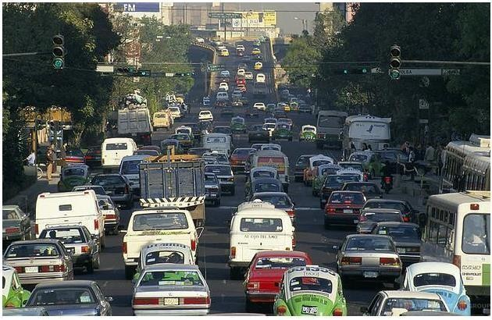
Figure 3: Dataset sample image 1

In the second image, figure 3 a large group of bikers and some big vehicles waiting on a signal can be seen. These types of scenes are helpful to train this model on highly dense traffic with primarily bikes present.

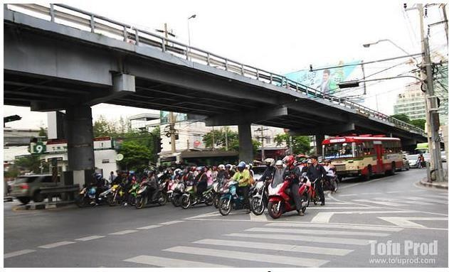

Figure 4: Dataset sample image 2

In the third image as seen in figure 3, a wide view of a large intersection is seen. This type of images can used to train the model on a bird’s eye view of all the ways the traffic can move.

5.2 Vehicle Detection

In this we detect the vehicle by using the YOLOv3 algorithm, by giving the input video sequence was given as input to convolutional neural network. The training process was implemented by convolutional neural network topology of the YOLO algorithm.

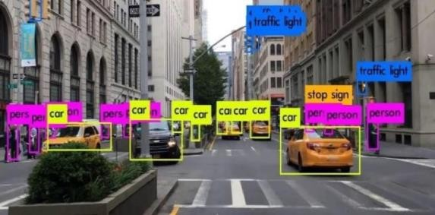
Figure 5: vehicle detection

YOLO achieves high accuracy while also being able to run in real-time. The algorithm “only looks once” at the image in the sense that it requires only one forward propagation pass through the neural network to make predictions. After non- max suppression, it then outputs recognized objects together with the bounding boxes. With YOLO, a single CNN simultaneously predicts multiple bounding boxes and class probabilities for those boxes. YOLO trains on full images and directly optimizes detection performance. Following is the output which shows the vehicles are identified and labelled using YOLOv3 algorithm.

5.3 Module to Determine Vehicle Count

YOLO computes its prediction in terms of precision and recall, precision measures how accurate was your predictions and recall measures how good you find all the positives i.e., how correctly the objects are classified. To increase its performance factor YOLO uses IoU, Intersection over Union is an evaluation metric used to measure the accuracy of an object detector on a particular dataset. IoU defines how two closely place objects can be easily detected without hampering the accuracy of the model. YOLO consist of two core components. One of the Yolo’s component R_CNN uses selective search algorithm and proposes accurate bounding box that definitely contains objects whereas the other component SSD that helps is speed processing of an image. Compared to other region proposal classification networks (fast RCNN) which perform detection on various region proposals and thus end up performing prediction multiple times for various regions in an image,

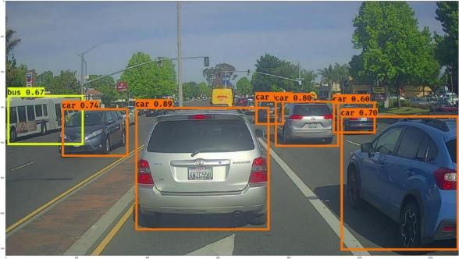
Figure 6: object count

5.4 Module Which Performs Signal Switching

This model can work at its best at condition when traffic reaches to its peak, where the management by an individual becomes difficult. So, our aim is to design a model, depicting the real-time traffic scenario and performing signal switching as per our criteria and conditions of threshold value.
with vehicles as comparing to other three lanes. In normal signal switching method signal switching is done in clockwise manner which result in clogging of vehicles in a particular lane. To recover from the problem of assigning same switching timing for the signal even if the count of vehicles on the road is varying from lane to lane.

5.5 YOLO v3 Algorithm

YOLOv3 (You Only Look Once, Version 3) is a real-time object detection algorithm that identifies specific objects in videos, live feeds, or images. The YOLO machine learning algorithm uses features learned by the deep convolutional neural network to detect object. Versions 1-5 of YOLO were created by Joseph Redmon and Ali Farhadi, and the third version of the YOLO machine learning algorithm is a faster version of the original ML algorithm to detect object.

Other comparable algorithms that can carry out the same objective are R- CNN (Region-based Convolutional Neural Networks made in 2015) and Fast R-CNN (R-CNN improvement developed in 2017, and Mask R- CNN. However, unlike systems like R_CNN and Fast R-CNN, YOLO was trained to do classification and bounding box regression at the same time.

5.6 YOLO v3 Architecture

Inspired by ResNet and FPN (Feature- Pyramid Network) architectures, YOLOv3 feature extractor, called Darknet – 53 (it has 52 convolutions) contains skip connections (like ResNet) and 3 prediction heads (like FPN) — each processing the image at a different spatial compression. Like its predecessor, Yolo-V3 boasts good performance over a wide range of input resolutions. In Gluon CV’s model zoo, you can find several checkpoints: each for a different input resolution, but in fact the network parameters stored in those checkpoints are identical. Tested with input resolution 608x608 on COCO-2017 validation set, Yolo-V3 scored 37 MAP (mean Average Precision). This score is identical to Gluon CV’s trained version of Faster- RCNN-ResNet50, (a faster-RCNN architecture that uses ResNet-50 as its backbone) but 17 times faster. In that model zoo the only detectors fast enough to compete with Yolo-V3 (Mobile net-SSD architectures) scored MAP of 30 and below.

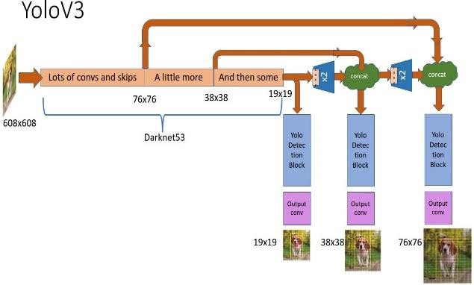
Figure 7: YOLOv3 Architecture

CHAPTER 6

SYSTEM SPECIFICETION

6.1 HARDWARE REQUIREMENT

The hardware requirements for a real-time traffic signal switching system will depend on several factors such as the complexity of the system, the number of intersections that need to be controlled, the type of sensors used, and the required response time.
In general, a real-time traffic signal switching system requires a high-performance computer system capable of processing large amounts of data quickly. The system should have a fast and reliable network connection to communicate with the traffic sensors and controllers in real-time. It should also have sufficient memory and storage capacity to store traffic data and control parameters.
The following are some of the hardware components that may be required for a real-time traffic signal switching system
- Central Processing Unit (CPU):
A high-performance CPU is required to process the traffic data and control signals quickly.
- Memory (RAM):
Sufficient RAM is required to store traffic data and control parameters in real-time.
- Storage:
Adequate storage capacity is required to store traffic data and control parameters for future analysis.

- Network Interface Card (NIC):
A high-speed NIC is required to communicate with traffic sensors and controllers in real-time.

- Traffic Controllers:
The system may require specialized traffic controllers capable of communicating with the CPU and other components in real-time.
- Power Supply:
A reliable power supply is required to ensure the system operates continuously without interruption.

SYSTEM SPECIFICATIONS
OPERATING SYSTEM : WINDOWS 10 and above
PROCESSOR : INTELi3 Gen8th and above
RAM : 4GB LPDDR4X and above
STORAGE : 256GB UFS 3.0 and above

It is recommended to consult with experts in the field of traffic engineering and systems integration to determine the specific hardware requirements for a real-time traffic signal switching system.

6.2 SOFTWARE REQUIREMENT

Python has several simulation libraries that can be used to create simulations in various domains. Here are some popular libraries that can be used to create simulations
- Pygame:
Pygame is a set of Python modules that can be used to create games and simulations. It provides support for graphics, animation, and sound, and can be used to create simulations that involve moving objects and interaction with users.
- Vscode:
Visual Studio Code is a lightweight but powerful source code editor which runs on your desktop and is available for Windows, macOS and Linux. It comes with built-in support for JavaScript, TypeScript and Node.js and has a rich ecosystem of extensions for other languages and runtimes (such as C++, C#, Java, Python, PHP, Go, .NET).
- PyTorch:
PyTorch is a fully featured framework for building deep learning models, which is a type of machine learning that’s commonly used in applications like image recognition and language processing. Written in Python, it’s relatively easy for most machine learning developers to learn and use.
- Conda:
Conda is an open-source package management system and environment management system that runs on Windows. Conda quickly installs, runs, and updates packages and their dependencies.
CHAPTER 7

SOURCE CODE

Simulation.py

import random
import time
import threading
import pygame
import sys
# variables
changeInRender = 0
index = 0
arg1 = sys.argv[1]
arg2 = sys.argv[2]
arg3 = sys.argv[3]
arg4 = sys.argv[4]
arguments = [arg1,arg2,arg3,arg4]
print(arguments)
# Default values of signal timers
defaultGreen = {0:60, 1:60, 2:60, 3:60}
defaultRed = 150
defaultYellow = 5
signals = []
noOfSignals = 4
#currentGreen = 0 # Indicates which signal is green currently
#nextGreen = (currentGreen+1)%noOfSignals # Indicates which signal will turn green next
currentGreen = int(arguments[index])-1
index += 1
nextGreen = int(arguments[index])-1
index += 1
currentYellow = 0 # Indicates whether yellow signal is on or off
speeds = {'car':2.25, 'bus':1.8, 'truck':1.8, 'bike':2.5} # average speeds of vehicles
# Coordinates of vehicles' start
x = {'right':[0,0,0], 'down':[755,727,697], 'left':[1400,1400,1400], 'up':[602,627,657]}
y = {'right':[348,370,398], 'down':[0,0,0], 'left':[498,466,436], 'up':[800,800,800]}
vehicles = {'right': {0:[], 1:[], 2:[], 'crossed':0}, 'down': {0:[], 1:[], 2:[], 'crossed':0}, 'left': {0:[], 1:[], 2:[], 'crossed':0}, 'up': {0:[], 1:[], 2:[], 'crossed':0}}
vehicleTypes = {0:'car', 1:'bus', 2:'truck', 3:'bike'}
directionNumbers = {0:'right', 1:'down', 2:'left', 3:'up'}
# Coordinates of signal image, timer, and vehicle count
signalCoods = [(530,230),(810,230),(810,570),(530,570)]
signalTimerCoods = [(530,210),(810,210),(810,550),(530,550)]
# Coordinates of stop lines
stopLines = {'right': 590, 'down': 330, 'left': 800, 'up': 535}
defaultStop = {'right': 580, 'down': 320, 'left': 810, 'up': 545}
# stops = {'right': [580,580,580], 'down': [320,320,320], 'left': [810,810,810], 'up': [545,545,545]}
# Gap between vehicles
stoppingGap = 15 # stopping gap
movingGap = 15 # moving gap
pygame.init()
simulation = pygame.sprite.Group()
class TrafficSignal:
def __init__(self, red, yellow, green):
self.red = red
self.yellow = yellow
self.green = green
self.signalText = ""
class Vehicle(pygame.sprite.Sprite):
def __init__(self, lane, vehicleClass, direction_number, direction):
pygame.sprite.Sprite.__init__(self)
self.lane = lane
self.vehicleClass = vehicleClass
self.speed = speeds[vehicleClass]
self.direction_number = direction_number
self.direction = direction
self.x = x[direction][lane]
self.y = y[direction][lane]
self.crossed = 0
vehicles[direction][lane].append(self)
self.index = len(vehicles[direction][lane]) - 1
path = "images/" + direction + "/" + vehicleClass + ".png"
self.image = pygame.image.load(path)
if(len(vehicles[direction][lane])>1 and vehicles[direction][lane][self.index-1].crossed==0): # if more than 1 vehicle in the lane of vehicle before it has crossed stop line
if(direction=='right'):
self.stop = vehicles[direction][lane][self.index-1].stop - vehicles[direction][lane][self.index-1].image.get_rect().width - stoppingGap # setting stop coordinate as: stop coordinate of next vehicle - width of next vehicle - gap
elif(direction=='left'):
self.stop = vehicles[direction][lane][self.index-1].stop + vehicles[direction][lane][self.index-1].image.get_rect().width + stoppingGap
elif(direction=='down'):
self.stop = vehicles[direction][lane][self.index-1].stop - vehicles[direction][lane][self.index-1].image.get_rect().height - stoppingGap
elif(direction=='up'):
self.stop = vehicles[direction][lane][self.index-1].stop + vehicles[direction][lane][self.index-1].image.get_rect().height + stoppingGap
else:
self.stop = defaultStop[direction]
# Set new starting and stopping coordinate
if(direction=='right'):
temp = self.image.get_rect().width + stoppingGap
x[direction][lane] -= temp
elif(direction=='left'):
temp = self.image.get_rect().width + stoppingGap
x[direction][lane] += temp
elif(direction=='down'):
temp = self.image.get_rect().height + stoppingGap
y[direction][lane] -= temp
elif(direction=='up'):
temp = self.image.get_rect().height + stoppingGap
y[direction][lane] += temp
simulation.add(self)
def render(self, screen):
screen.blit(self.image, (self.x, self.y))
def move(self):
if(self.direction=='right'):
if(self.crossed==0 and self.x+self.image.get_rect().width>stopLines[self.direction]): # if the image has crossed stop line now
self.crossed = 1
if((self.x+self.image.get_rect().width<=self.stop or self.crossed == 1 or (currentGreen==0 and currentYellow==0)) and (self.index==0 or self.x+self.image.get_rect().width<(vehicles[self.direction][self.lane][self.index-1].x - movingGap))):
# (if the image has not reached its stop coordinate or has crossed stop line or has green signal) and (it is either the first vehicle in that lane or it is has enough gap to the next vehicle in that lane)
self.x += self.speed # move the vehicle
elif(self.direction=='down'):
if(self.crossed==0 and self.y+self.image.get_rect().height>stopLines[self.direction]):
self.crossed = 1
if((self.y+self.image.get_rect().height<=self.stop or self.crossed == 1 or (currentGreen==1 and currentYellow==0)) and (self.index==0 or self.y+self.image.get_rect().height<(vehicles[self.direction][self.lane][self.index-1].y - movingGap))):
self.y += self.speed
elif(self.direction=='left'):
if(self.crossed==0 and self.x<stopLines[self.direction]):
self.crossed = 1
if((self.x>=self.stop or self.crossed == 1 or (currentGreen==2 and currentYellow==0)) and (self.index==0 or self.x>(vehicles[self.direction][self.lane][self.index-1].x + vehicles[self.direction][self.lane][self.index-1].image.get_rect().width + movingGap))):
self.x -= self.speed
elif(self.direction=='up'):
if(self.crossed==0 and self.y<stopLines[self.direction]):
self.crossed = 1
if((self.y>=self.stop or self.crossed == 1 or (currentGreen==3 and currentYellow==0)) and (self.index==0 or self.y>(vehicles[self.direction][self.lane][self.index-1].y + vehicles[self.direction][self.lane][self.index-1].image.get_rect().height + movingGap))):
self.y -= self.speed
def initSignal():
global arg1
for i in range(1,5):
if(i == int(arg1)):
#print('if {}'.format(i-1))
signals.append(TrafficSignal(0, defaultYellow, defaultGreen[i-1]))
else:
#print('else {}'.format(i-1))
signals.append(TrafficSignal(defaultRed, defaultYellow, defaultGreen[i-1]))
# Initialization of signals with default values
def initialize():
'''
ts1 = TrafficSignal(0, defaultYellow, defaultGreen[0])
signals.append(ts1)
ts2 = TrafficSignal(ts1.red+ts1.yellow+ts1.green, defaultYellow, defaultGreen[1])
signals.append(ts2)
ts3 = TrafficSignal(defaultRed, defaultYellow, defaultGreen[2])
signals.append(ts3)
ts4 = TrafficSignal(defaultRed, defaultYellow, defaultGreen[3])
signals.append(ts4)
'''
initSignal()
repeat()
def repeat():
global currentGreen, currentYellow, nextGreen, changeInRender, index
while(signals[currentGreen].green>0): # while the timer of current green signal is not zero
updateValues()
time.sleep(1)
currentYellow = 1 # set yellow signal on
# reset stop coordinates of lanes and vehicles
for i in range(0,3):
for vehicle in vehicles[directionNumbers[currentGreen]][i]:
vehicle.stop = defaultStop[directionNumbers[currentGreen]]
while(signals[currentGreen].yellow>0): # while the timer of current yellow signal is not zero
updateValues()
time.sleep(1)
currentYellow = 0 # set yellow signal off
# reset all signal times of current signal to default times
signals[currentGreen].green = defaultGreen[currentGreen]
signals[currentGreen].yellow = defaultYellow
signals[currentGreen].red = defaultRed
currentGreen = nextGreen # set next signal as green signal
#nextGreen = (currentGreen+1)%noOfSignals # set next green signal
if(index < 4):
nextGreen = (int(arguments[index])-1)
index += 1
signals[nextGreen].red = signals[currentGreen].yellow+signals[currentGreen].green # set the red time of next to next signal as (yellow time + green time) of next signal
changeInRender += 1
repeat()
# Update values of the signal timers after every second
def updateValues():
for i in range(0, noOfSignals):
if(i==currentGreen):
if(currentYellow==0):
signals[i].green-=1
else:
signals[i].yellow-=1
else:
signals[i].red-=1
# Generating vehicles in the simulation
def generateVehicles():
while(True):
vehicle_type = random.randint(0,3)
lane_number = random.randint(1,2)
temp = random.randint(0,99)
direction_number = 0
dist = [25,50,75,100]
if(temp<dist[0]):
direction_number = 0
elif(temp<dist[1]):
direction_number = 1
elif(temp<dist[2]):
direction_number = 2
elif(temp<dist[3]):
direction_number = 3
Vehicle(lane_number, vehicleTypes[vehicle_type], direction_number, directionNumbers[direction_number])
time.sleep(1)
class Main:
global changeInRender
thread1 = threading.Thread(name="initialization",target=initialize, args=()) # initialization
thread1.daemon = True
thread1.start()
# Colours
black = (0, 0, 0)
white = (255, 255, 255)
# Screensize
screenWidth = 1280
screenHeight = 800
screenSize = (screenWidth, screenHeight)
# Setting background image i.e. image of intersection
background = pygame.image.load('images/intersection.png')
screen = pygame.display.set_mode(screenSize)
pygame.display.set_caption("SIMULATION")
# Loading signal images and font
redSignal = pygame.image.load('images/signals/red.png')
yellowSignal = pygame.image.load('images/signals/yellow.png')
greenSignal = pygame.image.load('images/signals/green.png')
font = pygame.font.Font(None, 30)
thread2 = threading.Thread(name="generateVehicles",target=generateVehicles, args=()) # Generating vehicles
thread2.daemon = True
thread2.start()
while True:
for event in pygame.event.get():
if event.type == pygame.QUIT:
sys.exit()
screen.blit(background,(0,0)) # display background in simulation
for i in range(0,noOfSignals): # display signal and set timer according to current status: green, yello, or red
if(i==currentGreen):
if(currentYellow==1):
signals[i].signalText = signals[i].yellow
screen.blit(yellowSignal, signalCoods[i])
else:
signals[i].signalText = signals[i].green
screen.blit(greenSignal, signalCoods[i])
else:
if(signals[i].red<=10):
signals[i].signalText = signals[i].red
else:
signals[i].signalText = "---"
screen.blit(redSignal, signalCoods[i])
signalTexts = ["","","",""]
# display signal timer
for i in range(0,noOfSignals):
signalTexts[i] = font.render(str(signals[i].signalText), True, white, black)
screen.blit(signalTexts[i],signalTimerCoods[i])
lane1 = font.render("Lane 1", True, black, white)
lane2 = font.render("Lane 2", True, black, white)
lane3 = font.render("Lane 3", True, black, white)
lane4 = font.render("Lane 4", True, black, white)
screen.blit(lane1,(430,290))
screen.blit(lane2,(870,290))
screen.blit(lane3,(870,580))
screen.blit(lane4,(430,580))
# display the vehicles
for vehicle in simulation:
screen.blit(vehicle.image, [vehicle.x, vehicle.y])
vehicle.move()
pygame.display.update()
if(changeInRender > 3):
break
Main()

Track.py

# limit the number of cpus used by high performance libraries
import os
os.environ["OMP_NUM_THREADS"] = "1"
os.environ["OPENBLAS_NUM_THREADS"] = "1"
os.environ["MKL_NUM_THREADS"] = "1"
os.environ["VECLIB_MAXIMUM_THREADS"] = "1"
os.environ["NUMEXPR_NUM_THREADS"] = "1"
import sys
sys.path.insert(0, './yolov5')
import argparse
import os
import platform
import shutil
import time
from pathlib import Path
import cv2
import torch
import torch.backends.cudnn as cudnn
from yolov5.models.experimental import attempt_load
from yolov5.utils.downloads import attempt_download
from yolov5.models.common import DetectMultiBackend
from yolov5.utils.datasets import LoadImages, LoadStreams
from yolov5.utils.general import (LOGGER, check_img_size, non_max_suppression, scale_coords check_imshow, xyxy2xywh, increment_path)
from yolov5.utils.torch_utils import select_device, time_sync
from yolov5.utils.plots import Annotator, colors
from deep_sort.utils.parser import get_config
from deep_sort.deep_sort import DeepSort
FILE = Path(__file__).resolve()
ROOT = FILE.parents[0] # yolov5 deepsort root directory
if str(ROOT) not in sys.path:
sys.path.append(str(ROOT)) # add ROOT to PATH
ROOT = Path(os.path.relpath(ROOT, Path.cwd())) # relative
count = 0
data = []
def detect(opt,source):
out, yolo_model, deep_sort_model, show_vid, save_vid, save_txt, imgsz, evaluate, half, project, name, exist_ok= \
opt.output, opt.yolo_model, opt.deep_sort_model, opt.show_vid, opt.save_vid, \
opt.save_txt, opt.imgsz, opt.evaluate, opt.half, opt.project, opt.name, opt.exist_ok
webcam = source == '0' or source.startswith(
'rtsp') or source.startswith('http') or source.endswith('.txt')
# initialize deepsort
cfg = get_config()
cfg.merge_from_file(opt.config_deepsort)
deepsort = DeepSort(deep_sort_model,
max_dist=cfg.DEEPSORT.MAX_DIST,
max_iou_distance=cfg.DEEPSORT.MAX_IOU_DISTANCE,
max_age=cfg.DEEPSORT.MAX_AGE, n_init=cfg.DEEPSORT.N_INIT, nn_budget=cfg.DEEPSORT.NN_BUDGET,
use_cuda=True)
# Initialize
device = select_device(opt.device)
half &= device.type != 'cpu' # half precision only supported on CUDA
# The MOT16 evaluation runs multiple inference streams in parallel, each one writing to
# its own .txt file. Hence, in that case, the output folder is not restored
if not evaluate:
if os.path.exists(out):
pass
shutil.rmtree(out) # delete output folder
os.makedirs(out) # make new output folder
# Directories
save_dir = increment_path(Path(project) / name, exist_ok=exist_ok) # increment run
save_dir.mkdir(parents=True, exist_ok=True) # make dir
# Load model
device = select_device(device)
model = DetectMultiBackend(yolo_model, device=device, dnn=opt.dnn)
stride, names, pt, jit, _ = model.stride, model.names, model.pt, model.jit, model.onnx
imgsz = check_img_size(imgsz, s=stride) # check image size
# Half
half &= pt and device.type != 'cpu' # half precision only supported by PyTorch on CUDA
if pt:
model.model.half() if half else model.model.float()
# Set Dataloader
vid_path, vid_writer = None, None
# Check if environment supports image displays
if show_vid:
show_vid = check_imshow()
# Dataloader
if webcam:
show_vid = check_imshow()
cudnn.benchmark = True # set True to speed up constant image size inference
dataset = LoadStreams(source, img_size=imgsz, stride=stride, auto=pt and not jit)
bs = len(dataset) # batch_size
else:
dataset = LoadImages(source, img_size=imgsz, stride=stride, auto=pt and not jit)
bs = 1 # batch_size
vid_path, vid_writer = [None] * bs, [None] * bs
# Get names and colors
names = model.module.names if hasattr(model, 'module') else model.names
# extract what is in between the last '/' and last '.'
txt_file_name = source.split('/')[-1].split('.')[0]
txt_path = str(Path(save_dir)) + '/' + txt_file_name + '.txt'
if pt and device.type != 'cpu':
model(torch.zeros(1, 3, *imgsz).to(device).type_as(next(model.model.parameters()))) # warmup
dt, seen = [0.0, 0.0, 0.0, 0.0], 0
for frame_idx, (path, img, im0s, vid_cap, s) in enumerate(dataset):
t1 = time_sync()
img = torch.from_numpy(img).to(device)
img = img.half() if half else img.float() # uint8 to fp16/32
img /= 255.0 # 0 - 255 to 0.0 - 1.0
if img.ndimension() == 3:
img = img.unsqueeze(0)
t2 = time_sync()
dt[0] += t2 - t1
# Inference
visualize = increment_path(save_dir / Path(path).stem, mkdir=True) if opt.visualize else False
pred = model(img, augment=opt.augment, visualize=visualize)
t3 = time_sync()
dt[1] += t3 - t2
# Apply NMS
pred = non_max_suppression(pred, opt.conf_thres, opt.iou_thres, opt.classes, opt.agnostic_nms, max_det=opt.max_det)
dt[2] += time_sync() - t3
# Process detections
for i, det in enumerate(pred): # detections per image
seen += 1
if webcam: # batch_size >= 1
p, im0, _ = path[i], im0s[i].copy(), dataset.count
s += f'{i}: '
else:
p, im0, _ = path, im0s.copy(), getattr(dataset, 'frame', 0)
p = Path(p) # to Path
save_path = str(save_dir / p.name) # im.jpg, vid.mp4, ...
s += '%gx%g ' % img.shape[2:] # print string
annotator = Annotator(im0, line_width=2, pil=not ascii)
w, h = im0.shape[1],im0.shape[0]
if det is not None and len(det):
# Rescale boxes from img_size to im0 size
det[:, :4] = scale_coords(
img.shape[2:], det[:, :4], im0.shape).round()
# Print results
for c in det[:, -1].unique():
n = (det[:, -1] == c).sum() # detections per class
s += f"{n} {names[int(c)]}{'s' * (n > 1)}, " # add to string
xywhs = xyxy2xywh(det[:, 0:4])
confs = det[:, 4]
clss = det[:, 5]
# pass detections to deepsort
t4 = time_sync()
outputs = deepsort.update(xywhs.cpu(), confs.cpu(), clss.cpu(), im0)
t5 = time_sync()
dt[3] += t5 - t4
# draw boxes for visualization
if len(outputs) > 0:
for j, (output, conf) in enumerate(zip(outputs, confs)):
bboxes = output[0:4]
id = output[4]
cls = output[5]
#count
count_obj(bboxes,w,h,id)
c = int(cls) # integer class
label = f'{id} {names[c]} {conf:.2f}'
annotator.box_label(bboxes, label, color=colors(c, True))
if save_txt:
# to MOT format
bbox_left = output[0]
bbox_top = output[1]
bbox_w = output[2] - output[0]
bbox_h = output[3] - output[1]
# Write MOT compliant results to file
with open(txt_path, 'a') as f:
f.write(('%g ' * 10 + '\n') % (frame_idx + 1, id, bbox_left, # MOT format
bbox_top, bbox_w, bbox_h, -1, -1, -1, -1))
LOGGER.info(f'{s}Done. YOLO:({t3 - t2:.3f}s), DeepSort:({t5 - t4:.3f}s)')
else:
deepsort.increment_ages()
LOGGER.info('No detections')
# Stream results
im0 = annotator.result()
if show_vid:
#global count
color=(0,255,0)
start_point = (0, h-h)
end_point = (w, h-h)
cv2.line(im0, start_point, end_point, color, thickness=2)
thickness = 3
org = (150, 150)
font = cv2.FONT_HERSHEY_SIMPLEX
fontScale = 3
cv2.putText(im0, str(count), org, font,
fontScale, color, thickness, cv2.LINE_AA)
cv2.imshow(str(p), im0)
if cv2.waitKey(1) == ord('q'): # q to quit
raise StopIteration
# Save results (image with detections)
if save_vid:
if vid_path != save_path: # new video
vid_path = save_path
if isinstance(vid_writer, cv2.VideoWriter):
vid_writer.release() # release previous video writer
if vid_cap: # video
fps = vid_cap.get(cv2.CAP_PROP_FPS)
w = int(vid_cap.get(cv2.CAP_PROP_FRAME_WIDTH))
h = int(vid_cap.get(cv2.CAP_PROP_FRAME_HEIGHT))
else: # stream
fps, w, h = 30, im0.shape[1], im0.shape[0]
vid_writer = cv2.VideoWriter(save_path, cv2.VideoWriter_fourcc(*'mp4v'), fps, (w, h))
vid_writer.write(im0)
# Print results
t = tuple(x / seen * 1E3 for x in dt) # speeds per image
LOGGER.info(f'Speed: %.1fms pre-process, %.1fms inference, %.1fms NMS, %.1fms deep sort update \
per image at shape {(1, 3, *imgsz)}' % t)
if save_txt or save_vid:
print('Results saved to %s' % save_path)
if platform == 'darwin': # MacOS
os.system('open ' + save_path)
print('source : ' + source)
return len(data)
def count_obj(box,w,h,id):
global count,data
center_coordinates = (int(box[0]+(box[2]-box[0])/2) , int(box[1]+(box[3]-box[1])/2))
if int(box[1]+(box[3]-box[1])/2) > (h-h):
if id not in data:
count += 1
data.append(id)
def clearData():
global count
global data
count = 0
data = []
if __name__ == '__main__':
parser = argparse.ArgumentParser()
parser.add_argument('--yolo_model', nargs='+', type=str, default='yolov5n.pt', help='model.pt path(s)')
parser.add_argument('--deep_sort_model', type=str, default='osnet_x0_25')
parser.add_argument('--source1', type=str, default='videos/traffic01-cropped.mp4', help='source') # file/folder, 0 for webcam
parser.add_argument('--source2', type=str, default='videos/traffic02-cropped.mp4', help='source') # file/folder, 0 for webcam
parser.add_argument('--source3', type=str, default='videos/traffic03-cropped.mp4', help='source') # file/folder, 0 for webcam
parser.add_argument('--source4', type=str, default='videos/traffic04-cropped.mp4', help='source') # file/folder, 0 for webcam
parser.add_argument('--output', type=str, default='inference/output', help='output folder') # output folder
parser.add_argument('--imgsz', '--img', '--img-size', nargs='+', type=int, default=[480], help='inference size h,w')
parser.add_argument('--conf-thres', type=float, default=0.5, help='object confidence threshold')
parser.add_argument('--iou-thres', type=float, default=0.5, help='IOU threshold for NMS')
parser.add_argument('--fourcc', type=str, default='mp4v', help='output video codec (verify ffmpeg support)')
parser.add_argument('--device', default='', help='cuda device, i.e. 0 or 0,1,2,3 or cpu')
parser.add_argument('--show-vid', action='store_false', help='display tracking video results')
parser.add_argument('--save-vid', action='store_true', help='save video tracking results')
parser.add_argument('--save-txt', action='store_true', help='save MOT compliant results to *.txt')
# class 0 is person, 1 is bycicle, 2 is car... 79 is oven
parser.add_argument('--classes', nargs='+', type=int, help='filter by class: --class 0, or --class 16 17')
parser.add_argument('--agnostic-nms', action='store_true', help='class-agnostic NMS')
parser.add_argument('--augment', action='store_true', help='augmented inference')
parser.add_argument('--evaluate', action='store_true', help='augmented inference')
parser.add_argument("--config_deepsort", type=str, default="deep_sort/configs/deep_sort.yaml")
parser.add_argument("--half", action="store_true", help="use FP16 half-precision inference")
parser.add_argument('--visualize', action='store_true', help='visualize features')
parser.add_argument('--max-det', type=int, default=1000, help='maximum detection per image')
parser.add_argument('--dnn', action='store_true', help='use OpenCV DNN for ONNX inference')
parser.add_argument('--project', default=ROOT / 'runs/track', help='save results to project/name')
parser.add_argument('--name', default='exp', help='save results to project/name')
parser.add_argument('--exist-ok', action='store_true', help='existing project/name ok, do not increment')
opt = parser.parse_args()
opt.imgsz *= 2 if len(opt.imgsz) == 1 else 1 # expand
with torch.no_grad():
lane1 = detect(opt,opt.source1)
clearData()
lane2 = detect(opt,opt.source2)
clearData()
lane3 = detect(opt,opt.source3)
clearData()
lane4 = detect(opt,opt.source4)
print('Total objects detected in lane1 : %s' % lane1)
print('Total objects detected in lane2 : %s' % lane2)
print('Total objects detected in lane3 : %s' % lane3)
print('Total objects detected in lane4 : %s' % lane4)
print('Traffic Signal Switching According To Number Of Vehicles In Lane : ')
dict = {"1": lane1,"2": lane2,"3": lane3,"4": lane4}
arr = []
= dict.get, reverse = True)
CHAPTER 8

RESULT & OUTPUT

Video sourec 1:
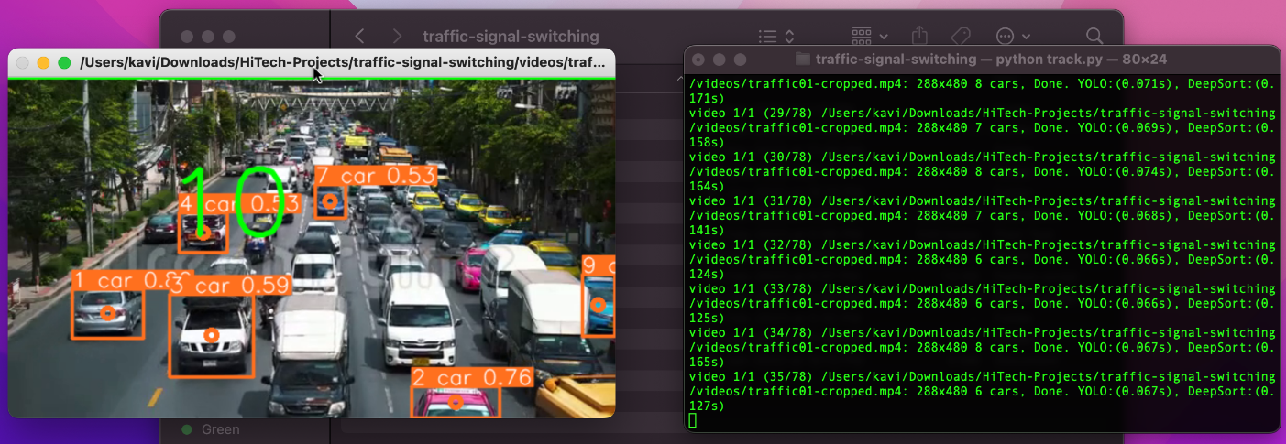

VIDEO SOUREC 2:
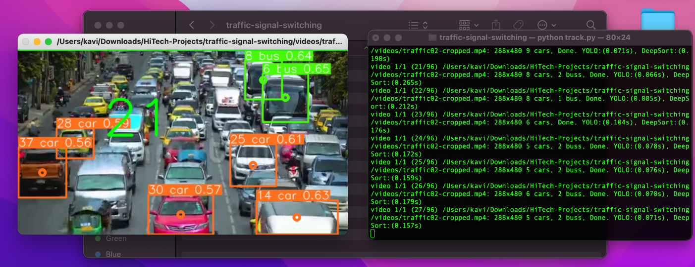

VIDEO SOUREC 3:
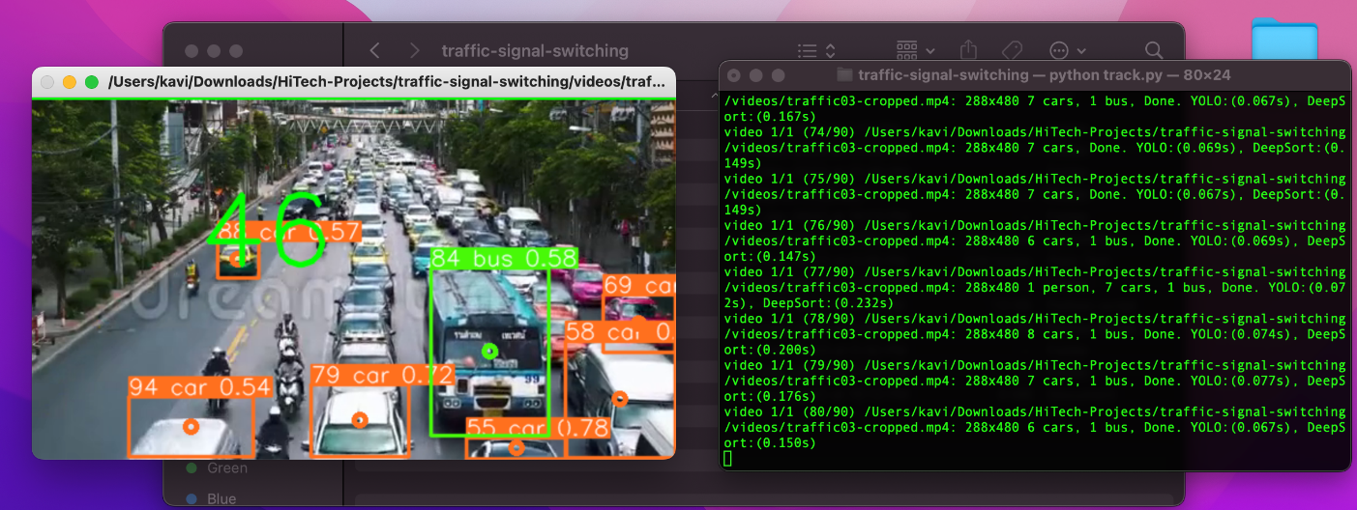
VIDEO SOUREC 4:
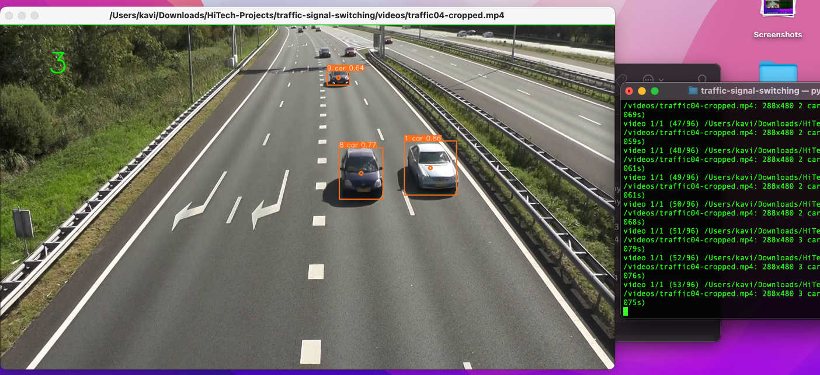

COMMAND PROMPT:
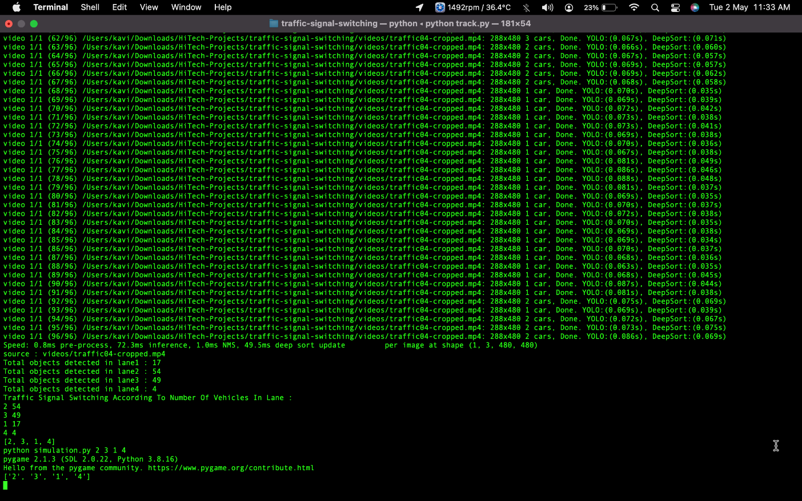

FIRST SIGNAL:
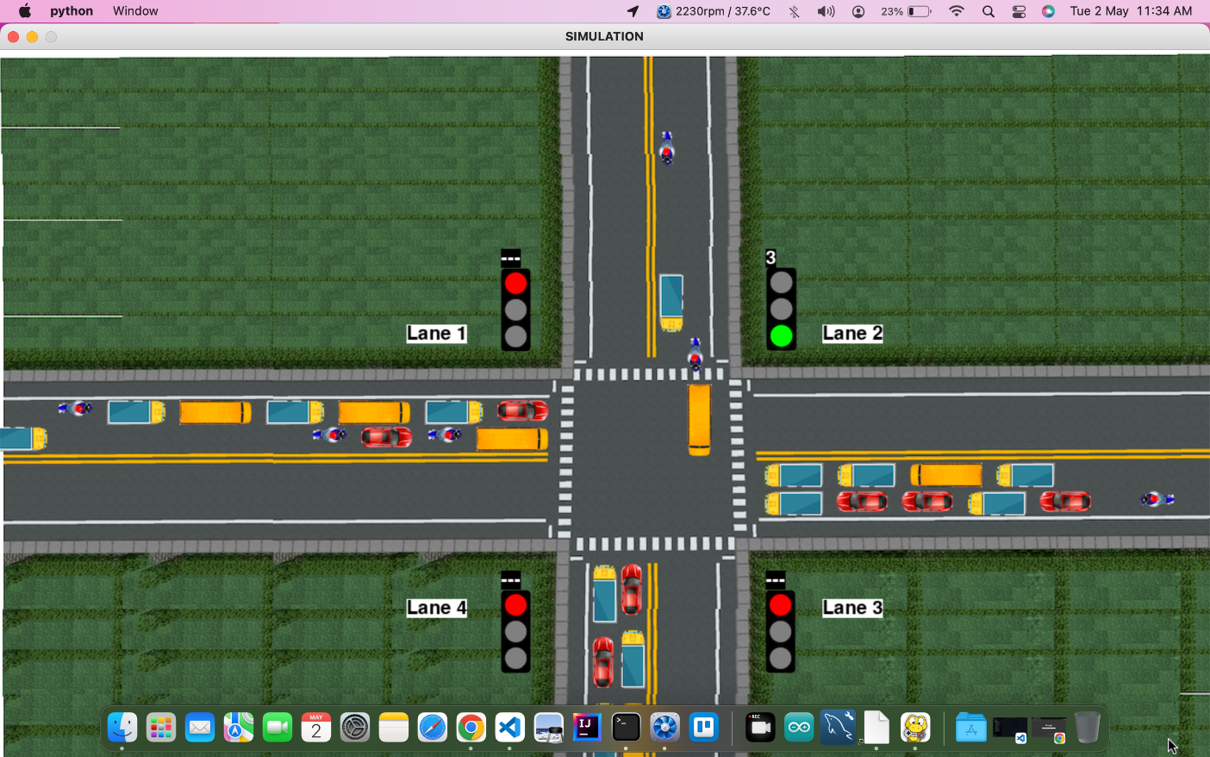

SECOND SIGNAL:
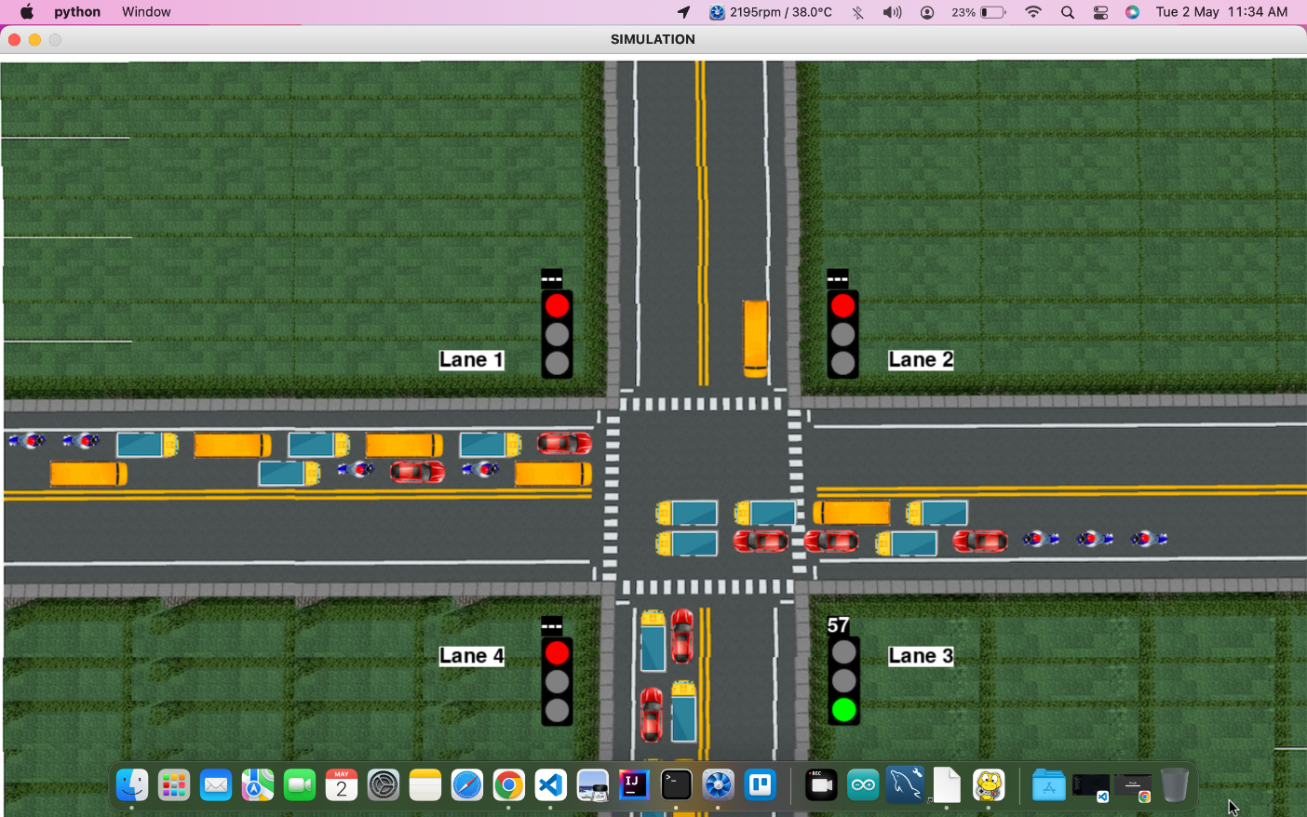

THIRD SIGNAL:
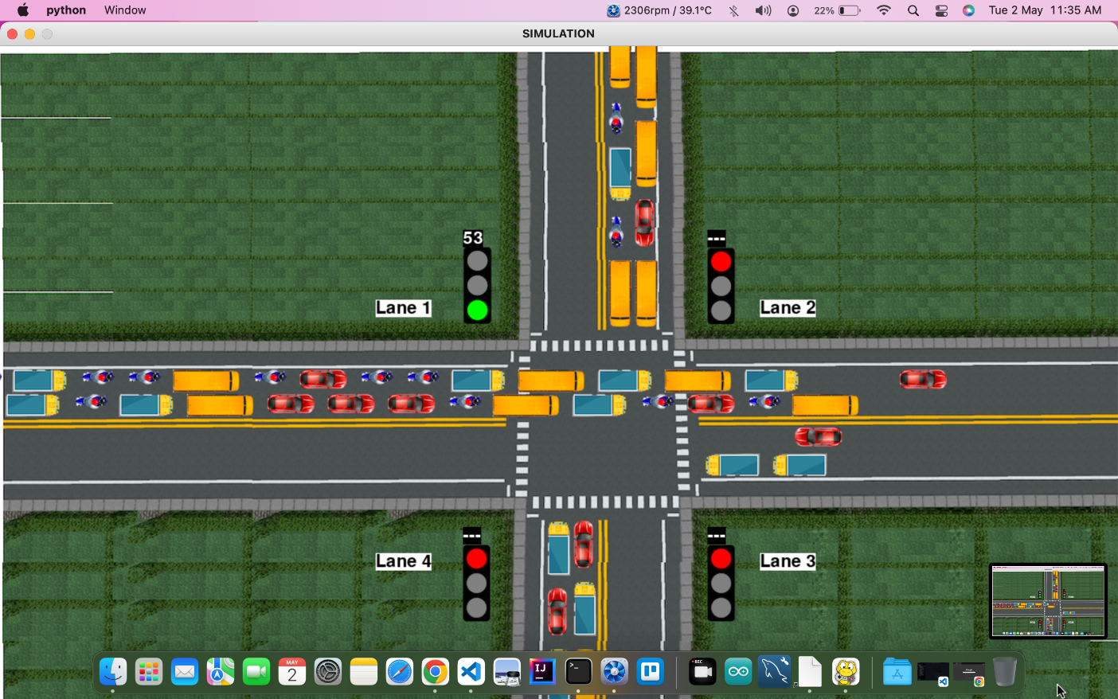

FOURTH SIGNAL:
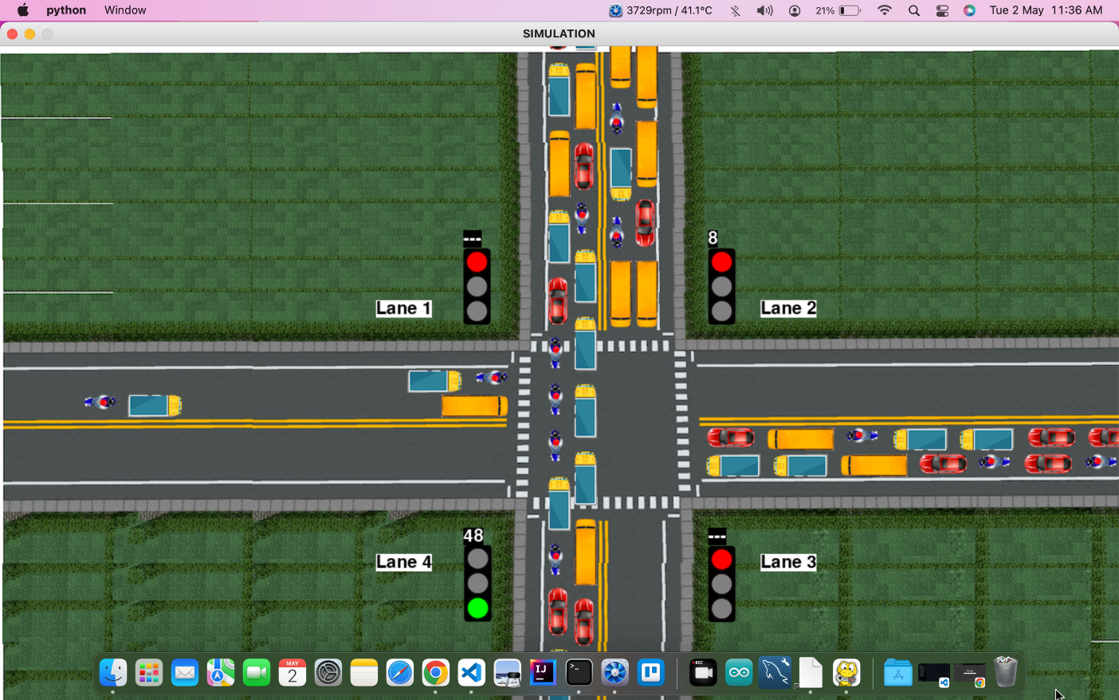

CHAPTER 9
CONCLUSION
Our project Real Time Traffic Signal Switching using Machine Learning aims to fix the conjunction of traffic which most of the cities in urban as well as rural areas are facing wherein the focus would be to minimize the vehicular congestion virtually without any installation of any kind of hardware. The setup requires camera and raspberry pi3 board as its hardware requirement and interfacing thereby forming portable medium. The model trained can used for efficient traffic flow without creating much chaos on the road. The model may take comparatively more training time but the response time will be less. The model is prepared in such a way that it decides smart switching timing for the signal on all sides of the road so the no one has to wait for longer interval of time on the road and flow of traffic is smooth on the road. In this first phase we have done with the Vehicle identification and detection using YOLOv3 algorithm and the remaining like finding the count and performing signal switching will be focused on the second phase.
In real-time traffic signal switching systems can play a significant role in reducing congestion and improving safety on the roads. By using data from sensors and cameras, deep learning models can accurately predict traffic patterns and optimize signal timing, resulting in reduced waiting times for drivers and improved traffic flow.
The proposed system for traffic signal switching, which includes data collection and pre-processing, deep learning model development, real-time data analysis, signal control module, system monitoring and control, and a user interface, can provide a reliable and optimized solution for traffic signal switching.
The development of such a system requires collaboration between transportation engineers, data scientists, and software developers. The system should be designed to be scalable and adaptable to changing traffic patterns and infrastructure.

FUTURE WORK

There are several potential avenues for future work in the field of traffic signal switching. Some of these include
- Integration with autonomous vehicles:
As autonomous vehicles become more prevalent on the roads, traffic signal switching systems may need to adapt to account for their presence. Future work may involve developing systems that can communicate with autonomous vehicles and adjust signal timing accordingly.
- Improved sensor technology:
The accuracy of traffic data is dependent on the quality of sensor data. Future work may involve developing new sensor technologies that can provide more accurate and detailed data on traffic patterns.
- Optimization of multiple intersections:
While the proposed system focuses on optimizing signal timing for individual intersections, future work may involve developing systems that can optimize traffic flow across multiple intersections in a coordinated manner.
- Integration with public transportation:
Public transportation, such as buses and trains, can significantly impact traffic flow. Future work may involve developing systems that can account for public transportation schedules and adjust signal timing accordingly.
- Environmental impact:
Traffic congestion not only impacts drivers but also contributes to air pollution and greenhouse gas emissions. Future work may involve developing systems that optimize traffic flow while also minimizing environmental impact.
there are many potential avenues for future work in the field of traffic signal switching, with the ultimate goal of improving traffic flow and reducing congestion on the roads.

REFERENCES

- Jyoti Tiwari, Real Time Traffic Management Using Machine Learning, Department of Information Technology, 2020.

- Xiaochen Hu, Beijing Signal and Information, A Moving Objects Based Real-time Defogging Method for Traffic Monitoring Videos. Aug 2014.

- Traffic Signal Management using Machine Learning Algorithm Prof. Sunayana Jadhav, June 2020.

- Traffic Management System using Machine Learning Algorithm. Dr. A. Ravi, April 2021.

- Ritu, Traffic Management using Machine Learning, Department of Computing, Jan 2022.

- Li Xun, Nan Kaikai, Liu Yao , Zuo Tao “A Real-Time Traffic Detection Method Based on Improved Kalman Filter” , 2018 3rd International Conference on Robotics and Automation Engineering (ICRAE) Guangzhou, China, 17-19 November 2018.

- Prof. S. T. Dumbre¹, Panchal Siddhi Santosh² Thakur Tejashri Chandrashekhar Smart traffic management system using machine learning, March. 2022.

- Zahra Zamani, Mohammad Hossein Saraee, Mahmoud Pourmand," Application of Data Mining in Traffic Management: Case of City of Isfahan", IEEE 2010.

- Celine Jacob, Baher, "Abdulhai Integrated Traffic Corridor Control Using Machine Learning", IEEE 2005.
- Soufiene Djahel, Mazeiar Salehie, Irina Tal, Pooyan Jamshidi, "Adaptive Traffic Management for Secure and Efficient Emergency Services in Smart Cities", IEEE PerCom conference 2013.
- Abhijit Gadge1, Hardik Bhawsar2, Piyush Gondkar3, Smart Traffic Control System Using Deep Learning July 2021.

- Mohamad Belal Natafgi Department of Electrical and Computer Engineering, Smart Traffic Light System Using Machine Learning, 2018

- Li, X., Yang, Y., Li, Z., & Liu, Y. (2017). A deep learning approach for real-time traffic signal control. IEEE Transactions on Intelligent Transportation Systems, 18(11), 3060-3073.

- Yang, Q., Zhang, Y., Wang, F. Y., & Zheng, N. (2018). Traffic signal control for urban road networks using deep reinforcement learning. Transportation Research Part C: Emerging Technologies, 91, 296-316.

- Haddad, A., Cheung, C. Y., & Chan, A. H. (2019). A novel deep learning approach for real-time traffic signal control using a high-resolution camera. Transportation Research Part C: Emerging Technologies, 104, 145-162.

- Wang, J., & Meng, Q. (2016). A survey of traffic signal control methods. Transportation Reviews, 36(6), 748-776.

- Zhang, Y., Liu, S., & Wang, F. Y. (2019). Coordinated signal control for a large-scale road network using deep reinforcement learning. Transportation Research Part C: Emerging Technologies, 106, 345-366.

- Liao, Y., Zhang, L., & Yu, X. (2021). A survey on deep reinforcement learning for traffic signal control. Neural Computing and Applications, 33, 11675-11687.

- Ma, W., & Zheng, N. (2019). Urban traffic signal control: A deep learning approach. IEEE Transactions on Intelligent Transportation Systems, 20(3), 982-991.

- Zheng, H., Chen, J., Wang, Q., & Zhang, L. (2019). A reinforcement learning-based signal control method for a single intersection. IEEE Access, 7, 184626-184637.

- Wu, H., Zhang, Y., Wang, F. Y., & Zhang, Y. (2019). Coordinated signal control at multiple intersections using deep reinforcement learning. Transportation Research Part C: Emerging Technologies, 98, 1-16.

- Sun, C., Yang, Y., & Xu, Y. (2020). A survey of intelligent traffic signal control. IEEE Transactions on Intelligent Transportation Systems, 21(2), 766-783.

- Liu, H., Zhang, H., Wang, J., & Zou, H. (2019). Real-time traffic signal control for large-scale urban road networks using deep reinforcement learning. Transportation Research Part C: Emerging Technologies, 98, 175-193.

- Qian, K., & Wang, Y. (2021). Real-time traffic signal control for a single intersection with uncertain arrival rates using deep reinforcement learning. IEEE Transactions on Intelligent Transportation Systems, 22(1), 9-22.

- Kim, J., Jang, W., & Kim, K. (2018). Deep reinforcement learning-based traffic signal control considering multiple intersections. IEEE Access, 6, 52506-52515.

- Li, Y., Lin, H., Wu, J., & Li, J. (2019). Urban traffic signal control with deep reinforcement learning. Neurocomputing, 365, 121-133.

- Li, M., Qian, K., & Yang, L. (2021). Dynamic traffic signal control for urban intersections via a hybrid deep reinforcement learning method. Transportation Research Part C: Emerging Technologies, 124, 103096.

- Zhang, Y., Wang, F. Y., & Zheng, N. (2016). Deep learning for traffic prediction and intelligent transportation systems: A survey. IEEE Transaction on intelligent Transportation System, 17(12),3210-3223.

