MATHEMATICAL MODEL DEVELOPMENT & CLEARANCE OPTIMIZATION IN SHEET METAL BLANKING PROCESS FOR COPPER

**-**

1. 1Mr.Laxman Tukaram Tambe, 2Mr. Mirza Umead Sadattulla, 3
2. 1Scholar in Mechanical engineering, 2 HOD Mechanical engineering, 3
3. 1Mechanical engineering,
4. 1Aditya Engineering College, Beed, India

**ABSTRACT**

Blanking process is widely used process in sheet metal production industries to fabricate components. The sheet metal blanking industry is facing an increasingly competitive global market. Due to shortage of experienced operators and unavailability of affordable CAD/CAM systems, it is difficult to predict optimum clearance between punch and die to obtain high quality in small scale industries. Blanking is metal fabricating process and it is characterized by complete material separation. It is difficult to simulate the shearing process because of the narrowness of the shear band formed and the lack of an appropriate fracture criterion. The effect of potential parameters like thickness of sheet, punch-die clearance, tool wear, and punch geometry is studied to investigate their interactions on blanking process. It is important to choose process leading parameters such that two identical products from two different materials can be manufactured on same mold with high quality. This study will help to investigate the effect of sheet thickness, punch-die clearance and type of material on blanking process and will help to predict optimal set of parameters to obtain reasonable quality. A mathematical model of blanking process is developed and design of experiments method is used to predict optimum punch-die clearance for copper which will result into high quality of component.

**Keywords:** Blanking, Burr, Optimization, Regression analysis.

1. **INTRODUCTION**

Blanking is one of the most widely used metal fabricating mechanical process, during which a metal work piece is removed by cutting of the sheet into appropriate shapes by physical process of shearing. The removed material is refereed as Product. The blanking process forces a metal punch into a die that shears the blank from the larger primary metal strip. Recent market demands are that parts manufactured should be high quality with good surface finishing and high accuracy. In actual practice, operators in sheet metal industries are faced with the problems of predicting proper punch-die clearance which can make process faster by eliminating surface irregularities like burr [1]. This paper presents a method of prediction of optimum punch-die clearance by using design of experiment method with the help of Taguchi method.

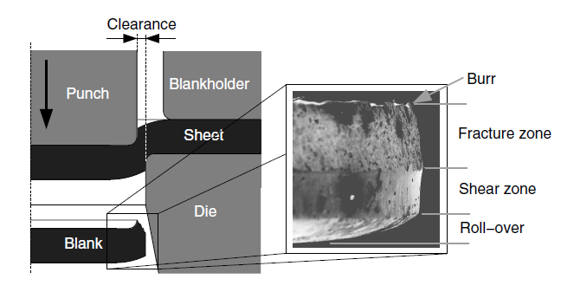

Figure 1: A schematic representation of the blanking process with an indication of the different zones [1, 2, 3]

Aluminum, Brass, Copper, Bronze, Mild Steel and Soft Steel are the most common materials used for blanking. This study is related with Copper which is an excellent material to be used in the blanking processes.

* 1. **Fundamentals of the sheared part**

The errors on blank product are depending upon the material properties, tool shape, tool wear and noise factors [4]. In Fig. 2 represents the sheared part such as the fracture depth, the smooth-sheared depth, the burr formation, the fracture angle and roll-over depth.

Rollover Depth: It happens because of plastic deformation of material.

Shear Depth: It happens because of shearing of material smooth and shiny area is created.

Fracture/Rupture Depth: It is rough surface, result after the material cracks.

Burr height: It is a caused of plastic deformation

Depth of crack penetration: It is an angle of fracture zone depends mainly on clearance [2]



Figure 2: Geometry of the sheared work piece [5, 6]

* 1. **Problems in blanking process**.
* Blanking process design: - In industry blanking operations are still performed based upon experimentations and process is governed by time-consuming and expensive trial and-error iterations due to lack of knowledge about optimum punch-die clearance.
* Due to more trial and error methods, more cycle time is required which result into inaccurate product dimensions and specification (especially formation of burr height) [7].
* Quality of component is not at satisfactory level due to formation of burr height.
* When there is a manual Quality control by operators without setting of optimum punch die clearance, it results into high quantity of rejection.

1. **FACTORS/ERRORS INFLUENCING BLANKING PROCESS**

Dimensional error, positional error and form error can affect the accuracy of work pieces as shown in Fig.3

The processes can be optimized to determine the following outputs:

• Total manufacturing cost of the product

• Quality improvement of the product.

• In-process time can be optimized etc.

The errors on blanks are caused by material, the tool shape, process variations and the machine. Therefore, clearance and tool geometry are the most important parameters. The variation in geometry of the sheared product such as the roll over depth, the fracture depth, the smooth sheared depth, the burr formation and fracture angle are considered as form errors [4].



Figure 3: Factors affecting errors on blanked work pieces. [4, 5]

* 1. **Influence of clearance between punch and die**

The clearance between punch and die is specified as,

C= ( $\frac{Dm-Dp}{2t}$) 100 (%)

As shown in above expression, Clearance is expressed as percentage of sheet thickness. t ,Dp, Dm are the sheet thickness ,diameter of punch, diameter of die [5, 6, 8, 9].

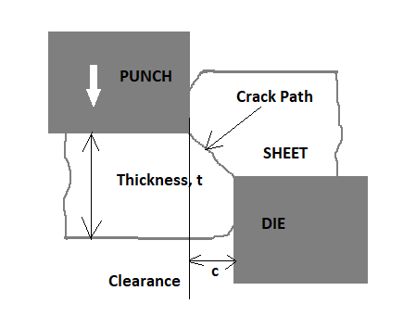

Figure 4: Representation of the clearance between die and punch [6]

To find out optimum clearance three setups are manufactured equivalent to three altered clearances as 5%, 10% and 15%. These values are commonly used clearances in sheet metal industry.

**2.2 Influence of tool wear**

It is important to design the punch tool for industrial fabrication process. The quality of the product cut is depending upon the wear condition of tool [6].

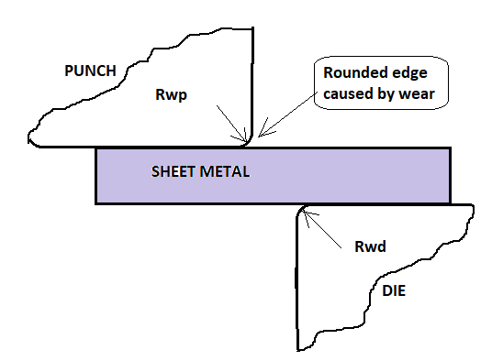

Figure 5: Cutting edges of the tool [8]

Wear is formed on tool because of the friction between punch tool and material sheet. Parameters affecting the rate of wear are punch velocity, material of punch, blanked work piece material, clearance between die and punch, lubrication and sheet thickness. Due to wear on outer edges of tool, the cutting edges become rounded (Fig.5). By varying the values of the radius of edge i.e. Rwp and Rwd (Fig.5), the effect of wear can be observed. So, the study of the tool wear effect on profile variations is important.

**2.3 Influence of the thickness of the material**

It is detected that the sheet thickness affects energy required for blanking. The conclusion is given as: When ratio of clearance with thickness of sheet increases blanking energy decreases and blanking is directly proportional with thickness of sheet. The magnitudes of the depth features are influenced by the thickness of sheet [6].

1. **DESIGN OF EXPERIMENT BY TAGUCHI METHOD**

The effect of many different parameters on the performance characteristic in a condensed set of experiments can be examined by using the orthogonal array experimental design proposed by Taguchi. Once the parameters affecting a process that can be controlled have been determined, the levels at which these parameters should be varied must be determined. Knowing the number of parameters and the number of levels, the proper orthogonal array (OA) can be selected. In this study, 2 parameters are selected i.e. thickness and clearance. For each parameter 3 levels are selected and so from orthogonal array selector, L9 OA is selected for 2 parameters and 3 levels

Table 1: Taguchi Design of L9 OA

|  |  |  |  |  |  |  |  |  |  |
| --- | --- | --- | --- | --- | --- | --- | --- | --- | --- |
| Ex. No. | 1 | 2 | 3 | 4 | 5 | 6 | 7 | 8 | 9 |
| Thickness(mm) | 0.5 | 0.5 | 0.5 | 0.8 | 0.8 | 0.8 | 1.5 | 1.5 | 1.5 |
| Clearance (%) | 5 | 10 | 15 | 5 | 10 | 15 | 5 | 10 | 15 |

The Experiment was carried on 10 Tonne Hydraulic Power Press.

The measurement was done to get burr height using Digital Vernier Height Gauge (Least Count 0.001mm)

## ANALYSIS OF COPPER

## Table 2: Response Table for Signal to Noise Ratio & Mean for Copper

## *C:\Users\swapnil\Desktop\SWAPNIL- ME\Thesis preparation\copper.png*

* 1. **Analysis by Signal to Noise Ratio and Means of Burr height**

## Quality Characteristic: Burr Height of Blanked Component

## Quality Characteristic Feature: Smaller-the-better

## Table 3: Response Table for Signal to Noise Ratio and Mean of Burr height

|  |  |  |  |  |
| --- | --- | --- | --- | --- |
| Level | SNRA analysis | | Mean analysis of Burr | |
| A (Thickness) | B (Clearance) | A (Thickness) | B (Clearance) |
| 1 | 18.49 | 25.35 | 0.12171 | 0.05791 |
| 2 | 20.97 | 21.19 | 0.09325 | 0.09119 |
| 3 | 24.67 | 17.60 | 0.06519 | 0.13105 |
| Delta | 6.18 | 7.75 | 0.05651 | 0.07314 |
| Rank, R | 2 | 1 | 2 | 1 |

## The larger the Delta value for a parameter, the larger the effect the variable has on the process.

## According to SNRA and Mean Analysis, Delta for clearance is larger than delta of thickness. It concludes that clearance is the major affecting parameter in blanking process.

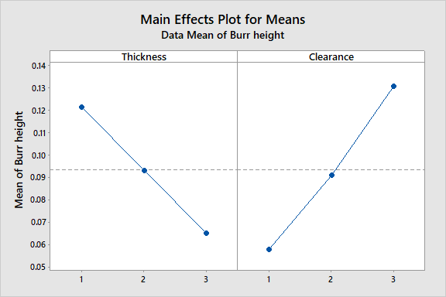

Figure 6: Main effect plot for Mean of Burr height

Figure 6 shows the means plot where the horizontal line indicates mean value of burr height. Basically, smaller the means i.e. burr height, the better is the quality characteristics for the blank. As per the means analysis from Fig. 6, the levels of parameters to be set for getting optimum value of burr height are **A3B1**(Thickness 1.5 mm and clearance 5%)

## 4.2 Analysis by ANOVA

## Table 4: ANOVA for SNRA, using Adjusted SS ANOVA

|  |  |  |  |  |  |  |
| --- | --- | --- | --- | --- | --- | --- |
| Source | DF | Seq SS | Adj SS | Adj MS | F | Percent Contribution |
| Thickness | 2 | 60.23 | 60.23 | 30.664 | 11.41 | 0.011 |
| Clearance | 2 | 88.32 | 88.32 | 44.565 | 16.79 | 0.22 |
| Error | 4 | 10.67 | 1.067 | 2.554 |  |  |
| Total | 8 | 160.32 |  |  |  |  |

## According to ANOVA analysis as shown in Table 4, the most effective parameter with respect to burr height is clearance. Percent contribution indicates the relative power of a factor to reduce variation. For a factor with a higher percent contribution, a small variation will have a great influence on the performance. The percent contributions of the blanking parameters like thickness and clearance on the burr height are shown in Table 4. According to ANOVA analysis, clearance was found to be the major factor affecting the burr height (22%). The percent contributions of sheet thickness is much lower, i.e. only 1.1%.There is no need of confirmation experiment as optimum level condition A3B1 (Thickness 1.5 mm and clearance 5%) has been already performed.

**4.3 Regression Analysis**

## Table 5: Regression Analysis: MEAN versus thickness, Clearance

|  |  |  |  |  |  |
| --- | --- | --- | --- | --- | --- |
| Predictor | Coef | SE Coef | T-value | P-value | VIF |
| Constant | 0.07676 | 0.00733 | 10.47 | 0.000 |  |
| Thickness | -0.02826 | 0.00249 | -11.35 | 0.000 | 1 |
| Clearance | 0.03657 | 0.00249 | 14.69 | 0.000 | 1 |

The Regression equation is

BURR HEIGHT = 0.07676 - 0.02826 A (Thickness) + 0.03657 B (Clearance)

S = 0.0060993 , R-Sq =98.29%, R-Sq(adj)= 97.72% , R-sq(pred)=96.09%

Solving previous regression equation by MS EXCEL-SOLVER

Table 6: MS EXCEL SOLVER Optimum values

|  |  |  |
| --- | --- | --- |
| X | Y | Z |
| 0.06518 | **0.05844** | **0.077876** |
| 0.09385 | 0.09131 | 0.078258 |
| 0.1217 | 0.131 | 0.078911 |

Where:-X=THICKNESS, Y=CLEARANCE, Z=BURR HEIGHT

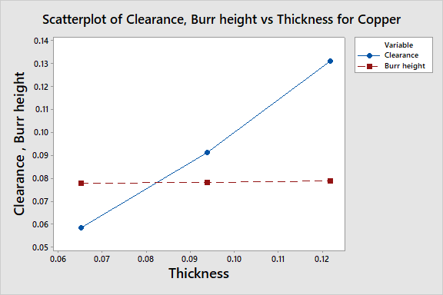

Figure 6: Scattered plot for X, Y & Z

Table 6 shows that the minimum Burr height 0.077876 mm corresponds to clearance value of 0.05844 i.e. 5.844%. It proves that the optimum clearance corresponds to minimum burr height is 5.844%.

## VALIDATION OF RESULTS WITH LITERATURE REVIEW OF COPPER

* By S. Maiti, A. Ambekar, U. Singh, P. Date, and K. Narasimhan, [10]

Tool clearance about 10% of sheet material thickness is good to improve quality according to different conditions of load and deformation of sheet.

* By Emad Al-Momani, Ibrahim Rawabdeh [7]

To minimize the formation of burr height, the clearance between punch and die should be set about 5 % with almost no blank holder force.

From above two results of respective Author it clear that our results and prediction about optimum clearance is promising and thus VALID.

1. **CONCLUSION**

The experiment conducted on sheet metal blanking process helps to study the effects of process parameters such as the material type, the punch-die clearance, the thickness of the sheet and their interactions on the geometry of the sheared edge especially the burrs height. The Design of experiments (Taguchi Method) method is used to investigate blanking process. This study concludes that the type of material, geometric characteristics of the tools and their configuration influence the burrs height of the sheared blanked product.

This investigation shows that, in order to minimize the burrs height, the clearance should be set at about 5 % with almost no blank holder force. The optimum process parameters are predicted by using design of experiment method. Lead-time can be reduced by using Taguchi Method as a Design of Experiment technique in the design process, where computer software like Minitab, Design expert can replace many time consuming experiments. This will make the design process faster and more reliable.

It is possible to build high quality products by reducing errors from the early design phases by predicting the shape and size of burs height of a blanked product. This will improve the output product’s quality and reduce burr which reduces finishing work in addition to increasing the manufacturing process flexibility and also reducing its cost through building one blanking setup for different materials. In conclusion, it can be stated that the Design of Experiments technique can be used in order to predict optimum punch-die clearance which contribute towards the optimization of sheet metal blanking processes.

# References

**[**1]Goijaerts, Ad (2000), “Prediction of Ductile Fracture in Metal Blanking” / by Ad Goijaerts. – Eindhoven: TechnischeUniversiteit Eindhoven, Proefschrift. – ISBN 90-386-2751- NUGI 834

[2]D. Brokken, W. Brekelmans, and F. Baaijens, (2000), “Predicting the shape of blanked products: a finite element approach”. Journal of Materials Processing Technology, Vol.103, page no. 51-56

[3]A.M. Goijaerts, L.E. Govaert, F.P.T. Baaijens (2001), “Evaluation of ductile fracture models for different metals in blanking” Journal of Materials Processing Technology 110 , page no. 312-323

[4]R. Hambli, (2002), “Design of Experiment Based Analysis for Sheet Metal Blanking Processes Optimization”. The International Journal of Advanced Manufacturing Technology, Vol.19, page No.403-410

[5]Ridha Hambli, (June 2005), “Optimization of blanking process using neural network simulation”, The Arabian Journal for Science and Engineering, Volume 30

[6]R. Hambli, (2003), “BLANKSOFT: a code for sheet metal blanking processes optimization”. Journal of Materials Processing Technology, Vol. 141, page no. 234-242

[7]Emad Al-Momani, Ibrahim Rawabdeh, (Mar. 2008), “An Application of Finite Element Method and Design of Experiments in the Optimization of Sheet Metal Blanking Process” Jordan Journal of Mechanical and Industrial Engineering. Volume 2, Number 1, Pages 53 -63

[8]F. Faura, A. Garcia, and M. Estrems, (1998), “Finite element analysis of optimum clearance in the blanking process”. Journal of Materials Processing Technology, Vol.80-81, Page no.121-125

[9]M., Samuel, (1998), “FEM simulations and experimental analysis of parameters of influence in the blanking process”. Journal of Materials Processing Technology, Vol. 84, page no. 97-106

[10]S. Maiti, A. Ambekar, U. Singh, P. Date, and K. Narasimhan, (2001), “Assessment of influence of some process parameters on sheet metal blanking”.Journal of Materials Processing Technology, Vol. 102, page no. 249-25

[11] Mohamed Sahlia,, Xavier Roizarda , Guillaume Colasa , Mohamed Assoula , Luc Carpentiera , Pierre-Henri Cornuaulta , S. Giampiccolob , J.P. Barbe, (2020), “Modelling and numerical simulation of steel sheet fine blanking process”, [Procedia Manufacturing](https://www.sciencedirect.com/science/journal/23519789), [Volume 50](https://www.sciencedirect.com/science/journal/23519789/50/supp/C), 2020, Pages 395-400

[12] Dr. P. Nageswara Rao, Dr. R. Kotaiah and Dr. D. Venkateswarlu, (2018), “Development of Mathematical Modeling and its Exploration Based on Genetic Algorithm for Blanking Die Design Parameters Optimization”,[Applied Mechanics and Materials](https://www.scientific.net/AMM) (Volume 877) pages 54-59

[13] A.N. Patil, [V.L. Kadlag](https://scholar.google.com/citations?user=HNMmMmkAAAAJ&hl=en&oi=sra) , (2016), “Blanking Process Optimization using Finite Element Analysis & Taguchi Method”. International Journal of Science Technology & Engineering, Volume 2, page no. 553-562