**DRIVER DROWSINESS DETECTION SYSTEM USING OPEN CV & KERAS**

**Uma Maheshwari1, Rajalakshmi.R2, Reena.J3, Sivanesan.M4**

1Assistant professor, Department of CSE, Hindusthan Institute of technology, Coimbatore, TamilNadu,

India

2,3,4Student, Department of CSE , Hindusthan institute of technology, Coimbatore, TamilNadu, India

**ABSTRACT**

On an average 1200 road accidents record daily in India out of which 400 leads to direct death and rest gets effected badly. The major reason of these accidents is drowsiness caused by both sleep and alcohol. To accomplish this, we implement the solution using computer-vision based machine learning model. If the driver’s face is drowsy, a sound alert is generated by the system. This alert can make the driver aware that he/she is feeling drowsy and the necessary actions can then be taken by the driver. This system can be used in any vehicle on the road to ensure safety of the people who are travelling and prevent accidents which are caused due to the drowsiness of the driver.

1. **INTRODUCTION**

Driver’s drowsiness is a very cautious thing and has already led to a lot of mishaps. Some researchers even provide a data that nearly 1200 deaths and 76000 major injuries are caused due to the fatigue driver was facing which eventually led to a crash. With the help of modern-day technology and real time scanning systems using cameras we can prevent major mishaps on the road by alerting car driver who is feeling drowsy through a drowsiness detection system. Detection of drowsiness depends on the eye movements and time elapsed between blinks to help generate a score on which a driver is assessed if he is drowsy or not. To prevent these accidents, we have developed a system using python, open Cv and keras which works on the live feed of the driver through a webcam which is then processed to generate a score based on the time between eyes closing and opening and when eyes are closed for a long time the score starts increasing and when it reaches a certain mark the alarm starts beeping alerting the driver and waking him up.

**2.METHODOLOGY**

The main purpose of this paper is to produce a simple and easy-to-use system that will lead to a safe road trip.

* 1. **Finding the system work**

The method first find the image of the eye using Conventional neural network algorithm **.**

**2.2Finding the process of the system**

Take image as input from a camera. Detect the face in the image and create a Region of Interest (ROI). Detect the eyes from ROI and feed it to the classifier. Classifier will categorize whether eyes are open or closed. Calculate score to check whether the person is drowsy.

**3.MODELING AND ANALYSIS**

The model we used is built with Keras using**Convolutional Neural Networks (CNN)**. A convolutional neural network is a special type of deep neural network which performs extremely well for image classification purposes. A CNN basically consists of an input layer, an output layer and a hidden layer which can have multiple layers. Using this CNN we easily able to capture the image and find out the drowsiness of the driver. Here we use python language .Python is an amazing programming language. It is simple to read but also powerful enough that it can do a lot of things. Compared to other languages, it allows fast iteration. If you want to tweak your code a bit, you only need to change a line or two, and you can run the modified code right away. No need to update many places for small changes. No need to wait for minutes and hours to re-compile your code to run it .Python is never meant to run fast. In fact, if execution speed is the concern, using a different language such as C++ or Java might be a better idea. In machine learning projects. We need many experiments and iterations to finalize our approach. Having a language that allows us to iterate fast means we can improve our solution faster. As a result, a lot of people are using Python. And a lot of libraries are written for Python. This virtuous cycle makes Python a mature language with a powerful ecosystem.



**Figure 1:** Block Diagram

1. **RESULTS AND DISCUSSION**

In this Python project, we will be using OpenCV for gathering the images from webcam and feed them into a  deep learning model which will classify whether the person’s eyes are ‘Open’ or ‘Closed’.The dataset used for this model is created by us. To create the dataset, we wrote a script that captures eyes from a camera and stores in our local disk. We separated them into their respective labels ‘Open’ or ‘Closed’. The data was manually cleaned by removing the unwanted images which were not necessary for building the model.we will set some amount of count for the alarm to happen ,if it is more than that only the sound will happen.If there is zero count means then the eyes is open.If the eyes is closed the count of the number will gwt increase and the alarm sound will happen and the driver will get from the drowsiness.

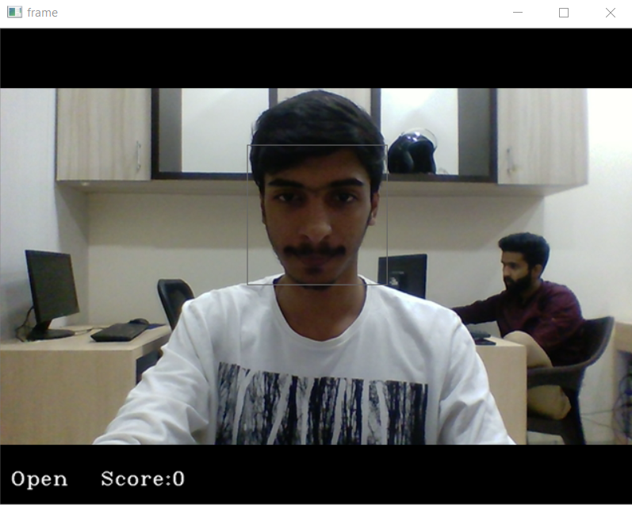

**Figure 1:Open eye detection**

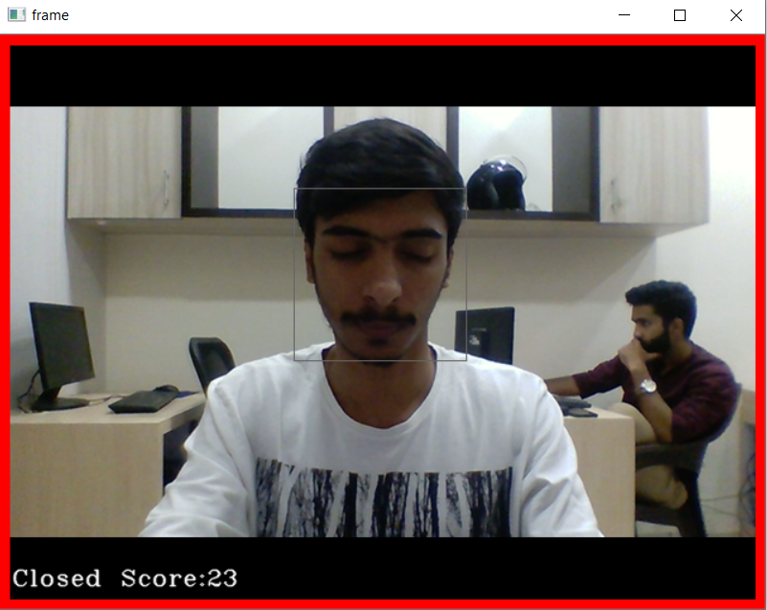

**Figure 2:Closed eye detection**

1. **CONCLUSION**

In this Python project, we have built a drowsy driver alert system that you can implement in numerous ways. We used OpenCV to detect faces and eyes using a haar cascade classifier and then we used a CNN model to predict the status.which will be very helpful for us to avoid the unwanted accidents because of drowsiness of the driver.

1. **REFERENCES**

[1] Rosebrock, A. (2017, May 8). Retrieved from Pyimagesearch: https://www.pyimagesearch.com/2017/05/08/drowsiness-detection-opencv/

[2] Awais M, Badruddin N, Drieberg M. A Hybrid Approach to Detect Driver Drowsiness Utilizing Physiological Signals to Improve System Performance and Wearability. Sensors (Basel). 2017 Aug 31;17(9):1991. doi: 10.3390/s17091991. PMID: 28858220; PMCID: PMC5620623. https://pubmed.ncbi.nlm.nih.gov/28858220/

[3] Arefnezhad, S., Samiee, S., Eichberger, A., & Nahvi, A. (2019). Driver Drowsiness Detection Based on Steering Wheel Data Applying Adaptive Neuro-Fuzzy Feature Selection. *Sensors (Basel, Switzerland)*, *19*(4), 943. https://doi.org/10.3390/s19040943

[4] B. K. Savaş and Y. Becerikli, "Real Time Driver Fatigue Detection Based on SVM Algorithm," 2018 6th International Conference on Control Engineering & Information Technology (CEIT), 2018, pp. 1-4, doi: 10.1109/CEIT.2018.8751886. https://ieeexplore.ieee.org/abstract/document/8751886/