**FUTURE SALES FORECASTING USING ARIMA MODEL**

**Mrithula V1, Nandhini Devi N2, Hari Haran E3 , Praveen Kumar G4**

1,2,3 Student,Computer Science,Agni College of Technology,Chennai,Tamilnadu,India.

4Assistant Professor, Computer Science,Agni College of Technology,Chennai,Tamilnadu,India.

**ABSTRACT**

For newly based items, this study recommends a knowledge- based database-based sales forecasting methodology. Despite the fact that projecting future demand is an essential part of business planning and management, the bulk of significant forecasting methodologies only apply to everyday consumables, which exhibit modest sales trends caused by seasonal cycles. Based on the sales results of the product's very early introduction and a database of correlations between short- and long-term accumulations, the model creates a long-term forecast. The architecture was created to address the three practical concerns of accuracy, predicted release timing, and broad item coverage. We can use the model to obtain an accurate sales projection for the product's lifecycle one or two weeks after it is published. Additionally, it provides important information for determining whether to reprint the piece. This experiment will illustrate the proposed method's dependability in accuracy and efficiency in contrast to currently applied, well-proven methods. However, the bulk of consumers for retail goods are erratic, as seen by the erratic and nonlinear sales trends.

1. **INTRODUCTION**

Estimating future revenues is the technique of sales forecasting. It's a crucial activity for businesses since it enables them to forecast income streams, plan for the future, and make informed decisions regarding marketing and inventories. Getting information on previous sales is the first stage in sales forecasting. This can include information on specific product or service sales as well as general business sales figures. Getting information on previous sales is the first stage in sales forecasting. This can include information on specific product or service sales as well as general business sales figures. External elements that could affect sales, such as the state of the economy, changes in customer behavior, or the emergence of new rivals, should be considered when making sales projections. The system should also have a feedback mechanism so that the model can be updated in response to fresh information and market modifications. Maintaining the forecasting model's accuracy and applicability requires regular usage which requires regular monitoring and updating. This could entail modifying the statistical techniques utilized, adding new variables, and revising the model parameters. Overall, to effectively forecast future sales income, a whole sales forecasting model needs to be combined with data analysis, statistical modeling, and business expertise. The quality of the data, the sophistication of the statistical techniques employed, and the level of knowledge of the analysts involved in the process will all affect how accurate the model is numerous sectors and company departments use future sales forecasting in a variety of ways. Businesses can gain a huge competitive advantage by streamlining their operations and making data- driven decisions if they can properly predict future sales. The breadth of future sales forecasting has expanded as a result of current technology and data analytics advancements. Future sales forecasting now encompasses much more thanks to developments in data analytics and technology.

1. **METHODOLOGY**

A variety of industries employ autoregressive integrated moving average (ARIMA) models. It is frequently applied to demand forecasting, such as when predicting future demand for the production of food. This is so that managers have solid rules to follow when making decisions on supply chains. On the basis of previous prices, ARIMA models can also be used to forecast the future price of your stocks. This is due to the fact that ARIMA models are a general class of models used for time series data forecasting. The standard abbreviation for ARIMA models is ARIMA (p,d,q), where p denotes the order of the moving-average model, d is the degree of differencing, and q is the order of the autoregressive model. ARIMA models transform a non-stationary time series into a stationary one via differencing and then extrapolate future values from the past. In order to predict future values, these models employ "auto" correlations and moving averages over residual errors in the data. By modeling the correlations in the data, the ARIMA methodology is a statistical technique for analyzing and creating a forecasting model that accurately depicts a time series.

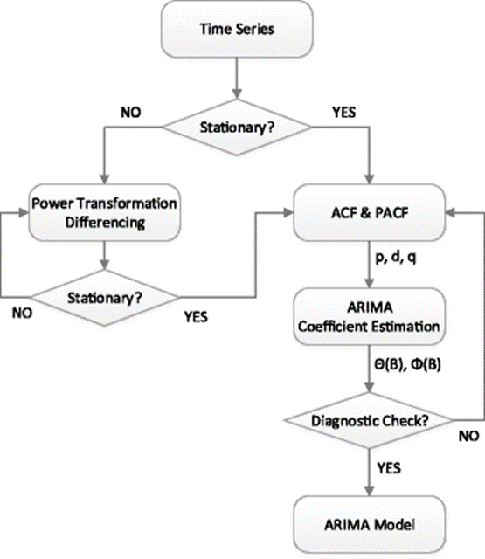

# **Fig 2.1 Flow Diagram of ARIMA Model**

Once the ARIMA model has been trained, we can use it to predict future sales by feeding it historical data and basing our predictions on the patterns the model has discovered. The model's output will be the anticipated sales for the subsequent time frame. It is significant to stress that stable data—data whose statistical characteristics do not vary over time—are necessary for ARIMA models. Before fitting the model, the data may need to be transformed if it is not stationary. In a time-series variable, Arima models can be used to identify odd patterns or outliers. This is helpful in industries like cybersecurity, where spotting atypical network activity can aid in the detection of potential security flaws. This would entail putting different models to the test and choosing the one that offers the best match for the data. After gathering the data, it would be pre-processed to eliminate any outliers, missing data points, or other anomalies that would compromise the analysis's accuracy.

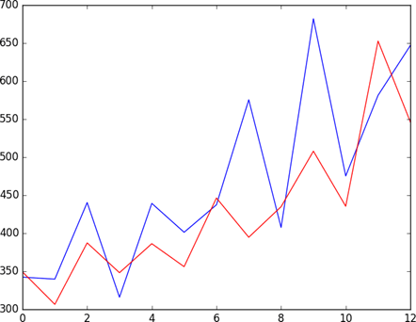

**Fig 2.2 Time series analysis using ARIMA Model**

1. **DATASETS**

The dataset used in this study was composed of a number of historical sales measures taken on various items inside an organisation. The number of categories, as well as attributes like monthly, yearly, and weekly, are included. The information was acquired over time at regular intervals. Each row of the data contains essential sales information. Holidays, festival holidays, etc. are included in the dataset. The dataset also includes annual peak and trough ranges. The future can be accurately anticipated based on this.

1. **RESULTS**

**4.1 Actual Graph**

Depending on the type of data and the goal of the forecast, the actual graph used for predicting future sales might take on a variety of shapes. But the majority of sales forecasting graphs usually show the following:

* Period Axis
* Sales Axis
* Forecast Line

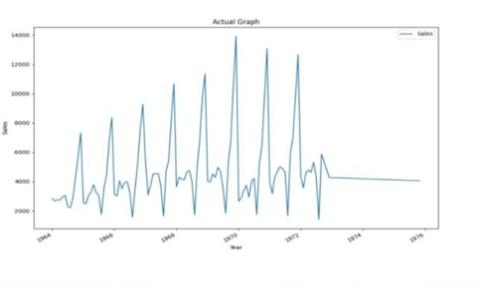

**Fig 4.1 Actual Graph**

**4.2 Forecast Graph**

A forecast graph is a visual representation of the anticipated sales trend over a given time period used in future sales forecasting. The type of data, the forecasting technique, and other pertinent elements will determine the precise shape of the forecast graph. However, the following elements are frequently found in forecast graphs used for future sales forecasting:

* Time Axis
* Sales Axis
* Forecast Line
* Confidence and Interval
* Trends and Patterns

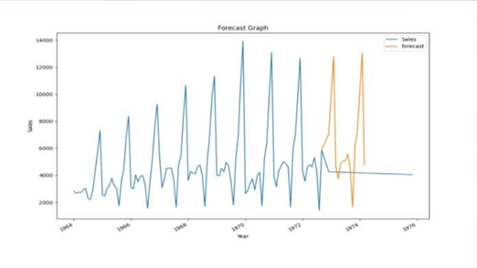

**Fig 4.2 Forecast Graph**

**4.3 Predicted Graph**

A key component of company planning is forecasting future sales trends, and a graph is a popular tool for displaying these forecasts. Future sales forecasting will take into account a number of variables, including the nature of the data and the forecasting techniques, to determine the precise form of the forecasted graph. But the majority of sales forecasting graphs usually show the following:

* Time Axis
* Sales Axis
* Forecast Line

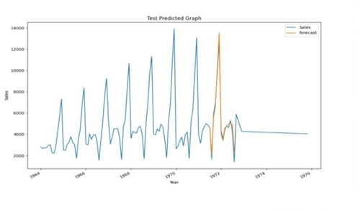

**Fig 4.3 Predicted Graph**

1. **REFERENCES**
2. Tingli Feng, Chenming Niu, Yuchen Song, "Short Term E- commerce Sales Forecast Method Based on Machine Learning Models", Proceedings of the 2022 6th International Seminar on Education, Management and Social Sciences (ISEMSS 2022), pp.1020, 2022.
3. Md. Anisur Rahman Mia, Mohammad Abu Yousuf, Rupon Ghosh, "Business Forecasting System using Machine Learning Approach", 2021 2nd International Conference on Robotics, Electrical and Signal Processing Techniques (ICREST), pp.314- 318, 2021.
4. Pei Guo, Aly Megahed, Shubhi Asthana, Paul Messinger, "Winnability Prediction for IT Services Bids", 2019 IEEE International Conference on Services Computing (SCC), pp.237- 239, 2019.
5. Kugamoorthy Gajananan, Aly Megahed, Shubhi Asthana, Valeria Becker, Taiga Nakamura, Mark Smith, "A method for estimating annual cost reduction of IT service deals", 2017 IEEE International Conference on Service Operations and Logistics, and Informatics (SOLI), pp.45-50, 2017.
6. Aly Megahed, Shubhi Asthana, Valeria Becker, Taiga Nakamura, Kugamoorthy Gajananan, "A Method for Selecting Peer Deals in IT Service Contracts", 2017 IEEE International Conference on AI & Mobile Services (AIMS), pp.1-7, 2017.
7. T.K. Thivakaran, M. Ramesh, "Exploratory data analysis and sales forecasting of bigmart dataset using supervised and ANN algorithms", Measurement: Sensors, pp.100388, 2022.
8. Chern Ching-Chin, Ao Ieong Ka Ieng, Wu Ling-Ling, Kung LingChieh, “Designing a decision-support system for new product sales forecasting”, Expert Systems with Applications (In Press), 5 July 2009.
9. R. Majhi, G. Panda, B. Majhi and G. Sahoo, “Efficient prediction of stock market indices using adaptive bacterial foraging optimization (ABFO) and BFO based techniques”, Expert Systems with Applications, Elsevier, vol. 36, issue 6, pp. 10097-10104, August 2009.