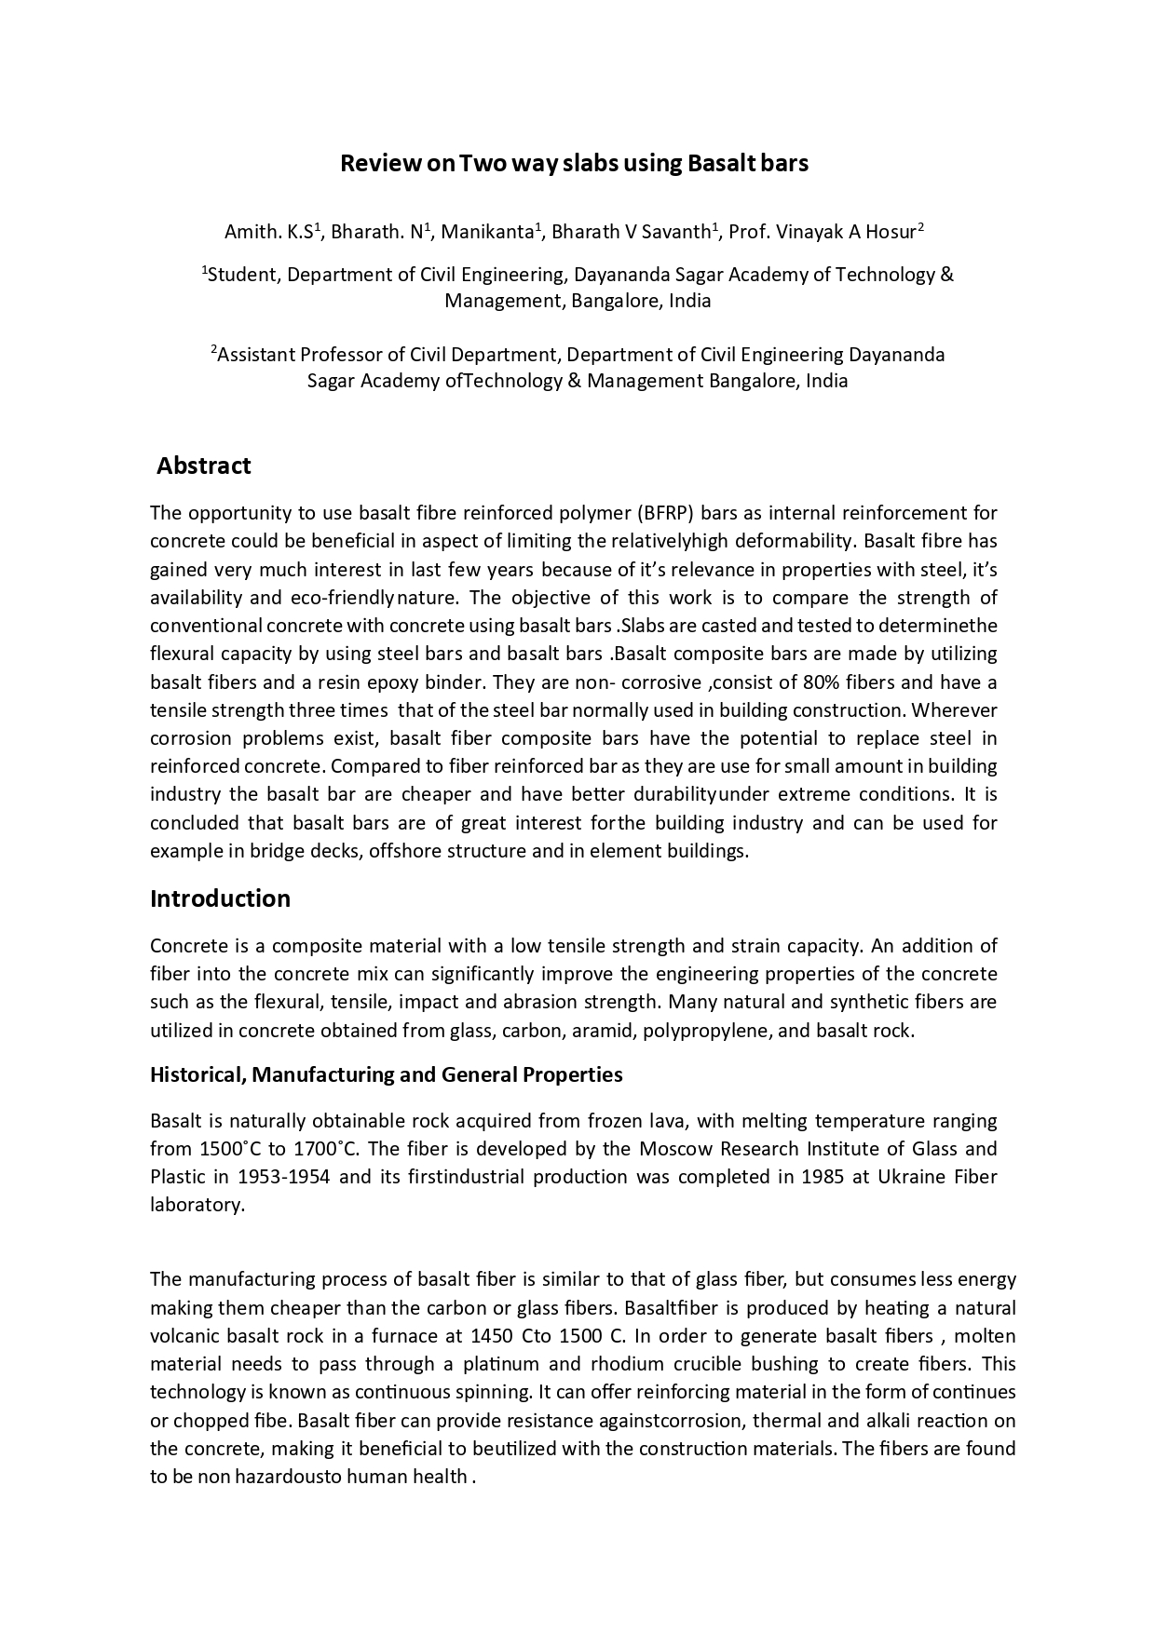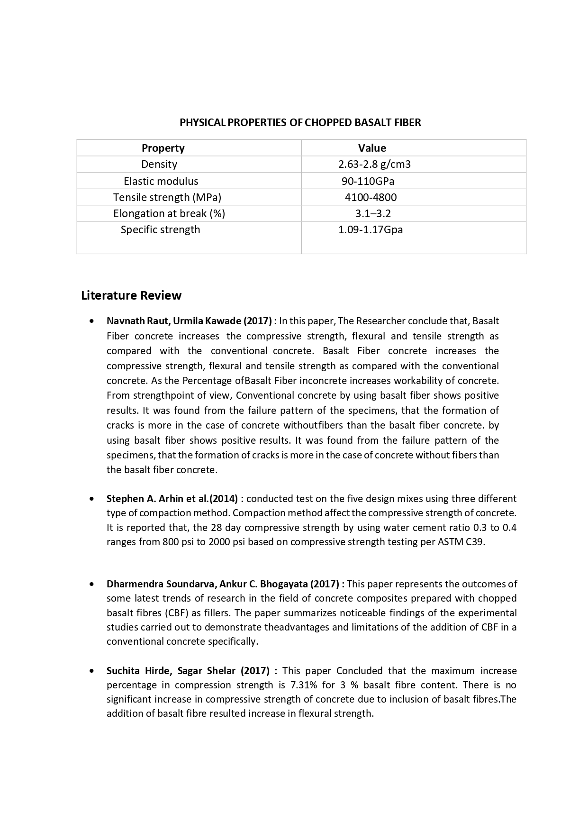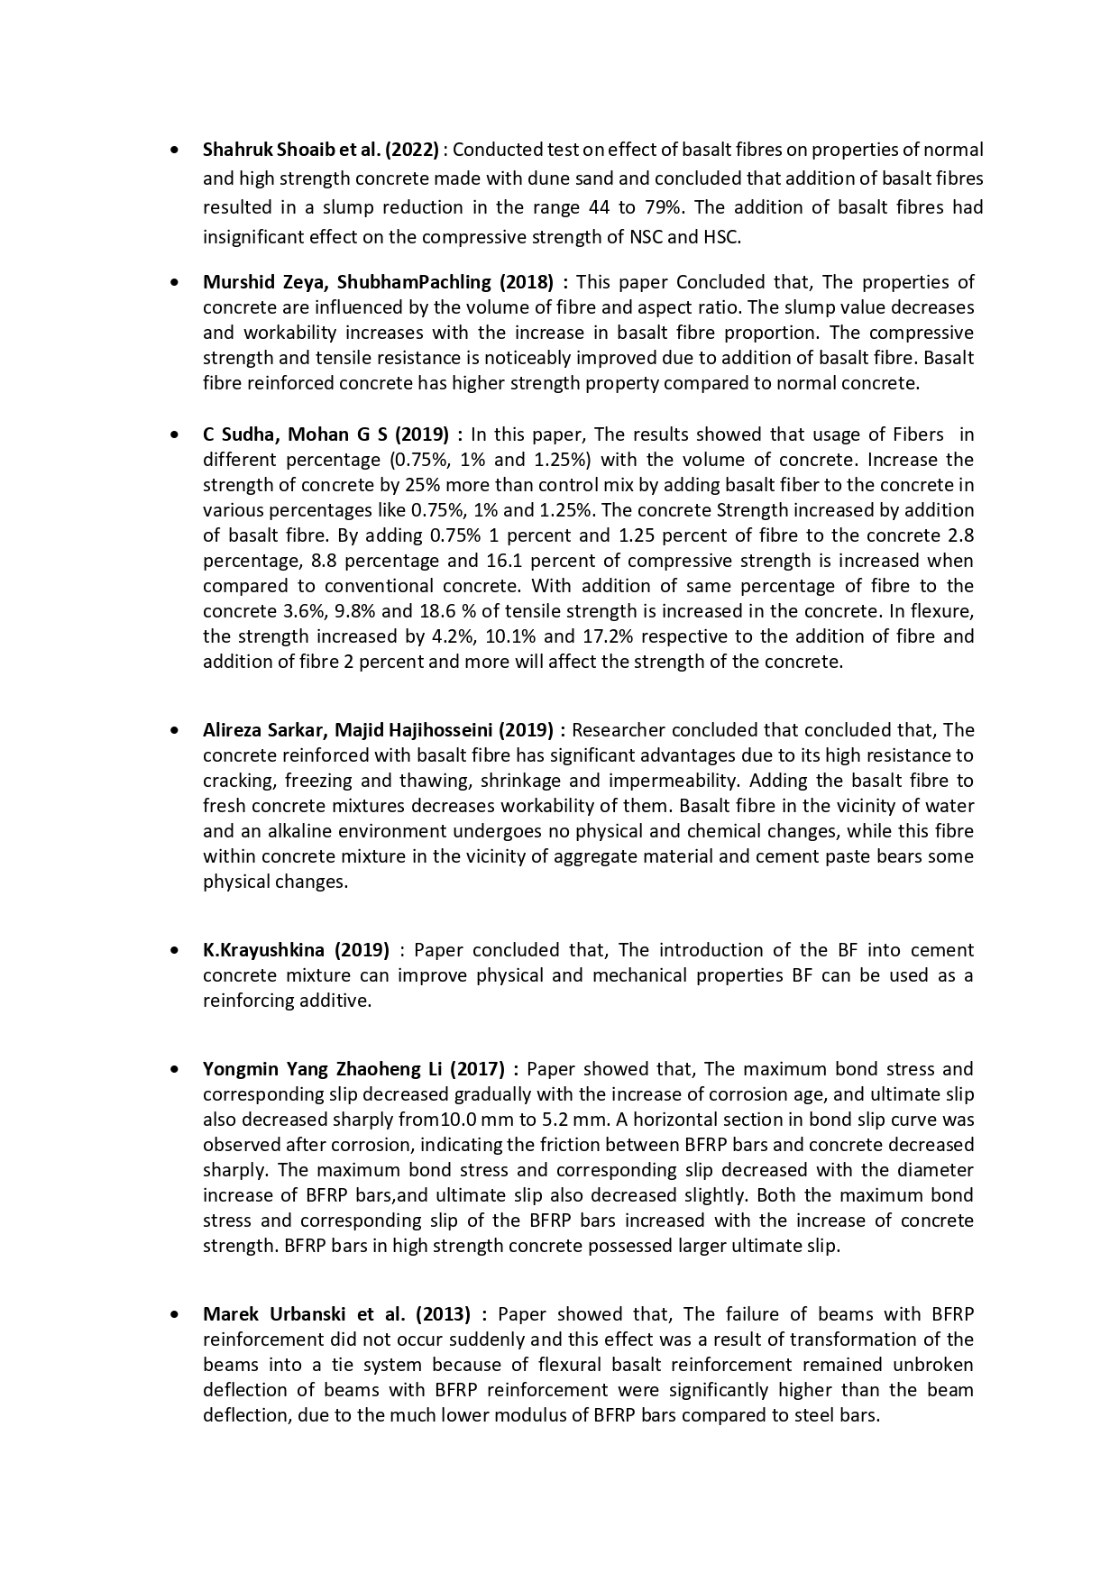

**Gorekethan and Prof. Suhasini M Kulkarni (2018) :** In this study, the researchers came to the following conclusions: the basalt fibre will outperform the design blend after 28 days; it won't burn; it won't expel when it comes into touch with other chemicals; and there won't be any adverse health effects. More of BF is in India. The price is ten times less than the cost of the raw materials for making fibre glass.

**Islam Eltantawi et al. (2019) :** The critical splice length and bond behaviour were examined while the BFRP-RC beams were tested in flexure. the experimental testing's results were expressed Regarding mid-span deflections, strains in concrete and BFRP bars, the ability to support a given load, the mode of failure, the estimation of the critical splice length, and the corresponding bond strength.

**Sanjamesh V biradar (2020) :** In this study, adding basalt fibres to concrete results in a decline in the workability of the concrete as the fibre quality rises. Concrete is best used when the basalt fibre content is less than 0.3% since it has a higher strength.

**N Subramanian (2021) :** In this work, the researchers come to the conclusion that a polymer matrix holds the fibres in place. At temperatures of around 100 degrees, polymers begin to soften. Despite the fact that steel lies just 20 millimetres beneath the surface of concrete, which is a poor heat conductor, the temperature of the rebars may approach the softening point without necessarily causing a catastrophic failure.

**Farid Abed et al. (2021) :** The use of HCSC mix enhanced and BFRP RC beam cracking moment around 10% compared to NSC beam in this study's investigation of the flexural behaviour and serviceability of BFRC beam employing 2 concrete mixes of 47MPa and 79MPa cubic compressive strength.

**Liyan et al. (2021)** : The strong acid and alkaline corrosion resistance of Bf, a novel class of inorganic fibres with a structure comparable to Gf's, has garnered a lot of attention in recent years. There was a crucial value in terms of volume conducted by short Bf in SBFRP, according to the tests done on shot Bf reinforced polymer with 3mm long Bf throwing the v-grooving orbital sharing the method.

**Jiri Militky Hafsa Jamshed (2018) :** Basalt fibres offer strong thermal resistance and low moisture absorption, with moisture absorption of BF being less than 0.02%, according to the researcher's conclusion in this publication.

**OBJECTIVE :**

* Determine the flexural capacity of slabs by using steel bars and basalt bars.
* Comparative analysis of slabs on Flexure, Deflection and crack propagation aspects.

