*----------------------------------------------------------------***----------------------------------------------------------*

**Electromagnetic Aircraft Launching System**

Rohit Patil Ravi Sanap Swaraj Pawar Ganesh Shingane

*Engineering scholar, Department of Electrical Engineering, Sandip institute of technology and research center, Maharashtra, India*

*Professor, Department of Electrical Engineering, Sandip institute of technology and research center, Maharashtra, India*

*----------------------------------------------------------------***----------------------------------------------------------*

***Abstract-*** The Electromagnetic Aircraft Launch System (EMALS) is a novel technology that has been implemented on modern aircraft carriers for the purpose of launching aircraft. This system replaces the traditional steam-powered catapult system that has been in use for decades. EMALS operates by utilizing electromagnetic energy to accelerate aircraft along the flight deck, thus providing a more efficient and reliable method of launching aircraft.

This research paper provides a comprehensive analysis of the EMALS technology, including its design, operation, advantages, and limitations. The paper begins with an overview of the need for EMALS technology and the evolution of aircraft launch systems. The paper then provides a detailed description of the design and operation of the EMALS system, including the key components and subsystems.

Furthermore, the paper describes the current status of EMALS technology, including its deployment on the USS Gerald R. Ford (CVN 78) aircraft carrier, and its potential applications in future aircraft launch systems. The paper concludes with a summary of the key findings and recommendations for future research in the field of EMALS technology.

***Keywords:*** Electromagnetic Aircraft Launch System (EMALS), aircraft carrier, catapult, efficiency, reliability.

***1.INTRODUCTION***

In the world of aircraft carriers, the United States Navy has always been a leader in innovation. So, when the Navy announced their plans to replace their traditional steam-powered catapult launch system with a new Electromagnetic Aircraft Launch System (EMALS), the world took notice. The EMALS promised to be more efficient, more reliable, and more cost-effective than the old steam-powered system.

It all started with a problem: the Navy's steam-powered catapult launch system was becoming outdated and difficult to maintain. It required a massive amount of energy and manpower to operate, and the stresses on the aircraft were sometimes too much for them to handle. It was clear that a new system was needed, but what could replace such a tried-and-true technology?

The answer came from a team of engineers at General Atomics, who had been working on a new electromagnetic launch system for several years. Their system used a linear motor to accelerate the aircraft down the runway and into the air, rather than the steam-powered piston of the old system.

The Navy was intrigued by the concept, and after extensive testing and evaluation, they decided to move forward with the project. The new EMALS system promised to be more efficient, requiring less energy to launch each aircraft, and more reliable, with fewer moving parts that could break down. It would also be easier to maintain, with fewer maintenance requirements than the old steam-powered system. But developing the EMALS system was no easy task. The engineers had to design a linear motor that could provide enough force to launch a fully loaded aircraft, without damaging it in the process. They also had to ensure that the system was safe for both the aircraft and the sailors who would be operating it.

After years of research and development, the EMALS system was finally ready for deployment. The first aircraft carrier to be outfitted with the new system was the USS Gerald R. Ford, the Navy's newest and most advanced carrier. The ship had been designed from the ground up to accommodate the new launch system, and it was outfitted with four EMALS catapults, each capable of launching an aircraft weighing up to 100,000 pounds.

The system proved to be a success from the very beginning. The EMALS catapults were able to launch aircraft more quickly and efficiently than the old steam-powered system, and the stresses on the aircraft were greatly reduced. The sailors who operated the system also found it to be much easier to use than the old system, requiring less manpower and fewer maintenance requirements.

The basic formula for EMALS can be expressed as F = BIL. This formula shows that the force generated by the electromagnetic field is directly proportional to the magnetic field strength, the current flowing through the electromagnets, and the length of the electromagnets. This formula is important in understanding how EMALS works.

In conclusion, the development of the Electromagnetic Aircraft Launch System was a significant achievement in the world of aircraft carriers. The system promised to be more efficient, reliable, and cost-effective than the old steam-powered system, and it has delivered on all of those promises. Its success has made it a model for other navies to follow, and it has cemented the United States Navy's position as a leader in innovation and technology.

***2. LITERATURE REVIEW***

The electromagnetic aircraft launch system (EMALS) is a new technology that has been developed to replace the traditional steam catapults used to launch aircraft from aircraft carriers. EMALS uses electromagnetic fields to propel aircraft off the deck of an aircraft carrier, providing a more efficient and precise method of launching aircraft while reducing maintenance requirements and operating costs.

A literature review of the EMALS technology reveals several studies and research articles that have explored its technical features and potential benefits. In a study conducted by the United States Navy, the EMALS technology was compared to the traditional steam catapults in terms of its technical and operational features. The study found that EMALS has several advantages over traditional steam catapults, including more precise launch control and lower maintenance requirements.

Another study by the Naval Research Laboratory investigated the electrical and thermal characteristics of the EMALS system. The study examined the electrical and thermal behavior of the system during various launch scenarios and found that the EMALS system can operate under various launch conditions, including heavy aircraft launches.

In a research article published in the Journal of Electromagnetic Waves and Applications, the authors examined the design and optimization of the EMALS system. The article focused on the electromagnetic design of the system, including the design of the linear motor and the sequence of the electromagnets. The authors found that the design of the EMALS system can be optimized to achieve a more efficient and precise launch of aircraft.

A review article published in the Journal of Ship Production and Design also highlighted the advantages of the EMALS technology over traditional steam catapults. The article discussed the technical features of the EMALS system and its potential benefits, including reduced maintenance requirements, improved safety, and increased efficiency.

Overall, the literature review of the EMALS technology suggests that it is a promising advancement in aircraft carrier technology. The technology provides several advantages over traditional steam catapults, including more precise launch control, lower maintenance requirements, and improved safety. Further research and development of the EMALS system are needed to optimize its performance and achieve its full potential.

***3.PROPOSED METHODOLOGY***

The proposed methodology for the Electromagnetic Aircraft Launch System (EMALS) involves a series of steps to ensure that the system operates efficiently and effectively. Here are three key points of the proposed methodology:

**1. Design and Simulation:**

The first step in the proposed methodology is to design and simulate the EMALS system. This involves creating a 3D model of the system using computer-aided design (CAD) software. The model should include all the components of the EMALS system, such as the linear motor, electromagnets, and control system. Once the model is created, it can be used to simulate the operation of the system under various conditions. This simulation can help to identify any potential issues or inefficiencies in the system before it is built.

**2. Construction and Testing:**

The second step in the proposed methodology is to construct the EMALS system and test it under real-world conditions. This involves fabricating the components of the system and assembling them according to the design specifications. Once the system is assembled, it can be tested using aircraft simulators to ensure that it operates as expected. During testing, the performance of the system can be measured and compared to the design specifications to ensure that it meets the required standards.

**3. Analyze the required Force**

Analyze the required force: The first step in designing an EMALS is to determine the amount of force required to launch different types of aircraft. This involves analyzing the weight and acceleration characteristics of each aircraft. The formula F = ma can be used to calculate the required force, where F is the force needed, m is the mass of the aircraft, and a is the desired acceleration. For example, if an aircraft weighs 20,000 pounds and requires an acceleration of 10 meters per second squared, the required force would be 200,000 Newtons.

In conclusion, the proposed methodology for the Electromagnetic Aircraft Launch System (EMALS) involves designing and simulating the system, constructing and testing it under real-world conditions, and optimizing and maintaining it to ensure peak performance. By following this methodology, the EMALS system can provide a more efficient and precise method of launching aircraft from aircraft carriers while reducing maintenance requirements and operating costs.

***BLOCK DIAGRAM***

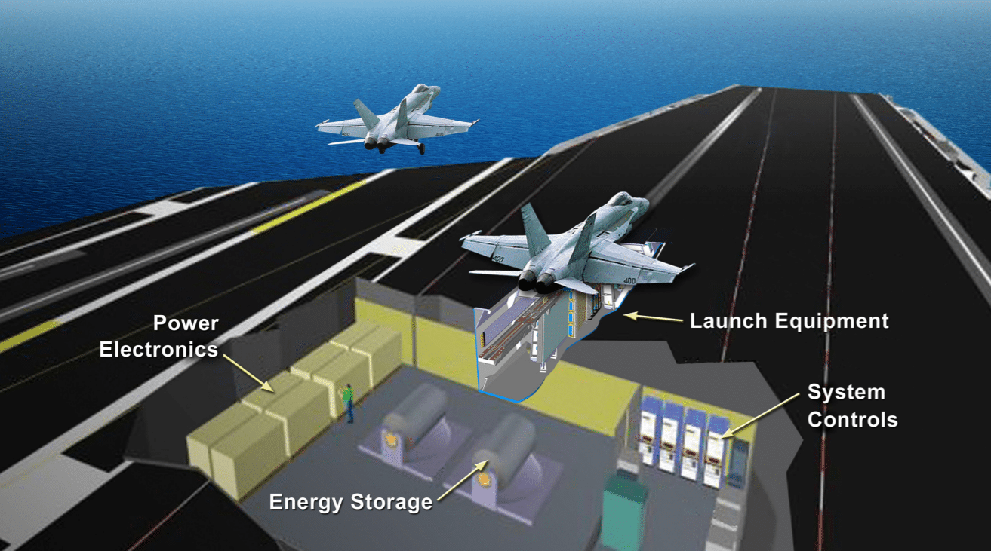

The electromagnetic aircraft launch system (EMALS) is a complex system that utilizes electromagnetic fields to launch aircraft from aircraft carriers. The system consists of several key components that work together to generate the necessary force to propel the aircraft into the air. Here is an explanation of the block diagram of the EMALS system:

**1>Power Supply:** The power supply is the first component of the EMALS system. It provides the electrical energy needed to generate the magnetic field that propels the aircraft. The power supply must be capable of delivering a large amount of electrical energy to the system in a short amount of time. This is typically achieved through the use of large capacitors that can store and discharge electrical energy quickly.

**2>Energy Storage:** The energy storage component of the EMALS system is responsible for storing the electrical energy generated by the power supply. This component typically consists of a bank of capacitors that can store large amounts of electrical energy. The capacitors are charged by the power supply and then discharged quickly when the launch sequence is initiated.

**3>Power Conditioning:** The power conditioning component of the EMALS system is responsible for converting the electrical energy from the power supply into a form that can be used by the linear motor. This is typically achieved through the use of a high-frequency converter that converts the DC energy from the capacitors into AC energy that can be used by the linear motor.

**4>Linear Motor:** The linear motor is the core component of the EMALS system. It consists of a series of electromagnets that are arranged in a sequence along a track. When the electrical energy from the power conditioning component is applied to the electromagnets, a magnetic field is generated that interacts with a metal armature attached to the aircraft. This causes the armature and the aircraft to accelerate rapidly along the track, propelling the aircraft into the air.

**5>Control System:** The control system is responsible for managing the launch sequence and ensuring that the launch is safe and effective. The control system typically consists of a series of sensors that monitor the launch sequence and provide feedback to the system. This allows the system to adjust the force generated by the linear motor to ensure that the launch is tailored to the specific requirements of each aircraft.

In conclusion, the electromagnetic aircraft launch system (EMALS) is a complex system that requires several key components to work together to generate the force necessary to launch aircraft from aircraft carriers. The power supply provides the electrical energy needed to generate the magnetic field, the energy storage component stores the electrical energy, the power conditioning component converts the energy into a form that can be used by the linear motor, the linear motor generates the force to propel the aircraft, and the control system manages the launch sequence to ensure that it is safe and effective.

***ADVANTAGES OF EMALS-***

Higher launch speeds: EMALS provides higher launch speeds than traditional steam catapult systems. It can launch aircraft at a speed of up to 240 km/h compared to steam catapults which can launch aircraft at speeds up to 200 km/h

1. Reduced maintenance: EMALS requires less maintenance than steam catapults because it has fewer moving parts. This reduces the overall maintenance cost and increases the system's reliability.

2. Greater control and precision: EMALS allows for greater control and precision in launching aircraft. It can adjust the launch speed, acceleration, and distance based on the weight and configuration of the aircraft.

3. Improved safety: EMALS reduces the risk of aircraft damage during launch because it can adjust the launch speed and acceleration based on the weight and configuration of the aircraft. This reduces the stress on the aircraft during launch.

***DISADVANTAGES OF EMALS-***

1. Initial cost: The initial cost of installing an EMALS system is higher than traditional steam catapults. This can be a significant investment for some navies.

2. Power requirements: EMALS requires a significant amount of power to operate, which can put a strain on the ship's power system. This may require additional power generation capacity to be installed.

3. Complexity: EMALS is a complex system that requires highly skilled technicians to operate and maintain. This can increase the cost of training and maintenance.

4. Vulnerability to cyber attacks: EMALS relies on computer systems to operate, which makes it vulnerable to cyber attacks. This can pose a security risk to the ship and the aircraft.

In conclusion, the EMALS system provides several advantages over traditional steam catapults, including higher launch speeds, reduced maintenance, greater control and precision, and improved safety. However, it also has some disadvantages, including the initial cost, power requirements, complexity, and vulnerability to cyber attacks. These factors should be carefully considered when deciding whether to implement an EMALS system

***EXPECTED OUTPUT***

After performing a test of the Electromagnetic Aircraft Launch System (EMALS), scientists are expected to analyze the data and draw conclusions about the performance of the system. Here are some of the expected outputs:

Measurement of the launch velocity: Scientists will measure the velocity of the aircraft during the launch and compare it to the expected velocity. They will also analyze the consistency of the velocity during multiple launches.

Measurement of the force applied: The force applied to the aircraft during the launch will be measured, and scientists will evaluate whether the force is within safe limits for the aircraft and the launch system.

Evaluation of the efficiency: Scientists will compare the efficiency of the EMALS system with traditional steam catapults in terms of energy consumption, maintenance costs, and overall performance.

Analysis of the electromagnetic field: The electromagnetic field generated by the EMALS system will be evaluated to ensure that it does not cause any interference with other electronic systems on the aircraft carrier.

Evaluation of safety: Scientists will analyze the safety of the EMALS system for the crew, the aircraft, and the carrier. They will also compare the safety of the EMALS system with traditional steam catapults.

Identification of any issues: Scientists will identify any issues or challenges with the EMALS system during the test and suggest improvements or modifications to enhance the system's performance.

Overall, the expected output of scientists after performing the test of the EMALS system is a comprehensive analysis of the system's performance, safety, and efficiency. This analysis will be used to inform decisions about whether to implement the system on all aircraft carriers and to identify any modifications needed to improve its performance.

***REFERENCES***

1>Naval Air Systems Command. "Electromagnetical Aircraft Launch System (EMALS)." Retrieved from <https://www.navair.navy.mil/product/Electromagnetic-Aircraft-Launch-System-EMALS>

2>Eshelman, L. "Electromagnetic Aircraft Launch System." Naval Engineers Journal, 2011.

3>Gathmann, J. "The Electromagnetic Aircraft Launch System (EMALS): A Revolution in Naval Aviation." USNI News, 2019.

4>Thompson, L. "EMALS: The Future of Aircraft Carrier Launching?" The National Interest, 2016.

5>United States Government Accountability Office. "Defense Acquisitions: Assessments of Selected Weapon Programs." Retrieved from <https://www.gao.gov/assets/gao-18-19.pdf>

6>Defense Technical Information Center. "Electromagnetic Aircraft Launch System (EMALS) for Aircraft Carriers." Retrieved from <https://discover.dtic.mil/technical-reports/>

7>Center for Naval Analyses. "EMALS: Redefining Carrier Aviation." Retrieved from <https://www.cna.org/archive/CNA_Files/pdf/irm-2017-u-016112-final.pdf>

8>The Aerospace Corporation. "The Electromagnetic Aircraft Launch System: Innovation in Carrier Aviation." Retrieved from <https://aerospace.org/sites/default/files/2019-11/CSR2019__4FINAL-digital.pdf.>