**Web-Based AR Location Identifier**

**Adharsh S*, Aswin K*, Siva shankari L*, Srinidhi Balaji\*\***

* Computer Science and Engineering, Agni College of Technology

**Assistant Professor, Computer Science and Engineering Department, Agni College of Technology

**Abstract:**

This study describes a web-based augmented reality (AR) detector that allows users to use their cell phones to identify and find locations of interest. This technology determines the user’s location and overlays relevant information on the user’s screen using a combination of GPS data and image recognition algorithms. The AR interface offers a straightforward and pleasurable way to interact with the world, making it perfect for use in public spaces such as parks, tourist attractions, and historic sites. The system will be simple to use and can be quickly integrated into existing websites or mobile applications, regardless of technical expertise. According to the poll results, the method is useful in terms of improving the user’s ability to navigate and identify local points of interest.

**Key words:** GPS, Augmented Reality, and AR location.

**I. INTRODUCTION**

By the use of digital information and virtual items that are superimposed over actual physical objects in real-time, Augmented Reality (AR) technology improves the user's perspective of the outside world. It is an immersive technology that fuses the real and virtual worlds together to produce fresh mixed-reality experiences. Several industries, including games, education, entertainment, marketing, healthcare, architecture, and manufacturing, can benefit from augmented reality. AR can be applied to games to produce engaging ones that blend the physical and digital worlds. AR can be utilized in education to deliver an immersive, interactive learning experience that simplifies difficult ideas. In marketing, augmented reality (AR) can be utilized to produce compelling product presentations and immersive advertisements. In the field of healthcare, augmented reality (AR) can be utilized to give medical staff real-time information and imagery during surgery and other treatments. To aid architects and builders in making better design decisions, augmented reality (AR) can be utilized to produce virtual building models and visualizations. AR can be utilized in manufacturing to give employees real-time information and instructions to increase efficiency and decrease errors. There are several uses for AR across numerous fields and spheres. These are a few instances:

AR may be used to make engaging games that blend the physical and digital worlds. One well-known example of an AR game is Pokémon Go.

Education: AR can be utilized to deliver interactive and interesting learning experiences that simplify difficult ideas. As an illustration, 3D models of scientific ideas, like the human body, can be made using AR software and then made interactive for students.

Healthcare: During surgery and other operations, augmented reality (AR) can be utilized to show real-time data and visualization to medical practitioners. An augmented reality headset, for instance, can place patient data and medical images over the surgeon's perspective of the patient.

Web AR, short for augmented reality, is a way to provide an AR web experience directly through a web browser through a URL, QR code, or NFC tag. Unlike app-based AR, it requires viewers to download and install an app before they can experience AR. Web-based AR is mainly designed for smartphones but can be used on desktops or other mobile devices such as laptops and tablets.

Web AR simplifies the process of delivering augmented reality experiences to consumers. By removing the hassle of downloading AR software, web-based AR makes it easier for consumers to enjoy an augmented reality experience that allows them to use this powerful technology for 3D advertising and marketing. You can provide a more engaging user experience that provides more realistic product previews, gives shoppers options to purchase items, and gives them options to return items.

To facilitate AR technology, developers have created several AR frameworks. Some popular frameworks are:

ARKit is provided by Apple for development in the iOS environment. ARCore is provided by Google for Android development. Vuforia is a development platform that supports iOS and Android and other options. js is an open-source framework that uses JavaScript. VNTANA integrates web-based 3D and AR with a cloud-based CMS to support the creation of digital showrooms, and the 3D web viewer can be embedded on the web platform using iFrame or API.

How does Web AR work?

To provide augmented reality without the need for an application, web AR must provide an AR experience directly through a desktop or mobile browser. This is achieved by combining several key technologies:

The 3D model simulates motion along a plane moving up, down, left, and forward from the viewer's perspective (called six degrees of freedom or 6DoF tracking). Camera Stream allows you to place a 3D model in the background directly from the user's camera on a smartphone or other device. Scene understanding is a technology that uses AI to analyse data from the user's camera feed and integrate features such as spatial relationships and lighting into 3D objects with a living environment. A cloud-based content management system (cloud-based CMS) allows companies to tag and manage 3D content for delivery in the cloud through URL links, QR codes, and NFC tags.

# RELATED WORK

In this Section, we looked at a few studies that demonstrate how deep learning is linked to the Strokes Analysis system.

1. "Web-based Augmented Reality Location-based Services for Mobile Learning" by Feng, Han, and Wang (2015). This paper proposes a web-based AR location-based service for mobile learning, which uses location-based data to provide users with interactive and contextualized learning experiences.

1. "Web-based Augmented Reality Location-based Services for Mobile Learning" by Feng, Han, and Wang (2015). This paper proposes a web-based AR location-based service for mobile learning, which uses location-based data to provide users with interactive and contextualized learning experiences.
2. "Web-Based Mobile Augmented Reality Application for Indoor Navigation" by Khatoon and team (2019). This paper describes a web-based AR application for indoor navigation, which uses computer vision techniques to recognize and track indoor landmarks.
3. "Web-based Augmented Reality for Navigation Assistance" by Wang, Yu, and Zhang (2018). This paper presents a web-based AR navigation system that provides users with real-time navigation assistance using computer vision and GPS technologies.
4. "Development of web-based AR application for cultural heritage tourism" by Zhang and team (2019). This paper describes the development of a web-based AR application for cultural heritage tourism, which allows users to explore and learn about historical sites using AR technology.

1. “Location-based augmented reality for mobile learning” by Sarwar and team. The author has created a smartphone application that instructional content to pupils based on their precise location-based augmented reality and location monitoring. Positive benefits from program usability testing are seen in user engagement and learning outcomes.
2. “Development of AR application for information provision of cultural heritage sites” by Park and team. The author has developed an augmented reality (AR) mobile application that uses geolocation to provide users with information and multimedia content about monuments around cultural heritage sites. Users have reported increased interest in cultural sites, with positive feedback for this application.

# PROPOSED SYSTEM

The proposed system ensures that a user can use Augmented Reality based location identifier on the web browser without installing any kind of application using WebGL API. WebGL is a JavaScript API that allows any compatible web browser to generate dynamic 2D and 3D visuals without the necessity of plug-ins. WebGL is fully integrated with other web standards, allowing GPU-accelerated physics, image processing, and effects to be used as part of the web page canvas.

In this model, we will be using Augmented Reality frameworks such as the A-Frame look-At component, A-Frame, and AR.js to make the system work seamlessly. The system works based on the format user interface, web server, location data, AR engine, device sensors, and AR digital content.

Fig1: FLOW DIAGRAM OF THE PROPOSED SYSTEM

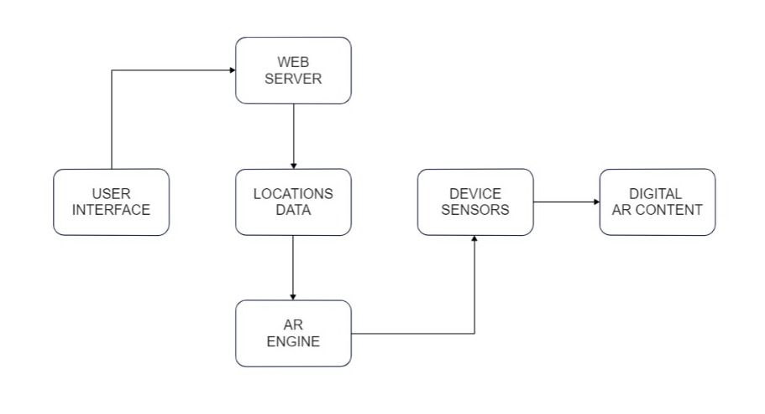

# MODULES

Modules include:

1. User Interface
2. Web server
3. Location data
4. AR engine
5. Device sensors
6. Output

* 1. USER INTERFACE MODULE

In this first user interface module, the user will be creating a perfect interactive webpage using HTML, CSS, and JavaScript. HTML is used to simply create the webpage whereas CSS and JavaScript are used to give a fashioned user interface and to give a seamless user interactive experience.

* 1. WEB SERVER MODULE

This module is completely based on importing and using the Augmented Reality frameworks which are completely written in JavaScript. Importing these modules will be an easy task but the user must have prior knowledge about the framework in order to use it in a way smooth. The frameworks that the user will import should support WebGL in order for the model to run on a web browser without installing any applications. The frameworks that the user will be importing are the A-Frame look-at component, A-Frame, and Ar.js.

Fig2: IMPORTING AR FRAMEWORKS SCRIPTS

<script src="https://aframe.io/releases/1.0.4/aframe.min.js"></script>

    <script src="https://unpkg.com/aframe-look-at-component@0.8.0/dist/aframe-look-at-component.min.js"></script>

    <script src="https://raw.githack.com/AR-js-org/AR.js/master/aframe/build/aframe-ar-nft.js"></script>

* 1. LOCATION DATA MODULE

The location data module will be focusing on the GPS entities that should be entered precisely in order for the web-based application to detect the location whose coordinates are predefined in the program. The location’s data should be maintained in a format of longitude and latitude.

Fig3: GPS COORDINATES DATA

gps-entity-place="latitude: 12.839372; longitude:  80.205362;"

* 1. AR ENGINE MODULE

AR engine module focuses on Augmented Reality workflow to be smooth with all its AR framework scripts. It also is the main module in which the main data such as the location name and other images of the 3D model are loaded and saved in order to display the location’s name or the 3D model that should be displayed on the screen when the user is in the exact location in which the coordinates and predefined in the program.

Fig4: AR engine’s predefined data

<a-text

        value="ASWIN's HOME"

        scale="120 120 120"

* 1. DEVICE SENSOR MODULE

The device sensor module is completely based on authorizing and giving access to the camera from the device that the user will be using this web-based application. This module is important module since this is the module that works on authorizing the camera access so that the Augmented Reality can work seamlessly.

Fig5: CAMERA AUTHORIZATION

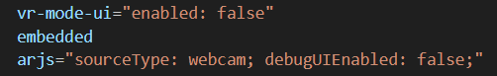 

* 1. OUTPUT MODULE

The final output module is what combines all other module and make a perfect model to work seamlessly. It will combine all AR engine workflow, webservers, and device sensors to run this web-based application in a way smoother.

# RESULT AND FUTURE WORKS

A web-based AR location identifier uses the camera and sensors of a mobile device to determine the user's location and orientation in the real world. It then overlays digital information onto the camera view, giving the user an augmented reality experience. The quality of the camera and sensors in the mobile device, the availability of the GPS signal, and the reliability of the internet connection are some of the variables that affect how accurate an AR locator is on the web. A solid web-based AR locator should usually be able to locate users from several meters away. Locating local points of interest, navigating both indoor and outdoor surroundings, and improving marketing and advertising efforts are just a few uses for web-based AR location identifiers.

**VII. REFERENCES**

1. "Augmented Reality: Principles and Practice" by Dieter Schmalstieg and Tobias Hollerer (Vol. 1, Chapter 6: "Markerless Tracking for AR Systems")
2. "Programming Augmented Reality for Android" by Dr. Javaid Perwaiz (Chapter 7: "Location-based Augmented Reality")

1. "WebGL Programming Guide: Interactive 3D Graphics Programming with WebGL" by Kouichi Matsuda and Rodger Lea (Chapter 13: "Creating Augmented Reality Applications with WebGL")
2. "ARKit by Tutorials: Creating Augmented Reality Apps in Swift 4" by Raywenderlich.com Team (Chapter 10: "Location-based AR with ARKit")
3. "ARCore by Example: A Project-based Guide to Augmented Reality using Google's ARCore 1.5" by Jorge Palacios (Chapter 8: "Creating a Location-based AR Game with ARCore")
4. "Web-based Augmented Reality: A Survey and Analysis" by Mika Luimula, Timo Koskela, and Janne Haverinen. This survey covers various aspects of web-based AR, including location-based AR, and provides an overview of current technologies and challenges. (DOI: 10.1145/3282894)
5. "A Survey of Mobile Augmented Reality Applications: Challenges and Future Research Directions" by Xinxin Liu, Hao Wang, and Wei Cai. This survey covers various aspects of mobile AR, including location-based AR, and discusses the challenges and opportunities in developing AR applications for mobile devices. (DOI: 10.1109/ACCESS.2019.2934437)

1. "Augmented Reality Technologies, Systems and Applications: A Survey" by M. Saranya and S. Suresh. This survey provides an overview of AR technologies, including location-based AR, and discusses the various applications and challenges. (DOI: 10.4018/978-1-7998-3312-2.ch002)

.

1. "Survey of Markerless Tracking Techniques for Augmented Reality Applications" by Miguel Angel Otaduy, Fernando Pérez, and David García. This survey covers various markerless tracking techniques, including location-based tracking, that are used in AR applications. (DOI: 10.1145/344779.344827)

1. "Web-Based Augmented Reality for Contextual Information Delivery: A Systematic Literature Review" by Rui José, Carlos Santos, and Luís Carriço. This paper presents a systematic literature review of web-based AR for contextual information delivery, including location-based AR. (DOI: 10.3390/s17040907)
2. "Web-Based Mobile Augmented Reality: A Systematic Review" by Isabella Seeber, Arjan Kuijper, and Philipp Wacker. This paper provides a systematic review of web-based mobile AR, including location-based AR, and discusses the various technologies and challenges. (DOI: 10.1109/ACCESS.2019.2934466)

1. "Web-Based Augmented Reality for Maintenance and Repair: A Review" by Wenbin Jiang, Quan Wang, and Guowei Hua. This paper reviews the use of web-based AR for maintenance and repair, including location-based AR, and discusses the challenges and opportunities. (DOI: 10.3390/app10010347)

1. "Web-Based Augmented Reality: A Review and Prospects for Future Research" by Yuanzhao Zhang, Junyan Wang, and Chun-Hsiang Chuang. This paper provides a review of web-based AR, including location-based AR, and discusses the various applications and challenges. (DOI: 10.1145/3407234)
2. "Augmented Reality: Principles and Practice" by Dieter Schmalstieg and Tobias Hollerer This book covers the basics of augmented reality and discusses various techniques for creating AR applications. Chapter 6 specifically focuses on AR tracking and localization.

1. "Pro HTML5 with CSS, JavaScript, and Multimedia: Complete Website Development and Best Practices" by Mark J. Collins This book covers HTML5, CSS, and JavaScript and discusses how to create web-based AR applications using these technologies. Chapter 14 specifically covers augmented reality.