**CHEMICAL LAB SAFETY AND SECURITY USING IOT**

**Manisha A. Tipare1, Anushka R. Sonawane2, Vaishnavi R. Sonawane3**

1,2,3Student, Department of Electronics and Telecommunication Engineering, NDMVP College of Engineering, Nashik, Maharashtra, India

**ABSTRACT**

Internet of Things (IOT) conceptualizes the idea of remotely connecting and monitoring real world objects (things) through the Internet This concept can be aptly incorporated to make laboratories smarter, safer and automated. This IOT project focuses on building a smart lab safety system which sends alerts to the owner by using Internet in case of any danger and raises an alarm. A safety system needs to be designed to ensure at most safety in the laboratories.

**Keywords:** component; formatting; style; styling; insert (Automation, chemical, hazards, IOT, Safety.

1. **INTRODUCTION**

The internet of things is a communication paradigm that refers to the idea of connecting the objects of everyday life to the internet. Automation not only refers to reducing human efforts but also energy efficiency and time saving. The main objective of project is to control the lab even from remote locations and in case of emergency. The critical parameters are monitored and in case of emergency control action can be taken. The system is secured, user friendly, reliable, flexible and affordable. Laboratory management is a very important element specifically in ensuring safety aspect of academic and research laboratory activities. Most cases in the past event where accidents in laboratory happened are due to the failure of keeping track those faulty and non-functional test and measurement equipment and machine, which are also closely related to the poor inventory and maintenance system. With the wireless technologies such as Wi-Fi, cloud networks in the recent past, wireless system are used every day and everywhere.

1. **METHODOLOGY**

# **Need Of Project**

In laboratory, fire hazard needs emergency response with firefighting equipment. During summer months with high heat index, in case of any major fire, combating fire is a big challenge. Temperature fluctuations may be caused by changes in weather, location or layout, cooling equipment, air circulation and many other factors. In case of any major gas leaks from catastrophic failure of the equipment or pipelines, which may leads to disaster. Electrical short-circuits can also lead to fire. Hazardous gases can evolve from indoor and outdoor sources including gaseous contaminants, particulates, fumes, odour complaints, amongst others.

In the chemical laboratories, several poisonous gases are being used. Chemicals like Carbon, Chlorine, H2S, Phenol, Hydrofluoric acid and many other gases are harmful to humans. If inhaled or come in contact with these for a longer period, eyes irritation, skin irritation and respiratory problems can occur. Poisonous gases should be monitored and indicated to the in charge and if necessary, an audible alarm to be generated.

# **Existing System**

## A. Working of Existing System

[2] A few systems have been proposed to apply IoT technology on laboratories. A Smart Laboratory implementation which is built across IOT and Mobile communication technologies to supervise the overall activities of the laboratory including power consumption and application of devices, sensing environmental parameters, thereby providing a smart environment with balanced energy consumption and comfort. The system monitors the consumption pattern of the devices and uploads it to their server and establishes remote control of appliances from anywhere thereby reducing power wastage. A smart laboratory implementation for management of subsystems of a university, including the biosafety. It highlights the benefits for university and the students using the smart laboratory. [2] A Secure and Smart Laboratory implementation with Wireless Sensor Network (WSN). The system is implemented using flame sensor and MQ135 for safety and security.

## B. Problem Statement

This IoT project focuses on building a smart lab safety system which sends alerts to the owner by using Internet in case of any danger and raises an alarm. A safety system needs to be designed to ensure at most safety in the laboratories.

## C. Block Diagram

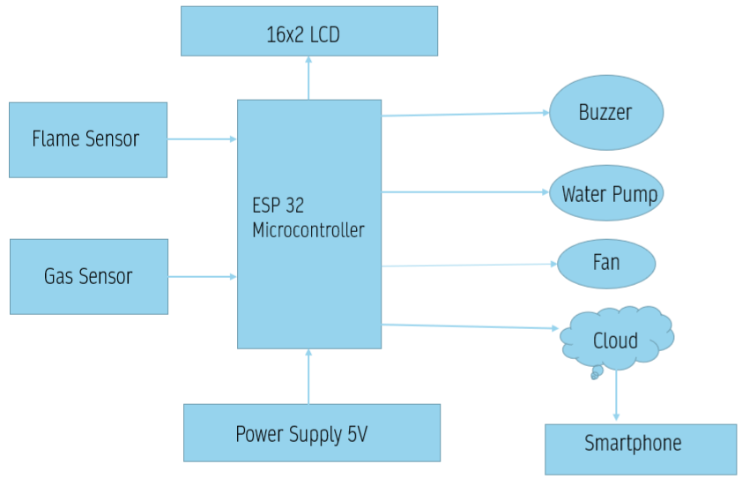

Block description:

ESP 32 is microcontroller used in the system. A 5V regulated power supply is given to this microcontroller, and along with this the components needed for the system such as,

* Flame sensor
* MQ135
* 16X2 LCD Display
* Water pump
* Fan
* Buzzer

## D. Circuit Diagram

## 

Power 5V gives to ESP32, LCD, relay, MQ-135, Flame sensor, Detection gas MQ-135 send digital data to ESP32, Detection of fire using flame sensor send data to ESP32 Send data to LCD, web application using serial data Buzzer on when abnormal emergency condition accrued Water pump and fan on when fire detected or gas detection using relay Pump and fan operated on 12V so we used relay for operation.

## E. FlowChart

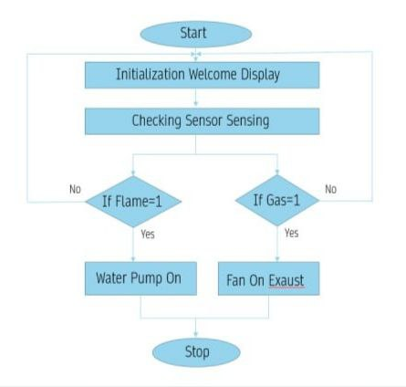

# F. Advantages

1. Less installation costs: The project requires less installation costs since there is no cabling is necessary. Wired solutions require cabling, where material used as well as the skilled for cables (e.g into walls) is expensive.
2. System scalability and easy extension: Deploying a wireless network is especially advantageous when, due to new or changed requirements, addition of the network is necessary. In contrast to wired installations, in which cabling addition is tedious. This makes wireless installations a influential investment.
3. Integration of mobile devices: Easy Integration of devices can be made using the devices like smart phones and PDA’s and as it uses wireless devices there is easy location access. (as long as the device is in reach of the network). Because of these advantages, wireless technology is an smart choice in renovation and refurbishment, but also for new installations.
4. A working model to maintain safety for laboratory is designed.
5. Abnormal parameters are sensed and alerted.
6. Thus, the safety for the labs is provided.
7. Both human safety and material is being provided using our project.
8. Low Operating Costs.
9. Smart sensors are used in monitoring different aspects of our daily life for assorted applications which successively saves time and money.
10. Better environment.

# G . Applications

School, Colleges, Laboratory, Chemical Industry, Electrical Industry Overall, these project applications can help improve chemical lab safety and security by providing real-time monitoring, remote control, and data analytics. They can also reduce the risk of accidents, increase efficiency, and ensure compliance with regulations.

# H. Future Scope

The system extends the home automation technology to the college laboratories, and hence to create a smart laboratory. The smart laboratory reduces the amount of power consumed throughout the day. Thus, the system helps in managing energy efficiently. Also, the automation of the laboratory leads to its improved organization and reduces staff involvement in simple administration tasks. If any issues it will generate message on mobile. This feature can accumulate records from daily, weekly, or monthly. The developed application, Internet-of-Things-based Smart Laboratory Environment Monitoring System, provided monitoring function for the laboratory users to remotely access data of environmental variables to enforce biosafety by devising notifications to pair with real-time assessment in a working facility. The future scope considers the security concerns of the IoT system and tries to implement security and privacy of user’s data using the Blockchain technology on top of IoT system.

1. **RESULTS AND DISCUSSION**

A working model to maintain safety for laboratory is designed. Abnormal parameters are sensed and alerted. Thus, the safety for the labs is provided. Both human safety and material is being provided using our project.

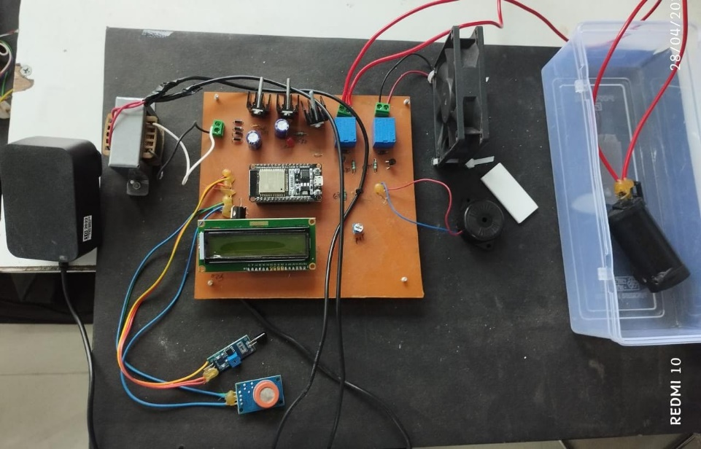

1. **CONCLUSION**

With this kind of application, the biosafety of the laboratory and its user will be prioritized. Because all the data from sensor can be viewed anywhere and can be manipulated anywhere. Whenever a sudden emergency occurred, the smart laboratory monitoring system will provide awareness to the laboratory personnel with the help of thresholds set and the notifications that the system can provide. The application would be beneficial to those employees because all the data coming out from the sensor is stored in a database and can be generated by reports generation.

Safety- Alert can be created thus alerting people in the room to move out, saving human lives.

Security- Only authorized user can access the room. You can be alerted every time there is an abnormality, especially when you are not present. Convenience. By using smart phone one can easily monitor the lab parameters and control everything with just touch of a finger.

Saves Time- With automation in line one can make sure everything is order even from remote locations using mobile app.

Save Money- This low-cost automation project can be applicable to all rooms for safety and by monitoring the necessary parameters damage of electronic components can be minimized and energy can be saved.

1. **REFERENCES**

[1] 1S V Priya, 2S.Vignesh, 3U. Swamyvel Chandar, 4K. Dinesh 1Associate Professor, 2,3,4Students Department of ECE Loyola Institute of Technology. IJSDR2009084 International Journal of Scientific Development and Research (IJSDR) www.ijsdr.org

[2] Amruta N. Banagar Department of Computer Engineering, Fr. C. Rodrigues Institute of Technology, Vashi, India Rajshankar Khattar Department of Computer Engineering, Fr. C. Rodrigues Institute of Technology, Vashi, India International Journal of Engineering Research & Technology (IJERT) http://www.ijert.org ISSN: 2278-0181 IJERTV9IS010178 (This work is licensed under a Creative Commons Attribution 4.0 International License.) Published by: www.ijert.org Vol. 9 Issue 01, January-2020

[3] Ahmed elshafee, Karim Alaa Hamed, ”Design and Implementation of a WIFI Based Home Automation System”, World Academy of Science, Engineering and Technology International Journal of Computer, Electrical, Automation, Control and Information Engineering Vol:6, No:8, 2012.

[4] Shrutika Narhari, Rohini Shinde, rutujagaikwad, Anuja Talathi, A.R.Kamble Department of Computer Engineering,Sinhgad Institute of Technology and Science Pune,Narhe,India International Journal of Scientific Research and Engineering trends Volume 4, Issue 2, Mar- Apr 2018, ISSN (Online): 2395-566X

[5] Lamir Shkurti, Xhevahir Bajrami, Ercan Canhasi, Besim Limani, Samedin Krrabaj and Astrit Hulaj, "Development of Ambient Environmental Monitoring System Through Wireless Sensor Network Using NodeMCU and WSN Monitoring", 6th MEDITERRANEAN CONFERENCE ON EMBEDDED COMPUTING (MECO), JUNE 11-15 2017, BAR, MONTENEGRO.

[6] Vaishnavi S. Gunge and Pratibha S. Yalagi, "Smart Home Automation: A Literature Review", National Seminar on Recent Trends in Data Mining- RTDM 2016.