**REAL-TIME FACE MASK DETECTION USING MOBILENETV2 ALGORITHM**

**Rajesh Kanna R1, Madhumitha R2, Magesh Kumar P3**

1Assistant Professor, CSE, Agni College of Technology, Chennai, Tamil Nadu

2Student, CSE, Agni College of Technology, Chennai, Tamil Nadu

3Student, CSE, Agni College of Technology, Chennai, Tamil Nadu

**ABSTRACT**

The coronavirus illnesses are an unprecedented crisis that has resulted in a large number of deaths and security issues.Covid-19 cases have sharply surged in India over the past few weeks. There are currently up to 6,000 Covid cases nationwide, with a daily positivity rate of 3% and a weekly positivity rate of nearly 4%, according to the Union Health Ministry. Covid-19 has been a major natural disaster that has affected the entire world for more than a year, and the solution is to wear a mask and avoid interacting with other people. We provide a solution to this problem in this paper. The work is carried out by this suggested technique using MobileNetV2 and TensorFlow, two cutting-edge object detection models.

**Keywords:** Detection, TensorFlow, technique, interacting

1. **INTRODUCTION**

The severe acute respiratory syndrome coronavirus (COVID-19) is the cause of the communicable disease coronavirus disease. The virus spreads mostly through the air, where it is carried by droplets from infected individuals' coughs, sneezes, and other respiratory motions. As they appear to be at a higher risk, elderly individuals with lung illness may have serious repercussions from COVID-19 infection. Some of the most common human coronaviruses that infect humans worldwide include 229E, HKU1, OC43, and NL63. Before infecting humans, viruses like 2019-nCoV, SARS-CoV, and MERS-CoV infect animals and transform into human coronaviruses. People who have respiratory problems can spread contagious beads to everyone with whom they come into contact. A contaminated person's surroundings may promote contact transmission because virus-carrying droplets may fall on nearby surfaces. For the prevention of COVID-19 and other respiratory viral infections, it is imperative to wear a clinical mask. Whether to wear the mask for source control or COVID-19 aversion should be made clear to the general public. Masks may reduce a person's susceptibility to noxious individuals during an illness’s “pre-symptomatic” stage and stigmatize those who wear them to prevent viral propagation. The WHO places a high priority on medical masks and respirators for healthcare assistants. In today's global community, detecting face masks has therefore become a major challenge. Face mask detection is identifying the location of a person's face and then assessing whether or not they are wearing a mask. The problem is related to general object detection, which is used to identify different types of objects. Face identification is the process of classifying and distinguishing a specific group of items, namely faces. It has a wide range of uses, including autonomous driving, education, and spying. The core Machine Learning (ML) packages such as TensorFlow, Keras, OpenCV, and Scikit-Learn are used in this dissertation to propose a simplified approach to serve the aforesaid objective.

1. **RELATED WORK**

The challenges that a computer vision (CV) approach must cope with include pattern learning and object recognition. Image segmentation and object detection are both included in object recognition. Using surveillance equipment and an effective object recognition algorithm, the task of detecting the mask over the face in the pubic region can be accomplished. The object recognition process begins with region predictions, which are ultimately divided into classes.

**2.1 Detectors with two stages**

The two-stage method uses a heuristic algorithm like CNN to produce a large number of region recommendations for each image, then classifies and regresses these candidate regions. R-CNN, the first deep learning-based object identification system, is a two-stage detector. To build a sparse collection of candidate regions, R-CNN initially uses selective search. Then, using CNN, it extracts the region's characteristics, and ultimately, using SVM, it determines the class of each object and fine-tunes the bounding boxes using linear regression. Fast R-CNN, Faster R-CNN, SPPNet, Feature Pyramid Network (FPN), Cascade R-CNN, and other popular models include Fast R-CNN, Faster R-CNN, SPPNet, Feature Pyramid Network (FPN), Cascade R-CNN, and so on. Although two-stage detectors have outstanding detection performance, their training processes are complex, and testing rates are often slow, making them impractical for real-time applications.

**2.2 Detectors with only one stage**

R. Joseph et al. proposed You Only Look Once (YOLO) in 2015, which broke the dominance of two-stage detectors in object detection. YOLO, unlike two-stage approaches, classifies and predicts the target at every position on the entire original image. The network divides the image into grids and predicts the bounding boxes and likelihood of each region in real-time. When compared to two-stage detectors, YOLO offers a much faster detection speed at the expense of location precision. Since then, R. Joseph et al. have presented YOLOv2 and YOLOv3, which are incremental enhancements. To increase YOLO's accuracy and speed, the anchor mechanism, a more robust backbone network, multiscale training, and other features were added. SSD, RetinaNet, EfficientDet, and RefineDet, in addition to the YOLO series, are exemplary models of one-stage object detection. T.-y. Lin et al. proposed RetinaNet as one of them in 2017. They discovered that the low accuracy of one-stage detectors was due to an extreme foreground-background class imbalance during the training phase of dense detectors. Focal loss was presented as a solution to this problem. The detector paid more attention to the samples that were harder to identify in the training phase thanks to the reconstruction of the standard cross-entropy loss, allowing the one-stage detector to attain comparable accuracy to two-stage detectors while maintaining a high detection speed.

**2.3 Detection of Face Masks**

Masks have become a requirement for people's life since the advent of the pandemic, and detecting masks on pedestrians has become a key direction. By combining the anchor point allocation technique with data expansion, Wang et al. suggested a new anchor-level attention algorithm for occluded face detection that could raise the features of face regions and improve accuracy. The work of Wang et al., on the other hand, did not address the issue of mask detection. D. Chiang created a face mask dataset using WIDERFace and MAFA and SSD for detection, although the number of parameters was compressed for real-time efficiency, resulting in an accuracy of only 89.6% on the dataset. Jiang et al. proposed RetinaMask, which coupled a Feature Pyramid Network (FPN) with a content attention mechanism and used ResNet or MobileNet as the backbone network to work on both high- and low-computation hardware. For better feature extraction and classification, Loey et al. used a hybrid transfer learning model and machine learning approaches. On the Real-Time Face Dataset (RMFD), 99.49 percent on the Masked Face Dataset Electronics 2021, 10, 837 4 of 17 (SMFD), and 100 percent on the Labeled Faces in the Wild (LFW) dataset, the ultimate accuracy was 99.64 percent. The detection speed, on the other hand, was not examined in [8,38]. The accuracy of recognizing masks was the focus of both of the previous studies, and the speed of detection was not well addressed. Furthermore, these systems could only detect masks and not tell if they were properly applied. Cabana et al presented masked face images based on facial feature landmarks and developed a huge dataset of 137,016 masked face photos, offering more training data. Simultaneously, they created a smartphone application that taught individuals how to properly wear masks by detecting whether users' masks covered both their noses and mouth. However, the data obtained in may not be completely applicable to a real-world scenario, and they did not consider detection speed. We expanded the PWMFD dataset by using Cabani et alconcept. .'s

1. **MOTIVATION**

The spread of covid is still evident in most places with new variants of the same virus. One thing that has become common while going out nowadays is the face mask. But still, there are many people unaware of the situation and refusing/avoiding wearing a face mask. This project helps in identifying people who are not wearing a face mask. A face mask has been introduced most recently after one of the usual items, a wallet, was previously included. Unlike our suggested system, which can recognize many faces quickly and with greater accuracy than the current model, the majority of existing systems do not include an alarm sound system to inform the monitor. We are leveraging the mobilenetv2 architecture to decrease the number of parameters and produce a thin deep neural network. Across the whole latency spectrum, MobileNetV2 models are quicker for the same accuracy. The new models, for instance, require 30% fewer parameters and 2x fewer processes.

1. **PROPOSED SYSTEM:**

We divided the project into two phases in this project. 1. Develop a masked face detection system. 2. Make use of a disguised face detector. 1. Develop a masked face detection system. • We must collect dataset photos of faces and types of masks from the internet using the Convolutional Neural Network technique. • Using Keras / TensorFlow, we must train the images as masked faces using the datasets. • Once the dataset has been trained, we must enter the name and id of the dataset, as well as the dataset we are presently using, into the database. • Once the dataset has been entered into the database, the masked face classifier must be written to the disc. 2. • Load the masked face classifier from the disc after serializing the masked face detector. • Once the process is finished, we must perform the detection utilizing photos or video streams. • Then apply a masked face classifier to each face Region Of Interest to identify " Mask with id/name" " No mask with id/name" " Mask without id/name" "No mask without id/name" or "No mask without id/name" • When the process is completed successfully, the result is displayed. • As a result, if the person is wearing a mask, the alarm will be acknowledged; otherwise, if the person is not wearing a mask, the alert will sound like a beep.

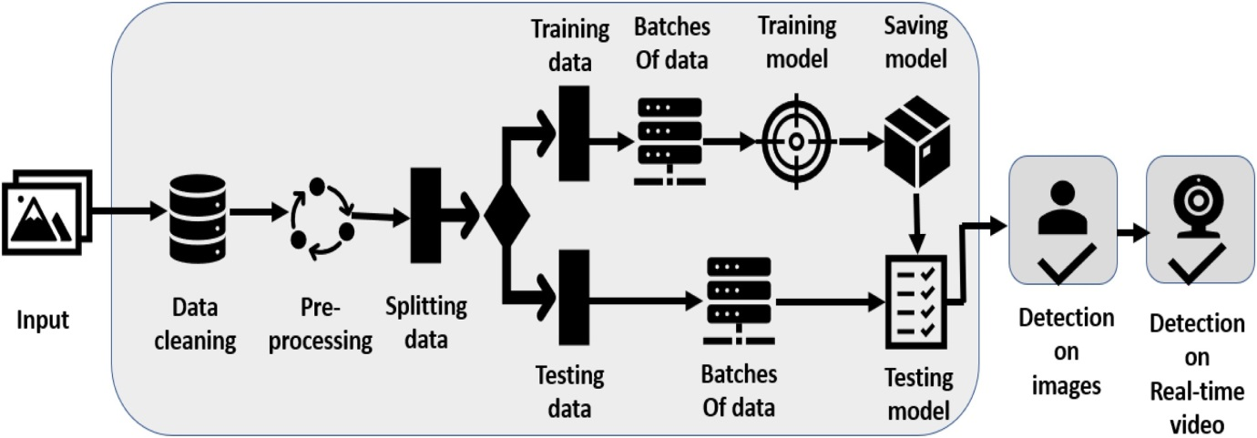

Fig 1:  Process Layout

* 1. **Mobilenetv2**

Specifically designed for mobile devices, MobileNetV2 is a convolutional neural network architecture. It is based on a residual structure that is inverted and has residual links between bottleneck levels. The intermediate expansion layer uses light depth-wise convolutions as a source of nonlinearity filtering. In the MobileNetV2 design, there is a 32-filter initial fully convolution layer followed by 19 further bottleneck layers.

* Convolution layers come in two varieties in the MobileNet V2 architecture:
* Convolution 1x1
* Depthwise Convolution at 3x3

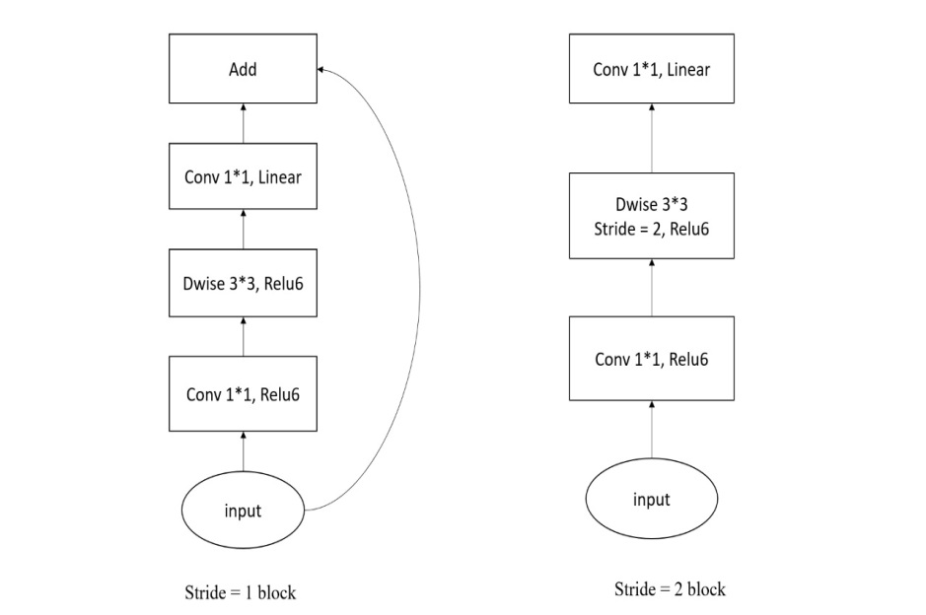

Fig 2: Frame for MobilenetV2

* 1. **Testing the model**

**Input:** Trained data

**Output**: Predicted data Process Description

**Step 1**: In this module, the training loss and training accuracy data are plotted.

**Step 2:** Next, a prediction on the training set is done.

**Step 3**: Finally, the model is evaluated.

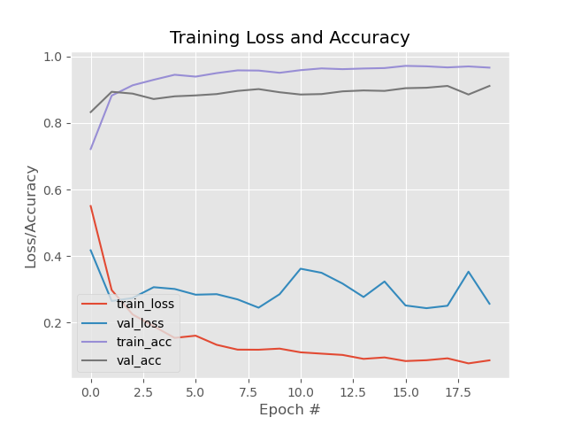

Fig 3: Training Loss and Accuracy

**Apply Image Preprocessing**

**Display face with appropriate message according to result**

**Initialize the video/web cam**

**Extract Image from the Frame**

**Load Face Detection Model**

**Face Image**

**Apply Face Mask detector to determine “Mask” or “No Mask”**

**Convert result into video Frame**

Fig4: Workflow of Face Mask Detector

1. **RESULTS AND DISCUSSION**

In the video, the model is used. The video is read frame by frame, and then the face detection algorithm is used. If a face is spotted, the program moves on to the next step. Reprocessing will be done on recognized frames containing faces, including shrinking the picture size, converting to the array, and preprocessing input using MobileNetV2.

Predicting input data from the stored model is the next step. Predict the input picture that has been processed using a model that has already been created. In addition, the video frame will be tagged with whether the individual is wearing a mask or not, as well as the predicted percentage.

There are phases in testing the model to ensure that it can predict effectively. Making predictions on the testing set is the initial stage. Table 1 shows the results of 20 iterations of testing the loss and accuracy during training the model.

*Accuracy= $(\frac{T_{P}}{T_{P+}F_{p {+T}_{N+}F_{N}}}$)*

WHERE $T_{P}$ =True positive , $T_{N=}$ True negative, $F_{p=}$ False positive , $F_{N=}$ False negative

There are numerous ways to show how well categorization results are performed. We looked at four important metrics: accuracy, precision, recall, and F1 Score similarity. "These metrics were calculated using the confusion matrix's true positive, true negative, false positive, and false negative values." "The total number of true positive and true negative samples divided by the total number of samples equals accuracy."

*Precision* = $(\frac{T_{P}}{T_{P+}F_{N}})$

$Recall$ = $(\frac{T_{P}}{T_{P+}F_{N}})$

$$f1score=2*\frac{(Recall*Precision)}{(Recall+Precision)}$$

1. **CONCLUSION AND FUTURE WORKS**

# This paper presents a deep learning-based solution for recognizing masks over faces in public locations to prevent the transmission of coronavirus in the community. At the pre-processing level, the suggested technique efficiently tackles occlusions in dense settings by employing an ensemble of single and two-stage detectors. The ensemble approach not only aids in reaching high accuracy but also significantly improves detection speed. The objective of the project is to recognize people wearing and not wearing masks using MobilenetV2. This algorithm is to convert an input image of a crowded place into our expected output which is identifying people not wearing a mask. Finally evaluating the numerical results. With the help of this project implemented under proper circumstances can help detect people not wearing masks. This could help health and sanitary officials to implement the WHO guidelines in a much better way. This project is tested in a webcam using the above-discussed methods and the results are as expected. With the wide use of this project in public gatherings and crowded localities, it will be easier to detect people violating the use of masks. In this project, used the MobilenetV2 algorithm and other Machine learning techniques to identify people not wearing a mask. Tested this scenario using a webcam and an input dataset. In the future, this project can be used along with other AI methodologies and can be implemented in devices like Raspberry Pi, Autonomous drone systems, etc., to improve the efficiency and reduce the detection time taken to detect people not wearing a mask.

1. **REFERENCES**
2. Xinbei Jiang, Tianhan Gao, Zichen Zhu, and Yukang Zhao., Real-Time Face Mask Detection Method Based on YOLOv3, Electronics, 7, pp.130-147, 2021.
3. Samuel Ady Sanjaya and Suryo Adi Rakhmawan., Face Mask Detection Using MobileNetV2, International Journal of Engineering and Advanced Technology, 4, pp.2249-8958, 2021.
4. Sunil Singh, Umang Ahuja, Munish Kumar, Krishna Kumar, and Monika Sachdeva., Face Mask Detection using YOLOv3 and faster R-CNN, International Journal Of Engineering and Technology, 12, pp.81-104, 2021.
5. G. Jignesh Chowdary, Narinder Singh Punn, Sanjay Kumar Sonbhadra, and Sonali Agarwal, Face Mask Detection using Transfer Learning of InceptionV3, IEEE Access, 20, pp. 456-665, 2021.
6. Shilpa Sethi, Mamtha Kathuria, and Trillok Kaushik., Face mask detection using deep learning, Multimedia Tools and Application, 8, pp.42-72, 2020.
7. Riya Chiragkumar Shah and Rutva Jignesh Shah., Detection of Face Mask using Convolutional Neural Network, Mobile Information System, 43, pp.382-487, 2019.
8. Safa Teboulbi, Seifeddine Messaoud, Mohamed Ali Hajjaji, and Abdellatif Mtibaa., Real-Time Implementation of AI-Based Face Mask Detection and Social Distancing Measuring System for COVID-19 Prevention, Scientific Programming, 32, pp.167-254, 2021.
9. Xueping Su, Meng Gao, Jie Ren, Yunhong Li, Mian Dong, and Xi Liu., Face mask detection and classification through deep transfer learning, Multimedia Tools and Applications, 53, pp.11042-11772, 2021.
10. Mohamed Almghraby and Abdelrady Okasha Elnady., Face Mask Detection in Real-Time using MobileNetv2, International Journal Of Engineering and Advanced Technology, 6, pp.49-89, 2021
11. Chhaya Gupta and Nasib Singh Gill., Corona mask: A Face Mask Detector for Real-Time Data, International Journal of Advanced Trends in Computer Science and Engineering, 9, pp.2278-3091, 2021.
12. Face Mask Dataset – Kaggle Repository.