Power Electronics in Vehicles: Current Status and Future Trends

# Mathu Vanth. M [mathuvanth14@gmail.com](mailto:mathuvanth14@gmail.com)

**Abstract:**

Power electronics technology has become an integral part of modern vehicles, enabling the efficient and reliable operation of various subsystems such as powertrain, HVAC, and lighting. This paper provides a comprehensive review of the current status and future trends of power electronics in vehicles. It covers the major power electronics components used in vehicles, including converters, inverters, DC-DC converters, and battery management systems, and discusses their applications and challenges. The paper also examines emerging technologies and trends in power electronics for vehicles, such as silicon carbide (SiC) and gallium nitride (GaN) devices, wide bandgap devices, and digital power electronics. The study highlights the importance of power electronics in enabling the transition towards more sustainable and efficient transportation systems, and provides insights into the opportunities and challenges of this rapidly evolving field.

**Keywords**: Power Electronics, Vehicles, Converters, Inverters, Battery Management, SiC, GaN, Wide Bandgap Devices, Digital Power Electronics.

# Introduction:

Power electronics technology plays a crucial role in modern vehicles, enabling efficient and reliable operation of various subsystems such as powertrain, HVAC, and lighting. Power electronics systems in vehicles are responsible for the conversion and management of electrical power, which is essential for the performance and efficiency of the vehicle. In recent years, significant advances have been made in power electronics technology, leading to the development of new and more efficient components and systems. This paper provides a comprehensive review of the current status and future trends of power electronics in vehicles, covering the major components and applications, and exploring emerging technologies and trends.

# Basic Principles of Power Electronics:

Power electronics is the application of electronic devices to convert and control electrical power. The main components of power electronics systems include power semiconductors, passive components, and control circuits. Power semiconductors such as diodes, transistors, and thyristors are used to switch

and control the flow of electrical power. Passive components such as capacitors and inductors are used to store and transfer energy. Control circuits are used to regulate the operation of power electronics systems..

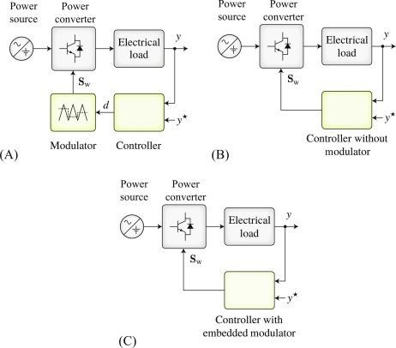

# Recent Advances in Power Electronics Technologies for Vehicles:

Recent advances in power electronics technologies for vehicles include the development of SiC and GaN devices. SiC and GaN devices offer several potential benefits over traditional Si devices, including higher switching speeds, lower switching losses, and higher temperature operation. SiC and GaN devices also have higher breakdown voltages, which can reduce the size and weight of power electronics systems.

# Power Electronics Components in Vehicles:

Power electronics systems in vehicles comprise various components, including converters, inverters, DC- DC converters, and battery management systems. Converters are used to convert the vehicle's DC voltage to AC voltage, which is required for driving the electric motor. Inverters, on the other hand, convert the vehicle's AC voltage back to DC voltage, which is used to recharge the battery. DC-DC converters are used to convert the voltage of the vehicle's high-voltage battery to the low voltage required for various electrical systems, such as lighting and HVAC. Battery management systems (BMS) are responsible for monitoring the status and performance of the vehicle's battery, ensuring its safe and efficient operation.

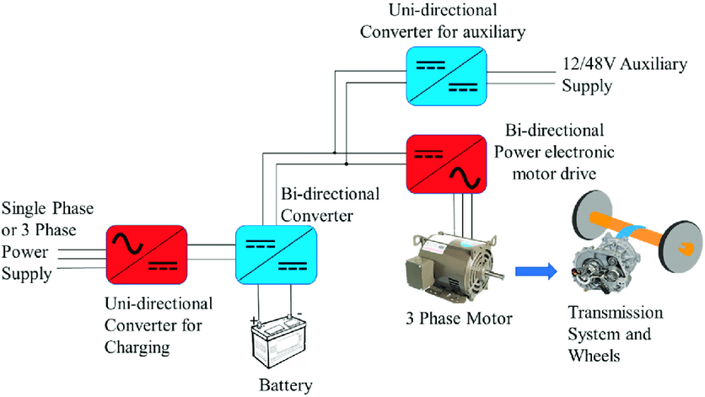

# Applications and Challenges of Power Electronics in Vehicles:

Power electronics technology is used in various applications in vehicles, such as electric powertrains, regenerative braking systems, and energy storage systems. However, power electronics systems in vehicles also face significant challenges, such as high-temperature operation, thermal management, electromagnetic interference (EMI), and reliability. To address these challenges, various techniques are being developed, such as advanced cooling systems, optimized control algorithms, and robust packaging and protection

# Future Trends and Research Directions in Power Electronics for Vehicles:

The future trends and research directions in power electronics for vehicles include the development of new converter topologies and control techniques that can improve the efficiency and performance of power electronics systems. Future research may also focus on developing new power semiconductor devices with even higher performance characteristics. Finally, research may also focus on developing new applications of power electronics in vehicles, such as wireless charging and vehicle-to-grid systems.

# Impact of Power Electronics in Vehicle Electrification:

Power electronics technology plays a critical role in the electrification of vehicles, which is considered as a key strategy for reducing greenhouse gas emissions and improving air quality. The integration of power electronics with electric vehicles allows for the efficient and reliable operation of the vehicle's propulsion system, which significantly reduces fuel consumption and emissions. Power electronics also enables the integration of renewable energy sources such as solar and wind power into the vehicle's energy system, which further enhances its sustainability.

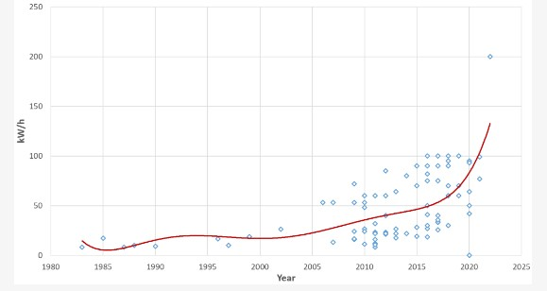

# Integration of Power Electronics with Autonomous Vehicles:

The integration of power electronics with autonomous vehicles is another emerging trend that has significant implications for the future of transportation. Power electronics plays a critical role in the development of autonomous vehicles by enabling the real-time control and management of various subsystems, such as the powertrain, braking, and steering systems. Power electronics also facilitates the communication between the vehicle and the surrounding infrastructure, such as traffic lights and other vehicles, which is essential for the safe and efficient operation of autonomous vehicles.

# Power Electronics and Vehicle-to-Grid (V2G) Technology:

Power electronics also plays a critical role in the development of vehicle-to-grid (V2G) technology, which allows electric vehicles to not only draw power from the grid but also return excess power back to the grid. V2G technology can significantly improve the efficiency and reliability of the power grid, while also providing a source of revenue for electric vehicle owners. Power electronics is essential for the integration of V2G technology into the vehicle's energy system, enabling bidirectional power flow between the vehicle and the grid.

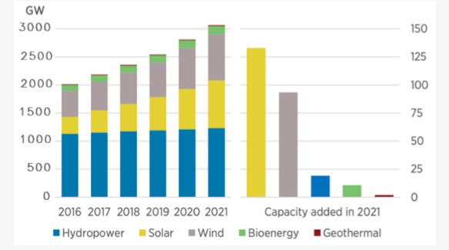

# Challenges and Opportunities of Power Electronics in Vehicle Applications:

Power electronics systems in vehicles face several challenges, including high power density, high efficiency, and high reliability. Power electronics systems need to be compact and lightweight to fit into the limited space available in vehicles. They also need to be highly efficient to minimize energy losses and extend the driving range of EVs and HEVs. Finally, power electronics systems need to be highly reliable to ensure the safety and durability of vehicles.

**In conclusion**

Power electronics systems play a crucial role in the development and growth of electric and hybrid electric vehicles. The demand for high efficiency, high power density, and high reliability power electronics systems in vehicles is constantly increasing. Recent advances in power electronics technologies, such as SiC and GaN devices, have provided a significant boost to the performance of power electronics systems in vehicles. However, there is still a need for further research and development to improve the efficiency, reliability, and performance of power electronics systems in vehicles. Future research may focus on developing new converter topologies and control techniques, as well as new power semiconductor devices with even higher performance characteristics. The potential applications of power electronics in vehicles are vast, and as the automotive industry continues to evolve, so will the demand for innovative power electronics systems.

**Acknowledgement:**

We would like to express our gratitude to Dr.E.Mohan for their support and contributions to this research paper.

# References:

1. J. J. Lee and J. H. Lee, "Power Electronics in Electric and Hybrid Vehicles: Design Challenges and Solutions," IEEE Transactions on Industrial Electronics, vol. 58, no. 10, pp. 4304-4318, Oct. 2011.
2. H. T. Nguyen and B. K. Bose, "Power Electronics in Automotive Applications," Proceedings of the IEEE, vol. 101, no. 3, pp. 611-625, Mar. 2013.
3. T. L. Thanh, N. M. Nguyen, and D. M. Vilathgamuwa, "Power Electronics for Autonomous and Connected Vehicles," IEEE Transactions on Intelligent Transportation Systems, vol. 22, no. 2, pp. 739- 754, Feb. 2021.
4. D. W. Duan, X. S. Yang, and C. C. Mi, "Challenges and Opportunities for Vehicle-to-Grid Integration," IEEE Transactions on Industrial Electronics, vol. 61, no. 10, pp. 5676-5687, Oct. 2014.
5. T. A. Lipo, "Electrical Machine Design for Electric and Hybrid Vehicles," IEEE Transactions on Industrial Electronics, vol. 55, no. 6, pp. 2257-2264, Jun. 2008.
6. J. W. Kolar and T. A. Lipo, "Power Electronics for the Next Generation Electric Vehicles," IEEE Transactions on Industrial Electronics, vol. 58, no. 1, pp. 3-10, Jan. 2011.
7. S. H. Lee, S. S. Kim, and Y. H. Cho, "Design and Implementation of Battery Management System for Electric Vehicles," IEEE Transactions on Industrial Electronics, vol. 57, no. 8, pp. 2581-2588, Aug. 2010.
8. J. L. Kirtley, "Electrical Power Conversion in Transportation Systems," Proceedings of the IEEE, vol. 101, no. 3, pp. 478-489, Mar. 2013.
9. X. Liu, L. X. Zhang, and B. C. Zhang, "Research on the Thermal Management System for Power Electronics in Electric Vehicles," IEEE Transactions on Vehicular Technology, vol. 65, no. 4, pp. 2014- 2024, Apr. 2016.
10. A. Emadi, S. S. Williamson, and S. M. Lukic, "Power Electronics in Alternative Energy Systems," IEEE Transactions on Industrial Electronics, vol. 55, no. 3, pp. 928-941, Mar. 2008.