FUTURE SALES FORECASTING USING ARIMA

MODEL

**MRITHULA V* , NANDHINI DEVI N* , HARI HARAN E* , PRAVEEN KUMAR G\*\***

**ABSTRACT:**

## * Computer Science and Engineering, Agni College of Technology

**Assistant Professor, Department of Computer Science and Engineering,

## Agni College of Technology

variables, and revising the model parameters. Overall, to

For newly based items, this study recommends a knowledge- based database-based sales forecasting methodology. Despite the fact that projecting future demand is an essential part of business planning and management, the bulk of significant forecasting methodologies only applies to everyday consumables, exhibiting modest sales trends caused by seasonal cycles. Based on the sales results of the product's very early introduction and a database of correlations between short- and long-term accumulations, the model creates a long-term forecast. The architecture was created to address the three practical concerns of accuracy, predicted release timing, and broad item coverage. We can use the model to obtain an accurate sales projection for the product's lifecycle one or two weeks after it is published. Additionally, it provides important information for determining whether to reprint the piece. This experiment will illustrate the proposed method's dependability in accuracy and efficiency in contrast to currently applied, well-proven methods. However, the bulk of consumers for retail goods are erratic, as seen by the erratic and nonlinear sales trends.

# INTRODUCTION

Estimating future revenues is the technique of sales forecasting. It's a crucial activity for businesses since it enables them to forecast income streams, plan for the future, and make informed decisions regarding marketing and inventories. Getting information on previous sales is the first stage in sales forecasting. This can include information on specific product or service sales as well as general business sales figures. Getting information on previous sales is the first stage in sales forecasting. This can include information on specific product or service sales as well as general business sales figures. The external elements that could affect sales, such as the state of the economy, changes in customer behaviour, or the emergence of new rivals, should be considered when making sales projections. The system should also have a feedback mechanism so that the model can be updated in response to fresh information and modifications in the market. Maintaining the forecasting model's accuracy and applicability requires regular usage of applicability requires regular monitoring and updating. This could entail modifying the statistical techniques utilised, adding new

effectively forecast future sales income, a whole sales forecasting model needs to be combined with data analysis, statistical modelling, and business expertise. The quality of the data, the sophistication of the statistical techniques employed, and the level of knowledge of the analysts involved in the process will all affect how accurate the model. Numerous sectors and company departments use future sales forecasting in a variety of ways. Businesses can gain a huge competitive advantage by streamlining their operations and making data- driven decisions if they can properly predict future sales. The breadth of future sales forecasting has expanded as a result of current technology and data analytics advancements. Future sales forecasting now encompasses much more thanks to developments in data analytics and technology.

# RELATED WORK

In this Section, we examined a few papers that show how machine learning and the ARIMA Model are related.

### Title: Time series modelling sales forecast for Amazon sales.

**Author Name: Nonita Sharma, Pawan Kumar, and Balpreet Singh**

### Description:

Particularly for B2C (business to consumer) e-commerce, accurate sales forecasting is crucial to cutting expenses and raising customer service standards. Based on previous sales data, this study makes an attempt to anticipate future sales at Amazon.com, Inc. First, it suggests three potential forecasting methods based on the historical data pattern: ARIMA (autoregressive integrated moving average), neural network autoregressive model, and Holt-Winters exponential smoothing. Second, it outlines certain accuracy metrics that will assess the applicability of the forecasting techniques in light of the given sales data. The three techniques will finally be used to project. Amazon's quarterly sales for 2019. The outcomes may aid Amazon in managing its operations going forward.

### Title: Market forecasting using the TSDM framework: mining the past to predict the future.

**Author Name: Jasmin D. Niguidula and Angelique D. Lascandile**

### Description:

It is commonly acknowledged that sales forecasting has enhanced the effectiveness of corporate strategy. Understanding a service provider's sales trends is essential for tracking or estimating future earnings or losses. The photocopier service provider COPYTRADE has offices close to schools and within malls, which are frequented by youngsters. Since there were numerous branches in various regions, it was difficult for the owners to consolidate daily sales, especially in places where technology is still out of the reach of the average person. They may use this information to forecast sales trends all year round. This might result in better management of their resources, including equipment, supplies, and labour. Along with TSDM, the data mining activity in COPYTRADE also made use of clustering, classification, and regression. The findings of this study suggest that frequency, amount, and monetary are the three most important factors in predicting the number of sales.

### Title: Utilising XGBoost, a machine learning model for sales forecasting.

**Author Name: Diaru Xie and Shilong Zhang Description:**

In order to extract features from past sales data, feature engineering is first carried out. Furthermore, we made use of these attributes for predicting the size of future sales using extreme Gradient Boosting (XG Boost). Our suggested model performs very well for sales prediction with less computing time and memory resources, as shown by the experiment results on a publicly available Walmart retail items dataset provided by the Kaggle competition. Exact sales forecasting is essential to modern retail firms that run a massive chain of businesses since it determines the growth and profitability of the company. Businesses may efficiently allocate resources, such as cash flow and production, and create more informed business plans, thanks to sales forecasting. In this research, we provide a machine learning-based methodology for accurate and efficient sales forecasting. The company's inability to produce items will have a detrimental impact on the standard of customer service, decreasing the company's ability to compete.

### Title: Impact of Sales Analytics for Agro-Based Product Forecasting.

**Author Name: Sudharsan, Pravin Yadav, and Shriram Badave.**

### Description:

Using the right data analysis tools and predictive analysis technologies, sales analytics may be used as a tool for projecting future sales. Data analytics is currently emerging as one of the major areas in minimising the uncertainty in business. The research report, which uses Microsoft Business Intelligence (BI), a cloud-based business intelligence solution, is titled Forecasting Sales Using BI. The company is used in the study paper to find the sales forecasting predictive analysis. Forecasting is a critical management responsibility that, in the current business climate, can help a manager or sales team make informed decisions about approaching clients. He can better position his organisation for potential marketing opportunities by foreseeing future consumer demand and supply.

### Title: Web application for sales forecasting in small and medium businesses.

**Author Name: Patrick Nelnonoi, Tora Fahrudin, and Nelsi Wisna.**

### Description:

Sales forecasting for small and medium-sized businesses (SMEs) is still difficult in modern times, particularly in Indonesia, where SMEs accounted for the majority of the country's economic growth. However, many SMEs in Indonesia lack the technological know-how necessary to utilize the digitization of their businesses. Therefore, in this study, a web-based application was created for Puri Utami, one of Indonesia's SMEs, to assist the owner in forecasting future sales. Least Squares Linear Regression and Support Vector Regression (SVR) algorithms were utilized as a library to construct sales forecasting modules in the machine learning library for PHP (PHP-ML). According to the experimental findings, Least Squares Linear Regression outperforms SVR in both MSE and MAE evaluation metrics. Future research can look more closely at sophisticated algorithms like Deep Learning and increased data pre-treatment to boost accuracy.

# DATASETS

The dataset used in this study was composed of a number of historical sales measures taken at various items inside an organization. The number of categories, as well as attributes like Monthly, Yearly, and Weekly, are included. The information was acquired over time at regular intervals. Each row of the data contains information on the essential sales information. Holidays, festival holidays, etc. are included in the dataset. The dataset also includes annual peak and trough ranges. Future can be accurately anticipated based on this.

# PROPOSED SYSTEM

A variety of industries employ autoregressive integrated moving average (ARIMA) models. It is frequently applied to demand forecasting, such as when predicting future demand for the production of food. This is so that managers have solid rules to follow when making decisions on supply chains. On the basis of previous prices, ARIMA models can also be used to forecast the future price of your stocks. This is due to the fact that ARIMA models are a general class of models used for time series data forecasting. The standard abbreviation for ARIMA models is ARIMA (p,d,q), where p denotes the order of the moving-average model, d is the degree of differencing, and q is the order of the autoregressive model.

ARIMA models transform a non-stationary time series into a stationary one via differencing and then extrapolate future values from the past. In order to predict future values, these models employ "auto" correlations and moving averages over residual errors in the data. By modeling the correlations in the data, the ARIMA methodology is a statistical technique for analyzing and creating a forecasting model that accurately depicts a time series. In order to generalize the forecast and boost prediction accuracy while maintaining the model's parsimony, ARIMA models only require the past data of a time series.

Once the ARIMA model has been trained, we can use it to predict future sales by feeding it historical data and basing our predictions on the patterns the model has discovered. The model's output will be the anticipated sales for the subsequent time frame. It is significant to stress that stable data—data whose statistical characteristics do not vary over time—are necessary for ARIMA models. Before fitting the model, the data may need to be transformed if it is not stationary. In a time-series variable, Arima models can be used to identify odd patterns or outliers. This is helpful in industries like cybersecurity, where spotting atypical network activity can aid in the detection of potential security flaws. This would entail putting different models to the test and choosing the one that offers the greatest match for the data. After gathering the data, it would be pre-processed to eliminate any outliers, missing data points, and other anomalies that would compromise the analysis's accuracy.

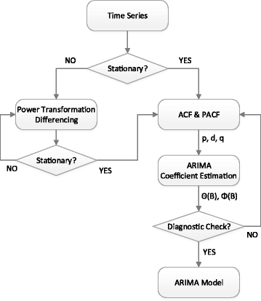

# Fig 4.1 Flow Diagram of ARIMA Model

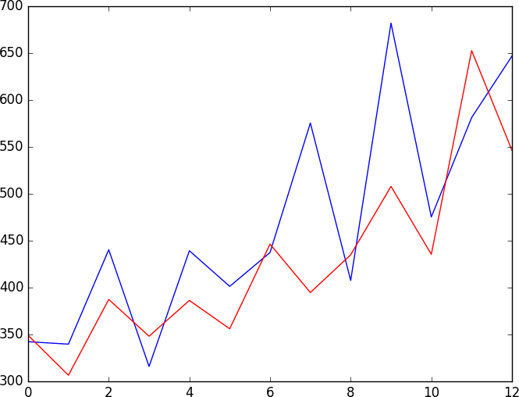

**Fig 4.2 Time series analysis using ARIMA Model**

# RESULTS

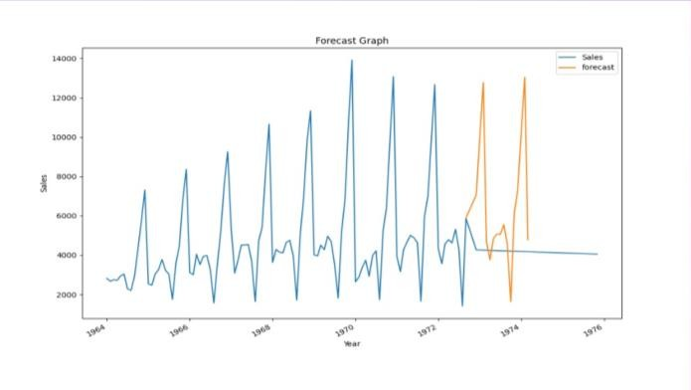**ACTUAL GRPAH:**

The actual graph in future sales forecasting can take different forms depending on the nature of the data and the purpose of the forecast. However, most sales forecasting graphs typically display the following:

* + Time Axis
  + Sales Axis
  + Forecast Line

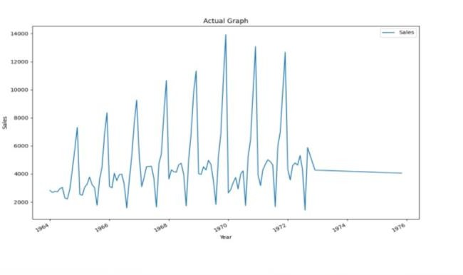

# Fig 5.1 Actual Graph

**FORECAST GRAPH:**

A forecast graph in future sales forecasting is a visual representation of the predicted sales trend over a specific period. The exact shape of the forecast graph will depend on the nature of the data, the forecasting method used, and other relevant factors. However, some common elements that may be included in a forecast graph for future sales forecasting are:

* + Time Axis
  + Sales Axis
  + Forecast Line
  + Upper and Lower Bounds
  + Confidence Interval
  + Trends and Pattern

# Fig 5.2 Forecast Graph

**PREDICTED GRAPH:**

Predicting future sales trends is a critical aspect of business planning, and one common way to represent these predictions is through a graph. The exact shape of the predicted graph in future sales forecasting will depend on several factors, including the nature of the data and the methods used to make the forecast.

However, most sales forecasting graphs typically display the following:

* + Time Axis
  + Sales Axis
  + Forecast Line

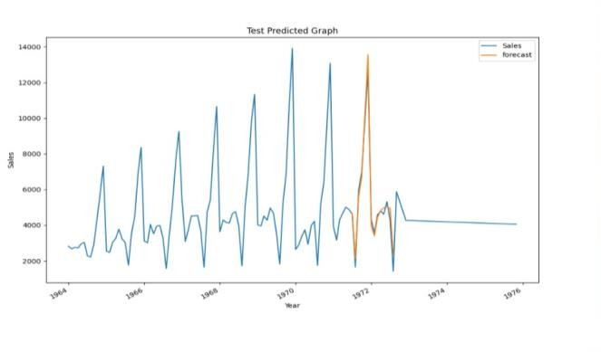

# Fig 5.3 Predicted Graph

1. **REFERENCES**
2. Tingli Feng, Chenming Niu, Yuchen Song, "Short Term E- commerce Sales Forecast Method Based on Machine Learning Models", Proceedings of the 2022 6th International Seminar on Education, Management and Social Sciences (ISEMSS 2022), pp.1020, 2022.
3. Md. Anisur Rahman Mia, Mohammad Abu Yousuf, Rupon Ghosh, "Business Forecasting System using Machine Learning Approach", 2021 2nd International Conference on Robotics, Electrical and Signal Processing Techniques (ICREST), pp.314- 318, 2021.
4. Pei Guo, Aly Megahed, Shubhi Asthana, Paul Messinger, "Winnability Prediction for IT Services Bids", 2019 IEEE International Conference on Services Computing (SCC), pp.237- 239, 2019.
5. Markdy Y. Orong, Ariel M. Sison, Ruji P. Medina, "A Hybrid Prediction Model Integrating a Modified Genetic Algorithm to K- means Segmentation and C4.5", TENCON 2018 - 2018 IEEE Region 10 Conference, pp.1853-1858, 2018.
6. Kugamoorthy Gajananan, Aly Megahed, Shubhi Asthana, Valeria Becker, Taiga Nakamura, Mark Smith, "A method for estimating annual cost reduction of IT service deals", 2017 IEEE International Conference on Service Operations and Logistics, and Informatics (SOLI), pp.45-50, 2017.
7. Aly Megahed, Shubhi Asthana, Valeria Becker, Taiga Nakamura, Kugamoorthy Gajananan, "A Method for Selecting Peer Deals in IT Service Contracts", 2017 IEEE International Conference on AI & Mobile Services (AIMS), pp.1-7, 2017.
8. T.K. Thivakaran, M. Ramesh, "Exploratory data analysis and sales forecasting of bigmart dataset using supervised and ANN algorithms", Measurement: Sensors, pp.100388, 2022.
9. Milan Zdravković, Hervé Panetto, Georg Weichhart, "AI- enabled Enterprise Information Systems for Manufacturing", Enterprise Information Systems, pp.1, 2021.
10. Tingli Feng, Chenming Niu, Yuchen Song, "Short Term E- commerce Sales Forecast Method Based on Machine Learning Models", Proceedings of the 2022 6th International Seminar on Education, Management and Social Sciences (ISEMSS 2022), pp.1020, 2022.
11. Md. Anisur Rahman Mia, Mohammad Abu Yousuf, Rupon Ghosh, "Business Forecasting System using Machine Learning Approach", 2021 2nd International Conference on Robotics, Electrical and Signal Processing Techniques (ICREST), pp.314- 318, 2021.
12. Pei Guo, Aly Megahed, Shubhi Asthana, Paul Messinger, "Winnability Prediction for IT Services Bids", 2019 IEEE International Conference on Services Computing (SCC), pp.237- 239, 2019.
13. Markdy Y. Orong, Ariel M. Sison, Ruji P. Medina, "A Hybrid Prediction Model Integrating a Modified Genetic Algorithm to K-means Segmentation and C4.5", TENCON 2018

- 2018 IEEE Region 10 Conference, pp.1853-1858, 2018.

1. Kugamoorthy Gajananan, Aly Megahed, Shubhi Asthana, Valeria Becker, Taiga Nakamura, Mark Smith, "A method for estimating annual cost reduction of IT service deals", 2017 IEEE International Conference on Service Operations and Logistics, and Informatics (SOLI), pp.45-50, 2017.
2. Aly Megahed, Shubhi Asthana, Valeria Becker, Taiga Nakamura, Kugamoorthy Gajananan, "A Method for Selecting Peer Deals in IT Service Contracts", 2017 IEEE International Conference on AI & Mobile Services (AIMS), pp.1-7, 2017.
3. T.K. Thivakaran, M. Ramesh, "Exploratory data analysis and sales forecasting of bigmart dataset using supervised and ANN algorithms", Measurement: Sensors, pp.100388, 2022.
4. Milan Zdravković, Hervé Panetto, Georg Weichhart, "AI- enabled Enterprise Information Systems for Manufacturing", Enterprise Information Systems, pp.1, 2021.