PLC Based on Automatic Fly Ash Brick Machine

Mr. M. Vignesh kumar1, S. Mahesh 2, J. Preetu mamta3, R. Buvaneswari4

1Assistant Professor, Dept. of Electrical and Electronics Engineering, P.A. College of Engineering & Technology, Tamil Nadu, India

2,3,4B. E Dept. of Electrical and Electronics Engineering, P. A. College of Engineering and Technology,

Tamil Nadu, India

***Abstract:-* An alternate use for fly ash is the manufacture of ash bricks. The Pan Mixer and mouldings machine are critical components of the Fly Ash Bricks factory. The Brick Moulding Mechanism was the primary focus of this research. There are other ways for moulding bricks, but we only employed the hydraulic compression method since it is more efficient and dependable. This study is primarily concerned with reducing avoidable economic losses, providing safety for plant workers, and increasing the efficiency of the bricks sector. We created this approach using a Programming Logic Controller (PLC). A fly ash brick machine is used to make the bricks in a highly compressed condition. The entire time required to make bricks in a single cycle is the most critical challenge in industries. The machine's design and programmer are totally updated in this effort to make bricks in a cycle in a shorter length of time. The PLC was used for this, and it was set to run for a limited period of time.**

***Key Words:* *Programming Logic Controller with Counter, LED, Push buttons, Hydraulic Machine, Gear motor, etc.,***

**1. INTRODUCTION**

India is currently entering a new period of development, with strong economic expansion and a high rate of population. In India, the total fly ash generation from thermal power plants is estimated to be over 180 million tons per year, with the potential to expand to around 226 million tons per year, making the use of fly ash for the construction of bricks an alternate use of fly ash. The sole solid element in the bricks is ash, and the only liquid ingredient is water. Much research on cement and concrete uses has been authorized and approved by the federal government. Fly ash may also be used to make bricks, which is an alternate usage for it. Fly ash may be used to make bricks since it has adequate ceramic qualities and capabilities. Other commercially protected substances are cheap, easily accessible, and, although necessary, are in small quantities.

1.1 Brick-Making Plant:

The technique for creating bricks involves mixing, shaping into molds, curing, drying, sorting for testing, and shipping. The Pan Mixer and moulding machine are critical components of the Fly Ash Bricks factory. In the mechanized pan mixer, the basic components are blended. One inclined conveyor belt is installed between the pan mixer and the pressing machine to transport the raw material mixture to the pressing machine. There are two mechanisms for producing bricks.

We exclusively use the hydraulic compression method since it is the most effective and dependable approach out of the two: the other being the vibro press. The pressing machine comprises three brick mould sets. One set of moulds receives the mixture, which is subsequently squeezed by hydraulic pressure and bricks are produced throughout the revolution of this machine.

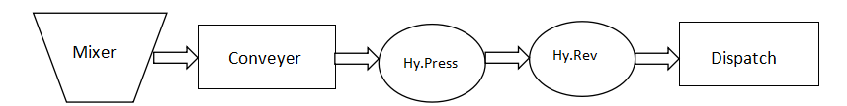

**Fig -1:** Basic brick making process

(Note: Hy. Press-Hydraulic Press, Hy.Rev-Hydraulic Reverse)

**1.2 Basics of PLC:**

A Programming Logic Controller, often known as a PLC or Programmable Controller, is a digital computer that is used to automate electromechanical operations. Control of equipment in factory assembly lines, recreational attractions, or light fixtures, for example. PLCs are built for numerous analog and digital input and output configurations, increased temperature ranges, electrical noise immunity, and vibration and impact resistance. Non-volatile memory is generally used to store programmers that regulate machine operations. A PLC is an example of a "hard" real-time system. since the output results must be provided in response to input circumstances within a specific time frame, or else unexpected operation may occur.

**1.3 Problem Background:**

A major issue in the brick making sector is a lack of communication and a sudden breakdown in the machine. In the industry, a loud sound is created when the machine is working, and some workers are unable to hear correct commands to turn on or off, which causes accidents. These mishaps cause financial problems.

The second difficulty is that in typical brick manufacturing plants, mixing and moulding are done by hand, which is a time-consuming operation. As a result, this operational routine should be automated. That improves plant safety efficacy without changing their main damaging technique.

**1.4 Objective of the Work:**

The primary goal of this thesis is to create a fully automated model of a fly ash brick producing machine. This will decrease communication breakdowns and mismanagement at the bricks plant. Less manpower is required, which enhances the speed and efficiency of manufacturing.

**2. METHODOLOGY**

The work is primarily concerned with the mechanics of fly ash brick moulding. There are two mechanisms for producing bricks. One is a hydraulic press, and the other is a vibro press, but we only use the hydraulic compression technique since it is more efficient and dependable. The pressing table is round, with three sets of brick moulds separated by 120°. One set of moulds receives the mixture, which is then broken down by hydraulic press, and after brick shipment hydraulic ejects the moulded brick from the mould. All of the procedures of filling moulds, pressing material, and shipping formed bricks for one revolution take place at the same time. In this manner, one round of this circular table produces two bricks.

**2.1 Hardware Description:**

It includes block diagram of the complete process and circuit diagram of the different electrical connections. A common Programmable Logic Controller (PLC) block diagram includes the following components Hardware description:

The power supply powers the PLC module and its peripherals.Central Processing Unit (CPU): The CPU is the PLC's brain, receiving input signals, processing them according to the programme, and producing output signals.Input Module: This module accepts sensor signals and translates them into a format that the CPU can interpret.Output Module: This module takes CPU signals and translates them into a format that the actuators can interpret.Memory is where the CPU stores programmes, data, and other information.It lets the PLC to connect with other devices, such as a computer or another PLC.

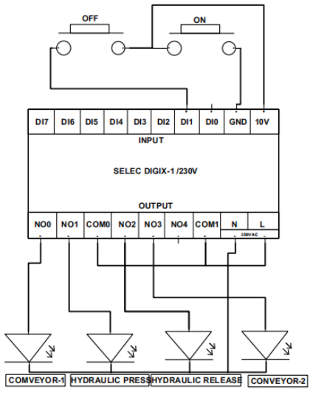

**Fig -2:** Block diagram of the model

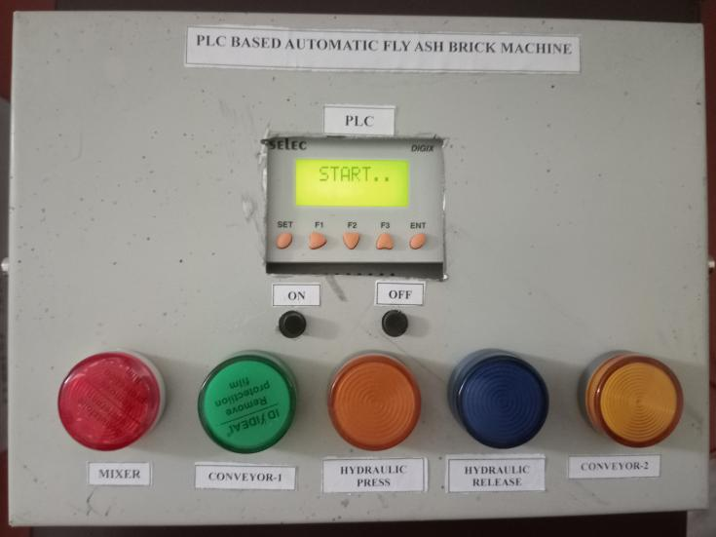

**Fig -3:** Figure of the model of moulding machine

Following are the main components of the model

proposed.

**Main motor** (Chuck Motor): It is nothing more than a DC gear motor. A gear motor can be either an alternating current (AC) or direct current (DC) electric motor. A gear motor is a type of electrical motor that produces high torque while retaining a low horsepower, or low speed, motor output. Gear motors are utilised in a variety of devices, including can openers, garage door openers, washing machine time control knobs, and even electric alarm clocks.

**Hydraulics System** (Press &Dispatch): In the suggested machine type, we use an electro-mechanical hydraulic press. It primarily operates on the shaded pole mechanism. In this mechanism, a fiber pole with a two-thirds iron sheet coating is explored. The fiber end of the pole is free, while the iron coated end is attached to a spring mechanism, which causes the pole to return to its original position. A fiber bobbin is also utilized, around which the winding is wrapped. A 230V alternating current supply is delivered across the winding, creating a magnetic field inside the spindle. This magnetic field produces a N-S pair. Because of the AC stimulation, the iron shaded region of the pole acts as an electromagnet, and the opposing polarities, S-N, are generated on it. The magnetic property states that opposing polarities attract one other. As a result, whenever ac excitation is applied to winding, the polarities of the field attract the polarities of the pole, and the pole comes through the spindle as hydraulic press or hydraulic dispatch from the open end. In the absence of a supply, the magnetic field vanishes and the pole returns to its original location related to the spring mechanism.

Proposed method is completely automatic and is

controlled by PLC programming. Flow of the process can be explained as:

**i.** Switch on the power supply

**ii.** Main motor starts and rotate the circular table

**iii.** Sensor start sensing for the Mould

**a.** Stops the motor when mould is present

**b.** Keep sensing until mould is present

**iv.** As motor stops, timer TON is turned on for required time

**v.** Both the hydraulic are pressed simultaneously until

timer is up

**a.** Keep pressed till timer is on

**b.** As timer times up, hydraulics are released

**vi.** Starts the chuck motor again Process explained above will be continued automatically till power switch is on.

**2.2. Software Description**

The PLC programming handles this automated operation. Ladder Programming is the term used to describe PLC programming. Relay logic diagrams, which illustrate relay control circuits, are comparable to ladder diagrams. A Ladder Diagram programme is made up of rungs, which are sequences of graphical instructions drawn between two vertical potential bars. The logic controller executes the rungs in a sequential order. Timer TON is used in the programming. It is the flexibility that we can increase or decrease the time of hydraulic action by the timer. Also output of the timer is used to stop or run the main motor.

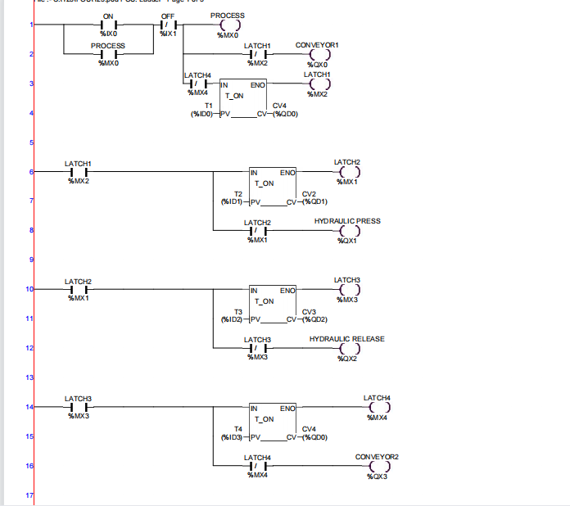

**Fig -4**: Ladder diagram of the complete process

**3. RESULTS**

The software program is successfully performed in the result section after connecting all components of the brick machine and its connection with the plc. It demonstrates that our hardware and software work efficiently.

**Table -1:** Outputs at different rpm

|  |  |  |  |  |
| --- | --- | --- | --- | --- |
| S.No | Speed of  motor (rpm) | No. of  moulds | No. of  bricks  /rotation | Total  Bricks  (8 hrs) |
| 1 | 3 | 3 | 3 | 4320 |
| 6 | 6 | 8640 |
| 2 | 5 | 3 | 3 | 7200 |
| 6 | 6 | 14400 |

From the above table we can draw a remarkable

conclusion that

|  |
| --- |
| **No. of bricks α No. of Moulds & rpm of motor** |

From the above relation we can see that how we can

increase the efficiency of the model.

**Table -2:** Boolean output for the different process

|  |  |  |  |  |  |
| --- | --- | --- | --- | --- | --- |
| **INPUTS** | | | **OUTPUTS** | | |
| **X1(switch)** | **X2 (Sensor)** | **Y2 (Timer**  **output)** | **Y1 (Motor)** | **Y3**  **(Hydraulic**  **Press)** | **Y4**  **(Hydraulic**  **Dispatch)** |
| 0 | 0 | 0 | 0 | 0 | 0 |
| 1 | 0 | 0 | 1 | 0 | 0 |
| 1 | 1 | 0 (till timer is up) | 0 | 1 | 1 |
| 1 | 0 | 1 | 1 | 0 | 0 |
| 1 | 1 | 0 | 0 | 1 | 1 |
| 1 | 1 | 0(up) | 0 | 1 | 1 |

The above process will goes on till we do not press the input switch.

|  |  |  |  |
| --- | --- | --- | --- |
| **S.**  **No.** | **Features** | **Proposed**  **method** | **Existing**  **method** |
| 1 | Time | Time saving (  Material filling ,  pressing &  ejection  simultaneously ) | Time  consuming  (One process  at a time) |
| 2 | Capacity | 8000-10,000  bricks per day | 5000-6000  bricks per day |
| 3 | Manpower | Manpower  reduces  (2-3 person) | Manpower is  needed for  every process  (5-8 person) |
| 4 | Safety and  fault  diagnosis | Safe and easier  (PLC operated) | Less safe and  faulty due to  contactor  relays |
| 5 | Nos. of  moulds | Can be increased  by changing the  die.(3,6,9.. as  available) | Not such  option  available |
| 6 | Costing | Installation cost is  high but running  cost is cheaper | Installation  cost is cheaper  but running  cost is high |
| 7 | Operation | Automatic based  on ladder  programming | Hydraulics are  operated  manually |

**4. CONCLUSION**

In the case of a semi-automatic plant, all processes are carried out by automated machines, but not simultaneously. Each procedure is given a time slot, after which only the next time-consuming activity may be performed. However, the suggested brick producing machine is completely automated and is controlled by a Programming Logic controller. The pressing machine contains three sets of brick moulds that are offset by 1200. One set of moulds receives the mixture, which is subsequently squeezed, and two bricks are produced in one revolution of this machine. As a result of implementing this paradigm, efficiency is boosted. The entire system is automated. Accidents are also becoming less common.

**REFERENCES**

[1] Kendesarin Pimraksa, Matthias Wilhelm and Michael kochhberger A New Approach to the Production of Bricks Made of 100% Fly Ash, International Ash Utilization Symposium, University of Kentucky, 2001.

[2] Obada Kayali, ǲHigh Performance Bricks From Fly Ashǳlecture notes, Lexington, Kentucky,USA, 2005.

[3] Ankit H Parmar, Kinnarraj P Zala, Ankit R Patel,

ǲ Modification of Foremost Element of Hydraulic Press Machine, IJASTR, vol. 3, june 2014.

[4] A. Sumathi, K. Saravana Raja Mohan, Compressive Strength of Fly Ash Brick with Addition of Lime, Gypsum and Quarry Dust, IJCRGG, Vol. 7, pp 28**-**36, 2014-2016.

[5] Cockrell, L. Sander, T.M. Holnan Inc., Dundee, MI. Process control in cement industry, IEEE Transaction, vol-28, pp: 945 – 953, 2006.

[6] Prime, J.B. Valdes, J.G, ǲuse of ladder diagram in discrete system of PLC, IEEE Transaction, vol. PAS- 100, pp- 143 – 153, January 1989.

[7] N. Gangadhar Reddy, High-Capacity Fly Ash Bricks & Blocks Unit, ǲA project report, May 2014.

[8] Ravi Masand, Prof. S.P Shukla, PLC and SCADA based Fault Diagnosis of Induction Motorǳ, IJDACR, Vol. 2, January 2001.

[9] A.K. Swain, August, ǲMaterial mix control in cement plant automation, IEEE, vol. 4, pp. 24-27, 2009.