**REAL TIME OBJECT DETECTION FOR VISUALLY CHALLENGED PEOPLE USING MACHINE LEARNING**

**Prof. Sneha A. Khaire1, Dhanraj Nikam2, Ajinkya Pawar3, Chaitanya Devkar4, Shubham Pagar5**

Assistant Professor1 BE Students2,3,4,5

Department of Information Technology,

Sandip Institute of Technology and Research Centre, College of Engineering, Nashik - 422213

**ABSTRACT**

Newer mobile phones have superior hardware and faster processing, which are powerful enough to support the development of applications that let users interact with the outside world at their own pace. This system makes use of both the camera and the camera app on your smartphone. It also scans OCR. Using a technology called optical character recognition (OCR), printed, handwritten, or typed text from an image may be transformed into machine-readable text. Using the camera on your phone, this method will help you take a picture of or scan a document that is now in your possession. Any English-language text in the image will be read by a programme once it has been scanned, and the findings will be converted into voice. According to the authors, one of the most important modalities for assisting persons with low vision and blindness in the modern accessible space is voice communication.

*Keywords*: OCR, camera app, speech, blind, vision

1. **INTRODUCTION**

The visually impaired experience many difficulties in daily life, with finding things being a typical one. This is in contrast to a normal sighted person. People who are blind have more acute perceptions than sighted people do. When in a familiar setting, they are aware of basic directions and the locations of useful objects. They have trouble finding things when they're in a strange setting. In order to make it simple for users to locate the items they seek; our goal was to develop an application that gives them a general feeling of direction.

Real-time object detection using machine learning can be a useful tool for visually challenged individuals. The process involves using computer vision algorithms to identify and label objects in a live video feed or image, allowing visually challenged individuals to understand their surroundings.

1. **METHODOLOGY**

**Figure 01**: Hardware Working

1. Input Sensors: These are the devices that capture the input data, such as cameras or depth sensors. They are used to collect visual information about the user's surroundings.
2. Preprocessing: The raw data collected from the sensors needs to be preprocessed before it can be used by the machine learning model. This may involve tasks such as image resizing, normalization, and filtering.
3. Object Detection Model: This is the core component of the system, which uses machine learning algorithms to detect and classify objects in real-time. Popular models for object detection include Faster R-CNN, SSD, and YOLO.
4. Postprocessing: Once the objects have been detected, postprocessing is applied to refine the results and extract additional information. This may include tasks such as non-maximum suppression, bounding box regression, and object tracking.
5. Output: The final output of the system is typically provided in the form of audio or tactile feedback, which is used to inform the user about the objects in their environment. This feedback may include object names, positions, and descriptions.

Overall, the architecture of real-time object detection for visually challenged people using machine learning is designed to leverage advanced machine learning algorithms and computer vision techniques to provide users with real-time information about their surroundings, helping them to navigate and interact with the physical world more easily.

1. **MODELING AND ANALYSIS**

The goal of the proposed real-time object identification for visually impaired persons utilizing machine learning system is to enable visually impaired people to autonomously navigate by transforming the visual world into an aural one. The technology utilizes a smartphone app to take real-time pictures, which are then uploaded to a model running on a laptop that can identify items and figure out how far away a person is from an object. When a user is in close proximity to an object, the system plays auditory feedback and cautions. Another technology that may be used to make printed, handwritten, or typed text into machine-readable text from a photograph is optical character recognition (OCR), which can help those who are blind read. Intelligent automated technologies must be created immediately to help people who are blind detect, identify, read, and feel their environment's things.

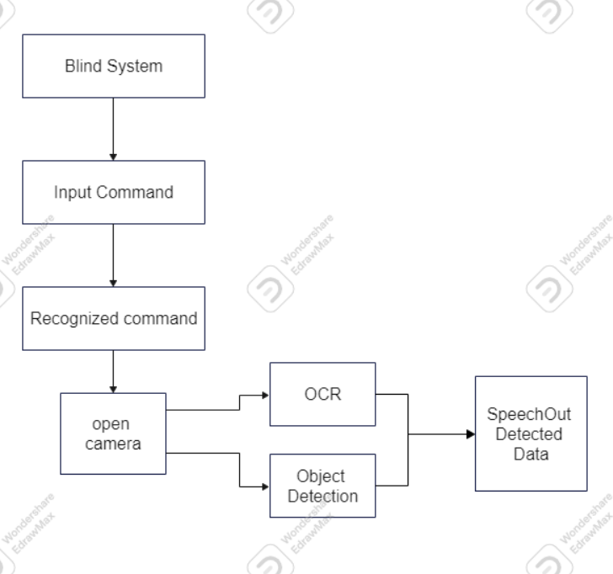

**Figure 02**: Block Diagram

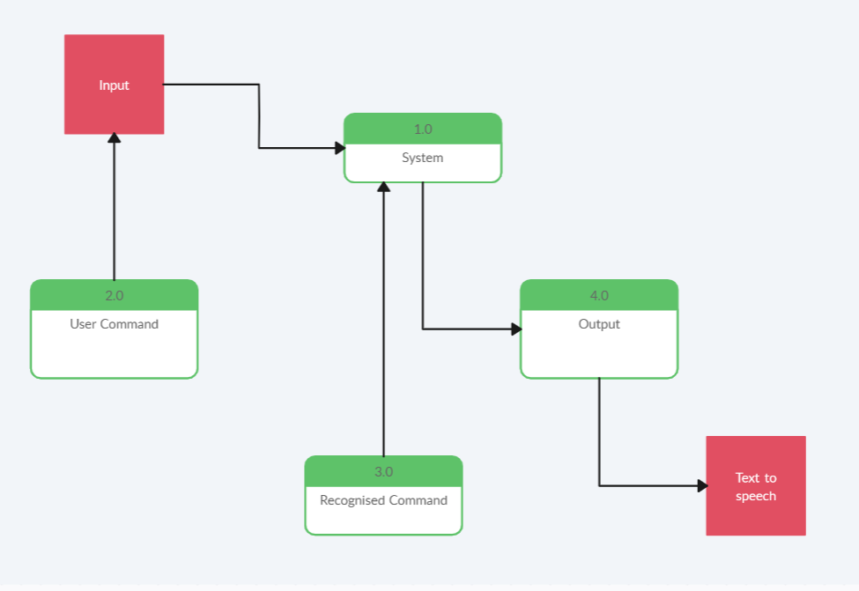

**Figure 03**: Data Flow Diagram

1. **RESULTS AND DISCUSSION**

The implementation of this project involves using machine learning algorithms to analyze live video streams from cameras or sensors, detect objects, and then provide auditory or haptic feedback to the user. The machine learning models used for object detection are typically trained on large datasets of labeled images to recognize different types of objects and their features.

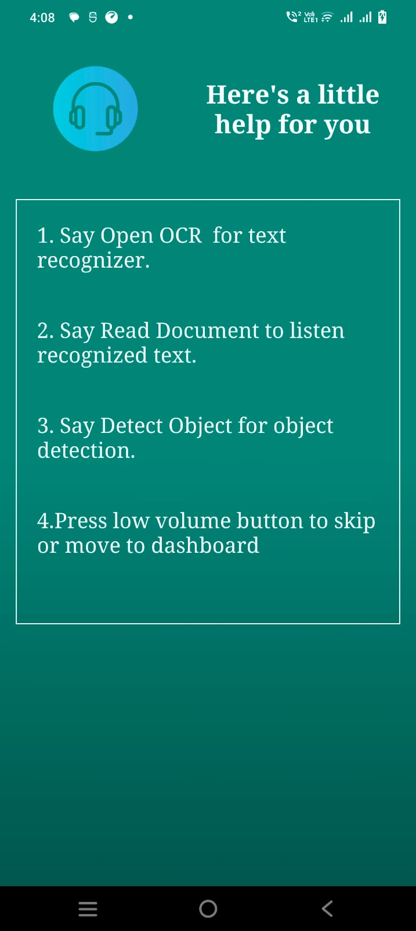

**Figure 04**: App Opening **Figure 05**: Help for using app

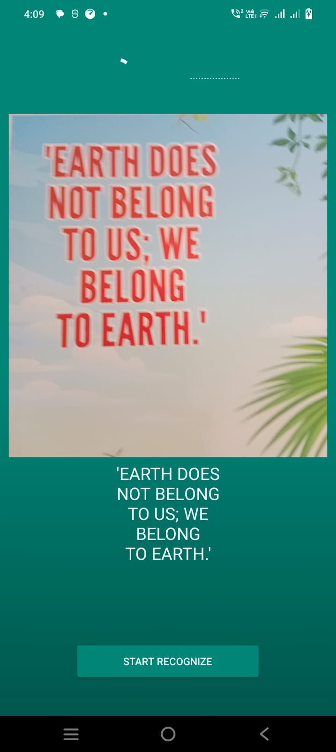

**Figure 06**: Dashboard **Figure 05**: Recognition Page

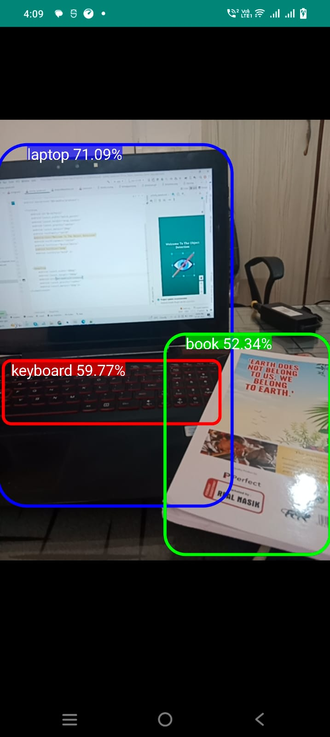

**Figure 05**: Detecting the object.

1. **CONCLUSION**

In conclusion, real-time object detection using machine learning has the potential to greatly improve the quality of life for visually challenged people. By leveraging technologies such as computer vision and deep learning, it is possible to develop algorithms that can recognize and describe the visual world in real-time, allowing users to navigate and interact with their environment more easily.

There are already several promising initiatives underway to develop assistive technologies based on real-time object detection, such as wearable devices that can identify objects and provide audio feedback to the user. As these technologies continue to evolve and improve, we can expect to see even more advanced and sophisticated applications in the near future.

Overall, the use of machine learning for real-time object detection is a promising and exciting area of research, with the potential to transform the lives of visually challenged people and help them to live more independently and confidently.

1. **REFERENCES**

[1] Maheshwari, K., Lamba, S., Sharma, R., & Yadav, P. A Survey on Mobile Applications for the Assistance of the Visually Impaired.(1997).

[2] Bhowmick, Alexy, and Shyamanta M. Hazarika. "An insight into assistive technology for the visually impaired and blind people: state-of-the-art and future trends." Journal on Multimodal User Interfaces 11.2 (2017): 149-172.

[3] David, Robert, et al. "Tensorflow lite micro: Embedded machine learning on tinyml systems." arXiv preprint arXiv:2010.08678 (2020).

[4] Aaron James S, Sanjana S, Monisha M, "OCR based automatic book reader for the visually impaired using RaspberryPI", Vol. 4, Issue 7, January 2016.

[5] Christopher G Relf, "Image Acquisition and Processing with LabVIEW", CRC Press, 2004.

[6] Sonia Bhaskar, Nicholas Lavassar, Scott Green, "Implementing Optical Character Recognition on the Android Operating System for Business Cards".

[7] G. Xydas, G. Argyropoulos, Th. Karakosta and G. Kouroupetroglou, An Experimental Approach in Recognizing Synthesized Auditory Components in a Non-Visual Interaction with Documents, in: Proc of the 11th Int Conference on Human-Computer Interaction, Las Vegas, Nevada, USA, 22–27 July, 2005.

[8] V. Zarikas, G. Papatzanis and C. Stephanidis, An Architecture for a Self-Adapting Information System for Tourists, in: Proceedings of the Workshop on Multiple User Interfaces over the Internet: Engineering and Applications Trends (in conjunction with HCI-IHM’2001), Lille, France, 10–14 September, 2001.

[9] Jisha Gopinath, Aravind S, Pooja Chandran, Saranya S S, "Text to Speech Conversion System using OCR", International Journal of Emerging Technology and Advanced Engineering , Volume 5, Issue 1, January 2015.

[10] Raviraj S Patkar , S. Pratap Singh , Ms. Swati V. Birje, "Marker Based Augmented Reality Using Android OS", International Journal of Advanced Research in Computer Science and Software Engineering ,Volume 3, Issue 5, May 2013.

[11] Ashwani Kumar, Ankush Chourasia, "Blind Navigation System Using Artificial Intelligence", March 2018

[12] Aaron James S, Sanjana S, Monisha M, "OCR based automatic book reader for the visually impaired using Raspberry PI", Vol. 4, Issue 7, January 2016.

[13] Christopher G Relf, "Image Acquisition and Processing with LabVIEW", CRC Press, 2004.

[14] Sonia Bhaskar, Nicholas Lavassar, Scott Green, "Implementing Optical Character Recognition on the Android Operating System for Business Cards".

[15] Julinda Gllavata, Ralph Ewerth and Bernd Freisleben, "A Robust Algorithm for Text Detection in Images".

[16] Chucai Yi, Yingli Tian, “Scene Text Recognition in Mobile Applications by Character Descriptor and Structure Configuration”, IEEE Transactions on Image Processing, Vol. 23 No. 7, July 2014