AN EXPERIMENTAL STUDY ON THE USE OF RECYCLED AGGREGATES IN RIGID PAVEMENT

**SAHIL1, MR. PARDEEP2, VIKAS SHARMA3**

1 M.Tech Scholar, Satpriya group of institutions, Rohtak, India

Singhmarsahil235[@gmail.com](mailto:refazgitm@gmail.com)

2 Assistant Professor, Satpriya group of institutions, Rohtak, India

[moharpardeep@gmail.com](mailto:moharpardeep@gmail.com)

3 M.Tech Scholar, Satpriya group of institutions, Rohtak, India

Vikasbhardwaj212@gmail.com

**ABSTRACT**

Concrete is one of the most widely used construction materials in the world, mainly due to its favorable features such as durability, versatility, satisfactory compressive strength, cost effectiveness. But with the depleting natural resources and the huge amount of concrete waste produced, it becomes essential to identify an effective way to solve the need of the moment. In this rapid industrialized world, recycling construction material plays an important role to preserve the natural resources. In this research, Recycled Coarse Aggregates (RCA) from demolished slab pieces was used. These demolished slab pieces are crushed to suitable size and reused as recycled coarse aggregate. Natural sand used as fine aggregate. Concrete industry, uses 12.6 billion tons of raw materials each year, is the largest user of natural resources in the world. The environmental impact of production of raw ingredients of concrete (such as cement and coarse and fine aggregates) is considerable. In this paper The mix design has been done by trial and error method. The mix proportions are calculated as per IS code. The design procedure as per IS code and IRC: 44-2008 is used in mix design of M30 grade cement concrete. The w/c ratio is taken 0.5% for all the mixes. Hence, Coarse aggregates was replaced in percentages of 0%, 20%, 40 %, 60 %, 80 %, 100 % with recycled coarse aggregates 150 × 150× 150mm, Beam and Cylinder moulds were used for casting.

**Keywords:** Recycled Aggregates, Compressive strength, Fresh Concrete, Waste management.

# INTRODUCTION

An alternate coarse aggregate that is often mixed with natural coarse aggregate for use in new concrete is crushed aggregate from either hardened residual concrete or demolition concrete. If not adequately regulated and monitored, the use of 100% recycled coarse aggregate in concrete is likely to have a detrimental impact on the majority of the characteristics of concrete, including compressive strength, elastic modulus, shrinkage, and creep, especially for higher strength concrete. Due to the high water demand of fine aggregate smaller than 150 m, which reduces strength and considerably increases concrete shrinkage, the use of fine recycled aggregate below 2 mm is also unusual in recycled aggregate concrete. Recycled aggregate cannot replace natural aggregate in excess of a certain amount according to several international norms or requirements. In comparison to concrete aggregate utilised in demolition, residual concrete aggregate may often be utilised at greater replacement rates. With residual concrete aggregate, information regarding the parent concrete's strength range, aggregate supplier, etc. will typically be available, however with demolition concrete, there may be very little information known. In addition to minor amounts of brick, masonry, or wood, the parent concrete and the resultant aggregate may be polluted with chlorides or sulphates, which might harm the recycled aggregate concrete. In contrast to recycled aggregate concrete where the recycled aggregate came from one source with a known history of use and known strength, it is common for the sources of material from which a recycled aggregate came (and there may be more than one source). As a result, the variability and strength of the recycled aggregate concrete may be adversely affected. Therefore, it is important to make a distinction between the characteristics of recycled aggregate concrete created using leftover concrete aggregate and that formed with demolition concrete aggregate. Aggregates must withstand pressures brought on by wheel loads on pavement, and they must also resist wear brought on by the abrasive action of traffic on the surface course. These are used in the creation of pavement made of cement concrete, bituminous concrete, and other types of bituminous construction, as well as in the granular base course that sits underneath the more advanced pavement layers. Crushing natural rock is used to create the majority of the road aggregates. Natural resources are scarce and their quantities are falling quickly, leading to a severe deficit. But if the parent concrete, the recycling of the aggregate, and the production of the recycled aggregate concrete are all tightly regulated, recycled aggregate concrete may be produced utilising recycled aggregate at 100% coarse aggregate replacement. Recycled aggregate, however, might restrict strength as goal strengths rise, necessitating a decrease in replacement of recycled aggregate.

# OBJECTIVE

The various objective of recycled aggregates which are as follow:

* Recycled Aggregate can be used in the following constructions
* Can be used for constructing gutters, pavements etc.
* Large pieces of crushed aggregate can be used for building revetments which in turn is very useful in controlling soil erosion.
* Recycled concrete rubbles can be used as coarse aggregate in concrete.
* Production of RAC also results in generation of many by-products having many uses such as a ground improvement material, a concrete addition, an asphalt filler etc.

# LITERATURE REVIEW ON RECYCLED AGGREGATES

**Gurukanth S**  analysed the Impact of Bituminous Concrete Surface Course's Use of Recycled Concrete Aggregates. Science and technology nowadays have a duty to develop new trends that are both affordable and environmentally friendly. Recycled aggregate (RA) may be produced from old, destroyed concrete constructions. In order to achieve a balance between supply and demand for building materials and lessen the impact on the environment, this may be utilised efficiently in conjunction with natural aggregates in a variety of infrastructure needs. The strength variation of bituminous concrete surface courses when recycled aggregates are employed in either a partial or complete replacement of natural aggregates is the subject of this inquiry. The strength differences in bituminous concrete surface courses using recycled aggregates in lieu of natural aggregates are studied using Marshall's approach. It was discovered that replacing up to 20% of the natural particles in bituminous concrete's surface course with recycled aggregates may be done without significantly changing the strength properties. However, the content of the binder has increased, necessitating an assessment of the replacement's economic worth.

**S R Yadav**  All of them looked at the usage of recycled concrete aggregate in concrete production. In this essay, the usage of recycled concrete as aggregates in concrete is reviewed in the literature, with a focus on compressive strength, and a method for using recycled concrete aggregate without sacrificing strength is suggested. Recycling research has emphasised the need for the final product to maintain the requisite compressive strength if utilised in second generation concrete. Study of the literature showsthat the main factors affecting compressive strength are adhering mortar, water absorption, Los Angeles abrasion, aggregate size, parent concrete strength, age of curing and replacement ratio, interfacial transition zone, moisture state, contaminants present, and regulated environmental conditions. There has to be established a straightforward and cost-effective way of employing destroyed concrete, accounting for the percentage adhering mortar, and calculating mix composition. Some research have recommended the mix design approach for recycled aggregates in concrete. Even though recycling has been the subject of much study, the building industry lacks an easy and affordable way to incorporate recovered aggregates into second-generation concrete.

[**López-Gayarre F**](https://www.ncbi.nlm.nih.gov/pubmed/?term=L%C3%B3pez-Gayarre%20F%5BAuthor%5D&cauthor=true&cauthor_uid=19709870)examined how recycled aggregate quality and proportioning standards affected the qualities of recycled concrete. The concrete created by partially replacing the native coarse aggregates with recycled aggregates from concrete demolition is used to show the experimental study findings in this article. On the desired quality of the concrete to be produced (strength and workability), the effect of the recycled aggregate quality (amount of declassified and source of aggregate), the percentage of replacement has been assessed. In this research, aspects that have not been examined in earlier studies—the granular structure of concrete and replacement criteria—were examined. The density, absorption, compressive strength, elastic modulus, quantity of trapped air, water penetration under pressure, and splitting tensile strength of recycled concretes were all examined. In order to make the amount of tests practical while ensuring the reliability of the results, a simplified test programme was created to control testing expenses while yet collecting enough data to establish trustworthy conclusions. The kind of aggregate, the replacement %, the type of sieve curve, the declassified content, the strength and workability of the concrete, as well as the replacement criteria, were all examined. The only variables that had a noticeable impact on the majority of the attributes were the kind of aggregate and the proportion of replacement. It is obvious that the quality of recycled aggregates has an impact on compressive strength. The proportion of replacement of recycled aggregate won't impact the compressive strength if the water-cement ratio is maintained and the loss of workability caused by the use of recycled aggregate is made up for using additives. The proportion of replacement affects the elastic modulus. If the replacement rate does not go beyond 50%, the elastic modulus will only marginally change.

**Tushar R Sonawane**  The utilisation of recycled aggregate in concrete was researched by all. Recycled aggregate is now being used in many building projects throughout various European, American, Russian, and Asian nations. To encourage the usage of recycled aggregate, several nations are relaxing their infrastructure rules. The fundamental characteristics of recycled fine aggregate and recycled coarse aggregate are reported in this paper, together with a comparison of these characteristics to those of native aggregates. All aggregate qualities undergo fundamental alterations, and their implications for concrete work are thoroughly examined. The characteristics of concrete using recycled aggregate are also established. Here are explanations of fundamental concrete qualities like as compressive strength, flexural strength, workability, etc. for various mixes of recycled aggregate with natural aggregate. Here are the codification rules for recycled aggregate concrete in different nations along with their impacts. pouring concrete. The overall state of recycled aggregate in India, as well as its future requirements and effective use, are covered here.

[**Paine, K. A**](http://opus.bath.ac.uk/view/person_id/2377.html) Concrete mixes including various ratios of unbound stone, crushed concrete, and crushed bricks were formed and tested in order to create this performance-related technique. Based on the findings and consideration of the Los Angeles coefficient, aggregate absorption, density, and drying shrinkage of the combined coarse aggregate, three classes of recycled aggregates have been developed. The idea is that although the two lower classes will be better suited for lower performance applications, the highest grade recycled aggregates will be acceptable for high-performance applications and fulfil the necessary standards and requirements. With this method, materials that are not completely defined for usage in BS 8500 today may be categorised and taken into consideration for pertinent applications. This should eliminate the primary technical obstacle impeding the use of recycled aggregates in concrete and give concrete specifiers and users more confidence.

**Janani Sundar** examined the effect of chemical addition on concrete made using recycled aggregates. In this study, aggregates from old concrete are recovered and used to make a durable, normal-strength concrete that contains 100% recycled concrete aggregate and chemical admixtures with a specific gravity of 1.19. The old concrete waste is broken down into the necessary aggregate size for this purpose, some simple tests are run, and the compressive strength of the concrete created with recycled aggregate is compared to that of the concrete made with regular aggregate. The direct percentage replacement idea is used. According to the test findings, recycled aggregate has a lower density than standard natural aggregates, which lowers the density of concrete. The compressive strength for 1.8% was found to be comparable to that of regular aggregate concrete when the chemical admixture was applied at 1.5, 1.8, and 2% of the weight of cement.

**Jitender Sharma** aggregates from recycled concrete were investigated. The introduction, manufacturing, and diverse construction industry uses of recycled concrete aggregates are covered in this study. The characteristics of recycled aggregates are discussed in this work, along with a comparison to natural aggregates. According to previous research, recycled aggregate is highly graded as natural aggregate but contains rough-textured, angular, and elongated particles, while natural aggregate is smooth and rounded compact aggregate. The ability of coarse recycled aggregate to absorb water is around two times or more than that of native coarse aggregate. In comparison to natural aggregate, recycled coarse aggregate has a lower dry density.

[**Marinković S**](https://www.ncbi.nlm.nih.gov/pubmed/?term=Marinkovi%C4%87%20S%5BAuthor%5D&cauthor=true&cauthor_uid=20434898)a comparative environmental evaluation of concrete using natural and recycled aggregate was conducted. The main goals of this study are to evaluate the structural applications of recycled aggregate concrete and compare the environmental effects of producing two different types of ready-mixed concrete: natural aggregate concrete (NAC), which is made entirely of river aggregate, and recycled aggregate concrete (RAC), which is made of natural fine and recycled coarse aggregate. It is determined that the use of RAC for low- to middle-strength structural concrete and non-aggressive exposure situations is technically possible after analysing recent experimental data, including personal test findings. The life cycle assessment (LCA), which includes transportation, is carried out for the extraction of raw materials and the manufacturing of materials. The assessment is based on regional LCI data and typical Serbian circumstances. According to the findings of this particular case study, the environmental effects of the aggregate and cement manufacturing phases are somewhat greater for RAC than for NAC, although the overall environmental consequences depend on the distances travelled by natural and recycled aggregates as well as the method of transport used. For the particular case study, the maximum natural aggregate transport lengths are determined, over which the environmental implications of RAC may be comparable to or even less severe than those of NAC.

# RESEARCH METHODOLOGY

**MIX PROPORTION**

The mix design was carried out using a trial-and-error methodology. According to the IS code, the mix proportions are computed. For the mix design of M30 grade cement concrete, the design technique outlined in the IS code and IRC: 44-2008 is applied. The following list outlines the materials needed to create concrete of the M20 grade, along with the test results for those materials. Hand mixing is used to combine the raw components, then cast cube and beam vibrators are used to condense the mixture. The samples were mixed for a total of 3 minutes, cast, and left for 24 hours before being demolded.The curing tank was then filled with them. For all combinations, the w/c ratio is 0.5%. Therefore, recycled coarse aggregates 150 150 150mm were utilised in lieu of new coarse aggregates in the following percentages: 0%, 20%, 40%, 60%, 80%, and 100%. Beam and cylinder moulds were employed for casting. Before the cubes were demolded and put in the curing tank, the concrete was left in the mould and allowed to set for 24 hours. For 7 to 28 days, the concrete cubes were cured in the tank. Table 1 displays the concrete's mix design.

Table 1: Mix Specification for 1 cubic meter Concrete

|  |  |  |  |  |  |  |
| --- | --- | --- | --- | --- | --- | --- |
| DESIGNATIONS | M 0 | M 1 | M 2 | M 3 | M 4 | M 5 |
| Particulars | Plain concrete mix | 20 % | 40 % | 60 % | 80 % | 100 % |
| Cement in kg/m3 | 375 | 375 | 375 | 375 | 375 | 375 |
| Sand in kg/m3 | 562.50 | 562.50 | 562.50 | 562.50 | 562.50 | 562.50 |
| Coarse aggregate in kg/m3 | 1125 | 900 | 675 | 450 | 225 | 0 |
| Recycled Aggregates | 0 | 225 | 450 | 675 | 900 | 1125 |

**COMPRESSIVE STRENGTH TEST**

The highest measured resistance of a concrete under axial loading may be referred to as the concrete's compressive strength. The compression test may be used to determine the strength of concrete specimens that have varied percentages of recycled aggregate substitution. Figure 1 depicts the compressive strength of concrete made using recycled aggregate.

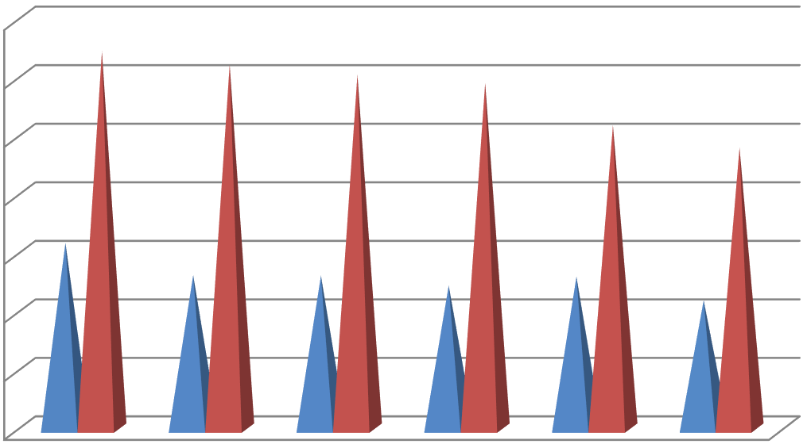

35

30

25

20

15

7 Days

28 days

10

5

0

Control

20 % RAC 40 % RAC 60 % RAC 80 % RAC 100 % RAC

Figure 1: Compressive strength of various mixes

**SPLIT TENSILE STRENGTH TEST**

Split cylinder test was carried out to ascertain tensile strength of standard cylinders cast from each mix. The Split strength of recycled aggregate concrete are shown in figure 2.

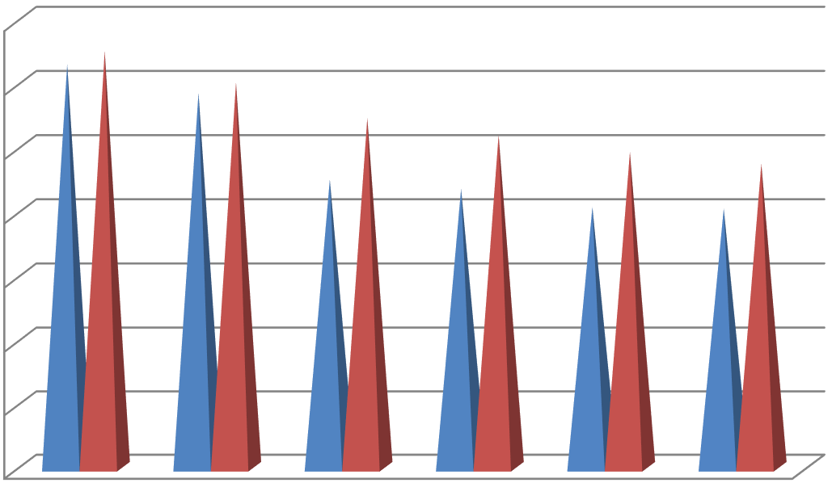

3.5

3

2.5

2

1.5

7 Days

28 days

1

0.5

0

Control

20 % RAC

40 % RAC

60 % RAC 80 % RAC 100 % RAC

Figure 2: Split tensile strength of various mixes

**FLEXURAL STRENGTH TEST**

Test resulted that the beams with 100% replacement of RCA obtained higher cracks and lower in deflection. Flexural Strength of recycled aggregate concrete are shown in figure 3.

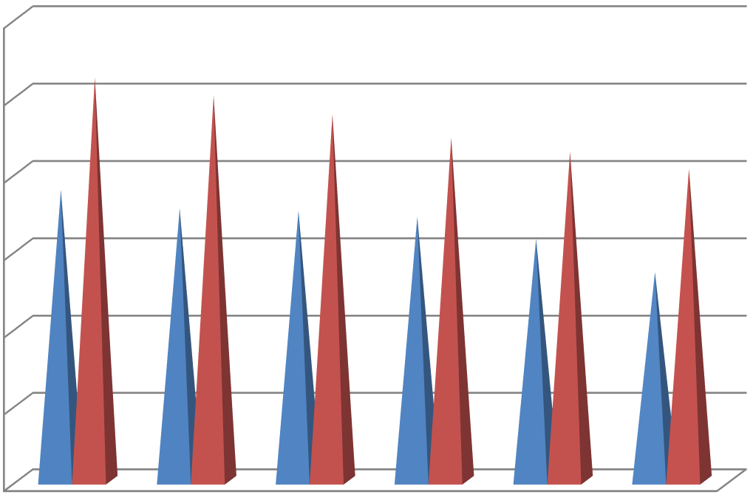

6

5

4

3

7 Days

28 days

2

1

0

Control

20 % RAC 40 % RAC 60 % RAC 80 % RAC 100 % RAC

Figure 3: Flexural strength of various mixes

# CONCLUSION

Based on the analysis and evaluation of the findings presented, the following set of general conclusions is drawn

1. It is discovered that recycled aggregate concrete has less slump.

The use of RCA increases shrinkage at a given water/cement ratio, increases the water demand at a certain consistency, and diminishes the workability of new concrete at a given water content.

2. The droop is also shown to be decreasing in concrete made with recycled material, albeit admixture has made it better.

3. In comparison to using fresh aggregate, incorporating RAP slows the pace at which compressive strength increases.

4. Energy and money used in the transportation of natural resources and excavation are greatly reduced by the use of recycled aggregate in building. This immediately lessens the negative environmental effects of garbage.

5. RA derived from clean, high-quality concrete has a better strength-to-weight ratio than regular aggregates.

6. According to the conclusions of the test results, using recycled aggregate up to 25% does not influence the functional requirements of the construction.

7. Tensile strength and elastic modulus are enhanced when the water cement ratio utilised in the recycled aggregate mix is decreased.

8. To ensure that recovered aggregates may be effectively utilised in the future, new criteria should be created.

9. Compared to NAs, recycled aggregate materials yield rough mixes with less workability.

10. If correct design is not used, the 100% substitution of NA by RCA in the concrete mixture may affect the resistance to chloride ions.

11. During the workability testing, it was found that a new concrete mix with a 40% substitution of RCA had the best workability.

# REFERENCES

1. Hansen, T.C., 2011. Recycled aggregates and recycled aggregate concrete second state-of-the-art report developments 1945–1985. Mater. Struct. 19: 201- 246. DOI: 10.1007/BF02472036
2. Hoe, K.W. and M. Ramli, 2012. Rational mix design approach for high strength concrete using sand with very high fineness modulus. Am. J. Eng. Applied Sci., 7: 1562-1568. DOI: DOI: 10.3844/ajassp.2010.1562.1568
3. Kumar, D.R. and B. Vidivelli, 2012. Acrylic rubber latex in ferrocement for strengthening reinforced concrete beams. Am. J. Eng. Applied Sci., 3: 277- 285. DOI: 10.3844/ajeassp.2010.277.285
4. Kumaran, G.S., N. Mushule and M. Lakshmipathy, 2012. A review on construction technologies that enables environmental protection: rubberized concrete. Am. J. Eng. Applied Sci., 1: 40-44. DOI: 10.3844/ajeassp.2008.40.44
5. Maghsoudi, A.A. and Y. Sharifi, 2013. The serviceability considerations of HSC heavily steel reinforced members under bending. Am. J. Applied Sci., 5: 1135-1140. DOI: 10.3844/ajassp.2008.1135.1140
6. Mehta, P.K. and P.J.M. Monteiro, 2014. Concrete. Microstructure, Properties and Materials. 3rd Edn, the McGraw Hill, New York, ISBN: 10:0071462899, pp: 659.
7. BalaguruP1, Stephen Kurtz 2, and Jon Rudolph 3. “Geopolymer for Repair and Rehabilitation of Reinforced Concrete Beams”. Geopolymer Institute 2015 02100 SAINT-QUENTIN – France.
8. Bhikshma, V., Kishore, R and Raghu Pathi, C.V. (2015), Investigations on flexural behavior of high strength manufactured sand concrete, Challenges, Opportunities and Solutions in Structural Engineering and Construction Ghafoori (ed.)© 2010 Taylor & Francis Group, London, ISBN 978-0- 415-56809-8.
9. GanapatiNaidu.P1, A.S.S.N.Prasad2, S.Adiseshu3, P.V.V.Satayanarayana4. “A Study on Strength Properties of Geopolymer Concrete with Addition of G.G.B.S”. International Journal of Engineering Research and Development Volume 2, Issue 4 (July 2016), PP. 19-28.
10. Joseph Davidovits. “Properties of Geopolymer cements”. Published in proceedings First International Conferences on Alkaline Cements and Concretes, Scientific Research Institute on Binders and Materials, Kiev State Technical University, Kiev, Ukraine, 2016, PP. 131-149.
11. Leopoldo Franco1, Alberto Noli.b2, Paolo.De.Girolamo.b3, Martina Ercolani.b4. “Concrete strength and durability of prototype tetra pod’s and dolosse: results of field and laboratory tests”. L. Franco et al. Coastal Engineering accepted 8 February 2020