**AUTOMATIC FLUSH AND FLOOR CLEANING SYSTEM**

**Aarti Shirsat1, Sakshi Shewale2, Rutuja Pingle3**

1, 2, 3Student, Department of Electronic and Telecommunication Engineering, NDMVP College of

Engineering, Nashik, Maharashtra, India

**ABSTRACT**

Auto flush and floor cleaning systems are innovative technologies designed to provide efficient and effective cleaning solutions for Restrooms and other areas with high foot traffic. The auto flush system is a sensor-based technology that automatically flushes toilets or urinals after use, thereby reducing water consumption and promoting hygiene. Hygiene has always remained a prime concern in growing urban areas. Conventional public toilets require land which is costly in cities. Most of the time they are not well maintained effective cleaning of the toilets was always a concern and a new generation toilet was required which is clean hygienic and user friendly because of this Automatic flush and floor cleaning machine is designed

**Keywords:** Toilet flusher, PIR sensor, Water conservation, Microcontroller

**1. INTRODUCTION**

This technology offers a comprehensive cleaning solution that ensures a clean and hygienic environment. Reducing labor costs and water. This system is particularly useful in public places such as airports, malls, hospitals, and school where maintaining cleanliness and hygiene is essential to prevent the spread of infection and diseases. Overall the auto flush and floor cleaning system represents a significant advancement in the field of cleaning technology, and it has the potential to revolutionize the way we approach cleaning in public places. The central government under the “SWACH BHARAT MISSION” has built a vast amount of new toilets to provide the citizens with a healthy and hygienic environment. Therefore cleaning public toilets is equally important as cleaning household toilets. So we have developed a mechanism to flush the toilets automatically.

**2. METHODOLOGY**

**2.1 Observation**

The provision of cost-effective and hygienic public toilets has always remained a prime concern in growing urban areas. Conventional public toilets require land which is costly in cities. Most of the time they are not well maintained effective cleaning of the toilets was always a concern and a new generation toilet was required which is clean hygienic and user friendly because of this Automatic flush and floor cleaning machine is designed. For this project, we used various forms to collect the data. The primary purpose of the data collection is observation, we come to know about this problem when we personally used public toilets. This was a sudden idea.

**2.2 Internet**

The project “auto flush”, the name itself says, is the automatic flash used in toilets. Here, flash is made automatic for the betterment of society, which provides effective cleaning by making use of wireless technology. The information related to this was moreover taken from the internet. As the internet is a vast source of information.

**2.3 Interview and Survey**

After keen observation, we started conducting interviews and research with the respective places and people. From this also we learned a lot. One more important part related to our project is, the public toilets depend on the user’s review, so we interviewed some of the users and visited some villages that basically use public toilets.

**2.4 Literature review**

As the data related to this topic was also collected from the various literature surveys. But to a limited extent, like the

The basic technology used. The names of the few literature surveys used by us for the information collection are mentioned in the reference section.

**3. MODELING AND ANALYSIS**

In this section, we have represented the block diagram, according to which the process takes place.

PIR Sensor

T-Shape Relay 1

Busy

Cube Relay 1

Floor Clean

IC PIC18F4550

T-Shape Relay 2

Vacant

Cube Relay 2

Flush

T-Shape Relay 3

Fan

Cube Relay 3

Meter Valve

T-Shape Relay 4

Light

Cube Relay 4

Door Lock

**Figure 1:** Block Diagram

In this section, we have represented the flow chart

**Initialization**

**Check seat is occupied or not**

**YES**

**Busy**

**If occupied**

**NO**

**Door open**

**No**

**Door will not open**

**Fan&light get on**

**Flush will on**

H

**When person out**

**NO**

**No action**

**YES**

**Floor cleaning relay get on**

**Yes**

**Meter valve aslo get on**

**Figure 2:** Flow chart

**4. RESULTS AND DISCUSSION**

The result of this project LED which is glowing means the floor cleaning and auto flush are activated

. 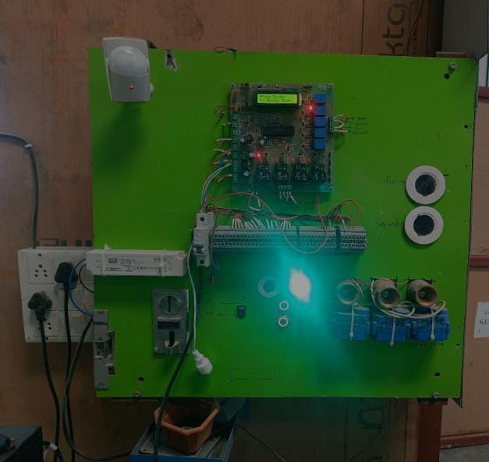

**Figure 3:** Testing and Result

**5. CONCLUSION**

A Smart Toilet flushing system using sensor technology and a microcontroller was introduced. The circuit was designed and implemented. The system is Fully Automated. It will reduce the dirty ness of public toilets. Thus the present Innovation provides a low-Cost alternative for the automatic compulsory regular and intentional and hands-free flushing of toilets which not only results in the development and facilitation of low-cost clean and hygienic but also results in the saving of precious natural resources like water and energy. In our proposed system. We found some advantages over the existing system, with the help of electronic sensors such as ultrasonic sensor IR sensors and Arduino controller we have implemented an automatic toilet monitoring system .which provides proper sanitization .our system also incorporates efficient use of power and reduces wastage of water

**ACKNOWLEDGEMENTS (optional)**

In the paper publishing and the project work, a lot of people help me. This paper would not have been possible without the help

Of my guide. I want to give my sincere thanks to my guide Ms. D. V. Patil Ma’am for guiding and supporting us throughout the work. And last thanks to my friends who help me with the paper

**REFERENCES**

1. Nafeesa manutashar, Shahana KN, Saniya Shilledar “Smart urinal mech- automatic flush,” SCET, Belagavi, India, Vol. 5, Issue 6, June 2018.
2. Anirudha Kesarkar, Ashutosh Jadhav, Pratik Dugge, Rahul Katkar, Ruturaj Aswale, P.K.Desai, " Design and Development Of Automatic Urinal Flushing System",for "International Research Journal of Engineering and Technology", vol.7, Issue.2, Feb 2020.
3. S.B.Wath," A Mechanical Automatic Urinal-Toilet Flusher for Swach Bharat Mission", for “International Conference on Social Waste Management, 5Icon SWM", 2015.
4. Dinesh Kumar Suppan, M.Saleem, “Design and fabrication of Automated Urinal Flushing System Using Mechanical Element with Disinfectant ", for “International Journal of Innovative Technology and Exploring Engineering (IJITEE)", ISSN: 2278-3075, vol.8, Issue.9.July 2019.