**Home Automation Using Bluetooth, Android and Arduino**

**Author Name**

1. Sushilkumar Lohakare 2 Suraj Shinde 3 Prof Sameer Raut

Student(EE) SSCET , Student(EE) SSCET , Asst.Professor (EE) SSCET

***Abstract:- Technology is a never ending process. To be able to design a product using the current technology that will be beneficial to the lives of others is a huge contribution to the community. This paper presents the design and implementation of a low cost but yet flexible and secure cell phone based home automation system. The design is based on a standalone Arduino BT board and the home appliances are connected to the input/ output ports of this board via relays. The communication between the cell phone and the Arduino BT board is wireless. This system is designed to be low cost and scalable allowing variety of devices to be controlled with minimum changes to its core. Password protection is being used to only allow authorized users from accessing the appliances at home.[1]***

***Keywords- Home automation; Smartphone; Arduino; Bluetooth; Home appliances.***

**Introduction**

Home automation is the use of one or more computerized remote to control basic home appliances remotely and sometimes automatically . It is designed to contr[1](https://www.sciencedirect.com/science/article/pii/S2468227621000156" \l "cit_1)ol lighting points, entertainment systems, and home security such as access control as well as alarm systems.[2] No wonder, home automation is already an exciting word, especially because the wave of second-generation homeowners is growing, they need quite a lot of shelter, water, and electricity. The primary and most evident advantage of Smart Homes is comfort and convenience, as more gadgets can cope with more operations (lighting, temperature, then on) which successively frees up the resident to perform other tasks. Almost everyone carries a smartphone nowadays, which can be used to control every appliance in their day to day life easily. Everyone knows how to use a smartphone due to their easy to understand interface. Appliances (such as lights, fans, Home Monitoring Systems, AC etc.) can be controlled using a Bluetooth module based remote application in the smartphone using Arduino. The smart home gadgets interact, seamlessly and securely. Smart homes stuffed with connected products are loaded with possibilities to create our lives easier, more convenient, and lighter.[3] Today, we have remote controls for our TV sets and various electronic systems, which have made our lives easier in reality. Have you ever been confused about home automation that might enable prominent lighting, fan, and receiver of various electrical appliances that use a remote control? Without a course, Yes! But, does square measure the available options less expensive? If there is no solution, get an answer for that. we also have a new system known as Arduino based mainly Bluetooth for home automation. this process is very expensive and may give the user, flexibility | control | manage} any device while there is no external control fee. This project helps the user to control all the electronic devices on his smartphone. Time can be very important. everyone wants to save as much time as they want. New technology square measure was introduced to save most of our time. In order to save time most people tend to measure square and introduce exploitation of the Home Automation Bluetooth system. With the help of this process you will be able to carry your household appliances to your luggage. you will be able to turn on / off your home appliances during Bluetooth variations.[4]

**Block Diagram**

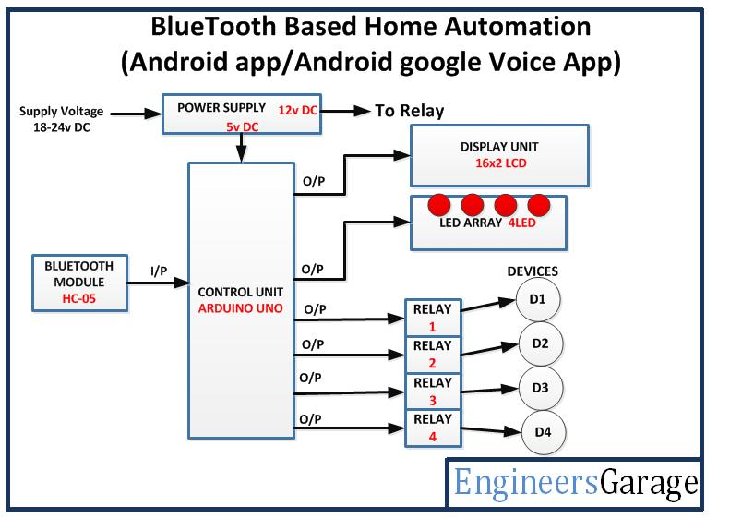

**Components**

Hardware Components: The designed Home Automation system contains three main hardware components Arduino UNO board, 4- Channel 5V relay Module and HC-05 Bluetooth module. Smartphone is used to provide communication between Arduino UNO board and Bluetooth module using a smartphone application named as Arduino Bluetooth Control Device. In this project Bluetooth module HC-05 and Arduino Uno board are used for hardware implementation. It communicates with the microcontrollers using serial communication (USART), it has a frequency of 2.45GHz. Relay are the switch that operates on electricity. It is based on electromagnetism. The switches opens and closes the circuits by receiving electrical signals from outside sources, as soon as the relay will receive a signal from Arduino it will turn on the respective circuit. Other devices include simple jumper wires, bulb, etc. The software application is built for the master device which will control the overall devices that are needed to be connected to relay and microcontroller. User can try for manual buttons that are available at the main screen of application. The number of devices to be connected depends on the number of modules in relay the more the modules the more the device connections.

Software Components: In this study, two pieces of software—the Bluetooth terminal application and the Arduino Integrated Development Environment (IDE)—are employed.[6]

**Advantage**

1. Everything is automated so it is easy to use.

2. It is control by mobile application so no extra training is required.

3. We can change controlling system as our requirement.

4. It works on Arduino based system so we can easily understand how it works.

5. It saves our time.

6. Every home appliance can control by one android application.

7. Easy installation and user friendly.[9]

**Program Flow:**

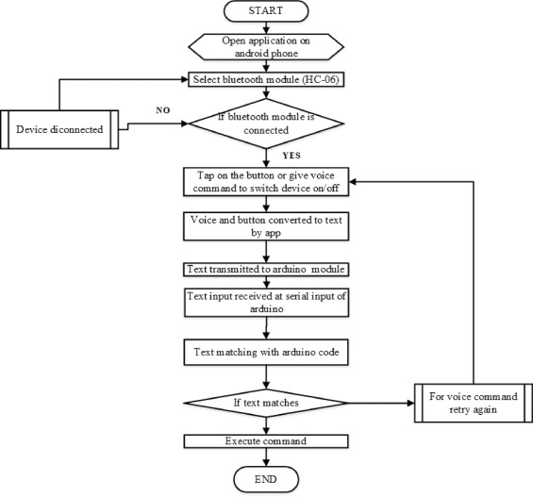

**Working**

Bluetooth module HC-05 transmits and receives data serially via Arduino board that can be read by the microcontroller. The following steps should be followed to run the project successfully:-

• Arduino UNO is the main component of this project. It performs the main function of the project.

• Arduino programming language is used to operate the Arduino UNO.

• Bluetooth module is used to receive and transfer the data through android mobile phone. It is connected to the Arduino UNO.

• AMR voice recognition android application is used to act as voice application which is downloaded from app store.

• People can control their home appliances via home automation devices and set up the controlling actions in their mobile.

• Used voice commands [10]

**Applications**

1. Using this project, we can turn on or off appliances remotely i.e. using a phone or tablet.

2. The project can be further expanded to a smart home automation system by including some sensors like light sensors, temperature sensors, safety sensors etc. and automatically adjust different parameters and transmit the information to our phone

3. Additionally, we can connect to internet and control the home from remote location over internet and also monitor the safety. Future Development of the project.

4. Arduino based device control using Bluetooth on Smartphone project can be enhanced to control the speed of the fan or volume of the buzzer etc.

5. Home automation and Device controlling can be done using Internet of Things – IOT technology.12]

**Conclusion**

This project helps to control the electrical loads with the help of android application. The electrical loads are controlled based on Bluetooth input signal. This input signal is received from the android device. Many times it becomes too tiring to operate the electrical switches manually every now and then. This is a big problem especially in case of aged or handicapped people. The android solves the issue by interfacing a unit with home appliances that switches these loads based on the input received from android device.[13]

**Future Scope**

• Voice commands can be implemented so that the persons without hands can also operate this system.

• Sophisticated electrical appliances can be controlled. For example: Microwaves, Air conditioning temperature, etc.

• The system can be used in home, small offices to the big malls [14]

**References:**

[1] <https://www.ijert.org/bluetooth-based-home-automation-using-arduino>

[2]<https://www.impactjournals.us/index.php/download/archives/03-07-2021-1625293994-6-.-3.%20Engg%20%20ARDUINO%20BASED%20HOME%20AUTOMATION%20USING%20BLUETOOTH%20ANDROID%20SMARTPHONE.pdf>

[3]<https://www.irjmets.com/uploadedfiles/paper/issue_5_may_2022/22923/final/fin_irjmets1652600108.pdf>

[4]<https://www.google.com/search?q=home+automation+using+bluetooth+android+and+arduino+block+diagram>

[5] https://www.ijraset.com/research-paper/home-automation-using-arduino

[6]https://www.google.com/search?q=home+automation+using+bluetooth+android+and+arduino+program+flow

[7]<https://www.rcciit.org/students_projects/projects/aeie/2018/GR6.pdf>

[8]<https://www.ijcrt.org/papers/IJCRT2101203.pdf>

[9]<https://www.ijsdr.org/papers/IJSDR1805044.pdf>

[10] https://ijireeice.com/wp-content/uploads/2021/06/IJIREEICE.2021.9554.pdf

[11]slideshare.net/Aakashkumar276/project-report-on-home-automation-using-by-bluetooth

[12]<https://www.irejournals.com/formatedpaper/1701557.pdf>

[13]<https://www.iiardjournals.org/get/WJIMT/VOL.%202%20NO.%201%202018/Home%20Automation.pdf>

[14] https://ijireeice.com/wp-content/uploads/2021/06/IJIREEICE.2021.9554.pdf