SCREENING AND IDENTIFICATION OF MICROBES FROM PACKED OR PROCESSED FOODS FROM MADURAI DISTRICT, TAMILNADU, INDIA
Mr. C. Santhaseelan, Tharunkumar. A. S, vinothkumar.C
Department of Biotechnology, V.S.B Engineering College, Karur
Abstract:
This study focuses on the crucial task of identifying and counting microorganisms found in pack or processed foods to ensure their safety and quality. The project also utilizes molecular and biochemical techniques to characterize these microorganisms. Various techniques such as serial dilution, enrichment culture, filtration, and direct plating methods are utilized to screen and isolate the microorganisms, and they undergo PCR amplification, sequencing and biochemical tests for characterization. The research discovered various microorganisms such as bacteria, yeasts, and fungi present in different food products with varying contamination levels. An analysis of the microorganisms showed that a few of them could cause food spoilage, including Pseudomonas, Bacillus, and Aspergillus species. Also, the study identified useful microorganisms such as lactic acid bacteria, which can be used as probiotics or for food fermentation. This research provides valuable insights into the microbiological quality of packed or processed foods and contributes to the development of effective strategies to improve food safety and quality.
1. Introduction:
In the food industry, food quality and safety are important concerns, and the presence of microbes in packaged or processed meals can have a big impact on both.[1] Food rotting brought on by microbial contamination can result in financial losses and public health issues. A few microbes can also result in foodborne infections, which can be serious and even fatal.[2] Hence, it is crucial to screen and isolate microorganisms from packaged or processed meals in order to ensure the safety and quality of the food. Identification and counting of the microorganisms in a sample are necessary for screening and isolating germs from food products.[3] In order to accomplish its goal, this project will screen and isolate bacteria from packaged or processed foods using a variety of microbiological techniques, and then identify and describe the isolated microorganisms using molecular and biochemical methods.[4] The outcomes of this project may offer insightful information about the microbiological consistency of packaged or processed foods, as well as aid in the creation of novel approaches to enhancing food quality and safety[5].
2. Materials and Methods:
2.1 Sample Collection:
Packed and Processed foods were purchased around the areas of Madurai district. A portion of each sample was aseptically moved to sterile tubes to reduce the risk of contamination. A total of 10 samples were purchased namely,
SNO | SAMPLES | COLLECTED AREA
1 | Almond Milk | Madurai
2 | Aloevera Drink | Madurai
3 | Dried Ginger Powder | Madurai
4 | Ginger Garlic Paste | Madurai
5 | Grape Juice | Madurai
6 | Idly Chilli Powder | Madurai
7 | Paruppu Saadha Podi | Madurai
8 | Pomegranate Juice | Madurai
9 | Tomato Puree | Madurai
10 | Water | Madurai

2.2 Serial Dilution:
During the sequential re-suspension of an original solution into predetermined amounts of a liquid diluent, a known or unknown substance is systematically reduced through serial dilution.[6] 1 gm or 1 mL of the sample is added to 1 mL of the double-distilled water to create the stock solution. The first tube (T1), which has the greatest dilution factor label and contains 900 μL, receives a 1 mL aliquot of the stock solution.[7] Repeat the procedure by aliquoting 1 mL of the fresh solution1 and putting it in tube 2. The stock concentration is diluted by a factor of 10 with each stage of aliquoting and resuspension until the last tube is reached.[8]
2.3 Preparation of the substrates:
Nutrient agar and Luria-Bertani medium were used for the majority of the samples as they promote bacterial growth.[9]
2.3.1 Nutrient agar medium: Medium was prepared by dissolving 2.8 g of commercially available Nutrient Agar Medium (HiMedia) in 100 ml of distilled water.[10] The dissolved medium was autoclaved at 15 pounds of pressure at 121°C for 15 minutes. The autoclaved medium was mixed well and poured into 100 mm petri dishes (25-30 ml/plate) while still molten.[11]
2.3.2 Nutrient Broth: It was prepared by dissolving 2.8 g of commercially available medium (HiMedia) in 100 ml of distilled water and boiling until the medium was completely dissolved.[12] Media was dispensed as needed and autoclaved at 15 lbs (121°C) for 15 minutes.[13]
2.3.3 LB Agar: Medium was prepared by dissolving 2.5 g of commercially available LB medium (HiMedia) in 100 ml of distilled water.[14] The dissolved medium was autoclaved at 15 pounds of pressure at 121°C for 15 minutes. The autoclaved medium was mixed well and poured into 100 mm Petri dishes (25-30 ml/plate) while still molten.[15]
2.4 Spread Plating:
Plate the bacteria: Pour the agar medium into a sterile Petri dish and allow it to solidify. Take a small volume of the diluted sample suspension (usually 0.1 mL) and place it on the centre of the agar plate.[16] Using the sterilized spreader, spread the bacterial suspension evenly over the surface of the agar plate or LB plate.[17]
Sterilize the spreader: Sterilize the spreader by dipping it in 70% ethanol and flaming it until it turns red hot. Allow it to cool for a few seconds before use. In a clockwise/counter clockwise motion, glide the horizontal portion of the spreading rod to equally distribute the sample within the petri dish.[18]
Incubate the plate: Invert the agar plate and incubate it at the temperature of 37°C for 24 hours and conditions for the bacterial strain being tested.[19]
2.5 Subculture Plating:
Streak the mixed culture: Using a sterile loop, streak a small amount of the mixed culture onto the surface of the agar plate in a zigzag pattern.[20] The streaking should be done in such a way that the bacterial cells are diluted as the streaks progress.
Incubate the agar plate: Invert the agar plate and incubate it at 37°C for 24 hours and conditions for the bacterial strain being tested.[21]
Observe the colonies: After incubation, observe the agar plate for bacterial colonies. There may be several different types of colonies present on the agar plate.
Pick a single colony: Using a sterile loop, pick a single colony of the bacteria of interest. The colony should be well-separated from other colonies.[22]
Subculture the colony: Streak the single colony onto a fresh agar plate using the streaking technique. The goal is to produce isolated colonies of the bacteria of interest.[23]
Incubate the agar plate: Invert the agar plate and incubate it at 37°C for 24 hours and conditions for the bacterial strain being tested.[24]
Observe the colonies: After incubation, observe the agar plate for bacterial colonies. There should be isolated colonies of the bacteria of interest.[25]
2.6 Bacterial Suspension
Sterilize equipment: Sterilize all equipment that will come into contact with the bacterial culture, including the test tubes, pipettes, and loop or swab.[26]
Prepare the nutrient broth: The Nutrient broth were prepared using commercially available nutrient medium (HiMedia) and autoclaved for free of contamination.
Obtain the bacterial culture: Obtain a bacterial culture that has been grown on an agar plate or stored in a culture collection.[27,28]
Inoculate the nutrient broth: Using a sterile loop or swab, transfer a small amount of the bacterial culture to the nutrient broth. The amount of bacterial culture added will depend on the desired cell density for the experiment.[29]
Incubate the nutrient broth: Incubate the nutrient broth at the appropriate temperature and conditions for the bacterial strain being tested. Ensure that the broth is well mixed by gently swirling the test tube.[30]
2.8 Biochemical Tests
Out of the 10 sub culture plates, 5 cultures which are unique in morphology was chosen for biochemical tests.
Nutrient broth was prepared and the cultures were grown in suspension.
The major biochemical tests used in this research are Indole test, Methyl Red test, Voges Proskauer test and Citrate utilization test.[31, 32].
Indole Test:
It is used to test whether bacteria can break down the amino acid. Tryptophan.[33]
Procedure:
1. Inoculate a 24 hours culture in Tryptophan Broth
2. Incubate at 37⁰ C for 24 hours
3. Add 0.5ml of Kovac’s Reagent to the broth
Methyl Red Test:
It is used to check the ability of bacteria to perform Mixed Acid Fermentation of glucose into Acetic acid, Lactic acid and Succinic acid.[34]
Procedure:
1. Inoculate a 24 hours culture in MR VP broth
2. Incubate at 370 C for 48 hours
3. Add 5 drops of methyl red to the broth
Voges Proskauer Test:
It is used to check the ability of bacteria to produce acetoin – a non-acidic neutral end product of glucose fermentation.[35]
Procedure:
1. Inoculate a 24 hours culture in MR VP broth
2. Incubate at 370 C for 48 hours
3. Add 0.3ml of Barritt’s reagent A then add 0.2ml of Barritt’s reagent B
4. Shake the tube and expose to atm. O2 and keep the tube for 10 – 15 mins undisturbed.

Citrate Utilization Test:
It is used to determine the ability of bacteria to utilize Sodium Citrate as its only carbon source inorganic Ammonium dihydrogen phosphate as the sole nitrogen source.[36]

Procedure:
1. Inoculate a 24 hrs culture in Simon Citrate Agar slant
2. Incubate aerobically at 37 C for 24 hrs
3. Some organism may require up to 7 days of incubation due to their limited rate of growth on citrate medium
2.9 Isolation of Genomic DNA:
1) Take 1.5 ml of O/N culture. Centrifuge at 10,000 rpm for 5 mins.
2) Discard the supernatant. To the pellet add 560ul of TE buffer and mix well.
3) Add 60ul of 10% of SDS and mix well. Incubate for 1hr at 37C.
4) Add 100ul of 5M NaCl and mix well. Then add 80ul of CTAB/NaCl solution. Mix and incubate at 65C for 10mins.[37]
5) Then add equal volume of phenol:chloroform:isoamyl alcohol(25:24:1).Mix well and centrifuge at 12,000rpm for 5mins.
6) Transfer the aqueous supernatant to a fresh tube and leave the interface behind.
7) Add equal volume of chloroform:isoamyl alcohol(24:1).Mix well and centrifuge at 10,000rpm for 5mins.[38, 39]
8) Transfer the supernatant to a fresh tube and add double the volume of absolute ethanol to precipitate DNA, shake the tube back and forth till the strongly white DNA precipitate becomes clearly visible.
9) Centrifuge at 10,000rpm for 5mins.Discard the supernatant and add 200ul of 70% ethanol.
10) Wash it and air dry it. Add 40ul Milli Q Water.[40]
Solution preparation:
TE buffer: 1ml of 1M Tris,0.2ml of 0.5M EDTA and make up to 100ml using distilled water.
10%SDS: 10g SDS in 100ml of distilled water.
CTAB/NaCl solution: Dissolve 2.5g of NaCl in 4oml distilled water. Add 5g CTAB and heat it at 65C.Adjust the volume to 50ml.[41, 42]
2.10 16s rDNA Amplification
Three microliters of the extracted DNA was amplified with primers 16sFp1(5’-GTGCCAGCAGCCGCGGTAA-3’) and 16sRp1 (5’-TACGGYTACCTTGTTACGACTT-3’) generating a PCR product corresponding to nucleotide positions 8 to 926 of the Escherichia coli 16S rDNA sequence. All reactions were performed in 25 µL volumes containing 12.5 µL of master mix, 1 µL of each forward and reverse primer, 2 µL of template DNA, 8.5 µL of PCR-H2O.[39]
PCR was performed in the pattern of the following thermocycling program: Denaturation at 95°C for 5 minutes, followed by 1 minute denaturation at 95°C up to 30 cycles, annealing at 55°C for a minute, extension at 72°C for a minute, and a final extension step at 72°C for 5 minutes. Visualization of PCR products was done in electrophoresis in 1% (wt/vol) agarose gels and the used staining was ethidium bromide (0.5 μg/ml). The amount of PCR product used for visualization is 10 microliters. [43]
Sterile water was used to prepare all solutions which was double distilled and treated with UV for 30 mins to avoid contamination. 3 separate rooms were used for the process of master mix preparation, template addition, and the gel electrophoresis of PCR products.[44, 45] To reduce the probability of false positive PCR results which occurs due to cross contamination, 2 negative controls were used for each master mix.[46]
2.11 16s rDNA Sequencing
16S rDNA sequencing is a molecular biology technique used to identify and classify bacteria based on their DNA sequences. The 16S rDNA gene is a small subunit of the bacterial ribosomal RNA gene, and it is present in all bacteria.[47] The PCR products can be sequenced using a next-generation sequencing platform, such as Illumina or PacBio. The generated sequence data can be analysed using bioinformatics tools, such as BLAST or QIIME, to identify and classify the bacterial species.[48]
3. RESULTS AND DISCUSSION:
3.1 SAMPLE COLLECTION:
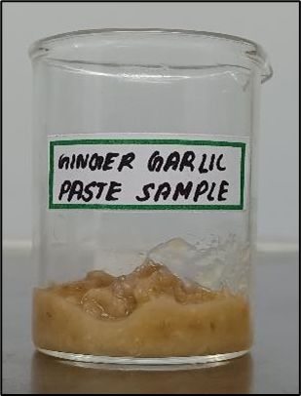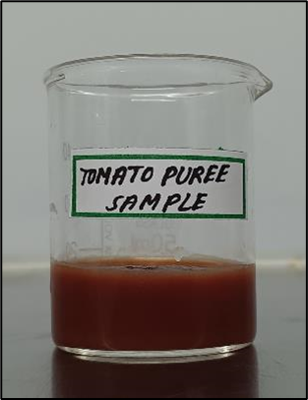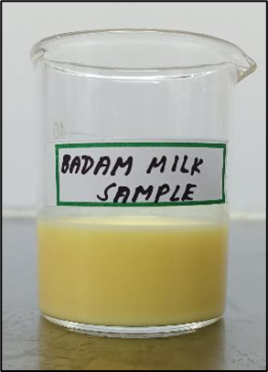
GINGER GARLIC PASTE TOMATO PUREE ALMOND MILK
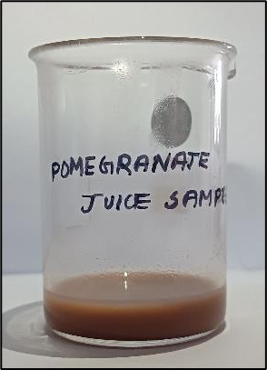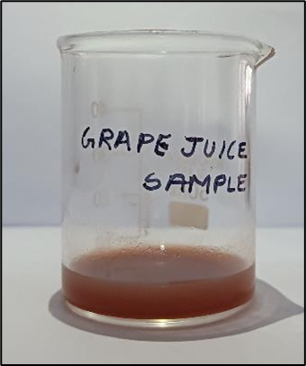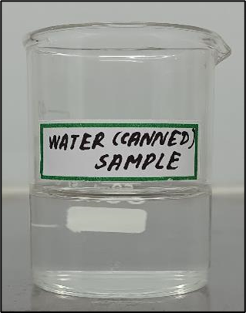
POMEGRANATE JUICE GRAPE JUICE WATER
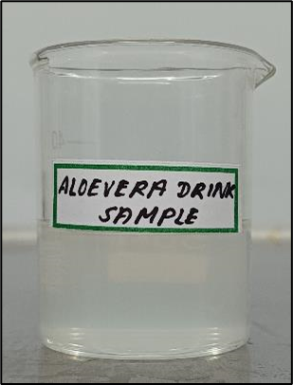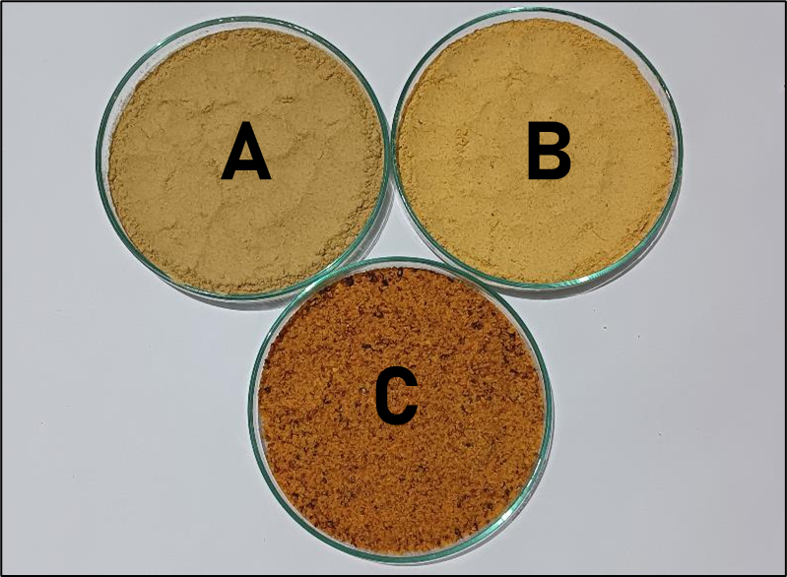
ALOEVERA DRINK A – DRIED GINGER POWDER B – PARUPPU SADHA PODI C – IDLY POWDER
All 10 samples were collected around the areas of Madurai and immediately transferred into sterile containers to avoid cross-contamination.
3.2 SPREAD PLATING RESULTS OF SAMPLES
Culture plates of the sample DRIED GINGER POWDER

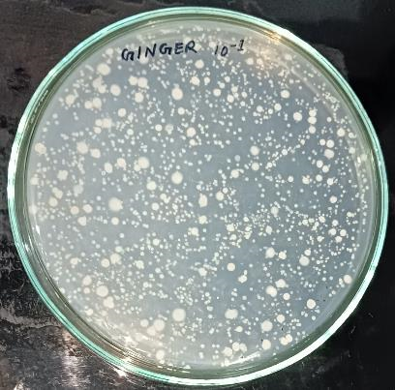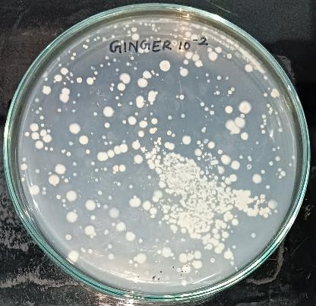
Concentration 10⁻¹ Concentration 10⁻ ²

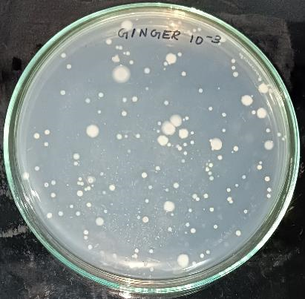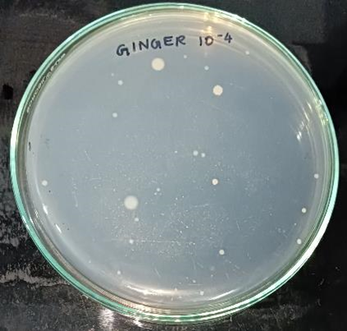
Concentration 10⁻³ Concentration 10⁻⁴
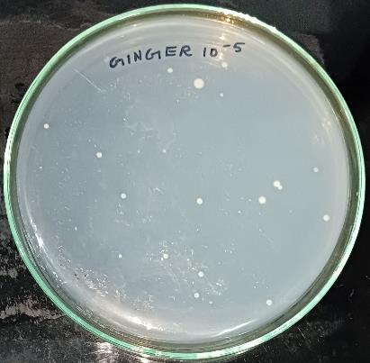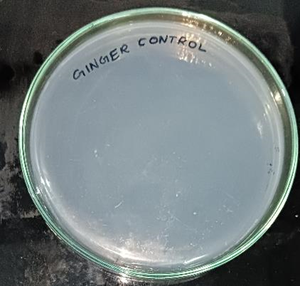
Concentration 10⁻⁵ Control plate
Culture plates of the sample TOMATO PUREE
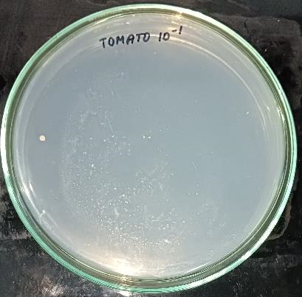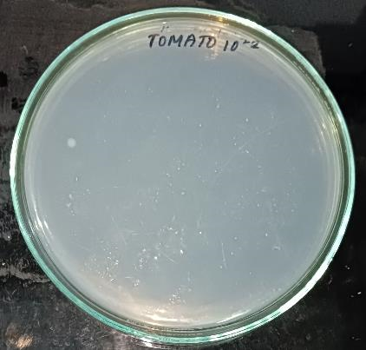
Concentration 10⁻¹ Concentration 10⁻ ²
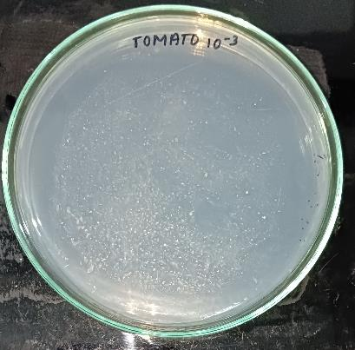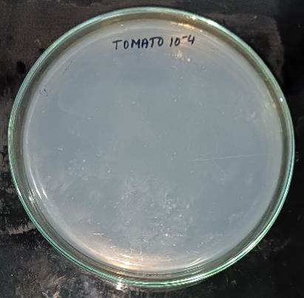
Concentration 10⁻³ Concentration 10⁻⁴
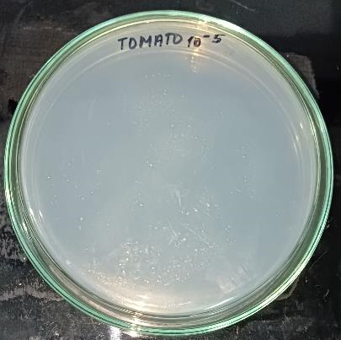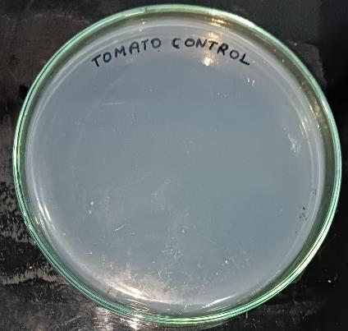
Concentration 10⁻⁵ Control plate
Culture plates of the sample POMEGRANATE JUICE
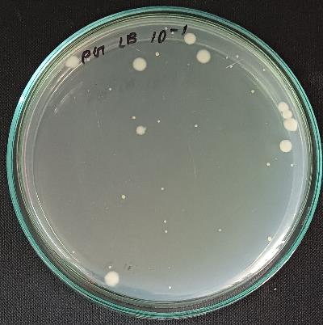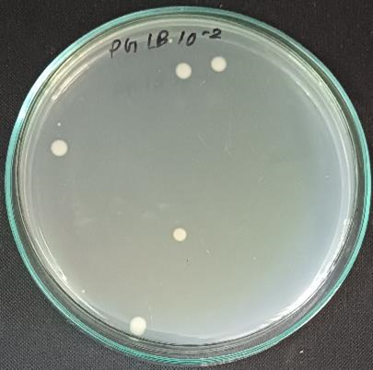
Concentration 10⁻¹ Concentration 10⁻ ²
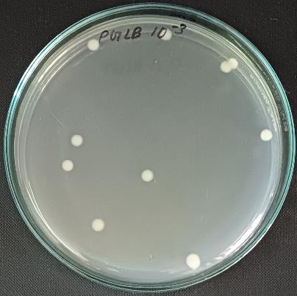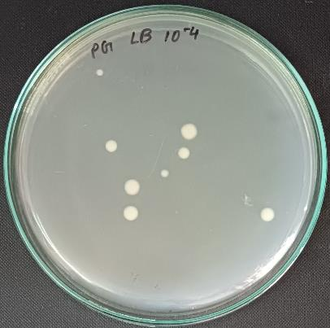
Concentration 10⁻³ Concentration 10⁻⁴
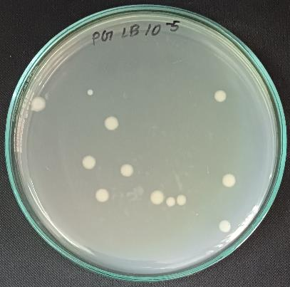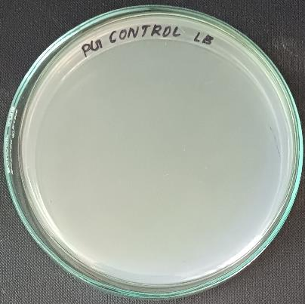
Concentration 10⁻⁵ Control plate
Culture plates of the sample GRAPE JUICE
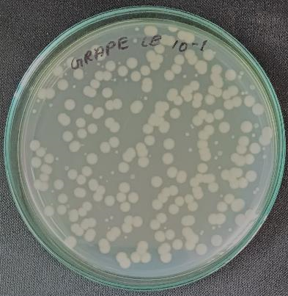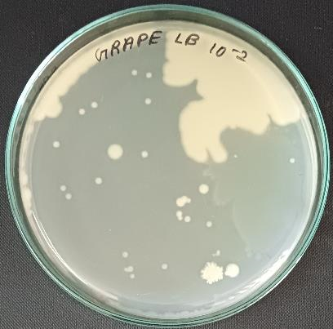
Concentration 10⁻¹ Concentration 10⁻ ²
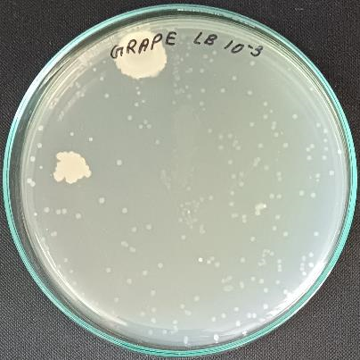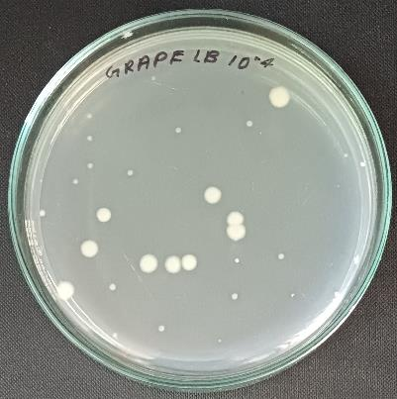
Concentration 10⁻³ Concentration 10⁻⁴
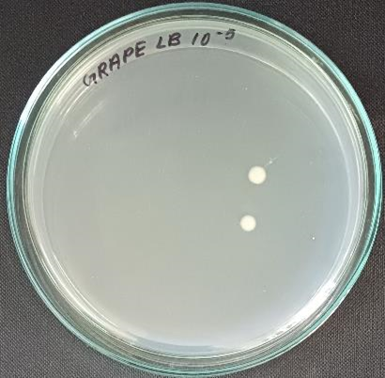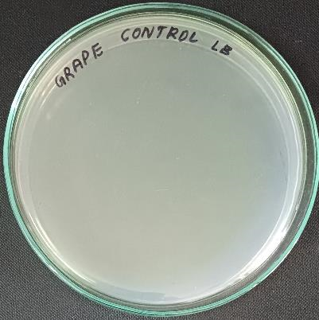
Concentration 10⁻⁵ Control plate
Culture plates of the sample IDLY POWDER
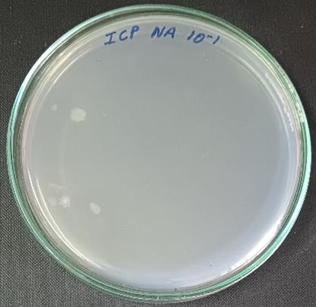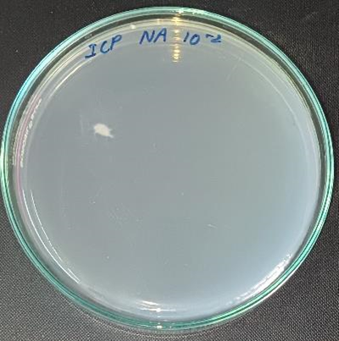
Concentration 10⁻¹ Concentration 10⁻ ²
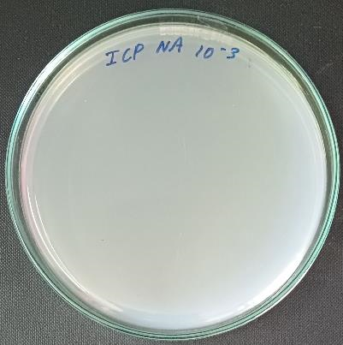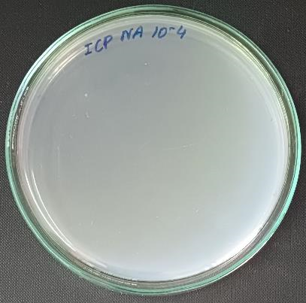
Concentration 10⁻³ Concentration 10⁻⁴
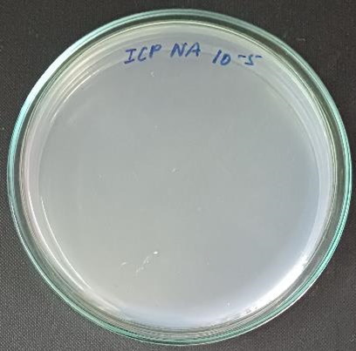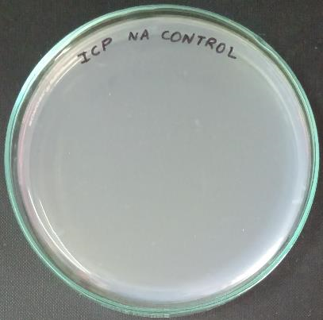
Concentration 10⁻⁵ Control plate
Culture plates of the sample PARUPPU SADHA PODI
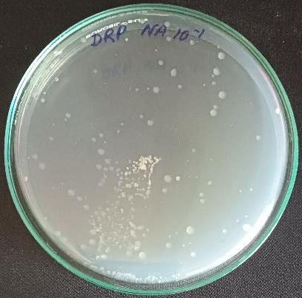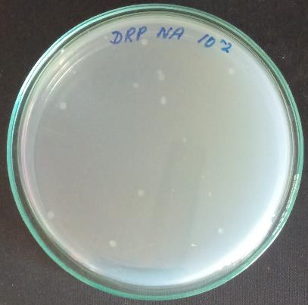
Concentration 10⁻¹ Concentration 10⁻ ²
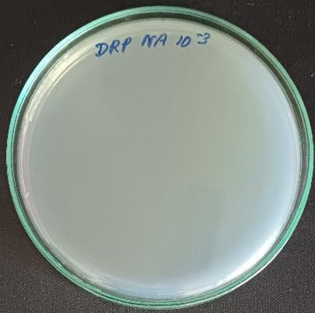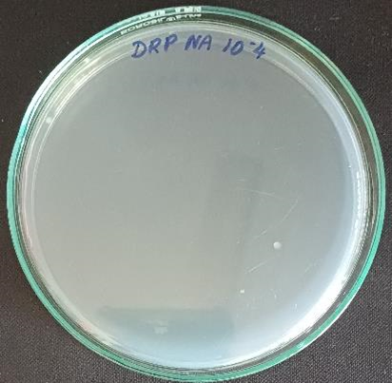
Concentration 10⁻³ Concentration 10⁻⁴
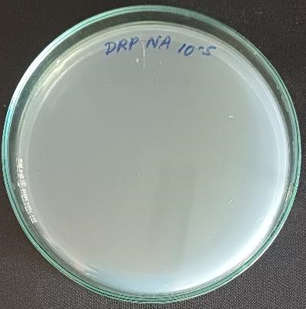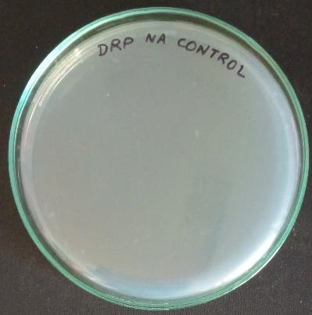
Concentration 10⁻⁵ Control plate
Culture plates of the sample GINGER GARLIC PASTE
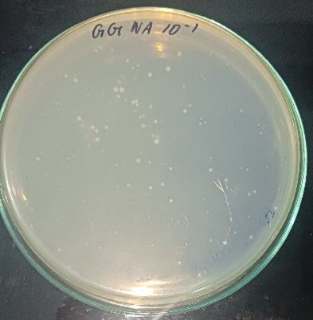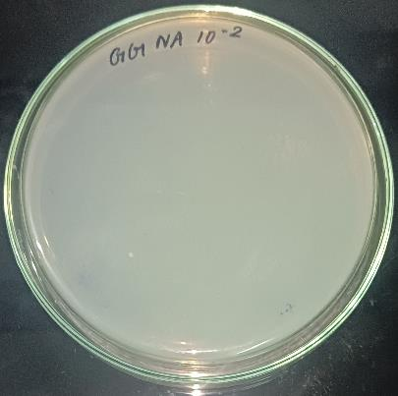
Concentration 10⁻¹ Concentration 10⁻ ²
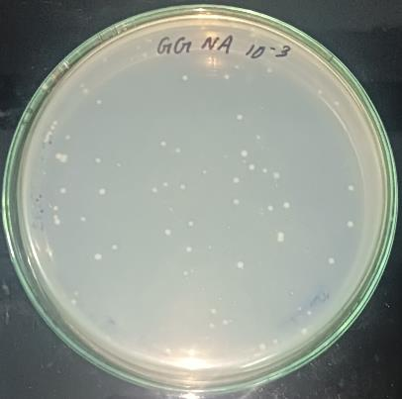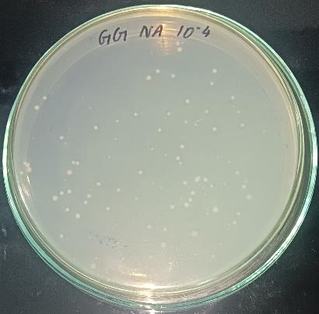
Concentration 10⁻³ Concentration 10⁻⁴
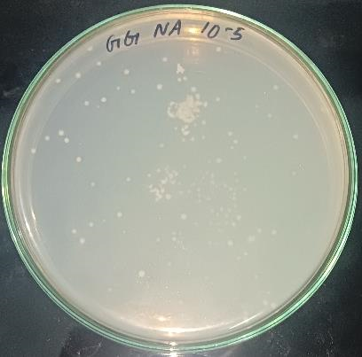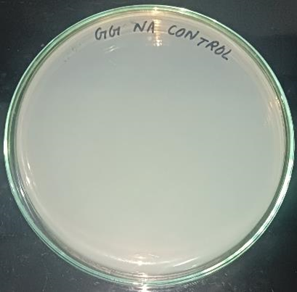
Concentration 10⁻⁵ Control plate
Culture plates of the sample ALMOND MILK
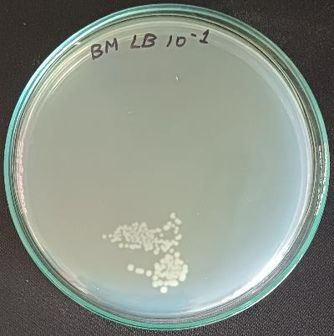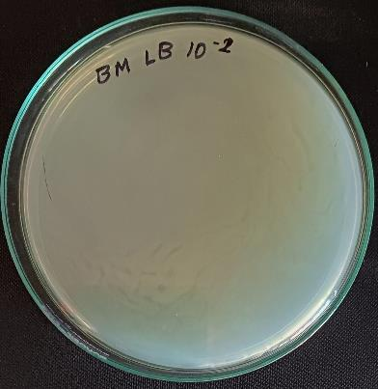
Concentration 10⁻¹ Concentration 10⁻ ²
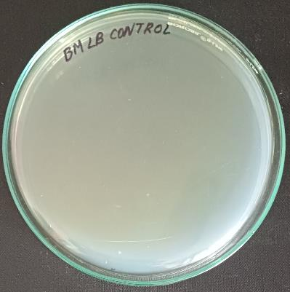
Control plate
Culture plates of the sample ALOEVERA DRINK
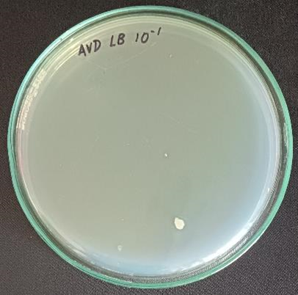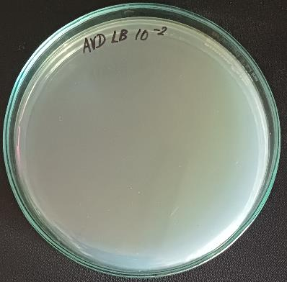

Concentration 10⁻¹ Concentration 10⁻ ²

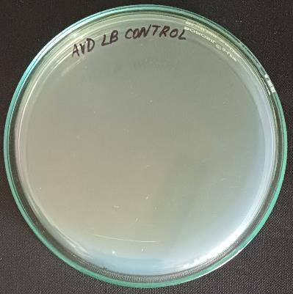

Control plate

Culture plates of the sample WATER

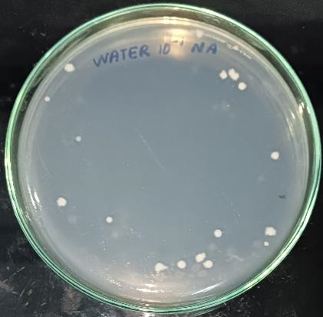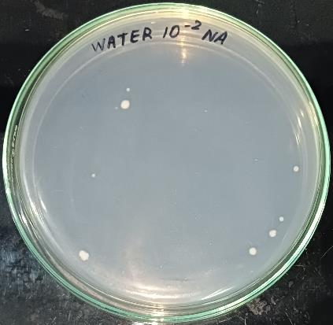

Concentration 10⁻¹ Concentration 10⁻ ²

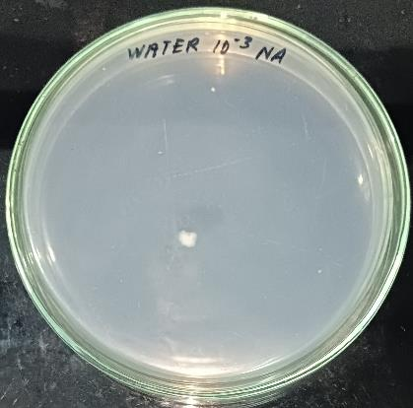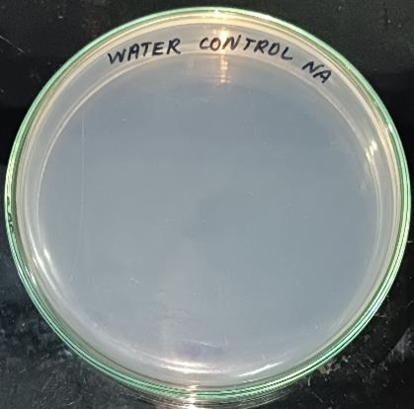

Concentration 10⁻³ Control plate

3.3 SUBCULTURE STEAKING:
Among the spread plates, the cultures which are unique in their morphology and colour were chosen for subculture. 16 specific colonies were subcultured by steaking.

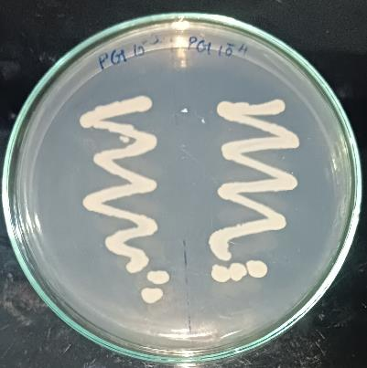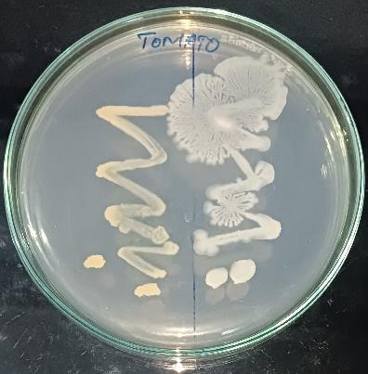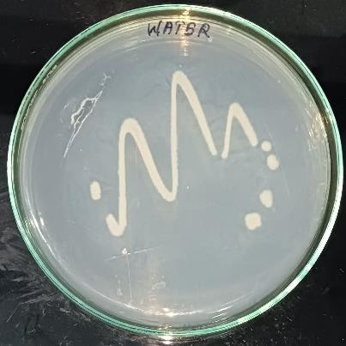
POMEGRANATE JUICE TOMATO PUREE WATER
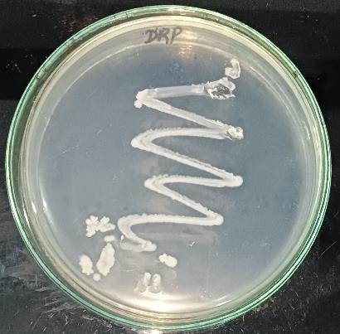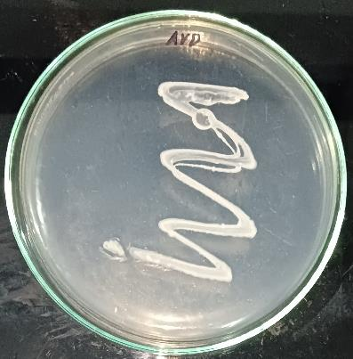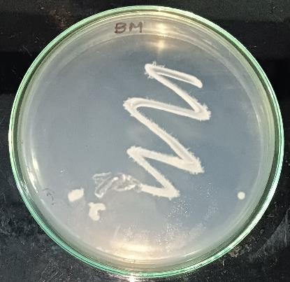
PARUPPU SADHA PODI ALOE VERA DRINK ALMOND MILK
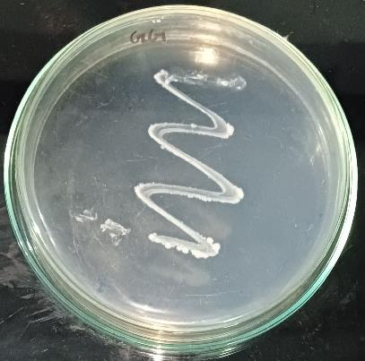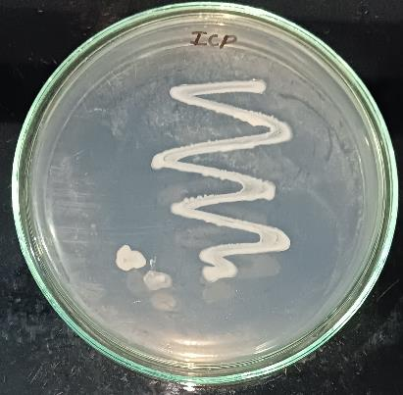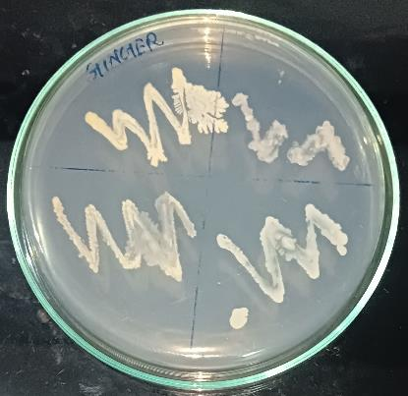
GINGER GARLIC PASTE IDLY POWDER DRIED GINGER POWDER
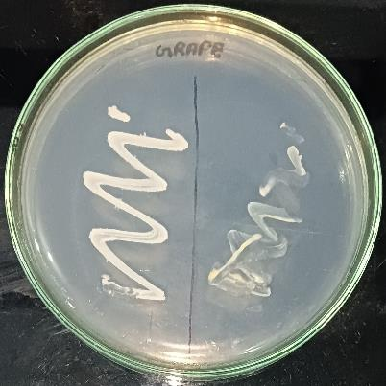
GRAPE
3.4 BIOCHEMICAL TESTS:
Out of the 10 sub culture plates, 5 cultures which are unique in morphology and color was chosen for biochemical tests. Agar broth was prepared and the cultures were grown in suspension. The major biochemical tests used in this research are
1. Indole test
2. Methyl Red test
3. Voges Proskauer test
4. Citrate utilization test
INDOLE TEST:
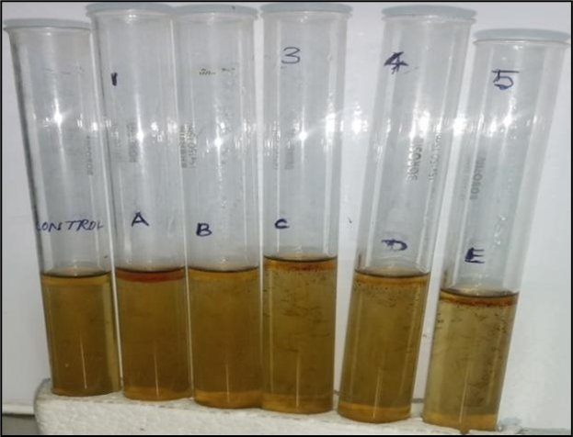
Sample A, C – Positive
Sample B, D – Negative, Sample E – Either Positive or Negative
METHYL RED TEST:
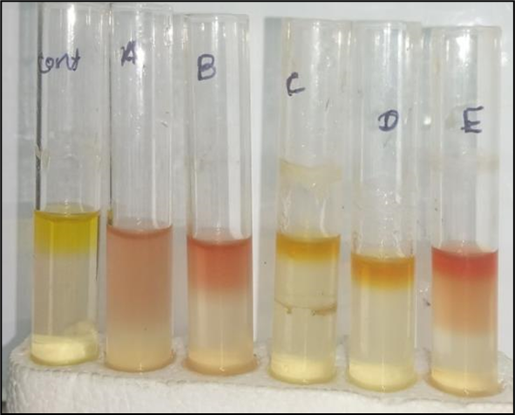
Sample A, B, E – Positive, Sample C, D – Negative

VOGES PROSKAUER TEST ;
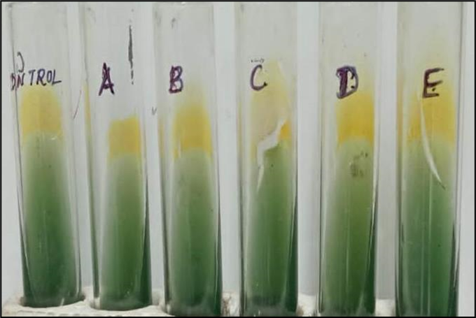
Sample A, B, C, D, E – Negative

CITRATE UTILIZATION TEST:
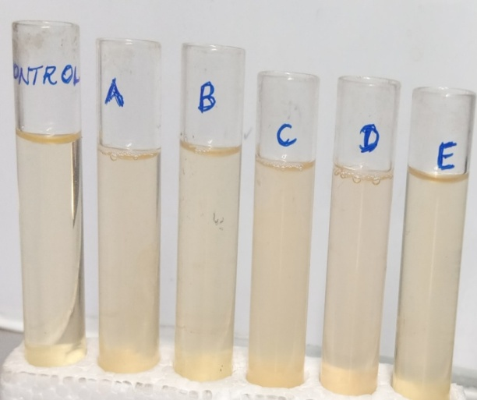
Sample A, B, C, D, E - Negative
SNO | SAMPLE | INDOLE TEST | METHYL RED TEST | VOGES PROSKAUER  TEST | CITRATE  UTILIZATION  TEST | NAME OF THE BACTERIAL STRAINS
1 | GRAPE - 1 | + | + | - | - | E.Coli
2 | GRAPE - 2 | - | + | - | - | E.Blatte
3 | ALOE VERA DRINK | + | - | - | - | Unpredictable
4 | IDLY CHILLI POWDER | - | - | - | - | Unpredictable
5 | ALMOND MILK | v | + | - | - | E.coli (Inactive)

From the table, Sample-A(Grape-1) has been identified as Escherchia coli
Sample-B(Grape-2) has been identified as Escherichia blatte
Sample-E(Almond milk) has been identified as Escherichia coli, which is in inactive state. The samples C & D are unpredictable and has to be sequenced.
3.5 ISOLATION OF GENOMIC DNA:
DNA has been isolated for the unpredictable samples C&D and visualization was done through electrophoresis in 1% agarose gel with ethidium bromide staining.
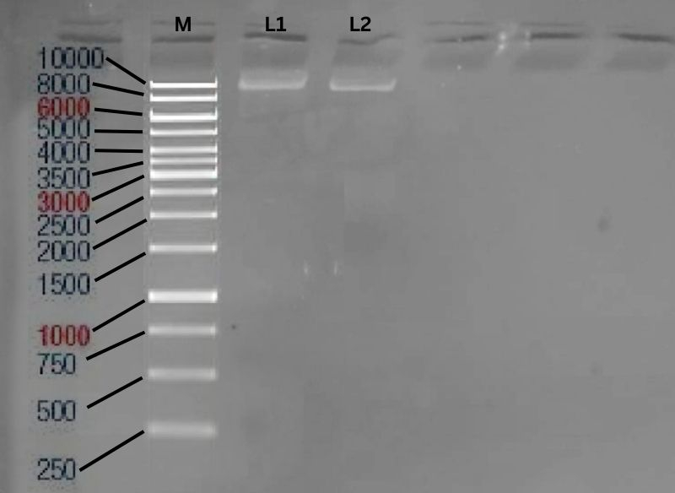
M – 1KB Marker, L1 – Sample 1, L2 – Sample 2

3.6 PCR PRODUCT VISUALIZATION:
After the DNA has been isolated, it is amplified using PCR and visualized in 1% agarose gel with ethidium bromide staining.
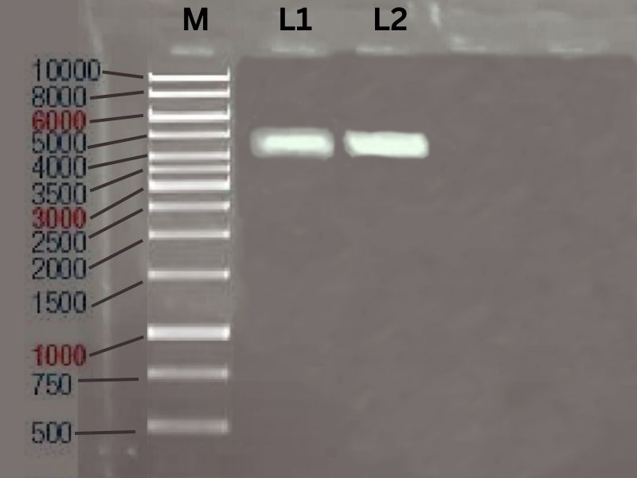
M – 1KB Marker, L1 – PCR product of Sample 1, L2 – PCR Product of Sample 2
3.7 16s rDNA SEQUENCING:
Two sequences were obtained by sequencing the samples 1 & 2. Between 88 and 92 percent of the sequences in the NCBI database have similarities to known bacterial sequences. According to the database, the 2 sequences were known to be a strain of
- Escherichia coli strain NRRI-CPD-COMB29
- shigella sp strain NCCP-416
Finding E. coli, Shigella sp, and E .blatte in food samples is a concerning result. These microorganisms are known to cause foodborne illnesses and can pose a significant risk to human health.
E. coli is a common bacterium found in the intestines of humans and animals. Some strains of E. coli can cause severe food poisoning, leading to symptoms such as abdominal pain, diarrhea, and vomiting.
Shigella sp is another bacterium that can cause foodborne illnesses, specifically shigellosis. Shigellosis can cause diarrhea, fever, stomach cramps, and dehydration.
E. blatte, also known as the oriental cockroach, is not a pathogenic microorganism, but its presence in food samples is a potential indicator of poor sanitation and hygiene.
Based on the results, it is essential to state that even packed foods contain microorganisms which shows that microbes are ubiquitous and unavoidable.[49] Therefore to reduce the risk of getting foodborne illness, consumers must choose the food products correctly and try to avoid the products which are made unhygiene.
Furthermore, it is essential to properly handle and cook all food products to prevent the transmission of these microorganisms to consumers. Food safety is a critical concern, and by taking appropriate measures, we can help ensure that the food we consume is safe and free from harmful microorganisms.[50]

4. CONCLUSION:
To ensure food safety and avoid foodborne illnesses, screening and identification of microorganisms from packaged or processed foods is crucial. Food can get contaminated by microorganisms at any point throughout production, processing, and packing; therefore, it is critical to find and identify these germs before the food is consumed by customers. Strong laboratory procedures, knowledgeable people, and effective quality control procedures are all necessary for the efficient screening and identification of microorganisms from packaged or processed foods. The study has identified both dangerous and non-harmful creatures. Overall, preserving consumer confidence in the food supply chain and safeguarding public health depend on the detection and identification of bacteria in food.

5. REFERENCES:
- Ahmed, R., Ahmed, N., Ahmed, R., & Ahmed, S. (2019). Screening of microorganisms in processed food and food packaging materials. Food Science and Technology, 9(4), 83-91.
- Alvarez-Ordóñez, A., Broussolle, V., & Colin, P. (2015). Emerging preservation techniques for controlling spoilage and pathogenic microorganisms in packaged foods. Food Research International, 74, 1-9.
- Arvanitoyannis, I. S. (2012). Current and future trends in food packaging: a review. Journal of Food Engineering, 113(1), 8-15.
- Bhattacharjee, S. (2016). Foodborne pathogens: challenges and solutions. Journal of Food Science and Technology, 53(1), 31-42.
- Cabral, J. P. (2010). Water microbiology. Bacterial pathogens and water. International Journal of Environmental Research and Public Health, 7(10), 3657-3703.
- Carvalho, M. P., & Silva, C. C. (2014). Microbiological quality of packed and processed food products: a review. Food Research International, 56, 555-566.
- Chauhan, A., & Lal, D. (2015). Microbiological quality of ready-to-eat processed foods from retail outlets in Delhi, India. Food Control, 50, 876-880.
- da Silva, L. A., Viana, C. A., & Diniz, C. G. (2018). Microbiological quality of packed and processed foods: a review. Food Science and Technology, 38(1), 1-12.
- Doherty, A. M., & Glass, K. A. (2010). Microbial risk assessment of packaged fresh-cut produce. Food Control, 21(12), 1561-1571.
- Dominguez, S. A., & Fornaguera, M. J. (2019). Foodborne pathogens: sources and risk factors. Food Science and Technology, 39(1), 1-12.
- Fajardo, P., Doherty, A. M., & O'Beirne, D. (2010). Microbial quality of modified atmosphere-packed fresh-cut vegetables. Food Control, 21(7), 858-863.
- Food and Agriculture Organization of the United Nations. (2019). FAO/WHO framework for developing national food safety emergency response plans. Retrieved from http://www.fao.org/3/i9957en/I9957EN.pdf
- Food and Drug Administration. (2019). Foodborne illness risk factors and contributing factors. Retrieved from https://www.fda.gov/food/foodborne-illness-risk-factors-and-contributing-factors
- Fricker, C. R., & de Haan, E. G. (2017). Rapid methods for detection of foodborne pathogens: a review. Journal of Microbiological Methods, 131, 1-8.
- Ghebremichael, S., Gunaratne, H. Q., & Rakshit, S. K. (2000). Detection of Salmonella enteritidis in food and food products using PCR and gene probe methods. Food Microbiology, 17(1), 69-77.
- Gombas, D. E., Chen, Doores, S. (2015). A review of Salmonella and its relationship to food safety. Critical Reviews in Food Science and Nutrition, 55(3), 371-388.
- Gálvez, A., López, R. L., Abriouel, H., & Ben Omar, N. (2017). Biopreservation of food products. In Advances in food and nutrition research (Vol. 82, pp. 223-262). Academic Press.
- Gao, Q., & Yuan, W. (2016). Nanotechnology in food science: function, applications and safety concerns. Journal of Nanoscience and Nanotechnology, 16(11), 11205-11219.
- Gopinath, S. C., Anbu, P., Lakshmipriya, T., & Hilda, A. (2015). Strategies to combat antibiotic resistance in the wastewater treatment plants. Applied Microbiology and Biotechnology, 99(23), 10155-10170.
- He, Y., Yang, Y., Xu, Y., Wang, M., Yu, L., & Zhang, X. (2015). Rapid and sensitive detection of Salmonella in food samples by a PCR-based method using a new DNA binding dye. Food Control, 51, 386-392.
- Hu, X., Liu, C., Zhang, Y., & Wang, J. (2017). Detection of foodborne pathogens by surface-enhanced Raman spectroscopy. Trends in Food Science and Technology, 69, 96-108.
- Ibrahim, F., & Hakeem, K. R. (2017). Nanotechnology in food industry: present status and future prospects. Journal of Food Science and Technology, 54(4), 1171-1184.
- Kaur, G., Singh, N., Pinnaka, A. K., & Jain, R. (2017). Immunological detection of foodborne pathogens: current state of the art. Critical Reviews in Food Science and Nutrition, 57(13), 2742-2760.
- Kim, S. H., & Lee, J. H. (2015). Microbial risk assessment in fresh produce supply chain. Korean Journal of Food Science and Technology, 47(3), 274-280.
- Kudva, I. T., & Blanchfield, B. (2015). Rapid detection of foodborne pathogens: current and emerging technologies. Journal of Food Protection, 78(6), 1190-1208.
- Li, Y., Wang, P., Hu, Y., & Sun, Y. (2017). Application of nanomaterials in food safety: current status and future prospects. Journal of Agricultural and Food Chemistry, 65(4), 704-718.
- Liu, X., Chen, J., Zhao, Y., Chen, Y., & Yang, H. (2015). Antibiotic resistance and molecular characterization of Escherichia coli and Salmonella isolates recovered from raw meat in China. Food Control, 50, 918-924.
- Madan, R., & Arora, A. (2015). Detection of food-borne pathogens by electrochemical sensors: a review. Biosensors and Bioelectronics, 70, 100-118.
- Mahajan, P. M., & Goswami, M. (2015). Emerging technologies in microbial diagnostics. In Microbial diagnostics: methods and protocols (pp. 1-10). Springer.
- Malik, A., Dahiya, S., & Chaudhary, R. (2015). Microbial diversity in soil: threats, challenges and opportunities. In Microbial diversity in ecosystem sustainability and biotechnological applications (pp. 1-26). Springer.
- Pan, Y., Breidt Jr, F., & Gorski, L. (2016). Synergistic effects of high hydrostatic pressure, organic acids, and cold storage on inactivation of Escherichia coli O157: H7 and Listeria monocytogenes in apple cider. Food Microbiology, 53, 92-99.
- Patel, J., Sharma, M., & Singh, M. (2015). Foodborne pathogens in dairy products: detection and control. In Microbial pathogens and strategies for combating them: science, technology and education (Vol. 2, pp. 1135-1144). Formatex Research Center.
- Perdana, J., Adhi, N. P. M., Mahendra, A. D., & Rahayu, W. P. (2017). Screening of pathogenic bacteria in street foods in Surabaya, Indonesia. Food Control, 78, 316-321.
- Rezaei, M., Farahmand, B., & Shahbazi, Y. (2016). A review of the applications of nanotechnology in food industry. Journal of Food Processing and Preservation, 40(5), 1039-1051.
- Reynolds, D. L., & Chassaing, C. (2015). Antibiotic resistance in the food chain: a developing country-perspective. Frontiers in Microbiology, 6, 1-5.
- Rong, X., Peng, X., & Wei, L. (2015). Microbial identification based on molecular techniques: a review. Journal of Food Agriculture and Environment, 13(2), 67-74.
- Sagar, R., Saini, S., & Kumar, R. (2019). Molecular detection of foodborne pathogens: a review. Journal of Food Science and Technology, 56(1), 1-13.
- Sakaridis, I., Soultos, N., & Iossifidou, E. (2017). Microbial quality of commercial chicken fillets: effects of storage and packaging conditions. Food Microbiology, 62, 20-26.
- Sanchez-Maldonado, A. F., Schaffner, D. W., & Patel, J. R. (2017). Microbial quality and safety of fresh and fresh-cut produce: advances and challenges in microbiome engineering, detection and control technologies. Current Opinion in Food Science, 18, 20-28.
- Schaffner, D. W. (2015). Modern methods for pathogen detection in foods: from microbiology to nucleic acid-based assays. Journal of Food Science, 80(S1), A15-A22.
- Sharma, A., Kumar, R., & Sharma, S. (2017). Emerging trends in nanotechnology-based detection of foodborne pathogens. Journal of Food Safety, 37(1), e12292.
- Sharma, S., Kaur, S., & Nagpal, A. K. (2017). Applications of nanotechnology in food packaging and food safety: barrier materials, antimicrobials and sensors. Journal of Food Science and Technology, 54(10), 3155-3166.
- Silva, N., & Junqueira, V. C. (2014). Methods for the recovery of microbial contaminants from food surfaces. In Foodborne pathogens and food safety (pp. 61-78). Springer.
- Singh, P., Singh, R., Singh, P. K., & Gupta, G. (2016). Food safety: detection techniques and role of nanotechnology. Current Nanoscience, 12(3), 330-342.
- Sirsat, S. A., Neal, J. A., & Schneider, K. R. (2016). Inactivation kinetics of Escherichia coli O157: H7 and Salmonella Enteritidis in peanut butter by radio-frequency heating. Food Control, 64, 45-51.
- Soliman, M., Farag, M., Wajid, A., & Omar, O. (2015). Microbial quality of some fresh-cut vegetables sold in Alexandria, Egypt. International Journal of Microbiology Research, 6(2), 126-130.
- Suman, S. P., Joseph, P., Biswas, A. K., & Chatli, M. K. (2016). Microbial safety concerns in fresh meat and meat products. In Advances in Meat Processing Technology (pp. 177-205). CRC Press.
- Takhistov, P. T., & Bruckner-Lea, C. J. (2015). Novel nanoscale approaches to food safety monitoring and risk assessment. In Advances in food and nutrition research (Vol. 75, pp. 105-136). Academic Press.
- Tamplin, M. L., Paoli, G., Marmer, B. S., & Phillips, J. G. (2015). Models for predicting microbial growth and inactivation in packaged foods. Journal of Food Science, 80(10), R2237-R2251.
- Teixeira, P., Sampaio, P., Fernandes, R., & Pastrana, L. (2014). Advances in biosensors for the detection of foodborne pathogens. Food Research International, 60, 51-65.

