“RFID BASED AUTO BILLING SHOPPING CART”

**Author name: Pratiksha Dhande**

Student, Department of Electronics & Communication Thakur Shivkumar Singh Memorial Engineering College, Burhanpur, Madhya Pradesh, India

E-mail: [Pratikshadhande17@gmail.com](mailto:Pratikshadhande17@gmail.com)

**Author name: Chanchal Gupta**

Student, Department of Electronics & CommunicationThakur Shivkumar Singh Memorial Engineering College, Burhanpur, Madhya Pradesh, India

E-mail: [cg2001gupta@gmail.com](mailto:cg2001gupta@gmail.com)

**Guide name: Prof. Pushpendra Singh Chouhan**

Assistant professor, Department of Electronics & Communication Thakur Shivkumar Singh Memorial Engineering College, Burhanpur, Madhya Pradesh, India

E-mail: pushp12.chouhan@gmail.com

**ABSTRACT**

Modern technology has increased people's standard of living. This has led to large crowds in shopping malls. In order to serve a large crowd, we need to shorten the time billing process. This is done using an intelligent purchasing system based on RFID technology. The items that are placed in the smart cart are read one by one and the invoice is generated and displayed. Once the final bill is generated, the customer pays the bill using the preloaded cards provided by the mall. The aim is to reduce the time required for the billing system. In shopping malls or markets, various items are bought with a shopping cart. Acquiring this product is a difficult process. For the convenience of the customers, they have to pull the cart to pick up the items every time and at the same time. After the purchase, the customer wants to pay the bill for the purchase. During this time, they have to queue to have their products scanned with an RFID reader with a barcode scanner and receive an invoice. To change that, the customer has to shop wisely in the mall. An RFID barcode must be affixed to each product in order for the product to be scanned with an RFID reader. The Smart Trolley consists of an RFID reader, an LCD screen and a ZigBee transmitter. When a customer wants to buy a product, they add it to their shopping cart. It scans and reads the product and displays the cost and product name on the LCD screen. The total cost of all products purchased is added to the final bill, with the final bill being stored as memory in the Arduino. All of these tasks are performed on the sender's side. On the receiver side, it is a wireless transmission method.

It is used to exchange product information and the final invoice amount for the items placed in the shopping cart is transmitted to the billing system via the ZigBee transmitter. It is used to save the customer time and the customer does not have to wait long and in a long queue. A new concept has been introduced, namely the "INTELLIGENT SHOPPING CART". This design is used to improve security performance and speed.

**Keywords:** RFID reader, RFID tag, LCD Display, Buzzer, NodeM

**INTRODUCTION**

RFID is a special type of radio card that has an integrated Chielo card with a loop antenna. The built-in embedded chip represents the 12-digit card number. The RFID reader is a system that generates a magnetic signal with a frequency of 125 kHz. This magnetic signal is transmitted through a loop antenna attached to this chip, which is used to read the RFID card number.

In this project, an RFID card is used as an access control card. Therefore, each product has an individual RFID card that represents the product name. The RFID reader works with a microcontroller. Here the microcontroller is a programmable flash microcontroller that we have already programmed the card number into. The microcontroller is connected to the keyboard. In the current shopping system, one of the challenges is guiding the queue through the lengthy checkout process. Therefore, this project aims to reduce the average time a customer spends in a mall by implementing an automatic billing system using RFID technology. In the current shopping system, one of the challenges is keeping an eye on the queues during the lengthy billing process. Therefore, this project aims to reduce the average time a customer spends in a mall by implementing an automatic billing system using RFID technology. The main goal of the project is the satisfaction of the customer and the reduction of the billing process time, i.e., H. complete the checkout process in the shopping cart instead of waiting in line for at least one or two products. After a quick scan, customers have to add the products to the shopping cart and after completing the purchase, the final amount is displayed in the shopping cart. The customer can pay the bill with a pre-loaded loyalty card provided by the store. Finally, all information is sent to the mall's central computer.

**Components – components which are used in this ‘Line follower Robot’**

The smart trolley system is equipped with RFID tag, RFID reader, LCD Display microcontroller, Buzzer, Transformer, Drive Circuit, PCB, Alarm, and LED. The RFID tag is attached to a product.

**RFID System Components and Their Effects in Libraries**

An RFID system consists of three components: the tag, the reader and the application that makes use of the data the reader reads on the tag. Tag Also known as a transponder, the tag consists of an antenna and silicon chip encapsulated in glass or plastic (Want, 2004).

The tags contain a very small amount of information. For example, many tags contain only a bar code number and security bit (128 bits) but some tags contain as much as 1,024 bits (Boss, 2003). Tags range in size from the size of a grain of rice to two inch squares depending on their application.

Researchers are now working on tags as small as a speck of dust (Cavoukian, February 2004). Tags can be passive, active, or semi-active. An active tag contains some type of power source on the tag, whereas the passive tags rely on the radio signal sent by the reader for Power. Most RFID applications today utilize passive tags because they are so much cheaper to manufacture. However, the lack of power poses significant restrictions on the tag’s ability to perform computations and communicate with the reader. It must be within range of the reader to function. Semi-active tags are not yet commercially available but will use a battery to run the microchip’s circuitry but not to communicate with the reader.

Semi-active tags rely on capacitive coupling and carbon ink for the antennas rather than the traditional inductive coupling and silver or aluminum antenna used in passive tags (Collins, 2004). Tags operate over a range of frequencies. Passive tags can be low frequency (LF) or high frequency (HF). LF tags operate at 125 KHz, are relatively expensive, and have a low read range (less than 0.5 meters). HF tags operate at 13.56 MHz, have a longer read range (approximately 1 meter) and are less expensive that LF tags. Most library applications use HF tags (Allied Business Intelligence [ABI], 2002). Tags can be Read Only (RO), Write Once Read Many (WORM) or Read Write (RW) (Boss, 2003). RO tags are preprogrammed with a unique number like a serial number (or perhaps eventually an ISBN number). WORM tags are preprogrammed but additional information can be added if space permits. RW tags can be updated dynamically.

Sometimes space on the RW tags is locked where permanent data is kept and the rest of the tag is writable. According to Sharma et al. (2002), RFID readers or receivers are composed of a radio frequency module, a control unit and an antenna to interrogate electronic tags via radio frequency (RF) communication. Many also include an interface that communicates with an application (such as the library’s circulation system). Readers can be hand-held or mounted in strategic locations so as to ensure they are able to read the tags as the tags pass through an “interrogation zone.” The interrogation zone is the area within which a reader can read the tag. The size of the interrogation zone varies depending on the type of tag and the power of the reader. Passive tags, with shorter read ranges, tend to operate within a smaller interrogation zone (Sarma, et al., 2002). Most RFID readers in libraries can read tags up to 16 inches away (Boss, 2003).

**Conversion station** – Where library data is written to the tags

**Staff workstation at circulation** – Used to check-in and check-out materials

**Patron self-check-out station** – Used to check-out books without staff assistance

**Exit sensors** – Verify that all books leaving the library have been checked out

**Patron self-check-in station** – Used to check in books without staff assistance

**Book drop reader** – Checks in books when patrons drop them in the book drop

**Sorter** – Automated system for returning books to proper area of library

**Portable reader** – Hand-held reader for inventorying and verifying that items are shelved correctly.

**TESTING**

1. In the beginning, when the kit is switched on by providing the power supply to the kit, the below images are seen which show “WELCOME” on the LCD screen of the device.
2. When an RFID tag is scanned by the RFID reader, the images as shown below are displayed along with the details of the name of the product, weight of the product, cost of the product and the total billing amount.’
3. After completion of the shopping, press the shopping completed button. The image as shown below is seen and the information is sent to the PC using ZIGBEE technology.
4. The items with their individual costs and the total cost is displayed on the PC as shown in the below image.

**CIRCUIT DIAGRAM DESCRIPTION:**

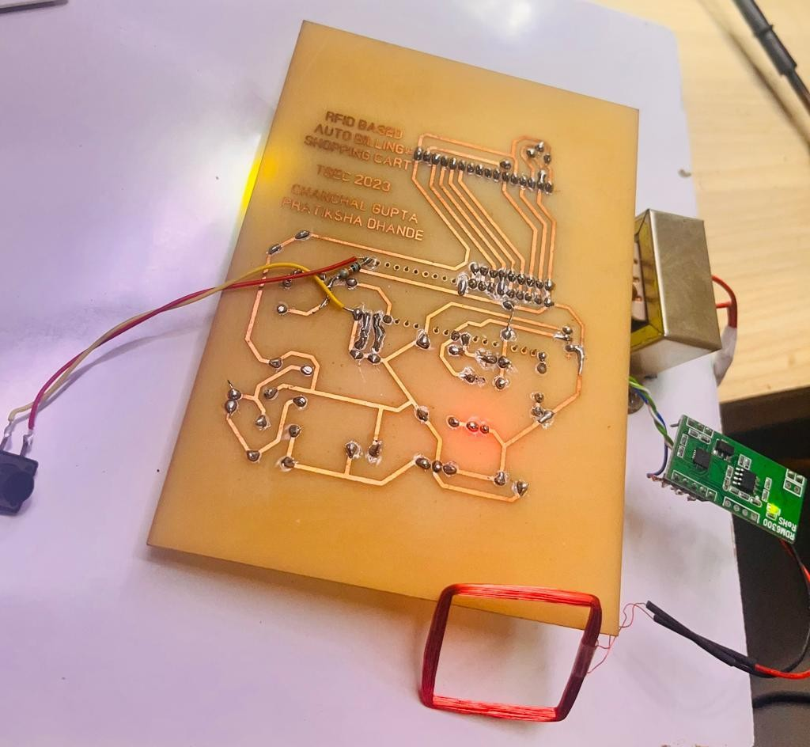

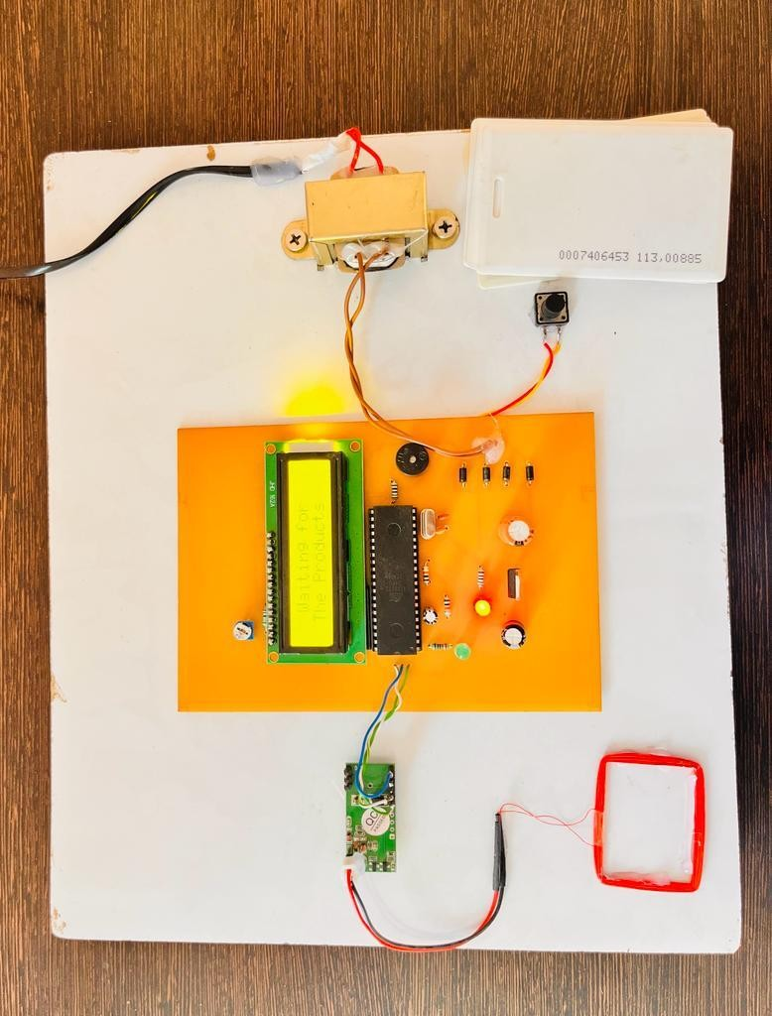**Figure 1 Circuit Diagram**

**Figure 2 Circuit Diagram**

**WORKING OF RFID**

After uploading the code, you can start testing the device. Initially, the LCD display will show the message “Welcome to Super Market”. The LCD will display the message to add the item. You can add any item simply by scanning the item with an RFID tag. For example, the RFID Card marked as Tea is scanned in our project.

The LCD will display Tea is Added along with the price value of the tea. You can scan other cards with different item names like Milk, Butter, or whatever you have assigned in your code. Every time you add any item, the price is added to the previous value with a total cost. In case you want to remove any item from the list, then press and hold the reset button and scan the item. The item will be removed from the system and the price will be updated automatically. At the end of shopping the shopper can show the total price value of the products and pay the final price. This is how you can build your own Smart Shopping Cart with an Automatic Billing System using RFID and Microcontroller.

**FEATURES**

1. Ability to capture images in challenging lighting conditions.
2. The right shutter type and frame rate to consistently capture items dropped into a shopping trolley.
3. A lens with the perfect field of view to effectively cover the whole of a shopping trolley or checkout counter.
4. A well-tuned ISP to bring out the best possible image quality.

**ADVANTAGES**

1. Low Power Consumption.
2. We Can Shop Vary Easily.
3. Improves Security Performance In The Security Places .
4. Make The Duplicate Rfid Card.
5. Easy Billing For Shopkeeper.
6. Easy Shopping Budget Management.

**APPLICATION**

* We Can Use RFID Based Security System in Highly Secured Areas Such As.
* Rfid Based Bank Security System.
* Rfid Based Door Opening and Closing.
* Rfid Based Production Security System.

# FUTURE SCOPE

1. Development Of Project Can Be Done In Many Ways, Where RFID Tags Can Be Replaced By RFID Stickers Which Are Small In Size, Low Cost.
2. Security Can Be Improved by Counting the Number of Items or Placing Weight Sensors.
3. Multiple Rfid Tags Can Be Read Using a Single Rfid Reader for More Number of Products Which Are Added in The Cart.

**CONCLUSION**

learning progress & Technology is a continuous process. New things and new technologies are invented. As technology advances day by day, we can envision a future where we can take any place. This design is used in a mall to buy products. In this project, the RFID card serves as security for access to the product. If the product is added to the shopping cart, it means that the amount is shown in addition to the total amount. But in this project, the RFID card is used to access the products. This design therefore improves security performance and speed. Therefore, based on the proposal, we conclude that automatic product invoicing using RFID technology will be a more cost-effective option in the future. The RFID-based system is efficient, compact and offers promising performance. Also, RFID is better and faster than barcode scanning because it later works in direct line of sight, which is not the case with RFID technology. It will take your whole shopping experience to another level. Various parameters are displayed, such as B. the parameters of the intelligent shopping cart system, such. B. Product name, product cost, product weight, etc.

**REFRENCES**

1. Chandrasekhar P, Ms. Sangeetha ―Smart shopping cart with automatic central billing system through RFID and ZigBee‖, IEEE, 2014
2. Hubert, M. but, C. Brock, Backhaus, and T.Eberhardt ―Acceptance of smart phone based mobile shopping: mobile benefits, customer characteristics, perceived risks, and the impact of application context”, IEEE 2018
3. A conference paper on ―Iot Based Smart Shopping Mall‖ by 1 Ashok Sutagundar, Masuda Ettinamani, Ameen begum Attar
4. A conference paper on ―Internet of Things (IOT) Based Smart Shopping Center “RFID, by Ajay Kumar, shlock Srivastava and U. gupta.
5. A conference paper on ―IoT Applications on Secure Smart Shopping System "by Ruining Li, Tianyi Song, Nicholas Capurso, Jingo Yu, Jason Couture, and Xiuzhen
6. Ruinian Li, Tianyi Song, Nicholas Capurso,"IoT Applications on Secure Smart Shopping" in International Conference on Identification, Information and Knowledge in the Internet of Things,2017.
7. Tharindu Athauda, Juan Carlos Lugo Marin, Jonathan Lee, Nemai Karmakar,"Robust low- cost passive UHF RFID based smart shopping trolley" in IEEE Journal of Radio Frequency Identification, Issue in 2018.
8. Rajlakshmi Badi, Bashirahamad Momin,"SISC: Sensor-based Intelligent Shopping Cart" in 3rd International Conference for Convergence in Technology (I2CT), Apr 06-08, 2018 India.
9. Mr.P. Chandrasekar, Ms.T. Sangeetha,"Smart Shopping Cart with Automatic Billing System through RFID and ZigBee" in IEEE S.A. Engineering College, Chennai, Tamil Nadu, 2014,India.
10. Akshay Kumar, Abhinav Gupta, S. Balamurugan, S. Balaji and Marimuthu R., "Smart Shopping Cart" in School of Electrical Engineering, VIT University,Vellore IEEE,2017.