**JWELLARY HUB MANAGEMET SYSTEM**

# Kalpesh Patil2 Ashish Damodare2 Kunal Awarkar3 Akshay Dalal4

1Tha. Shiv Kumar Memorial Engee. College Dept. of Computer Science Department, Burhanpur(M.P.), India.

# ABSTRACT

# Maintaining the same quality or upgrading the present one is not an easy task because quality is the ultimate picture of the entire business. Good quality of a product depends on many factors e.g. sound infrastructure, better management control, etc. So to obtain the optimum quality, jewellers have to upgrade those ingredients by which the quality is affected. To upgrade those ingredients the jewellers have to depend on some types of data. So, if the decision making person of the business wants to have a grip on the total business, he/she will have to have a knowledge of the entire flow of data and information within the organisation.

# INTRODUCTION

# It cannot be done without the help of a Business Related Software. Jewellery management system is developed in Asp.Net, which can keep track of all your business activity in a jewellery shop from small segments to large and very large segments.As we all know the jewellery trade can be divided into three major categories i.e.

* + 1. Retail
    2. Wholesale
    3. Export

**EXISTING SYSTEM**

At present all the activities in transaction are handled manually. Manual data processing system, whole providing economy, flexibility and adaptability at low data volumes become more complex when the volume of data becomes large. As an organization expands in size and function, a stage is reached when manual procedures become inadequate and inefficient. No matter how many clerks are employed a stage is reached then it becomes impossible to systemize such a large amount of information. What is required then is an upgrading in the class of information processing technology.The present system is not sufficient to hold all the information that is necessary for the processing. So the library is in need of new computerized system, which is very flexible, user-friendly and capable of holding the system in a robust manner.

**LIMITATIONS OF EXISTING SYSTEM**

There were a lot of reasons for the introduction of the new system. They are mainly due to the drawbacks and efficiency of the existing system.

* Physical volume of the data is very large.
* The delay in information search and retrieval.
* Problems in updating and backup.
* Damage of papers containing the information.
* Considerable time taken for report generation.
* Accuracy of data is very lower in manual system.

**PROPOSED SYSTEM**

The system study phase studies the problem, identifies alternate solution, evaluates these solutions and finally recommends best solution. The system gives the structure and function of the system. A detailed system study is essential for developing an efficient system. The proposed system provides a better user interface. The system is a menu driven program.

**ADVANTAGES OF PROPOSED SYSTEM**

* The proposed system can be utilized for easy documenting and accessing various data carriers such as forms, reports, records etc.
* Automation makes the system to be user-friendly and hastily in manipulation and generation of valuable reports providing menu driven facilities.
* Accuracy and security of data will be more comfortable for the organization.

**INTEGRATION TESTING:**

Integration testing is a systematic technique for consulting the software architecture while at the same time conducting test to uncover errors associated with interfacing. The objective is to take unit tested components and build a program structure that has been dictated by design.

**VALIDATION TESTING:**

Validation testing is that validation succeeds when software functions in a manner that can be reasonably expected by the user. Validation testing begins after the culmination of integration testing, software is completely assembled as a package; interfacing errors have been uncovered and corrected.

The error detecting during this testing is:

Incorrect Function

Input Condition Errors

Database Error

Performance Error

**SECURITY TESTING:**

Security testing verifies that protection mechanisms built into a system will, in fact, protect it from improper penetration. The system security must, of course, be tested for invulnerability from flank or rear attack.

**FEASIBILITY STUDY**

During system analysis, a feasibility study of the proposed system is carried out to see whether it is beneficial to the organization.The integration unit is currently manual. To get the detailed information on production, bagging etc large bundles of files have to be looked into. It is very time consuming affair. An operator has to keep in mind or search a file for the details of department for the data. So working with the existing system is quite tedious. Whereas considering the merits of the new system it is very beneficial. The results of the feasibility study are given below:

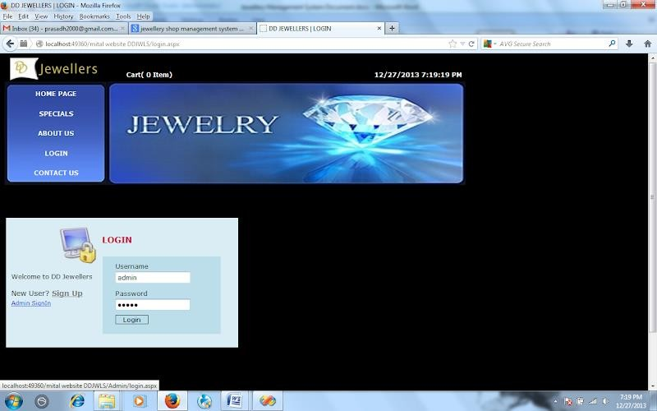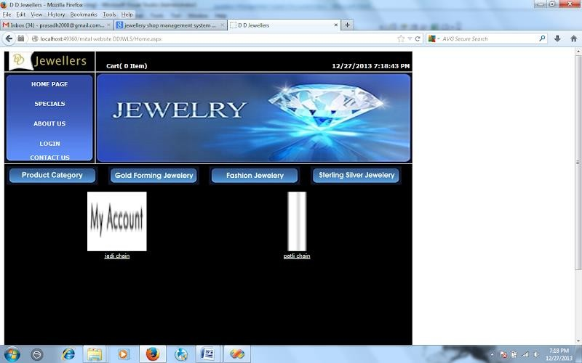

**Future Enhancement**

This system is developed such a way that additional enhancement can be done without much difficulty. The renovation of the project would increase the flexibility of the system. Also thefeatures are provided in such a way that the system can also be made better and efficient functionality The programs were coded in an easier and more structured manner so that may further modifications may be incorporated easily. The processing time in this system is very lesser compared to existing system. This system has good flexibility of accommodating any more changes that might arise in the future also. In this system, data integrity is maintained and data redundancy is avoided and it increase system efficiency. The database is designed in such a way that it will be also helpful for enhancement of the system

# CONCLUSION

The system “Jewellary Management system” deals with purchase and sales processing of a Jewellary shop. This system has been developed to satisfy all the proposed requirements. The process of recording details about supplier, item, Billing andcustomers is more simple and easy. The system reduces the possibility of errors to a greatextent and maintains the data in an efficient manner. User friendliness is the uniquefeature of this system. The system generates the reports as and when required. Thesystem is highly interactive and flexible for further enhancement.The coding is done in a simplified and easy to understandable manner so thatother team trying to enhance the project can do so without facing much difficulty. Thedocumentation will also assist in the process as it has also been carried out in a simplifiedand concise way

# REFERENCES

1. Dos concepts and design By Manoj K. Sinha
2. Eriksson P, Kovalainen A. Qualitative Methods in Business Research. SAGE Publications; 2008 DOI: http://dx.doi.org/10.4135/9780857028044
3. 2.Kemmis S, Wilkinson M. Participatory action research and the study of practice. In: Atweh B, Kemmis S, Weeks P, editors. Action Research in Practice. Partnerships for Social Justice in Education. Routledge; 1998. p. 21-36. ISBN: 0203024478
4. 3.Gummesson E. Qualitative Methods in Management Research. SAGE Publications; 2000 DOI: 10.1002/jsc.512
5. 4.Heikkinen HLT, Rovio E, Syrjälä L. Toiminnasta tietoon. Toimintatutkimuksen menetelmät ja lähestymistavat. Hansaprint Oy; 2010. ISBN: 9789519140360