**Design and Implementation of a Toll Collection System**

**Using GPS and RF Technology**

**Yash Yatin Yeola,** **Atharva Sanjay Kothawade,** **Chetan Dilip Patil, Dr. Vijay M. Birari**

Student, Department of E&TC, NDMVP KBTCOE, Nashik, Maharashtra, India

Student, Department of E&TC, NDMVP KBTCOE, Nashik, Maharashtra, India

Student, Department of E&TC, NDMVP KBTCOE, Nashik, Maharashtra, India

Asso. Professor, Department of E&TC, NDMVP KBTCOE, Nashik, Maharashtra, India

**ABSTRACT**

In this paper, we present the design and implementation of a toll collection system that utilizes GPS and RF technology. The proposed system aims to reduce the time and effort required for toll collection, while also increasing the accuracy and reliability of the collection process and the user has to pay only for the amount of distance travelled (Cost is dynamic). The system uses GPS technology to identify the location of the vehicle, and RF technology to communicate and initiate the cashless payment process from a start point to an end point. Also, the user gets instant and detailed information at a single terminal using the mobile application.

**Keywords:** GPS, RF technology, dynamic cost, cashless payment, single terminal, mobile application

1. **INTRODUCTION**

The Toll collection is an important aspect of transportation infrastructure management, and it is crucial for maintaining the quality of roads and highways. Due to increasing population the need of vehicles also increased. This has indirectly resulted in huge number of vehicles on roads. This has resulted in increased demand for proper infrastructure. To meet these demands, almost every country has its own network on roadways.

Nations are spending huge amount of money on developing infrastructure especially on laying highways. These highways usually connect major cities across the country and help in easy transport of goods, fast commuting for vehicles due to less disturbance unlike in county side roads where lot many domestic vehicles ply. Governments charge for usage of these highways in the form of tolls and some highways will be free to use. The toll fee varies depending on the type of vehicle.

Ideally vehicles should be charged toll fee based on the usage of roads. Currently the prices are standard per type of vehicle and there is no means of measuring the actual distance covered by that vehicle in the highway. Highways will be used by both kinds of vehicles wherein one set of vehicles cover a longer distance in highways itself and other set of vehicles travel only lesser distance in highways. With the existing means of collection, the toll booths are only set up in such a way that irrespective of the distance covered every vehicle ends up paying the dedicated amount in every toll booth in the entire stretch of highway.

1. **NEED FOR PROJECT**

An automatic toll detection system using RF and GPS can be a useful project for various applications, including toll collection, vehicle tracking, and fleet management. The basic need of the project is the user should pay only for the distance travelled and seamless travelling of vehicles. Here are some of the features:

Database Management: The toll booth's system can maintain a database of all registered vehicles and their toll payments. The database can be used to verify the vehicle's identification, calculate the toll fee, and record the transaction.

Payment System: The payment system can be integrated with the toll booth's system to accept toll payments. The payment can be made through various modes such as cash, credit card, or electronic payment.

User Interface: The user interface can be designed to display the toll fee and other transaction details to the driver. This can be achieved through an LCD screen or an app on the driver's smartphone.

Real-Time Monitoring: Real-time monitoring can be done to track the movement of vehicles on the toll road and ensure smooth traffic flow.

Overall, an automatic toll detection system using RF and GPS can be a useful project that can be implemented in real-world scenarios. It can reduce human error, increase efficiency, and improve traffic management on toll roads and also the user has to only pay for distance travelled.

1. **PROBLEM STATEMENT**

In India, the tolling is generally under the open system, whereby fee payable is a fixed amount based on the length of stretch under one project which is normally 60 kilometers. If a stretch is of lesser length, user fee of actual decided length is only collected and user has to pay more amount than what actually he needs to pay.

Each and every day more and more vehicles are increasing rapidly, and major problem occurs at the site of toll booths due to heavy traffic causing endless number of problems such as wastage of time, fuel and money as well as causing environmental pollution.

1. **BLOCK DIAGRAM AUTOMATIC TOLL COLLECTION SYSTEM: SYSTEM**

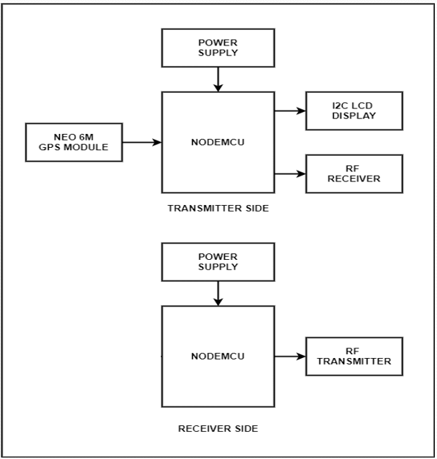

**Figure 1. Block diagram of toll collection system**

1. **METHODOLOGY**

In this system, the automatic toll collection system is the main focus. A RFID receiver will be mounted on every car. When a vehicle passes through an access point, the RFID transmitter constantly transmits data, and the RFID receiver within the vehicle picks up the signal. The controlling device is then sent the received signal. (ESP8266 microcontroller). The data is logged on the server and sent to the server by the microcontroller together with the received data. The amount that must be paid is calculated and automatically debited from the user's account, which is linked to the bank account. Whenever the controller determines the user has passed from the start point and crossed the destination point the application allows the user to view his balance, balance history, and track deductions. By utilizing technology, we have enabled automobiles to travel smoothly.

Working:

1. The system uses NodeMCU Microcontroller at the transmitter as well as the receiver end.
2. The reason for using NodeMCU is it has inbuilt Wi-Fi which makes it suitable for IOT Applications.
3. A NEO-6M GPS Module is used to sense start point and end point based on which distance and fare is calculated.
4. To make the system more robust we have used RF Tx-Rx Pair for checking exact location.
5. The RF Tx bombards signal which is captured by RF Rx to find exact location.
6. Cost is deducted from the Thing Speak Cloud Server.
7. Android App is developed to perform action such as recharge, balance check and travel history.

. 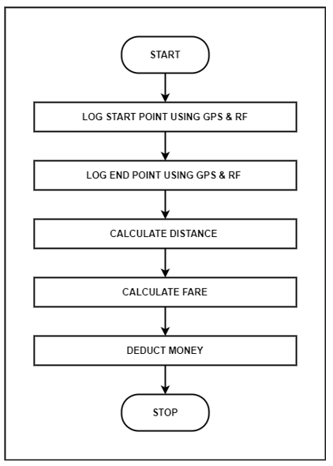

**Figure 2. Flowchart**

1. **RESULTS**

We can see the practical implementation and working of the hardware.

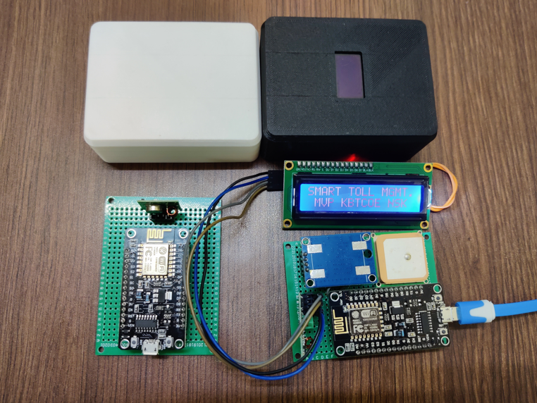

**Figure 2:** Proof of Concept

Advantages:

* + Cost is dynamic hence user pays only for the distance travelled.
  + Automatic fare deduction.
  + Removes human intervention
  + Communication through Radio wave so, line of sight is not required.

Disadvantages:

* Availability of internet connection is must.
* Needs a structured infrastructure.

1. **CONCLUSION**

The proposed toll collection system is an efficient and reliable way to collect tolls using GPS and RF technology which saves time. By using this system and the user has to only pay for the distance travelled i.e. the cost is dynamic. User can avail the data at a single terminal on a mobile application. The system can also be used to provide real-time traffic updates and analytics, which can be used to improve the overall transportation infrastructure and make it more time efficient. We believe that the proposed system has the potential to revolutionize the toll collection process and can be implemented on a large scale.

1. **REFERENCES**

[1] Gabriel Nowacki, Izabella Mitraszewska, Tomasz Kamiński, The National Automatic Toll Collection System For The Republic Of Poland, Transport And Telecommunication, 2008, Volume 9, No 2, 24–38

[2]Kumawat, A. and Chandramore, K., 2014. Automatic toll collection system using RFID. International Journal of Electrical and Electronics Research, 2(2), pp.67-72.

[3] Kwon, K., Choi, J., Choi, J., Hwang, Y., Lee, K. and Ko, J., 2010. A 5.8 GHz integrated CMOS dedicated short range communication transceiver for the Korea/Japan electronic toll collection system. IEEE Transactions on Microwave Theory and Techniques, 58(11), p.2751.

[4] Balamurugan, K., Elangovan, S., Mahalakshmi, R. and Pavithra, R., 2017, September. Automatic check-post and fast track toll system using RFID and GSM module with security system. In *2017 International Conference on Advances in Electrical Technology for Green Energy (ICAETGT)* (pp. 83-87). IEEE.

[5]Xu, G.X., Liu, J.H., Tao, Z.Y. and Li, X.C., 2007. The research and development of the highway's electronic toll collection system. *World Academy of Science, Engineering and Technology*, *31*, pp.231-235.