A Review on Transdermal Drug Delivery System

Prajakta G. Chavhan, Amruta N. Patil, Sulbha G. Patil

P.S.G.V.P. Mandal’s College of Pharmacy, Shahada.

Abstract -

Transdermal drug delivery system (TDDS) is one of the systems lying under the category of

controlled drug delivery, in which the aim is to deliver the drug through the skin in a

predetermined and controlled rate. It has various advantages, like prolonged therapeutic effect,

reduced side-effects, improved bioavailability, better patient compliance and easy termination of drug therapy. The stratum corneum is considered as the rate limiting barrier in transdermal

permeation of most molecules. There are three main routes of drug penetration, which include

the appendageal, transcellular and intercellular routes. Skin age, condition, physicochemical

factors and environmental factors are some factors that are to be considered while delivering

drug through this route. Basic components of TDDS include polymer matrix, membrane, drug,

penetration enhancers, pressure-sensitive adhesives, backing laminates, release liner, etc.

Transdermal patches can be divided into various systems like reservoir system, matrix system

and micro-reservoir system, which are used to incorporate the active ingredients into the

circulatory system via the skin. After preparation of transdermal patches, consistent

methodology are adopted to test the adhesion properties, physicochemical properties, in vitro

drug release studies, in vitro skin permeation studies, skin irritation studies and stability studies. According to the duration of therapy, various drugs are commercially available in the form of transdermal patche.

**Keywords-** Transdermal Drug Delivery System, Routes of Penetration, Factors Affecting Transdermal Drug Delivery, Types of Transdermal Patches, Evaluation of Transdermal Films.

INTRODUCTION

Innovations in the area of drug delivery are taking place at a much faster pace as compared with the last two decades. Improved patient compliance and effectiveness are inextricable aspects of new drug delivery systems. A more radical approach has been to explore newer interfaces on the body for introducing therapeutics. One such approach, transdermal drug delivery, makes use of human skin as a port of entry for systemic delivery of drug molecules. Transdermal drug delivery system (TDDS) is one of the systems lying under the category of controlled drug delivery, in which the aim is to deliver the drug through the skin in a predetermined and controlled rate. TDDS are adhesive drug-containing devices of defined surface area that deliver a predetermined amount of drug to the surface of intact skin at a programmed rate to reach the systemic circulation. Transdermal delivery provides a leading edge over injectables and oral routes by increasing patient compliance and avoiding first-pass metabolism, respectively. Transdermal route has vied with oral treatment as the most successful innovative research area in drug delivery, as oral treatment involves attainment and maintenance of drug concentration in the body within a therapeutically effective range by introduction of a fixed dose at regular intervals, due to which the drug concentration in the body follows a peak and trough profile, leading to a greater chance of adverse effects or therapeutic failure; large amount of drug is lost in the vicinity of the target organ and close attention is required to monitor therapy to avoid overdosing. The limitations of the oral route can be overcome and benefits of intravenous drug infusion such as to bypass hepatic “first pass” hepatic elimination (HEPE) to maintain constant prolonged and therapeutic effective drug levels in the body can be closely duplicated, without its potential hazards, by transdermal drug administration through intact skin.

Skin and drug permeation: The objective of TDDS is to achieve systemic medication through topical application on intact skin; therefore, it is important to review the structural and biochemical features of the human skin and those characteristics that contribute to the barrier function and the rate of drug access into the body via the skin. Anatomically, the skin can be divided into two layers: epidermis and dermis or corium [Figure 1], penetrated by hair shafts and gland ducts. The skin is one of the most extensive organs of the human body, covering an area of about 2 m2 in an average human adult. The major skin layers, from inside to outside, comprise the fatty subcutaneous layer (hypodermis), the dermis of connective tissue and the stratified avascular cellular epidermis. This multilayered organ receives approximately one-third of all blood circulating through the body. Epidermis results from an active epithelial basal cell population and is approximately 150-μm thick. It is the outermost layer of the skin, and the process of differentiation results in migration of cells from the basal layer toward the skin surface. The epidermis contains no blood vessels; therefore, nutrients and waste products must diffuse across the dermal–epidermal junction to maintain its vitality. The epidermis consists of five layers, which, from the inside to the outside, are the stratum germinativum (basal layer), stratum spinosum (spinous layer), stratum granulosum (granular layer), stratum lucidum and stratum corneum (SC). Because the SC cells are dead, the epidermis without the SC is usually termed the viable epidermis. The SC is considered as the rate-limiting barrier in transdermal permeation of most molecules. The SC comprises 15–20 layers of keratin-filled corneocytes (terminally differentiated keratinocytes) anchored in a lipophilic matrix. The lipids of this extracellular matrix are distinctive in many respects: (1) they provide the only continuous phase (and diffusion pathway) from the skin surface to the base of the SC; (2) the composition (ceramides, free fatty acids and cholesterol) is unique among biomembranes and particularly noteworthy is the absence of phospholipids; (3) despite this deficit of polar bilayer-forming lipids, the SC lipids exist as multilamellar sheets; and (4) the predominantly saturated, long-chain hydrocarbon tails.

-Advantage of TDDD:

-Self administration is possible and continuous, sustained release of drug. -Avoids peak and trough drug levels and longer and multiday dosing intervals. -Avoids rst-pass hepatic metabolism and enzymatic degradation by the gastrointestinal tract and also avoids gastrointestinal irritation Not suitable for high drug doses.

-Less frequent dosing improves patient compliance.

- Alternate route for patients who are unable to take oral medications.

-Dose delivery unaffected by vomiting or diarrhea. Drug administration stops with patch removal.

-Disadvantages of TDDD

-Drug molecule must be potent because patch size limits the amount that can be delivered.

-Not suitable for high drug doses.

-Adhesion may vary with patch type and environmental conditions.

- Skin irritation and hypersensitivity reactions may occur. The barrier functions of the skin change from one site to another on the same person, from person to person.

-facilitate a highly ordered, interdigitated configuration and the formation of gel phase membrane domains as opposed to the more usual (and more fluid and permeable) liquid crystalline membrane systems. In the dry state, the SC has a thickness of 10–15 μm; upon hydration, the SC swells and its thickness can reach 40 μm. The structure of the SC is often depicted as a bricks and mortar arrangement, where the keratin-rich corneocytes (bricks) are embedded in the intercellular lipid-rich matrix (mortar).

Dermis is the foundation of a firm of connective tissue upon which the epidermis is laid, and

is of mesoderm origin. The dermis or corium consists of a dense network of connective tissue in which bundles of collagen fibers predominate, mingled with elastic tissue in the superficial levels. The dermis contains fine plexuses of blood vessels, lymphatics, nerves, hair follicles, sweat glands and sebaceous glands.

Anatomy and physiology of skin

Skin is one of the most extensive organ of thebody covering an area of about 2m2 on in an average human adult. This multilayerd organ receives approximately one third of all blood circulating through the body. With thickness of only a millimeter, the skin separates the underlying blood circulation network from outside environment.

Human skin comprises of three distinct but

mutually dependent tissues:

1. The stratified, vascular, cellular epidermis,
2. Underlying dermis of connective tissues and
3. 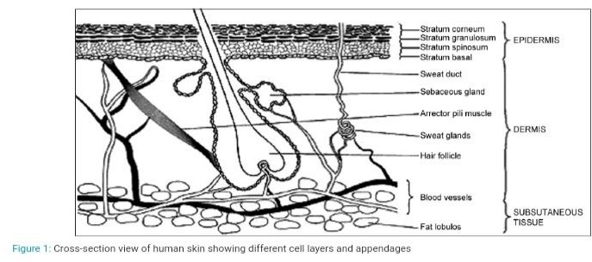Hypodermic

Epidermis: it results from an active epithelial basal cell population and is approximately 150 micrometer thick. It is the outermost layer of skinand process of differentiation results in migration of cells from basal layer towards the skin surface. The end result of this process is the formation of a thin, stratified and extremely resilient layer(the stratum corneum) at the skin surface.

Stratum corneum: This is the outermost layer of skin, also called horny layer. It is approximately 10 mm thick when dry but swells to several times this thickness when fully hydrated. It contains 10 to 25

layers of parallel to the skin surface, lying dead,keratinized cells, called corneocytes. It is flexible but relatively impermeable. The stratum corneum is the principal barrier for penetration. The barrier nature of the horney layer depends critically on its constituents: 75 to 80% proteins, 5 to 15% lipids, and 5 to 10% ondansetron material on a dry weight basis. Protein fractions predominantly contain alpha-keratin (70%) with some beta-keratin (10%) and cell envelope (5%). Lipid constituents vary with body site (neutral lipids, sphingolipids, polar lipids, cholesterol). Phospholipids are largely absent, a unique feature of mammalian membrane.

Viable epidermis: This is situated beneath the stratum corneum and varies in thickness from

0.06 mm on the eyelids to 0.8 mm on the palms.

Dermis: electron microscopic examination shows that the dermis is made up of a network of robust collagen fibers of fairly uniform thickness with regularly spaced cross striations.

It is about 3 to 5 mm and contains the blood vessels, lymph vessels, and nerves. It also provideoxygen and nutrients to the skin while removing toxins and waste products.

Hypodermis: The hypodermis or subcutaneous fat tissue supports the dermis and epidermis. It serves as a fat storage area. This layer helps to regulate temperature, provides nutritional support and mechanic protection. It carries principal blood vessels and nerves to skin and may contain sensory pressure organs. For transdermal drug delivery, the drug has to penetrate through all these three layers and reach into systemic circulation while in case of topical drug delivery, only penetration through stratum corneum is essential and then retention of drug in skin layers is desired.

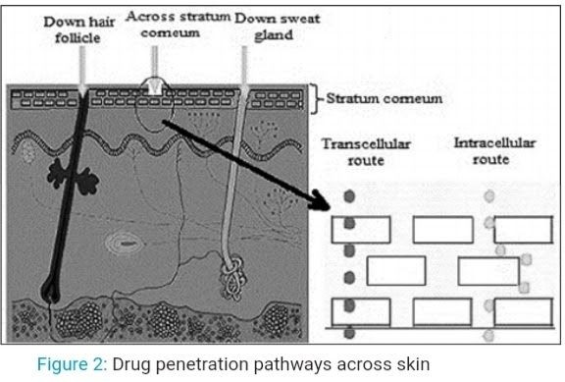ROUTES OF PENETRATION:

There are critically three ways in which a drug molecule can cross the intact SC: via skin appendages (shunt routes), through the intercellular lipid domains or by a transcellular route. Physiochemical properties of the molecule govern the flux of a particular drug to permeate by a combination of these routes.

Fig: drug penetration pathway across the skin.

The appendageal route

The transappendageal routes are also known as the shunt routes, and include permeation through the sweat glands and across the hair follicles with their associated sebaceous glands. Skin appendages provide a continuous channel directly across the SC barrier. Recent studies have re-examined the long held assumption that the follicles occupy approximately 0.1% of the surface area of the human skin. the follicular number, opening diameter and follicular volume are important considerations in drug delivery through these appendages and, indeed, the forehead provides 13.7 mm2/cm2 as the follicular infundibula, i.e. approximately 13.7% of the surface area of the forehead is available as follicles. Interestingly, the same study also showed that the historically held view of the follicles providing approximately 0.1% of the SC appears to be valid for forearm skin.

Transcellular route

Drugs entering the skin via the transcellular route pass through the corneocytes. Corneocytes containing highly hydrated keratin provide an aqueous environment from which hydrophilic drugs can pass. The transcellular pathway requires not only partitioning into and diffusion through the keratin bricks but also into and across the intercellular lipids.

Intercellular route

The intercellular route involves drug diffusion through the continuous lipid matrix. This route is a significant obstacle for two reasons: (i) recalling the “bricks and mortar” model of SC, the interdigitating nature of the corneocytes yields a tortuous pathway for intercellular drug permeation, which is in contrast to the relatively direct path of the transcellular route. (ii) The intercellular domain is a region of alternating structured bilayers. Consequently, a drug must sequentially partition into and diffuse through repeated aqueous and lipid domains. This route is generally accepted as the most common path for small uncharged molecules penetrating the skin.

Rational For Transdermal Drug Delivery

Given that the skin offers such an excellent barrier to molecular transport, the rationale for this delivery strategy needs to be carefully identified. Clearly, there are several instances in which the most convenient of drug intake methods (the oral route) is not feasible and when alternative routes must be sought. Although intravenous introduction of the medicament avoids many of these shortfalls (such as gastrointestinal and hepatic metabolism), its invasive and apprehensive nature (particularly for chronic administration) has encouraged the search for alternative strategies, and few anatomical orifices have not been investigated for their potential as optional drug delivery routes. Nevertheless, the transdermal mode offers several distinct advantages: (1) the skin presents a relatively large and readily accessible surface area (1–2 m2) for absorption; and (2) the application of a patch-like device to the skin surface is a non-invasive (and thus a patient compliant) procedure that allows continuous intervention (i.e., system repositioning, removal or replacement).Further benefits of TDDSs have emerged over the past few years as technologies have evolved. These include the potential for sustained release (useful for drugs with short biological half-lives requiring frequent oral or parenteral administration) and controlled input kinetics, which are particularly indispensable for drugs with narrow therapeutic indicate of course implementation of TDD technology An must be therapeutically “justified”: drugs with high oral bioavailability and infrequent dosing regimens that are well accepted by patients do not warrant such measures. Similarly, transdermal administration is not a means to achieve rapid bolus-type drug inputs; rather, it is usually designed to offer slow, sustained drug delivery over substantial periods of time and, as such, tolerance-inducing drugs or those (e.g., hormones) requiring chronopharmacological management are, at least to date, not suitable. Nevertheless, there remains a large pool of drugs for which TDD is desirable but presently unfeasible. The nature of the SC is, in essence, the key to this problem. The excellent diffusional resistance offered by the membrane means that the daily drug dose that can be systemically delivered through a reasonable “patch-sized” area remains in the 10 mg range. This limitation imposes the first criterion for a successful transdermal candidate: transdermal drugs must be pharmacologically potent, requiring therapeutic blood concentrations in the ng/ml range, or less. The second criterion is that SC is very selective with respect to the type of molecule that can be transported across this outer covering, and not all molecules that pass the “potency” test will have the necessary physicochemical properties.

FACTORS AFFECTING TRANSDERMAL DRUG DELIVERY

Skin condition: The intact skin itself acts as a barrier, but many agents like acids and alkali cross the barrier cells and penetrate through the skin. Many solvents open the complex dense structure of the horny layer: solvents like methanol and chloroform remove the lipid fraction, forming artificial shunts through which drug molecules can pass easily.

Skin age: It is seen that the skin of adults and young ones is more permeable than that of the older ones. but there is no dramatic difference. Children show toxic effects because of the greater surface area per unit body weight. Thus, potent steroids, boric acid and hexachlorophene have produced severe side-effects.

Physicochemical factors

Hydration of skin: Generally, when water saturates the skin, it swells tissues, softens wrinkles on the skin and its permeability increases for the drug molecules that penetrate through the skin.

Temperature and pH of the skin

The penetration rate varies if the temperature varies and the diffusion coefficient decreases as

the temperature falls;, however adequate clothing on the body prevents wide fluctuations in temperature and penetration rates. According to pH, only unionized molecules pass readily across the lipid membrane, and weak acids and bases dissociate to different degrees according to their pH and pKa or pKb values. Thus, the concentration of unionized drug in applied phase will determine the effective membrane gradient, which is directly related to its pH.

Environmental factors

Sunlight Because of to sunlight, the walls of blood vessels become thinner, leading to bruising, with only minor trauma in the sun-exposed areas. Also, pigmentation, the most noticeable

sun-induced pigment change, is a freckle or solar lentigo.

Cold season

The cold season often results in itchy and dry skin. The skin responds by increasing oil production to compensate for the weather’s drying effects. A good moisturizer will help ease symptoms of dry skin. Also, drinking lots of water can keep your skin hydrated and looking radiant.

Air pollution

Dust can clog pores and increase bacteria on the face and the surface of skin, both of which lead to acne or spots, which affects drug delivery through the skin. Invisible chemical pollutants in the air can interfere with the skin’s natural protection system, breaking down the skin’s natural oils that normally trap moisture in the skin and keep it supple.

BASIC COMPONENTS OF TDDS•

Polymer matrix/drug reservoir•

Membrane•

Drug•

Permeation enhancers•

Pressure-sensitive adhesives (PSA)

* Backing laminate
* Release liner
* Other excipients like plasticizers and solvents

Polymer matrix/drug reservoir-

Polymers are the backbone of TDDS, which control the release of the drug from the device. A polymer matrix can be prepared by dispersion of drug in a liquid or solid state synthetic polymer base. Polymers used in TDDS should have biocompatibility and chemical compatibility with the drug and other components of the system, such as penetration enhancers and PSAs.

Additionally, they should provide consistent and effective delivery of a drug throughout the product’s intended shelf-life, and should be safe.The following criteria should be preferred in selecting the polymer to be used in the transdermal system:(i) Molecular weight, glass transition temperature and chemical functionality of the polymer should be such that the specific drug diffuses properly and gets released through it.(ii) The polymer should be stable, nonreactive with the drug, easily manufactured and fabricated into the desired product, and should be inexpensive.

(iii) The polymer and its degradation products must be nontoxic or nonantagonistic to the

host.(iv) The mechanical properties of the polymer should not deteriorate excessively when large amounts of active ingredients are incorporated into it. The polymers utilized for TDDS are presented in Table

Membrane

A membrane may be sealed to the backing to form a pocket to enclose the drug-containing matrix or used as a single layer in the patch construction. The diffusion properties of the membrane are used to control availability of the drug and/or excipients to the skin. For example, ethylene vinyl acetate, silicone rubber, polyurethrane, etc. are used as a rate-controlling membrane.

Drug

For successfully developing a TDDS, the drug should be chosen with great care. Transdermal patches offer many advantages to drugs that undergo extensive first-pass metabolism, drugs with narrow therapeutic window or drugs with a short half-life, which cause noncompliance due to frequent dosing.[13,19] Some of the desirable properties of a drug and factors to be considered for transdermal delivery are shown in Tables 3 and 4.There are some examples of drugs that are suitable for TDDS, like Nicardipine hydrochloride, Captopril, Atenolol, Metoprolol tartarate, Clonidine, Indapamide, Propranolol hydrochloride, Carvedilol, Verapamil hydrochloride and Niterdipine, etc.

Permeation enhancers

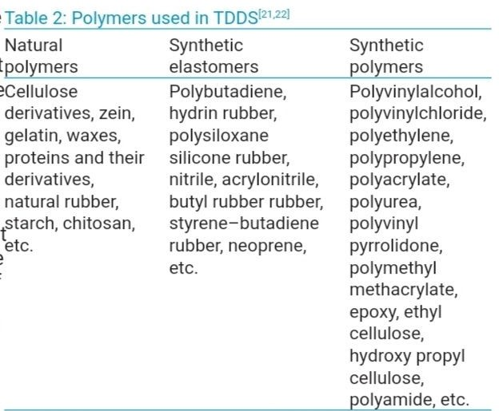One long-standing approach for improving TDD uses penetration enhancers (also called sorption promoters or accelerants), which increase the permeability of the SC so as to attain higher therapeutic levels of the drug candidate. Penetration enhancers interact with structural components of the SC thus modifying the barrier functions, leading to increased permeability. Three pathways are suggested for drug penetration through the skin: polar, nonpolar and polar/nonpolar. The enhancers act by altering one of these pathways. The key to altering the polar pathway is to cause protein conformational change or solvent swelling. The key to altering the nonpolar pathway is to alter the rigidity of the lipid structure and fluidize the crystalline pathway (this substantially increases diffusion). The fatty acid enhancers increase the fluidity of the lipid portion of the SC. Some enhancers (binary vehicles) act on both polar and nonpolar pathways by altering the multilaminate pathway for penetrants.[9,13] The methods employed for modifying the barrier properties of the SC to enhance the drug penetration (and absorption) through the skin can be categorized as (1) chemical and (2) physical methods of enhancement.

Polymers used in TDDS

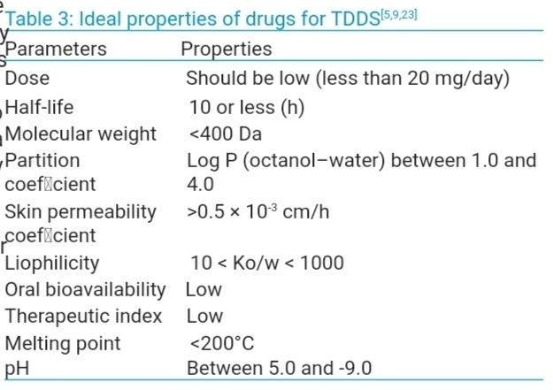

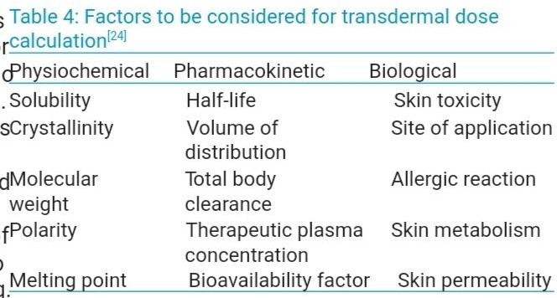 Factors to be considered Transdermal does calculation

Chemical enhancers

Chemical that promote the penetration of topically applied drugs are commonly referred to as accelerants, absorption promoters or penetration enhancers. Chemical enhancers act by:

• Increasing (and optimizing) the thermodynamic activity of the drug when functioning as a

co-solvent.

• Increasing the partition coefficient of the drug to promote the it releases from vehicle into the skin.condition to SC to promote drug diffussion. Promoting penetration and establishing drug reservoir in the SC.

Some of the more desirable properties for penetration enhancers acting within the skin have been given as:

• They should be nontoxic, nonirritating and non-allergenic

• They should ideally work rapidly, and the activity and duration of the effect should be both predictable and reproducible

• They should have no pharmacological activity within the body, i.e. should not bind to receptor sites

• The penetration enhancers should work undirectionally, i.e. should allow therapeutic agents into the body while preventing the loss of endogenous material from the body

• When removed from the skin, barrier properties should return both rapidly and fully

• The penetration enhancers should be appropriate for formulation into diverse topical preparations and, thus, should be compatible with both excipients and drugs

• They should be cosmetically acceptable with an appropriate skin “feel”Some of the most widely studied permeation enhancers are sulphoxide (DMSO), fatty acids (oleic acid), alcohol (methanol), glycol (propylene glycol) and surfactant (anionic surfactant), azone (lauracapran), etc.

Physical enhancers

Iontophoresis and ultrasound (also known as phonophoresis or sonophoresis) techniques are examples of physical means of enhancement that have been used for enhancing percutaneous penetration (and absorption) of various therapeutic agents.

PSAs

PSAs are the material that adhere to a substrate, in this case skin, by application of light force and leave no residue when removed. They form interatomic and intermolecular attractive forces at the interface, provided that the intimate contact is formed. To obtain this degree of contact, the material must be able to deform under slight pressure, giving rise to the term “pressure sensitive.” Adhesion involves a liquid-like flow, resulting in wetting of the skin surface upon the application of pressure, and, when the pressure is removed, the adhesive sets in that state. A PSA wets and spreads onto the skin when its surface energy is less than that of the skin. After the initial adhesion, the PSA/skin bond can be built by stronger interactions (e.g., hydrogen bonding), which will depend on skin characteristics and other parameters. Widely used PSA polymers in TDDS are polyisobutylene-based adhesives, acrylics and silicone-based PSAs, hydrocarbon resin, etc. The PSA can be located around the edge of the TDDS or be laminated as a continuous adhesive layer on the TDDS surface. The PSA should be compatible with the drug and excipients, as their presence can modify the mechanical characteristics of the PSA and the drug delivery rate.

Backing laminates

Backings are chosen for appearance, flexibility and need for occlusion; hence, while designing a backing layer, the consideration of chemical resistance of the material is most important.

Excipient compatibility should also be considered because the prolonged contact between the backing layer and the excipients may cause the additives to leach out of the backing layer or may lead to diffusion of excipients, drug or penetration enhancer through the layer. The most comfortable backing will be the one that exhibits lowest modulus or high flexibity, good oxygen transmission and a high moisture vapor transmission rate. Examples of backing materials are vinyl, polyethylene, polyester films, aluminum and polyolefin films.

Release liner

During storage, the patch is covered by a protective liner that is removed and discarded before the application of the patch to the skin. Because the liner is in intimate contact with the TDDS, the liner should be chemically inert. Typically, a release liner is composed of a base layer that may be nonocclusive (e.g, paper fabric) or occlusive (e.g, polyethylene, polyvinyl chloride) and a release coating layer made up of silicon or Teflon. Other materials used for TDDS release liner are polyester foil and metalized laminates.[5,29,30]Other excipients like plasticizers and solventsVarious solvents such as chloroform, methanol, acetone, isopropanol and dicholoromethane are used to prepare drug reservoir. In addition, plasticizers such as dibutylphthalate, triethyl citrate, polyethylene glycol and propylene glycol are added to provide plasticity to the transdermal patch.

TYPES OF TRANSDERMAL PATCHES

Most commercially available transdermal patches are categorized into the following three types

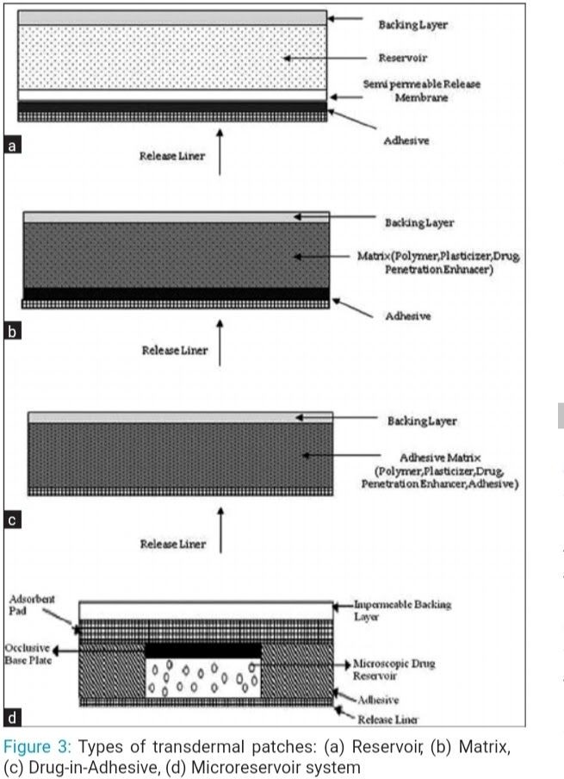

Reservoir system

In this transdermal system, the drug reservoir is embedded between an impervious backing layer and a rate-controlling microporous or non-porous membrane.[5] The drug releases only through the rate-controlling membrane. In the drug reservoir compartment, the drug can be in the form of a solution, suspension or gel, or may be dispersed in a solid polymer matrix.

Hypoallergenic adhesive polymer can be applied as a continuous layer between the membrane

and the release liner or in a concentric configuration around the membrane. Matrix system

Drug-in-adhesive system

In this type, the drug reservoir is formed by dispersing the drug in an adhesive polymer and then spreading them edicated adhesive polymer by solvent casting or melting (in the case of hot melt adhesives) on an impervious backing layer. On the top face of the reservoir, unmediated adhesive polymer layers are applied for protection purpose.

Matrix-dispersion system

The drug is dispersed homogenously in a hydrophilic or lipophilic polymer matrix. This drug-containing polymer disk is then fixed onto an occlusive base plate in a compartment fabricated from a drug-impermeable backing layer. Instead of applying the adhesive on the face of the drug reservoir, it is spread along the circumference to form a strip of adhesive rim.

Micro reservoir systems

This TDDS is a combination of a reservoir and a matrix-dispersion system. The drug reservoir is formed by first suspending the drug in an aqueous solution of water-soluble polymer and then dispersing the solution homogenously in a lipophilic polymer to form thousands of unleachable, microscopic spheres of drug reservoirs. The thermodynamically unstable dispersion is stabilized quickly by immediately cross-linking the polymer in situ.

EVALUATION OF TRANSDERMAL FILMS

Interaction studies

Excipients are integral components of almost all pharmaceutical dosage forms. The stability of a formulation among other factors depends on the compatibility of the drug with the excipients.The drug and the excipients must be compatible with one another to produce a product that is stable; thus, it is mandatory to detect any possible physical or chemical interaction as it can affect the bioavailability and stability of the drug. If the excipients are new and have not been used in formulations containing the active substance, the compatibility studies play an important role in formulation development. Interaction studies are commonly carried out in thermal analysis, Fourier Transform Infrared spectroscopy, UV and chromatographic techniques by comparing their physicochemical characters, such as assay, melting endotherms, characteristic wave numbers, absorption maxima, etc.

Thickness of the patch

The thickness of the drug-loaded patch is measured in different points by using a digital micrometer, and determines the average thickness and standard deviation for the same to ensure the thickness of the prepared patch.

Weight uniformity

The prepared patches are to be dried at 60°C for 4 h before testing. A specified area of patch is to be cut in different parts of the patch and weighed in a digital balance. The average weight and standard deviation values are to be calculated from the individual weights.

Folding endurance

A strip of the specific area is to be cut evenly and repeatedly folded at the same place till it breaks. The number of times the film can be folded at the same place without breaking gives the value of the folding endurance.

Percentage moisture content

The prepared films are to be weighed individually and are to be kept in a desiccator containing fused calcium chloride at room temperature for 24 h. After 24 h, the films are to be reweighed to determine the percentage moisture content from the below-mentioned formula:Percentage moisture content = [Initial weight - Final weight / Final weight] × 100

Percentage moisture uptake

The weighed films are to be kept in a desiccator at room temperature for 24 h, which contains a saturated solution of potassium chloride in order to maintain 84% RH. After 24 h, the films are to be reweighed to determine the percentage moisture uptake from the below-mentioned formula:[6]Percentage moisture uptake = [Final weight - Initial weight / initial weight] × 100

Water vapor permeability evaluation

WVP can be determined with the foam dressing method, wherein the air-forced oven is replaced by a natural air circulation oven.[6] The WVP can be determined by the following formula:WVP = W / A (3)Where, WVP is expressed in gm/m2 per 24 h, W is the amount of vapor permeated through the patch, expressed in gm/24 h, and A is the surface area of the exposure samples, expressed in m2.

Drug content

A specified area of the patch is to be dissolved in a suitable solvent in a specific volume. Then, the solution is to be filtered through a filter medium and analyze the drug content with the suitable method (UV or HPLC technique). Each value represents an average of three different samples.

Uniformity of the dosage unit test

An accurately weighed portion of the patch is to be cut into small pieces and transferred to a specific volume using a volumetric flask, dissolved in a suitable solvent and sonicate for complete extraction of the drug from the patch and made up to the mark with the same. The resulting solution was allowed to settle for about 1 h and the supernatant was suitably diluted to give the desired concentration with the suitable solvent. The solution was filtered using a 0.2-μm membrane, filtered and analyzed by a suitable analytical technique (UV or HPLC), and the drug content per piece was to be calculated.

Polariscope examination

This test is to be performed to examine the drug crystals from the patch by a polariscope. A specific surface area of the piece is to be kept on the object slide and observed for the drug crystals to distinguish whether the drug is present as a crystalline form or an amorphous form in the patch.

Shear adhesion test

This test is to be performed for measurement of the cohesive strength of an adhesive polymer. It can be influenced by the molecular weight, the degree of cross-linking and the composition of the polymer and the type and amount of tackifier added. An adhesive-coated tape is applied onto a stainless steel plate; a specified weight is hung from the tape to affect it, pulling in a direction parallel to the plate. Shear adhesion strength is determined by measuring the time it takes to pull the tape off the plate. The longer the time taken for removal, greater is the shear strength.

Peel adhesion test

In this test, the force required to remove an adhesive coating from a test substrate is referred to as peel adhesion. Molecular weight of the adhesive polymer and the type and amount of additives are the variables that determine the peel adhesion properties. A single tape is applied to a stainless steel plate or a backing membrane of choice and then the tape is pulled from the substrate at a 180º angle, and the force required for tape removal is measured.

Thumb tack test

It is a qualitative test applied for tack property determination of the adhesive. The thumb is simply pressed on the adhesive and the relative tack property is detected.

Flatness test

Three longitudinal strips are to be cut from each film at different portions, like one from the center, one from the left side and another from the right side. The length of each strip was measured and the variation in length because of nonuniformity in flatness was measured by determining the percent constriction, with 0% constriction equivalent to 100% flatness.

Percentage elongation break test

The percentage elongation break is to be determined by noting the length just before the break point. The percentage elongation can be determined from the below-mentioned formula:Elongation percentage = (L1 - L2) / L2 × 100 (4)Where, L1 is the final length of each strip and L2 is the initial length of each strip.

Rolling ball tack test

This test measures the softness of a polymer that relates to talk. In this test, a stainless steel ball of 7/16 inches in diameter is released on an inclined track so that it rolls down and comes in contact with the horizontal, upward facing adhesive. The distance the ball travels along the adhesive provides the measurement of tack, which is expressed in inches.

Quick stick test

(peel-tack) testIn this test, the tape is pulled away from the substrate at 90º at a speed of 12 inches/min. The peel force required to break the bond between the adhesive and the substrate is measured and recorded as tack value, which is expressed in ounces or grams per inch width.

Probe tack test

In this test, the tip of a clean probe with a defined surface roughness is brought into contact with the adhesive. And, when a bond is formed between the probe and the adhesive, the subsequent removal of the probe mechanically breaks it. The force required to pull the probe away from the adhesive at a fixed rate is recorded as tack, and it is expressed.

In vitro drug release studies

The paddle over disc method (USP apparatus V) can be employed for assessment of the release of the drug from the prepared patches. Dry films of known thickness are to be cut into a definite shape, weighed and fixed over a glass plate with an adhesive. The glass plate was then placed in 500 mL of the dissolution medium or phosphate buffer (pH 7.4), and the apparatus was equilibrated to 32 ± 0.5°C. The paddle was then set at a distance of 2.5 cm from the glass plate and operated at a speed of 50 rpm. Samples (5-mL aliquots) can be withdrawn at appropriate time intervals up to 24 h and analyzed by a UV spectrophotometer or HPLC. The experiment is to be performed in triplicate, and the mean value can be calculated.

In vitro skin permeation studies

An in vitro permeation study can be carried out by using diffusion cells. Full-thickness abdominal skin of male Wistar rats weighing 200–250 g was selected. Hair from the abdominal region is to be removed carefully by using a electric clipper; the dermal side of the skin was thoroughly cleaned with distilled water to remove any adhering tissues or blood vessels, equilibrated for 1 h in dissolution medium or phosphate buffer pH 7.4 before starting the experiment and was placed on a magnetic stirrer with a small magnetic needle for uniform distribution of the diffusant. The temperature of the cell was maintained at 32 ± 0.5°C using a thermostatically controlled heater. The isolated rat skin piece is to be mounted between the compartments of the diffusion cell, with the epidermis facing upward into the donor compartment. Definite volume of sample is to be removed from the receptor compartment at regular intervals, and an equal volume of fresh medium is to be replaced. Samples are to be filtered through the filtering medium, and can be analyzed spectrophotometrically or by using HPLC. Flux can be determined directly as the slope of the curve between the steady state values of the amount of drug permeated (mg/cm2) versus time in hours, and permeability coefficients were deduced by dividing the flux by the initial drug load (mg/cm2).

Skin irritation study

Skin irritation and sensitization testing can be performed on healthy rabbits (average weight 1.2–1.5 kg). The dorsal surface (50 cm2) of the rabbit is to be cleaned and the hair is to be removed from the clean dorsal surface by shaving. Clean the surface by using rectified spirit and, then, the representative formulations can be applied over the skin. The patch is to be removed after 24 h and the skin is to be observed and classified into five grades on the basis of the severity of the skin injury.

Stability studies

Stability studies are to be conducted according to the ICH guidelines by storing the TDDS samples at 40 ± 0.5°C and 75 ± 5% RH for 6 months. The samples were withdrawn at 0, 30, 60, 90 and 180 days and analyzed suitably for the drug content.

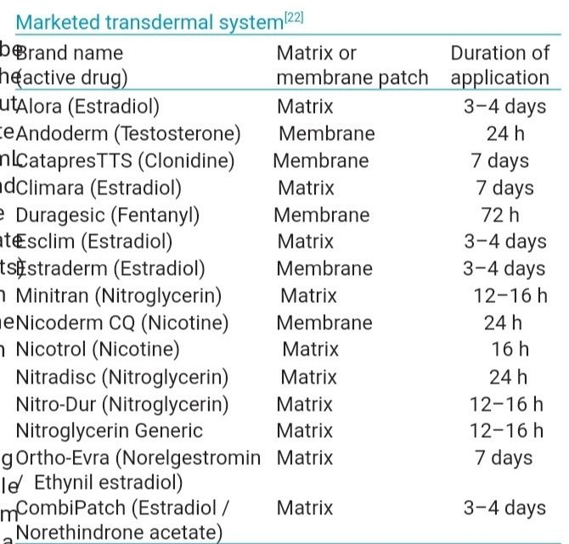

CONCLUSION

TDDS is a newer approach in the area of dosage forms for many injected and orally delivered drugs having appropriate physicochemical and pharmacological properties. The TDD ensures that a pharmacologically active substance arrives at a relevant in vivo location with minimal side-effects. Because of the several advantages of the TDDS, many new researches are going on to incorporate newer drugs in the system. Various devices that help in increasing the rate of absorption and penetration of the drug are also being studied. TDDSs are heavily based on polymers, penetration enhancers, backing laminates, plasticizers, liners to ensure good adhesion and controlled release of drug to systemic circulation via skin over a period of several hours or days. Transdermal patches can be divided into various systems, like reservoir system, matrix system and microreservoir system. After preparation of transdermal patches, consistent methodologies are adopted to test the various parameters. Because of the recent advances in technology and the incorporation of the drug to the site of action without rupturing the skin membrane, the transdermal route is becoming the most widely accepted route of drug administration. This drug delivery overcomes the challenges associated with current popular drug delivery; thus, it shows a promising future. According to the duration of therapy, various drugs are commercially available in the transdermal patche.

Reference:

1. Tiwary AK, Sapra B, Jain S. Innovation in transdermal drug delivery: Formulation and techniques. Recent Pat Drug Deliv Formul 2007;1:23-36

2. Chong S, Fung HL, In: Hadgraft J, Guy RH, editors. Transdermal drug delivery. development issues and research initiatives. New York: Marcel Dekker; 1989. p. 135-54.

3. Singh A, Singh MP, Alam G, Patel R, Vishvakarma D, Datt N. Expanding opportunities for transdermal delivery systems: An overview. J Pharm Res 2011;4:1417-20.

4. Ansel HC, Allen LV and Popovich NG. Pharmaceutical dosage forms and drug delivery system. 7th ed. New York: Lipponcott Williams and Wilkins; 2002.

5. Patel RP, Baria AH. Formulation and evaluation consideration of transdermal drug delivery system. Int J Pharm Res 2011;3:1-9.

6. Kumar JA, Pullakandam N, Prabu SL, Gopal V. Transdermal drug delivery system: An overview. Int J Pharm Sci Rev Res 2010;3:49-54.

7. Jain NK. Advances in controlled and novel drug delivery. 1st ed. New Delhi: CBS Publishers and Distributors; 2001. p. 108-10.

8. Soni M, Kumar S, Gupta GD. Transdermal drug delivery: A novel approach to skin permeation. J Pharm Res 2009;2:1184-90.

9. Naik A, Kalia YN, Guy RH. Transdermal drug delivery: Overcoming the skin’s barrier function. Pharm Sci Technol Today 2009;3:318-26.

10. Chandrashekhar NS, Shobha R. Physicochemical and pharmacokinetic parameters in drug selection and loading for transdermal drug delivery. Indian J Pharm Sci 2008;70:94-5.

11. Merkle HP. Transdermal delivery systems. Methods Find Exp Clin Pharmacol 1989;11:135-53.

12. Brown L and Langer R. Transdermal delivery of drugs. Annu Rev Med 1988;39:221-9.

13. Arunachalam A, Karthikeyan M, Kumar DV, Prathap M, Sethuram S, Kumar AS. Transdermal drug delivery system: A review. Curr Pharma Res 2010;1:70-81.

14. Flynn GL. Percutaneous Absorption. 3rd ed. New York: Marcel Dekker; 1985.

15. Hadgraft J. Skin Deep. Eur J Pharm Biopharm 2004;58:291-9.

16. Singh MC, Naik AS, Sawant SD. Transdermal drug delivery systems with major emphasis on Transdermal Patches: A review. J Pharm Res 2010;3:2537-43.

17. Aulton ME. Aulton’s Pharmaceutics The design and manufacture of medicine. 3rd ed. Churchill Livingstone: Elsevier; 2007. p. 567-8.

18. Jain NK. Controlled and Novel Drug Delivery. New Delhi: CBS Publishers and Distributors; 2002. p. 107.

19. Kumar TS, Selvam RP, Singh AK. Transdermal drug delivery systems for antihypertensive drugs. Int J Pharm Biomed Res 2010;1:1-8.

20. Chien YW. Novel drug deliver y systems, Drugs and the Pharmaceutical Sciences, Vol. 50. New York: Marcel Dekker; 1992. p. 797

21. Sugibayashi K, Morimoto Y. Polymers for transdermal drug delivery systems. J Control Release 1994;29:177-85.

22. Hadgraft J, Guy RH. Transdermal Drug Delivery. 2nd ed. New York: Marcel Dekker; 1989.

23. Keleb E, Sharma RK, Mosa EB, Aljahwi A. Transdermal drug delivery system and evaluation. Int J Adv Pharm Sci 2010;1:201-11.

24. Spencer TS, Smith SE, Conjeevaram S. Adhesive interactions between polymers and skin in transdermal delivery systems. Polym Mater: Sci Eng 1990;63:337-9.

25. Minghetti P, Cilurzo F, Tosi L, Casiraghi A, Montanari L. Design of a new water-soluble pressure-sensitive adhesive for patch preparation. AAPS Pharm Sci Tech 2003;4:9.

26. Tyle P. Drug Delivery device. 3rd ed. New York and Basel: Marcel Dekker; 2003.

27. Pfister WR, Sieh DS. Permeation Enhancer compatible with transdermal drug delivery systems. Part I: Selection and Formulation consideration. Med Device Technol 1990;1:48-55.

28. Godbey KJ. Improving patient comfort with non-occlusive transdermal backings. AAPS Pharm Sci Tech 1996;1-2.

29. Walters KA. Transdermal drug delivery system In: Swarbick K, Boylan JC, editors. Encyclopedia of Pharmaceutical Technology. New York: Marcel Dekker; 1997. p. 253-93.

30. Foco A, Hadziabdic J, Becic F. Transdermal Drug Delivery Systems. Med Arch 2004;58:230-4.

31. Sakalle P, Dwivedi S, Dwivedi A. Design, evaluation, parameters and marketed products of transdermal patches: A review. J Pharm Res 2010;3:235-40.

32. Brahmankar DM, Jaiswal SB. Biopharmaceutics and pharmacokinetics A treatise. Delhi: Vallabh Prakashan; 1995. p. 335-71

33. Novel drug Delivery system, Second Edition, Revised and Expanded, Yie W. Chien. P: 301-31