**SMART CALENDAR**

**Yash Bhavsar1, Nikita Gosavi2, Madhura Birari3**

1,2,3Students, Electronics and Telecommunication Department, MVP’s KBTCOE, Nashik, Maharashtra, India

**ABSTRACT**

As we know calendars are essential for professionals working in industry, government, education and many other fields, which play a key role in the planning and scheduling of people’s day-today events. Status report of university academic calendar implementation can be used as one of many parameters due to Quality Assurance (QA) in Higher Education. We are developing monitoring system for University academic calendar implementation by using pocket computer Raspberry Pi and display on the LCD screen As a result, the monitoring system shows implementation status for every agenda of each unit in Higher Educational Institution, such as the list of activities in current week along with implementation status (“Scheduled”, “On-Process”, “Implemented”, “Canceled” and “Failed”). The system works by mean of comparing the scheduled data that has been submitted and verified from the reported agenda of each unit.

**Keywords:**{Raspberry Pi, LCD}

1. **INTRODUCTION**

A Smart Calendar can make your work and life easy with its flexible, versatile, and collaborative solutions. It may also Consume time and paper. Fundamentally, planning and scheduling is a combinational optimization problem with symbolic representation of events and various types of constraints on events. The smart calendar view is helpful to know what needs to be done on what day. With a project timeline, you would have a clear idea of which tasks are critical and can’t be delayed. Although some events, such as lectures, conferences and birthdays, have fixed dates and times that can easily fit into the structure that conventional calendars offer, many events, such as social meetings and studying, are more flexible in when they can be done. As each and every thing is moving  towards the digitalization. Then why we cannot make our old paper printed calendar as smart calendar. Existing calendar systems assume that all the events are fixed and hence they only provide an overview of events and tasks that are happening in a given period of time. A smart calendar system capable of optimizing the timing of events to address the limitations of the existing calendar systems.

1. **METHODOLOGY**

Our project mainly consists of two components. They are:-

1. Raspberry Pi
2. LCD
   1. **WORKING:**

As raspberry pi is boot up our file starts executing at first it will fetch the data(Events and Image Notice) via API and whatever data is been received will be in JSON format then it will get extracted from it and after formatting the data in specific manner it is been send to the UI(Display). As per the input given to the system or by sharing the file, text ,image will be displayed on the screen.

* 1. **BLOCK DIAGRAM**

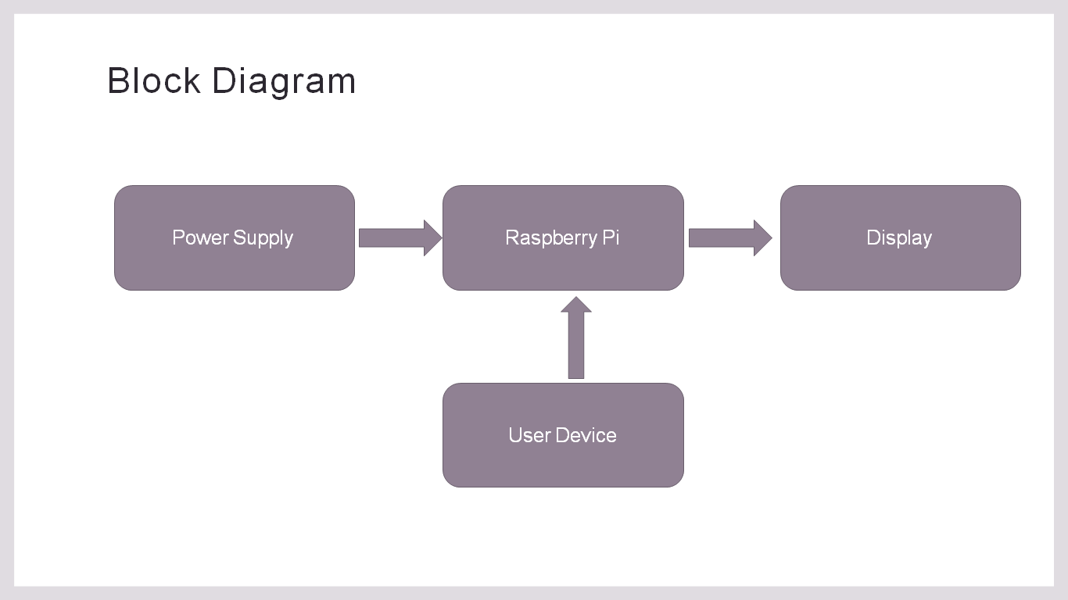

**Figure 2.1 Block Diagram of Smart Calendar**

* 1. **FLOW CHART**

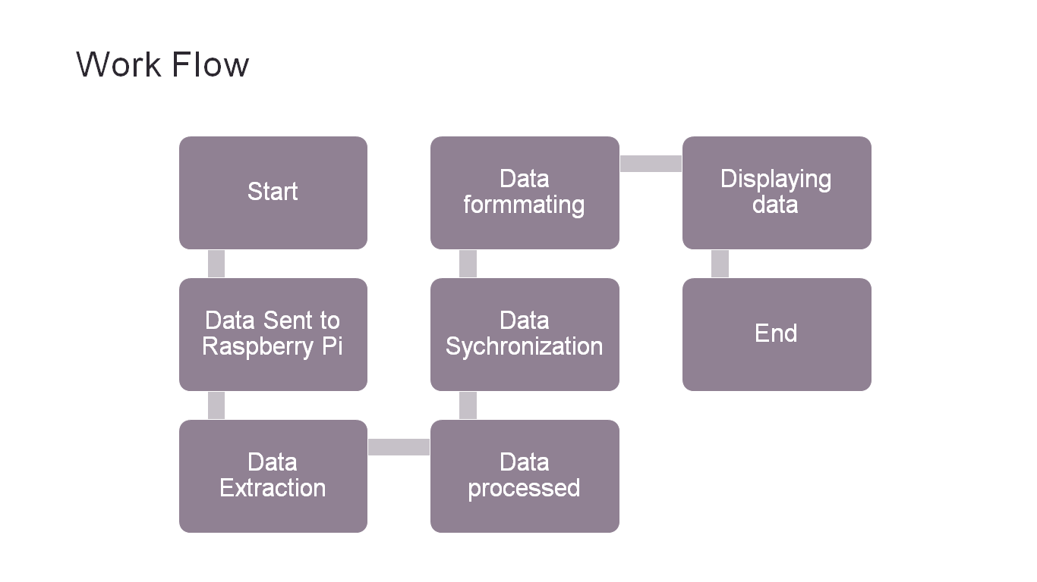

**Figure 2.3 Flow Chart of Smart Calendar**

1. **COMPONENTS AND SPECIFICATIONS**
2. **Raspberry Pi 3:** The Raspberry Pi 3 Model B+ is the latest product in the Raspberry Pi 3 range, boasting a 64-bit quad core processor running at 1.4GHz, dual-band 2.4GHz and 5GHz wireless LAN, Bluetooth 4.2/BLE, faster Ethernet, and PoE capability via a separate PoE HAT.

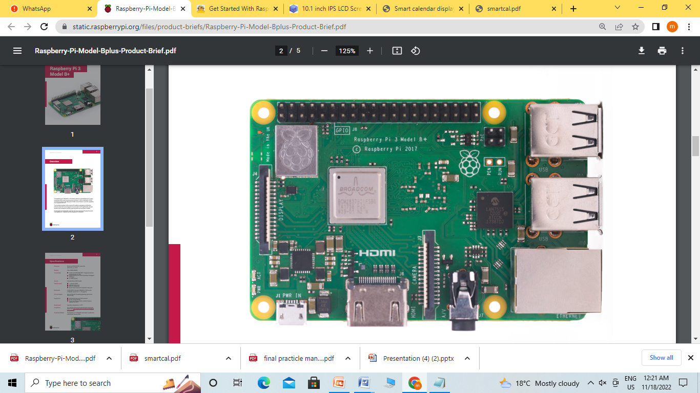

**Figure3.1: Raspberry Pi 3**

**Specifications:**

* Processor: Broadcom BCM2837B0, Cortex-A53 64-bit quad core processor operating at 1.4GHz frequency.
* Memory: 1GB LPDDR2 SDRAM
* Connectivity: 2.4GHz and 5GHz IEEE 802.11.b/g/n/ac wireless LAN, Bluetooth 4.2, BLE.
* Gigabit Ethernet over USB 2.0 (maximum throughput 300Mbps).
* 4×USB 2.0 ports.
* Access: Extended 40-pin GPIO header.
* Video & sound: 1 × full size HDMI.
* MIPI DSI display port.
* MIPI CSI camera port.
* pole stereo output and composite video port.
* SD card support: Micro SD format for loading operating system and data storage.
* Input power: 1)5V/2.5A DC via micro USB connector.

2)5V DC via GPIO pins

3) Power over Ethernet (PoE)–enabled (requires separate PoE HAT).

* Environment: Operating temperature, 0–50°C.

1. **LCD:** The 10.1 inch IPS LCD Screen 1280x800 with Driver Board Kit for Raspberry Pi is an HD IPS digital LCD screen kit with HDMI+VGA+2AV.Do not reverse the positive and negative of the power supply. The back of the drive plate is marked positive and negative (GND).The driver board must be insulated around so as no conductor or metal conductor can touch the circuit board.

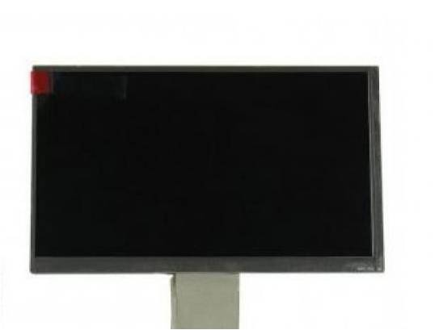

**Figure3.2 LCD Display**

**Specifications:**

|  |  |  |
| --- | --- | --- |
| * LED Brightness (MCD) |  | |
| * Contrast | | 600:1 | |
| * Display Color | | 16.7M (6bits + Hi-FRC) | |
| * Operating Voltage (VDC) | | 12 | |
| * Max. Operating Current (mA) | | 2A MAX | |
| * Display Size (inch) | | 10.1 | |
| * HDMI Port | | HDMI 1.1 | |
| * Interface Type | | Digital | |
| * Luminance | | 350cd/m2 | |
| * Number of Wiring | | 40 Pin LVDS | |
| * Panel Type | | TFT | |
| * Physical Resolution | | 1280 x 800 | |
| * Rated Power (W) | | 6 ~ 7 | |
| * Shape Size | | 228.6 x 149.2 x 2.39 | |
| * Signal Input | | 2 Road AV+VGA | |
| * System Mode | | PLA/NTSC | |

1. **RESULTS**

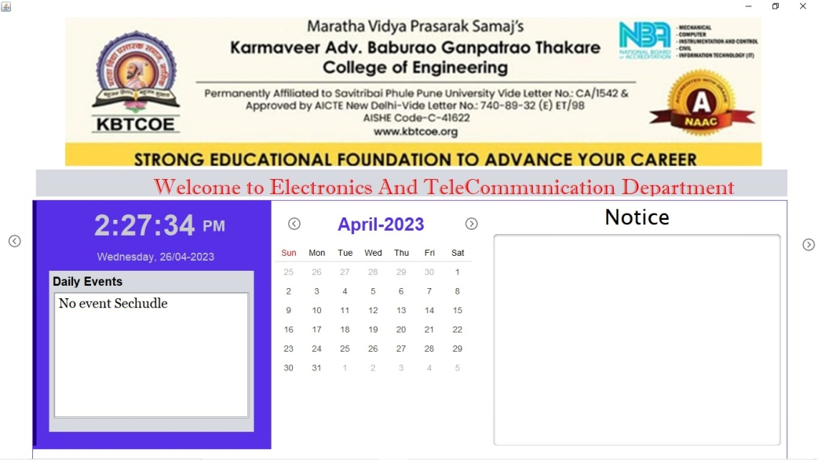

**Figure 4.1 Result with Daily Events, Calendar, Notice**

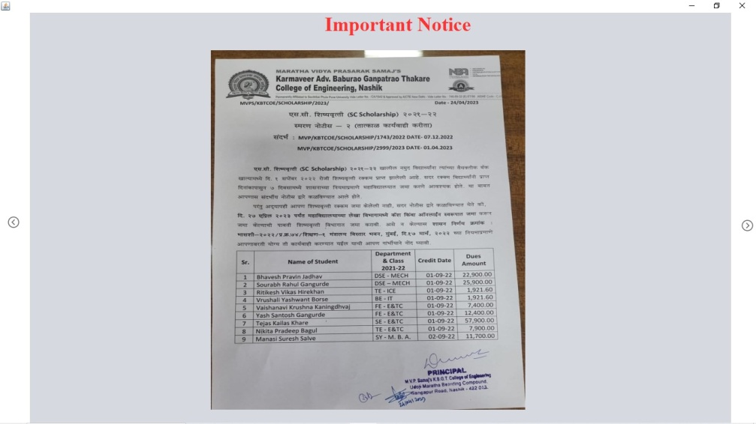

**Figure 4.2 Result with Image as input**

1. **CONCLUSION**

# We have successfully studied the requirement of Smart Calendar. The main motive of the project is to cover the aspects to save the time and paper. In this project, we will be developing a calendar which uses Raspberry Pi. A smart calendar is works as a complementary of a regular calendar by adding extra functionality of a comprehensive planning system. Smart calendar can possibly upgrade the user experience of getting to and connecting with data. In addition to the fact that they allow users to see daily data easily. This is done by using LCD display. This is implemented through the use of hard and soft constraints to make the calendar more flexible for the user. While a project management calendar provides a lot of extra features and benefits, you may still want to utilize your existing calendar application, especially if you're also keeping track of non-project-related events, meetings, and deadlines. Look for a system that allows you to control the degree of detail that is published to your conventional calendar.

.

1. **REFERENCES**
2. Melinda T Gervasio, Michael D Moffitt, Martha E Pollack, Joseph M Taylor, and Tomas E Uribe. Active preference learning for personalized calendar scheduling assistance. In Proceedings of the 10th international conference on Intelligent user interfaces, pages 90–97. ACM, 2005.
3. Dr. C K Gomathy, Article: A Semantic Quality of Web Service Information Retrieval Techniques Using Bin Rank, International Journal of Scientific Research in Computer Science Engineering and Information Technology . ( IJSRCSEIT ) Volume 3 | Issue 1 | ISSN : 2456-3307, P.No:1563-1578, February-2018
4. G. Ayorkor Mills-Tettey, Anthony Stentz, and M Bernardine Dias. The dynamic hungarian algorithm for the assignment problem with changing costs. 2007.
5. Manreet Kaur, Preeti Abrol “Design and Development of Floor Cleaner Robot (Automatic and Manual) “International Journal of Computer Applications (0975 – 8887) Volume 97– No.19, July 2014.