**Safety Helmet for a bike rider using AT mega 328 with Controlled ignition**

**Mohini Mankar1, Esha Jadhav2, Sneha Jadhav3**

123Student, Department of Electronics and Telecommunication Engineering, NDMVP College of Engineering, Nashik, Maharashtra, India

**ABSTRACT**

Everyday around the world a large percentage of people die from road accident. An effective approach is made to solve the problem by using smart helmet. Smart helmet is an idea which make motorcycle driving safer than before.

Vehicle won’t start without wearing helmet. Limit switch is fitted inside helmet inside the helmet, which will detect whether the rider has worn the helmet or not, if not then the vehicle will not start. Alcohol sensor in helmet will detect the smell of alcohol consumed by driver. In that case also vehicle will not start. Helmet has accelerometer sensor to detect head movement. This helps to detect neck bend moment for sleep detection. A buzzer inside vehicle will give audio indication to the wake up driver. So that he/she will be alert. An indicator light can be control through helmet movement with the help of accelerometer sensor.

**Keywords**: Accelerometer, Limit Switch, Buzzer, Smart helmet.

.

**INTRODUCTION**

There is an alarming increase in the morbidity and mortality due to two wheeler road traffic accidents. This has been a matter of great concern globally. In India, it is estimated that one accident takes place every 2 minutes. Data from the National Crime Records Bureau indicates that deaths and injuries related to road traffic accident has increased two and four fold respectively during the period of 1991–2005. Reportedly 98,254 persons were killed in 2005 on Indian roads. The occupants and riders of two wheeler vehicles are among the majority to be affected in road traffic accidents. Two wheeler accidents have also been shown to have maximum case fatality in accidents. Despite of the safety rules made by the government, many riders fail to abide by them. The riders in India often bypass the prime rule of wearing the helmet while riding bike. This leads to fatal injuries to the rider in case of accidents. Apart from manual checking, there needs to be a system that could enforce this rule upon the riders and hence prevent them from bypassing it. One of the prime reasons that leads to accidents is “drunk and drive”. Due to drinking and driving two wheeler riders often get into accidents. Almost 70% of the accidents in our country can be prevented if the riders stop consuming alcohol before riding. The people involved in the accidents need to be taken care of and immediately taken to the emergency room. But there is a lag in handling the aftermath of road accidents in the country. The nearby police station needs to be notified immediately about the accidents so that they can be taken to the hospitals immediately. Project is divided into two sections. One is helmet module and another is vehicle module. At first driver need to wear a helmet and then connect it with vehicle module through wire bus. Once helmet connected, vehicle can be turn on. Then helmet will measure amount of alcohol and if alcohol found, vehicle won’t be on. Right and left indicators can be control by moving head slowly in right or left side. In case of sleep, acceleration sensor will detect down movement of neck & vehicle will be off with buzzer alert.



1. **MODELING AND ANALYSIS**

In this section we have represented the block diagram, according to which the procedure takes place

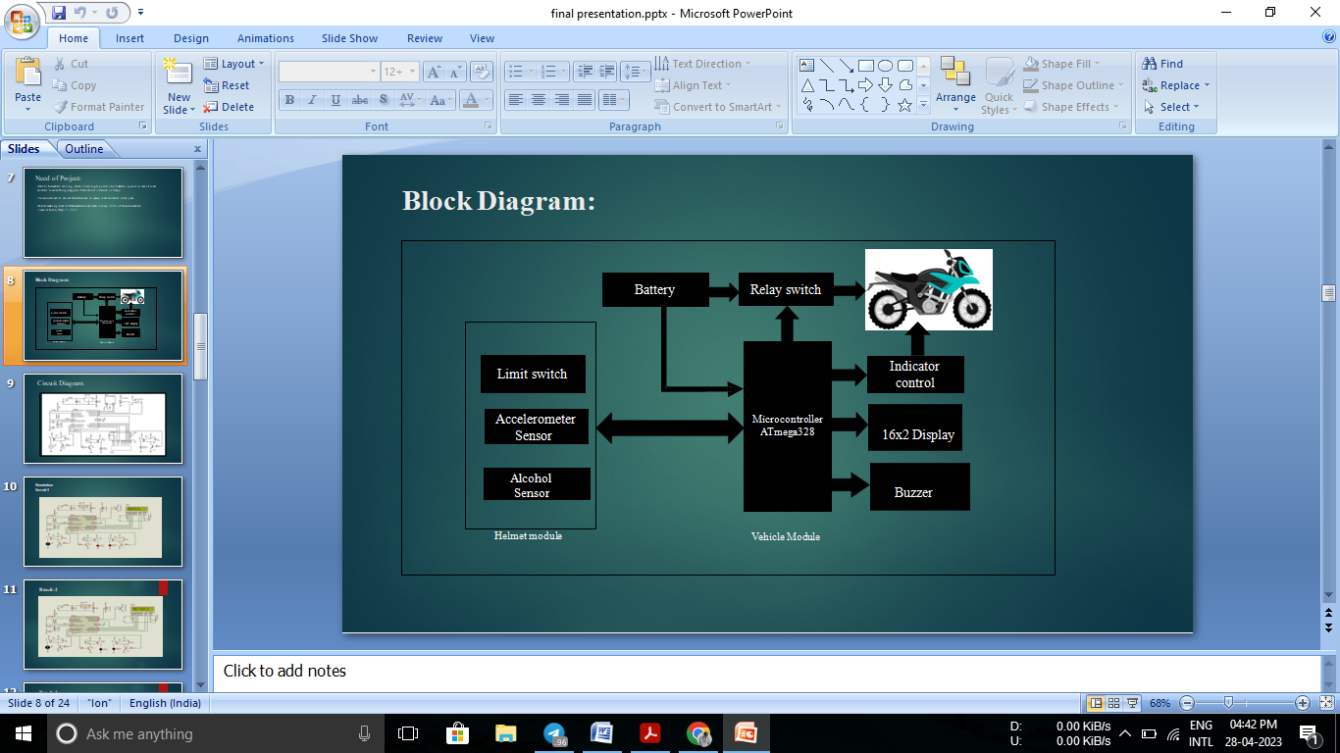

**Figure1:**Block Diagram.

Project is divided into two sections. One is helmet module and another is vehicle module. Vehicle module consist of battery for powering the helmet, display for user interface and indicator lights. Whereas other arrangement is made on helmet itself. Both sections will be connected through wire bus.

To turn on the vehicle, it is necessary to connect the helmet with vehicle using the wire bus. At first driver need to wear a helmet and then connect it with vehicle module. Once helmet connected, vehicle can be turn on. When driver wears helmet, limit switch will detect it and give signal to controller. Then helmet will measure amount of alcohol using the MQ2 sensor. If alcohol found, vehicle can’t be turn on. In this case, buzzer will be on. Whereas ADXL accelerometer module will monitor head movement. When driver tilt his/her head on left side slowly, left indicator will be on. For turning on right indicator, driver need to tilt head on right side slowly. In case of neck down movement, accelerometer calculates angle which is not regular, and microcontroller will generate alert signal to wake up the driver.

Also, with that we have shown the circuit diagram of the project. (fritzing Software)

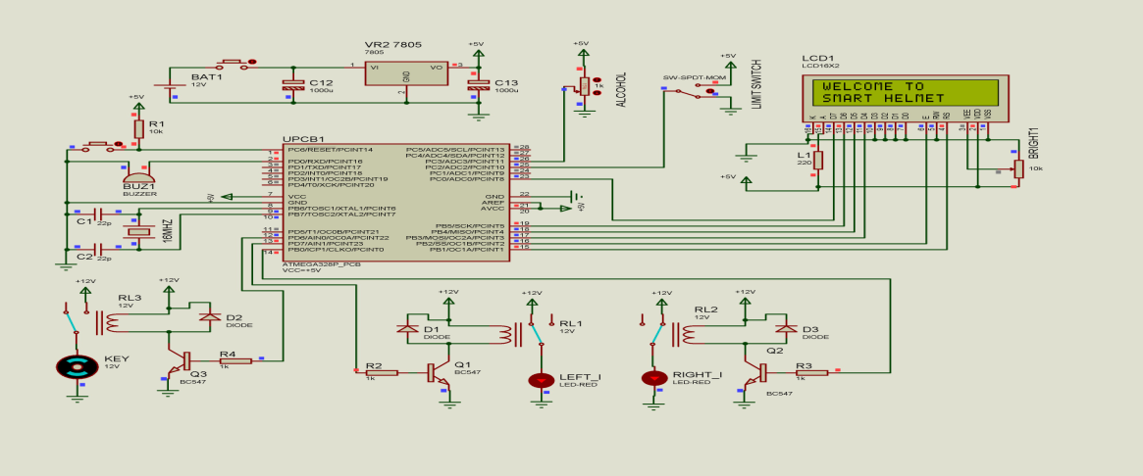

**Figure 2:**Circuit Diagram

1. **RESULTS**

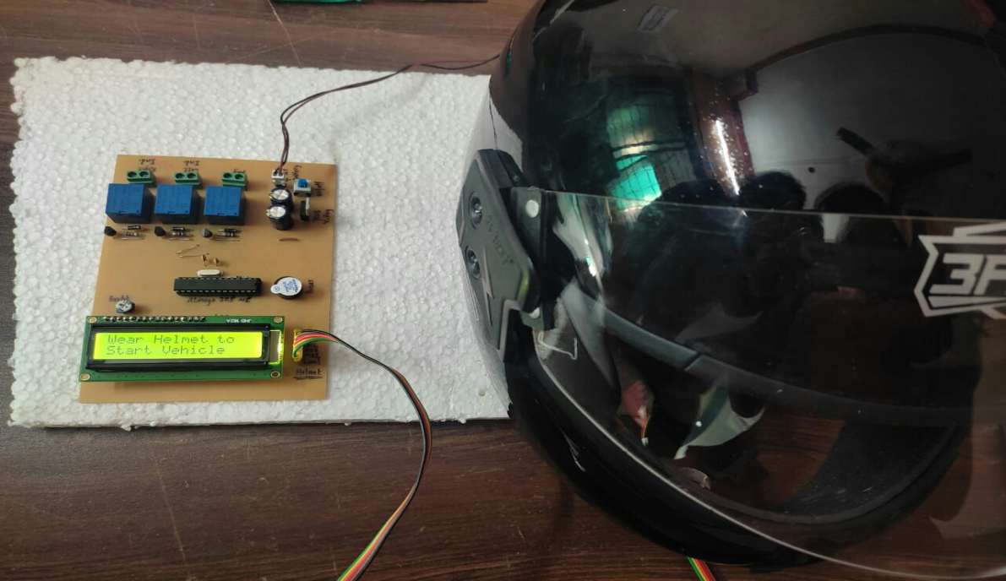

**Figure 3:**Result

1. **CONCLUSION**

In this project by considering all the situations and possibility, we decided the specification for project and chosen components and sensors which are helping to achieve the desire target. Though, design of circuit and simulation is critical due to non-availability of accelerator module in Proteus simulation software. Whereas due to the use of Arduino development tools, reduce difficulties during programming & troubleshooting was reduced. Due to compulsion of helmet to start the vehicle makes driving safer. Alcohol detection & sleep detection is biggest advantage to avoid casualties. Vehicle gets stop automatically when sleep or alcohol is detected. Auto indicator control provides comfort while driving. Though circuit is critical to design due to multiple components, use of Arduino development tools was great help. It reduces difficulties during programming & troubleshooting was also easy.

1. **REFERENCES**
2. R.Nazir, A.Tariq, S.Murawwat, S.Rabbani “Accident Prevention and Reporting System Using GSM (SIM 900D) and GPS (NMEA 0183)” Dept. of Electrical Engineering, Lahore College for Women University, Lahore, Pakistan, Accepted 30 July 2014.
3. V.Krishna Chaitanya, K.Praveen Kumar, “Smart helmet using arduino”, Journal of Scientific and Engineering Research,Volume 2,Issue 3,March 2016.
4. R. Prudhvi Raj, Ch. Sri Krisna Kanth, A. BhargavAdityaand K. Bharath, “Smart-tec Helmet,” AEEE, India. International Journal on Recent and Innovation Trends in Computing and Communication, Volume 4, Issue 4, April 2016
5. Manjesh N, Prof. Sudarshan Raj, “Smart Helmet Using GSM &GPS Technology for Accident Detection and Reporting System”, International Journal of Electrical and Electronics Research, Vol. 2, Issue 4, October - December 2014.