**Scrolling LED Display**

**Siddhi Bafana1, Nimish Bhangale2, Jayesh Gharte3**

1Student, Department of Electronics & Telecommunication Engineering, MVPS’s KBT college of engineering, Nashik , Maharashtra, India

2 Student, Department of Electronics & Telecommunication Engineering, MVPS’s KBT college of engineering, Nashik , Maharashtra, India

3 Student, Department of Electronics & Telecommunication Engineering, MVPS’s KBT college of engineering, Nashik , Maharashtra, India

**ABSTRACT**

Because of developments in technology, there have also been developments in terms of the ways that information can be shown for the sake of marketing and advertising. These developments have been made possible by those technological developments. These enhancements are a direct result of the technical developments that have taken place in recent years. LED matrix display boards are frequently used for the purpose of showing a variety of adverts and messages of varying lengths and formats. These Display boards have evolved into a regular fixture in several public spaces, including educational institutions, shop floors (workstations), and other public settings. Other public settings also frequently make use of these boards. They are utilized to display information such as the timetables for public transit platforms and times, in addition to displaying a variety of advertisements for items and important notices. Important notices and advertising are two examples of the additional forms of information that can be displayed on them. People are now accustomed to the concept that they can access any information in the world with only a few clicks of their mouse. This concept has revolutionized the way people acquire information. In earlier iterations of display boards, the technique of communication was accomplished using wired technology because wireless technology was not yet on the market at the time. In this situation, the act of communicating is accomplished by utilizing a form of wireless technology known as wi-fi.

**KEYWORDS***:* Wired display boards, Wi-fi, LED matrix display, Wireless technology,

1. **INTRODUCTION**

An LED Display or Notice board is a surface that can be used for a variety of purposes, including but not limited to the transmission of important news, the advertisement of items that are sought or needed to sell, the announcement of events, and the provision of information. It is feasible to design an LED scrolling display that is capable of presenting information in a timely and effective manner. This will enable you to communicate and change your messages as frequently as is required. You can view the content remotely and bring these displays up to date in a very short amount of time. Using the internet, it is possible to exercise remote control over these systems. The major purpose of this project is to develop a concept for a system that would display various types of college events such as notices of upcoming tests, information about interviews, information about seminars and webinars, and other forms of college activities. This system has the potential to be employed in a range of significant sites, such as shopping malls, movie theatres, public transportation, traffic and highway signboards, and other areas that require the presentation of information that is up to date. Specifically, this system has the potential to be applied in these and other areas.

1. **RELATED WORK**

This system takes ideas from other systems which have already been implemented earlier. It merges two different project ideas into single unit. It is an extension of already existing LED scrolling display board. But here we are using text message technology using mobile app through Wi-Fi module. For making this LED display more portable, an android phone can be used instead of carrying a computer or keyboard every time user needs to change the messages to be displayed on the LED matrix display. A Wi-Fi module which is the driver is connected to the LED display hardware and is used to receive the text message and send it to the controller circuit of the LED display. Then the controller circuitry which drives the led matrix stores the received data in externally interfaced RAM and tallies the same with the lookup table stored in controller program displays the text on LED displays accordingly. By using Wi-Fi it is possible to change the message on the LED display board through app, from any desired location in the country. This idea used in this project minimizes the total cost that is required in the traditional LED display boards and makes easier to send data to these LED display boards. The project uses a Wi-Fi at the display side to receive the text signal. Along with this, Switch mode power supplies are used for controlling led driver and led matrix.

1. **METHODOLOGY**

Our project mainly consists of 5 major components: -

* + Power supply
  + SMPS
  + Driver
  + LED matrix display
  + LedArt app

This proposed system allows people to directly check the important information on the display. Here, we used the wireless Wi-Fi technology for communication. 230V AC power supply is given to the 12V SMPS device which converts AC into DC. SMPS gives power to the Driver and LED matrix display. Basically, Driver (ROHS HD-W00 V7. 0. 2) is a low cost, high cost-effective single color Wi-Fi controller device. Firstly, check the Wi-Fi is connected to the driver W00. Then, connect W00 to the LedArt app for text updating purpose. LedArt app is the software which is used for connecting Driver to the Wi-Fi. The system constantly transmits this data to the W00 controller, which now processes this data and keeps on transmitting it to the online web server over a Wi-Fi connection. The transmitted data is sent to the LED display and then it will print data on LED matrix display

**2.1 BLOCK DIAGRAM**

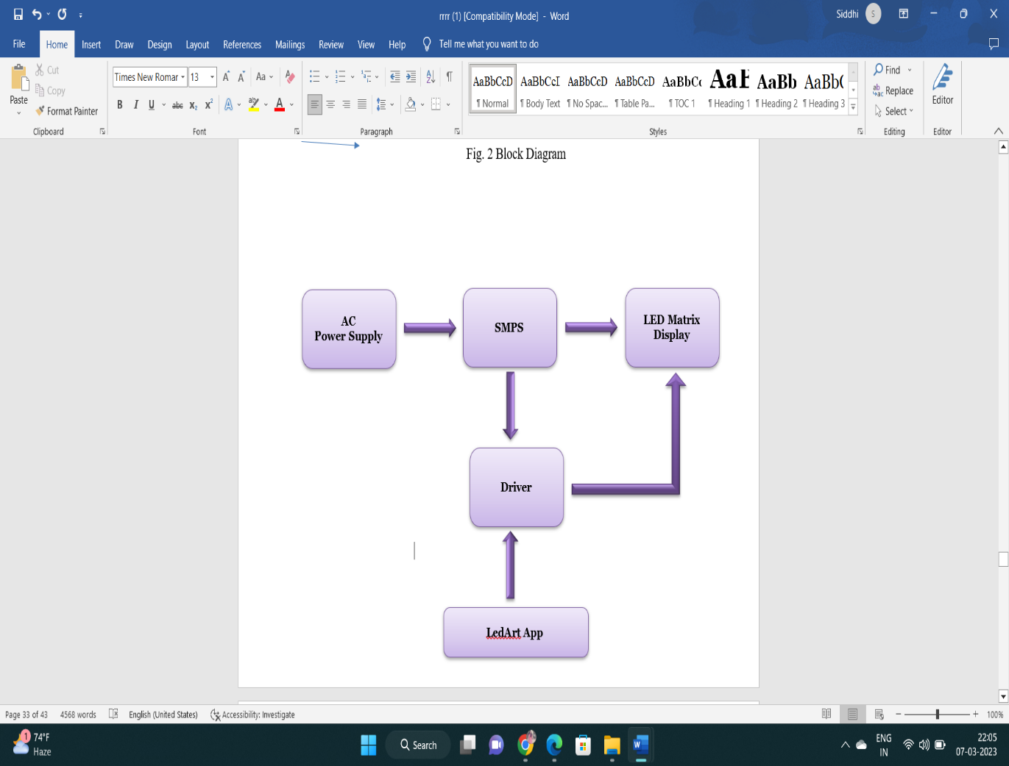

**Figure 1:** Block Diagram

**2.2 FLOWCHART**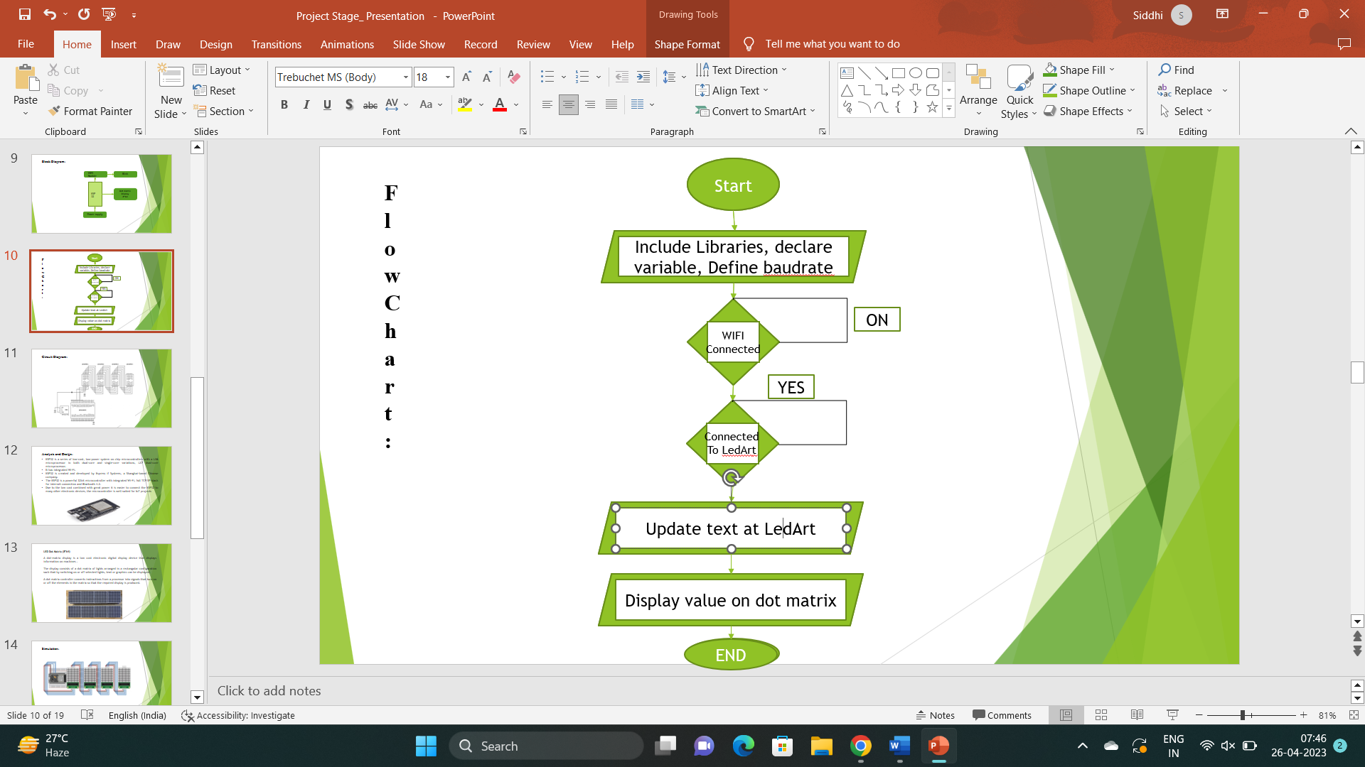

**Figure 2:** Flowchart

1. **RESULTS**

**Figure 3:** Hardware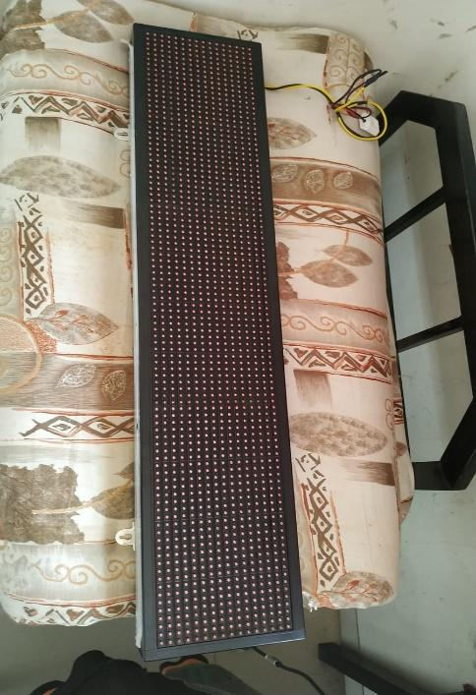

1. **CONCLUSION**

The prototype of the display that is based on WI-FI was designed in an efficient manner, which contributed to its overall success. This prototype already has all of the essential components built into it, and with the addition of a display board, it can be transformed into a real mobile/PC device. After recording the message or information, it checks to make sure that it is correct before eventually displaying it on the LED display once it has determined that it is correct. When the message is read from the EEPROM, it is instantly deleted, making room for the next message to be placed into the EEPROM's memory. There is only room for one SMS to be displayed at a time on the screen. These limitations can be overcome by employing microcontrollers with a higher end and increasing the amount of RAM that is available. When it comes to producing the prototype, one alternative worth considering is to use pre-existing commercial display boards. In this particular setting, the immediate flow of information has the potential to solve the problem that has been presented.

1. **REFERENCES**

[1]. Prachee U. Ketkar, Kunal P. Tayade, Akash P. Kulkarni, Rajkishor M. Tugnayat: GSM Mobile Phone Based LED Scrolling

Message Display System, International Journal of Scientific Engineering and Technology Volume 2 Issue 3; PP : 149-155

[2]. Ervin John U. Benigra, Bryan Leonard D. Montaño and Engr. Maridee B. Adiong,‖ RUNNING MESSAGE BOARD USING DOT-MATRIX DISPLAY‖ Capitol University,College of Engineering, Cagayan de Oro City.

[3]. Foram Kamdar, Anubbhav Malhotra and Pritish Mahadik : Display Message on Notice Board using GSM, ISSN 2231-1297, Volume 3, Number 7 (2013); pp. 827-832

[4]. Darshankumar C. Dalwadi, Ninad Trivedi, Amit Kasundra : WIRELESS NOTICE BOARD, National Conference on Recent Trends in Engineering & Technology.

[5]. Prachee U. Ketkar, Kunal P. Tayade, Akash P. Kulkarni, Rajkishor M. Tugnayat: GSM Mobile Phone Based LED Scrolling Message Display System, International Journal of Scientific Engineering and Technology Volume 2 Issue 3; PP : 149-155 .

[6]. Foram Kamdar, Anubbhav Malhotra and Pritish Mahadik : Display Message on Notice Board using GSM, ISSN 2231-1297, Volume 3, Number 7 (2013); pp. 827-832