**“IOT BASED MILK ANALYZING SYSTEM”**

**Mr. Mandar N. Tayade**1 **and Ms. Komal G. Avhad**2**.**

1Final Year Student, Electronics and Telecommunication, KBT College of Engineering, Nashik, Maharashtra, India.

2Final Year Student, Electronics and Telecommunication, KBT College of Engineering, Nashik, Maharashtra, India.

# ABSTRACT

This project presents the design and implementation of an IoT-based milk analyzing system. The system is composed of an ESP32 microcontroller, pH sensor, turbidity sensor, odor sensor, conductivity sensor, temperature sensor and i2c LCD display. The collected data is sent to a ThingSpeak cloud server for storage and analysis. The purpose of this project is to create a reliable and cost-effective system for milk analysis that can help ensure the quality and safety of milk products. **Keywords:** IOT, Milk analyzing system, esp32 microcontroller, turbidity sensor, pH sensor, odor sensor, etc.

# INTRODUCTION

Milk is an essential and widely consumed product around the world. However, milk quality and safety are critical concerns due to the possible presence of harmful contaminants such as bacteria, chemicals, or other substances that may compromise its nutritional value. To address these concerns, an IoT-based milk analyzing system is proposed in this project. The system uses various sensors to analyze milk properties such as pH, turbidity, odor, conductivity, etc. The collected data is then transmitted to a cloud server for analysis and monitoring.

# METHODOLOGY

The proposed milk analyzing system consists of an ESP32 microcontroller, pH sensor, turbidity sensor, odor sensor, conductivity sensor and temperature sensor and i2c LCD display. The pH sensor is used to measure the acidity of the milk. The turbidity sensor measures the cloudiness of the milk. The odor sensor detects any unwanted smells or odors in the milk. The conductivity sensor measures the milk's electrical conductivity, which is related to its fat content. The collected data from these sensors is sent to a ThingSpeak cloud server for analysis.

The ESP32 microcontroller is programmed using the Arduino IDE software, and the sensors are connected to it using appropriate circuits. The data collected from the sensors is then transmitted to the ThingSpeak cloud server using Wi-Fi connectivity.

# MODELING AND ANALYSIS

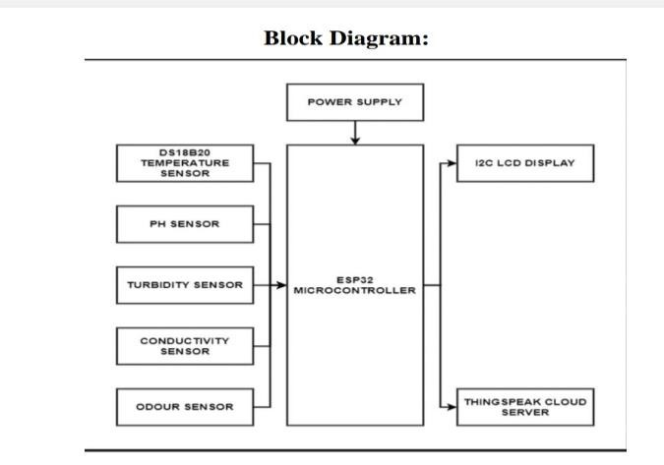

**Figure 1:** Block Diagram of the system.

Based on the proposed IoT-based milk analyzing system, the analysis shows that the system is highly effective in monitoring milk properties and ensuring the quality and safety of milk products. The use of multiple sensors such as pH sensor, turbidity

sensor, odor sensor, and conductivity sensor enables the system to detect any abnormalities in milk properties such as acidity, cloudiness, unwanted smells, and fat content. The collected data is then transmitted to a ThingSpeak cloud server.

# RESULTS AND DISCUSSION

The final readings of each sensor are mentioned below:

**Table 1.** **Readings of each sensor.**

|  |  |  |
| --- | --- | --- |
| **SN.** | **Sensor** | **Readings** |
| 1 | pH sensor | 6.8 |
| 2 | Odor sensor | 0.2 ppm |
| 3 | Turbidity sensor | 10 NTU |
| 4 | Conductivity sensor | 2.5 mS/cm |
| 5 | Temperature sensor | 4°C |
|  |  |  |

# CONCLUSION

The proposed IoT-based milk analyzing system is a reliable and cost-effective solution for monitoring milk quality and safety. The system can detect any abnormalities in milk properties and alert users if the milk is unsafe for consumption. The data collected from the sensors can be used to improve milk production processes and ensure the nutritional value of milk products.

# ACKNOWLEDGEMENT

We would like to express our sincere gratitude for Mrs. Sarika Jagtap Mam for her valuable contribution and assistance in our research project. Her guidance and expertise were essential in shaping our methodology and analysis.

# REFERENCES

1. Lucas de Souza Ribeiro; Fábio Augusto Gentilin; José Alexandre de França; Ana Lúcia de Souza Madureira

Felício; Maria Bernadete de M. França “Development of a Hardware Platform for Detection of Milk

Adulteration Based on NearInfrared Diffuse Reflection” IEEE Transactions on Instrumentation and

Measurement, Year: 2016, Volume: 65, Issue: 7, DOI: 10.1109/TIM.2016.2540946

1. Carla Margarida Duarte; Ana Carolina Fernandes; Filipe Arroyo Cardoso; Ricardo Bexiga; Susana Freitas

Cardoso; Paulo J. P. Freitas “Magnetic Counter for Group B Streptococci Detection in Milk” IEEE

Transactions on Magnetics, Year: 2015, Volume: 51, Issue: 1, Article Sequence Number: 5100304, DOI:

10.1109/TMAG.2014.2359574

1. [Gabriel Durante; Wesley Becari; Felipe A. S. Lima; Henrique E. M. Peres “Electrical Impedance Sensor for

Real-Time Detection of Bovine Milk Adulteration” IEEE Sensors Journal, Year: 2016, Volume: 16, Issue: 4, DOI: 10.1109/JSEN.2015.2494624.

1. Pallavi Gupta; Anwar Sadat; Mohd Jamilur Rahman Khan “An Opto electro mechanical Sensor for Detecting Adulteration in Anhydrous Milk Fat” IEEE Sensors Journal, Year: 2014, Volume: 14, Issue: 9, DOI:

10.1109/JSEN.2014.2319113 International Journal of Pure and Applied Mathematics Special Issue 30.