**Technique to Control Illegal Tree Cutting Through Low-Power Smart Lighting using IoT devices**

**AUTHOR NAME: ANIL KUMAR KHANDALE**

**DESIGNATION: FOREST GUARD**

**DEPARTMENT: FOREST DEPARTMENT (M.P.)**

**MOBILE NUMBER: 9630528286**

**EMAIL ID: anilbist.kumar56@gmail.com**

**Abstract:**

# Forests play an important role in protecting the environment and fighting global warming. Unfortunately, they are diminished by human intervention such as logging, fires, etc. This paper proposes and evaluates a framework to automatically detect illegal logging by classifying sound events. We develop small devices with ultra-low power consumption, embedded microcontrollers for edge processing and long-range wireless communication to cover large areas of the forest of . To reduce energy consumption and resource consumption for efficient and ubiquitous detection of illegal, efficient and accurate deforestation Audio classification based on convolution neural networks specifically designed for resource-constrained wireless edge devices. Compared to previous work, the proposed system detects a broader range of deforestation-related threats through a distributed and ubiquitous edge computing technique. Various pre-processing techniques were evaluated, with a focus on trade-offs between classification accuracy and computational resources, memory, and power consumption. In addition, experimental long-distance communication tests were carried out in real environments. Data from experimental results show that the proposed solution can detect and report felling events for efficient and cost-effective forest monitoring via intelligent IoT with 85% accuracy.

**Introduction**

# As of this writing, about a third of the Earth's landmass is still covered by forests, which play a key role in protecting the planet's environment. They are very important to prevent erosion and landslides, droughts and water shortages. They also clean the air, improve water quality and naturally absorb huge amounts of carbon dioxide, making a fundamental contribution to the fight against global warming and climate change. In this context, large-scale deforestation associated with illegal logging is taking place, exacerbating the problems of global biodiversity conservation, ecological balance and habitat loss for millions of wild animals. They also disrupt the global water cycle, reduce biodiversity through habitat loss, and promote conflict and other social impacts. However, every year in the world an area larger than all of Italy is deforested due to illegal logging or fires, especially in developing countries such as Brazil, Indonesia, etc. mandatory. On the other hand, on-site surveillance by personnel patrols using ground-based observation and control towers is too costly and time-consuming to provide comprehensive and ubiquitous surveillance due to a lack of human, environmental, and other resources. Therefore, automatic detection techniques are required. Wireless Sensor Networks (WSN) have played a key role in indoor and outdoor surveillance in recent years, offering interesting solutions for different scenarios.In terms of WSN technologies and protocols, long-distance solutions (e.g. LoRa) have been introduced alongside short-distance low-power networks based on Zigbee and Bluetooth to create low-power wide-area networks (LPWAN). LoRa offers low power consumption, low cost, long range, and long-term maintenance-free functionality that ensures long range and low battery consumption. The adoption of this long-distance communication technology is very useful for the design and implementation of widespread and ubiquitous detection scenarios, such as: B. rural surveying and logging systems.

# This article addresses the main issue of detecting deforestation from various activities. For this reason we propose an innovative tree felling detection system based on the robust classification of events and wireless transmission of remote sensors located in the area to a central server capable of collecting alerts (i.e. this is based on a specific Set of warnings and sounds related to hand saws, chainsaws and fire sounds) and transmits them to operators concerned with environmental protection and forestry. The main contribution of the proposed study concerns the implementation of a lightweight neural network to detect audio tree-cutting events on LoRa, ultra-low-power IoT devices with limited memory specifically designed for ubiquitous audio classification scenarios. The proposed solution makes it possible to minimize the amount of data sent over the wireless network, thus reducing the energy consumption of IoT devices. This goal was achieved by designing and testing a neural network architecture capable of pattern recognition by taking on pre-processed audio functions on a resource-constrained ARM Cortex M4F device with only 256 KB of RAM. The proposed solution offers good accuracy and low resource consumption at low cost.

# Related Work

# This section describes the promising solutions found in the recent literature on good classification techniques for logging detection. Due to the impact of illegal logging on the environment, climate change and the economy, automatic logging detection has become an interesting research topic. Many studies in the bibliography aim to provide solutions to this problem. In order to provide sufficient low-power solutions for deploying sensors and devices in the forest, several research papers focus on motorized chainsaw detection (i.e. detecting noise thresholds) and vibration detection.

# A system with sound and vibration sensors was presented. For communication, it uses a low-power microcontroller and the Xbee Pro S2C module. The solution has been tested in small forests and open scenarios, demonstrating the effectiveness and efficiency of the system. Another work based on a combination of vibration and sound sensors was proposed in The system comprised multiple devices and low-power network controllers organized in a Fog-based network architecture by adopting the ZigBee protocol for data transmission. Thanks to the implementation of adapted sleep procedures, the devices can last 3 months without charging. Also ref. no. has a device with vibration and sound sensors, as well as a low-power microcontroller and a GSM module to transmit the tree felling/falling event. These sensors were tested under different environmental conditions to obtain the appropriate values ​​for the correct behavior of the implemented threshold algorithm. W introduces a new algorithm.Detects the approximate location of chainsaws by processing the difference in arrival times of sound in the air (e.g. via the microphone sensor) and on the ground (e.g. via the geophone sensor).This allows you to estimate the distance between the saw and the tree/machine. In addition, it is also possible to rotate the microphone to get the effective direction of the sound. The proposed system can achieve about 95% accuracy for power chain saws. The paper proposes a LoRa-based tree felling system. As in other works, it is based on sound sensors and accelerometers using microcontrollers and chip-on-chip (eg.Arduino and Raspberry Pi) for sensor data processing and GPS data acquisition. In contrast to the previously described works, the use of LoRa technology provides a communication range of several kilometers in one jump in a forest without cellular network coverage, with a battery life of 140-195 hours.

# System Description

# The system proposed in this paper combines the wide coverage of LPWAN protocols with an efficient CNN-based audio classification system for automatic tree felling detection in low-power IoT edge computing nodes. It consists of an application server connected to multiple LoRa gateways, and each gateway covers a large area where the endpoints are scattered. Each endpoint monitors ambient noise to detect general noise (eg.fire) to classify them correctly. When sounds related to fire or tree felling behavior are detected, the node sends a message to the server and sends a LoRa data packet, which is received by LoRa gateways in range. After receiving the packet, the gateways send the received data from the end nodes within range to the LoRaWAN network server (i.e., adopting a fixed terrestrial connection or an LTE connection). Finally, the application retrieves information from a web server in the LoRaWAN paradigm. Figure 1 gives an overview of the proposed architecture .

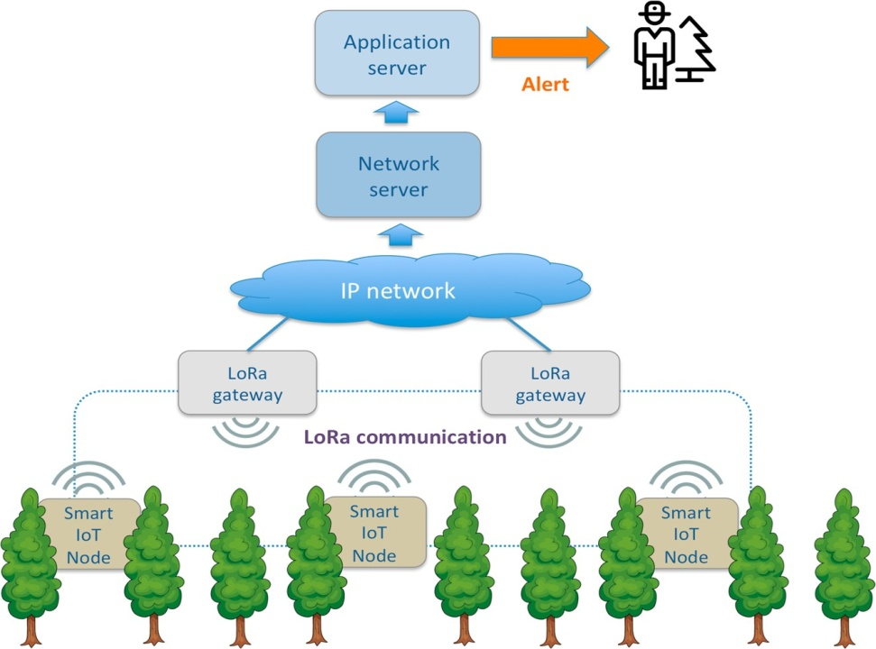 **Figure 1. System architecture.**

# The current operational scenario of the proposed system involves the distribution of multiple IoT nodes in the monitored forest under the wireless range of one or more gateways in a star topology typical of LoRa technology. Nodes and gates can be placed in trees or on a specially camouflaged pole to listen to the sounds of the wood. Suppose someone nearby is using a hand or chainsaw to chop down trees or start a fire.

# In this case, the device detects such a specific sound and alerts the application server, which alerts the person in charge of forest protection. For solutions where the IoT node only collects and forwards audio data, this IoT architecture has the advantage that the feature extraction and audio classification is performed by the neural network directly in the IoT node according to the top of the computational paradigm. In this configuration, only event notification with very low bandwidth usage (eg.for example 99.99% ready to broadcast). This bandwidth efficiency enables the adoption of LPWAN communication protocols such as LoRa, which offers long range and very low power consumption for low-speed data transmission.

# Figure 2. Operational flowchart

# The monitoring system implemented in the LoRa endpoint consists of four key components as shown in Figure 3 : an acquisition module that performs the sampling and quantization of the incoming audio, a pre-processing module for data representation and feature extraction; CNN-based classifier; low-power, long-range wireless communication module for providing audio classification response notifications to a remote device (e.g., a gateway). The first three elements described above form the sound processing and event classification subsystem.

# 

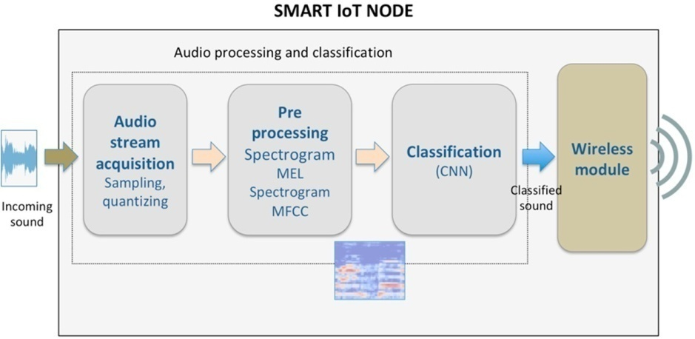

**Figure 3. System design—LoRa end node.**

**Result**

This section presents results related to preprocessing performance and classification accuracy. It describes an experimental test bed deployed in a rural area with forest and few buildings to evaluate wireless LoRa network coverage and power consumption of an IoT device. First, samples were conveniently collected by sampling and quantization methods using a sliding window technique, and then developed in a pre-processing step to extract features for more efficient classification. More specifically, for each sample window, preprocessing operations were performed according to line spectrogram, mel spectrogram, or MFCC techniques. Table 1 compares the performance of different preprocessing techniques in terms of processing time and maximum RAM used to process the incoming sample window using the hardware used.

|  |  |  |
| --- | --- | --- |
| **Method** | **Processing Time** | **Peak RAM** |
| Linear Spectrogram | 714 ms | 208 kB |
| Mel Spectrogram | 1414 ms | 114 kB |
| MFCC | 928 ms | 46 kB |

**Table 1** Performance comparison adopting different pre-processing techniques.

The table shows that the processing required to calculate the linear spectrogram takes about half the calculation time of the mel spectrogram. On the other hand, the maximum RAM usage of the first preprocessing technique is twice that of the second. As for the MFCC pre-processing technique, for both spectrogram methods it has a very small computational memory footprint, requiring only 46 KB of RAM with a processing time comparable to the faster technique (e.g.714ms). For this reason, MFCC preprocessing is the best compromise between low RAM usage and good processing time, since the overall classification time requirements are not as strict. A comparison of the performance of different preprocessing methods in terms of inference time, maximum RAM usage, ROM usage and accuracy (compared to the assumed 64 MHz ARM Cortex-M4F processor) is presented in Table 3. The results were obtained on a test device implementing a CNN with preprocessed inputs using line spectrogram, mel spectrogram, or MFCC techniques, respectively, and using a 32-bit quantization bit depth for audio recording (i.e.,, floating-point) and 8 bit (i.e., integer), respectively.

|  |  |  |  |  |
| --- | --- | --- | --- | --- |
| **CNN** | **Inferencing Time** | **Peak RAM** | **ROM** | **Accuracy** |
| Spectrogram-32 | 14126 ms | 406.0 kB | 289.8 kB | 71.77% |
| Spectrogram-8 | 3001 ms | 104.6 kB | 96.6 kB | 54.31% |
| Mel spectrogram-32 | 4132 ms | 402.9 kB | 144.3 kB | 65.19% |
| Mel spectrogram-8 | 878 ms | 103.8 kB | 60.2 kB | 64.63% |
| MFCC-32 | 1089 ms | 203.9 kB | 93.9 kB | 85.37% |
| MFCC-8 | 232 ms | 54.1 kB | 47.6 kB | 85.03% |

**Table 2.** CNN performance comparison adopting different pre-processing techniques.

Table 2 shows that the MFCC solution outperforms all others and that a significant reduction in memory resources and response time (i.e. 4.5 inference times, 3.8 RAM spikes, 2 ROMs) can be achieved by converting integers from 8 bits to 32 Bit floating-point number, variables with negligible loss of precision are used**.**

# Discussion

The results described show that a correct classification on a device with very limited resources (i.e. low power consumption) is not a trivial task.The design of neural networks for this purpose must take into account the scarcity of RAM and ROM resources and low computational power, which can affect the overall classification time. In particular, it can be seen that the Linear Spectrogram and Mel Spectrogram based preprocessing methods have higher double and quadruple peak RAM usage than MFCC. The Small CNN was clearly designed to find a good compromise between accuracy and utilization of compute/memory resources. In addition, the choice of spectrogram pre-processing by adopting this neural network requires large computational and memory resources to obtain sufficient levels of accuracy (e.g., 71.77% with 32-bit quantization); Therefore, it is not durable for hardware architectures designed for low-power IoT monitoring. On the other hand, solutions based on MFCC preprocessing require less resources at higher precision values, which significantly reduces the chance of misclassification. Although the MFCC solution achieves the highest level of precision with 32-bit quantization, the highest performance can be achieved with 8-bit integer quantization. As already shown in Table 3, the latter solution offers very low RAM/ROM usage and inference time and becomes a state-of-the-art solution for sound classification on devices with very limited resources

Regarding wireless communication, the tests performed in that LoRa is a viable communication technology capable of long-distance communication of up to more than 8 km in LoS scenarios and more than 2.5 km in a light one provide NLoS scenario. However, as forest experiments have shown, the communication distance between transmitter and receiver is reduced due to the density and thickness of the forest. In the configuration tested, the attenuation provided by the oak forest is , calculated at the level of about 17 dBm/100 m, assuming an estimated coverage radius of less than 1 km. Similar experiments with other LPWAN technologies like NB-IoT will be explored in future work. The designed enables low-power edge computing by sending warning information only when a sound related to a dangerous event is detected (such as a chainsaw, fire, or handsaw). -Device provides solid task classification for 61 hours continuously without recharging the battery, paving the way for PV charging for low-maintenance IoT devices with LoRa transceivers. The response times of the system are made up of the processing time and the transmission time. The total processing time (i.e. from digitizing the input audio to final classification) is 1160 ms using the most promising solution using MFCC pre-processing and 8-bit quantization. Shorter detection times would be possible with more powerful detection devices. However, this solution would inevitably lead to higher power consumption, which would not be suitable for our conditions, where sensors with associated processing have to work in remote areas for years without replacing the battery.

In addition to the processing times, the transmission time for sending messages to the server must also be taken into account, since the information speed is several hundred bits per second and packet retransmissions in the event of non-delivery of packets take time (retransmissions are triggered at certain time intervals, for example 10, 30, 60 seconds). However, the fall detection scenario does not have strict time constraints, so the alarm times received with a delay of seconds remain an effective solution for rapid intervention and environmental protection.

**Findings and Limitations**

**The main findings achieved in this work are summarized below:**

* Audio classification on ultra-low-power devices such as ARM M4F microcontrollers is not a trivial task because specific optimizations and pre-processing techniques have to be considered and tested to obtain a good trade-off between accuracy and low calculation and memory resource consumption;
* LoRa technology can actually be adopted for pervasive monitoring in forest and rural scenarios, but vegetation and other obstacles (buildings, hills, etc.) introduce a heavy signal degradation, thus reducing the communication range in case of dense woods or NLoS scenarios;
* keeping in mind these key issues, in this work, a pervasive and accurate tree-cutting audio detection system running on ultra-low-power resource-constrained devices has been successfully implemented, providing a proof of concept also for other audiobased monitoring applications in rural areas and forests scenarios.

**In this work, the following limitations have to be considered as well:**

* the audio recognition test has only been performed based on recorded sounds in the ESC dataset, so an extensive test of the audio recognition system can be envisaged by listening to real sounds emitted by chainsaws, handsaws, fires, etc. However, a sound detected in a real-life scenario undergoes a sampling and quantization process on the IoT device as it happens for the prerecorded sounds present in the dataset;
* the adopted testbed only envisages measurements in small wood areas for a prevalent rural scenario on sunny weather. Extensive simulations and a deeper empirical validation of the LoRa module transmission under different weather conditions (i. rain, snow, wind, fog, etc.) and various vegetation scenarios (e.g. tropical jungle, montane coniferous forest, etc.).) can provide a more accurate understanding of the range of LoRa in real-world conditions.

# Conclusions

This article presents and tests a framework to automatically detect illegal logging in forests. It is based on the automatic classification of sounds, which is achieved through the use of convolutional neural networks. The work focused on the design and implementation of an efficient neural network capable of achieving good classification accuracy with extremely low computational power, memory and power consumption. This goal was achieved by designing, implementing, testing and evaluating various audio pre-processing techniques and a neural network specifically designed for resource-constrained peripherals. Experimental results show that tree felling events can be accurately detected through audio classification on IoT devices with limited capabilities, resulting in a significant reduction in resource consumption as predicted by efficient and ubiquitous IoT monitoring systems.In addition, the introduction of LoRa communication in the end nodes of edge processing enables monitoring of tree felling activities over large areas with long-distance communication, as confirmed by the results of LoRa local propagation experimental tests.

Considering the results obtained in this work, the proposed system provides an interesting demonstration of the feasibility of trimming the detection tree of audio events by edge computing at very low power consumption, limited memory and large radius of battery powered IoT devices. In the future, this framework could be extended to other scenarios involving audio and video classification and surveillance systems in different areas of interest, such as: B. Smart Cities and species protection.

# References

1. Okia, C.A. (Ed.) Deforestation: Causes, Effects and Control. Strategies. In *Global Perspectives on Sustainable Forest Management*; InTech: Rijeka, Croatia, 2012. [[CrossRef](http://doi.org/10.5772/33342)]
2. Chethan, K.; Srinivasan, J.; Kriti, K.; Sivaji, K. Sustainable forest management techniques. In *Deforestation around the World*; Moutinho, P., Ed.; IntechOpen: London, UK, 2012. [[CrossRef](http://doi.org/10.5772/35823)]
3. Mutiara, G.A.; Suryana, N.; Mohd, O.B. Wireless sensor network for illegal logging application: A systematic literature review. *J.* *Theor. Appl. Inf. Technol.* **2019**, *97*, 302–313.
4. Jang, I.; Pyeon, D.; Kim, S.; Yoon, H. A Survey on Communication Protocols for Wireless Sensor Networks. *J. Comput. Sci. Eng.*

**2013**, *7*, 231–241. Available online: <http://jcse.kiise.org/files/V7N4-03.pdf>(accessed on 14 November 2021). [[CrossRef](http://doi.org/10.5626/JCSE.2013.7.4.231)]

1. Mutiara, G.A.; Suryana, N.; Mohd, O. WSN nodes power consumption using multihop routing protocol for illegal cutting forest.

*Telkomnika Telecommun. Comput. Electron. Control* **2020**, *18*, 1529–1537. [[CrossRef](http://doi.org/10.12928/telkomnika.v18i3.14844)]

1. Zourmand, A.; Kun Hing, A.L.; Wai Hung, C.; AbdulRehman, M. Internet of things (IoT) using LoRa technology. In Proceedings of the IEEE International Conference on Automatic Control and Intelligent Systems (I2CACIS), Selangor, Malaysia, 29 June 2019; pp. 324–330. [[CrossRef](http://doi.org/10.1109/I2CACIS.2019.8825008)]
2. Mutiara, G.A.; Herman, N.S.; Mohd, O. Using long-range wireless sensor network to track the illegal cutting log. *Appl. Sci.* **2020**,

*10*, 6992. [[CrossRef](http://doi.org/10.3390/app10196992)]

1. Merenda, M.; Porcaro, C.; Iero, D. Edge machine learning for AI-enabled IoT devices: A review. *Sensors* **2020**, *20*, 2533. [[CrossRef](http://doi.org/10.3390/s20092533)] [[PubMed](http://www.ncbi.nlm.nih.gov/pubmed/32365645)]
2. S¸as¸maz, E.; Tek, F.B. Animal sound classification using a convolutional neural network. In Proceedings of the 3rd International Conference on Computer Science and Engineering (UBMK), Sarajevo, Bosnia and Herzegovina, 20–23 September 2018; pp. 625–629. [[CrossRef](http://doi.org/10.1109/UBMK.2018.8566449)]
3. Das, J.K.; Ghosh, A.; Pal, A.K.; Dutta, S.; Chakrabarty, A. Urban sound classification using convolutional neural network and long short term memory based on multiple features. In Proceedings of the Fourth International Conference on Intelligent Computing in Data Sciences (ICDS), Fez, Morocco, 21–23 October 2020; pp. 1–9. [[CrossRef](http://doi.org/10.1109/ICDS50568.2020.9268723)]
4. Piczak, K.J. Environmental sound classification with convolutional neural networks. In Proceedings of the 25th International Workshop on Machine Learning for Signal Processing (MLSP), Boston, MA, USA, 17–20 September 2015; pp. 1–6. [[CrossRef](http://doi.org/10.1109/MLSP.2015.7324337)]
5. Raspberry Pi Foundation. Available online: <https://www.raspberrypi.org/>(accessed on 13 July 2021).
6. Chen, J.T.; Lin, C.B.; Liaw, J.J.; Chen, Y.Y. Improving the implementation of sensor nodes for illegal logging detection. In Proceedings of the International Conference on Intelligent Information Hiding and Multimedia Signal Processing, Sendai, Japan, 26–28 November 2018; Springer: Cham, Switzerland, 2018; pp. 212–219. [[CrossRef](http://doi.org/10.1007/978-3-030-03748-2_26)]
7. Mutiara, G.A.; Suryana, N.; Mohd, O. Multiple sensor on clustering wireless sensor network to tackle illegal cutting. *Int. J. Adv. Sci. Eng. Inf. Technol.* **2020**, *10*, 164–170. [[CrossRef](http://doi.org/10.18517/ijaseit.10.1.8849)]
8. Chen, Y.-Y.; Liaw, J.-J. A novel real-time monitoring system for illegal logging events based on vibration and audio. In Proceedings of the 2017 IEEE 8th International Conference on Awareness Science and Technology (iCAST), Taichung, Taiwan, 8–10 November 2017; pp. 470–474. [[CrossRef](http://doi.org/10.1109/ICAwST.2017.8256503)]
9. Prasetyo, D.C.; Mutiara, G.A.; Handayani, R. Chainsaw sound and vibration detector system for illegal logging. In Proceedings of the 2018 International Conference on Control, Electronics, Renewable Energy and Communications (ICCEREC), Bali, Indonesia, 5–7 December 2018; pp. 93–98. [[CrossRef](http://doi.org/10.1109/ICAwST.2017.8256503)]
10. Jubjainai, P.; Pathomwong, S.; Siripujaka, P.; Chiengmai, N.; Chaiboot, A.; Wardkein, P. Chainsaw location finding based on travelling of sound wave in air and ground. *IOP Conf. Ser. Earth Environ. Sci.* **2020**, *467*, 012065. [[CrossRef](http://doi.org/10.1088/1755-1315/467/1/012065)]
11. Mporas, I.; Perikos, I.; Kelefouras, V.; Paraskevas, M. Illegal logging detection based on acoustic surveillance of forest. *Appl. Sci.*

**2020**, *10*, 7379. [[CrossRef](http://doi.org/10.3390/app10207379)]

1. Laffitte, P.; Wang, Y.; Sodoyer, D.; Girin, L. Assessing the performances of different neural network architectures for the detection of screams and shouts in public transportation. *Expert Syst. Appl.* **2019**, *117*, 29–41. [[CrossRef](http://doi.org/10.1016/j.eswa.2018.08.052)]
2. Piczak, K.J. ESC: Dataset for environmental sound classification. In Proceedings of the 23rd ACM International Conference on Multimedia, Brisbane, Australia, 26–30 October 2015; pp. 1015–1018. [[CrossRef](http://doi.org/10.1145/2733373.2806390)]
3. Salamon, J.; Jacoby, C.; Bello, J.P. A dataset and taxonomy for urban sound research. In Proceedings of the ACM International Conference on Multimedia, Orlando, FL, USA, 3–7 November 2014; pp. 1041–1044. [[CrossRef](http://doi.org/10.1145/2647868.2655045)]
4. Salamon, J.; Bello, J.P. Deep convolutional neural networks and data augmentation for environmental sound classification. *IEEE* *Signal Process. Lett.* **2017**, *24*, 279–283. [[CrossRef](http://doi.org/10.1109/LSP.2017.2657381)]
5. Zhang, X.; Zou, Y.; Shi, W. Dilated convolution neural network with LeakyReLU for environmental sound classification. In Proceedings of the IEEE 22nd International Conference on Digital Signal Processing (DSP), London, UK, 23–25 August 2017; pp. 1–5. [[CrossRef](http://doi.org/10.1109/ICDSP.2017.8096153)]
6. Baucas, M.J.; Spachos, P. Using cloud and fog computing for large scale IoT-based urban sound classification. *Simul. Model. Pract.* *Theory* **2020**, *101*, 102013. [[CrossRef](http://doi.org/10.1016/j.simpat.2019.102013)]
7. Abdoli, S.; Cardinal, P.; Lameiras Koerich, A. End-to-end environmental sound classification using a 1D convolutional neural network. *Expert Syst. Appl.* **2019**, *136*, 252–263. [[CrossRef](http://doi.org/10.1016/j.eswa.2019.06.040)]
8. Cerutti, G.; Prasad, R.; Brutti, A.; Farella, E. Compact recurrent neural networks for acoustic event detection on low-energy low-complexity platforms. *IEEE J. Sel. Top. Signal Process.* **2020**, *14*, 654–664. [[CrossRef](http://doi.org/10.1109/JSTSP.2020.2969775)]
9. Lai, L.; Suda, N.; Chandra, V. CMSIS-NN: Efficient neural network kernels for arm cortex-M CPUs. *arXiv* **2018**, arXiv:1801.06601.
10. Gaita, A.; Nicolae, G.; Radoi, A.; Burileanu, C. Chainsaw sound detection based on spectral Haar coeffluents. In Proceedings of the IEEE 2018 International Symposium ELMAR, Zadar, Croatia, 16–19 September 2018; pp. 139–142. [[CrossRef](http://doi.org/10.23919/ELMAR.2018.8534594)]
11. Ahmad, S.F.; Singh, D.K. Automatic detection of tree cutting in forests using acoustic properties. *J. King Saud Univ.-Comput. Inf.* *Sci.* **2019**, *32*, 1208–1209. [[CrossRef](http://doi.org/10.1016/j.jksuci.2019.01.016)]
12. Kalhara, P.G.; Jayasinghearachchd, V.D.; Dias, A.H.A.T.; Ratnayake, V.C.; Jayawardena, C.; Kuruwitaarachchi, N. TreeSpirit: Illegal logging detection and alerting system using audio identification over an IoT network. In Proceedings of the IEEE 2017 11th International Conference on Software, Knowledge, Information Management and Applications (SKIMA), Malabe, Sri Lanka, 6–8 December 2017; pp. 1–7. [[CrossRef](http://doi.org/10.1109/SKIMA.2017.8294127)]
13. Zhang, Y.; Suda, N.; Lai, L.; Chandra, V. Hello edge: Keyword spotting on microcontrollers. *arXiv* **2017**, arXiv:1711.07128.
14. Marom, N.D.; Rokach, L.; Shmilovici, A. Using the confusion matrix for improving ensemble classifiers. In Proceedings of the IEEE 26th Convention of Electrical and Electronics Engineers in Israel, Eilat, Israel, 17–20 November 2010; pp. 000555–000559. [[CrossRef](http://doi.org/10.1109/EEEI.2010.5662159)]
15. Feltrin, L.; Buratti, C.; Vinciarelli, E.; De Bonis, R.; Verdone, R. LoRaWAN: Evaluation of link-and system-level performance. *IEEE* *Internet Things J.* **2018**, *5*, 2249–2258. [[CrossRef](http://doi.org/10.1109/JIOT.2018.2828867)]
16. Attenuation in Vegetation, Recommendation ITU-R P.833-9. Available online: <https://www.itu.int/rec/R-REC-P.833/en> (accessed on 13 July 2021).