**HANDY VENTILATOR**

**Hemant Jadhav1, Hemant Pelmahale2, Utkarsha Gavit3**

123Student, Department of Electronics and Telecommunication Engineering, NDMVP College of Engineering, Nashik, Maharashtra, India

**ABSTRACT (Font-Times New Roman, Bold, Font Size -12)**

The whole world is under the influence of the novel Coronavirus disease-2019 (COVID-19), which hit hard most of the developed and developing countries, leading to the death of millions of people around the world. This disease majorly affects the respiratory tract, which can progress to more severe or potentially deadly conditions such as acute respiratory distress syndrome (ARDS) or hypoxemia, owing to widespread inflammation of the lungs. Conventionally used ventilator devices are quite expensive and require trained staff for its smooth operation. Generally, in developing countries these types of ventilators are limited in numbers and available only at multispecialty hospitals. So as to tackle and fulfill the urgent need of ventilators, we come up with a device which is a low-cost, easy to assemble, portable automated AMBU resuscitator system, that can be easily scaled, to fight the ongoing pandemic. The device provides precise control over various ventilation parameters, such as pulse-oximeter, temperature sensor, while operating in pressure mode.

Keywords: component, Covid-19, AMBU bag, Pressure mode, Breaths per minute (BPM), I:E ratio, temperature sensor, pulse-oximeter.

.

1. **INTRODUCTION (Font-Times New Roman, Bold, Font Size -12)**

The COVID-19 pandemic has produced critical shortages of ventilators worldwide. There is an unmet need for rapidly deployable, emergency-use ventilators with sufficient functionality to manage COVID-19 patients with severe acute respiratory distress syndrome. Based on this situation there is a need of affordable low-cost ventilators in India to fight against COVID-19, also managing patience during this time challenging task and it is intended to develop a low-cost ventilator. Here, we show the development and validation of a simple, portable and lowcost ventilator that may be rapidly manufactured with minimal susceptibility to supply chain disruptions. To develop a system which provides a low-cost ventilator system for COVID19 patients. Size of the device is small so that it can be carried easily. Inbuilt Pulse Oximeter for heart rate and oxygen level detection. This system will prove helpful in providing the primary help in maintaining health of the patient. Coronavirus disease-2019 (COVID-19) is a highly infectious disease caused by a novel coronavirus, causing severe respiratory illness which has infected over 171.47 million as per 01 June, 2021 million people all over the world. This disease majorly affects the respiratory tract, which can progress to more severe or potentially deadly conditions such as acute respiratory distress syndrome (ARDS) or hypoxemia, owing to widespread inflammation of the lungs. Mechanical ventilators play a crucial role in fighting not only COVID-19, as it assists patients breathing while the underlying disease runs its course. This has led to an increased surge in the demand for mechanical ventilators, with 3-26% of patients infected with COVID-19 (percentage varies across age groups and severity of symptoms) requiring mechanical invasive and prolonged ventilation. But the disruption in supply chains, transport restrictions and various other factors collectively in the ongoing pandemic has put pressure on the supply of ventilators, aimed to reduce the mortality rates. Cheaper alternatives for mechanical ventilation, especially automated artificial manual-breathing units (AMBU) bags, have received wide attention from clinicians, researchers and policymakers, owing to fast production, economical deployment and easy accessibility to a larger portion of the population all across the world. Automated AMBU bags or resuscitator devices aim to assist patient breathing via compressing and releasing the AMBU bags at a specific frequency while delivering oxygen to meet the breathing rate, pressure, tidal volume and other needs of individual patients. Apart from this, these systems provide an edge over their manual counterparts, allowing staff to perform other critical tasks relevant to patient healthcare, rather than manually bagging patients. Additionally, owing to the simple design, low-cost, portability, battery or mains-in powered, simple control systems with few knobs to control variables, these kinds of systems can be easily used during transportation of patients without even requiring specialized training to operate these devices.

1. **MODELING AND ANALYSIS**

In this section we have represented the block diagram, according to which the procedure takes place

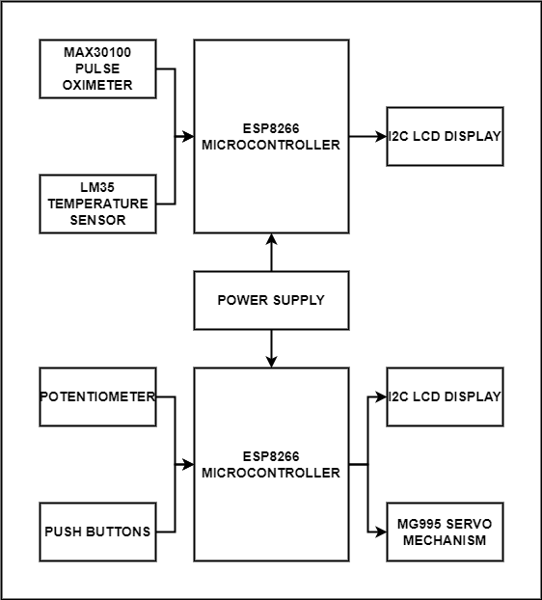

**Figure 1:**Block Diagram.

Also, with that we have shown the circuit diagram of the project. (fritzing Software)

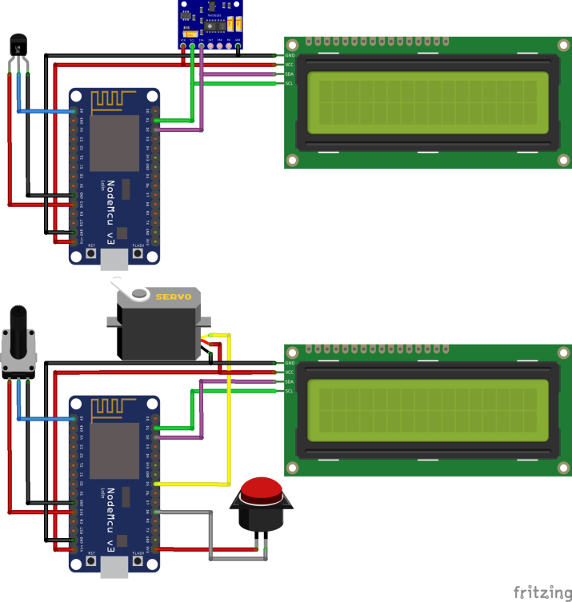

**Figure 2:**Circuit Diagram

1. **RESULTS AND DISCUSSION**

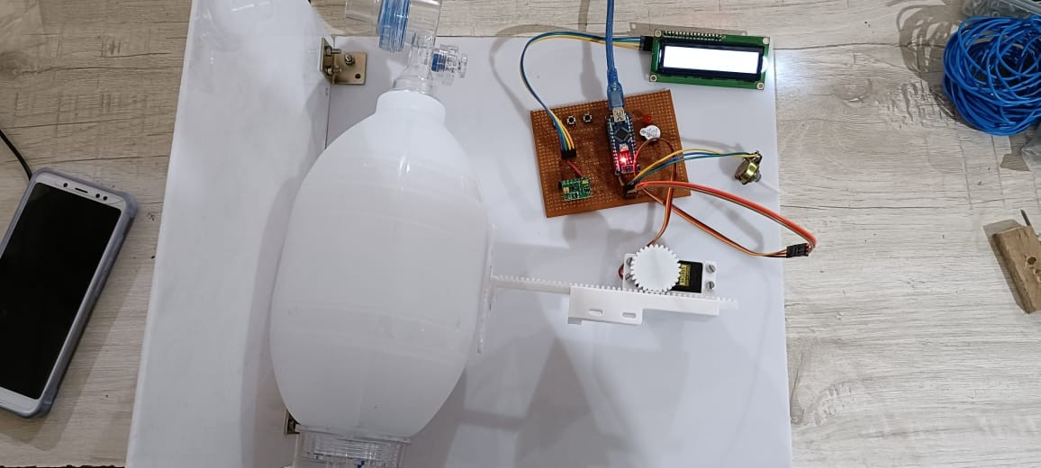

**Figure 3:**Result

1. The system uses Node MCU ESP8266 microcontroller for the control of handy ventilator.
2. Push buttons and a potentiometer are used for parameter tuning of the Ventilator which can be seen on an I2C LCD Display connected to the system.
3. Ambu(Automated Artificial Manual Breathing Unit) Bag is used along with a 3D printed linear actuator mechanism for providing ventilator support.
4. MG995 Servo motor is used in the 3D linear actuator mechanism.
5. Another Node MCU ESP8266 microcontroller is used in the system to which a MAX30100 and LM35 Sensors are connected.
6. MAX30100 Pulse Oximeter is used here for measuring pulse rate and oxygen level.
7. LM35 is used to monitor the temperature of the user.
8. An I2C LCD Display is used to display parameters and readings.
9. **CONCLUSION**

In this project, a prototype device to assist the patients who can partially breathe by their own is developed. This device is provided with very basic design and reliable structure that is easily acceptable by the patient. Main focus in this project is to minimize the components, cost and size and increase the efficiency of the device, so that while using this device to the patient, they should feel as comfortable as the normal portable ventilator. This research has led to the development of lab model ventilator with inbuilt oximeter.

**ACKNOWLEDGEMENTS**

We would like to thank Prof. Vijay Birari Head & H.O.D of E&TC at MVP college of Engineering and Prof. B.N.Rajole for their constant support and guidance, and gratefully acknowledges.

1. **REFERENCES**
2. Whitney Menzel, Deepthi Nacharaju, Evan FontaineA Rapid Solution to Coronavirus Disease 2019: 3D Printed Ventilators Induced Supply-Chain Shortages published in US National Library of Medicine National Institutes of Health search database, 2020.
3. Liu Jijun, Wu Yaoyu- " Application and Development of miniaturized emergency & transport ventilators," 2011 IEEE International Symposium on IT in Medicine and Education, Cuangzhou, 2011. K. Elissa, Title of paper if known, unpublished.
4. Ehab G, Daoud. Airway pressure release ventilation. Annals of thoracic medicine, vol. 2,4 in PMCID, 2007.