**“Real Time PUC Monitoring System for Petroleum Vehicle”**

**Ms. Chaitrali M. Gaikwad*1, Mr. Aditya S. Gangurde*2,**

**Mr. Sunny A. Andhalakar*3, Prof. Mr. Atul R. Chaudhari*4**Electronics & Telecommunication MVP’S KBT College of Engineering  
Nashik, Maharashtra, India

**ABSTRACT**

The proposed system uses a sensor to monitor the CO emission and engine temperature of a vehicle. The collected data will be displayed on an LCD and sent to a mobile device via GSM technology. The data will also be transmitted to a web portal using GPRS, allowing for the creation of an online database. Additionally, the system will send an alert message to the vehicle owner when the vehicle is emitting gases more than standard limits & encouraging them to take prompt action. The purpose of this PUC detection system is to use communication technology such as GSM to monitor and control emissions.

**Keywords:** PUC, GSM, MQ7 Gas Sensor, MAX-6675 Temperature Sensor, CO, etc.

1. **INTRODUCTION**

Our environment is degrading largely as a result of pollution. Urbanization, industrialization, and population growth are all occurring rapidly. As a result, there are more cars on the road and other forms of human activity, which upset the balance of nature. Particularly in developing nations like India, the Transportation sector contributes the most to air pollution.

The Pollution Under Control (PUC) System is designed to monitor emissions from running petroleum vehicles. This project implements a unique CO reduction, fuel consumption control, and engine temperature monitoring technique. Because of the gases that are emitted by automobiles, a significant amount of pollutants are released into the atmosphere every day. There is an issue when a vehicle's emissions exceed the allowable standard limits. The insufficient combustion of the vehicle fuel is the primary cause of the emission level violation. To solve this problem our system is made which can continuously monitor the individual vehicles’ emission in real-time.

1. **NEED FOR PROJECT**
2. **Mandatory by Law**

In India, obtaining a PUC certificate to legally drive a vehicle on public roads is mandatory.  A legal offense and potential fines would arise from failing to obtain this certificate. Thus, it is essential to have a PUC certificate for your vehicle. Additionally, you must obtain third-party liability insurance for your vehicle in accordance with Indian rules and regulations. You must present a PUC certificate as confirmation that your vehicle complies with pollution standards in order to receive insurance. Therefore, getting a PUC certificate for the vehicle is essential.

1. **Beneficial for the Environment**

The main goal of the PUC certificate is to verify that each certified vehicle complies with the prescribed standard limit of vehicular emissions. To avoid negative environmental effects and reduce potential damage from your vehicle emissions, it is necessary to make sure your vehicle complies with these regulations.

1. **PROBLEM STATEMENT**

The objective is to address the issue of air pollution caused by vehicle emissions, particularly gases like CO that contribute to environmental degradation, the goal is to build a small pollutant monitoring system that can be put on a vehicle. It is important to limit the amount of harmful pollutants that are generated by vehicles, and the primary cause of emission level violations is the inefficient combustion of fuel. A monitoring system that can continuously identify the pollution level of specific automobiles is designed to address this problem.

1. **BLOCK DIAGRAM**

Atmega 328P is Micro Controller used in this system. A 5V regulated power supply is given to this microcontroller, and along with this the components needed for the system such as,

• GSM Modem-SIM 900A

• MQ7-Gas Sensor

• 16x2 LCD

• MAX 6675-Temperature Sensor

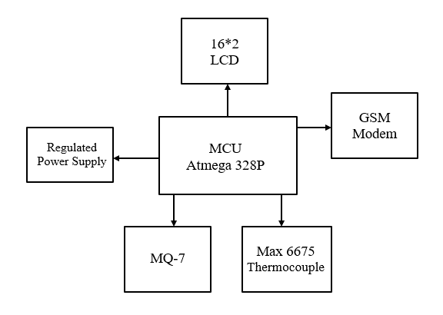

**Figure 1:** Block Diagram.

1. **METHODOLOGY**

The focus of this technique is on monitoring vehicle emissions and alerting the vehicle user if the pollution level exceeds the regulatory limit. The system uses a gas sensor MQ7 to detect the presence of CO and a temperature sensor MAX 6675 to detect the temperature value. The sensors are placed near the vehicle exhaust. The gas sensor is connected to the microcontroller's analog pin PC2, while the temperature sensor is connected to PC1 for analog to digital conversion. The microcontroller used is the ATMEGA 328P. The output values are displayed on an LCD in real-time. A GSM module SIM 900A is also connected to the microcontroller to send real-time data of the gas and temperature sensors to the vehicle owner's phone. This allows the owner to monitor their vehicle's emission levels and health.

If the carbon monoxide value from the sensor exceeds the pollution limit, the microcontroller sends an alert message to the user's phone app via the GSM module, indicating that their vehicle is emitting pollutants above the standard limit. This alerts the user to service and repair their vehicle.

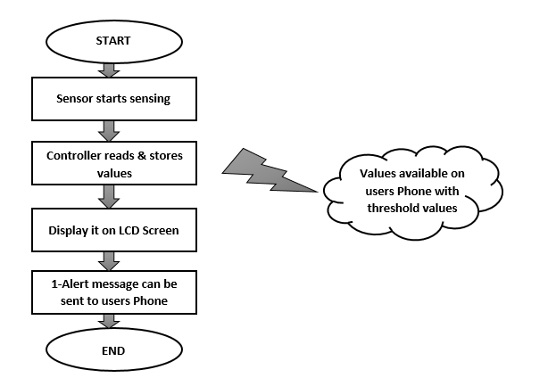

**Figure 2:** PUC Monitoring Procedure.

1. **RESULTS**

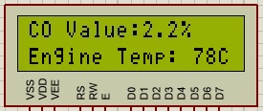 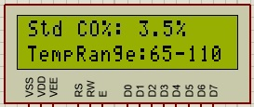

**Figure 3:** Result-1 **Figure 4:** Result-2

The project “Real Time PUC Monitoring System for Petroleum Vehicle” uses ATmega 328P, Gas sensor MQ7, Temperature sensor max 6675, LCD 16*2, GSM module SIM 900A has been successfully designed and tested.

1. **CONCLUSION**

* The system is made to continuously monitor Carbon Monoxide (CO) and hydrocarbon emissions from petroleum vehicles.
* By installing a PUC system in your vehicle, you can help keep your vehicle’s emissions under control and reduce air pollution.
* Vehicles that are not properly maintained are likely to release more pollutants. Therefore, regular PUC monitoring can also show whether the vehicle is in good condition or needs maintenance.
* The environment is currently facing immense damage from air pollution, therefore the installation of a PUC system can help in contributing to the environment's well-being.

1. **REFERENCES**
2. Prachi Shahane, Preeti Godabole, “Real Time Monitoring of CO2 Emission in the vehicle using cognitive IOT”,International journal of science and research(IJSR), ISSN(online):2319-7094, Index copernicus3 value (2013):6.14|Impact factor (2014):5.611
3. Panneer Selvam, Arun Mozhi Devan & Hussin, Fawnizu Azmadi & Ibrahim, Rosdiazli & Bingi, Kishore & Nagarajapandian, M.. (2019). IoT Based Vehicle Emission Monitoring and Alerting System. 161- 165. 10.1109/SCORED.2019.8896289.
4. Joseph Mathew Skaria Maliyekal , Shancy Elizabeth Shaji , Vandana H , Divya R S, “Vehicular Pollution Monitoring System Using IoT”,Journal of Communication Engineering and Its Innovations ,DOI: 10.5281/zenodo.3570505, Volume 5 Issue 3, 2019
5. Suvitha Vani P, Karthika S, Nabhanya K, Gowtham Ram S, Aishwarya Lakshmi N,“Vehicle Pollution Monitoring System using IoT”,International Journal of Recent Technology and Engineering (IJRTE) ISSN: 2277-3878, Volume-9 Issue-1, May 2020
6. G.Arun Francis, M.Dhinesh, J.Arok Lijo, P.Hariprasad, K.Balasubramanian,“IoT Based Vehicle Emission Monitoring System”,International Journal of Innovative Technology and Exploring Engineering (IJITEE) ISSN: 2278-3075, Volume-8 Issue5S March, 2019