**REVIEW PAPER ON SEISMIC RESPONSE IN IRREGULAR RC STRUCTURES USING ETABS**

**GEETA RAWAT1, MR. SITENDER2, SURAJ SINGH3**

**1 M.Tech Scholar, Ganga Institute Of Tech. & Management, Jhajjar, India**

Rawat.geet25feb[@gmail.com](mailto:refazgitm@gmail.com)

**2 Assistant Professor, Ganga Institute Of Tech. & Management, Jhajjar, India**

[Sitender0123456@gmail.com](mailto:Sitender0123456@gmail.com)

**3 M.Tech Scholar, Ganga Institute Of Tech. & Management, Jhajjar, India**

[Rawat.suraj084@gmail.com](mailto:Rawat.suraj084@gmail.com)

**ABSTRACT**

The IS: 1893-2016 standard as it stands now mandates that almost all multi-story structures be examined as three-dimensional systems. Buildings may be classified as Regular or Irregular based on their bulk and stiffness across their storeys. India's hilly terrain is largely seismically active. In this work, a structural analysis tool called ETABS software was used to create a 3D analytical model of G+15-story structures for both regular and irregular building types. The static analysis of a structural system is evaluated using two fundamental parameters: mass and stiffness. Various factors, including soil conditions, foundation types, and the distribution of mass stiffness, affect how multi-story structures behave. The damage and collapse of the structures brought on by abnormalities in structural stiffness and floor mass were evident in the 2001 Bhuj earthquake in Gujarat, India. The impact of different vertical imperfections on a structure's seismic response are the focus of this project. The project's goal is to use the Dynamic Analysis Method to design both regular and irregular RC building frames. The outcomes of the examination of irregular and regular structures are compared.

**Key Words**: Irregular and Asymmetric structures; Dynamic analysis, Storey Deflection, StoreyShear, Stiffness

## INTRODUCTION

Regular buildings are structures that withstand earthquakes. This construction must have a straightforward, regular design, a minimal amount of lateral strength, and structural stiffness. A subset of vertically uneven structures having discontinuities in the geometry are setback buildings. Structural analysis is the process of analysing a structure's behaviour or reaction to a set of defined loads or load combinations. It is impossible to prevent irregularities during building construction. It is necessary to research how these buildings behave during earthquakes, however. The basic goal of earthquake engineering is to design and construct a structure in such a manner that the damage to the building and its structural components during an earthquake is minimised by adopting appropriate safeguards. When structures are subjected to seismic excitations, they may sustain a variety of damages. Even if the same structural arrangement, area, and earthquake occurred, the system's damages are not uniform nor equal. The seismic behaviour of the building is therefore determined by a number of elements, including the structural system, earthquake characteristics, the quality of construction, the soil of the site, and its maintenance. But based on historical and present earthquake experiences, the majority of damages are linked to architectural and structural layout in plan and elevation as well as site ground impacts. The infrastructure of contemporary cities is mostly made up of irregular structures. Precautions must be taken as necessary. For earthquake design and behaviour, a comprehensive understanding of the structural behaviour of structures with irregularities is necessary. The seismic reaction of irregular constructions must thus be well understood by the structural engineer.The evaluation of the response of "RegularStructures," an irregular structure with a discrepancy between the centre of mass and the centre of resistance, has been the subject of many related research. All of the constructions are asymmetrical technically. Depending on where they are and how big they are, the buildings have a variety of abnormalities, but the following are the primary ones:

## They are divided into two groups:

* 1. **Planirregularities**

## Verticalirregularities

the components, stresses, material characteristics, and the support A structure's analysis entails looking at it from the perspectives of its strength, stiffness, stability, vibration, and reaction of all parts.

## Objectives

The main goal is to use the programme ETABS to create the elements. Likewise, think about earthquake load. Use code IS 1893:2016 for load combinations. Comparing regular vs irregular construction. ETABS programme 1 has been used to carry out the designing.to conduct a comparative analysis of the various seismic characteristics of various configurations and irregularity kinds of moment resistant frames (MRF) made of reinforced concrete.

1. To use ETABS to examine the SRSS Method's application in tall structures.
2. Comparison of regular and irregular frames based on node displacement, storey drift, and shear force, among other factors.
3. To research how various earthquake response metrics vary when height and bays increase.
4. To suggest the ideal construction arrangement based on the current situation.
5. To improve the response spectrum method's strength.

## LITRATURE REVIEW:

**Pardeshi Sameer et.al (2016) :** Basically, they used four different models—Regular, L-Shape, T-Shape, and Plus Shape—to assess the structure using the Time History Analysis method. They discovered that the plan's seismic response was good, and that the first storey's shear force was the most. In contrast, a substantial displacement will be seen in a T shape.

**Tushar Saxena et.al(2018):** The primary goal of the current study is to analyse the behaviour of the structures and to adopt a technique to reduce the damages brought about by them while the outcome is in the form of a comparison and the base shear value is larger in the regular configuration. as a result of the structure's increased symmetry. In the standard arrangement, the tale 13 has a higher narrative drift value.

**Prof. Vedantee Prasad Shukla et.al (2018)** This topic focuses on the design of irregular and regular buildings in various earthquake zones with slopes greater than 3 degrees. The analysis is carried out using the Response Spectrum Method, with results presented in the form of storey displacement, storey drift, base shear, and time. The normal building's time span is more regular than not. earthquake activity. The Push Over analysis approach was used. While it can be observed that the base shear for a regular structure is greater than that of an irregular structure in the Results Comparison of base shear & Roof displacement

**Mr. S.Mahesh et.al (2014)** : When utilising STADD PRO to compare the analysis and design of multi-story buildings in regular and irregular configurations in different seismic zones, they discovered that the drift in regular buildings is weak in seismic Zone

**.Dr.S.K.Dubey&P.D.Sangamnerkar(2015**) “In their study, "Seismic behaviour of Asymmetric R.C. buildings," they used STAADPRO to model and analyse a five-story frame structure. It is thought that the structure is a business complex. The building has a 'T'-shaped geometry with open ground-floor parking. They looked for Zone IV.

**Abhay Guleria (2016) :** The study of a multistory RCC structure was presented for various design configurations. The study has been done for the seismic loads. The lateral load specifications were extracted from IS 1893 (Part 1)2002. ETABS, a finite element programme, was used for the modelling and analysis.This research also reveals that the responses to overturning moments, tale drift, and story displacement are almost identical for L-shape and I-shape structures.

**Sanhik Kar Majumder and Priyabrata Guha(2015)** : There was a comparison of seismic and wind loads on various kinds of constructions. According to IS 875(Part 3)1987 and IS 1893(Part 1)2002, the effects of both wind and seismic activity will be taken into account in this research while taking into account a location with medium soil. They came to the conclusion that the planned structures with abnormalities are more vulnerable to earthquake damage and that torsion is the most important element contributing to significant damage or building collapse.

**Magliulo G.,MaddaloniG. &Petrone (2017):“** For the study of "Influence of Earthquake Direction on the Seismic Response of Irregular Plan R.C. Frame Buildings," researchers employed a three-story R.C. structure, which represents a highly popular structural topology in Italy. A rectangular plan shape, an L-plan shape, and a rectangular plan shape with a courtyard building, respectively.STAAD Pro is used to model and analyse (G+5) structures as a result.

**Dr. B. G. Naresh Kumar1, Avinash Gornale2 and Abdullah Mubashir3 Presented (2018**): “Torsionally asymmetric buildings are evaluated for seismic performance using RC-framed buildings. In this research, an attempt is made to investigate the impact of infill wall stiffness on building performance as well as the eccentricity between the centre of mass and the centre of stiffness. The effectiveness of the structures is evaluated.

## Methodology

Buildings Taken Into Account in the Analytical Study For the current project, a reinforced concrete building frame with a (PLINTH+G+15)-story height positioned on a ground slope is the subject of a seismic study. ETABS is used to carry out analysis and design. Using the Dynamic Analysis technique, static analysis is performed for R.C.C. frame regular and irregular buildings up to G+15 storeys in civil constructions. the issues caused by the discontinuity in the structure's stiffness, mass, and shape. The seismic reaction of irregular constructions must thus be well understood by the structural engineer. The reaction of "Regular Structures" has been the subject of other related research. However, the seismic reaction of structures with imperfections is not well understood.

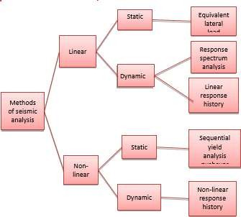

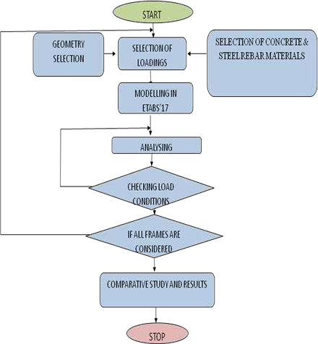

|  |  |  |
| --- | --- | --- |
| S.NO | Description | Value |
| 1. | Area | 16 X 20 m |
| 2. | Number of bays in X- direction | 4 |
| 3. | Number of bays in Y direction | 5 |
| 4. | Overall height | 45m |
| 5. | Seismic zone | V |
| 6. | WALLS | RED BRICK |
| 7. | SUPPORT TYPE | FIXED SUPPORT |

Table No.01: MODELLING & PROBLEM FORMULATION

PARAMETERS FOR REGULAR AND IRREGULAR STRUCTURE:

|  |  |  |
| --- | --- | --- |
| S.NO | DESCRIPTION | SIZES |
| 1. | Type of Structure | Framed |
| 2. | Type of Building | Residential |
| 3. | Number of storey | 16(G + 15) |
| 4. | Height of storey | 3 m |
| 5. | Cross section of beams | 300x500mm |
| 6. | Cross section of columns | 500x500mm |
| 7. | Slab Thickness | 150mm |
| 8. | Grade of concrete | M25 |
| 9. | Grade of steel | Fe 500 |
| 10. | Dead Load | 1 factor |

## Table no.2 Loadings

|  |  |  |
| --- | --- | --- |
| S.NO | LOAD PARAMETERS | DESCRIPTION |
| 1. | DEAD LOAD | 1. WALLLOAD-   5KN/M2   1. SLABLOAD   4.8KN/M2 |
| 2. | LIVE LOAD | 2 KN/M2 |
| 3. | SEISMIC LOAD | AS PER IS 1893- 2012 |
| 4. | SEISMIC ZONE | V |
| 5. | SITE LOCATION | VERY SEVERE |
| 6. | IMPORTANCE FACTOR | 1.2 |
| 7. | SOIL PROPERTY | HARD SOIL |

Table no.03 Storey Force (KN**)**

**IRREGULAR BUILDING**

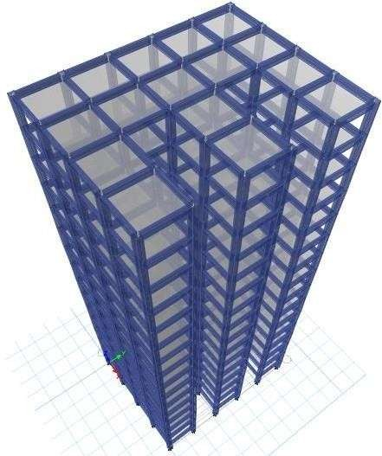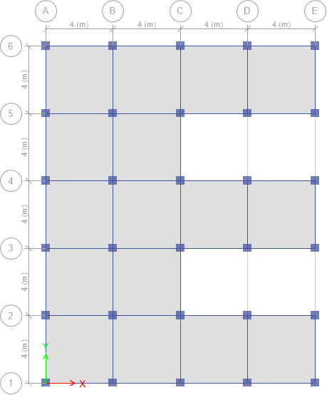

## REGULAR BUILDING

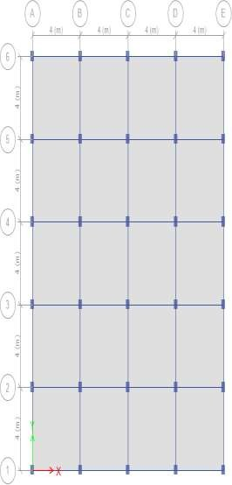

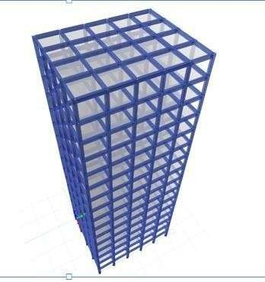

|  |  |  |
| --- | --- | --- |
| MAX. STOREYFORCE | | |
|  | REGULAR | IRREGULAR |
| 1. | 4439.95 | 4297.17 |

## Table No. 4 STOREY DISPLACEMENT

|  |  |  |
| --- | --- | --- |
| MAX. SHEARDRIFT | | |
|  | REGULAR | IRREGULAR |
| 1. | 0.011846 | 17.507 |

Table No. 5, STOREY DRIFT

## CONCLUSIONS:

Based on the work presented following conclusions can be drawn:

* As the amount of setback grows, so does the shear force. When compared to setback normal frames, the shear force of the irregular construction frames is relatively less.
* For all story heights, the critical bending moment of irregular frames is lower than that of the regular frame. This is a result of building frames being less rigid as a result of setbacks.
* The stiffness irregular structure had more inter-storey drifts than regular frames and geometric irregular frames, according to the findings of the Dynamic Response technique.
* It can be noticed that the stiffness irregular structure frame has the largest joint displacements for all floor levels and the stiffness irregular structure frame's storey displacement is highest among all the frames. However, both the vertical and regular practically all joint displacements in geometric frames are variable.
* . In almost all instances, regular frames perform better seismically than equivalent irregular ones.

Therefore, it should be built in a way that reduces the consequences of earthquakes. The geometric irregular frame 1 building with the setback at the third story arrangement is proven to be better than others among setback frames.

## REFERENCES:

[1].“Comparative Study of the Static and Dynamic Analysis of MultiStorey Irregular Building” Bahador Bagheri, Ehsan Salimi Firoozabad, and Mohammadreza Yahyaei [2]. Static and Dynamic Behaviour of Reinforced Concrete Framed Building: A Comparative Study [3]. Prakash Sangamnerkar*, Dr. S. K. Dubey

[2]. Professor, Deptt. Of Civil Engineering, Maulana Azad National Institute of Technology, Bhopal (M.P.) 462051 [6]. Response Analysis of Multistory RC Buildings under Equivalent Static and Dynamic Loads According to Egyptian Code Sayed Mahmoud1, Waleed Abdallah2

[3]. N. Lakshmanan, K. Muthumani, G. V. RamaRao,N.Gopal krishnan and G. R. Reddy (2017), "Verification of Pushover Analysis Method With Static Load Testing", International Workshop on Earthquake Hazards and Mitigation, Guwahati, India, 78 December2007.

[4] . Pardeshi S, N. G. Gore, “Study of seismic analysis and design of multi storey symmetrical and asymmetrical building”, International Research Journal of Engineering and Technology, Volume03, Issue01, pp.732737, January 2018.

[5]. Kumar P, A. Naresh , M. Nagajyothi, M. Rajasekhar, “Earthquake Analysis of Multi Storied Residential Building”, International Journal of Engineering Research and Applications, Volume 4, Issue 11, pp.5964, November 2018.

[6]. Neha P. Modakwar, Sangita S. Meshram, Dinesh W. Gawatre (2019),“Seismic Analysisof Structures with Irregularities"

IOSRJournalof Mechanical and Civil Engineering (IOSRJMCE) eISSN:22781684, pISSN:2320334XPP6366

[7]. Dr.S.K.Dubey&P.D.Sangamnerkar (2019), "Seismic Behaviour of Asymmetric RC Buildings", International

[8]. Journal of Advanced Engineering Technology EISSN 09763945, IJAET/Vol.II/ Issue IV/October December, 2019/296301

[9].Chourasiya Rahul, Rashmi Akalle, “Seismic Evaluation Of MultiStoried R.C. Structure Using Different Floor Diaphragms”, International Journal Of Research In Engineering, And Technologies,Volume02, Issue, 09, pp. 641648 December 2015.M. Young, The Technical Writer’sHandbook. MillValley,CA:University Science, 2020.

[10].Dubey S. K, Sangamnerkar P. D, “Seismic Behaviour Of Asymmetric RC Buildings”, International Journal Of Advanced Engineering, Volume02,SpecialIssue04,pp.641648,(2021).