IOT Based Wheelchair Fall detection

# Shweta Pardhi1, Priyal Sharma2, Shravan Powar3, Prof. Tushar Kafare4

*1-3Student, Dept. of Electronics and Telecommunication Engineering, Sinhgad College of Engineering, Maharashtra, India.*

4*Assistant Professor, Dept. of Electronics and Telecommunication Engineering, Sinhgad College of Engineering, Maharashtra, India.*

---------------------------------------------------------------------***---------------------------------------------------------------------

**Abstract –** *Keeping an in depth tab of recent folks or folks on chair with bound health conditions for his or her health and safety is a very important task. With maturity, weak bones and weakness because of alternative health connected problems could lead to will increase risk of falling. A supervisor might not continually be on the market with them and if correct assistance is not provided at the correct time it should cause larger health considerations which will need extra resources for treatment. For this purpose we've projected a wise .*

*IOT Fall Detection System exploitation acceptable sensors that square measure integrated facilitate to assist} report these incidents to assist avail help at the correct time to forestall additional injury to health. The same system uses sensors like associate degree measuring system to live the speed of the person, a rotating mechanism to live the person’s orientation so as to live their stability, a load sensing element once the system is employed by an individual employing a chair to live their weight, a Wi-Fi module and a microcontroller that sends the general readings to alert the involved those that shall give with the right suggests that to assist the person in want.*

**Key words: Measuring system, Gyro meter, Microcontroller**

## INTRODUCTION

Every country in the world was focusing on developing their nation which includes growing the country’s population. The number of increasing of population lead increasing number of older people and health issue people. With increasing number of these people, the demand of healthcare service increases rapidly. These people who have health issue or elderly people usually does not have enough strength to walk thus, wheelchair will be used. For those who used wheelchair but

live independently are exposed to higher risk of falls. Besides that, falling down frequently may cause psychological and physiological damage that led to severe injury and even death if medical attention is not provided immediately.

Most objectives of the merchandise is to form an answer to forestall the intense consequences of a fall whereas providing a convenient usage of the merchandise similarly as alert once a fall event has occurred. All this is often finished the employment of sensors like a rotating mechanism to live the person’s orientation and acceleration, a load sensing element to live the burden of an individual United Nations agency is on a chair, a Wi-Fi module and a small controller that sends the general readings to alert the involved folks. this method is formed convenient to use by creating it a wearable device which will be worn on the hand or hooked up to a chair.

Elderly people and the disability people are the one who mostly use wheelchair in their daily life. These people have a high risk of falling and injured themselves. Falling down and become unconscious can be fatal because nobody is aware of this this happens event themselves. If these people are live alone or their family not around, it may lead the faller to have more severe injuries. It is important to have a quick response and rescue time if falling event occurs.

### Problem Statement

In this Project, we are focusing on developing iot based wheelchair fall detection.

If sensor value exceeds, it will turn ON the buzzer and alert the people around the place.

Fall detection, alert message will display in the LCD and send to cloud by use of IOT.

### Objectives

**Sr No**

1

**Author**

**Proposed Method**

**Software Method**

**Accuracy**

**Year**

Nethaji

An IoT Based Fall Detection System

App

95%

2019

2 Bhattacharya

# WHEELCHAIR-PERSON FALL DETECTION WITH INTERNET OF THINGS

App

96%

2020

3 Ghandhi

A Survey of IoT-Based Fall Detection for Aiding Elderly Care: Sensors, Methods, Challenges and Future Trends- a

practical approach.

Website

92%

2016

4 Chou & Malhotra

Fall detection in older adults with mobile IoT devices and machine learning in the cloud and on the edge

App

94%

2017

In this Project, we are focusing on developing iot based wheelchair fall detection. Accelerometer and Gyroscope sensors used to monitor the position of the person. If sensor value exceeds , it will turn ON the buzzer and alert the people around the place.

### Literature Survey

In venture with the planet Health Organization pretty much 28- 35% of people matured sixty-five and over fall every year expanding to 32-42% for those more than seventy years getting on. The recurrence of falls will increment with age and slightness level. A fall recognition framework will be plot as partner degree accommodating gadget whose fundamental target is to caution once a fall occasion has happened. Amid a genuine circumstance, they require the possibility to moderate some of the unfavorable outcomes of a fall. In particular, fall indicators will have an on-the-spot effect on the decrease inside the stress of falling and furthermore the quick arrangement of assistance once a fall. Indeed, falls and stress of falling depend upon each other. Treatment and social insurance speak to one in all the principal drawing in application zones for the IoT. The IoT can possibly exhibit ascend to a few medicinal applications like remote wellbeing watching, work out regimes, constant maladies and more seasoned consideration. Fluctuated restorative gadgets.

Due to the improvement of the technology, the wheelchair had been developed into smart wheelchair. A smart wheelchair is wheelchair which will be designed to have the ability of self-move with the help of the user command.

Following states, the survey table:

**Table 1.1**

## SOFTWARE/HARDWARE REQUIREMENTS

## 3.1 Block diagram

## 

## A block diagram is a visual representation of a system that shows the functional components and their relationships.

* 1. **ADXL345**

The**ADXL345 sensor** module is 3-axis Accelerometer Module. it is Micro-Electro-Mechanical Systems (**MEMS**) that is used to measure acceleration, velocity, orientation, displacement, and many other motion-related parameters. Apart from this, it also has an additional built-in sensor.

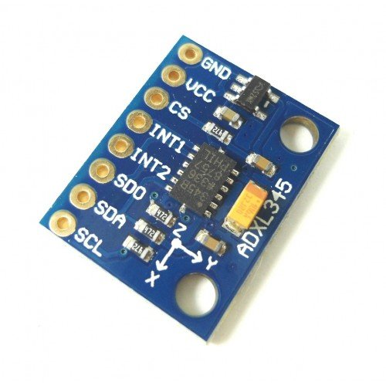

## WIFI ESP8266

A self-contained SOC called the WIFI Module, which includes an integrated TCP/IP protocol stack, can grant any microcontroller access to your WiFi network. It has the ability to offload all WiFi networking tasks to another application processor or host an application. The module is a very affordable message board with a sizable, constantly expanding community. With its GPIOs, this module may be coupled with sensors and other application-specific devices with a minimum of upfront development and runtime loading because to its robust onboard processing and storage capabilities. Because of its high level of on-chip integration, it only requires a small amount of external circuitry, and even the front-end module is made to take up little space on the PCB. In addition to supporting APSD for VoIP applications and Bluetooth co-existence interfaces, the module has an internal self-calibrated RF that enables it to function in all operating environments without the need for external RF components.

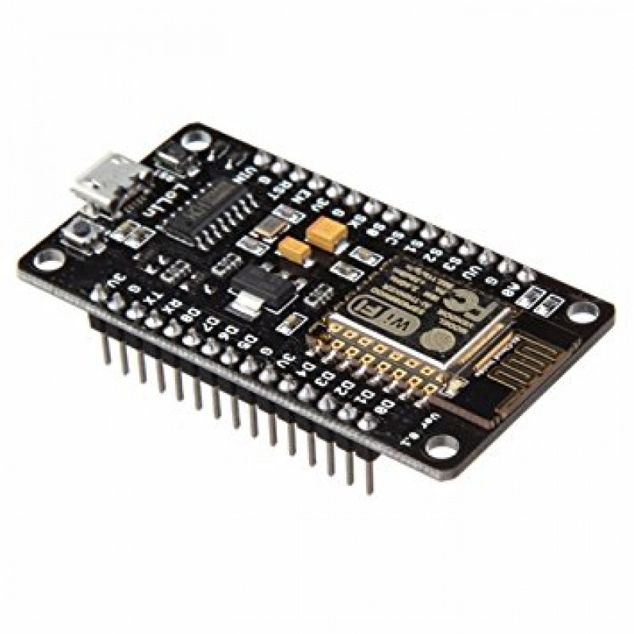

## 3.4 Thing Speak

Thing Speak is an IoT platform that allows users to collect, analyze, and visualize data from sensors or other devices. It provides an easy-to-use web-based interface that enables users to create IoT applications without the need for extensive programming knowledge.

The key features of Thing Speak include:

1] Data collection: Thing Speak allows users to collect data from various sources such as sensors, devices, and social media feeds.

2] Data storage: The platform provides cloud-based storage for the collected data, making it easily accessible from anywhere.

3] Data analysis: Thing Speak provides built-in data analysis tools such as MATLAB Analytics, which enables users to perform complex data analysis without the need for programming skills.

4] Visualization: The platform offers visualization tools that allow users to create customized graphs, charts, and maps to represent the collected data.

5] Integration: Thing Speak provides integration with various third-party services such as IFTTT, Twitter, and Twilio, enabling users to create powerful IoT applications.



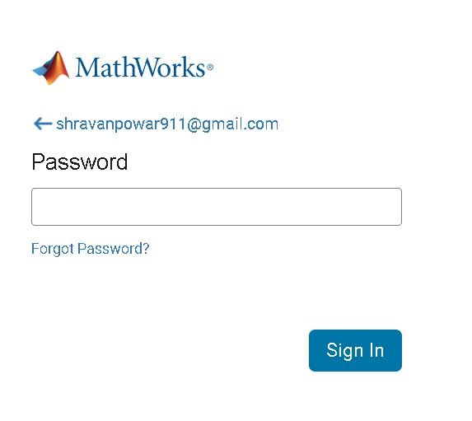

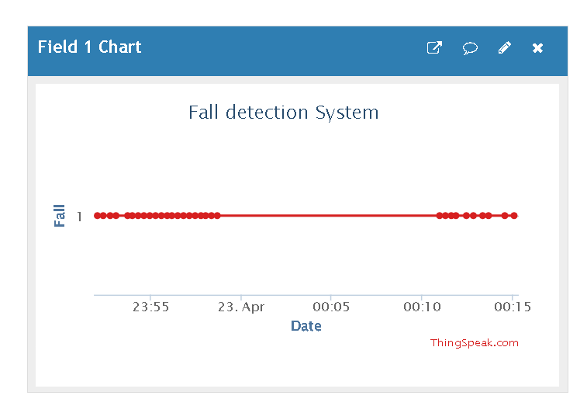

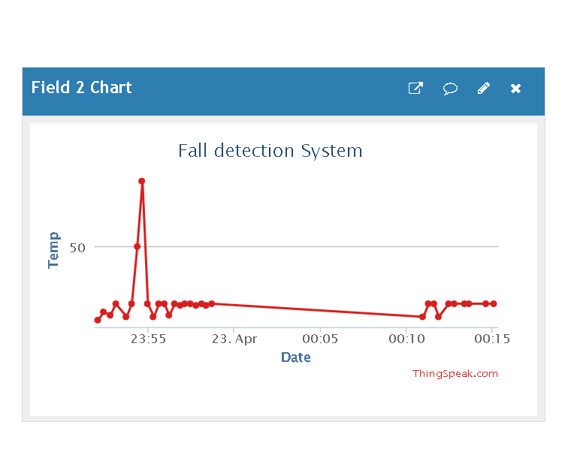

## 

## Flow chart

## A block diagram is a visual representation of a system that shows the functional components and their relationships.

## 

## RESULT

## Wheelchair fall detection systems are designed to detect when a wheelchair user has fallen and alert caregivers or emergency services to provide assistance.

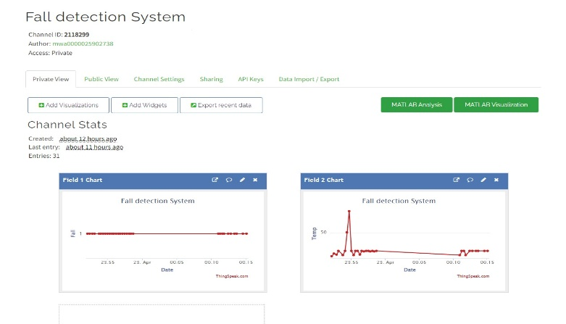

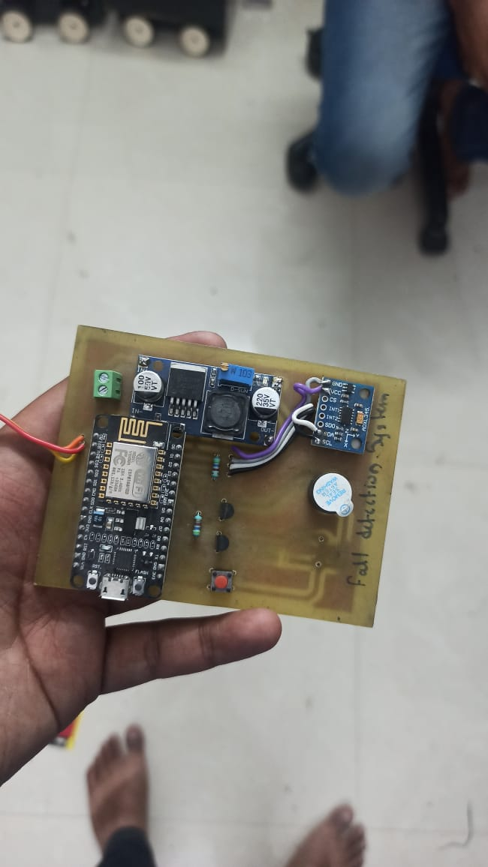

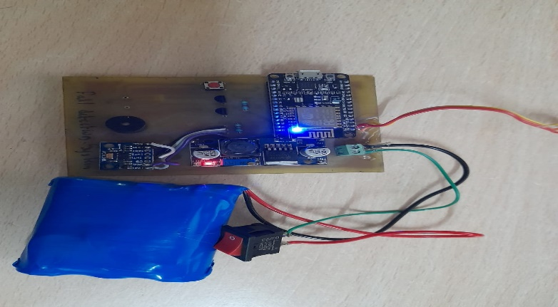

## CONCLUSION

The device can detect falls and direct much needed attention to the person. Furthermore, the device also needs to take into account other factors like different medical conditions of the person. The situation has attracted a lot of researchers and various researches are going on to determine a perfect way to detect and prevent falls.

## FUTURE SCOPE

The lot system will send email notification to the registered person to alert them fall event happen and help needed.

This system requires less implementation cost and provides a quick response.

It can install in the existing commercial wheelchair.

## REFERENCES

1. Vishwakarma, S. K., 2017. Development of smart wheelchair, Dehradun: Dit University,
2. Isreal, A., 2014. System and Method for fall prevention and detection. United State, Patent No. US 8866620 B2.
3. El-Bendary, N., Tan, Q., Pivot, F. C. & Lam, A., 2013. Fall detection and prevention for the elderly. International Journal on Smart Sensing and Intelligent System, 6(3), pp. 1230-1266. Solid State Technology Volume: 63 Issue: 1s Publication Year: 2020 922 Archives Available @ [www.solidstatetechnology.us](http://www.solidstatetechnology.us)
4. H. J. Dong, R. Abdulla, S. K. Selvaperumal, S. Duraikannan, R. Lakshmanan, and M. K. Abbas, “Interactive on smart classroom system using beacon technology,” International Journal of Electrical and Computer Engineering (IJECE), vol. 9, no. 5, p. 4250, Jan. 2019.
5. RAED ABDULLA, ADEN ABDILLAHI, Maythem K. Abbas. Electronic Toll Collection System Based on Radio Frequency Identification System. International Journal of Electrical and Computer Engineering (IJECE). 2018;8(3):2088-8708.
6. Leaman, J. & M.La, H., 2017. A Comprehensive Review of Smart Wheelchairs. New York, s.n.
7. Posugade, V. G., Shedge, K. K. & Tikhe, C. S., 2012. Touch-Screen Based Wheelchair System. International Journal of Engineering Research and Application (IJERA), 2(2), pp. 1245-1248.

## BIOGRAPHIES

**Shweta Pardhi**

Student,

Dept. of Electronics and Telecommunication Engineering, Sinhgad College of Engineering, Maharashtra, India.

**Priyal Sharma**

Student,

Dept. of Electronics and Telecommunication Engineering, Sinhgad College of Engineering, Maharashtra, India.

**Shravan Powar**

Student,

Dept. of Electronics and Telecommunication Engineering, Sinhgad College of Engineering, Maharashtra, India.

**Prof. Tushar Kafare**

Assistant Professor, Dept. of Electronics and

Telecommunication Engineering, Sinhgad College of Engineering, Maharashtra, India