Comparative Study on Design of RCC and PSC Beams

# Krishan Kumar*1, Ravinder Panwar*2, Refaz-Ur-Rehman*3

# *1M.Tech Scholar,Ganga institute of Technology and Management, Kablana, jhajjar, Haryana)

Krishankumar31121@gmail.com

*2 Assistant Professor, Ganga institute of Technology and Management, Kablana, Jhajjar, Haryana)

ravinderpanwar7043@gmail.com

*3 Assistant Professor, Ganga institute of Technology and Management, Kablana, Jhajjar, Haryana)

refazgitm@gmail.com

.

**ABSTRACT**: The cost of R.C.C. and pre-stressed concrete beams are compared in the current research. Concrete that is pre-stressed comprises of tension-bearing reinforcing and concrete that resists compression. In order to effectively use the compressive strength of reinforced concrete and to prevent or regulate cracking and deflection, pre stressing became crucial in many applications. In this study, R.C.C. Beam and Post-tensioned Beams with 16.2m and 4.3m Spans are designed and estimated. SAP 2000 is used for the analysis, whereas manual labor is used for the design. The loads are analyzed in accordance with IS 875 part-2.The analysis, design, and details of a function hall are covered in the article, along with a cost comparison of RCC and post-tensioned pre-stressed beams. The bottom floor and ground floor of the building are intended to function as a public building. The purpose of this study is to design, estimate, and compare pre-stressed concrete and R.C.C. beams with spans of 16.2 and 4.3 meters, respectively. The goal is to come to a firm judgment on which of the two strategies is preferable.

## INTRODUCTION

Both residential and commercial buildings in India often employ RCC structures. Beams that have been post-tensioned and pre-stressed are seldom employed in short-span buildings. There was a severe shortage of skilled workers for pre-stressing work two decades ago. However, there are currently several agencies that do the same tasks. Due to a deflection restriction, the depth of RCC beams grows as the span rises. Pre-stressed sections allow for a reduction in beam depth, and pre-stressed beams are more affordable for longer spans. The most recent significant building method to be used in structural engineering is prestressed concrete. Given that the technology is now accessible in all industrialized and many developing nations, it has established itself as a reliable way of building. Today, prestressing is employed in bridge systems of all kinds, subterranean structures, communication towers, floating storage structures, offshore structures, power plants, and nuclear reactor vessels.

The desire for greatness is one of "homo-sapiens" strongest strengths. The human person has steadfastly resisted resting on his laurels and showing signs of complacency. This has often led to new inventions, as well as enhanced goods and methods. The most innovative method of building in contemporary times has been reinforced cement concrete construction. A composite material that is strong, long-lasting, and affordable has been created by combining the high compressive strength of concrete with the high tensile strength and flexibility of steel. And it has stood the test of time. Concrete's very low tensile strength led to the discovery of R.C.C. R.C.C.'s bulk led to the development of shells. The R.C.C. structures' concern with serviceability kept the human mind busy for a while. Pre-stressing turned out to be the answer. Pre-stressed reinforced concrete is constructed of tension-bearing reinforcement and concrete that resists compression. To fully use the compressive strength of reinforced concrete and to prevent or regulate cracking and deflection, pre stressing became crucial in many applications.

For structural engineers, the main design goals are safety, usability, economics, and these days, legality of design. It is crucial for engineers and architects to comprehend the proper use of post-tensioned concrete and the potential implications when choosing a structural construction system. Concrete constructions made of high-quality materials may provide a better mix of durability, sound control, and fire safety required in today's building market if correctly studied and erected. Concrete is often chosen over steel as the most cost-effective material given the market's current pricing alternatives, material availability, lower floor-to-floor heights, and developer finance possibilities. When internal stresses are induced into concrete, they must be of a size and distribution that the stresses brought on by certain external loadings are at least somewhat offset.

## LITERATURE REVIEW

**A.R.Mundhahda, Mohammad Shahezad (2012**) studied **“**Economics Constant R.C.C. Beams In the project "Vis-Vis Continuous Pre Stressed Concrete Beams," continuous R.C.C. and continuous pre-stressed concrete beams with a range of spans are designed and estimated. This study compares the outcomes of designing medium span continuous R.C.C. beams with continuous pre-stressed concrete varieties. In order to design the beams, programming is done in MS EXCEL. According to the findings, continuous R.C.C. beams are less expensive than continuous pre-stressed concrete beams for smaller spans, but not for greater spans.[1]

**Vaibhav G Tejani, Hitesh K Dhameliya, Jasmin Gadhiya (2015)** The work "Review For Study Of Pre Stressing Systems For All Structural Element" includes research on structures that are cost-effective for post tensioning, for a span, as well as high labor cost nations, to avoid external scaffolding, for low-rise structures to precast as much as is practical, and to pre stress concrete, not only horizontally but also vertically to resist lateral loads. Pre-stressing is being used more often in most modern buildings, which has opened up possibilities for shapes that were previously thought to be impracticable, uneconomical, or too bulky to withstand loads. Because pre stressing keeps the concrete in constant compression and prevents cracking, which may otherwise result in water infiltration over time, flat roof surfaces can be made impermeable even without the use of conventional bituminous waterproofing.. [2]

**Anupam Sharma, Suresh Singh Kushwah (2015)** Studied “In the study "Comparative Analysis Of Reinforcement & Prestressed Concrete Beams," prestressed concrete beams are analyzed as being more effective in flexure than reinforcement concrete beams. This work introduces simply supported beams under various loading scenarios, including as point loads, and performs a stadd pro analysis. This study shows that prestressed concrete beams perform better in every way than reinforced concrete beams when subjected to flexural loads under various conditions. [4]

**Ankit Sahu, Prof. Anubhav Rai, Prof. Y. K. Bajpai (2014)** Studied “*Cost & Constructional Comparison Between RCC & Prestressed Beams Spanning 16m*” the work includes design and estimate of R.C.C. Beam and post-tensioned Beam of span 16 m and then comparing the results. Result shows that, for span 16m Post-Tensioned Pre-stressed concrete beam is 14% cheaper than RCC beam. When we Design for various spans ranging from 6m to 26m & above than, Result shows that for 11.25 meter length cost of RCC Beam & PT Beam are same. RCC Beams are cheaper for spans up to 11.25 meter. And Post-Tensioned pre-stressed beams are cheaper for spans larger than 11.25 meter. [5]

## OBJECTIVES

* To carry out analysis of function hall in SAP 2000.
* Based on the results drawn from the SAP2000, the beams with different spans of function hall is to be designed (RCC and PSC)
* And to compare the cost of RCC & Post-tensioned pre- stressed concrete beams**.**

## METHODOLOGY

First, a R.C.C. beam was manually developed based on IS: 456-2000's limit state approach. based on the procedures and formulae used. By initially utilizing the programmed to create the manually constructed beam and comparing the outcomes, the program's output is tested. Since a mix richer than M -20 is often utilised in the field for RCC, the grade of concrete is kept at M -20 for R.C.C. The process for pre-stressed concrete beams is the same. The limit state technique recommended by Indian code provisions IS: 1343-1980 served as the foundation for the manual design. By first resolving the manual issue and contrasting the outcomes, the outcome is verified. The beam is designed for M-40 grade concrete for pre-stressing. The most prevalent cable profile, the parabolic one, is the only one for which design work is done. Programmers are also ready for pricing and estimation. The KPWD SR 2015–16 will be used to determine rates. Some of the prices for pre-stressed concrete will be acquired from a reputable private infrastructure provider.

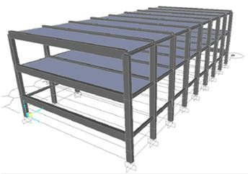

Fig 4.1 Model of function hall in SAP 2000

## RESULTS AND DISCUSSIONS

The following results shows that, for all spans the Post-Tensioned Prestressed concrete beams are cheaper than RCC beams:

## Table 5.1 Bending Moment and Shear Force (SAP 2000)

|  |  |  |  |
| --- | --- | --- | --- |
| **Sl.No** | **Beams** | **Shear force (Vu)**  **KN** | **Bending moment (Mu)**  **KN-m** |
| 1 | Primary Beam at 12m Outer | 349.92 | 709.5012 |
| 2 | Primary Beam at 12m Intermediate | 109.350 | 214.748 |
| 3 | Primary Beam at 7.5m Outer | 590.49 | 1373.7642 |
| 4 | Primary Beam at 7.5m Intermediate | 109.35 | 244.9095 |
| 5 | Primary Beam at 3m Outer | 590.49 | 1366.7877 |
| 6 | Secondary Beam at 7.5m Outer | 288.288 | 198.6182 |

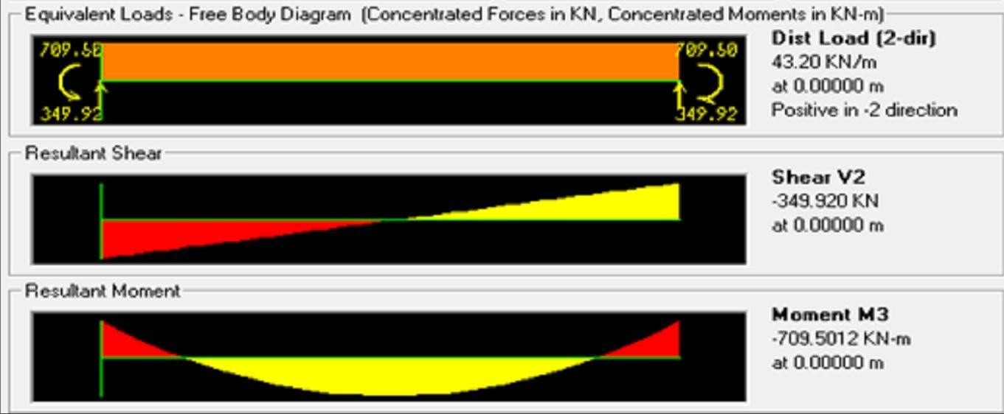

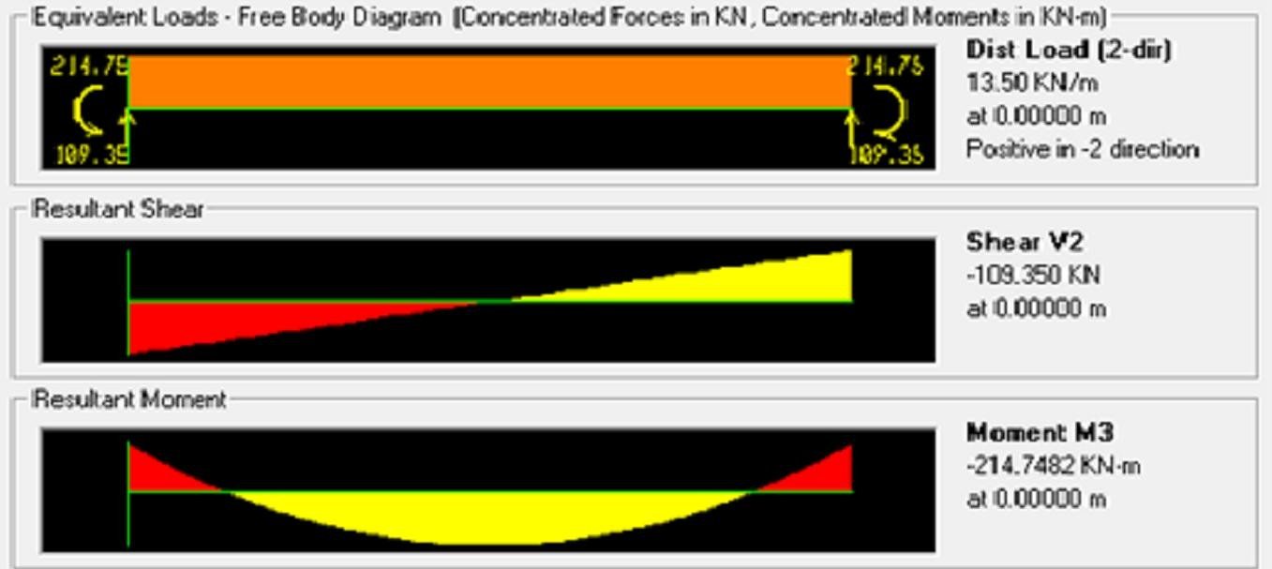Fig 5.1 Bending Moment & Shear Force of Primary Beam at 12m Outer

Fig 5.2 Bending Moment & Shear Force of Primary Beam at 12m Intermediate

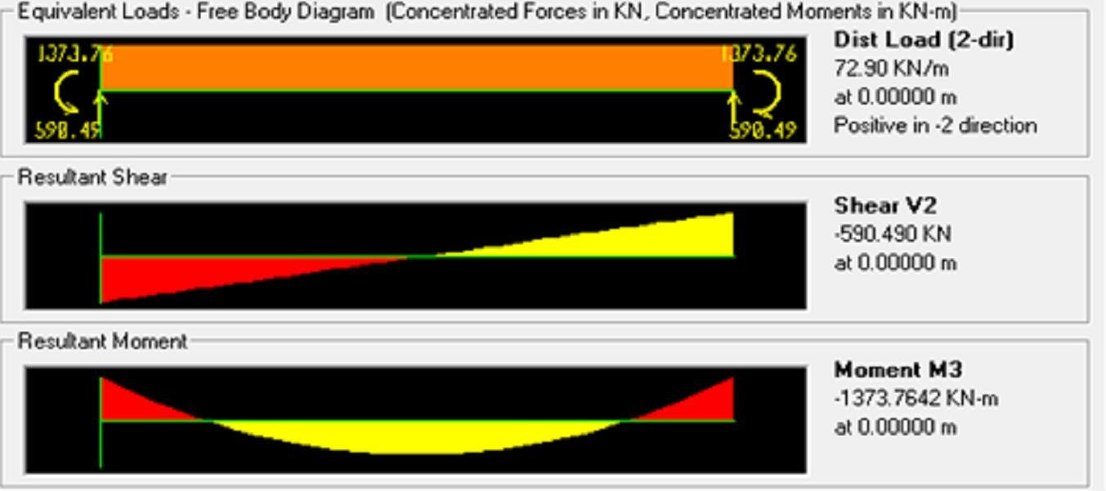

Fig 5.3 Bending Moment & Shear Force of Primary Beam at 7.5m Outer

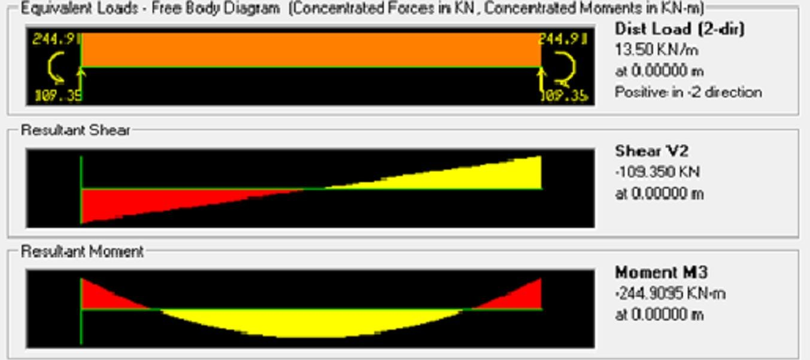

Fig 5.4 Bending Moment & Shear Force of Primary Beam at 7.5m Intermediate

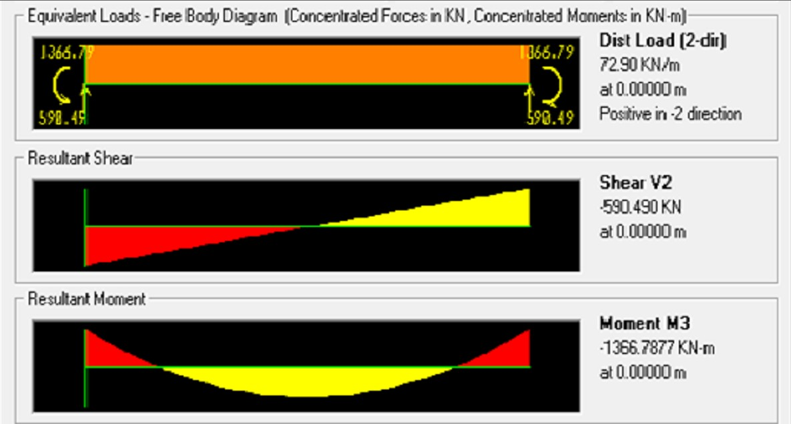

Fig 5.5 Bending Moment & Shear Force of Primary Beam at 3m Outer

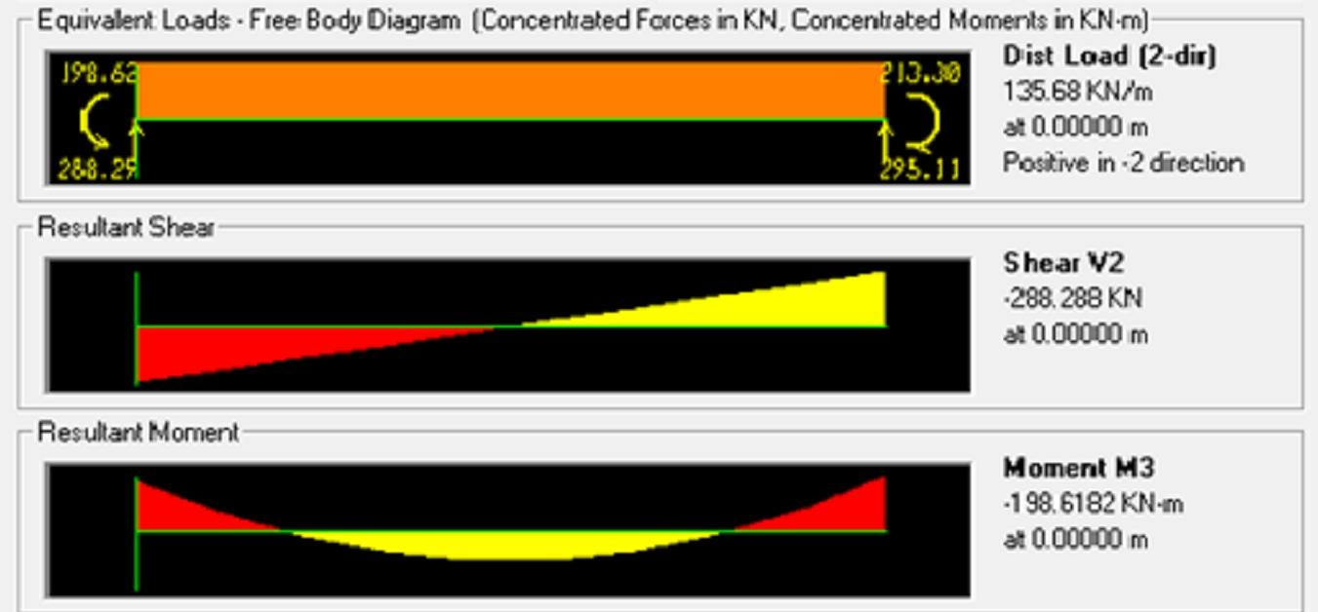

Fig 5.6 Bending Moment & Shear Force of Secondary Beam at 7.5m Outer

## Table 5.2 Costs of RCC and PSC Beams

|  |  |  |
| --- | --- | --- |
| **Sl.No** | **Amount of RCC (INR)** | **Amount of PSC (INR)** |
| 1 | 50268.312 | 47111.661 |
| 2 | 39598.344 | 32949.686 |
| 3 | 68694.12 | 52666.236 |
| 4 | 39598.344 | 31496.936 |
| 5 | 72530.8344 | 52666.236 |
| 6 | 21178.008 | 6184.007 |
| Total | 291867.9624 | 223074.762 |

80000

70000

X axis - Beam, Y axis– Cost (INR)

60000

50000

40000

30000

AMOUNT OF RCC

AMOUNT OF PSC

20000

10000

0

1 2 3 4 5 6

Fig 5.7 Cost Comparison of RCC and PSC

## VI CONCLUSION

based on shear force and bending moments from SAP 2000. The event hall's beams are RCC and PSC designed. When RCC and PSC's construction costs are compared for various spans, it is clear that PSC's construction costs are more affordable than RCC's (Fig. 5.7).

## REFERENCES

1. A.R.Mundhada, Mohammad Shahezad “Economic Of Continuous R.C.C. Beams Vis-À-Vis Continuous Pre Stressed Concrete Beams” International Journal of Scientific & Engineering Research , Volume 3, Issue 7, July 2012.
2. Vaidhav G Tejani, Hitesh K Dhameliya, Jasmin Gadhiya “Review for Study of Prestressing System for All Structural Element” International Journal of Scientific Research in Science, Engineering & Technology, Volume 1, Issue 6, 2015
3. Amlan K Sengupta and Prof. Devdas Menon “Prestressed Concrete Structures” NPTEL.
4. Anupam Sharma and suresh singh kushwah “Comparative Analysis Of Reinforcement And Pre-stressed Concrete Beam” International Journal of Current Engineering and Technology Volume 5, No 4, July 2015
5. Ankit Sahu, Prof.Anubhav Rai, Prof.Y.K.Bajpai.” Cost Comparision between RCC & Post tensioned Prestressed beam Spanning 26m” International Journal of Computational Engineering Research , Volume 4, Issue 6, June 2014.
6. Code:IS875 part 2 [7] Code:IS456-2000 [8] Code: IS1343: 1980