**Behaviour of Steel Fiber Reinforced Concrete at elevated temperatures**

**Sanjiv Mohanty1, Divyansh Golani2, Niranjan Yadav3, Dr. Viswanathan T S4**

1Student, School of Civil Engineering, Vellore Institute of Technology, Vellore, Tamil Nadu, India

2 Student, School of Civil Engineering, Vellore Institute of Technology, Vellore, Tamil Nadu, India

3 Student, School of Civil Engineering, Vellore Institute of Technology, Vellore, Tamil Nadu, India  
4Associate Professor, School of Civil Engineering, Vellore Institute of Technology, Vellore, Tamil Nadu, India

**ABSTRACT**

The construction sector offers a diverse range of fibers that can enhance the attributes of concrete, such as its strength, durability, and aesthetics. This study aims to present the outcomes of an experiment that investigated the impact of temperature on Steel Fiber Reinforced Concrete (SFRC). The experiment involved subjecting both SFRC and regular concrete samples to different temperatures, ranging from room temperature to 100, 300, and 600°C, and analyzing their characteristics. The SFRC used in the experiment contained hooked-end steel fiber, which had dimensions of 30mm length and 0.60mm diameter. Both types of concrete underwent compression, split tensile, and flexural strength tests, and the results were compared and evaluated. After concluding all the tests, our results showed that our SFRC concrete is not just giving a better strength but also a good level of ductility. This paper has also discussed the comparison of crack patterns between both types of concrete and how the crack patterns enhance the reliability of the SFRC concrete.

1. **INTRODUCTION**

Steel fibers are a form of extra element in steel fiber reinforced concrete (SFRC), which is a composite material. Steel fibers are uniformly placed at random in modest quantities of between 0.5% and 1.5% by volume in plain concrete. Steel fibers are added to the concrete slurry in a mixer before the green concrete is poured into molds to create SFRC products. The finished product is subsequently compressed and cured according to standard procedures. To achieve a consistent dispersion of fibers, segregation or balling should be prevented throughout the mixing and compacting process. For better mixing and to prevent fiber balls from forming, a pan mixer and fiber dispenser must be used. Whilst SFRC requires a little more energy throughout the mixing, transporting, putting, and finishing processes, the advantages of greater strength make it a sensible choice for designing beams.

Concrete is strengthened by the addition of steel fibers, allowing us to minimize the depth of the beam and more efficiently design it. The moment carrying capacity of a beam, which is exactly related to the square of its depth, must be taken into account. After a certain point, reducing the depth of the beam might have a negative impact on its ability to transport moments; for this reason, an ideal limit of steel fiber is set at a minimum of 0.5% and a maximum of 1.5%.

1. **METHODOLOGY**

The methodology for testing the properties of materials like cement and aggregates, and preparing mix designs of normal concrete and SFRC, can be broken down into several steps. First, the properties of the raw materials, such as cement and aggregates, must be tested to ensure their suitability for the mix.   
  
Once the materials have been approved, collect the moulds that will be required for casting. Cube moulds of (100mm x 100mm x 100mm), Cylinder moulds (200mm length x 100mm dia) and prism moulds (500mm x 100mm x 100mm) dimensions.

Next, trial mixes of both normal concrete and SFRC should be prepared and tested to ensure that they meet the desired specifications. This involves adding the required amount of steel fibers to the concrete mix for the SFRC trial mix.

After the trial mixes have been approved, specimens should be cast for both normal concrete and SFRC using the mix designs that were finalized. These specimens can be in the form of cubes or cylinders, depending on the type of testing that will be performed.

Once the specimens have been cast, their mechanical properties should be determined through compression testing, split tensile testing, and flexural testing. These tests will help to determine the strength, durability, and ductility of the concrete specimens.

Finally, the data collected from the mechanical testing can be analyzed, and conclusions can be drawn about the performance of the normal concrete and SFRC. This will help to identify the benefits of using SFRC and any areas for improvement in the mix design and casting process.  
  
**2.1 Mix Design**  
The grade of concrete used in this experiment is M40, PPC conforming to IS 1489 (Part 1), maximum nominal aggregate size of 20 mm(angular), minimum cement content and maximum water-cement ratio is mild with a 75mm slump workability. The method of concrete placing has been done manually with a good degree of site control.  
  
The casting utilizes Ordinary Portland Cement (OPC), with a specific gravity of 3.12 for cement, 2.48 for coarse aggregate, and 2.74 for fine aggregate. The ratio of water:cement:fine aggregate:coarse aggregate is 0.45:1:1.12:2.15. Cement used is 532.16 kg, water used is 191.58 kg, coarse aggregate used is 1156.45 kg and fine aggregate used is 606.07 kg. The calculations of design have been done by referring to IS456, IS1489 (Part 1) and IS 10262:2019.

**2.2 Steel Fiber**The type of fiber used in the experiment is hooked-end, with length 30 mm and diameter 0.6 mm. Percentage of C, Mn, Si and P is 0.08%, 0.35%, 0.15% and 0.35% respectively. The percentage of fiber used for casting of SFRC specimens has been taken 1% of the total volume of the concrete.  
  
**2.3 Temperature Study**  
To prepare the specimens for testing, they should be sun-dried for 12-18 hours after curing is complete. Then, place them in an oven at 100°C for 24 hours to dry. After removing the specimens from the oven, allow them to cool for 1-2 hours before transferring them to the furnace. The furnace should be set to the required temperature, either 100, 300, or 600 °C, and heated at a rate of 10°C per minute. Once the furnace reaches the desired temperature, leave the specimens inside for 1 hour. After that, switch off the furnace and let the specimens cool inside for another hour. Then, take out the specimens and cool them in open air until they reach a comfortable temperature for handling, at which point you can proceed with testing.

**2.4 Testings Conducted:**  
Various tests are carried out on concrete samples to evaluate their strength and robustness. One of these tests is performed on concrete at 7 days. After curing the sample for 7 days, a compression strength test is conducted to determine its strength.

Another test involves analysing the concrete at 28 days at normal temperature. The sample is cured for 28 days before conducting compression strength, split tensile strength, and flexural strength tests.

To examine the behavior of concrete under harsh circumstances, samples are tested at high temperatures of 100℃, 300℃, and 600℃ at 28 days of curing. The specimens are first cured for 28 days and then subjected to the desired temperature. Subsequently, a compression strength test and a split tensile strength test are performed on each sample. These tests play a crucial role in evaluating the concrete's strength and durability under extreme conditions.

1. **MODELING AND ANALYSIS**
2. **RESULTS AND DISCUSSION**

Compressive Strength (in N/mm2 ) after 7 days-

|  |  |  |
| --- | --- | --- |
| **S.No.** | **Normal Concrete** | **SFRC** |
| **1** | 32.3 | 37.6 |
| **2** | 31.7 | 36.1 |
| **3** | 28.5 | 37 |

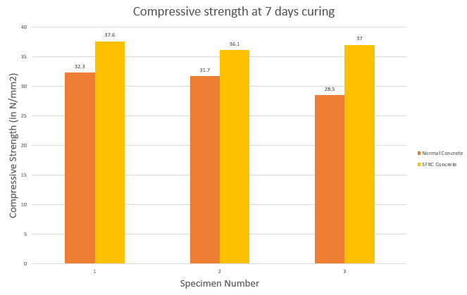

Average Compressive strength (NC) = 30.83 N/mm2

Average Compressive strength (SFRC) = 36.90 N/mm2

Average Compressive Strength (in N/mm2 ) at different temperatures after 28 Days-

|  |  |  |
| --- | --- | --- |
| **Temperature (in °C**) | **Normal Concrete** | **SFRC** |
| 25 | 41.53 | 48.02 |
| 100 | 36.47 | 42.94 |
| 300 | 26.07 | 32.29 |
| 600 | 9.34 | 25.99 |

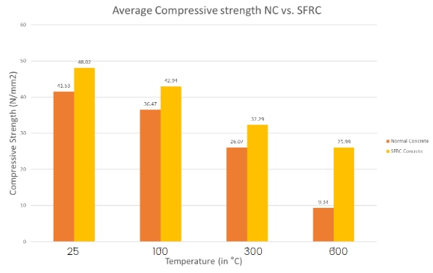

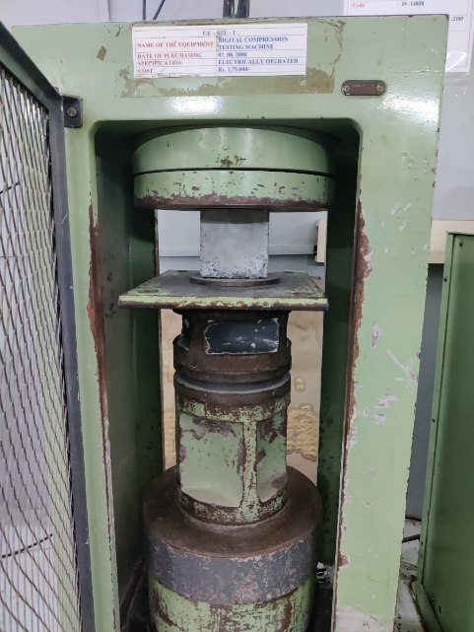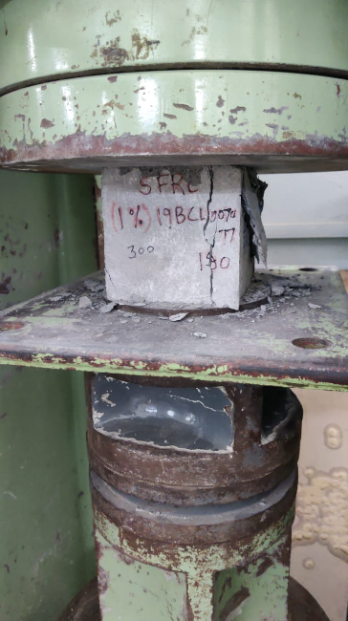

Average Tensile Strength (in N/mm2 ) at different temperatures after 28 Days-

|  |  |  |
| --- | --- | --- |
| **Temperature (in °C**) | Normal Concrete | SFRC |
| 25 | 2.98 | 4.71 |
| 100 | 2.56 | 4.42 |
| 300 | 1.88 | 3.88 |
| 600 | 0.96 | 3.08 |

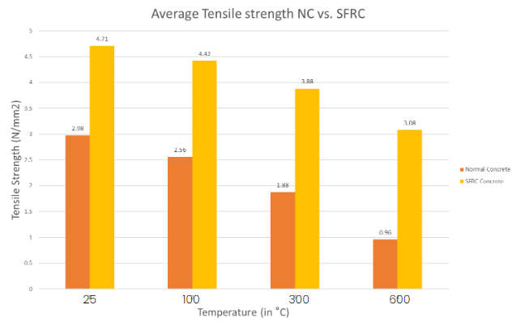

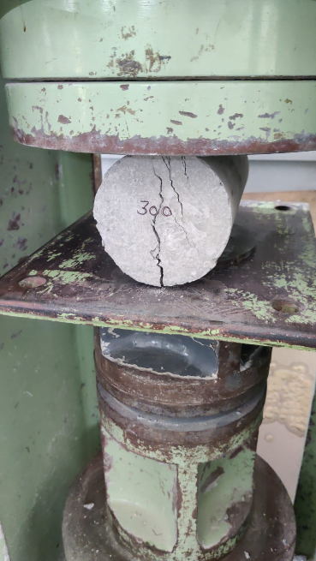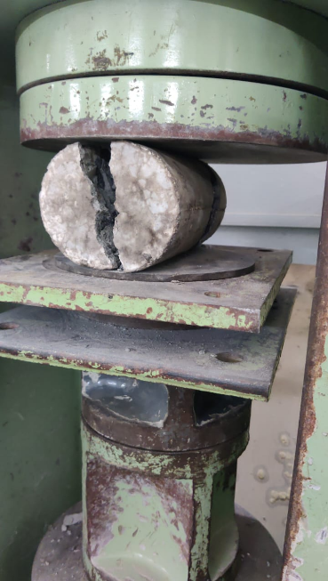

Flexural Strength (in N/mm2 ) after 28 days-

|  |  |  |
| --- | --- | --- |
| **S.No.** | **Normal Concrete** | **SFRC** |
| **1** | 9.38 | 9.31 |
| **2** | 12.47 | 7.61 |
| **3** | 8.63 | 7.81 |

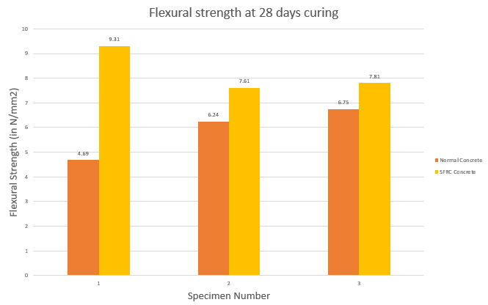

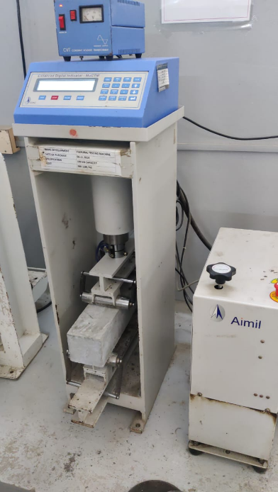

Residual Compressive Strength (in %) at different temperatures after 28 Days-

|  |  |  |
| --- | --- | --- |
| **Temperature (in °C)** | **NC** | **SFRC** |
| 25 | 100 | 100 |
| 100 | 87.81 | 89.42 |
| 300 | 62.77 | 67.24 |
| 600 | 22.48 | 54.12 |

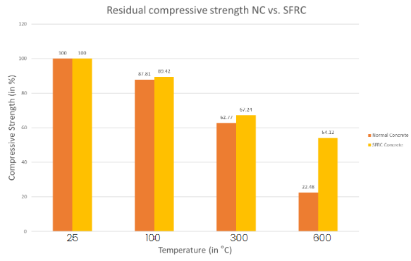

Residual Tensile Strength (in % ) at different temperatures after 28 Days-

|  |  |  |
| --- | --- | --- |
| **Temperature (in °C)** | **NC** | **SFRC** |
| 25 | 100 | 100 |
| 100 | 85.9 | 93.84 |
| 300 | 63.08 | 82.37 |
| 600 | 32.21 | 65.39 |

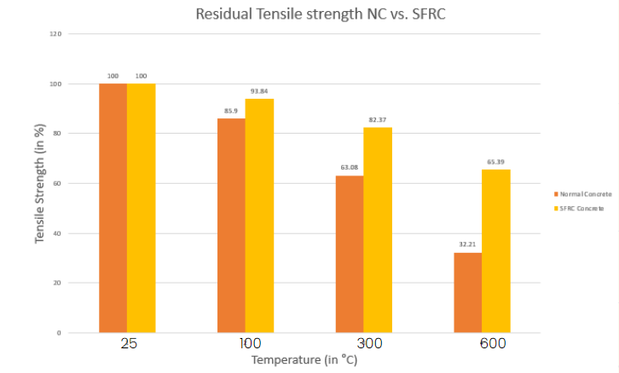

1. **CONCLUSION**

All the main points of the research work are written in this section. Ensure that abstract and conclusion should not same. Graph and tables should not use in conclusion.

**ACKNOWLEDGEMENTS (optional)**

The authors can acknowledge professor, friend or family member who help in research work in this section.

1. **REFERENCES**
2. Noumowé, A., Siddique, R., Ranc, G., 2009. Thermo-mechanical characteristics of concrete at elevated temperatures up to 310°C. Nuclear Engineering and Design 239, 470.
3. Gawin, D., Pesavento, F., Schrefler, B.A., 2004. Modelling of deformations of high strength concrete at elevated temperatures. Mat. Struct. 37, 218–236.
4. Campbell-Allen, D., Desai, P.M., 1967. The influence of aggregate on the behaviour of concrete at elevated temperatures. Nuclear Engineering and Design 6, 65–77.
5. Thomas, J., Ramaswamy, A., 2007. Mechanical Properties of Steel Fiber-Reinforced Concrete. Journal of Materials in Civil Engineering 19, 385–392.
6. Xu, B.W., Shi, H.S., 2009. Correlations among mechanical properties of steel fiber reinforced concrete. Construction and Building Materials 23, 3468–3474.