### **Food Image Recognition And Calorie Prediction Using CNN Approach**

**Mr. Pranjal Ranjan , Mr. Abu Safwan Shaikh, Mr. Sanyyam Jain, Mr. Shivam Shinde,**

**Mrs. Anuja D. Tawlare**

**Dept. Of Information Technology, Sinhgad College of Engineering, Pune, India**

Email - [pranjalranjan797@gmail.com](mailto:pranjalranjan797@gmail.com) , 1[abusafwan@gmail.com](mailto:abusafwan@gmail.com) , [sayyamjain28@gmail.com](mailto:sayyamjain28@gmail.com) , [shivamshinde175@gmail.com](mailto:shivamshinde175@gmail.com) , [adtawlare.scoe@sinhgad.edu](mailto:adtawlare.scoe@sinhgad.edu)

**ABSTRACT**

In this report, we propose a food recognition system that when feed with the right amount of data can help a user monitor his/her day to day intake of calories. The user inputs an image from the gallery or mobile phone camera. Our Work is to first determine the Category of food and after predicting the category of Food(Fruit or Vegetable) Our System determining the Category of that Image(Either the Image is in the Category of Food or Vegetable) After Determining these Things We are predicting the Calorie of that Food as well. In This Our Work is totally based on the deep learning Algorithms. Deep learning and is used to recognize the image and based on The image it will Identify the Category. Our System Comprises with several segmentation and image parameters as well. If a system informs the nutritional information of a food item and classify it as healthy or non-healthy to the user, then people are able to identify their daily intake of calorie Value of their food items.

**Keywords -** Food Image Recognition, Calorie Prediction, convolutional neural network, Deep Learning Approach, Image Recognition.

**INTRODUCTION**

A food recognition system the purposes of which are estimating calorie and identify food items. With the rapid development of our society, more attention has been paid to the quality of life, especially the food eat. Food recognition systems is a system which could identify the type of food in an image that is captured with a camera. This is an idea to help the users to keep track of their calorie intake. The user can automatically record their food and calorie intake with just a snap of its photo. Adopt image recognition methods which are suitable for all suitable platforms. To recognize food items, a user draws bounding boxes around the food item, and then the system starts food item recognition within the indicated bounding boxes. To recognize them more accurately, segment each food item region, extract image features and finally classify it into one of the one hundred food categories with a convolution neural networks. Can awake users if their food habits problems such as bad food trends and unhealthy food. It is useful for disease prevention. Our project proposes on recognizing/detecting food items in a food image and show its calorie value by using convolutional neural network (popular for image recognition). will train our model to recognize food items, then with the help of support vector machines (SVM), classify those food items into different categories (e. g burger, pizza etc ).

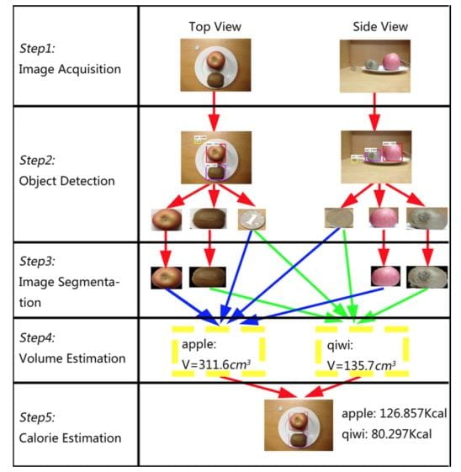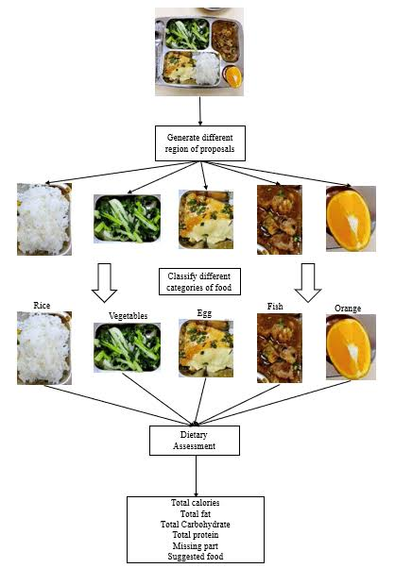

Fig. 1: Sample Food Image Recognition And Calorie Prediction image

**Motivation**

There’s a variety of development which has been made regarding digital image processing and deep learning algorithms which also include its various applications. Computer vision has been introduced to estimate calories from food images. But current food image datasets don’t contain volume and mass records of foods, which leads to an incomplete calorie estimation. Current obesity treatment techniques require the patient to record all food intakes per day. In most of the cases, unfortunately patients have troubles in estimating the amount of food intake because of the self-denial of the problem, lack of nutritional information, the manual process of writing down this information (which is tiresome and can be forgotten), and other reasons. In this report we basically focused on the problem regarding food calorie prediction using Convolutional Neural Networks Algorithm

**Project requirement**

**Python** is an interpreted, high-level and general-purpose programming language. Created by Guido van Rossum and first released in 1991, Python’s design philosophy emphasizes code readability with its notable use of significant whitespace. Its language constructs and object-oriented approach aim to help programmers write clear, logical code for small and large-scale projects.

Python is dynamically typed and garbage-collected. It supports multiple programming paradigms, including structured (particularly, procedural), object-oriented, and functional programming. Python is often described as a ” batteries included” language due to its comprehensive standard library.

**Anaconda:** Anaconda is a free and open-source distribution of the Python and R programming languages for scientific computing (data science, machine learning applications, large-scale data processing, predictive analytics, etc.), that aims to simplify package management and deployment. The distribution includes data-science packages suitable for Windows, Linux, and macOS. It is developed and maintained by Anaconda, Inc., which was founded by Peter Wang and Travis Oliphant in 2012. As an Anaconda, Inc. product, it is also known as Anaconda Distribution or Anaconda Individual Edition, while other products from the company are Anaconda Team Edition and Anaconda Enterprise Edition, both of which are not free.

Open source packages can be individually installed from the Anaconda repository, Anaconda Cloud (anaconda.org), or the user’s own private repository or mirror, using the conda install command. Anaconda, Inc. compiles and builds the packages available in the Anaconda repository itself, and provides binaries for Windows 32/64 bit, Linux 64 bit and MacOS 64-bit. Anything available on PyPI may be installed into a conda environment using pip, and conda will keep track of what it has installed itself and what pip has installed.

Custom packages can be made using the conda build command, and can be shared with others by uploading them to Anaconda Cloud, PyPI or other repositories.

The default installation of Anaconda2 includes Python 2.7 and Anaconda3 includes Python 3.7. However, it is possible to create new environments that include any version of Python packaged with conda

**METHODOLOGY**

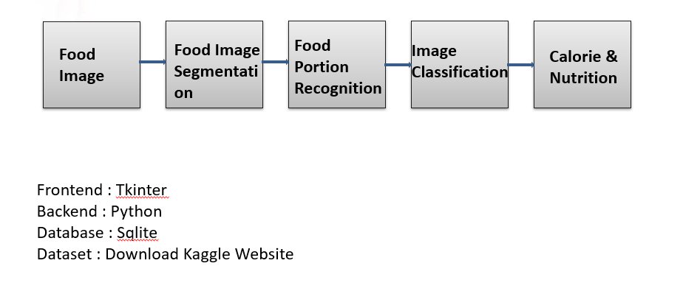

A CNN typically has three layers a convolutional layer, a pooling layer, and a fully connected layer.

The **convolution layer** is the core building block of the CNN. It carries the main portion of the network’s computational load. This layer performs a dot product between two matrices, where one matrix is the set of learnable parameters otherwise known as a kernel, and the other matrix is the restricted portion of the receptive field.

The **pooling layer** replaces the output of the network at certain locations by deriving a summary statistic of the nearby outputs. This helps in reducing the spatial size of the representation, which decreases the required amount of computation and weights. The pooling operation is processed on every slice of the representation individually.

**Connected layer**: Neurons in this layer have full connectivity with all neurons in the preceding and succeeding layer as seen in regular FCNN. This is why it can be computed as usual by a matrix multiplication followed by a bias effect. The FC layer helps to map the representation between the input and the output.

**system architecture**

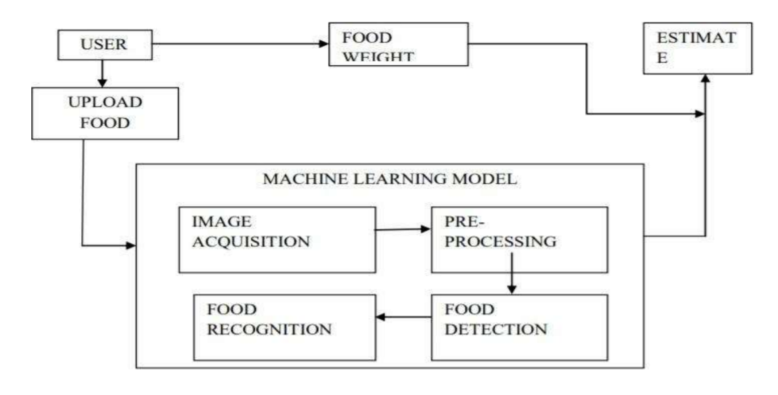

Data Flow Diagram

In Data Flow Diagram, we Show that flow of data in our system in DFD0 we show that base DFD in which rectangle present input as well as output and circle show our system, In DFD1 we show actual input and actual output of system input of our system is text or image and output is rumor detected like-wise in DFD 2 we present operation of user as well as admin.

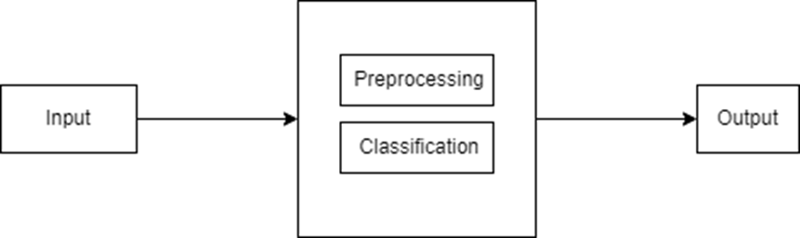

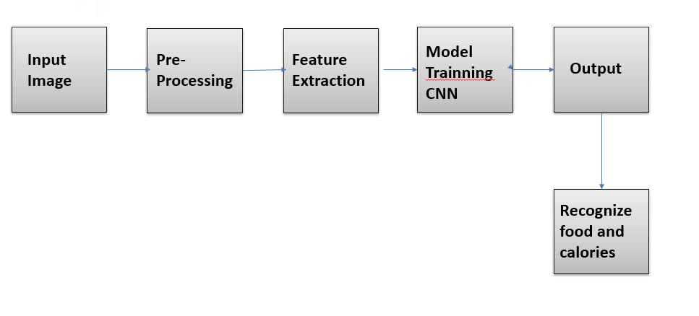

Block diagram

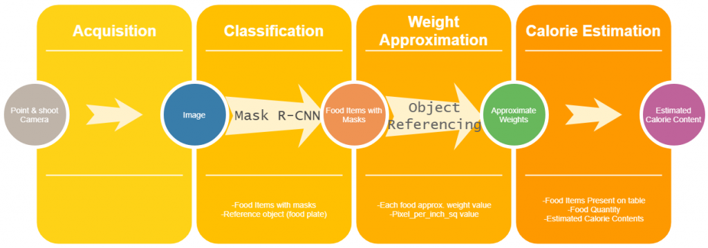

Data Flow diagram

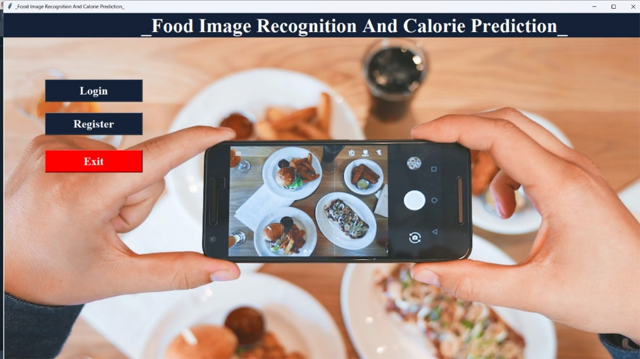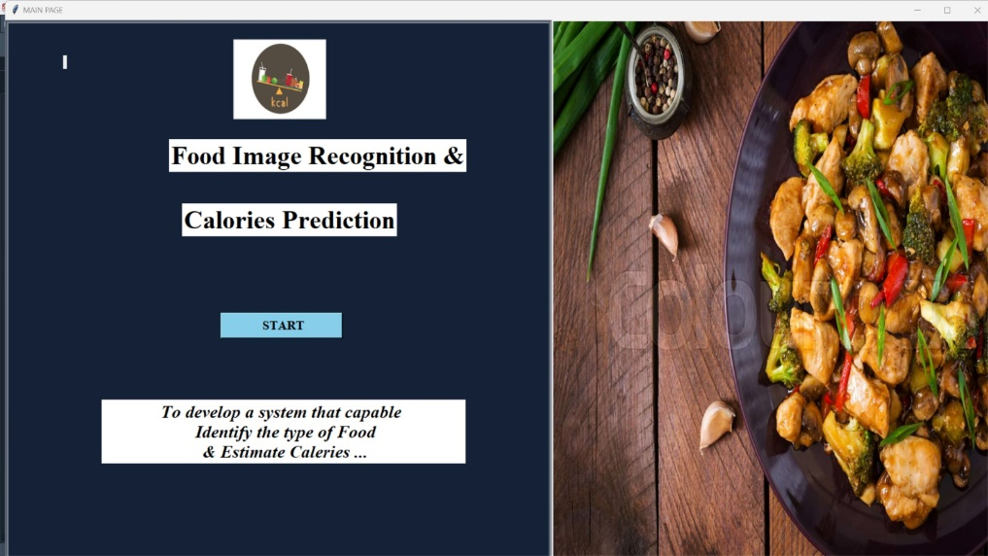**USER INTERFACE**

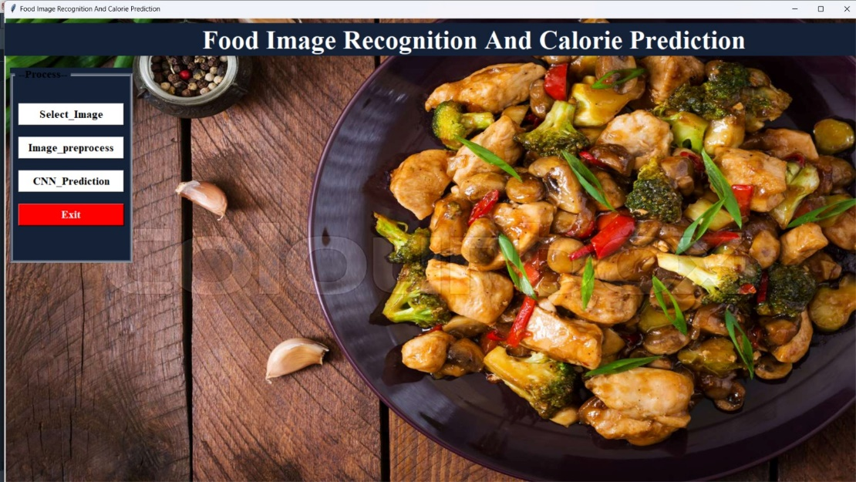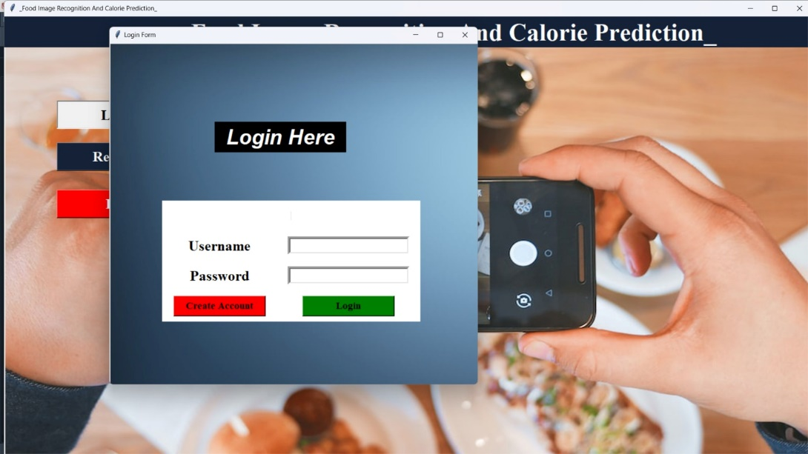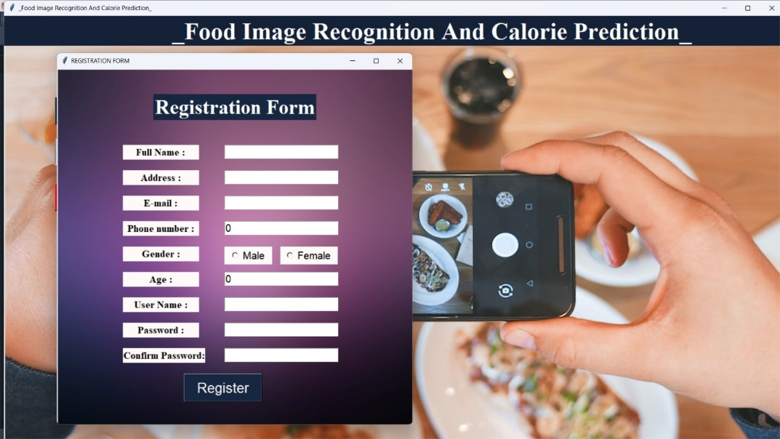

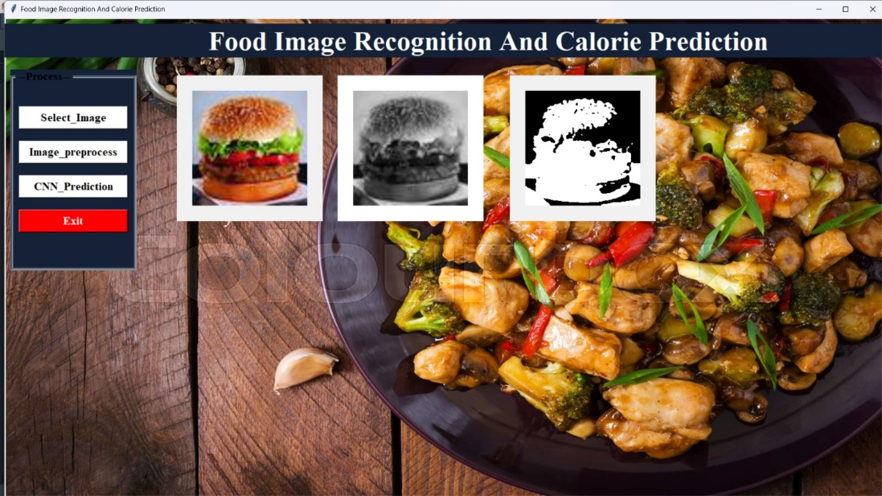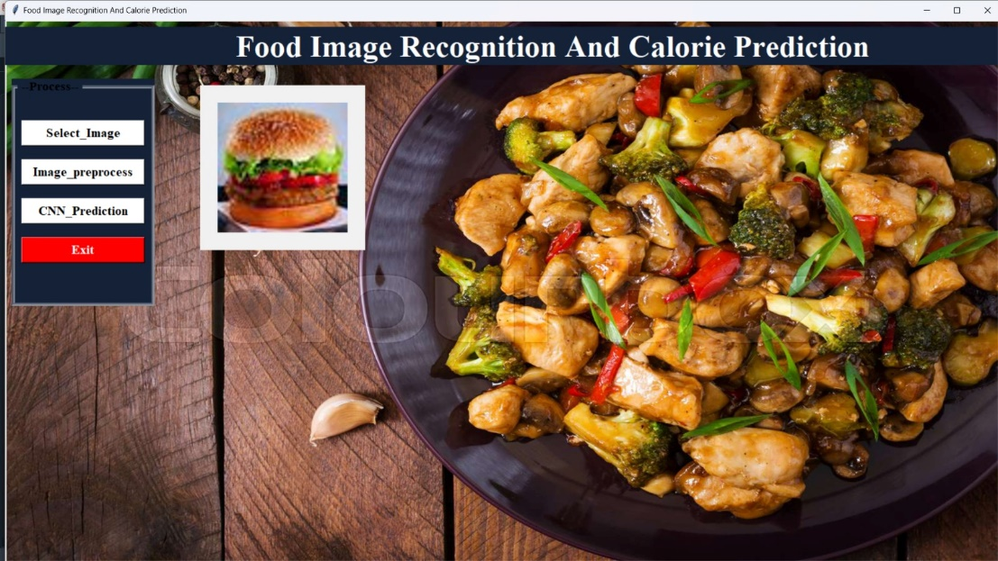

**OUTPUT**

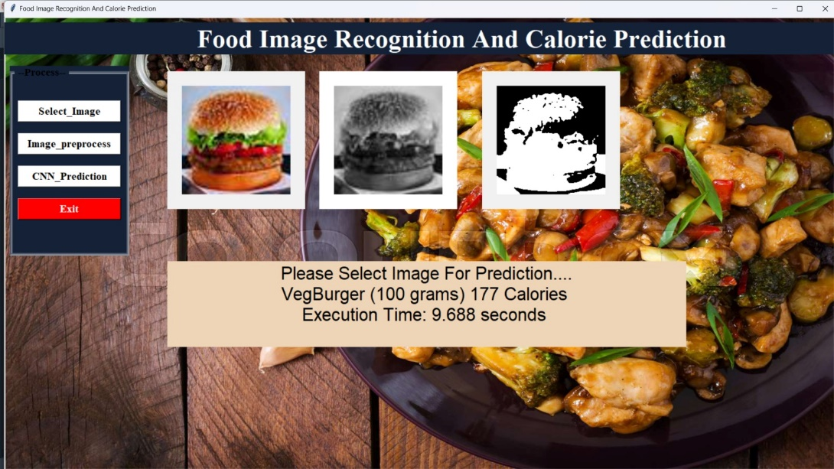

**CONCLUSION**

we proposed an image-based calorie estimation system which runs on a consumer smartphone without external recognition servers ,The system estimate food calories automatically by simply taking a meal photo from the top with a preregistered reference object. Extend our system by using deep learning and correctly process the extracted features.

A picture of food as input to the system, it will quickly recognize the food item/items in the image with it’s calorie value as output. Today about 30% of the entire human population is obese and over-right. Obesity has been directly linked with various diseases such as diabetes, high blood pressure and even cancer. On a social level, it will help bring awareness among people with respect to the food items they consume amount of calorie intake. This would in turn lead to a fall in the fraction of population suffering from obesity

##### **REFERENCES**

**1. Food Image Recognition and Calorie Prediction**

**Author: Narayana Darapaneni, Subhav Kataria, Anwesh Reddy Paduri, Vishal Singh, Nayana Bansal, Yasharth Singh Tarkar, Abhijeet Kharade**

**2.FoodieCal: A Convolutional Neural Network Based Food Detection and Calorie Estimation System**

**Author: Shahriar Ahmed Ayon, Chowdhury Zerif Mashraf, Abir Bin Yousuf, Fahad Hossain, Muhammad Iqbal Hossain**

**3. Image Based Food Calories Estimation Using Various Models of Machine Learning**

**Author name: Haoyu Hu1, Zihao Zhang2, Yulin Song3**

**4. Predicting Calorific Value for Mixed Food Using Image Processing**

**Author name: R.Kohila, Prof. R.Meenakumari**

**5.** [**https://ieeexplore.ieee.org/document/9422510**](https://ieeexplore.ieee.org/document/9422510)

**6.** [**https://ieeexplore.ieee.org/document/9421353**](https://ieeexplore.ieee.org/document/9421353)

**7.** [**https://ieeexplore.ieee.org/document/9428820**](https://ieeexplore.ieee.org/document/9428820)

**8.** [**https://ieeexplore.ieee.org/document/8276066**](https://ieeexplore.ieee.org/document/8276066)