**IOT based bank locker security system with voice reporting and RFID**

# C.Mallesh1, K.Lokesh2, N.Sandeep3, D.Unish4, P.Karthik Kumar5 and Girish Babu.S6

*1,2,3,4,5,6Department of Electronics and Communication, Santhiram Engineering College, India,* E-mail:

girishbabu.ece@srecnandyal.edu.in

**ABSTRACT:**

As a society, we place increasing value on the safety of our financial transactions and the protection of our most prized possessions, including money, jewelry, and other valuables. A lot of progress has been made in transitioning from mechanical to electrical systems. Many methods are offered to increase bank security in order to stay up with the times, but biometrics is one of the most promising. As technology improves, we may build upon this concept using tools like RFID and voice verification as our foundation.

**INTORDUCTION:**

Here, we see how various comparable projects have integrated RFID and speech recognition with Arduino to improve security. In [1], a prepaid water meter system has been developed to automatically charge customers for their water use based on remote monitoring that eliminates the need for any human intervention. Water use can be accurately billed in a timely manner, and the system may help avoid abuse. The monitoring of water meter readings in outlying areas has been made possible by the [5] creation of a module for reading water meters. The need for human intervention in meter reading and billing might be reduced as a result. Using an RFID network, the authors of [6] describe how to keep tabs on the use of electricity. The meter reading was tracked by the system and an SMS was sent to the billing hub. As a result, the estimated reading is lower when the authorized individual is unable to access the RFID reader RS232 meter. While the owner is away from home, the system may be utilized to keep things running well and keep things safe [7]. Smart home system design and development is covered in [8]. You may use it to keep tabs on and

**LITERATURE SURVEY:**

In the past, mechanical locks were used for bank lockers, which led to a less than secure system. Modern electronic locks were employed to prevent theft and unlawful entry as technology advances.

[1] It is advocated that this approach be used to improve upon the safety measures now in place for bank lockers. Given the ease with which hackers and crooks may exploit the current system. The current method uses RFID tags that allow anybody with the tag to access the locker, even if they don't have permission to do so. So, with this method, we are using the user's face and voice as a key to unlock the locker. First, we utilize the camera that is interfaced with the raspberry pi to recognize the client's face. Second, we use the node MCU that is also interfaced with the raspberry pi to identify the client's voice. The suggested system operates as follows: initially, a camera connected to a Raspberry Pi captures relevant information and saves it to a database under a unique identifier; this identifier must then be matched with the one on file in order to get access to the locker. In a similar vein, MCU is interfaced with Google Assistant for speech recognition. Due to its high level of security and low power requirements, this system would be an excellent upgrade for use in bank lockers to ensure the safety of customers' possessions.

The proposed security band vault system's primary focus is on devices and systems that can be monitored remotely, without the need for human intervention. Due to its two-tiered security architecture, this system provides exceptional protection. In order to get access to the vault, you'll need to provide both a numerical code and biometric data. Several sensors, including passive infrared (PIR) and infrared (IR) detectors, are used for round-the-clock surveillance of the vault's outside and interior. The proposed system's principal controller, the Arduino, receives data from these sensors on a continual basis over an interface. Its primary function is to receive information from connected devices and then provide access to the correct person at the locker. The constant updates also eliminate many of the mistakes made by humans in the current system. There are numerous ways in which the system might be improved in the future to make bank lockers the safest and most dependable option for customers to store their belongings.

**EXISTING SYSTEM:**

Security is the protection from danger that comes from warding off potential dangers. Security has always been an important issue in settings like homes, companies, institutions, labs, etc., where people's personal information could be exposed to outsiders. In the past, there were fewer safeguards in place to prevent unwanted entry. These locations and their associated software have recently seen a rise in the prevalence of security measures. Yet just as there are many different kinds of security measures, so too are the ways used to steal, and the latter are evolving and becoming more common. With the current technology, we can provide some security for our homes and businesses. Yet, this is not the case in really important environments like military headquarters or a research laboratory. There can never be a moment when these locations don't need highly secure systems to safeguard their money and information. These days, you may choose from a wide range of security options, from those that need a password to those that use RFID cards or biometric data. Depending on the specifics of their design, these systems may be used in a variety of contexts. Another option is to employ a system that combines two different security methods, however this still only provides partial protection since it relies on a single source of authentication. In addition, criminals or hackers may find a way to compromise such systems. Thus, these systems can't be used in the most crucial locations where extra protection is required. Our safe system is based on the integration of three of the greatest security methods available today: RFID technology, encryptions, and one-time passwords. It doesn't discount the value of exploring other technologies, however. According to an assessment of existing methods for controlling access via locks on doors, the aforementioned trio of methods utilized here is much superior to the competition. Also, all three approaches may be used together without interference to create a more robust structure. Here, we make use of the programmable microcontroller PIC16F877A. The advantages of microcontrollers are their cheap cost, high speed performance, and adaptability in terms of programming. Specifically, there are 5 GPIO ports. Unfortunately, though, only one job at a time may be run to manage a given system. The body of this publication is broken up into numerous parts. An analysis of the current literature is provided in Section 2. Methodology for the constructed system is discussed in Section 3. To secure the door, hardware is presented in Section 4. In Chapter 5, we discuss the system's enciphering software in detail. The operation of OTP technology and the functioning of the secure wallet application for Android are presented in Section 6. After a discussion of the findings in Section 7, the paper is wrapped up in Section 8.

**PROPOSED SYSTEM:**

This article describes how an RFID reader may get information from a tag and relay it to a microcontroller. If the card is legitimate, the microcontroller reads its eight-digit number and displays it. The locker door will open automatically for the authorized user after they've entered, or they may use the voice recognition feature. Upon inside, they change in the lockers. Compared to other systems, this one is easy to implement and very dependable.

**METHODOLOGY;**

A part of RFID processing is enrollment. The em18 card reader must be used throughout the enrollment process. After analysis, a template of the RFID card id will be generated and stored in the system. To do a comparison, a user inputs RFID cards through the coil in the em18 reading sensor, and the system then creates a template of the card or voice to compare to the card library's existing templates. For one-to-one matching, the system will compare the live card to a predefined template in the Module; for one-to-many matching, or searching, the system will comb through the whole card library in search of a matching card or voice. In either scenario, the system will always provide the same response: success or failure.

In this section, some related works are discussed

below. In [3] was developed a Password Protected

Lock System using Microcontroller. The door is

opened when the entered password is correct, and

permit a concerned person to access secured place.

The door would close after the number of time. On the

other hand, another person enters an incorrect

password, the door would not open, rejecting access to

the person. In [4] was designed and implemented a

digital security system that using a passive type of

RFID which be able to activate and authenticate the

user and open the door for secure access in actual time.

In [5] was implemented a bank locker security system

based on RFID and GSM technology. The purpose of

this paper was to read the ID number by RFID reader

tag. If the id number if correct send an SMS to a

mobile number of a legalized person. In [6] was

developed a Locker Opening and Closing System

Using RFID. The main concept of this paper was read

ID number using the RFID tag. If the ID number of

RFID equal to storage number in a microcontroller.

After that, the system requires a user for fingerprint

verification. GSM Mode sent a message to a user

phone number consist on “password number”. If the

password is a valid the door will open.

In this section, some related works are discussed

below. In [3] was developed a Password Protected

Lock System using Microcontroller. The door is

opened when the entered password is correct, and

permit a concerned person to access secured place.

The door would close after the number of time. On the

other hand, another person enters an incorrect

password, the door would not open, rejecting access to

the person. In [4] was designed and implemented a

digital security system that using a passive type of

RFID which be able to activate and authenticate the

user and open the door for secure access in actual time.

In [5] was implemented a bank locker security system

based on RFID and GSM technology. The purpose of

this paper was to read the ID number by RFID reader

tag. If the id number if correct send an SMS to a

mobile number of a legalized person. In [6] was

developed a Locker Opening and Closing System

Using RFID. The main concept of this paper was read

ID number using the RFID tag. If the ID number of

RFID equal to storage number in a microcontroller.

After that, the system requires a user for fingerprint

verification. GSM Mode sent a message to a user

phone number consist on “password number”. If the

password is a valid the door will open.

In this section, some related works are discussed

below. In [3] was developed a Password Protected

Lock System using Microcontroller. The door is

opened when the entered password is correct, and

permit a concerned person to access secured place.

The door would close after the number of time. On the

other hand, another person enters an incorrect

password, the door would not open, rejecting access to

the person. In [4] was designed and implemented a

digital security system that using a passive type of

RFID which be able to activate and authenticate the

user and open the door for secure access in actual time.

In [5] was implemented a bank locker security system

based on RFID and GSM technology. The purpose of

this paper was to read the ID number by RFID reader

tag. If the id number if correct send an SMS to a

mobile number of a legalized person. In [6] was

developed a Locker Opening and Closing System

Using RFID. The main concept of this paper was read

ID number using the RFID tag. If the ID number of

RFID equal to storage number in a microcontroller.

After that, the system requires a user for fingerprint

verification. GSM Mode sent a message to a user

phone number consist on “password number”. If the

password is a valid the door will open.

In this section, some related works are discussed

below. In [3] was developed a Password Protected

Lock System using Microcontroller. The door is

opened when the entered password is correct, and

permit a concerned person to access secured place.

The door would close after the number of time. On the

other hand, another person enters an incorrect

password, the door would not open, rejecting access to

the person. In [4] was designed and implemented a

digital security system that using a passive type of

RFID which be able to activate and authenticate the

user and open the door for secure access in actual time.

In [5] was implemented a bank locker security system

based on RFID and GSM technology. The purpose of

this paper was to read the ID number by RFID reader

tag. If the id number if correct send an SMS to a

mobile number of a legalized person. In [6] was

developed a Locker Opening and Closing System

Using RFID. The main concept of this paper was read

ID number using the RFID tag. If the ID number of

RFID equal to storage number in a microcontroller.

After that, the system requires a user for fingerprint

verification. GSM Mode sent a message to a user

phone number consist on “password number”. If the

password is a valid the door will open.

**BLOCK DIAGRAM:**

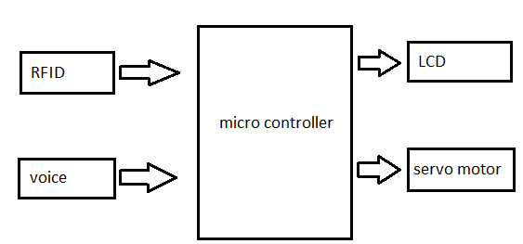

**MATERIAL REQUIRED:**

In case you weren't aware, the EM-18 reader is one of the most popular modules for RFID projects. The RS232 port on a PC or microcontroller may be used to establish a direct connection. The UART and Wiegand26 output formats are supported, and the module is compatible with 125KHz RFID tags.

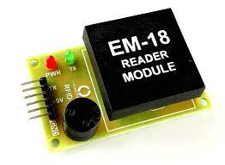

**LCD:**

There are both 8-bit and 4-bit LCD options, with the difference coming down to the number of lines needed to connect to the microcontroller. At the "initialization" stage of the procedure, the best mode is selected. As was previously mentioned, in the first scenario, data are sent through outputs D0-D7. In 4-bit LED mode, only the upper bits (D4-D7) are utilized for communication, freeing up additional I/O pins on the microcontroller for other purposes.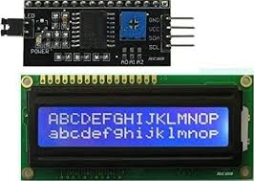

The result is that all data is delivered to the LCD in two stages: the upper four bits (which would typically be supplied over lines D4-D7) are sent first, followed by the bottom four bits. Initialization ensures that the LCD establishes a proper connection and appropriately interprets all incoming data. Moreover, as data are seldom read from LCD (data are mostly sent from microcontroller to LCD), an additional I/O pin may be spared by simply connecting R/W pin to the Ground. Spending less comes at a cost. It will still be able to show messages normally, but as it will be impossible to read from the display, the busy flag cannot be read.

**Servo Motor:**

A servo motor is an electric motor with precise rotational control, used for example, in a robotic arm.

A servo motor is a DC motor equipped with a negative feedback system that can detect and correct for errors. In this way, the motor's angular velocity and location may be precisely controlled. It is sometimes necessary to employ alternating current (AC) motors.

In a closed-loop system, the shaft's motion and end position are controlled by negative feedback.

Unlike regular AC/DC motors, it's not utilized for continuous spinning.

There's a full 360 degrees of rotational freedom.

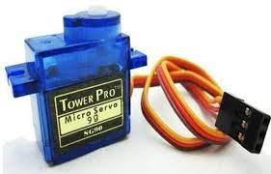

**RESULT:**

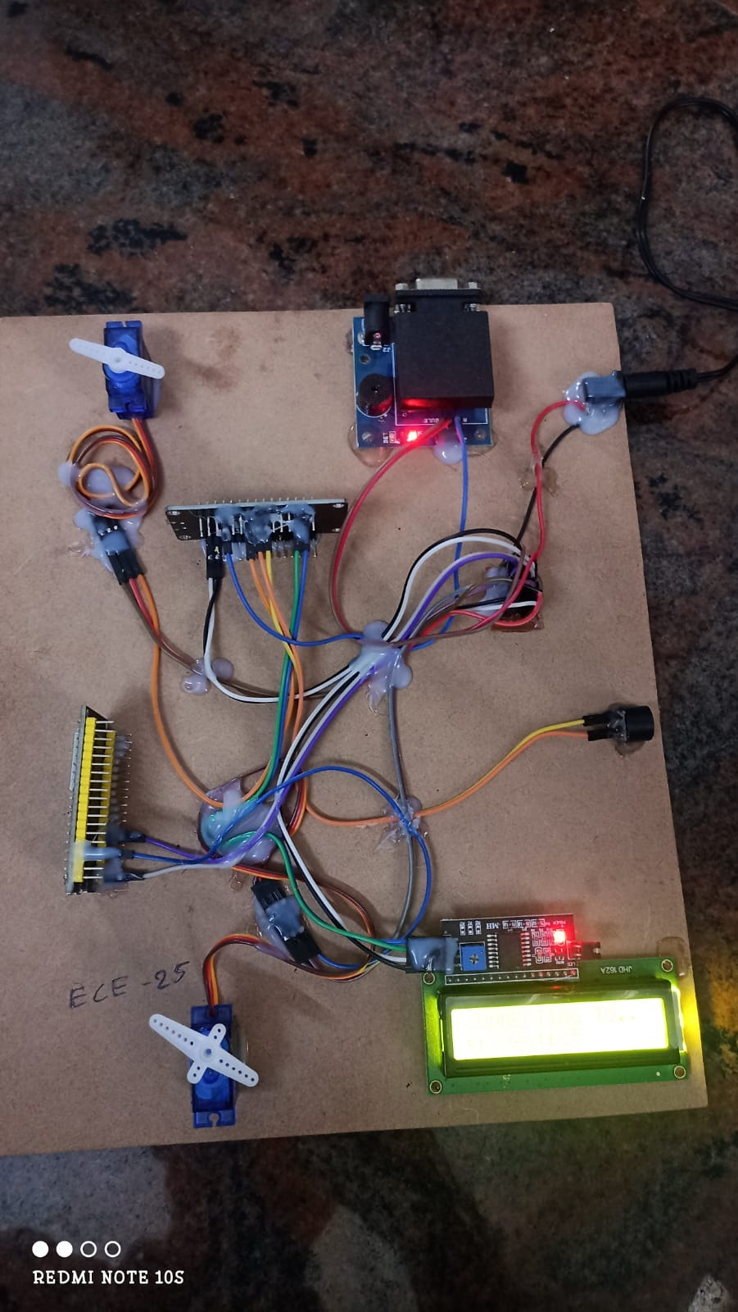

**CONCLUSION:**

Using Arduino, passive RFID, and speech, this article develops a safe for a bank's lockers. It's a low-cost, low-power, small-footprint, completely independent system. The microcontroller evaluates the keypad input and the one-time-password (OTP) received from the mobile device. The bank safe deposit box will unlock if both passwords are accurate, and the microcontroller will send the appropriate control signal. If an incorrect password is entered, a buzzer will sound. A biometric system for individual identification will form the basis of this paper's proposed future work on security systems.

**REFERENCE:**

[1]. Parvathy A, Venkata Rohit Raj, Venumadhav, Manikanta, “RFID Based Exam Hall Maintenance System’’, IJCA Special Issue on “Artificial Intelligence Techniques-Novel Approaches& Practical Applications” AIT, 2011.

[2]. Gyanendra K Verma, Pawan Tripathi, “A Digital Security System with Door Lock System Using RFID Technology”, International Journal of Computer Applications (IJCA) (0975 – 8887), Volume 5– No.11, August 2010.

[3]. Kumar Chaturvedula .U.P, “RFID Based Embedded System for Vehicle Tracking and Prevention of Road Accidents”, International Journal of Engineering Research & Technology (IJERT) , Vol. 1 Issue 6, August – 2012, ISSN: 2278-0181.

[4]. Islam, N.S. Wasi-ur-Rahman, M. “An intelligent SMS-based remote Water Metering System”. 12th International Conference on Computers and Information Technology, 2009, 21-23 Dec. 2009, Dhaka, Bangladesh.

[5]. Mohd Helmy Abd Wahab, Siti Zarina MohdMuji, Fazliza Md. Nazir. “Integrated Billing System through GSM Network”. In Proceeding of 3rd International Conference on Robotics, Vision, Information and Signal Processing 2007 (ROVISP2007), Penang, 28 – 30 November 2007.

[6]. Malik Sikandar Hayat Khiyal, Aihab Khan, and ErumShehzadi. “ SMS Based Wireless Home Appliance Control System (HACS) for Automating Appliances and Security”, Issues in Informing Science and Information Technology. Vol. 9. pp. 887 – 894. 2009.

[7]. Al-Ali, A.R. Rousan, M.A. Mohandes, M. “GSM-Based Wireless Home Appliances Monitoring & Control System”, Proceedings of International Conference on Information and Communication Technologies: From Theory to Applications, pp 237-238, 2004.

[8]. Ahmad A.W., Jan N., Iqbal S. and Lee C., “Implementation of ZigBee-GSM based home security monitoring and remote control system”, IEEE 54th International Midwest Symposium on Circuits and Systems (MWSCAS), 2011, pp. 1-4.

[9]. Pravada P. Wankhade1 and Prof. S.O. Dahad2, “Real Time Vehicle Locking and Tracking System using GSM and GPS TechnologyAn Anti-theft System”, International Journal of Technology And Engineering System (IJTES):Jan –March 2011- Vol.2.No.3.