**IN-CAMPUS INDOOR NAVIGATION SYSTEM**

Prof. Bhagyashree Dharaskar Satyendra Dhamgaye

Computer Science and Engineering Computer Science and engineering Nagpur, Maharashtra Nagpur, Maharashtra

bhagyashreedharaskar@gmail.com satyendradhamgaye2@gmail.com

Mo Aifaz Sheikh Rahul Gakhare Computer Science and Engineering Computer Science and Engineering Nagpur, Maharashtra Nagpur, Maharashtra aifazsheikh101@gmail.com rahulgakhare2805@gmail.com

Samiksha Sawarkar Ayushi Talewar

Computer Science and Engineering Computer Science and Engineering Nagpur, Maharashtra Nagpur, Maharashtra samikshasawarkar01@gmail.com ayushitalewar10@gmail.com

**ABSTRACT**

At some point in their life, everyone has probably gotten lost in an auditorium, had trouble finding an exit at an airport, or maybe they got there late because they didn't find suitable lecture hall in a university. But this way of getting lost in complexes and large halls could soon be a thing of the past. Today, indoor navigation apps for mobile devices are common and people need to find their destination inside tall buildings. Most indoor navigation apps use different technologies such as Wi-Fi fingerprints and Bluetooth beacons. These applications use pre-computed paths and fixed background maps to guide users to their destinations. Users of these systems need to understand how specific interior cards and card reading signals work in general. Additionally, these systems require complex and precise calculations to determine a route before navigating begins, which can be affected by spotty Wi-Fi signals. Discover Indoor Maps, the new generation of indoor navigation. In this article, we offer an indoor map that expands to 3D capabilities using augmented reality, with an increasing focus on commerce and general orientation. Indoor navigation systems integrating augmented reality allow users to locate locations in buildings and gain more knowledge about their surroundings. Although different efforts with different technologies, infrastructures and capabilities have been introduced, the procedures used to specify these systems have not yet been standardized. Additionally, while systems generally manage location contextual information in a proprietary format, a platform-independent model is desirable, which would encourage its access, updating, and management. This article proposes an approach for the development of an indoor navigation system based on the integration of augmented reality and semantic web technologies to present navigation instructions and contextual information about the environment. It consists of four modules: Defining Spatial Models, Data Management (Ontology Supported), Location and Navigation, and Content Visualization.

1. **INTRODUCTION**

Indoor Navigation is all about providing flexible guidance to people in chaotic and unfamiliar buildings in universities and resorts. Navigation systems help users easily enter unfamiliar surroundings. The term "navigation" collectively includes the tasks of locating a user's location, planning a feasible route, and guiding the user along the route to a desired destination. Our system will provide smooth localized navigation in large institutions using our navigation system. Indoor navigation is a revolutionary concept that visualizes indoor sites and spatial data on 2D or 3D digital maps.  
This allows us to walk around universities, large shopping malls, hospitals, auditoriums, etc. navigation. In terms of complexity, indoor navigation is very different from outdoor navigation. In our indoor navigation, the technology is rather complex as it consists of 3 modules which should be categorized as site mapping, database population and user interface design. Augmented Reality (AR) leverages dynamic and accurate 3D maps for real-world experiences. Displaying people, assets and places on a digital map enables solutions such as indoor navigation and indoor positioning.  
Indoor navigation apps for mobile devices are common and people need to find a destination inside a tall building. These applications use pre-computed paths and fixed background maps to guide users to their destinations. Users of these systems need to understand how specific interior cards and card reading signals work in general. Additionally, these systems require complex and precise calculations to determine a route before navigating begins, which can be affected by spotty Wi-Fi signals. Discover Indoor Maps, the new generation of indoor navigation.  
In this article, we offer an indoor map that expands to 3D capabilities using augmented reality, with an increasing focus on commerce and general orientation. Indoor navigation systems integrating augmented reality allow users to locate locations in buildings and gain more knowledge about their surroundings. Although different efforts with different technologies, infrastructures and capabilities have been introduced, the procedures used to specify these systems have not yet been standardized. Additionally, while systems generally manage location contextual information in a proprietary format, a platform-independent model is desirable, which would encourage its access, updating, and management. This article proposes an approach for the development of an indoor navigation system based on the integration of augmented reality and semantic web technologies to present navigation instructions and contextual information about the environment.  
It is an indoor navigation app that can use augmented reality without any restrictions. The first step in the development of this application is to build a 3D model of the building and its interior where we will deploy this application. We use cellular tools to develop 3D models of buildings. The system needs to know the user's location and it needs to be mapped to a 3D model of the building. A unit that allows the device to detect horizontal and vertical surfaces and planes.  
It also includes motion detection, allowing phones to understand and track their position relative to the world. As AR Core continues to improve and expand, it will add more contextual and semantic understanding of people, places, and things. Unity is a free and open-source 3D computer graphics software tool used to create animated films, visual effects, art, 3D printed models, motion graphics, interactive 3D applications, virtual reality and computer games. Unity will naturally import DCC (Digital Content Creation), fbx and obj files. To achieve this, we will install QR codes in all possible destinations in the building, assuming that any destination can be used as a starting point for the user.  
Each QR code is linked to a specific graph node, but not all nodes contain a QR code. Using QR codes, the navigation map can identify the user's location and place 3D objects on the smartphone screen. 3D objects are represented by arrows defining the direction to the next point. Once the user scans a QR code, the system will know their current location and prompt them to choose a destination. After the user selects a destination, the user's camera is activated.  
Google AR Core performs both location and mapping by getting real-time information from the user's camera, which means comparing the real-time information from the camera with the 3D model of the building to get the location exact from the user. As the user moves through the building, their location is updated very seamlessly, like GPS. Depending on the selected path, the AR (augmented reality) arrows point to the next node on the path. So the user knows exactly where to turn right or left. When the system knows the user's location, it uses the A* shortest path search algorithm to find the shortest path to the selected destination.  
The A* algorithm is faster, more efficient and more reliable than Dijkstra's algorithm. After the system finds the way to the destination, it places a virtual 3D arrow object on the user's camera screen to help the user reach the destination by the shortest path. The shortest path is continually updated as the user's location is updated.

**2. Literature Review**

Research on indoor positioning systems/indoor navigation is comprehensive and diverse. This is a subject that has been studied over the years using various techniques. Therefore, the objective of the following study is to identify different methods that can be used to determine inland navigation. The time people of all age groups spend on cell phones has increased dramatically every year, reducing the use of other media. Smartphone ownership and fast internet connections such as home broadband, 3G, 4G and 5G are increasing dramatically.  
According to multiple statistics conducted by several research centers, 92% of users are between 18 and 29 years old, 74% are between 50 and 64 years old, and 42% of smartphone users are 65 and older. This has led to the use of mobile applications. According to analytics, users spend 5 hours on their smartphones, 90% of which is spent on various apps. The purpose of this report is to identify the need for inland navigation and the different technologies and devices that can be used to achieve it. Additionally, a user survey was conducted to shed light on the usage habits of users in their daily life for the positioning system.  
Data collection raises many questions about how data will be integrated and identifies the need to verify program content. The objective of the research is to find out how to develop the desired applications or functions, and which functions are of most interest to users. It mainly focuses on indoor navigation and the applications created for it. Different technologies like GPS, AR, ie.  
Augmented reality must be replaced by other solutions to create indoor navigation. More detailed measurements such as infrared, ultrasound, radio signals, etc. The study evaluates various positioning technologies. Traditional positioning technologies such as GPS fail when a user moves from an outdoor location to an indoor location. This is due to signal attenuation that occurs when the GPS signal encounters obstacles such as construction walls.  
To overcome this problem, this article mentions different positioning techniques with different ideologies.  
In recent years, several reviews of as-built modeling from point clouds have been published (Volk, Stengel and Schultmann et al., 2014) (Patraucean, Armeni, Nahangi, Yeung, Brilakis and Haas et para.  
2015) (Liu and Zlatanova et al., 2013). Most of the work has focused on the efficient reconstruction of structural elements of the building (Oesau, Lafarge and Alliez et al.  
2014) (Mura, Mattausch and Pajarola et al., 2016) (Tran, H.; Khoshelham, Kealy and Díaz-Vilariño et al., 2019) and openings while correctly modeling floor elements, free space modeling and taking into account Given the importance of barriers to inner orientation, barrier modeling has received less attention.  
Several recent works have addressed the complete simulation of floor assemblies. In indoor conditions, point clouds and handheld laser scanner trajectories were combined to segment and identify stairs, staircases and floors in plan (Staats, Diakité, Voûte & Zlatanova et al., 2017) (Balado, Vilariño, Arias and Gonzalez -Jorge et al.  
2018). The process begins with a projection into a point cloud discretized into a voxel-based model and a region ascent followed by a projection into a point cloud discretized into a voxel-based model. Outdoors, the orientation of the trajectory has been used to identify road segments and thus define the soil composition in curbs, sidewalks, ramps and stairs based on geometric and topological characteristics (Balado, Vilariño , Arias and Soilan et al., 2017) (Vilariño, Verbree , Zlatanova and Diakité et al.  
Already 2017).  
Optical and vision-based location systems use motion sensors or cameras in a user's mobile device to assess the location of a person or object within a building by detecting markers or images in the building (Mautz & Tilch, 2011); Klopschitz, Schall, Schmalstieg and Reitmayr, 2010). A marker is a static object with a marker that can be used as a reference in the field of view of an image sensor (e.g., cell phone camera) (Mautz, 2012).

**3. ANALYSIS AND DESIGN**

**3.1 Needs analysis:**  
**Hardware requirements:**  
Any smart device with a camera. The requirement of the camera is to locate the user's current location and provide real-time navigation through the camera.  
 **Software requirements:**  
1. Android operating system  
2.Unity Software  
3. Windows 7 (+)  
4. 2 GB RAM  
5. Graphics API  
**3.2 Technical and software details:**  
**Unity:** Unity provides a workspace that combines artistfriendly tools with a design based on the components. fairly intuitive game development.  
Both 2D and 3D development can take place in Unity, with 2D physics being handled by the popular Box2D engine. Unity uses a component

based approach to game development around prefabs. Prefabs allow game designers to create objects and environments more efficiently and scale faster. Google AR Core is a plugin that unifies AR functionality. In order to provide augmented reality, our devices must understand it.  
AR Core provides several tools for understanding objects in the real world. These tools include context recognition, which allows the device to detect horizontal and vertical surfaces and planes. It also includes motion tracking, allowing phones to understand and track their position relative to the world. As AR Core continues to improve and expand, it will add more contextual and semantic understanding of people, places, and things. Blender is a free and open-source 3D computer graphics software tool used to create animated films, visual effects, art, 3D printed models, motion graphics, interactive 3D applications, virtual reality and computer games.

**4. ANALYSIS AND DESIGN**  
**4.1 Design and Work Proposal:**  Indoor Navigation Systems shall be able to display their location on a map on their own smart devices. Users should be able to choose their preferred destination on their device. Their devices must be able to direct users where they want.  
The software should use the camera and 3D animations to guide the user. They should be a minimap for better understanding by the user.  
Users of indoor navigation systems display their location on a map on their smart device. After selecting a destination or point of interest. The route to the selected destination is displayed on the map.

**BLOCK DIAGRAM:**

App Launched

User starts from Starting Point

User must scan QR code to get current location at starting point

False

User can start navigation by selecting any of the destination

User can change destination Midway

User Reaches the Destination

Permission

True

**5. METHODOLOGY:** The proposed indoor navigation system consists of three main components: a mobile application and a database. The mobile application is used by users to access the navigation system. The server processes the user's requests and provides real-time navigation guidance to the user. The database stores the 3D maps, the user's location data, and other relevant information.

The mobile application is developed using UNITY software and runs on Android and devices. The application uses the device's camera to capture the user's surroundings to track the user's movement. When users launch our application, there is a six-button interface to help them navigate the application properly. The first is the "show line options" interface, which helps the user navigate through the line or arrow. The second one is "Show Debug Option," which helps scan QR codes for the particular location you want to reach. The third one is "Show Floor Options," where the user needs to select the floor for where he actually wants to go. After selecting the floors, select the room number for the destination you want to reach. Another one is the "Switch Navigation Visualization" button, which helps users change their navigation line or arrow.

The server uses the user's location data to determine the best route for the user to take. The server also communicates with the database to retrieve the 3D maps and other relevant information. The server sends real-time navigation guidance to the user's mobile application, which is displayed on the device's screen using augmented reality.

**6.RESULT**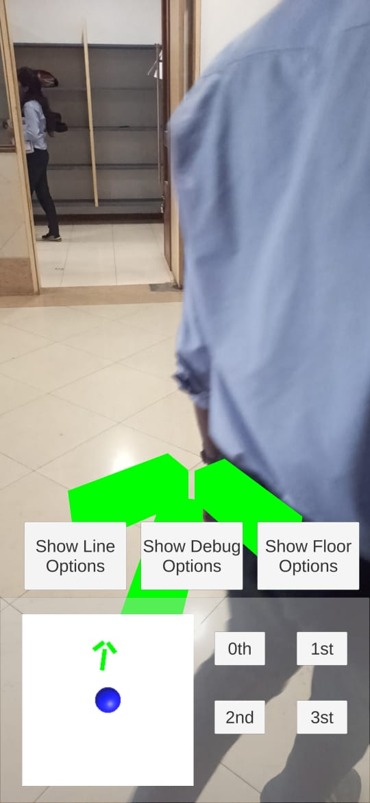

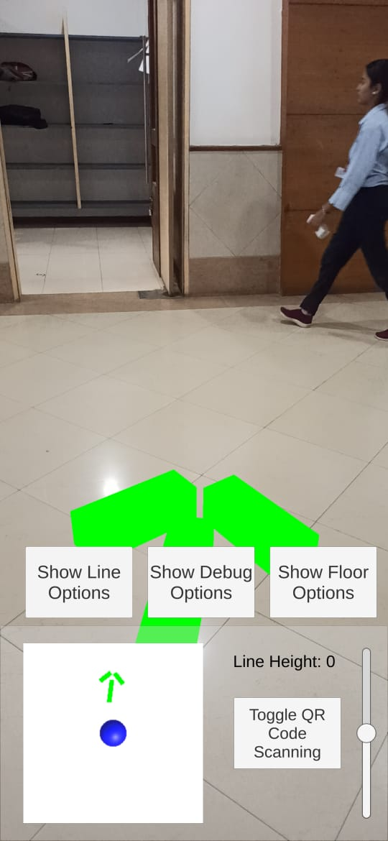

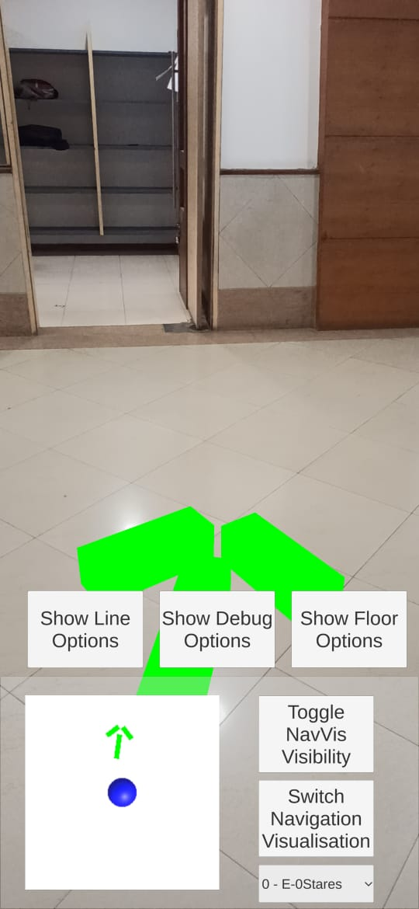

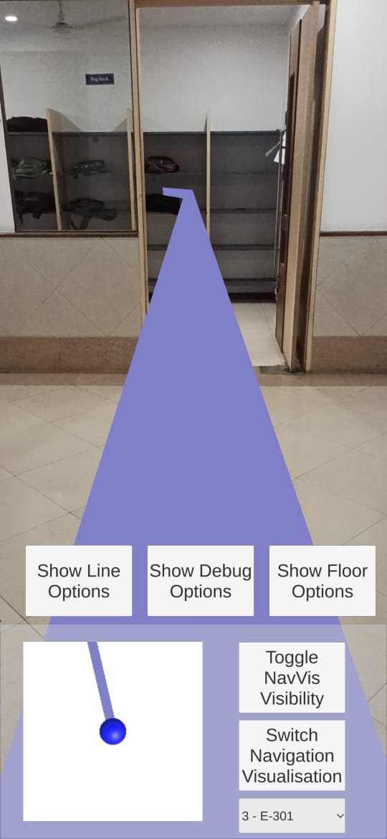

**7.CONCLUSION**

Users of indoor navigation systems can view their location on a map on their smart device. After selecting a destination or point of interest, the route to the selected destination is displayed on the map. This tool is invaluable for newcomers and guests as they can find their destination room faster and easier. Some people may find it an added benefit not to have to ask a stranger for help if they get lost in a new building. Navigation instructions are displayed on the camera view.

**8.REFERENCES**

**1.** Mulloni, A.; Wagner, D.; Barakonyi, I.; Schmalstieg, D. Indoor positioning and navigation with camera phones. *IEEE Pervasive Comput.* **2009**, *8*, 22–31

**2.** Huey, L.C.; Sebastian, P.; Drieberg, M. Augmented reality based indoor positioning navigation tool. In Proceedings of the IEEE Conference on Open Systems, Langkawi, Malaysia, 25–28 September **2011**; pp. 256–260.

**3.** Mehdi Mekni and Andre Lemieux,” Augmented reality: Applications challenges and future trends”, Applied Computational Science— Proceedings of the 13th International Conference on Applied Computer and Applied Computational Science (ACACOS ‘14), pp. 205- 209, **2014.**

**4.** Basiri, A.; Lohan, E.S.; Moore, T.; Winstanley, A.; Peltola, P.; Hill, C.; Amirian, P.; Figueiredo e Silva, P. Indoor Location Based Services Challenges, Requirements and Usability of Current Solutions. *Comput. Sci. Rev.* **2017**, *24*, 1–12.

**5.** Li, K.-J.; Zlatanova, S.; Torres-Sospedra, J.; Perez-Navarro, A.; Laoudias, C.; Moreira, A. Survey on Indoor Map Standards and Formats. In Proceedings of the 2019 International Conference on Indoor Positioning and Indoor Navigation (IPIN), Pisa, Italy, 30 September–3 October **2019**; pp. 1–8