Desire for mobile banking!!

**Dhanush M**

Research assistant, school of commerce

Jain (deemed-to-be university), Bengaluru

[dhanushmurthy.22@gmail.com](mailto:Dhanushmurthy.22@gmail.com)

**Ravikiran N A**

Research assistant, school of commerce

Jain (deemed-to-be university), Bengaluru

[naravukiran5@gmail.com](mailto:Naravukiran5@gmail.com)

**Dr. Ck Suresh**

Professor, school of commerce

Jain (deemed-to-be university), Bengaluru

[cksuresh.jgi53@gmail.com](mailto:Cksuresh.jgi53@gmail.com)

**Abstract**

Mobile banking is the application provided by the bank for the account holders of their respective banks to do financial transaction from there account. The mobile banking helps the account holders to see account balance, transfer money, download statements, and other services. The paper is aimed to see the users of mobile banking application provided by the bank for account holders and the transactions done through the mobile banking application. The data was collected through a set of questions and a secondary data is also collected. The pie chart shows the data of number of mobile banking users, age, and their banking application. And, the bar graph shows the transaction of imps, rtgs and neft done through mobile banking application. The users of mobile banking are desired to use the mobile banking application because of its convenience, flexibility, and accessibility to the customers of the bank. The mobile banking has seen growth in recent due to easy access to internet in india.

**Introduction**

Mobile banking in india with the white spread adoption of smartphones and tablets, more and more people are using their mobile devices to access banking services. The trend towards mobile banking in india has been growing rapidly due to the increasing penetration of mobile devices and the growing need for convenient, secure, and accessible banking services.

In india, mobile banking services are offered by most major banks and financial organizations and include services such as account balance checking, bill payment, money transfers, recharges, and other financial transactions.

One of the major pros of mobile banking in india is its ease and openness, allowing customers to perform banking transactions from anywhere and at any time, without having to visit a bank branch. It also offers customers a reliable and convenient platform to manage their assets and make transactions and reduces the need for cash transactions, thereby reducing the risk of theft and fraud.

However, there are also capacity risks connected with mobile banking in india, such risk of mobile banking malware, phishing attacks, and unapproved access to delicate financial information. Address these risks, most mobile banking providers in india have executed strict security measures, such as two-factor verification and secure data security, to ensure the welfare and privacy of customer data and transactions.

Overall, mobile banking has revolutionized the way people access and manage their finances in india, providing convenience, security, and accessibility to millions of customers.

**Review of literature**

The scholar Agarwal, Poddar & Karnavat (2020), did a detail investigation on “India’s growth in mobile banking during covid-19”. The research goal was to analyse how covid-19 affected mobile banking services, comprehend the transition from traditional to e-banking during coronavirus, and investigate how e-banking will support social segregation policies. To analyse the literature and comprehend the theoretical underpinnings of e-banking in india, one and the other before coronavirus and during covid, alternate data was gathered over internet material on livemint, economic times and various other publications and journals. They discovered that mobile banking has been highly beneficial in periods like covid because it was useful in supporting the social disengagement ethics and offering their consumers access to financial services around-the-clock. Succeeding demonetization, covid is the further factor that has accelerated the transition of banking consumers to digital platforms and from January 2020 to April 2020, there was a 4% increase in the number of persons using online payment platforms. Mobile wallets like Paytm have seen a bigger piece of action in the value of transactions in mobile banking apps like google pay, icici mobile, sbi yono, and others.

Chawla & Joshi (2018) conducted research on the moderating impact of demographic factors on adaptation of mobile banking. The objective of the case is to determine how different antecedents to mobile banking affect attitudes towards it as well as to evaluate the moderating power of various demographic factors between those antecedents and attitudes towards adoption. Fisher z transformation and multiple linear regression are two methods used to test the moderating impact. They discovered that by expanding the diffusion of innovations (doi) theory and the technology acceptance model (tam), the paper provides the insights to the elements impacting consumers' stance towards adopting mobile banking utilization. Additionally, moderating impact help to understand how demographic disparities affect how widely mobile banking is used.

The researcher Hassan et al. (2021), conducted a study on the utilisation of mobile technology in emerging markets and the motive to use mobile banking in india. The study’s goal was to address the gap and conceive a model that can be understood as a crucial mediator to deal with the consumers' desire to use mobile banking. Purposive sampling was used in the review, which was directed in northern part in india. Of the 584 respondents chosen, 403 provided functional responses and the answers were examined using structural equation modelling (sem). The outcome showed, while two aspects have negative impact, seven dimensions has impact on handlers' expectations to recognise mobile banking.

The scholar d’ Souza (2018), analysed mobile banking as a tool for financial inclusion in india in a study. In order to shed light on the numerous reasons that have fuelled the application of mobile banking as well as those that get acted as barriers to such work, the study analyses India’s performance in this area. She suggests a strategy centred on the digitalization of the natural economy because of ussd-based mobile banking.

Chawla & Joshi (2021) conducted research on grouping clients of mobile banking facilities based on the way they use those services. The study's objectives are to categorise mobile banking users into groups according to whether they use mobile funding facilities or not, to outline these groups according to demographic factors, to see if there is an affiliation among the groups and the acknowledged outlines, and to determine there are differences among the groups in relationships of the features that led to the approval of mobile banking. The technology acceptance model (tam) is integrated in this study to create an intangible model for debating customer attitudes along with intentions about mobile banking services. A survey was given to a sample of 367 respondents. For segmentation, the graded gathering technique was applied. Three groups, labelled functional user, conventional supporter, and slowpoke, were discovered. According to the findings, there is a statistically considerable variation across clusters in terms of different antecedents to mobile banking, including attitude and intention.

The researcher Kumar et al. (2020), carried out a study on India’s usage of mobile banking. The study examines the significant precursors of Indian customers' intent to agree to mobile banking. By increasing the conventional machinery recognition paradigm, comprehensive framework is created (tam). Group of four customer-positioned paradigms have also been evaluated for this intention in addition, two tam-provided constructs. The conceptual model has undergone empirical validation, including data collected from 203 potential customers of mobile banking services. For the purpose of determining the authority of the antecedents on the plan to embrace mobile banking, the fundamental equation modelling system has remained utilized. Findings show that, in addition to the tam constructs of perceived utility in addition alleged easiness of practice, as healthy as all additional pertinent behavioural reasons, including personal standards, individual innovativeness, personality-usefulness, has statistically momentous constructive impact upon customers' intentions to adopt mobile banking.

Chawla & Joshi (2019) conducted research on the scale improvement and authentication for measuring the implementation of mobile banking service sector. The purpose of the study was to acquire along with authenticate a scale designed for evaluating adoption of mobile banking in india. Through a review of the literature, focus group talks, and some individual interviews, an exploratory study was carried out. Seven components emerged through exploratory factor analysis (efa), which was used to analyse the data. By including tr, con, and eff as pertinent elements, the study enhances the technological acceptance model (tam). The scale emphasises both socio-technical components and incorporates ls into the already-existing factors. They suggest that banks can use the scale to gauge how customers feel about their mobile banking service and determine m-banking service development potential and gap areas.

Sankaran & Chakraborty (2021) conducted an analysis upon the determinants affecting mobile banking in india. Ambition of this research is to examine the variables influencing Indian customers' advantage of mobile banking. The exploration use the extended utaut2, which incorporates moderating effects of gender along with social value (sv), monetary value (mv), emotional value (ev), quality value (qv), and trust. 457 Indian consumers who utilised m-banking provided the primary data, which was gathered using online and offline survey methods. The conceptual model was experimentally validated using spss Amos, which was also used to assess the study hypothesis and the moderating impact. Routine expectation and public value were not shown to be major, but behavioural intent (bi) was found to be significantly influenced by the factors. Using these motivating elements to use m-banking and other associated financial services, banking businesses can create strategies to draw in new customers and keep existing ones (mfs).

**Objective**

* To know the age of users and their banking application.
* To know the transactions made through mobile banking application of imps, rtgs & neft

**Methodology**

**Sample**

a series of questionnaires was created online to collect the sample. The statistics collected from a survey of 60 people has been taken. The responses consist of 61.7% men and 38.3% women. Further, the respondents are below the age of 30 years and above 18 years. The questionnaire was distributed to people using mobile banking, and we asked them to distribute it further to help with the survey.

The paper consists of secondary data collected from various sources like newspapers, the internet, journals, etc. The data is used to discover the transactions made through mobile banking in india.

**Findings and results of the study**

The findings are the first objective of the research paper which shows the age, gender, are they using mobile banking application, the application of banking which they use to do mobile banking and for how many years they are using the mobile banking application are the topic which is selected from a series of questionnaire prepared to do a survey on mobile banking is healthier or conventional banking is healthier.

the primary data collected from the 60 respondents are interpreted and, in the diagram, given below according to the questions asked to the respondents.

**figure 1**

the figure 1 shows the gender of the male and female mobile banking users. The data shows 61.7% male and 38.3% female users. The male users are 23.4% more than the female users from the 60 respondents survey.

figure 2

The figure 2 shows the age of the 60 respondents who use the mobile banking application. The age of 25 has more users than the age of the youngster below the age of 21 and age 22 has the second highest users of mobile banking product users.

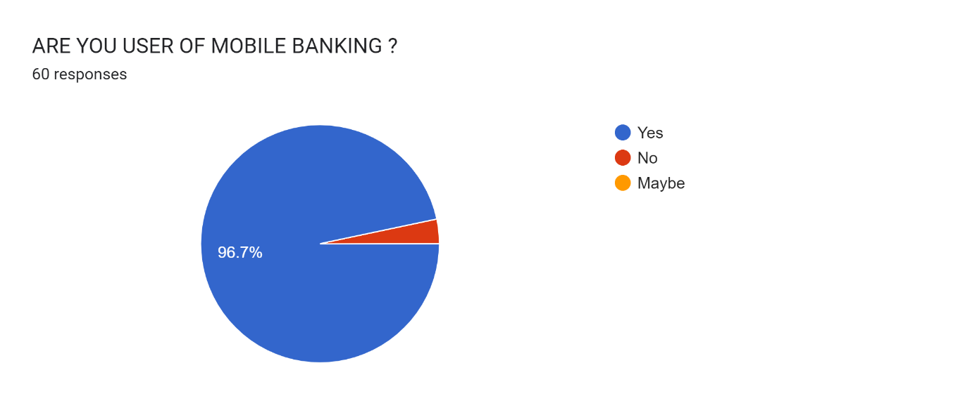the figure 3 show the number of clients of mobile banking applications a total to 96.7% are users and 3.3% is not users of mobile banking application.

Figure 3

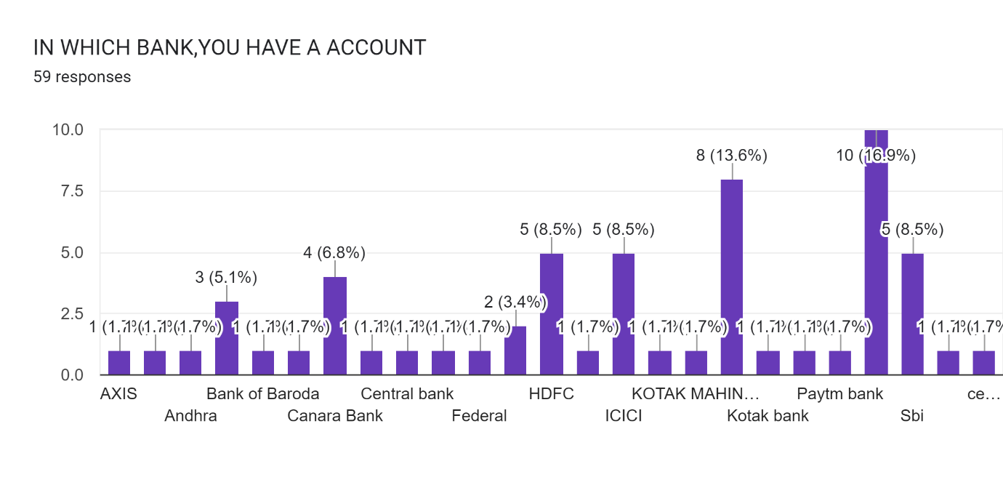

Figure 4

The data collected from the 60 respondents are the bank account they use for day-to-day transactions from mobile banking applications. The greater number of users of the mobile banking application sbi (state bank of india) a total of 15 people use the sbi mobile banking application followed by Karnataka bank (8 respondents) and hdfc& icici (5 respondents each). The table shows the list of banks used for mobile banking.

figure 5

The figure 5 shows the number of years they have used the mobile banking application the most they have used is for a period of 4 years and the least is 1 year according to the survey answers provided by the respondents.

The additional purpose of the research document is to know, transaction made through mobile banking application. The data is based on the secondary data for the second object of the paper where it shows the transaction of imps, neft and rtgs.

The transaction value is shown in a graphical representation. Where, it shows the total value of the amount transacted for a period of a year. The data shows the transaction value from 2013-2022 the value is in billions.

Figure 6

The figure 6 shows the data of instant fund transfer (imps). The imps is the main transfer facility used by customers to do a quick transfer of funds. The about chat shows the data of a particular year’s transaction amount till the present year 2022. The imps transaction is increasing because the mount can be transferred to others instantly without any charges. So, there is a big jump in imps transaction from year to year.

Figure 7

The national electronic fund transfer (neft) is a type of fund transfer used for making payments to credit card, loan repayments etc., the transactions are settled immediately from transferring the amount. The neft chart shows there is an increase in transaction till 2021, it increased due to pandemic, but it is registering less transactions from customers in the year 2022 due to increase in upi payments.

Figure 8

The real time gross settlement is a type of fund transfer a minimum of rs.200000 to maximum amount from one account another the mobile banking has made it easy by implementing this function in mobile banking application. The transaction happened through rtgs is as shown in figure 8. The transactions have increased constantly till 2019. But after 2019 there is a fluctuation till 2022 the transaction made through rtgs has been decreased in the present year 2022.

**Conclusion**

In conclusion, mobile banking has modernized the traditional banking system by offering convenience, accessibility, and protection to users. It has allowed users to perform various financial transactions from their smartphones, reducing the need for physical visits to banks. From the data we can see that there are users of mobile banking users who want to use mobile banking application than go to bank. The people of india wish to use mobile banking over conventional banking due to easy access to account information, transfer of money and internet. The mobile banking also has its share of flaws in the application.

**References**

* Kumar, Ashish, et al. "a framework of mobile banking adoption in india." *journal of open innovation: technology, market, and complexity* 6.2 (2020): 40.
* Agarwal, varsha, Shresth Poddar, and Sahil j. Karnavat. "a study on growth of mobile banking in india during covid-19." *palarch's journal of archaeology of Egypt/Egyptology* 17.6 (2020): 9461-9485.
* Chawla, Deepak, and Himanshu Joshi. "the moderating effect of demographic variables on mobile banking adoption: an empirical investigation." *global business review* 19.3_suppl (2018): s90-s113.
* Chawla, Deepak, and Himanshu Joshi. "segmenting mobile banking users based on the usage of mobile banking services." *global business review* 22.3 (2021): 689-704.
* Sankaran, raja, and shibashish Chakraborty. "factors impacting mobile banking in india: empirical approach extending utaut2 with perceived value and trust." *iim Kozhikode society & management review* 11.1 (2021): 7-24.
* Chawla, Deepak, and Himanshu Joshi. "scale development and validation for measuring the adoption of mobile banking services." *global business review* 20.2 (2019): 434-457
* D’Souza, Renita. "examining mobile banking as a tool for financial inclusion in india." *orf issue brief* 265.5 (2018).
* Hassan, Junaid, et al. "emerging market & mobile technology usage: evaluating intention to use mobile banking in india." *Aarif and Bashir, Ishfaq, emerging market & mobile technology usage: evaluating intention to use mobile banking in india (February 8, 2021)* (2021).
* <https://factly.in/data-average-transaction-value-of-neft-rtgs-fell-significantly-in-the-last-five-years/>