“Message Moving Display On Led Panel Using Bluetooth Technology”

**Author name: Radhika Bundele**

Student, Department of Computer Science Thakur Shivkumar Singh Memorial Engineering College, Burhanpur, Madhya Pradesh, India

E-mail: [radhikabundeletsec@gmail.com](mailto:radhikabundeletsec@gmail.com)

**Author name: Tanushri Sisodiya**

Student, Department of Computer Science Thakur Shivkumar Singh Memorial Engineering College, Burhanpur, Madhya Pradesh, India

E-mail: [tanushrikushawah1432@gmail.com](mailto:tanushrikushawah1432@gmail.com)

**Author name: Ashika Tayde**

Student, Department of Computer Science Thakur Shivkumar Singh Memorial Engineering College, Burhanpur, Madhya Pradesh, India

E-mail: [ashika.tayde2001@gmail.com](mailto:ashika.tayde2001@gmail.com)

**Guide name: Prof. Raviraj Singh Savner**

Assistant professor, Department of Computer Science Thakur Shivkumar Singh Memorial Engineering College, Burhanpur, Madhya Pradesh, India

E-mail: [ravi.sawner@gmail.com](mailto:ravi.sawner@gmail.com)

# ABSTRACT

The information sharing aspect of information technology is playing a prominent role in all kinds of business either its non-profit organization or profit organization. Now a day’s, all types of business require and adopts the facility of advertisement to promote their services and products. Digital advertisement is the current requirement of the modern businesses sand information world. Scrolling led dot matrix displays are used at international airports, stock exchanges, metro railway stations, shopping complex, bus stations etc. led display is an effective mode on displaying information but the complicated task is to make the message dynamic as the users have to change the massage content according to this specific requirement. When the message content changes, the user needs to connect the LED display to the computer, so there is nowhere to place the display board due to the dedicated and complicated circuit diagram. The wireless dot matrix display provides a wireless connection between the user's mobile phone and the LED display. It provides the ability to view messages in real-time, which means the user can change the content of the message to be viewed. The mobile phone is used to send the message to the LED display and the microcontroller performs all the activities associated with displaying the message content on the LED display in scroll mode.

The goal of the project is to develop a wireless scrolling bulletin board that allows the user to change the content of messages without having to connect the bulletin board to a computer or laptop with a cable. The user can update the message content via Bluetooth.

**INTRODUCTION**

# This project is based on the idea of ​​designing an LED display system for wireless communication between a mobile phone and an LED screen. In this case, wireless communication takes place via Bluetooth. Every mobile phone is now equipped with Bluetooth capabilities. Mobile phone users can send a message to the display to blink or display the message content as a scroll. The Bluetooth module is used to receive messages in the circuit. The content of the message sent by the user is stored in the microcontroller. The dot matrix LED display is 8*8 matrix, and the distance between rows or pins is 10mm. The programmed microcontroller is used to provide a standard format of a character set containing characters and alphabets with the ability to generate and display punctuation marks, numbers, special characters, and simple graphics.

# Each character is displayed in a pattern based on hexadecimal values ​​stored in the microcontroller called a lookup table or lookup table. The microcontroller finds or compares a pattern and sends data bits and a clock signal serially. Shift registers are used to shift Dada between pins connected to each diode. The persistence of vision is the basis for a quick analysis of the data set in rows and columns, which shows the pattern due to the persistence of vision.

**The system requires the following hardware components:**

# • LED dot matrix display

# • HC-05 Bluetooth module

# • power adapter (5V)

# • Microcontroller

**EXPLANATION**

* **Original Circuit Of The Project**

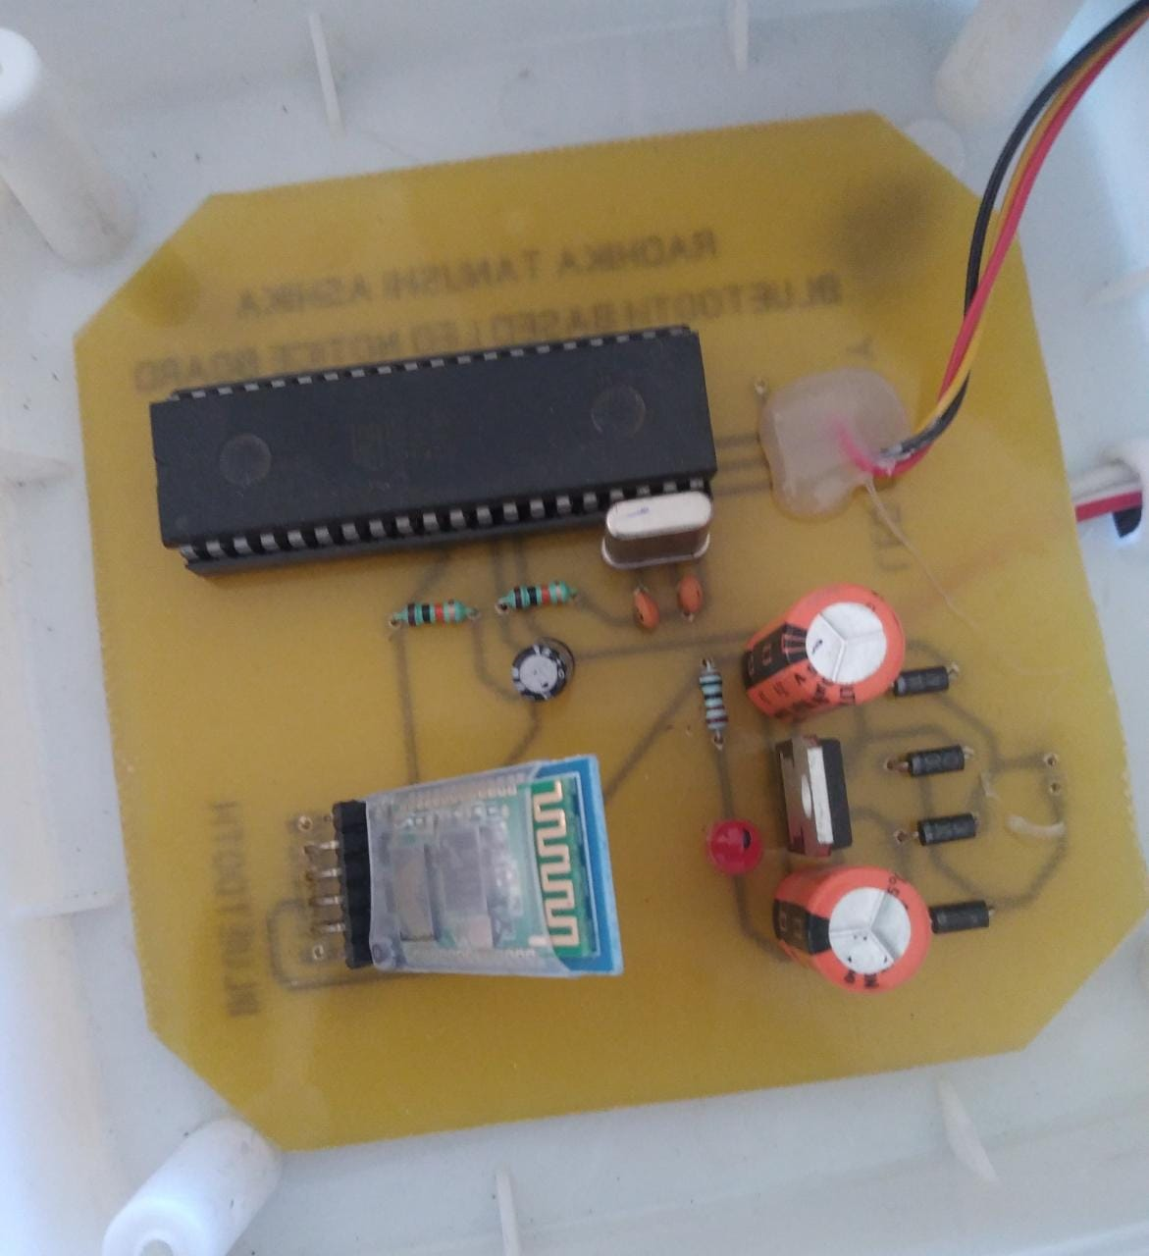

* **Working**

First of all, we need to install any Bluetooth terminal app on our smartphone. Next, we need to activate the project and find the HC 05 Bluetooth module in our mobile Bluetooth settings. After pairing the Bluetooth module, we are ready to send the first message to the LED screen. The Terminal application converts our text message into serial data and transmits it over the cell phone's Bluetooth radio. In the project, the HC 05 receives this CL data and then sends it to the microcontroller. The microcontroller verifies the data and password and then sends them to the LED display. The LED display saves the message, so even if we restart the project, the message will remain the same until we change it.

* **This is complete project**

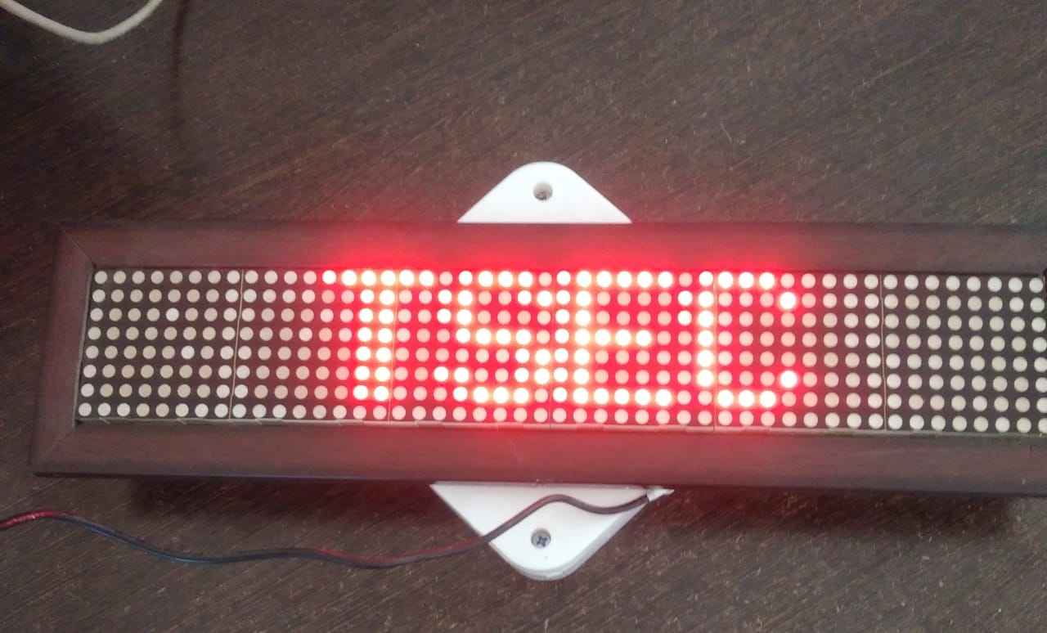

**ADVANTAGES**

* Easy Wireless control
* No need of keyboard or computer
* Can be controlled via any smartphone
* Portable and easy to install
* Requires easy coding
* Bright display can be viewed from 10 feet

**Compiler & Design tools**

* We have used BASCOM8051 complier for coding
* The Sprint layout software is used for PCB design
* Express PCB software is used for circuit design
* Microsoft word and Power point is used for report generation
* ISP programmer is used for copying code into microcontroller

**LIMITATIONS**

* Maximum 250 characters message length.
* 20 feet Bluetooth range.
* Only English & Alphanumeric characters support.

# FUTURE SCOPE

The business model can only display one message at a time. Considering the priority conditions, we can improve the design. The wives-based system can be scaled for extended-range connectivity. With the advent of this technology, new devices may appear and thus new markets will develop. We can also add voice prompts to the system.

# CONCLUSION

In this work, a Bluetooth-based message display system was carefully designed and implemented. The project turned out to be successful and profitable. After successful implementation, messages sent from an Android phone via the mobile app were received by the Bluetooth module and immediately displayed on the LED screen. The project was carried out over a wireless network, which eliminated all the problems that the wooden board used in various factories had, such as: E.g.: overcrowding, destruction, obstruction, stamping and compliance.

The big advantage of this project is advertising, since the board can be placed at any height and there is no need to use cables for communication.

**REFRENCES**

1. <https://www.researchgate.net/publication/27587841_Design_Simulation_of_Moving_Message_Display_using_Microcontroller>
2. https://www.electronicsforu.com/electronics-projects/hardware-diy/moving-message- display-LED
3. https://www.scribd.com/doc/47304156/LED-BASED-MOVING-MESSAG DISPLAY-with pc data
4. <https://kitsguru.com>.
5. https://www.engineersgarage.com/displaying-moving-text-string-on-16x2-LED-using-T89S52 Microcontroller.