“ATM Management System”

1. **Author name: Deepak Vaman Mahajan**

Student, Department of Computer Science Thakur ShivKumar Singh Memorial Engineering College, Burhanpur, Madhya Pradesh, India

E-mail: [deepakmahajan970@gmail.com](mailto:deepakmahajan970@gmail.com)

**Guide name: Prof. Swapnil Gupta**

Assistant professor, Department of Computer Science Thakur ShivKumar Singh Memorial Engineering College, Burhanpur, Madhya Pradesh, India

# ABSTRACT

In today's busy and expensive life, we ​​are very anxious to make money but at the end of the month we broke up. Because we unknowingly spend money on small and unwanted things. That is how we came up with the idea of ​​tracking our income in. In personal and business finance, money management typically includes budgeting, spending, saving, and investing. Expense tracker app is designed to help anyone who intends to know their expenses and save money on them.

# INTRODUCTION

This document describes the requirements and software specifications (SRS) for the automated teller machine (ATM). This document is intended for the customer and the developer (designer, tester, and maintainer). It is assumed that the reader has a basic understanding of bank accounts and accounting services. Knowledge and understanding of Unified Modeling Language (UML) diagrams is also required.

This document describes the requirements and software specifications (SRS) for the automated teller machine (ATM). This document is intended for the customer and the developer (designer, tester, and maintainer). It is assumed that the reader has a basic understanding of bank accounts and accounting services. Knowledge and understanding of Unified Modeling Language (UML) diagrams is also required. It helps a person achieve a long-term financial goal. The "money information" was developed to replace the manual system that is prevalent in practice. This is argued to eliminate and, in some cases, reduce the

difficulties faced by this existing system. In addition, this system is tailored to the specific needs of the company in terms of effective and efficient business operations.

# EXPLANATION

Before creating any website, one has to go through the various processes involved in it. The multiple processes combined together to form a model which is used by every software developer to maintain the flow of cycle which creating any kind of application.

The Software Life Cycle Model (**SDLC**) is a conceptual framework that describes all activities of a software development project from planning to maintenance. This process is linked to several models, each with different tasks and activities. SDLC provides a set of steps that must be followed in order to design and develop software effectively.

**Iterative Waterfall Model: -**

The Iterative in the Iterative model, iterative process starts with a simple implementation of a small set of the software requirements an iterative life cycle model does not attempt to start with a full specification of requirements.

**Characteristics of Iterative waterfall model: -**

• This process is then repeated, producing a new version of the software at the end of each iteration of the model.

• An iterative life cycle model does not attempt to start with a full specification of requirements. It is very easy to understand and use. In the iterative waterfall model.

The flow of our project can be seen in the following diagram which gives a quick introduction of how our project will flow through multiple stages and what all functionality it will include and how the processes are related to each other through multiple stages.

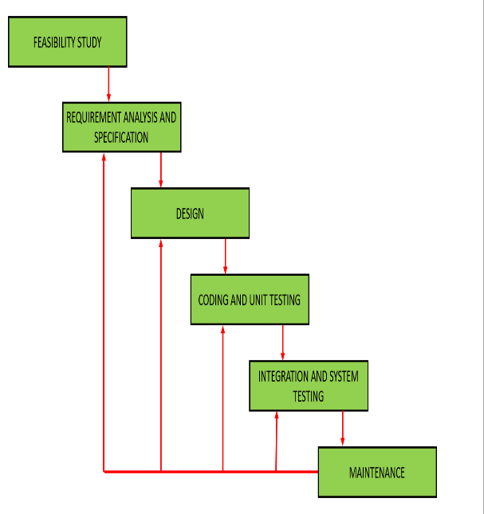

**Objective of Project**

This document describes the software requirements and specification (SRS) of an automated teller machine (ATM). This document is intended for the customer and developer (designer, testers, and maintainers). The reader is assumed to have a basic knowledge of banking accounts and accounts services. Knowledge and understanding of unified modeling languages (UML) diagrams is also required.

• Effective financial management, like all financial planning, is a process, not a product.

• Manage expense details.

The main goal of the Money Info. project is to manage the details of expenses, categories, typologies, users, and subscriptions. Manages all information about expenses, payments, membership, expenses. The project is built entirely on the administration side, so only the administrator is granted access. The goal of the project is to create a program that reduces the manual work involved in managing expense, category, payment, and type. Tracks all types, users, registration details**.**

Putting focuses on the designing perspective we have created a choosing a mobile application, these TrackerApp easily loads on the user’s devices without consuming memory. We have designed our TrackerApp in such manner that it is compatible to almost all devices including the laptops of different brands, mobile phone, tablets and many more.

The multiple pages in our TrackerApp are home page, category page, dashboard page, sign in and login page.

**Home Page|** It includes the short description of the different categories of an automated teller machine (ATM) including with the button of the sign up, log in.



**Login page|** This page will allow registered user to access on the system by using the Phone number and password they can login to the system. We have kept an option of forgot password if a user forgot their password, then by using their Phone number they will get their password.

**Category page|** It will contain multiple categories and by clicking on them user can see a wide variety of cloths available in that kind of information, but for viewing the statements present in different category user first have to login on these app.

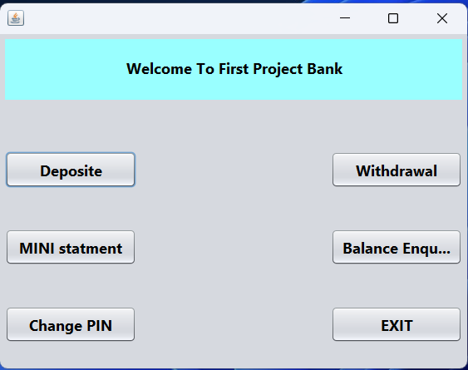

# CONCLUSION

In Our project we discuss from this presentation, it can be seen that the ATM system is related to consumer banking transactions. First, the ATM system is used for transactions involving consumer funds. Consumers make extensive use of ATMs to withdraw money from their bank accounts. It is a quick way to withdraw money from your account, especially when you are on the go or traveling. Once the tools for understanding how to derive cash flow were introduced, the concept of capital budgeting was introduced.

# FUTURE SCOPE

* We can access the money and verify the account details without using the account number and PIN, but we use the barcode instead of the account number and PIN.
* A money transfer system will be added.
* The system allows the member to verify  **their bank** account and/or change account options.

# REFRENCES

* [www.w3school.com](http://www.w3school.com/)
* [www.scribd.com](http://www.scribd.com/)
* [www.google.com](http://www.google.com/)
* [www.wikipedia.com](http://www.wikipedia.com/)
* [WWW.stackoverflow.com](http://www.stackoverflow.com/)
* [WWW.jssor.com](http://www.jssor.com/)
* [WWW.youtube.com](http://www.youtube.com/)
* [WWW.gfg.com](http://www.gfg.com/)
* [WWW.javatpoint.com](http://www.javatpoint.com/)
* www.youtube.com
* [www.geksforgeks.in](http://www.geksforgeks.in)
* java Black book 8th Edition.