**DETECTION AND VOICE ASSISTANCE FOR VISUALLY IMPAIRED**

**Sri Sai Krishnaa R C1 , Mukesh Kanna G2 , Sarath Kumar D3,Mrs. Shimona S4**

1.2.3Student, Computer Science and Engineering, Agni College of Technology, Chennai - 600 130, Tamil Nadu, India

4Assistant Professor, Computer Science and Engineering, Agni College of Technology, Chennai-600130, TamilNadu, India

# **ABSTRACT**

This project involves using Android Studio to create an Android app that helps visually impaired people find goods and money while providing audio services. The application uses computer vision algorithms to find and find money, and voice assistants allow the system to transmit information to the user. The application has the ability to develop the independence of the visually impaired, who can use it to perform daily tasks that require visual acuity. Product research, financial research, voice assistance, visually impaired, Android Studio and applications are the main topics related to this project. The use of the application is discussed and the results of the tests and evaluations for the visually impaired are presented. The results of the study show that the application is useful for helping visually impaired people in their daily work. Overall, the project demonstrates the potential of combining computer vision and audio technology to create systems that can assist visually impaired people in their daily lives. The app has the potential to improve the quality of life of the visually impaired, making them more self-confident and independent.

# **1.INTRODUCTION**

Most of the information we need is always available on our smartphones and working on a touchscreen is no easy task when you have vision problems. Therefore, these applications are designed to enable visually impaired people to use smartphones like everyone else and to benefit from all the features offered by these devices. We hope these apps will provide many services to anyone who needs it. The system accepts the voice command and works accordingly. To do the rest of the work, it first converts the speech to text and then displays it in speech format. The aim of this study is to discuss the development of Android-based smart software applications for the use of blind or visually impaired people.This application is designed to help visually impaired or blind people access their Android device so that they can use their device to use library resources on Android.

# **2. LITERATURE SURVEY**

**Roger A. Grice et. al,** Speech can be a powerful tool for human-computer interaction because it's the way people communicate. With the rapid development of wireless communication, the demand for speech recognition is very high. Voice applications such as voice interaction, voice recognition, and interactive voice control can help users focus on the task at hand without additional hands or eyes and more work time. In this article, we present the general requirements and design software and design principles for the effective use of voice on mobile devices, and also present potential models. Interact with users via voice commands. Additionally, we introduce usability evaluation of applications to discover usability issues through the proposed evaluation process and then discuss the progress of further development of applications on mobile devices.

**Shivam Upadhay et. al**, Voice Assistant for the Blind is a new development for the blind as a voice assistant for the blind. The system is used to help the visually impaired use the most important function of the mobile phone, by using different rules and speech-to-text to improve the quality of the system. The system has custom messages including inbox and delivery, call logs and phone numbers, notes and battery checks and alerts. The system communicates every action the user performs and helps the user understand their current location. The system also helps the user to read the content of the message including the sender, date and time.

**Damarla K**, In this project, speech input is processed and output is output with speech and text displayed on the screen. Using the audio input from the microphone, the voice assistant translates the sound into a language that the computer can understand and provides the desired solution as well as the answer the user wants. The program connects to the World Wide Web to provide results in user queries.

**Vipul Samala et. al**, The main purpose of this article is to provide information about automatic watering of plants that helps save money and water. The entire control system uses an ATMEGA 328 microcontroller, which sends the corresponding signal to the motor. The temperature and humidity sensor is connected to the internal port of the microcontroller via analog, when the temperature and humidity sensor changes, the sensors will know the temperature and humidity change and start by sending the corresponding signal to the microcontroller. motor, Use with this buzzer to indicate that the pump is on.

# **3. EXISTING SYSTEM**

Talkback - An app that's part of Talkback, Google's Android Accessibility Service, helps visually impaired people hear what they're trying to do with their phone. The app will inform them about the products they have just selected or selected. Talkback is an accessible service that helps visually impaired users interact and enjoy their devices. It uses speech, vibration, and other feedback to let you know what's on the screen, what you tapped, and what you can do with it. The disadvantage of the intercom is that it drains the battery and makes it difficult to use. The problem with the app is that it cannot be stopped without exiting the app. It will also be read aloud, although there is a button to stop the user from reading when they have finished the posts.

# **4. PROPOSED SYSTEM**

The prepared system is a voice assistant that can respond to commands and perform various tasks. The system always listens for its name and wakes up when its role is called. He learns questions about the content and remembers these sentences for future discussion. When the same topic comes up, he starts the conversation by asking related questions. The system is capable of performing arithmetic operations based on voice commands and calculating results with voice input. It can also search the Internet based on the user's voice input and answer by voice and continue asking questions with the machine. Voice recognition will be used to accurately interpret the user's voice commands. Overall, the proposed system will provide users with an easy-to-use and intuitive interface to interact with their device and work without physical input.

# 4. DIRECTORIES OF MODULES

## 4.1 MODULE 1 : VOICE ANALYSER - ACOUSTIC MODEL

Acoustic models are used in automatic speech recognition to represent the relationship between sound signals and phonemes or other spoken words. The model is learned from a set of registers and their annotations. It is created by taking recorded sounds and their transcription and using software to create a representation of the sounds that make up each word. When using the acoustic model we need to show the original audio waveform. Convert them to vector-valued values ​​that the model can do. The key to doing this is to use classical signal processing techniques. These techniques also allow us to solve many of the problems described in the previous section, such as removing noise and unevenness between different speakers. Typically, signal processing features are captured using 25ms sliding window frames 10ms apart. This allows the featurization process to capture key features of the sound while ensuring that those features don't become too fine-grained.

## **4.2 MODULE 2 : VOICE PROCESSING - LEXICON & LANGUAGE MODEL**

An essential part of any automatic speech recognition system is the dictionary. Interpreting a dictionary can be difficult because sometimes it can mean different things depending on the context. In its simplest form, a dictionary is a collection of words whose sounds are divided into phonemes, that is, the units in which words are spoken. In many ways, as the dictionary says. Another way to use the dictionary term is to refer to the finite state transformer, sometimes referred to as "L.FST", resulting from the elaboration of the dictionary. A finite state transformer is a finite state automaton that displays two sets of signals together. In the case of dictionaries, such converters show the word symbol for their speech**.**

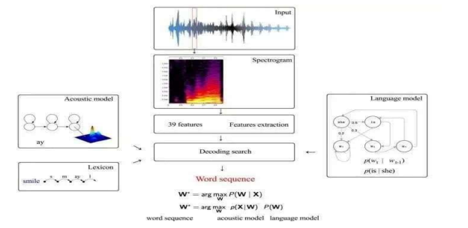

Fig 4.1 Voice Processing - Lexicon & Language Model

The reason why the dictionary is an important tool for learning to speak is because it helps to distinguish between different words and spellings. Many words from the same author have different words in different contexts. For example, past the word "uff", dough, cough, rough, twig, clear, adequate, etc. think like Voice cannot be learned by typing. In this case, the actual pronunciation of a given word will be contextually determined by the dictionary and the encoded case-change probabilities in the word/phoneme case.

## **4.3 MODULE 3 : IMAGE ANALYSER – HISTOGRAM OF ORIENTED GRADIENTS**

The Directed Histogram of Gradients (HOG) algorithm is a widely used deconstruction technique in computer vision and image targeting for object detection and recognition. Density is different from shape. The image is divided into small regions and the gradient histogram is calculated for each region. Histograms capture local aesthetic information and information about perceived objects. The HOG algorithm then normalizes the histogram to account for changes in brightness and contrast and combines them into a feature vector that can be used as input for machine learning classifiers such as support vector machines (SVM). Overall, the HOG algorithm is effective at identifying different objects and images such as human faces or cars and is widely used in applications such as surveillance, electric driving, and robots.

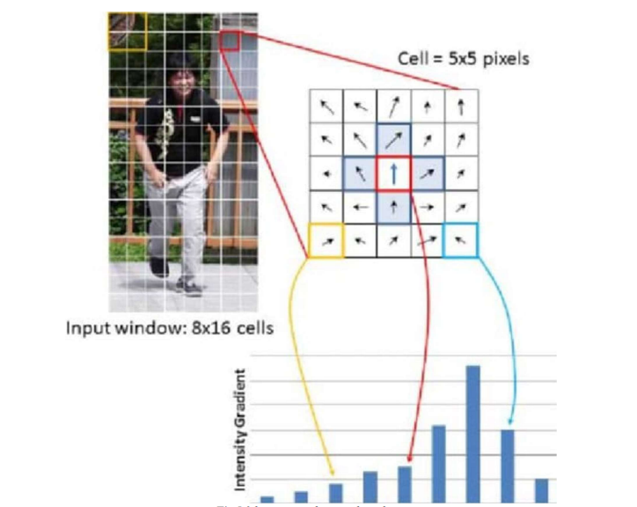

Fig 4.2 Image Analyser – Histogram Of Oriented Gradients

## 4.4 MODULE 4 : OBJECT DETECTION – SUPPORT VECTOR MACHINE

Support vector machine (SVM) is a widely used machine learning algorithm for classification and recognition tasks in image processing. In DVM, the goal is to find a general plane that allows the separation of data points at a particular location. In the context of image processing, feature points represent vectors extracted from images, such as HOG features. A hyperplane is chosen to generate the edges of the two classes of data points, resulting in a more powerful classifier that generalises well to the invisible data. The SVM algorithm works by transforming image vectors into a higher order space using a kernel function such as a radial basis function (RBF) kernel. Transfer vectors are used to train a binary classifier that separates two classes of data points.

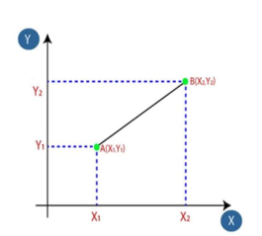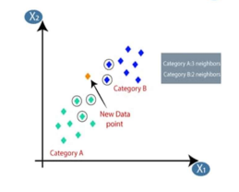

Fig 4.3 Object Detection – Support Vector Machine

During training, the SVM algorithm finds a hyperplane that maximizes the separation of data points. This is done by solving an optimization problem that involves minimizing the classification error and ensuring the separation of the two classes. After the DVM classifier is trained, new images can be classified by extracting the vectors and applying the classifier to the transform space. In general, SVM is a powerful image classification and recognition algorithm that is widely used in object detection, face recognition, text recognition and other applications.

# **5.** **MODELLING AND ANALYSIS**

## 5.1 WORKFLOW DIAGRAM

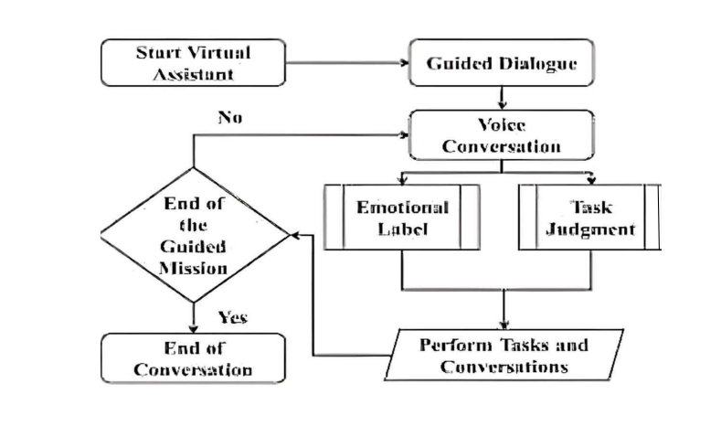

Fig 5.1 Block Diagram for Voice Assistant Application

## 5.2 SYSTEM ARCHITECTURE

Fig 5.2 System Architecture

## **6.** **RESULTS AND DISCUSSION**

In the specific case of analysing the results using machine learning algorithms, some things may be wrong, sometimes the results may be wrong and the accuracy depends on the quality of the phone's camera. It may be difficult for the environment to recognize objects such as ambient noise, camera flashes or light beams, in which case we use support vector machine algorithms instead of convolutional neural network (cnn) algorithms to identify objects, so training with maximum time objects will be difficult.

## 6.1. SCREENSHOTS

Fig 6.1 Voice Recognition – Opening Default Apps

Fig 6.2 Voice Recognition – Opening Browser (Chrome)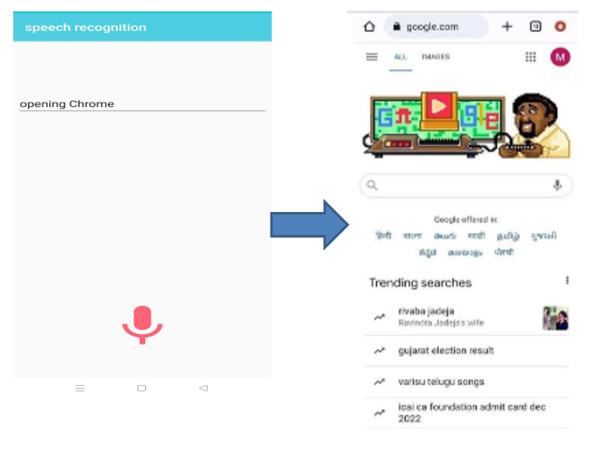

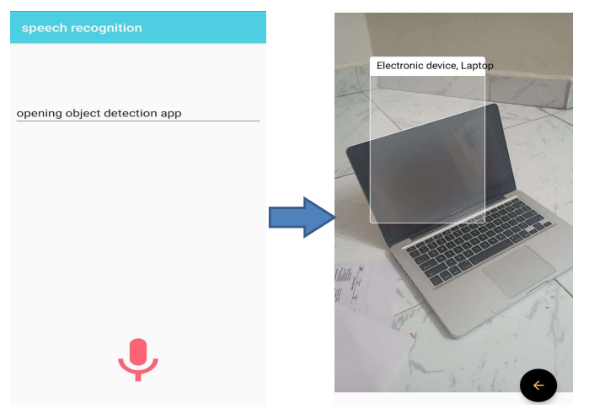

Fig 6.3 Object Detection

Fig 6.4 Money Detection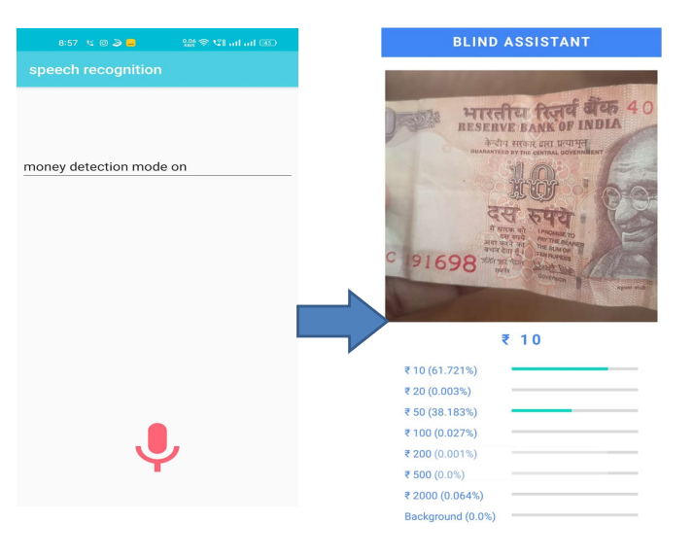

# **8.** **CONCLUSION**

In summary, the project aims to create an Android application that can help visually impaired people find goods and money while providing voice services. The app uses computer video algorithms to analyse and find money, and a voice assistant sends messages to users. The app provides blind people with daily tasks that require vision, independence and confidence in their eyesight. These studies include topics such as Product Research, Financial Research, Audio Services, Visually Impairment, Android Studio and Applications. The use of the application is discussed and the results of the tests and evaluations for the visually impaired are presented. The project demonstrates the potential of combining computer vision and audio technologies to create systems that can assist visually impaired people in their daily lives and ultimately improve their quality of life.

## **9.** **REFERENCES**

[1] R. Piyare and S. R. Lee, "Smart Home-Control and Monitoring System Using Smartphone," in 1st

International Conference on Convergence and its Application (ICCA), 2013.

[2] P. Milhorat, S. Schogl, G. Chollet, J. Boudy, A. Esposito and G. Pelosi, "Building the next generation of

Personal Digital Assistants," in 1st International Conference on Advanced Technologies for Signal and

Image Processing, 2014.

[3] J. G. Linvill, "Research And Development Of Tactile Facsimile Reading Aid For The Blind

(The Optacon),"Stanford, California, 1973.

[4] Google Cloud, "Cloud Text To Speech Basics," Google, 31 July 2019. [Online]. Available:

https://cloud.google.com/speech-to-text/docs/basics. [Accessed 28 October 2019].

[5] J. Baker, "Voice User Interfaces (VUI) — The Ultimate Designer’sGuide," 25, November, 2018. [Online].

Available: https://medium.muz.li/voice-userinterfaces-vui-the-ultimate-designers- guide-8756cb2578a1.

[Accessed 28 October 2019].

[6] Google Mobile Vision, "Text Recognition API Overview," 2019. [Online]. Available:

https://developers.google.com/vision/android/text-overview. [Accessed 28 October 2019].

[7] Google Cloud, "Cloud Text-to-Speech basics," 2 July 2019. [Online]. Available:

https://cloud.google.com/text-to-speech/docs/basics. [Accessed 29 October 2019].

[8] A. M. D. Celebre, A. Z. D. Dubouzet, I. B. A. Medina, A. N. M. Surposa and R. C. Gustilo, "Home

Automation Using Raspberry Pi through Siri," in 8th IEEE International Conference Humanoid,

Nanotechnology, Information Technology, Communication andControl, Environment and Management

(HNICEM), Cebu City, Philippines, 2015.

[9] A. Mishra, P. Makula, A. Kumar, K. Karan and V. K. Mittal, "A Voice-Controlled Personal Assistant

Robot," in 2015 International Conference on Industrial Instrumentation and Control (ICIC), Pune, India,

2015.

[10] Kwang B. Lee, Roger A. Grice, “The Design and Development of User Interfaces

for Voice Application in Mobile Devices,” 2006 IEEE.