**Wireless electric bell**

**Parth Patil1, Prachi Jorwar2, Nikhil Patil3**

123BE, Electronics and telecommunication engineering, MVP’s Adv. Karmaveer Baburao Ganaptrao Thakre College of Engineering 422013, Nashik, Maharashtra, India.

**ABSTRACT**

Many school and college bells today are manually controlled. There is in turn a great need for accuracy.

There are numerous digital clocks with bells on the market, but they only sound at particular times and cannot stop after those times. Here, a novel design is displayed.

The advantage of this design is that the bell rings to a high degree of accuracy at the beginning of each period without any human intervention, thereby replacing the manual duty of turning the college bell on and off according to time.

**Keywords:** NodeMCU: Wi-Fi; Wireless bell; real time clock; LCD; App; College.

1. **INTRODUCTION**

We are going to show you a method that not only provides the best accuracy, but also saves us money and manpower. Each class's bell is rung by one of the staff members. The bell in colleges would sound automatically at the scheduled time if this design were to be implemented, taking over the responsibility of ringing the bell.

It makes use of an actual Time Clock (DS3231) that monitors actual time. Furthermore, two additional bells that will sound in addition to the major bell will be used here. Wireless communication between the bells on the transmitting and receiving sides is made possible by the NodeMCU Wi-Fi module.

We can utilise this automated bell ringing system for exams in addition to using it for lecture schedules.

The bells used in schools and colleges nowadays are manually operated, which has accuracy issues. This automatic wireless bell encourages great accuracy.

There is no danger of data leakage because data is entirely kept on the cloud. Some of the early techniques, including hand-ringing bells, are still in use today. More dependable and accurate systems have been introduced as technology has advanced.

1. **METHODOLOGY**

* Block Diagram:

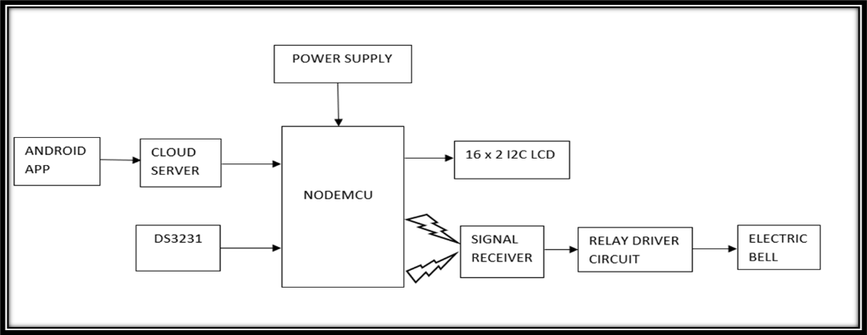

1. NodeMCU ESP-12E:

A compact microcontroller with a Wi-Fi chip is called the NodeMCU ESP8266. When linked to the same network, multiple ESP8266 devices can communicate with one another. Multiple receivers can establish wireless connection using a single NodeMCU.

1. Relay:

Relays are used to control multiple circuits with a single signal and to control a circuit individually with a low-power signal. Any number of connections in various contact configurations, such as make contacts, break contacts, or combinations where relays are employed, may be included on the switch.

1. I2C LCD module:

I2C Bus allows two devices to communicate with one another in a stable, quick, bidirectional manner. I2C Bus uses Serial Data Line (SDA) and Serial Clock Line (SCL) as its two lines of communication, hence the term "bidirectional" protocol.

1. DS3231 RTC module:

It features a built-in comparator that checks the VCC state in order to detect power outages and switch to a backup power source automatically. 32Kb of non-volatile memory are available. This module is readily interfaced with Raspberry Pi, Arduino Boards, and all other Microcontrollers.

* Flow diagram :

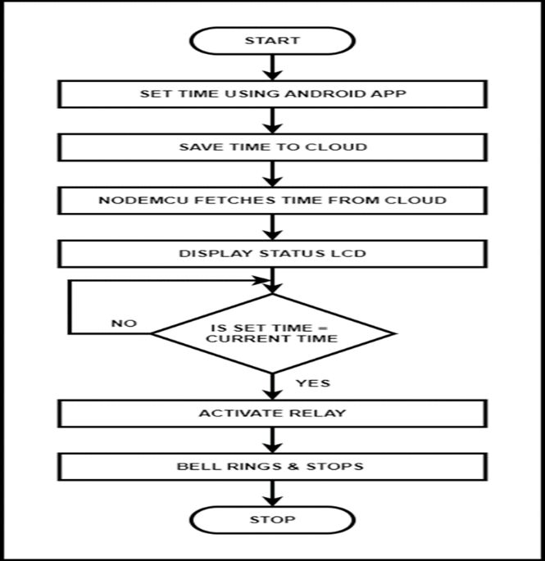

Step 1: Set the timing according to schedule with the help of android application.

Step 2: That time will be saved on cloud.

Step 3: NodeMCU is connected further which fetches data from cloud.

Step 4: Status of timing or when the bell will ring that is displayed on lcd screen.

Step 5: If set time and current time is equal then only the relay will be activated otherwise not, this will be done using RTC module.

Step 6: When relay will pass higher logic then bell will ring for certain time according to code, otherwise bell will remain off.

Step 7: End.

* Circuit Diagram :

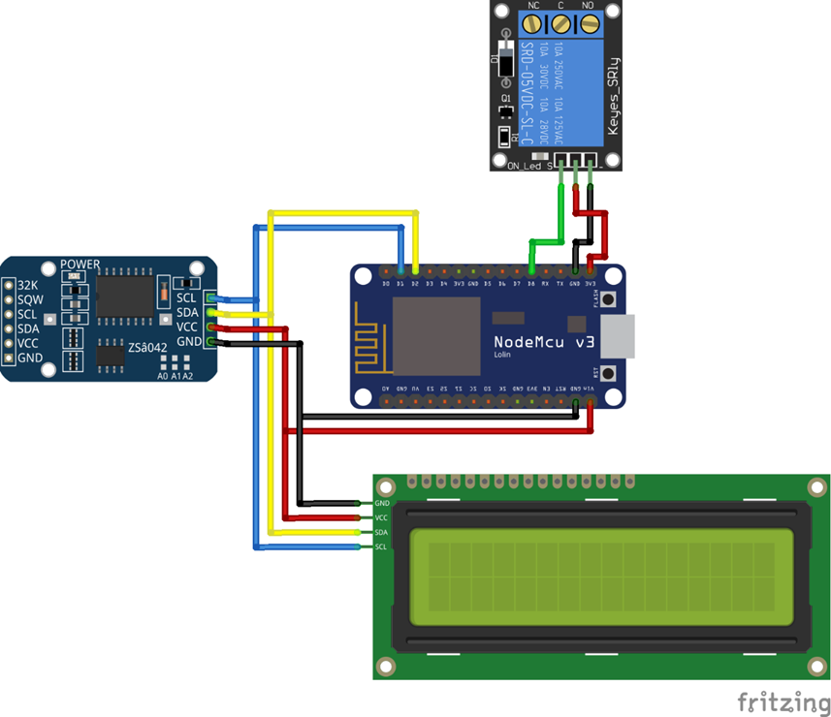

1. Cloud storage:

The data sent by the microcontroller is kept in cloud storage. Data is kept on the cloud using APIs (Application Programming Interfaces). And instead of using the Internet or a LAN (Local Area Network), HTTP and MQTT protocol is used to retrieve data from the cloud.

1. Bell:

The NodeMCU board is connected to the electric bell. Through a switching transistor, it is connected. The collector terminal of the transistor is linked to the bell, and the base of the transistor is connected to a 1K ohm pull-up resistor. The transistor's emitter terminal is grounded. The relay is set to logic HIGH when the true time and the preset time coincide. The bell is turned on when the relay is set to logic HIGH. The bell is in the OFF state when the relay has logic LOW.

1. Working:

A NodeMCU Microcontroller Breakout Board is utilised by the system. The fact that this microcontroller has built-in WIFI makes it appropriate for Internet of Things applications, which is a key justification for utilising it. The electrical board's timer may be set wirelessly and remotely from any location in the world using an Android application created using Kodular. Users can only set the time using the API Keys incorporated in the custom Android app that was designed for this system because it has a secure IoT Server. All three systems retrieve the data from the cloud after it has been written there, and I2C LCDs are used to display the data and the status. To determine the accurate time, a DS3231 RTC is utilised. If the time matches the desired time, the logic high makes the bell ring.

1. **RESULTS AND DISCUSSION**
2. The bell, which was programmed to ring every 45 minutes, is operating as intended.
3. By utilising the app attached to it, we can change the bell's timing.
4. The led panel displays the time and date.
5. This circuit is also applicable to and makes use of timing variation.

**4. CONCLUSION AND FUTURE SCOPE**

This research describes the shortcomings of humanly controlled bell ringing systems and how these deficiencies are addressed by the automatic college bell ringing system.

The college bell, a Wi-Fi module, and an LCD have been effectively coupled to display the status. This attempt aids in the timely and precise ringing of the bell everywhere.

GSM can be used to make more advancements. The RTC can be managed through GSM, allowing for the editing of timings.

**REFERENCES**

1. Nalini, Naveen Raj, Sharwanjana, Satish Kumar and Vijay, “IOT based wireless automated bell ringing system in an institution”, International journal of creative research thoughts (IJCRT), Volume 8, Issue 3 March 2020.
2. Abyash Gautam, Deepak Rasaily and Sejal Dahal,” Microcontroller Controlled Automated College Bell”, International Journal of Engineering Trends and Technology (IJETT), Volume 32, Issue 4, Pages 184-187, February 2016.
3. Rajesh Kannan Megalingam, Venkat Krishnan Balasubramanian, Mithun Muralidharan Nair, Vineeth Sarma Venugopala Sarma, Rahul Srikumar: Power Aware Automatic Microcontroller Based Smart, College Electric Bell System with Time Display, 2009 Fifth International Conference on MEMS NANO, and Smart Systems.
4. Burgoji Santhosh Kumar, Implementation Of Automatic College Bell Ringing System Using Arduino, ISSN: 2393-8374,VOLUME-5, ISSUE-4, 2018.
5. Shweta Butoliya, Nupur Shal, Snehal Girhepunje, Aakanksha Rannaware, Prerna Baddalwar and Vaishali Badwe,” Microcontroller based automatic college bell with monitoring system”, International Journal of Advanced Research in Computer Engineering & Technology (IJARCET), Volume 4, Issue 2, Pages 401-404, February 2015.
6. Mrs. S.P. Gaikwad, Manikeshwari Shahdeo, Meghna Priya, Prashant Kr. Raghav, Wireless GSM Based Electronic Notice Board, May 2017.