SEISMIC RESPONSE OF RC BUILDINGS WITH VARIED STRUCTURAL CONFIGURATION HAVING SOFT STOREY DEFECT

**Suraj Singh1, Mr. Md Anzar Rabbani2, Geeta Rawat3**

**1 M.Tech Scholar, Ganga Institute Of Tech. & Management, Jhajjar, India**

[Rawat.suraj084@gmail.com](mailto:Rawat.suraj084@gmail.com)

**2 Assistant Professor, Ganga Institute Of Tech. & Management, Jhajjar, India**

[rabbanianzar1@gmail.com](mailto:rabbanianzar1@gmail.com)

**3 M.Tech Scholar, Ganga Institute Of Tech. & Management, Jhajjar, India**

Rawat.geet25feb[@gmail.com](mailto:refazgitm@gmail.com)

**ABSTRACT** - Soft floor structure is a common element in high rise or multi-story buildings due to urbanisation and space occupancy constraints. Without taking into account the strength and stiffness contributions of the in-fills, reinforced concrete framed structures with infills are often analysed as bare frames. However, infill panels have a tendency to interact with bonding frames when exposed to significant lateral stresses, which might result in a load resistance mechanism that was not intended. Due to their soft storeys, these measures cause a reduction in the stiffness of the lateral load resisting system, making a gradual collapse in a powerful earthquake inevitable for such structures. Due to the concrete columns' inability to offer significant shear resistance, damage and collapse are most often seen in soft-story structures during earthquakes. In contemporary multi-story buildings in metropolitan India, open first floors are a common design element. As shown by countless instances of intense shaking during previous earthquakes, such qualities are particularly undesirable in structures constructed in seismically active locations. Since response spectrum analysis offers response to the applied loads and spectral conditions, it is selected for the study of the model. With the aid of the response spectrum approach, the performance and behaviour of a structure with soft flooring at various levels are the main emphasis of the present research. ETABS V.16.03 is used to study six distinct model scenarios for analytical purposes. Following IS 456:2000 and IS 1893:2002, a G+20 building with a straightforward square layout is taken into account.

**Key Words:** Nonlinear-static analysis, Response Spectrum analysis, Performance based assessment, Soft storey, Stiffness, Drift index.

1. **INTRODUCTION**

The open first level is a common and inescapable characteristic of urban multi-story structures in India nowadays. The main reason for adopting this is to provide room for parking or reception lobbies in the first storeys. Brick infill wall panels are seen on the top storeys. A soft storey is one whose lateral stiffness is less than 70% of the storey above, according to the Indian seismic code. In contrast to the seismic force distribution, which depends on the distribution of stiffness and mass along the height, the total seismic base shear that a structure experiences during an earthquake is influenced by the earthquake's natural period. Buildings with ground-floor soft storeys saw lesser inter-storey drifts because the higher storeys were stiffer. The base soft story has a high inter-storey drift index, nevertheless. Given that the shear in the first level is greater, there is also a significant need for strength on the columns in the ground storey. One of the common reasons for building collapse during earthquakes is soft floors.

**Behavior of Soft Storey:**

In the recent earthquakes, several buildings with soft storeys sustained severe structural damage and collapsed. Damages are caused by large open spaces with less infill and outside walls on the bottom level compared to higher floors. The lateral load resisting systems in such structures are far less stiff at such storeys than they are at stories above or below. If there are unusual inter-story drifts between neighbouring stories during an earthquake, the lateral stresses will not be evenly distributed across the structure's height. Due to this circumstance, the storey with the greatest displacement is the focus of the lateral pressures. Additionally, due to the high level of load deformation effects, a local failure mechanism or, worse yet, a storey failure mechanism that may result in the collapse of the system may form if the local ductility demands are not met in the design of such a building structure for that storey and the inter-storey drifts are not limited. A storey's lateral displacement depends on its stiffness, mass, and the distribution of lateral forces over it. It is also well known that the mass and stiffness of each story directly affect the distribution of lateral forces along a building's height. In the event that the P-delta effect is thought to be the primary factor contributing to the dynamic collapse of building structures during earthquakes, precisely computed lateral displacements derived during the elastic design process may be able to give highly valuable insight into the structural behaviour of the system. Recent RC buildings sometimes contain a unique design element that leaves the ground floor unobstructed for parking, meaning that there are no RC or masonry partition walls separating the ground floor's columns. These structures are also referred to as buildings on stilts or open ground story structures. A structure with an open ground floor with only columns in the bottom floor and partition walls and columns in the higher floors has two different features, The relative horizontal displacement it experiences in the base storey is much more than what each of the storeys above experience. This indicates that the bottom storey is particularly flexible Its ground storey is relatively weak; that is, the total horizontal earthquake force that it can support there is much less than the combined capacity of the storeys above it. As a result, the open ground floor might potentially be weak. Even though their ground storey may be soft and weak, open ground storey structures are sometimes referred to as soft story buildings. Although it might be at any other story level, the soft or weak storey often resides at the ground storey level.

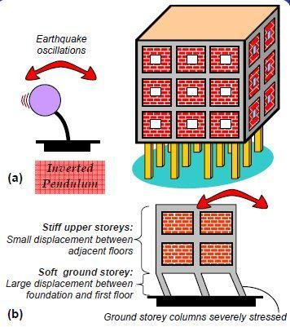

Figure 1: Upper storeys of open ground storey building move together as a single block – such buildings are like inverted pendulums.

Upper stories are substantially stiffer than the open ground story because of the existence of walls. As a result, the building's higher storeys almost move as a single unit, with the soft ground story experiencing the majority of the building's horizontal displacement. This kind of structure may be described as a building on chopsticks in everyday language. As a result, during an earthquake, these structures shake back and forth like inverted pendulums, severely stressing the columns in the open ground story. If the columns are weak (lack the necessary strength to withstand these high loads) or if they lack sufficient ductility, they may suffer significant damage that might possibly cause the structure to collapse. Because of this, similar inverted pendulum behaviour also occurs when soft storeys are built over floors. During an earthquake, the storeys below and above the soft story behave independently like a single block, with the top half swaying like an inverted pendulum.

1. **Scope & Objective**

The strength and stiffness of infill walls in infill frame buildings are ignored in the structural modeling in conventional design practice. The design in such cases will generally be conservative in the case of fully infill framed building. But things will be different for an open ground storey framed building. Open ground storey building is slightly stiffer than the bare frame, has larger drift especially in the ground storey, and fails due to soft storey mechanism at the ground floor. The scope of the study is to find the effect of masonry infill panel on the response of RC frames subjected to seismic action by conducting response spectrum analysis for RC frame with infill wall at varying arrangement using ETABS 2015.

* The main objectives of the study are:
* To study the behaviour of reinforced concrete framed multi-storeyed building with soft storey at different floor levels.
* To study the critical condition generated due to soft storey conditions.
* To compare various parameters such as displacement, stiffness, inter-storey drift index and base shear.
* To find the minimum damage level of high rise buildings with soft storeys

**Response Spectrum Analysis**

Pushover analysis, time history analysis, and response spectrum analysis are the three analytical techniques used for the seismic investigation of the structure. Since it offers response to the applied loads and spectral conditions, response spectrum analysis is used for the examination of the model. This technique aids in the investigation of that comparison, which is one of the main goals of this work, which is to analyse the impact of soft-storey at different layouts. Each mode of the model is seen as a separate SDOF system in the response spectrum analysis process. Each mode's maximum responses are computed separately. The model's overall response to the applied spectrum is then obtained by combining these modal responses. A lot of people agree that the response spectrum approach is an appropriate way to gauge how any structural model would react to any arbitrary base excitation, notably earthquakes. There is really no need to employ the static approach since it is simpler, quicker, and more accurate. A linear-dynamic statistical analysis technique known as "response spectrum analysis" evaluates the contribution from each natural mode of vibration to estimate the expected maximum seismic response of a basically elastic structure. It is a method for calculating a structure's statistical maximum response to a base excitation. It is possible to suppose that each vibration mode under consideration will behave independently as a system with one degree of freedom. Due to the connection between structural type selection and dynamic performance, it is helpful for design decision-making. The method of response spectrum analysis is based on the assumption that a structural model's dynamic response may be roughly described as the sum of the responses of its separate dynamic modes. Seismic analysis is where this approach is most often used. Any single degree-of-freedom (SDOF) system's maximal response may be predicted using the response spectrum approach. It is understood that "any SDOF system" refers to an SDOF system with any natural frequency. The term "maximum response" refers to the greatest deflections. Each model mode is treated as a separate SDOF system throughout the response spectrum analysis process. Each mode's maximum responses are computed separately. The model's overall response to the applied spectrum is then obtained by combining these modal responses. A lot of people agree that the response spectrum approach is an appropriate way to gauge how any structural model would react to any arbitrary base excitation, notably earthquakes. For certain constructions, building regulations mandate a dynamics-based process. This approach meets the need for dynamic behaviour. There is really no need to employ the static approach since it is simpler, quicker, and more accurate.

**Structural & Loading Details**

Table 1: Modeling and Loading of Structure

|  |  |  |
| --- | --- | --- |
| 1 | Size of column | 600mm x 600mm |
| 2 | Thickness of infill wall | 230mm |
| 3 | Thickness of slab | 150mm, M40 |
| 4 | Zone and zone factor | III, 0.16 |
| 5 | Importance factor | 1.5 |
| 6 | Response factor (R) | 5 |
| 7 | Grade of concrete and rebar in beam | M35, Fe500 |
| 8 | Grade of concrete (Slab) | M35 |
| 9 | Grade of concrete and  rebar in column | M40, Fe415 |
| 10 | Grade of shear wall | M40 |
| 11 | Live load and floor finish load | 3kN/ m2and 1kN/m2  kN/ |
| 12 | Top floor load | 2kN/ m2 |
| 13 | Masonry load | Half brick wall, 7.2 kN/m m2 |

The infill wall is modelled using the Equivalent Diagonal Strut Method. The infill wall is idealised as diagonal in this approach. truss or beam element, and the frame is treated as a strut. The elastic analysis makes use of frame analysis tools. According to the studies done, walls improve the stiffness of a building to some extent. Different configurations inside the structure allow for the soft story layout.

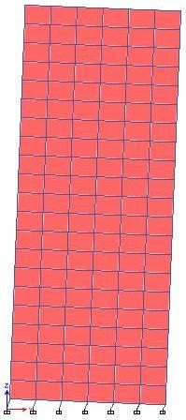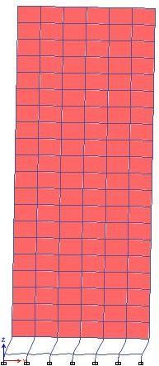

(a) (b)

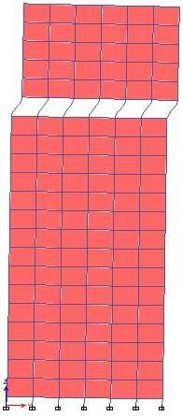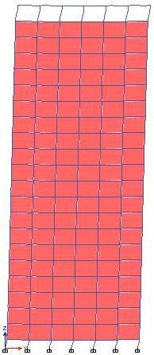

### (c) (d)

Figure 4: Behavior of structure with soft storey at different floor during earthquake

Any one level of the building is more flexible (less rigid) as compared to other floors in a structure with a soft storey layout. This might be at the bottom or any other intermediary spots where the floor may be firmer above or below it than it is. From the standpoint of seismic forces, this seems to be a weak component. This flaw might manifest as a sudden change in the stiffness, drift index, or strength characteristics. It is undesirable that these fluctuations lead to an uneven distribution of masses throughout the floor.

1. **RESULTS**

**BASE SHEAR**

For each situation, baseline responses are evaluated, and subsequent calculations are made in accordance. Due to all the modes included in the Response Spectrum Base Reaction Table, base shear is evaluated. No additional action is necessary if the reported dynamic base shear is more than 85% of the static base shear. However, the scaling factor should be changed such that the response spectrum base shear corresponds to 85% of the static base shear if dynamic base shear is less than this threshold. The greatest projected lateral force that would result from seismic ground motion at the base of a structure is estimated as base shear. It is a crucial factor in the construction of structures that can withstand earthquakes. Base shear is greatest for complete masonry structures and lowest for ground-floor soft storeys in all circumstances. This suggests that scenario 2, or a soft-storey at ground level, is the most earthquake-vulnerable. Under these circumstances, the whole structure is crucial. The most reliable construction is one made entirely of masonry.

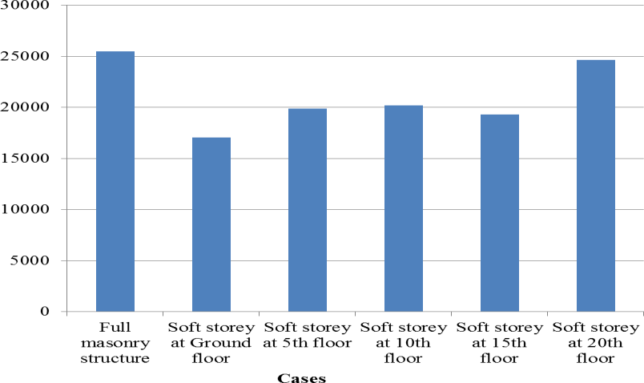

Figure 5: Bar graph showing variations in base shear of all the cases on Y-axis

**INTER-STOREY DRIFT INDEX**

A multi-story building's storey drift is the movement of one level in relation to the level below. The damage parameters lateral drift and inter-storey drift are often employed in structural analysis. This research examined the lateral drift of a 3D building structure under long-direction earthquake loads. Additionally assessed and recorded was the inter-storey drift index, which is represented by

Where, VUi – VUi-1 = Relative displacement between successive storey.

hi = Storey height.

The lack of masonry infill is responsible for the abrupt increase in drift index that is seen in all instances at the soft story level. At that floor, the lateral load is more efficient. The building's ground floor soft level has a higher drift index value. When soft story is at the top of the structure, the drift index value is quite low..

**STOREY STIFFNESS**

The degree to which an item resists deforming in the face of an applied force is known as stiffness, or rigidity. A soft storey, according to IS 1893:2016, is one whose lateral rigidity is lower than that of the level above. According to IS 1893:2002, a soft storey is one whose lateral stiffness is less than 80% of the average of the three storeys above or less than 70% of the level above. There is a reduction in the storey rigidity at the soft-story level. As we go higher, the stiffness goes down, thus as the storey height goes up, so does the storey stiffness. Following the decrement point, the prior curve continues. This indicates that the top part of the story is less rigid than the bottom part.

1. **CONCLUSIONS**

Buildings made on RC frames with soft floors are known to shake badly during big earthquakes. This project uses an example building to demonstrate how seismically vulnerable structures with soft storeys at various floor levels are. Using the software programme ETABS 2015, a tall structure with G+20 storeys is equipped with soft story at various floor levels to be assessed for the load in accordance with IS 1893:2016. The structure is in seismic zone III. The findings could be useful for future soft-story building development. From the outcome, it can be said that,

* Because more dynamic pressures are being applied to the soft storey level, the displacement of the storey rises. The infill wall enhances the stability of the building and may have a significant impact on the seismic behaviour of frame structures.
* At the soft story level, the storey rigidity always decreases. The columns in the soft story must be designed with additional care as a result. The rigidity of the structure is increased via infill panels. Because of this, the behaviour of a building changes when infill configurations alter.
* Compared to rigid constructions, buildings with soft storeys are less resistant to pressures. structures with soft storeys experience less base shear at various floor levels than rigid structures do. The base shear in a structure without a soft storey is determined to be at its maximum, or 25482.2 kN.
* When analysing the instances' storey responses, it is shown that buildings with soft storeys have far larger storey drift indices than rigid structures. Due to the building's high relative drift index, there were many unfavourable extra bending moments in the columns, which caused the whole structure to collapse. A building with an open first story frame may collapse under the force of a big earthquake because the storey drift index, which is 0.002068 in this example, is much higher than it is in the upper storeys.
* More reinforcing is needed for the soft story columns.At upper altitudes, it is advisable to give soft storey. The top floor is substantially stiffer than the open ground storey because of the walls above. As a result, the top level practically moves as a single unit, while the soft ground floor alone accounts for the majority of the building's horizontal displacement during an earthquake. Thus, it is evident that buildings with just columns in the ground stories perform worse during earthquakes than those with both walls and columns.

Buildings with open ground floors are widely recognised to be earthquake vulnerable. Without any lateral load resisting features, such as a shear wall or bracing, a building's strength is considered to be very weak and is susceptible to failure during an earthquake. Other strategies to accomplish the same goal include:

(i) Adding stronger columns to the first floor if the ground is soft, and

(ii) The building's inclusion of a concrete service core.

Only the first level columns' lateral drift need is reduced by the former. But the latter is beneficial in lowering drift and the demands on the soft story columns' strength.

1. **REFERENCES**
2. A. Madan, A. M. Reinhorn, J. B. Mander, R. E. Valles, “Modelling of Masonry Infill Panels for Structural Analysis”, Journal of Structural Engineering, October 1997.
3. Abhishek Arora, “Alternative Approach to Soft Storey in Seismic Analysis of R.C.C Building Structures”, April 2015.
4. Agarwal, P. and Shrikhande, M., “Earthquake Resistant Design of Structures”, PHI Publication, 2004.
5. Bhakti Narayan Harne, R. R. Shinde, “Seismic Performance of Multi-Storied RC Building with Soft Storey”, International Journal of Emerging Technology and Advanced Engineering, Volume 5/ pp.116-122/ 2015.
6. Bureau of Indian Standards, “Criteria for Earthquake Resistant Design Of Structures” IS: 1893 (Part I): 2016 (Sixth Revision).
7. Bureau of Indian Standards, “Code Of Practice For Design Loads (Other Than Earthquake) For Buildings And Structures: Special Loads And Combinations” IS: 875 ( Part 5 ) – 1997 (Second Revision).
8. Bureau of Indian Standards, “Plain and Reinforced Concrete – Code of Practice” IS: 456-2000 (Fourth Revision).
9. Bureau of Indian Standards, “Earthquake Resistant Design And Construction Of Buildings —Code Of Practice” IS: 4326-1993 (Second Revision).
10. C. V. R. Murty, “How do Brick Masonry houses behave during Earthquakes?”, Building Materials and Technology Promotion Council, New Delhi.
11. C. V. R. Murty, “Why are Open Ground Storey Buildings vulnerable in Earthquake?”, Indian Institute of Technology, Kanpur.