IOT BASED SCADA SYSTEM FOR A BTS SITE MONITORING SYSTEM

Syed Feroz Shah Ahmed1 (Ph.d )M.Tech, Y.Tejkumar2, B. R.Venkatesh3, A.Hari krishna4, V.Krushi5

Assistant Professor1, B. Tech scholors2,3,4,5

Department of Electronics and communication Engineering1,2,3,4,5

Santhiram Engineering College, Nandyal (Dist)1,2,3,4,5

Andhra Pradesh, India.

[feroz.ece@srecnandyal.edu.in1](mailto:feroz.ece@srecnandyal.edu.in1),[tejkumar464ece@srecnandyal.edu.in2](mailto:tejkumar464ece@srecnandyal.edu.in2),[venkatesh445@gmail.com3](mailto:venkatesh445@gmail.com3), [harikrishna402@gmail.com4](mailto:harikrishna402@gmail.com4), [krushi463@gmail.com5](mailto:krushi463@gmail.com5)

**Abstract:**

This paper points out controlling to the generator of power station, collecting the required information of the station, analyzing the communication metrics of the SCADA system and predicting the electricity production without hydrological events based on the historical data under the IoT-based SCADA system. SCADA system based on the IoT is the modernization of the SCADA system for hydropower station to get the required information and to conduct the power station for balancing with the national grid in a timely manner. This system supports the varieties of the information of the station such as alarm system, data monitoring and control system, data logging and generated capacity, and so on. Moreover, the performance of the IoTbased SCADA system such as communication metrics is analyzed by using the data packet analyzer and WiFi analyzer. In addition, historical data (generated electricity) is used to analyze and detect the circumstance of the production of hydropower stations and to predict the production for coming year by using the time series analysis. In this research, the actual historical data of the Yeywa hydropower station which is collected by on-ground recording is used for statistical analysis of generated capacity.

**Introduction**

SCADA is an abbreviation of “Supervisory Control and Data Acquisition” system. The SCADA system has been widely used for a variety of sectors such as water supply system, home automation system, industrial control system, electricity distribution system, power generation system, and so on [1]-[6]. Human Machine Interface (HMI) has already used as an industrial realistic monitoring system for power stations [7]. Nowadays, most of the industrial controls and automation systems use IoT (Internet of Things) devices to monitor and control system via the internet everywhere instead of HMI

SCADA monitoring and control system was implemented based on the ZigBee wireless communication protocol and NI LabVIEW interface [12]. The automatic SCADA monitoring system was designed by using RS-485 serial communication interface and Labview VISA program and then it analyzed the power on the AC load line [13]. These SCADA systems carried out the monitoring and control system that can be applied to the operators at the same locations in the station. Thus, only the SCADA system is an impossible benchmark automatic control and monitoring system to inspect and collect the real-time information from a longer distance location. When the SCADA system combines with IoT technology, it will grow up as a modernized SCADA system.

In this research, IoT-based SCADA system design is proposed for hydropower stations to collect the acquired data and control the generator of the power station. The main objective of IoT-based SCADA systems is to design the user interface, to find out up-to-date station information and to conduct the power station on any location with the internet access

The IoT-based SCADA system is composed of Master Terminal Unit (MTU) and Remote Terminal Unit (RTU) over the wireless network and its performance is a very important factor that is the data transmission and receiving process. Network traffic was analyzed and monitored by the users via the internet by using the packet sniffer method such as Wireshark tool [15]. SCADA system would go down because of the data traffic bottleneck that is due to malware threats and attacks. Therefore, data traffic is analyzed by using the Wireshark to test the SCADA network’s situation [16]. The signal strength of the wireless network is appraised by network performance tools: InSSIDer, Acrylic Wi-Fi, Xirrus, Netspot

In this research, the performance of the IoT-based SCADA system is measured and tested by using the Wireshark data packet analyzer and then the location of the RTU from Internet Service Provider (ISP) is regarded by using the Netspot WiFi analyzer

The performance of the hydropower station can be analyzed over the historical data received from the SCADA system. The production of the hydropower station is predicted by using the time series model: ARIMA in Ecuador [19]. Most authors analyzed the electricity consumption and smart technology provided not only to get the load consumption profiles but also to conduct the electricity load demand, and smart meters were used to obtain electricity consumption profiles which are the main role to balance the power purchase and power sales portfolio of developers.

**Existing System:**

People may have gotten sick from the garbage in past projects since they weren't properly cleaned. And there is a time when dusting is appropriate and a time when it is not. The government should stop spending so much time and start maintaining every street by checking to see whether the dustbins are full or empty. As a result, urban areas get zero propose cleaning.

**Proposed System:**

IoT-based SCADA system is a low-cost M2M industrial 4.0 technology and supports the operators to monitor the desired information and control the power station upon the generated capacity. The performance of IoT-based SCADA system is analyzed by using the data packet analyzer and the location of RTU is regarded by using the WiFi analyzer. The performance of the tolerance (±3%) is very well on hardware implementation and the result of throughput (6720 bps) and RTT (42.052ms) are very rapid to post the data from RTU to MTU under the communication metrics analysis for SCADA system. Statistical data analysis on this research assists the hydropower station how to control the condition of electricity generation in the dry season and wet season to justify the fulfillment of electrification for the country pursuant to the collected annual generated electricity. The deviation of annual generation between the actual value and predicted value for the year of 2020 is 4% which is calculated by using the lease square.

**METHODOLOGY:**

Several scientists have looked into the potential of IoT technology and created new uses for automated cities, particularly in the realm of garbage collection. A simple method was developed for determining whether or not garbage cans were full; it gathered data and sent it through wireless mesh network, reducing power consumption and maximizing operating time [5]. Yet, there are still some unclear aspects to the plan. While [14] launched smart city platform software for better waste management, this software primarily focused on data collecting and relied on the technology of third parties.

On the other side, there are methods that use optimization to create effective waste management systems. Using IOT SCADA equipment and route optimization, the authors of [15] proposed a waste administration and control stage suitable for deployment in rural locations. In addition, an IoT-based solution was put up, however it lacked transparency in terms of garbage can connection and optimization. In [16], academics from Philadelphia, United States, used a system based on multiple regressions (LR) and heuristic algorithm (GA) techniques to assess the health of smart garbage cans and choose a collection route. They also did not include any methods for data communication from the garbage can to the rest of the system's hardware. IoT-based waste management has specific optimization algorithms that have been devised, such as closest neighbor search, colony optimization, algorithm, and optimization ( pso [17, 18]. Without using any algorithms to improve trash collection, the authors of [19] suggest a way to manage a garbage system connected with IoT technology: an autonomous line-following truck with a robotic hand for rubbish collection. In [20], the project delivered an IoT framework for a fully automated garbage collection system, allowing for continuous monitoring and user interaction. The focus of this study is not on optimizing garbage collecting systems, but rather on presenting an Internet of Things cloud solution that integrates refers to promoting, data processing, and control. In [21], a system for collecting food waste is described in which data is gathered by RFID tags and transferred over a wireless mesh network. Considering that one of the primary goals of a smart city is large-scale administration, the long-term drawbacks of this technology are significant. The optimization algorithm's final output was too imprecise to be used to improve a functioning system like a city.

**Block Diagram**

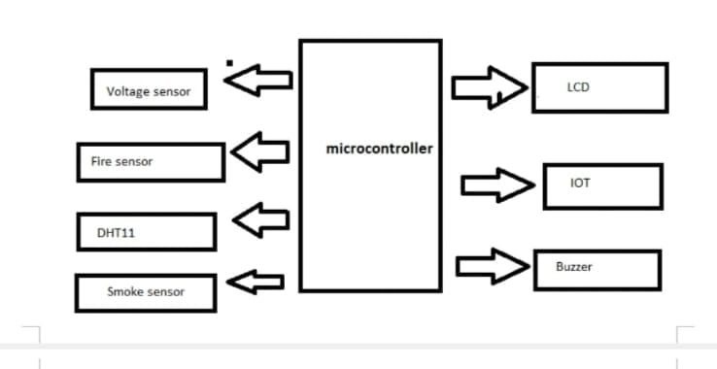

* Central Processing Unit (CPU)
* Memory (Read-only Memory and Random Access Memory)
* Input Devices
* Output devices
* Communication interface
* Application-specific circuitry

## Central Processing Unit (CPU) :

The Central Processing Unit (processor, in short) can be any of the following: microcontroller, microprocessor or Digital Signal Processor (DSP). A micro-controller is a low-cost processor. Its main attraction is that on the chip itself, there will be many other components such as memory, serial communication interface, analog-to digital converter etc. So, for small applications, a micro-controller is the best choice as the number of external components required will be very less. On the other hand, microprocessors are more powerful, but you need to use many external components with them. D5P is used mainly for applications in which signal processing is involved such as audio and video processing.

## Memory:

The memory is categorized as Random Access 11emory (RAM) and Read Only Memory (ROM). The contents of the RAM will be erased if power is switched off to the chip, whereas ROM retains the contents even if the power is switched off. So, the firmware is stored in the ROM. When power is switched on, the processor reads the ROM; the program is program is executed.

## Input devices:

Unlike the desktops, the input devices to an embedded system have very limited capability. There will be no keyboard or a mouse, and hence interacting with the embedded system is no easy task. Many embedded systems will have a small keypad-you press one key to give a specific command. A keypad may be used to input only the digits. Many embedded systems used in process control do not have any input device *for* user interaction; they take inputs *from* sensors or transducers 1’fnd produce electrical signals that are in turn fed to other systems.

## Output devices:

the output devices of the embedded systems also have very limited capability. Some embedded systems will have a *few* Light Emitting Diodes (LEDs) *to* indicate the health status of the system modules, or *for* visual indication of alarms. A small Liquid Crystal Display (LCD) may also be used to display *some* important.

## Communication interfaces

The embedded systems may need to, interact with other embedded systems at they may have to transmit data to a desktop. To facilitate this, the embedded systems are provided with one or a *few* communication interfaces such as RS232, RS422, RS485, Universal Serial Bus (USB), IEEE 1394, Ethernet etc.

## Application-specific circuitry

Sensors, transducers, special processing and control circuitry may be required fat an embedded system, depending on its application. This circuitry interacts with the processor to carry out the necessary work. The entire hardware has to be given power supply either through the 230 volts main supply or through a battery. The hardware has to design in such a way that the power consumption is minimized.

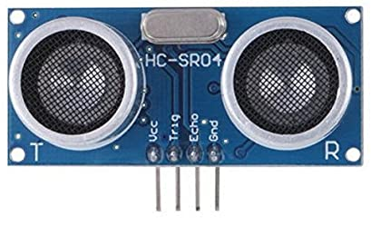

**Buzzer**

A buzzer or beeper is an audio signaling device, which may be mechanical, electromechanical, or piezoelectric (piezo for short). Typical uses of buzzers and beepers include alarm devices, timers, and confirmation of user input such as a mouse click or keystroke.

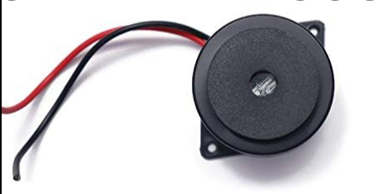

**LCD Connections:**

Depending on how many lines are used for connection to the microcontroller, there are 8-bit and 4-bit LCD modes. The appropriate mode is determined at the beginning of the process in a phase called “initialization”. In the first case, the data are transferred through outputs D0-D7 as it has been already explained. In case of 4-bit LED mode, for the sake of saving valuable I/O pins of the microcontroller, there are only 4 higher bits (D4-D7) used for communication, while other may be left unconnected.

Consequently, each data is sent to LCD in two steps: four higher bits are sent first (that normally would be sent through lines D4-D7), four lower bits are sent afterwards. With the help of initialization, LCD will correctly connect and interpret each data received. Besides, with regards to the fact that data are rarely read from LCD (data mainly are transferred from microcontroller to LCD) one more I/O pin may be saved by simple connecting R/W pin to the Ground. Such saving has its price. Even though message displaying will be normally performed, it will not be possible to read from busy flag since it is not possible to read from display.

**FIRE SENSOR:**

An infrared (IR) sensor is an electronic device that measures and detects infrared radiation in its surrounding environment. Infrared radiation was accidentally discovered by an astronomer named William Herchel in 1800. While measuring the temperature of each color of light (separated by a prism), he noticed that the temperature just beyond the red light was highest. IR is invisible to the human eye, as its wavelength is longer than that of visible light (though it is still on the same electromagnetic spectrum). Anything that emits heat (everything that has a temperature [above around five degrees Kelvin](https://www.livescience.com/50260-infrared-radiation.html)) gives off infrared radiation.

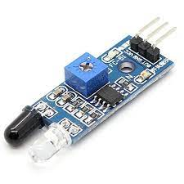

**RESULT:**

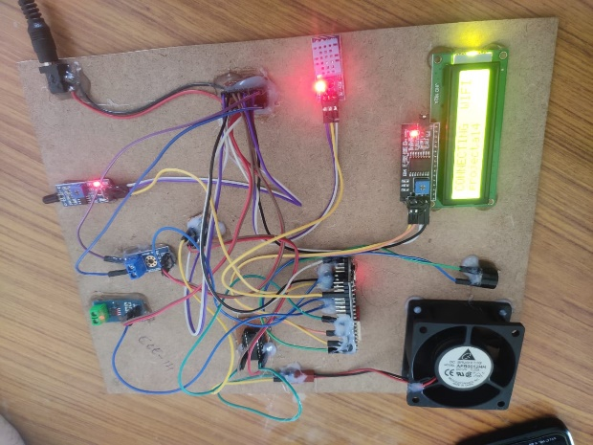

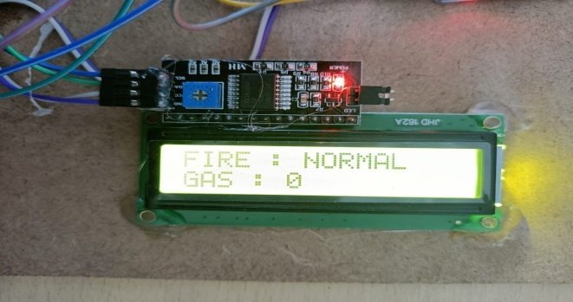

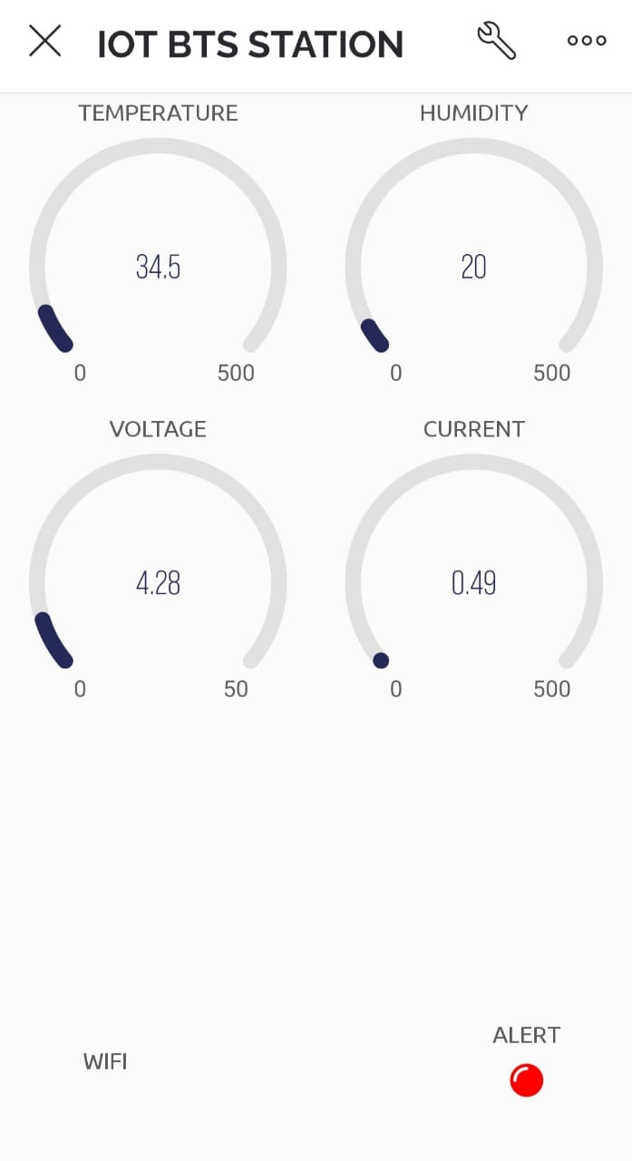

**CONCLUSION:**

IoT-based SCADA system is a low-cost M2M industrial 4.0 technology and supports the operators to monitor the desired information and control the power station upon the generated capacity. The performance of IoT-based SCADA system is analyzed by using the data packet analyzer and the location of RTU is regarded by using the WiFi analyzer. The performance of the tolerance (±3%) is very well on hardware implementation and the result of throughput (6720 bps) and RTT (42.052ms) are very rapid to post the data from RTU to MTU under the communication metrics analysis for SCADA system. Statistical data analysis on this research assists the hydropower station how to control the condition of electricity generation in the dry season and wet season to justify the fulfillment of electrification for the country pursuant to the collected annual generated electricity. The deviation of annual generation between the actual value and predicted value for the year of 2020 is 4% which is calculated by using the lease square line regression method. For a hydropower station, this value is very small for generation forecasting. Moreover, the usage of electrification in 2020 is lower than another year because of COVID-19 pandemic in Myanmar. So, this method can be safety used to forecast the generation for all power stations in coming year. After upgrading and modifying this IoT-based SCADA system design, it is able to reduce human resources as an employee, to operate the power station with safety and to timely collect the station information.

**REFERENCES**

[1] D. Babunski, E. Zaev, A. Tuneski, and D. Bozovic, “Optimization methods for water supply SCADA system,” in Proc. 7th Mediterranean Conf. on Embedded Computing (MECO), Budva, Montenegro, 2018, pp. 11-14. [2] O. Krejcar, “Complete low cost SCADA system of the intelligent house,” in Proc. 10th IEEE Jubilee Int. Symposium on Applied Machine Intelligence and Informatics (SAMI), Herl'any Slovakia 2012, pp. 339-343. [3] J. Mathew, S. Shankar, H. Pratheesh, B. R. Singh, C. Lajitha, and A. M. Irshad, “Implementation of high availability SCADA system for superheater steam temperature control in a 210MW thermal power plant,” in Proc. IEEE Int. Conf. on Electronics, Computing and Communication Technologies (CONECCT), Bangalore, 2014, pp. 1-6. [4] M. Regula, A. Otcenasova, M. Roch, R. Bodnar, and M. Repak, “SCADA system with power quality monitoring in smart grid model,” in Proc. IEEE 16th Int. Conf. on Environment and Electrical Engineering (EEEIC), Florence, 2016, pp. 1-5. [5] G. Schneider, V. F. de Lima, L. G. Scherer, R. F. de Camargo, and C. M. Franchi, “SCADA System Applied To Micro Hydropower Plant,” in Proc. 39th Annual Conf. of the IEEE Industrial Electronics Society, 2013, pp. 7205-7209. [6] D. L. Hakim, A. G. Abdullah, and Y. Mulyadi, “SCADA application for geothermal power plant,” Journal of Engineering Science and Technology, vol. 15, no. 2, pp. 1018-1031, 2020. [7] L. Padeanu, M. Svoboda, F. M. Frigura-Iliasa, and P. Andea, “Human machine interface for a SCADA system applied on a district heating power plant,” in Proc. Int. Conf. on Information and Digital Technologies, Zilina, 2015, pp. 272-277. [8] S. K. Vishwakarma, P. Upadhyaya, B. Kumari, and A. K. Mishra, “Smart energy efficient home automation system using IoT,” in Proc. India, 4th Int. Conf. on Internet of Things: Smart Innovation and Usages (IoT-SIU), Ghaziabad, 2019, pp. 1-4. [9] A. K. Gupta and R. Johari, “IoT-based electrical device surveillance and control system,” in Proc. 4th Int. Conf. on Internet of Things: Smart Innovation and Usages (IoT-SIU), Ghaziabad, India, 2019, pp. 1-5. [10] K. Chooruang and K. Meekul, “Design of an IoT energy monitoring system,” in Proc. 16th Int. Conf. on ICT and Knowledge Engineering (ICT&KE), Bangkok, 2018, pp. 1-4. [11] L. O. Aghenta and M. T. Iqbal, “Development of an IoT-based open source SCADA system for PV system monitoring,” in Proc. IEEE Canadian Conf. of Electrical and Computer Engineering (CCECE), Edmonton, AB, Canada, 2019, pp. 1-4. [12] S. Paul and S. Narang, “Design of SCADA based wireless monitoring and control system using ZigBee,” in Proc. Annual IEEE India Conf. (INDICON), New Delhi, 2015, pp. 1-6. [13] H. Singh and G. Mangeni “RS based SCADA system for longer distance powered devices,” Int. Journal of Electrical, Computer, Energetic, Electronic and Communication Engineering, vol. 10, no. 2, pp. 155-161, 2016. [14] A. K. Myint, K. Z. Latt, T. T. Hla, and N. M. Tun, “Implementation of SCADA system for hydropower station,” in Proc. 2nd Joint Int. Conf. on Science, Technology and Innovation, Mandalay, Myanmar, 2019, pp. 60-64. [15] A. Siswanto, A. Syukur, E. A. Kadir, and Suratin, “Network traffic monitoring and analysis using packet sniffer,” in Proc. Int. Conf. on Advanced Communication Technologies and Networking (CommNet), Rabat, Morocco, 2019, pp. 1-4. [16] H. Hilal and A. Nangim, “Network security analysis SCADA system automation on industrial process,” in Proc. Int. Conf. on Broadband Communication, Wireless Sensors and Powering (BCWSP), Jakarta, 2017, pp. 1-6. [17] S. Rahane, S. Ulekar, R. Vatti, T. Meshram, and S. Male, “Comparison of wireless network performance analysis tools,” in Proc. Int. Conf. on Current Trends towards Converging Technologies, Coimbatore, 2018, pp. 1-4. [18] A. K. Myint, K. Z. Latt, T. T. Hla and N. M. Tun, “Analysis on communication metrics of SCADA system for hydropower station,” in Proc. Universal Academic Cluster International March Conf., Bangkok, 2020, pp. 68-80. [19] M. Mite-Leon and J. Barzola-Monteses, “Statistical model for the forecast of hydropower production in Ecuador,” Int. Journal of Renewable Energy Research, vol. 8, no. 2, pp. 1130-1137, June 2018. [20] N. Beliaeva, A. Petrochenkov, and K. Bade, “Data set analysis of electric power consumption,” European Researcher, vol. 61, no 10-2, pp. 2482-2487, 2013. [21] P. Wu and J. Tan, “The design of distributed power big data analysis framework and its application in residential electricity analysis,” in Proc. Sixth Int. Conf. on Advanced Cloud and Big Data (CBD), Lanzhou, 2018, pp. 77-82. [22] U. Ali, C. Buccella, and C. Cecati, “Households electricity consumption analysis with data mining techniques,” in Proc. 42nd Annual Conf. of the IEEE Industrial Electronics Society, Florence, 2016, pp. 3966-3971. [23] A. Sauhats, R. Varfolomejeva, O. Lmkevics, R. Petrecenko, M. Kunickis, and M. Balodis, “Analysis and prediction of electricity consumption using smart meter data,” in Proc. IEEE 5th Int. Conf. on Power Engineering, Energy and Electrical Drives (POWERENG), Riga, 2015, pp. 17-22. [24] China Gezhouba Water and Power (Group) Co., Ltd., Operation and Maintenance Manual for Mechanical & Electrical Equipment for Shwegyin Hydropower Plant, Myanmar, vol. 4, 2009.