Advance Notice Based Display Projector

Author: Deepak Katadhire, Diksha Bari, Shivani More, Umar Siddiqui

Department: TSEC – Department of Electrical Engineering

City: Burhanpur, M.P.

# ABSTRACT

The end of this study is to design a compact LED projector that is divided into two systems an illumination system and an imaging optical system. This illumination system consists of an RGB LED light source with a collimator lens group and a glass with a color sludge and a lens array integrator rather of an integrated rod so as to meliorate the uniformity of the light intensity. By using a new total internal reflection prism and projection lens, the whole optical machine is lower in size and has a advanced distinction rate for image quality. The imaging optical system consists of a total of eight lenses (six spherical lenses and two a spherical lenses), for a total length of 52 mm; a forbearance analysis is conducted. For this system analysis, optical simulation software is employed to assess the efficacy and uniformity of the light intensity. In this design, the uniformity of the screen reaches further than 82, and the effectiveness increases by approx. 44.

# INTRODUCTION

A device known as an LED projector uses light- emitting diodes to project video content onto a flat screen. It ensures users of premium picture quality. It also eliminates the requirement to project content using outmoded halogen lighting. iCODIS combines the potential of LED projectors in small, portable devices. These devices are further enhanced by a host of other capabilities, such the ability to provide users access to Android applications and live streaming options. The high production levels of these LED projectors are likely to astound you right away. You may stream and project your preferred music videos, videos, TV shows, movies, and many other files on a flat-screen while you're on the go with the help of these gadgets. The days of transporting bulky boxed projectors are quickly passing away. The development of pocket-sized dynamic LED projectors that are significantly more useful, effective, and portable is entirely the responsibility of iCodis. iCodis' new technological brilliance, included in their LED projectors, replaces wires and space-consuming gadgets.

# LITERATURE REVIEW

1. (18 April 2013) Csinan Many teachers believe that with the introduction of projectors in the classroom, chalkboards are all but obsolete. Through the use of projectors, instructors may use PowerPoint presentations, graphics, and even video as teaching aids in place of writing notes on the board. Projectors are therefore practical classroom tools that are appreciated by both teachers and students, objectors, replaces wires and space-consuming gadgets.
2. Study on a compact LED projector design with great uniformity and efficiency, Chuen-Lin Tien, October 2014. The objective of this research is to develop a small LED projector with two separate systems: an illuminating system, and an imaging optical system. To increase the uniformity of the light intensity, the lighting system substitutes an integrated rod for an RGB LED light source with a collimator lens group, a mirror with a colour filter, and a lens array integrator.
3. 4, April 2019, Researchers Ipsa Lal, Zeba Mujawar, Arbaaz Utkoor, and S.S. Hippargi examined the little LED projector. the Raspberry PiA credit card- sized, budget-friendly computer called the Raspberry Pi connects to a computer display or television and operates with a regular keyboard and mouse. A number of hardware iterations of the Raspberry Pi have been produced, each with a different amount of memory and support for external devices.

**COMPONENTS**

1. LCD Screen
2. SMPS(switch mode power supply)
3. Motherboard
4. Speaker
5. Fan
6. OHP Mirror
7. High power led
8. OHP Fresnel lens
9. Projector Lens

**CONSTRUCTION AND WORKING**

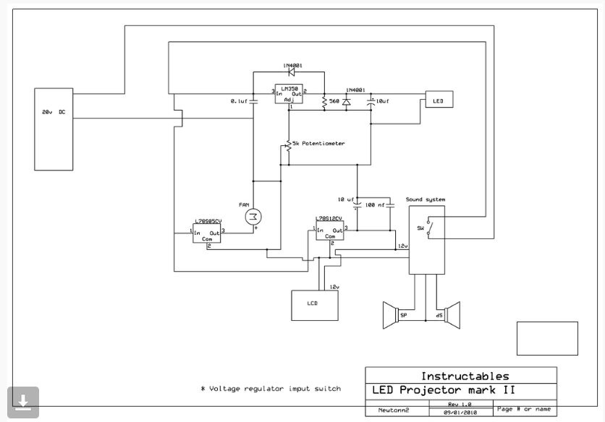

Single chip, high brightness LED projectors are now achievable because to the rapid development of LEDs as projector light sources. Efficiency, dependability, and image quality are improved when LED lighting is used in conjunction with single chip DLP projection technology. These technologies innately provide colourful visuals that are bright and have a large colour spectrum. As LEDs take over as the primary source of illumination for all applications, high power LEDs are getting brighter and more efficient.

**ADVANTAGES**

1. Large Picture Size
2. Best Alternative for Large Screen Television
3. Low Cost
4. Space Saving
5. Easy To Install
6. Better Experience
7. Easy to install

**DISADVANTAGES**

1. A dark room is very often required to use a projector.
2. It requires maintenance on regular intervals.
3. Installation Cost can be more in some cases as it depends upon how you get it installed.
4. Most of the projectors need a separate audio system.

**APPLICATIONS**

1. Engineering Projectors
2. Educational and Classroom Projectors
3. Advertising and Art Installation Projectors
4. The Versatile Short-Throw Projectors
5. Non-Portable Vintage Business
6. Menu Projection in a Restaurant
7. Seasonal Decorations

**CONCLUSION**

According to the material presented and the study conducted, organic LED displays have the most potential for use in future panoramic displays. The commercial and exhibiting opportunities will become more widely known when the display technology builds a production infrastructure like to those of LCDs and CRTs. Pass-through displays lack several of the more important characteristics required for the aesthetics of screen presentation, such as gamut, resolution, and overall fidelity, although showing tremendous promise with the prospect for floor embedded housing and walk through panels. People wishing to build a panorama using the Pass-through screens now made should exercise care due to the high cost of entry and the concerns mentioned above.

For overall consumer market relevance, picture positioning flexibility, and image quality, projectors are currently the preferred option. Projectors may offer a very good answer for the development of a panoramic environment if attention is given in the selections for the environment and design. The content of the image that will be shown in a panoramic context must also be carefully considered. As a result of the knowledge obtained through comprehending the various presentations, various presenting techniques may improve the overall aesthetic of the panorama being exhibited.

**REFERENCES**

1. Knowledge about projector, [https://www.makeuseof.com/how-does-a-](https://www.makeuseof.com/how-does-a-projector-work/) [projector-work/](https://www.makeuseof.com/how-does-a-projector-work/)
2. Construction Idea, <https://www.instructables.com/DIY-Multimedia-LED-Projector/>
3. Components, [https://www.analog.com/en/analog-](https://www.analog.com/en/analog-dialogue/articles/how-to-control-fan-speed.html) [dialogue/articles/how-to-control-fan-speed.html](https://www.analog.com/en/analog-dialogue/articles/how-to-control-fan-speed.html)
4. Compact LED projector design with high uniformity and efficiency, [https://www.researchgate.net/publication/26632](https://www.researchgate.net/publication/266326218_Compact_LED_projector_design_with_high_uniformity_and_efficiency) [6218_Compact_LED_projector_design_with_hi](https://www.researchgate.net/publication/266326218_Compact_LED_projector_design_with_high_uniformity_and_efficiency) [gh_uniformity_and_efficiency](https://www.researchgate.net/publication/266326218_Compact_LED_projector_design_with_high_uniformity_and_efficiency)
5. OHP LENS and MIRROR- https://[www.tech-faq.com/how-overhead-](http://www.tech-faq.com/how-overhead-) projectors-work.html
6. Working Idea and block digram, [https://www.researchgate.net/figure/Circuit-](https://www.researchgate.net/figure/Circuit-diagram-of-the-electronics-used-to-flicker-a-conventional-LED-projector-The_fig2_260874911) [diagram-of-the-electronics-used-to-flicker-a-](https://www.researchgate.net/figure/Circuit-diagram-of-the-electronics-used-to-flicker-a-conventional-LED-projector-The_fig2_260874911) [conventional-LED-projector-](https://www.researchgate.net/figure/Circuit-diagram-of-the-electronics-used-to-flicker-a-conventional-LED-projector-The_fig2_260874911)
7. [The_fig2_260874911](https://www.researchgate.net/figure/Circuit-diagram-of-the-electronics-used-to-flicker-a-conventional-LED-projector-The_fig2_260874911)
8. Advantages and Disadvantages, [https://www.linkedin.com/pulse/advantages-](https://www.linkedin.com/pulse/advantages-disadvantages-led-lucas-du) [disadvantages-led-lucas-du](https://www.linkedin.com/pulse/advantages-disadvantages-led-lucas-du)
9. Other Knowledge, https://[www.soundandvision.com/content/digital](http://www.soundandvision.com/content/digital)-projection-m-vision-cine-led-dlp-projector- conclusion Guided by, Mr. Umar Siddiqui.