A REVIEW PAPER ON COLUMNS WITH SPIRAL REINFORCEMENT UNDER CONCENTRIC COMPRESSION

**KRISHNA MOHAN BHARTI 1, MR. RAVINDER PANWAR2, REFAZ UR REHMAN3**

1 M.Tech Scholar, Ganga Institute Of Tech. & Management, Jhajjar, India

[krishnabharti22799@gmail.com](mailto:krishnabharti22799@gmail.com)

2 Assistant Professor, Ganga Institute Of Tech. & Management, Jhajjar, India

[ravinderpanwar7043@gmail.com](mailto:moharpardeep@gmail.com)

3 Assistant Professor, Ganga Institute Of Tech. & Management, Jhajjar, India

refazgitm[@gmail.com](mailto:refazgitm@gmail.com)

# ABSTRACT

The experimental study concerns the behaviour of circular cross-sectional structures (such as piles or columns) under an axial compressive force. The study used 10 column specimens of 205mm in diameter and 800mm in height. The primary factors whose effects were investigated are: Spiral reinforcement ratio, Density (step) of spiral reinforcement, Ductility of spiral reinforcement, Strength of spiral reinforcement, and Possibilities for enhancing the mechanical behaviour (strength and ductility) of these components by using either special ties or fibre reinforced concrete. Stress-strain graphs are created using the results of the experiments, and they led to some intriguing findings.

**Keywords*:*** *Columns, Spiral reinforcement, Compression, Circular*

1. **INTRODUCTION**

There is no mechanical characteristic in which circular cross-section columns with spiral reinforcing underperform their rectangular counterparts. Due to the greatly increased strength provided by the concrete confinement resulting from the presence of spiral reinforcement, their use in regions with less seismic risk might result in a decrease of the cross section. Due to its greater ductility, they demonstrate their advantage in earthquake-prone areas. The Olive View Hospital columns' historic role in the San Fernando earthquake of 1971 is well-known. Constructional factors, such as the issue with their formwork or the installation of the spiral reinforcement, contribute to the columns in question not receiving, at least not in our nation, the spread to which they are legally entitled. However, with the spread of single-use paper formwork and the potential standardisation of metallic spirals, construction barriers are now being removed, and it's possible that the only things standing in the way are people's ignorance of the advantages and the historical momentum that is unquestionably in favour of rectangular section columns. However, it's odd that the rules don't pay enough attention to its design, particularly the seismic design. To provide one example, their check against shear has no prediction. Additionally, a significant difference in the minimum acceptable reinforcement ratio, which was equal to 2% in the older version compared to 1% in the new version, can be seen if one compares the relevant article &18.4.7 of a recent issue (2000) of the reformed Greek Concrete Code with the same article in a previous issue (1991) of the code. According to the authors, the only explanation for this significant discrepancy is a lack of accurate information.Applications of high-strength concrete (HSC), or increased concrete strength higher than the maximum stipulated quality (C50) of the Regulations, are a contemporary issue whose solution is linked to the employment of spiral reinforcing . According to the literature, high strength concretes are defined as having a strength more than 80 MPa. However, it is well known that as concrete strength rises, the material becomes more brittle; similarly, steel loses ductility as yield strength rises. A column or pillar is a crucial part of structural engineering and architecture because it uses compression to distribute the weight of the framework above to other structural elements. Column is a density component as a result. The column is regarded to be a massive spherical support with a base, capital, or pedestal that is typically made of pebbles or another solid material. A post is a small metal or wooden support that extends through another rectangular or non-round area, generally referred to as piers. Piers may also have a rounded shape, as in connections. The columns are designed to limit lateral force, including that from strong winds and earthquakes. The columns that are often constructed to support arches and beams support the top portions of walls and ceilings. The main element of a structure's design is a column, which has certain ornamental and proportional qualities. Sometimes, rather of serving as a structural support or source of strength, columns are utilised just for decoration.

1. **LITERATURE REVIEW**

**C.G.Karayannis** studied on the behaviour of rectangular spiral reinforced concrete beams Experimental investigation is done into reinforcement under monotonic loading. Three beam specimens with a ratio of 2.67 were built in this direction and put to the test under monotonic shear stress. Common stirrups were present in the first example, spiral transversal reinforcement was present in the second, and favourably inclined legs were present in the third spiral transversal reinforcement. The specimens with continuous spiral shear reinforcement showed 15% and 17% greater shear strengths than the beam with closed stirrups, according to the experimental findings and behavioural curves of the tested beams, respectively. Additionally, compared to the other beams, the one with spiral transversal reinforcement and advantageously inclined legs demonstrated improved performance and a more ductile reaction.

**Ioannis A. Tegos** The behaviour of circular cross-section structures (piles or columns) under axial compressive force is experimentally explored in this paper. 10 column specimens of 205mm in diameter and 800mm in height were examined. Spiral reinforcement ratio, spiral reinforcement density (step), and spiral reinforcement ductility are the primary variables whose effects were evaluated. The durability of spiral reinforcement and the possibilities for enhancing the mechanical behaviour (strength and ductility) of these components by utilising fibre reinforced concrete or unique ties. Using data from experiments, stress-strain The experimental study of Ioannis A. Tegos concerned the behaviour of circular cross-sectional structures (such as piles or columns) when subjected to an axial compressive force. 10 column specimens of 205mm in diameter and 800mm in height were examined. Spiral reinforcement ratio, Density (step) of spiral reinforcement, Ductility of spiral reinforcement, Strength of spiral reinforcement, and Possibilities for enhancing the mechanical behaviour (strength and ductility) of these components by using either special ties or fibre reinforced concrete are the main parameters whose influence was examined. Using research findings, stress-strain.

1. **EXPERIMENTAL INVESTIGATION**

**Objectives – Variables**

The current study is a component of a larger research project that was carried out at the Aristotle University of Thessaloniki's Laboratory of Reinforced Concrete and Masonry Structures.

The following are the work's main goals:

a) Examining the potential for enhancing confinement outcomes using different tool combinations.

b) Researching the impact of steel's ductility on the outcomes of confinement.

The parameters studied in this paper mainly refer to the characteristics of spiral reinforcement as:

The step of the spiral

The diameter of the spiral

The yield limit of the spiral

The ductility of the spiral

In the context of examining the possibilities of improving the results through appropriate combinations of spiral reinforcement with other ways of improving confinement, the following combinations of spiral reinforcement with other materials were tested:

**Fiber reinforced concrete**

**Conventional ties**

As was noted in the introduction, the elimination of brittleness in high-strength concretes is efficiently accomplished by the combination of spiral reinforcement and steel fibre reinforced concrete . But the second approach—which is simpler to put into practice—was inspired by a genuine issue with a technological structure put up in Greece's north. Pile columns were incorporated in this project, and although they were reinforced longitudinally, they lacked spiral reinforcing. In light of this, the project manager requested actions to finish the transverse reinforcement. However, because the densification of the already-installed spiral reinforcement could not be fixed, it was planned to complete the spiral reinforcement using conventional ties, which were simple to install as opposite stirrup pairs. According to Section 18.4.4 of the Greek Concrete Code, "The Supervision does not confine itself to the computational coverage of the "solution and an additional experimental assessment of the potential for superposition of the two techniques of confinement was made. The concrete's quality, which was maintained constant for all specimens, and the absence of longitudinal reinforcement, which was present in all specimens, are the criteria that did not alter in the work's test specimens. It should be emphasised that three spiral reinforcement step instances (20, 35, and 50mm) were evaluated. The middle one complies with the Greek Concrete Code's [5] minimum requirement that the largest step not exceed 20 percent of the core section's diameter (35 = 0.2 x 175). The first value reacts to strong confined columns, while the third value is beyond the bounds of the Code [5]. The other two values are symmetrical with regard to the prior one.One of the two primary goals of the research—investigating the impact of spiral reinforcement's ductility on confinement results—was combined with the selection of two diameters of spiral reinforcement. The diameters 4.2 and 5.5 were selected, with the first relating to steel that is essentially non-ductile and has a failure strength of 800MPa, and the second relating to ductile steel that has a failure strength of 475MPa. Figure 5 provides stress-strain graphs for the two types of steels. The same tensile capacity in both cases was the selection criterion for the diameters with the previously described characteristics, but in one diameter (4.2), there was no steel ductility available, whereas in the other diameter (5.5), S400-classified steel ductility was available. The formula w = (4 As fys) / (D s fc), where As is the area cross-section of the spiral, D is the core diameter, s is the spiral step, and fys and fc are the material strengths, is used to compute the mechanical reinforcement percentages corresponding to steps s. Therefore, the appropriate mechanical reinforcement ratios for the three examples of steps of 20, 35, and 50mm were 0.05, 0.03, and 0.02.

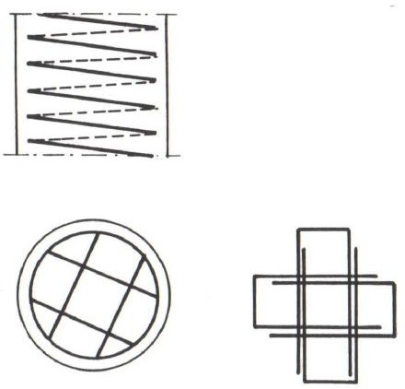

**Fig. 1**: Strengthening of confinement results by placing conventional ties

**Specimens – Measurements**

Nine circular cross-section columns with C25 concrete quality and no longitudinal reinforcing are included in the work. The features of the specimens' spiral reinforcement are listed in Table 1. The table's last column lists additional measures to enhance confinement that only apply to specimens 8 and 9. Traditional ties of specimen 8 feature .The ties have a 4.2 mm diameter and a 35 mm spacing between them. Additionally, specimen 9's fiber-reinforced concrete has a metal fibre percentage of Vf = 0.75% by volume. The aspect ratio of the fibres is 60 (l/d).In order to compare test specimens and determine how spiral reinforcement affects strength and confinement, test specimen 1 was built without reinforcement. The specimens have the following measurements: an exterior diameter of 205mm, a core diameter of 175mm, and a height of 800mm. A appropriate drum was used to create the spiral reinforcement. To account for the inescapable "fluff" following the drum, the diameter of the drum was less than the spiral's ultimate diameter. In order to reduce the influence of manufacturing flaws in these crucial locations, which (flaws) might lead to early failure owing to rupture phenomena, the spiral reinforcement's pitch was compressed to 10 mm at the ends of the specimens. These spirals were likewise positioned at the unreinforced specimen 1's margins. The spiral reinforcement of a specimen with pitch inspissation at the ends is shown in Fig.

The largest grain size in the concrete sample was 16 mm. Six cylindrical specimens measuring 15/30 cm were utilised for quality testing of the concrete, and the test specimens were concretized on a vibrating table with them. These control specimens were used to determine the 25MPa concrete strength. All specimens were kept in a water tank for upkeep. The specimens were loaded onto the load device (laboratory press) after they reached the necessary strength of 25 MPa. After that, they were subjected to an axial compressive load that was applied gradually and slowly while, at the same time, the specimen's shortening was observed at load stages of 50kN . A appropriate strain gauge with a wide range was used to record the shortening.

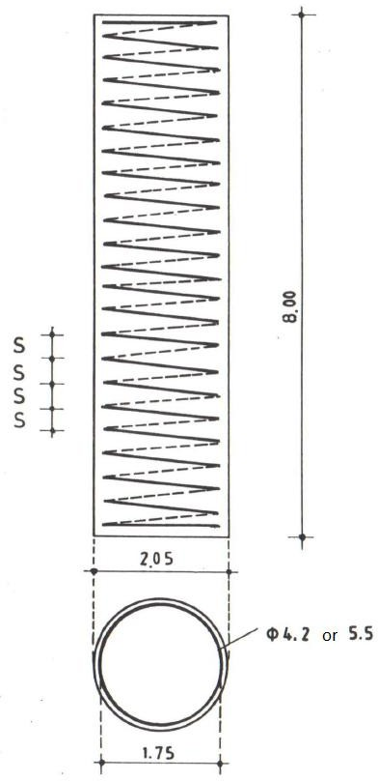

**Fig. 2**: Typical specimens’ spiral reinforcement

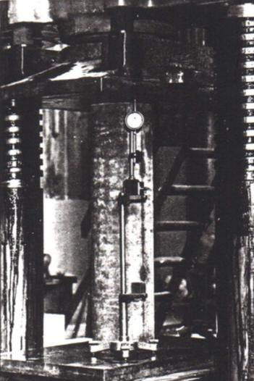

**Fig. 3**: Test setu

**Table 1**: Characteristics of specimens’ spiral reinforcement

|  |  |  |  |  |  |  |  |  |
| --- | --- | --- | --- | --- | --- | --- | --- | --- |
|  | fc (MPa) | Spiral reinforcement | | | | | | |
| Ø  (mm) | s (mm) | fys (MPa) | Ø  (mm) | s (mm) | fys (MPa) | Additional confinement |
| 1 | 25.5 | - | - | - | - | - | - |  |
| 2 | 26.0 | 4.2 | 20 | 800 | - | - | - |  |
| 3 | 25.0 | 4.2 | 35 | 800 | - | - | - |  |
| 4 | 26.0 | 4.2 | 50 | 800 | - | - | - |  |
| 5 | 25.5 | - | - | - | 5.5 | 20 | 475 |  |
| 6 | 24.5 | - | - | - | 5.5 | 35 | 475 |  |
| 7 | 24.0 | - | - | - | 5.5 | 50 | 475 |  |
| 8 | 24.5 | 4.2 | 35 | 750 | - | - | - | Ø4.2/35 |
| 9 | 26.0 | 4.2 | 35 | 750 | - | - | - | Fiber-reinforced with Vf=0.75% |

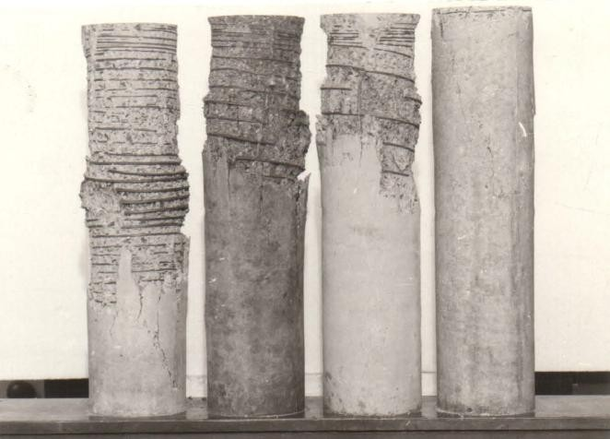

1. **EXPERIMENTAL RESULTS**

Figure 9 displays the findings of the current study as stress-strain graphs for each specimen. Diagrams fundamentally show the degree of confinement that has been established based on the pitch, diameter, strength, and ductility of the specimens' spiral reinforcement. The degree of compatibility between these various methods of confinement is also seen in the stress-strain diagrams of the two specimens, in which confinement was accomplished in two distinct ways.

Regarding the behaviour of the specimens under stress, it can be said specifically that: a) Specimen 1, without spiral reinforcement, failed abruptly, mostly with longitudinal fractures appearing. Despite the anticipated impact of the size effect, the failure stress of the unreinforced specimen was the same as that of the control cylinders with a fc = 25MPa.

b) Near the maximum failure load, the remaining specimens with transverse spiral reinforcement displayed peeling, and depending on the degree of confinement that had occurred by that point, the downward branch of the figure either had a severe slope or a gentler slope. The increase in failure load as compared to the comparable load in the unreinforced specimen was similarly impacted by confinement. The highest improvement in resistance seen in specimens 2 and 5 with thick reinforcement was just over 40% of the strength of the unreinforced specimen. However, the computation understates the real percentage of increase due to confinement since it was based on the whole cross-section of the unreinforced specimen. The increase in strength caused by triaxial stress, in the authors' view, should be estimated using the core diameter D = 175mm rather than the entire diameter of 205mm. As a result, it is projected that the maximum strength gain from confinement will exceed 50% of the strength of the unreinforced specimen.

c) The strain at specimens with strong confinement reached a value of 3.5%, however the column was still able to support the service load as prescribed by the Code [5].

d) Bursting fracture of the spiral reinforcement caused failure in all specimens, with the exception of the unreinforced one. Other fractures at the initial site of the spiral's break occurred after the first break, which happened under very high strain (shortening). Six spiral reinforcement breakpoints were found at specimen 2 following unloading, all in the middle of the specimen.

A decrease in the specimen's strength occurred in the case that the reinforcement failed. The resistance quickly deteriorated due to many fractures, which also made the descending branch of the stress-strain diagram steeper.

e) At specimen 8, the combination transverse reinforcement (ties and spiral) produced an outstanding behaviour. The specimen in question showed no swelling tendencies while experiencing repeated failures of its spiral reinforcing, in contrast to specimens that were only reinforced with spirals that deformed once the spiral ruptured unilaterally (often swelling of the region of mass failure of spirals). This is because the material was kept in place by the unbroken bonds of the "wound" area rather than expanding from the pierced core as in previous instances. It should be noticed that the specimen lacked any evidence of bonds snapping. The concrete mass may have anchorages that have slipped.

f) Specimen 9, which had a mixed confinement reinforced made of steel fibres and spiral reinforcement, had a much better downward branch of the stress-strain diagram but did not significantly enhance resistance when compared to specimens 2 and 5.

1. **CONCLUSIONS**

This work's findings may be summed up as follows:

1. By using strong spiral reinforcement, the columns' compressive strength is increased by roughly 50% and their failure strain is dramatically increased by around 10 times (w = 0.05).

2. High yield-limit steels are very effective as confinement reinforcements.

3. The stress-strain diagram's maximum value of strain (shortening) cu is improved by confinement reinforcement with high ductility.

4. The use of mixed confinement reinforcement, which consists of both spiral and conventional ties, is a particularly effective method of confinement. It also enables the structural component to maintain its shape and some of its resistance even after multiple spiral reinforcement failures.

1. **REFERENCES**
2. Bertero, V.V., Bresler, B., Selna, S.G., Chopra, A.K., Koretsky, A.V., “Design implications of damage observed in the Olive View Medical Center buildings”, Proceedings of the 5th World Conference on Earthquake Engineering, Rome, Italy, 1974.
3. Chopra, A.K., Bertero, V.V., Mahin, S.A., “Response of the Olive View Medical Center main building during the San Fernando earthquake”, Proceedings of the 5th World Conference on Earthquake Engineering, Rome, Italy, 1974.
4. Jennings, P.C., Housner, G.W., “The San Fernando, California, earthquake of February 9, 1971”, Proceedings of the 5th World Conference on Earthquake Engineering, Rome, Italy, 1974.
5. Ministry of Environment, Planning and Public Works, “Greek Code for the Design and Construction of Concrete Works”, Athens, Greece, 1991. (In Greek).
6. Ministry of Environment, Planning and Public Works, “Greek Code for the Design and Construction of Concrete Works”, Athens, Greece, 2000. (In Greek).
7. European Committee for Standardization, “EN 1992-1.1:2004, Eurocode 2: Design of concrete structures - Part 1.1: General rules and rules for buildings (Incorporating corrigendum January 2008)”, Brussels, Belgium, 2004.
8. Fintel, Μ., “Handbook of Concrete Engineering”, Van Nostand Reinhold Company, 1974.
9. CEB-FIP, “Model Code 1990 (Final Draft 1993)”, Comite Euro-International Du Beton, Lausanne, 1991.
10. ACI Committee 363, “State-of-the-art report on high strength concrete”, SCM 15-87, American Concrete Institute, Detroit, 1987, pp. 364-411.
11. Albinger, J., Moreno, S. Ε. J., “High strength concrete Chicago style”, Concrete Construction, Vol. 26, No. 2, 1981, pp. 241-245.itcin, Ρ. C., Neville, Α., “High performance concrete demystified”, Concrete International, Vol. 15, No. 1, Jan. 1993, pp. 21-26.
12. Carrasquillo, R. Ι., Nilson, Α. Η., Slate, F. Ο., “Properties of high strength concrete subject to short-term loads”, ACI Structural Journal, Vol. 78, No. 3, May-June 1981, pp. 171-178.
13. Hsu, Ι., Hsu Τ., “Stress-strain behavior of steel-fiber high-strength concrete under compression”, ACI Structural Journal, Vol. 91, No. 4, July-August 1994, pp. 448-457.