**IMPLEMENTATION OF SMART REMOTE FOR DISABLED PEOPLE**

T.Nagamani1, S.Ruksana2, M.Lakshmi Saraswathi3, P.Lakshmi Lavanya4, K.Jahnavi5 ,R.Anjali6

*1Assistant Professor, Department Of Electronics and Communication Engineering, Santhiram Engineering College, Nandyal, India.*

*2,3,4,5,6Department of Electronics and Communication Engineering, Santhiram Engineering College, Nandyal, India.*

**Abstract**

To manage the flow of power to disabled people, switches have long been the norm. The more technologically sophisticated the world becomes, the more pervasive new technology becomes in every aspect of life, including the domestic sphere. The habit of automating one's home by using smart remote is gaining ground and gaining popularity all around the globe. This smart remote is the practice of employing electronic devices to do routine household chores without human intervention. Several chores around the house may be handled by this system. The primary goal of this project is to use a basic circuit to manage our household appliances. The controlled device is wired between the relay's pole and the neutral terminal of the mains. When the relay is energised, the normally open (N/O) contact makes contact with the live terminal of the AC mains. The home appliances in our proposal are controlled through the Bluetooth or Wi-Fi.

**Introduction**

Traditionally electrical appliances in a home are controlled via switches that regulate the electricity to AC devices. As the world gets more and more technologically advanced, we find new technology coming in deeper and deeper into our personal lives even at home. Home automation is becoming more and more popular around the world and is becoming a common practice. The process of home automation works by making everything in the house automatically controlled using technology to control and do the jobs that we would normally do manually. Home automation takes care of a lot of different activities in the house. The main objective of this project is that we are controlling our home appliances using a simple circuit. The appliance to be controlled is connected between the pole of the relay and neutral terminal of mains. It gets connected to live terminal of AC mains via normally opened (N/O) contact when the relay energizes. The aim of the proposed system is to develop a cost-effective solution that will provide controlling of home appliances remotely and enable home security against intrusion in the absence of homeowner. The home appliances control system with an affordable cost was thought to be built that should be providing remote access to the appliances and allowing home security. These devices should be controlled as well as turn on/off if required. Most of the times it was done manually. Now it is a necessity to control devices more effectively and efficiently at anytime from anywhere. In this system, we are going to develop a remote control-based home/office appliance. Remote control for home appliances is an absolute necessity in our fast-paced life. As a result, much important has been given to this aspect and a range of remote controls are prevalent today. One of the most common is that which makes use of IR radiations at particular frequencies. Our project is a Remote Operated Home Appliance or Remote-controlled home appliance. The circuit is connected to any of the home appliances to make the appliance turn on/off from a TV, VCD, VCR, Air Conditioner or DVD remote control. The circuit can be activated from up to 10 meters. It is very easy to build and can be assembled on a general-purpose PCB. For this purpose, we make a circuit that consist of an IR module, CD4017 IC, LEDs to indicate the reception of the IR radiations, otherwise indicating the ON/OFF state, relay and other components.

**Literature Review**

A smart remote incorporates a number of theoretical and practical approaches to modern and future lifestyles. Smart remote using wireless communication technology may be achieved in a number of different ways. Here are a few examples: - (a) A suggested approach to home automation employing mobile devices running the Android operating system. Bluetooth, an in-built feature of Android mobile phones, was proposed as a means of home automation and an 8-bit microcontroller. (b)Another approach suggested using infrared technology to enable remote management of a central switch for all of a home's electrical equipment. They had developed a novel remote control circuit that enabled automated switch and switch board operation from a distance, independent of the availability of an internet connection, a mobile data plan, or a battery. One that relies only on physical components. (c) An IR remote control signal decoder was suggested by a third party as a means of controlling electrical appliances in the house. Infrared (IR) sensors, triacs, and NEC555 timer ICs are discussed, as well as their usage in home automation. This was another endeavor that relied on physical components. (d) A PC Internet-Uno microcontroller based smart remote system is shown in a different study. This study demonstrates a different approach to home automation by using a PC Internet-Uno microcontroller-based system. The suggested system may function in either of two modes.

Home and office automation with a remote control are presented in this study. They are crucial in today's society. Everyone is worried most about the wireless control. In this study, we provide the blueprints for a sophisticated home-monitoring system operated by remote control. Here, we take care of issues with home automation as well as remote controls specially for disabled people. The greatest way to avoid wasting electricity is detailed in this document. Without physically accessing the wall switches or power outlets, household appliances may be turned on and off using infrared remote controls.

**Existing System**

Digital technology that relies on a network to function has been rapidly adopted in domestic settings in recent years. Increased home automation via device connection is made possible by this cutting-edge technology. As the Internet continues to grow, there will also be more opportunities for controlling and monitoring devices like this remotely. Unfortunately, home automation systems have not been widely adopted. Reasons for the delayed acceptance of home automation systems are identified, and potential for resolving these issues via the development of a versatile home automation architecture is assessed. Humans often engage in the process of controlling devices. Most homes have many systems, and it may be a hassle to keep them all under control. As mobile connectivity improves and prices drop, it is becoming more practical to integrate mobile devices into home automation systems. The home environment has shifted in recent years to prioritise facilitating the user's ability to manage and know the precise state of electrical equipment in the house at any given time. A pressure sensor evaluates the health of home electronics. Only from the approved user's cellphone number can this system listen, react, and carry out the orders.

**Proposed System**

Our device, which incorporates an infrared (IR) sensor and a microcontroller, was developed after careful consideration of the aforementioned methods. No coverage or network gaps exist in the proposed system. People of all ages, disabilities, and backgrounds, including those who have trouble communicating, are given special attention. It's simple to set up and comes at a low price.

**METHODOLOGY:**

As there is no significant development for disabled people,

we have designed the smart assistance gloves for them. The

proposed model is designed with the help of flex sensors and

the instructions are fed into the Arduino Uno board. The finger

gesture is captured by the flex sensor and a corresponding

output is displayed in the form of a sentence in the Android

app and output is also displayed as an audio output. The

overall process is carried out by Arduino Uno, Raspberry Pi

and GSM module. The Data transmission between the

Arduino Uno and Raspberry Pi is done with the help of a

wireless serial port module. An alert message will be sent

through the GSM module during emergency situation to the

emergency contact

As there is no significant development for disabled people,

we have designed the smart assistance gloves for them. The

proposed model is designed with the help of flex sensors and

the instructions are fed into the Arduino Uno board. The finger

gesture is captured by the flex sensor and a corresponding

output is displayed in the form of a sentence in the Android

app and output is also displayed as an audio output. The

overall process is carried out by Arduino Uno, Raspberry Pi

and GSM module. The Data transmission between the

Arduino Uno and Raspberry Pi is done with the help of a

wireless serial port module. An alert message will be sent

through the GSM module during emergency situation to the

emergency contact

As there is no significant development for disabled people,

we have designed the smart assistance gloves for them. The

proposed model is designed with the help of flex sensors and

the instructions are fed into the Arduino Uno board. The finger

gesture is captured by the flex sensor and a corresponding

output is displayed in the form of a sentence in the Android

app and output is also displayed as an audio output. The

overall process is carried out by Arduino Uno, Raspberry Pi

and GSM module. The Data transmission between the

Arduino Uno and Raspberry Pi is done with the help of a

wireless serial port module. An alert message will be sent

through the GSM module during emergency situation to the

emergency contact

As there is no significant development for disabled people,

we have designed the smart assistance gloves for them. The

proposed model is designed with the help of flex sensors and

the instructions are fed into the Arduino Uno board. The finger

gesture is captured by the flex sensor and a corresponding

output is displayed in the form of a sentence in the Android

app and output is also displayed as an audio output. The

overall process is carried out by Arduino Uno, Raspberry Pi

and GSM module. The Data transmission between the

Arduino Uno and Raspberry Pi is done with the help of a

wireless serial port module. An alert message will be sent

through the GSM module during emergency situation to the

emergency contact

As there is no significant development for disabled people,

we have designed the smart assistance gloves for them. The

proposed model is designed with the help of flex sensors and

the instructions are fed into the Arduino Uno board. The finger

gesture is captured by the flex sensor and a corresponding

output is displayed in the form of a sentence in the Android

app and output is also displayed as an audio output. The

overall process is carried out by Arduino Uno, Raspberry Pi

and GSM module. The Data transmission between the

Arduino Uno and Raspberry Pi is done with the help of a

wireless serial port module. An alert message will be sent

through the GSM module during emergency situation to the

emergency contact

As there is no significant development for disabled people,

we have designed the smart assistance gloves for them. The

proposed model is designed with the help of flex sensors and

the instructions are fed into the Arduino Uno board. The finger

gesture is captured by the flex sensor and a corresponding

output is displayed in the form of a sentence in the Android

app and output is also displayed as an audio output. The

overall process is carried out by Arduino Uno, Raspberry Pi

and GSM module. The Data transmission between the

Arduino Uno and Raspberry Pi is done with the help of a

wireless serial port module. An alert message will be sent

through the GSM module during emergency situation to the

emergency contact

As there is no significant development for disabled people,

we have designed the smart assistance gloves for them. The

proposed model is designed with the help of flex sensors and

the instructions are fed into the Arduino Uno board. The finger

gesture is captured by the flex sensor and a corresponding

output is displayed in the form of a sentence in the Android

app and output is also displayed as an audio output. The

overall process is carried out by Arduino Uno, Raspberry Pi

and GSM module. The Data transmission between the

Arduino Uno and Raspberry Pi is done with the help of a

wireless serial port module. An alert message will be sent

through the GSM module during emergency situation to the

emergency contact

As there is no significant development for disabled people,

we have designed the smart assistance gloves for them. The

proposed model is designed with the help of flex sensors and

the instructions are fed into the Arduino Uno board. The finger

gesture is captured by the flex sensor and a corresponding

output is displayed in the form of a sentence in the Android

app and output is also displayed as an audio output. The

overall process is carried out by Arduino Uno, Raspberry Pi

and GSM module. The Data transmission between the

Arduino Uno and Raspberry Pi is done with the help of a

wireless serial port module. An alert message will be sent

through the GSM module during emergency situation to the

emergency contact

As there is no significant development for disabled people,

we have designed the smart assistance gloves for them. The

proposed model is designed with the help of flex sensors and

the instructions are fed into the Arduino Uno board. The finger

gesture is captured by the flex sensor and a corresponding

output is displayed in the form of a sentence in the Android

app and output is also displayed as an audio output. The

overall process is carried out by Arduino Uno, Raspberry Pi

and GSM module. The Data transmission between the

Arduino Uno and Raspberry Pi is done with the help of a

wireless serial port module. An alert message will be sent

through the GSM module during emergency situation to the

emergency contact

As there is no significant development for disabled people,

we have designed the smart assistance gloves for them. The

proposed model is designed with the help of flex sensors and

the instructions are fed into the Arduino Uno board. The finger

gesture is captured by the flex sensor and a corresponding

output is displayed in the form of a sentence in the Android

app and output is also displayed as an audio output. The

overall process is carried out by Arduino Uno, Raspberry Pi

and GSM module. The Data transmission between the

Arduino Uno and Raspberry Pi is done with the help of a

wireless serial port module. An alert message will be sent

through the GSM module during emergency situation to the

emergency contact

As there is no significant development for disabled people,

we have designed the smart assistance gloves for them. The

proposed model is designed with the help of flex sensors and

the instructions are fed into the Arduino Uno board. The finger

gesture is captured by the flex sensor and a corresponding

output is displayed in the form of a sentence in the Android

app and output is also displayed as an audio output. The

overall process is carried out by Arduino Uno, Raspberry Pi

and GSM module. The Data transmission between the

Arduino Uno and Raspberry Pi is done with the help of a

wireless serial port module. An alert message will be sent

through the GSM module during emergency situation to the

emergency contact

As there is no significant development for disabled people,

we have designed the smart assistance gloves for them. The

proposed model is designed with the help of flex sensors and

the instructions are fed into the Arduino Uno board. The finger

gesture is captured by the flex sensor and a corresponding

output is displayed in the form of a sentence in the Android

app and output is also displayed as an audio output. The

overall process is carried out by Arduino Uno, Raspberry Pi

and GSM module. The Data transmission between the

Arduino Uno and Raspberry Pi is done with the help of a

wireless serial port module. An alert message will be sent

through the GSM module during emergency situation to the

emergency contact

The following is an outline of the system's fundamental methodology: The system is an remote controller that, with the help of the user's android app, can be used to control any electronic household appliance, b. Inputs include choosing a device, operating it using a universal remote, and then using its specific features. Like an ON/OFF toggle. Depending on the device's availability and the desired features, this system will modify its present state. c. eg. Tube lights and similar devices only have an on/off switch.

Furthermore, we can control the gadgets with our voices, and if someone is bothering you, you may click a button to activate a voice-activated alarm system.

**Block Diagram**

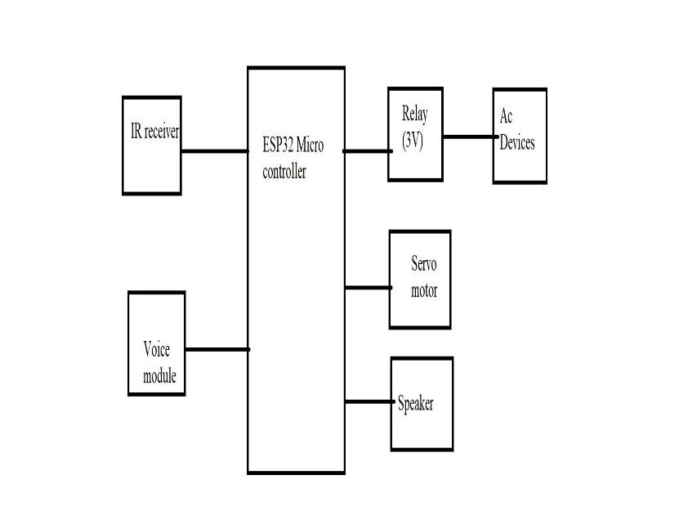

# Relay

# Electrical equipment, such as a timer circuit, may switch power through relays at predetermined intervals. For a long time, relays were the go-to for switching on and off electrical equipment in factories.

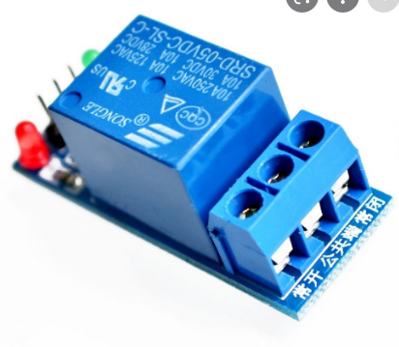

**AC DEVICES**

AC can be produced by using a device is called as an alternator. This device is a special type of electrical generator designed to produce alternating current. A loop of wire is rotated inside of a magnetic field, which induces a current along the wire.

**Servo Motor:**

Servo motor is an electrical device which can be used to rotate objects (like robotic arm) precisely.

Servo motor consists of DC motor with error sensing negative feedback mechanism. This allows precise control over angular velocity and position of motor. In some cases, AC motors are used.

It is a closed loop system where it uses negative feedback to control motion and final position of the shaft.

It is not used for continuous rotation like conventional AC/DC motors.

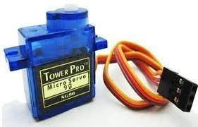It has rotation angle that varies from 0° to 180°.

**Voice module:**

It is the spoken voice that the worker hears and uses to interact with the system. The Voice Module converts the text information coming from the Voice Application to audible commands for the operator to hear.

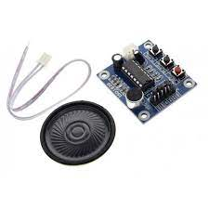

**IR RECEIVER:**

These devices pick up infrared signals from your remote control just like a TV or Cable box. After receiving an IR signal they encode and amplify it to be suitable for transmission via low-voltage wiring.

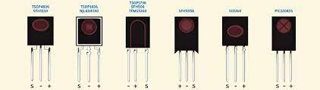

TSOP1738 is an IR receiver with an amplifier that acts as a switch and converter within a circuit. It has one input and output which only acts on the base of the input IR signal. The basic purpose of TSOP1738 is to convert the IR signal to electric signals. Every IR receiver has a special frequency to operate.

**RESULT:**

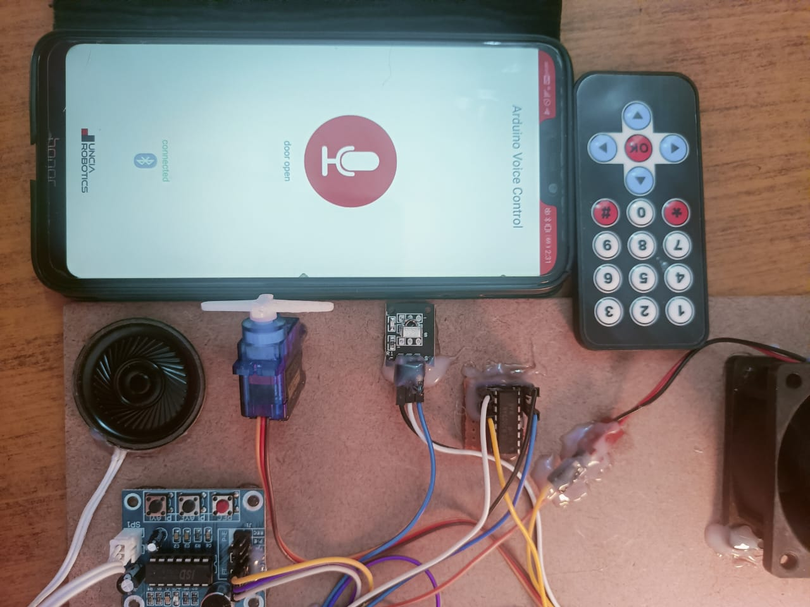

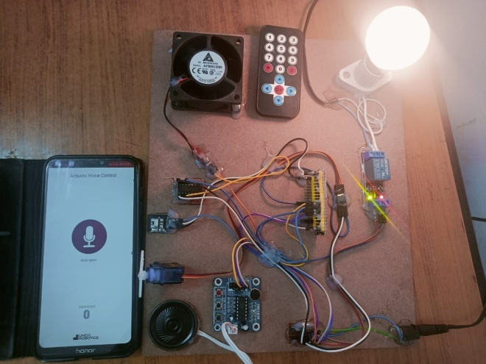

**CONCLUSION**

Everyone with a smartphone today was targeted for implementation of this system. For this reason, the Bluetooth system is included in all modern smartphones. In this project, we will utilise the HC-05 Bluetooth module to remotely turn on and off various home appliances using a basic Arduino-based home automation system. A home automation system may provide us with peace of mind and convenience. Here, we'll use a Bluetooth-connected smartphone app to manage four different household gadgets.

**REFERENCES**

[1] S. M. Anamul Haque, S. M. Kamruzzaman and Md. Ashraful Islam1 “A System for Smart-Home Control of Appliances Based on Timer and Speech Interaction” Proceedings of the 4th International Conference on Electrical Engineering & 2nd Annual Paper Meet 26-28 , pp. 128-131, January, 2006J. Breckling, Ed., The Analysis of Directional Time Series: Applications to Wind Speed and Direction, ser. Lecture Notes in Statistics. Berlin, Germany: Springer, 1989, vol. 61.

[2] Prashant Chakole and Dr. Pradip B. Dahikar “RF Remote Control of Power Line Devices Using Embedded System” proceeding of International Journal of Engineering Science and Innovative Technology (IJESIT) Volume 2, Issue 3, May 2013

[3] Rifat Shahriyar, Enamul Hoque, S.M. Sohan, Iftekhar Naim,Md. Mostafa Akbar and Masud Karim Khan “Remote Controlling of Home Appliances using Mobile Telephony” Proceedings of theInternationalJournal of Smart HomeVol. 2, No. 3, July, 2008.

[4] Tam Van Nguyen, Dong Gun Lee, Yong Ho Seol, Myung Hwan Yu, Deokjai Choi, “Ubiquitous Access to Home Appliance Control System using Infrared Ray and Power Line Communication”, ICI 2007, 3rd IEEE/IFIP International Conference in Central Asia, Tashkent, Uzbekistan, vol 1, pp1-4,26-28 Sept.20

[5] Malik Sikandar Hayat Khiyal, Aihab Khan, and ErumShehzadi “SMS Based Wireless Home Appliance Control System (HACS) for Automating Appliances and Security”. Issue in Information Science and Information Technology Vol 6,, Pp 887-894, 2009.

[6] Mr. Pawan Sharma, Mr. lokesh Mehta “SPY Night Vision Robot with Moving Wireless Video Camera & Ultrasonic Sensor”

[7] A. Pawar, R. Sharan, R. Patil, and S. Chavan, “International Journal of Innovative Research in Computer and Communication Engineering Home Automation using Bluetooth and IOT,” pp. 896–902, 2018, doi: 10.15680/IJIRCCE.2018.0602036.

[8] J. B. Sy, M. G. Rojo, E. R. Calibara, A. V. Comendador, and W. Degife, “Multi-Station Automated Hand Washing System ( MSAHWS ),” no. 3, pp. 36–43, 2020, doi: 10.35940/ijrte.C4243.099320.

[9] J. B. Sy, W. Degife, W. Teka, and E. B. Panganiban, “Automated Hand Washing System With Hand Dryer,” Int. J. Emerg. Trends Eng. Res. Available, vol. 8, no. 9, 2020.

[10] D.Lakshmaiah, Dr.M.Subramanyam, Dr.K.Satya Prasad,” Design of low power 4- bit CMOS Braun Multiplier based on threshold voltage Techniques”, Global Journal of Research in Engineering, Vol.14(9),PP.1125-1131,2014.

[11] R Sumalatha, Dr.M.Subramanyam, “Image Denoising Using Spatial Adaptive Mask Filter”, IEEE International Conference on Electrical, Electronics, Signals, Communication &amp; Optimization (EESCO-2015), Organized byVignans Institute Of Information Technology, Vishakapatnam, 24 th to 26th January 2015.

[12] K.Mallikarjuna, Dr.K.Satya Prasad, Dr.M.V.Subramanyam,” Compression of Noisy Images based on Sparsification using Discrete Rajan Transform”, International Journal of Computer Applications, Vol.132,NO.12,PP.37-43,2015.

[13] Vlsi Implementation Of Ternary Adder And Multiplier Using Tanner Tool”, Journal of Pharmaceutical Negative Results , Volume 13 ,Special Issue 5 ,2022

[14] Voice Activated Programmable Multipurpose Robot”,Vol-2,Issue 7,July 2013-IJARCET.

[15] “Combined DCT and companding for PAPR reduction in OFDM signals”,H Bindu, M Chandrika Int. J. Innov. Res. Sci. Technol. 2 (2), 730-735,2016

[16] RELATIVE STUDY AND DESIGN OF CSRO IN 16nm TECHNOLOGY” VOL-3,ISSUE 8 ,AUG-2022-IJRPR

[17] J. B. Sy, “A Low-Cost Arduino-based Smart Irrigation System ( LCABSIS ),” Int. J. Emerg. Trends Eng. Res., vol. 8, no. 9, 2020.

[18]. D. Nctrsd, W. Degife, and A. Sisay, “Non - Contact Temperature Reader with,” vol. 10, no. 9, pp. 583–592, 2020, doi: 10.29322/IJSRP.10.09.2020.p10567.

[19] J. R. Rana and S. N. Pawar, “Zigbee Based Home Automation,” SSRN Electron. J., no. April 2010, 2012, doi: 10.2139/ssrn.1587245.

[20] K. Venkatesh, P. Rajkumar, S. Hemaswathi, and B. Rajalingam, “IoT based home automation using raspberry Pi,” J. Adv. Res. Dyn. Control Syst., vol. 10, no. 7 Special Issue, pp. 1721–1728, 2018.

[21] P. M. B. R, V. K. R, and D. N. Gowda, “IoT Based Home Automation System over Cloud,” Int. J. Trend Sci. Res. Dev., vol. Volume-3, no. Issue-4, pp. 966– 968, 2019, doi: 10.31142/ijtsrd24005.

[22] R. K. Kodali and A. Anjum, “IoT Based HOME AUTOMATION Using Node-RED,” Proc. 2nd Int. Conf. Green Comput. Internet Things, ICGCIoT 2018, no. March, pp. 386–390, 2018, doi: 10.1109/ICGCIoT.2018.8753085.